Elevated-Fitness
Application: Elevated Fitness

Keyan Goodridge | 816047609 | keyanGoodridge | UI Design
Tyrese Lovell | 816037998 | TyreseLovell1 | Lead
Isaiah Porter-Lee | 816047712 | wtfjeron | DevOps
Joshua Lalla | 816042555 | JoshuaLalla10 | Marketing

Problem Description:
Although there are many gyms that can be found across Trinidad there aren’t as many stores that may sell gym equipment and products. Most may specialize in specific machinery to train the body, while others may focus on personal items like resistance bands or free weights and some stores may focus entirely on protein powder and other nutritional products. To add on to this, you may not be able to find out how great the quality of the product is immediately unless you use it yourself. This leads to wasted money and time and no leads to an alternative product that the customer is looking for.

Problem Solution:
What we are seeking to do is to centralize these various products into one sleek and well-designed website. This lets gym goers have a catalogue of several items where people may leave reviews about different products and items used, and how effective they were for them.
These products come in several categories such as:
- Machinery
- Personal Items
- Nutrition

This catalogue lets gym goers make a more informed decision about what they may want to purchase in order to improve their gym experience, may it be at a public or at home gym. Additionally, there are sorting and searching functions that allow customers to traverse the catalogue more easily with the sorting function.

UI Design
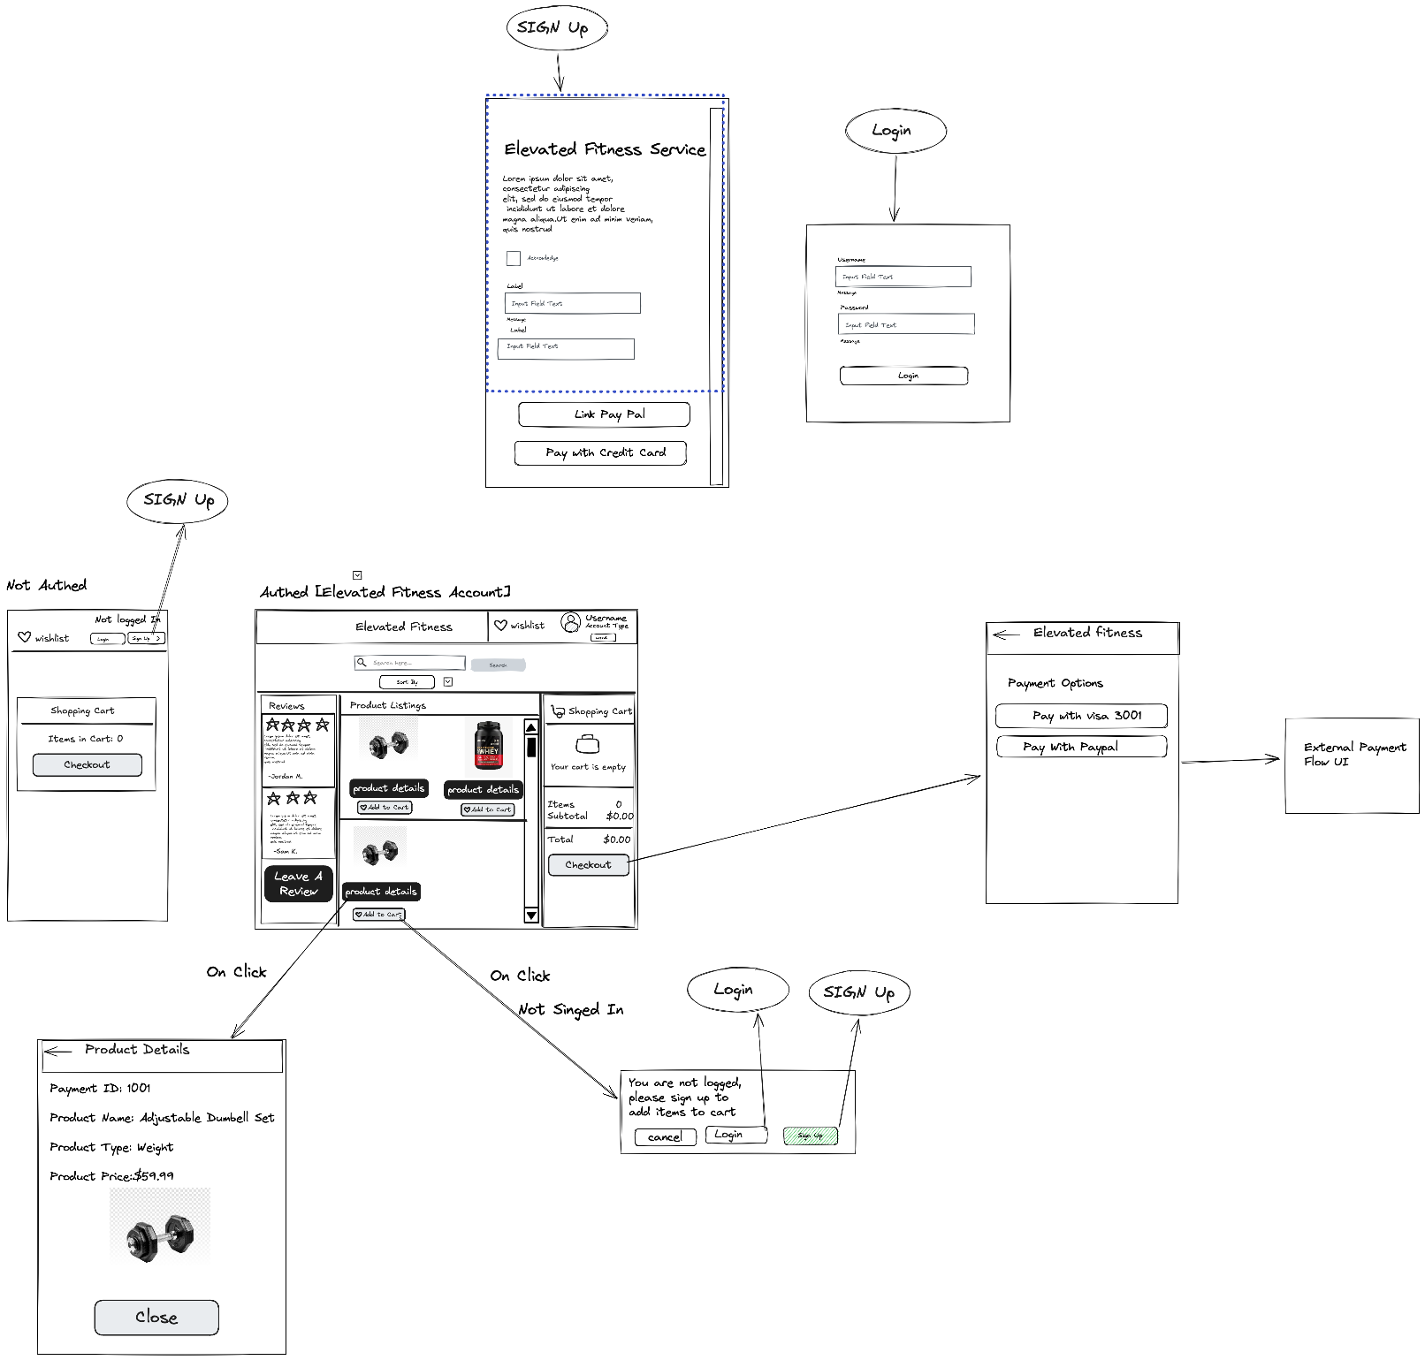
Wireframe Diagram Link:
https://excalidraw.com/#json=BvZJj3oU5YcaRdxFl-ISf,PzCznrmHgL8WKXFDlded_Q
Technologies Used:
- Handmade API .Json file
- Firebase
- Excalidraw (Wireframe Diagrams)
- Visual Studio Code (Coding medium)
- ClaudeAI
- ChatGPT

Features:
Sorting:
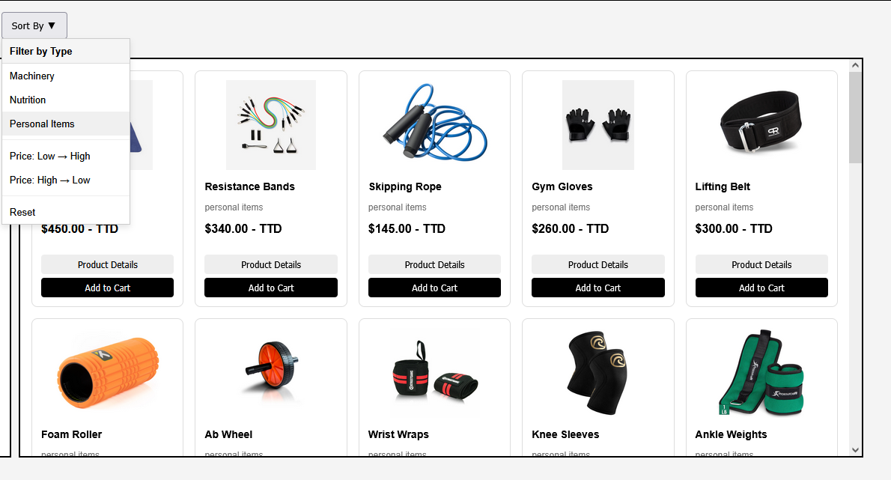

Reviews:
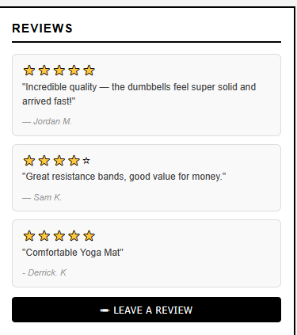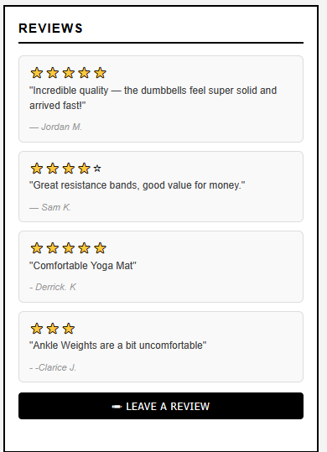

Searching:
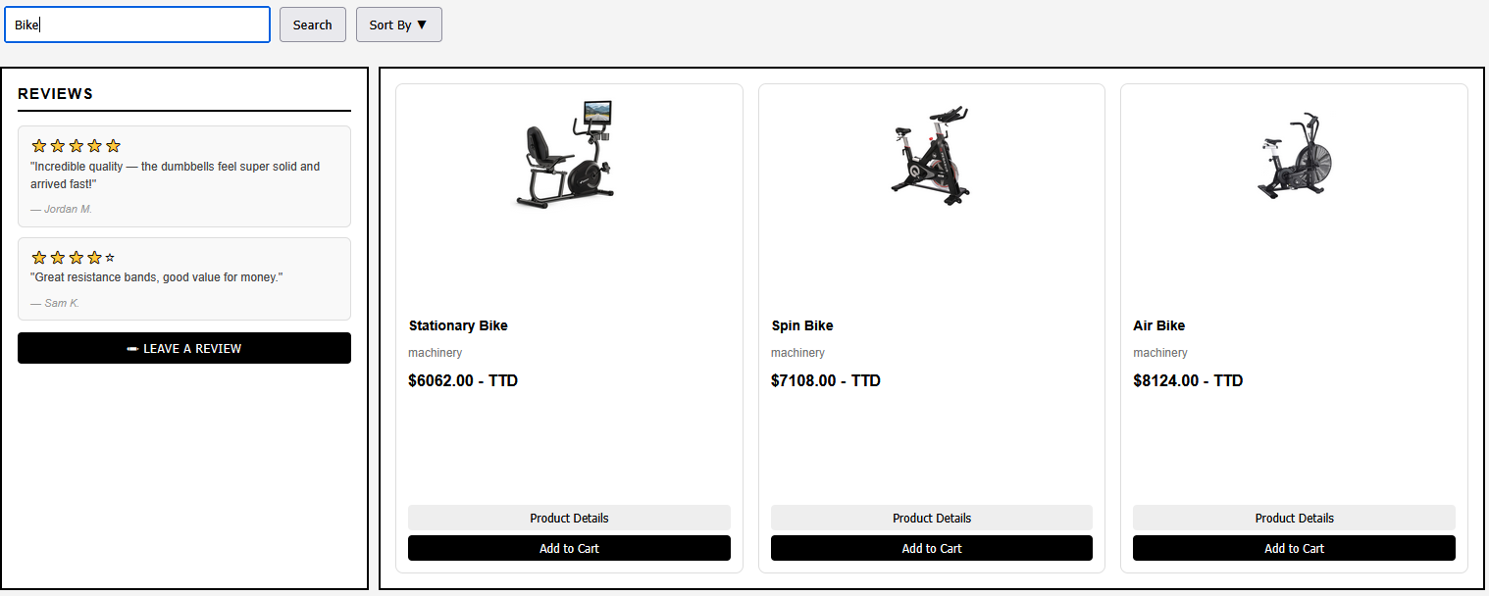

Login and Signup
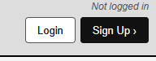
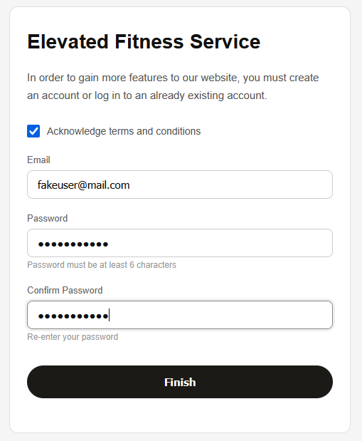

Deliverables:
GitHub Repo: https://github.com/wtfjeron/Elevated-Fitness
Presentation:
Deployed Application: https://elevated-fitness-6c0a5.web.app/index.html
Eg User Credential:
- User: fakeuser@mail.com
- Password: password123

