# Linux Commands Practical Assignment

**Github repo :-** [**Link**](https://github.com/wth-aryan/linux-commands-practice)

## 1. Creating and Renaming Files/Directories

Command:  
mkdir test_dir  
cd test_dir  
touch example.txt  
mv example.txt renamed_example.txt  
cd ..  
  
Explanation:  
This creates a new directory named "test_dir". Inside it, an empty file "example.txt" is created using the touch command.  
Then the file is renamed to "renamed_example.txt" using mv.  
 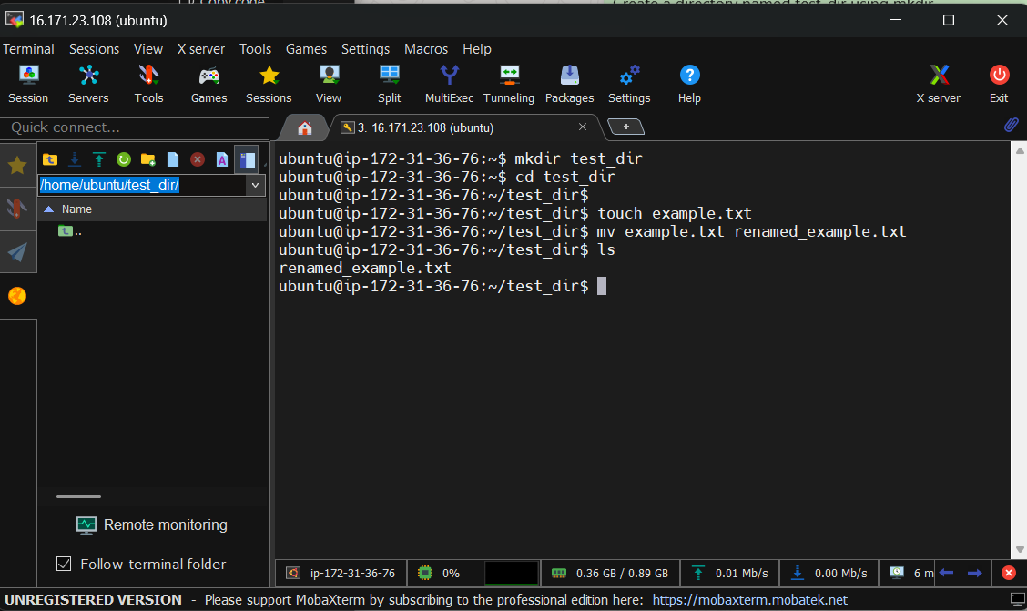

## 2. Viewing File Contents

Command:  
cat /etc/passwd  
head -n 5 /etc/passwd  
tail -n 5 /etc/passwd  
  
Explanation:  
cat displays the full contents of the /etc/passwd file.  
head -n 5 shows only the first 5 lines.  
tail -n 5 shows only the last 5 lines.

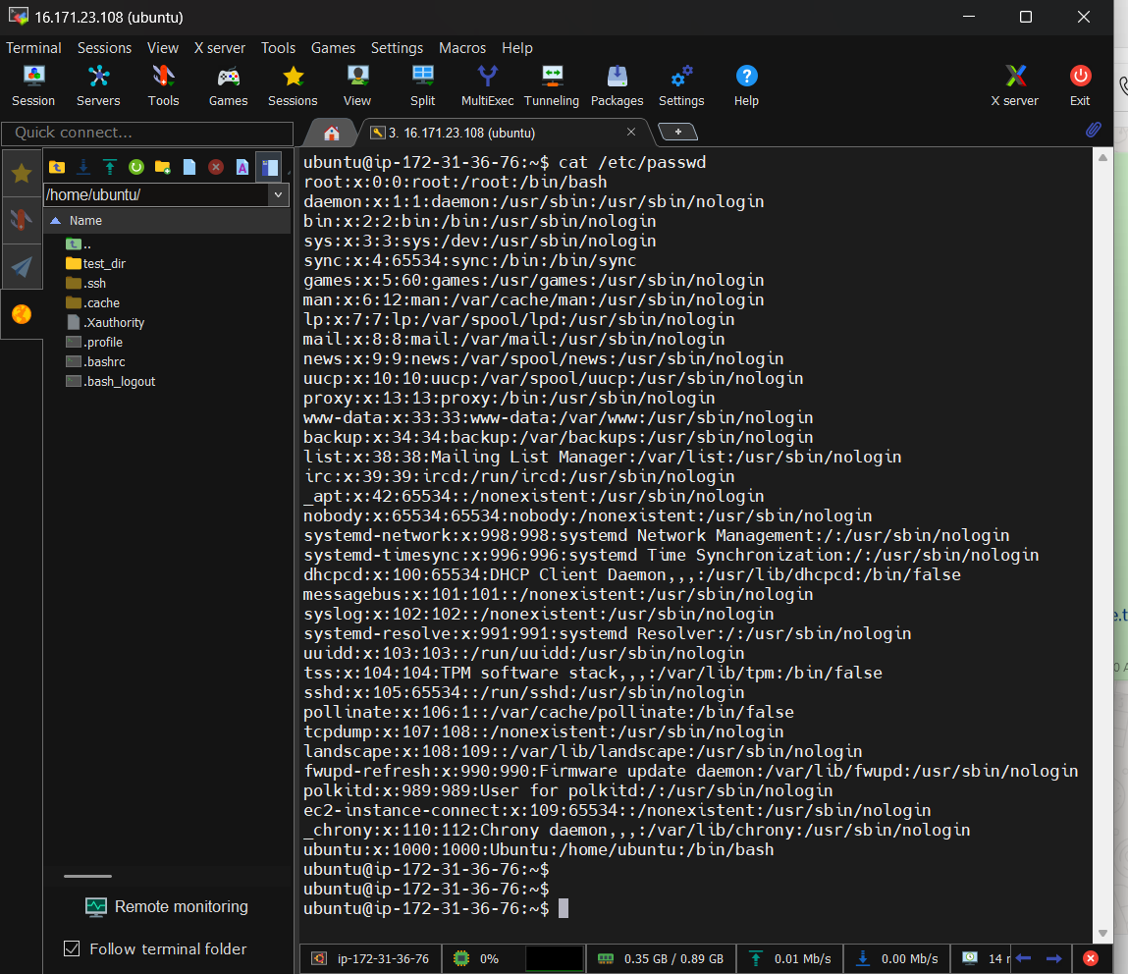

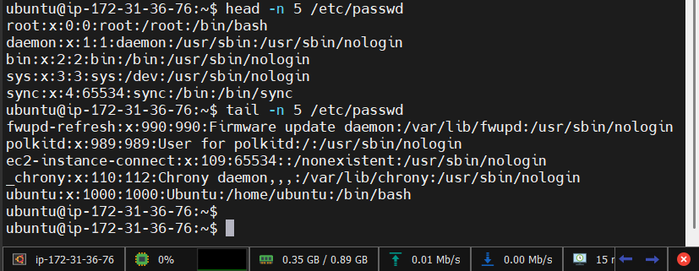

## 3. Searching for Patterns

Command:  
grep "root" /etc/passwd  
  
Explanation:  
grep searches for lines containing the word "root" in the /etc/passwd file and displays them.

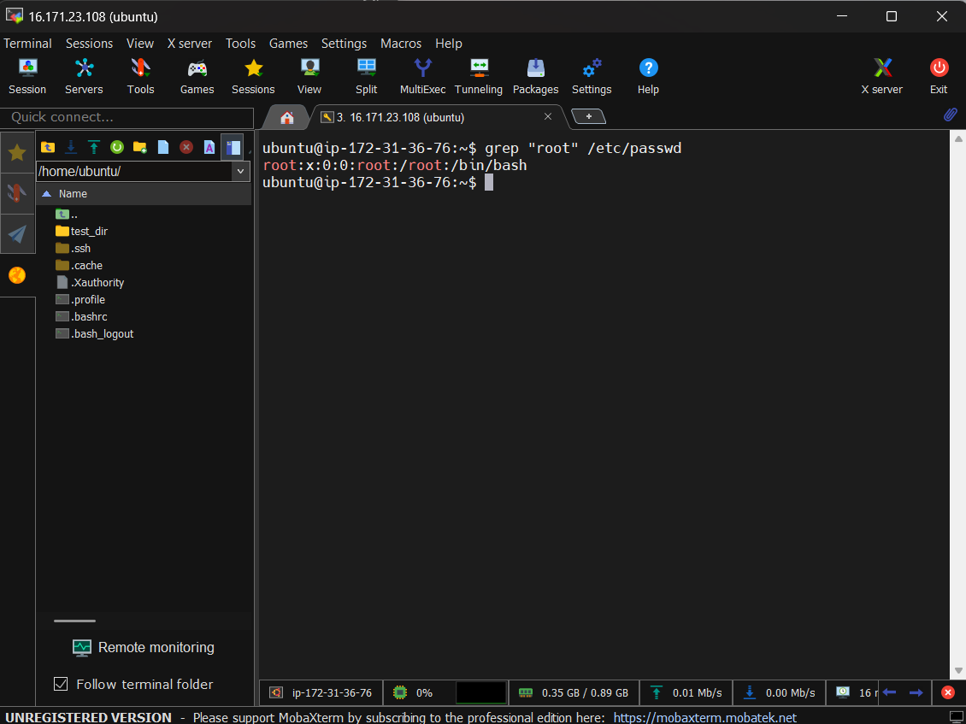

## 4. Zipping and Unzipping

Command:  
zip -r test_dir.zip test_dir  
unzip test_dir.zip -d unzipped_dir  
  
Explanation:  
The zip command compresses the folder test_dir into a file called test_dir.zip.  
The unzip command extracts its contents into a new directory called unzipped_dir.

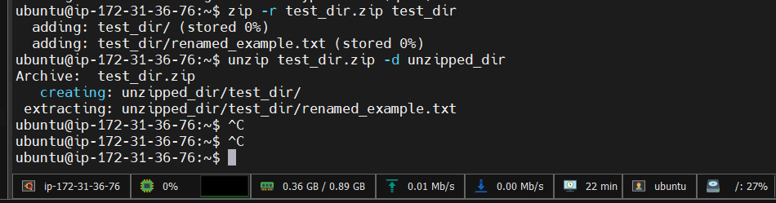

## 5. Downloading Files

Command:  
wget https://raw.githubusercontent.com/kubernetes/website/main/README.md  
  
Explanation:  
wget downloads a file from the given URL and saves it in the current directory.

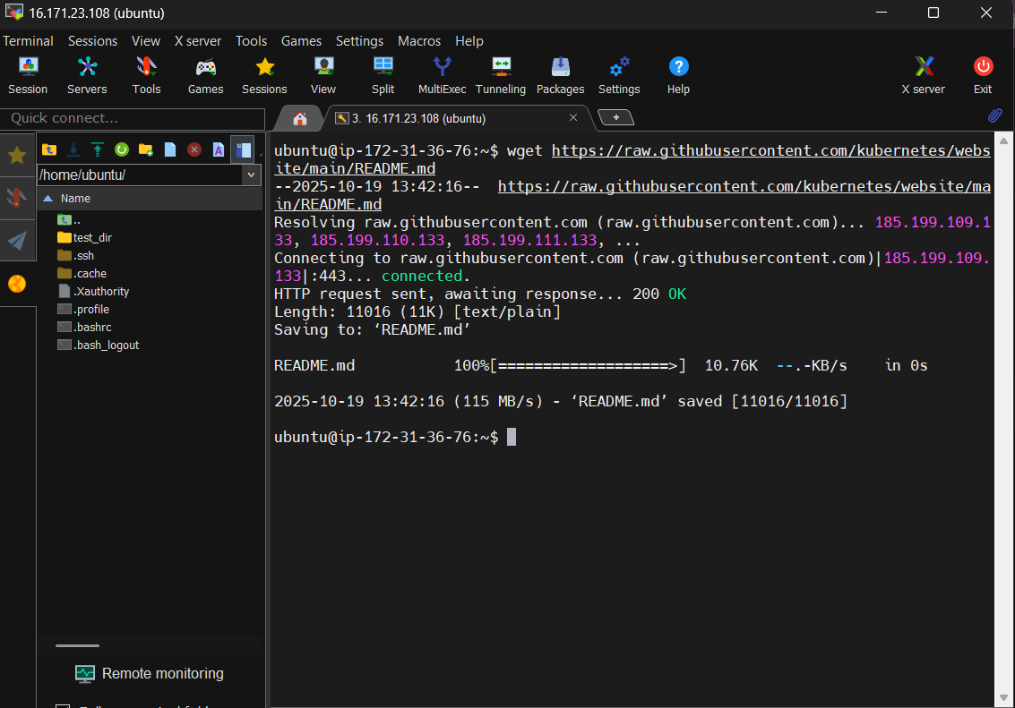

## 6. Changing Permissions

Command:  
touch secure.txt  
chmod 444 secure.txt  
ls -l secure.txt  
  
Explanation:  
touch creates an empty file named secure.txt.  
chmod 444 sets its permissions to read-only for everyone.  
ls -l displays the updated file permissions.  
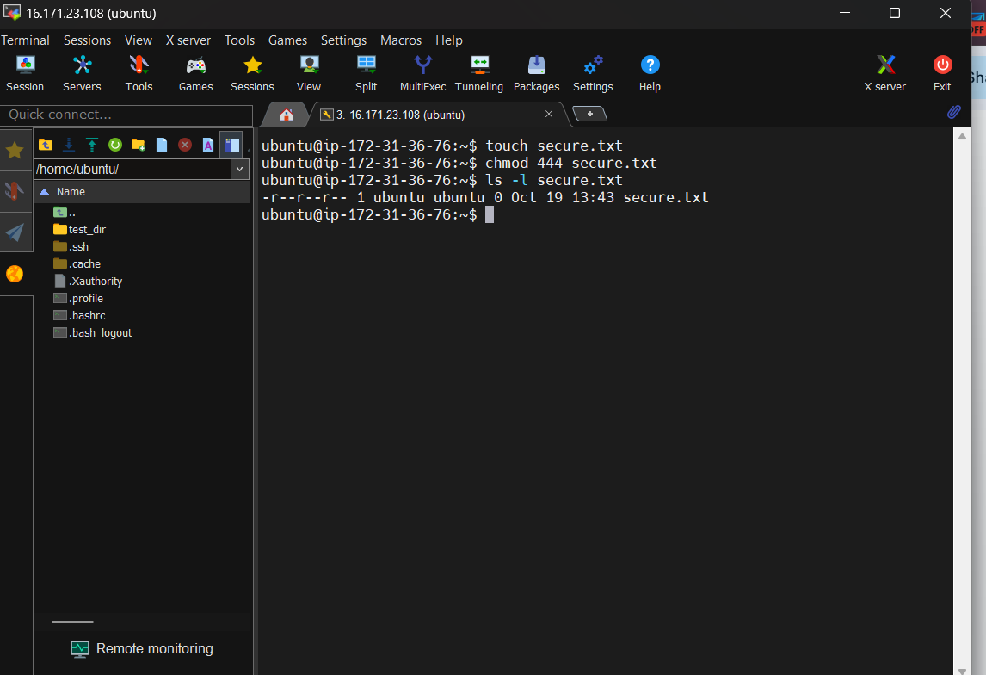

## 7. Working with Environment Variables

Command:  
export MY_VAR="Hello, Linux!"  
echo $MY_VAR  
  
Explanation:  
export creates a temporary environment variable named MY_VAR with the value "Hello, Linux!".  
echo displays its value in the terminal.

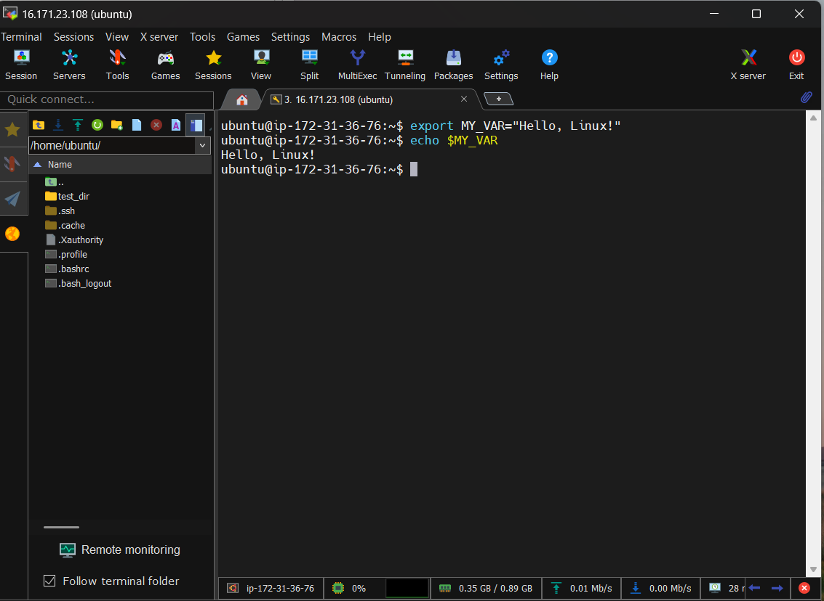

**Complete Practice script**

