YoucanstopanAzureSQLDatabaseinstancetodecreasecosts.

There is no way to stop SQL Azure Database to avoid billing charges when not in use. The azure virtual machine can be suspended and by doing that you can avoid hourly charges, but you cannot do the same with a SQL Azure Database which is charged hourly per database

**Azure Synapse Analytics**

an Azure ExpressRoute circuit

**Azure Sentinel:**

Analyze security log files from Azure VM

uses playbooks to automatically respond to threats?

**Azure Security Center**

- From Azure Security Center, you can download a Regulatory Compliance report

Display the secure score for Azure subscription

**Virtual Network**

* Is one region only
* To connect them VNet peering
* 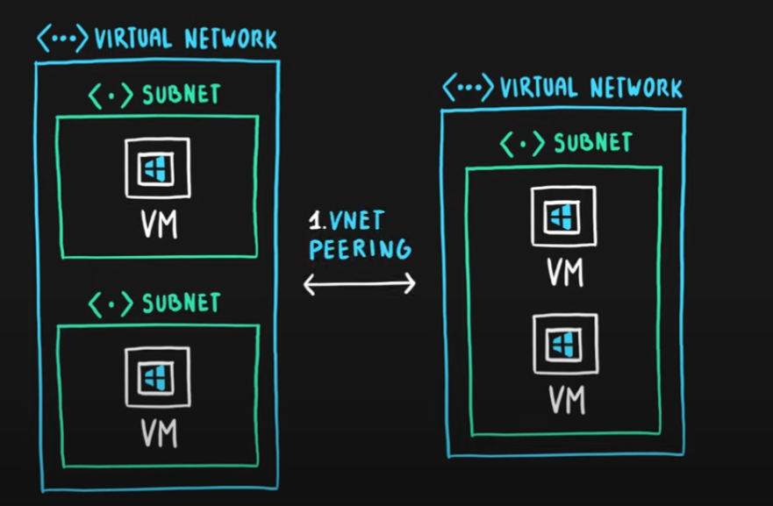
* or **VPN GATEWAY**
* 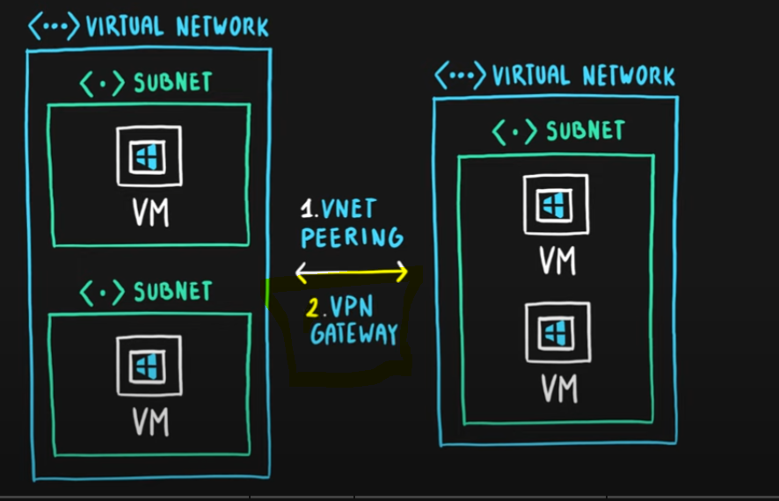

**Network security group**, to control internet for that subnet

Or between subnets

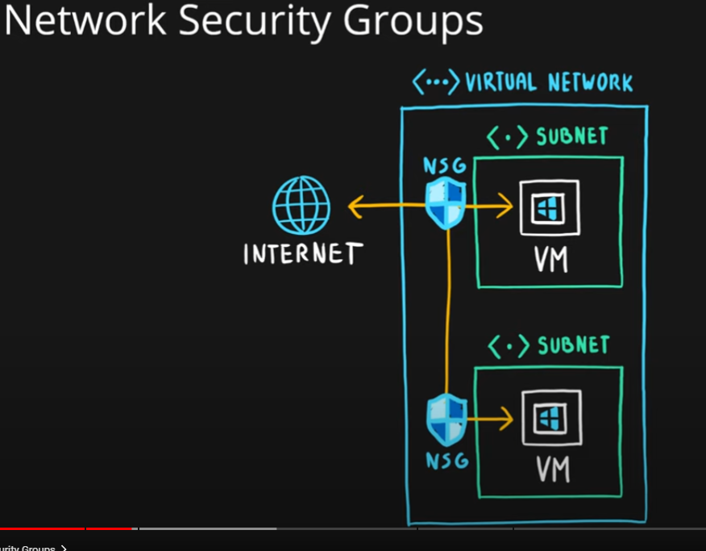

**VPN GATEWAY =** Virtual Network Gateway

* Enable you to connect you to the on premise envoropnment

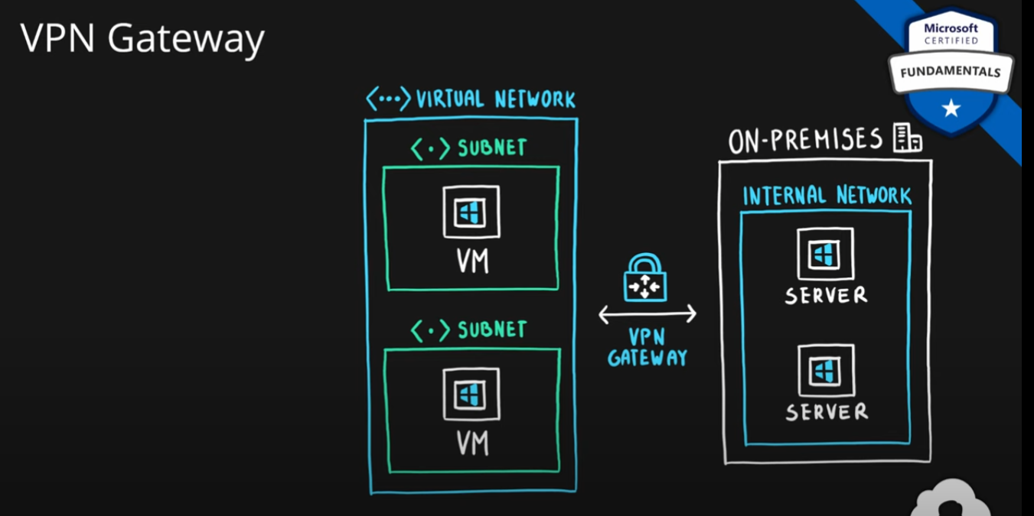

Can connect virtual network’s as we seen it before>

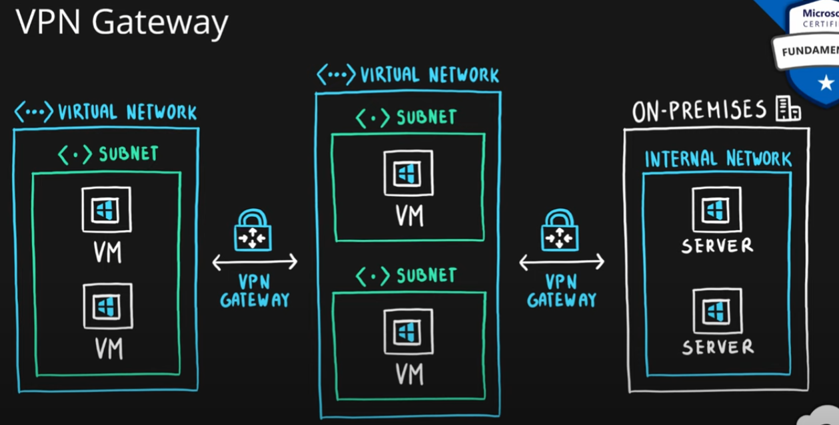

Azure Load Balancer

* For evenly distribute the traffic between virtual machines

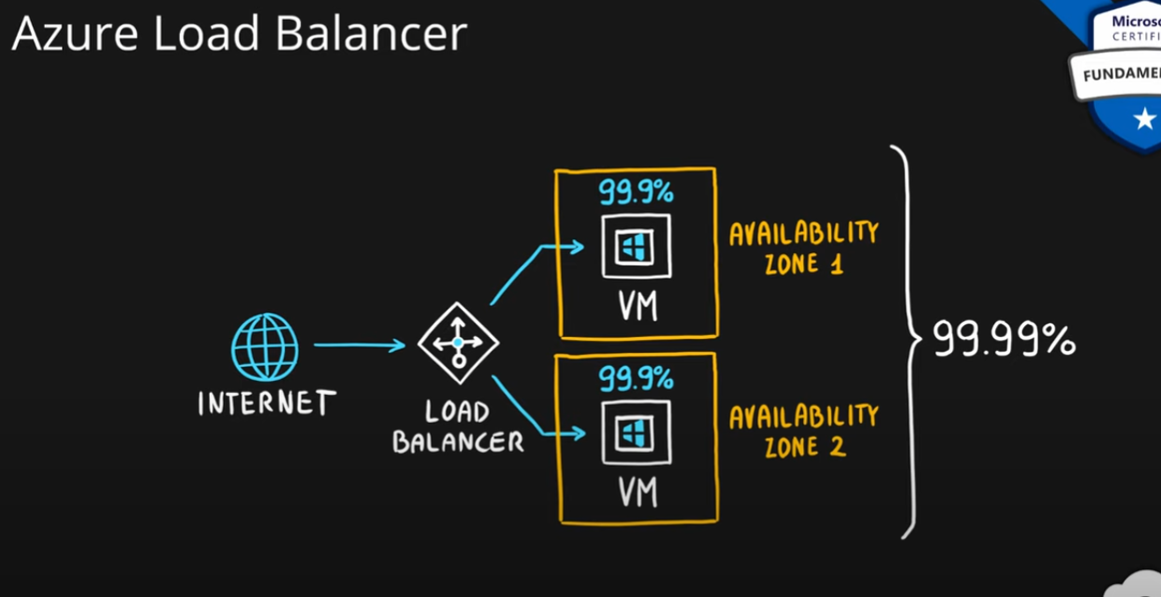 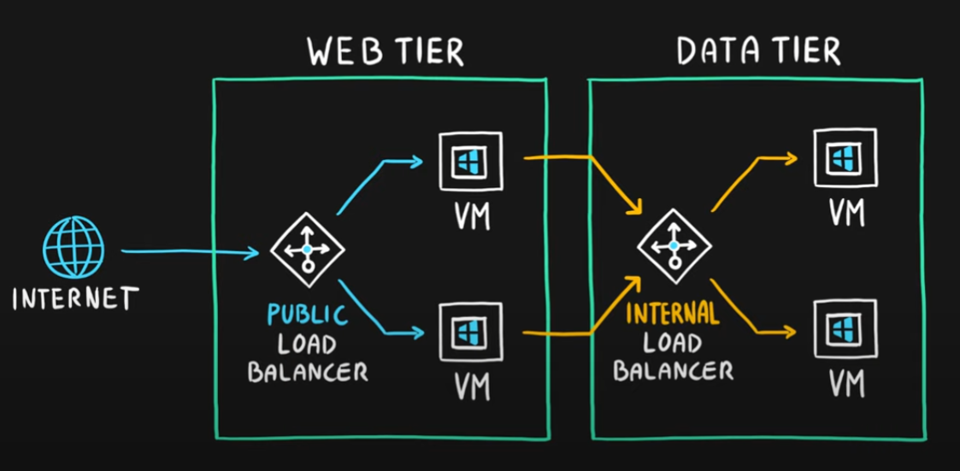

Content Delivery Network

* Minimize latency for delivering content

//

**#### Q32. You are planning a strategy to deploy numerous web servers and database servers to Azure. This strategy should allow for connection types between the web servers and database servers to be controlled. Solution: You include a local network gateway in your strategy.**

- [ ] Yes

- [x] No

A local network gateway represents the hardware or software VPN device in your local network. Use this with a connection to set up a site-to-site VPN connection between an Azure virtual network and your local network.

Answer should be probably virtual network getaway

//

**#### Q48. To achive a hybrid cloud model, a company must always migrate from a private cloud model**

- [ ] Yes

- [x] No

No, Hybrid cloud is the mixture of private and public cloud. So basically you do not extend internal network to Hybrid cloud, you extend to public cloud.

//

**#### Q30. Your company has an Azure Active Directory (Azure AD) environment. Users occasionally connect to Azure AD via the Internet. You have been tasked with making sure that users who connect to Azure AD via the internet from an unidentified IP address, are automatically encouraged to change passwords. Solution: You configure the use of Azure AD Privileged Identity Management.**

- [ ] Yes

- [x] No

Correct service would be Azure AD Identity Protection.

//