Question #1Topic 23
Introductory InfoCase study -
This is a case study. Case studies are not timed separately. You can use as much exam time as you would like to complete each case. However, there may be additional case studies and sections on this exam. You must manage your time to ensure that you are able to complete all questions included on this exam in the time provided.
To answer the questions included in a case study, you will need to reference information that is provided in the case study. Case studies might contain exhibits and other resources that provide more information about the scenario that is described in the case study. Each question is independent of the other questions in this case study.
At the end of this case study, a review screen will appear. This screen allows you to review your answers and to make changes before you move to the next section of the exam. After you begin a new section, you cannot return to this section.
To start the case study -
To display the first question in this case study, click the Next button. Use the buttons in the left pane to explore the content of the case study before you answer the questions. Clicking these buttons displays information such as business requirements, existing environment, and problem statements. When you are ready to answer a question, click the Question button to return to the question.
Background -
Wide World Importers is moving all their datacenters to Azure. The company has developed several applications and services to support supply chain operations and would like to leverage serverless computing where possible.
Current environment -
Windows Server 2016 virtual machine
This virtual machine (VM) runs BizTalk Server 2016. The VM runs the following workflows:
Ocean Transport `" This workflow gathers and validates container information including container contents and arrival notices at various shipping ports.
Inland Transport `" This workflow gathers and validates trucking information including fuel usage, number of stops, and routes.
The VM supports the following REST API calls:
Container API `" This API provides container information including weight, contents, and other attributes.
Location API `" This API provides location information regarding shipping ports of call and trucking stops.
Shipping REST API `" This API provides shipping information for use and display on the shipping website.
Shipping Data -
The application uses MongoDB JSON document storage database for all container and transport information.
Shipping Web Site -
The site displays shipping container tracking information and container contents. The site is located at http://shipping.wideworldimporters.com/
Proposed solution -
The on-premises shipping application must be moved to Azure. The VM has been migrated to a new Standard_D16s_v3 Azure VM by using Azure Site Recovery and must remain running in Azure to complete the BizTalk component migrations. You create a Standard_D16s_v3 Azure VM to host BizTalk Server. The Azure architecture diagram for the proposed solution is shown below:
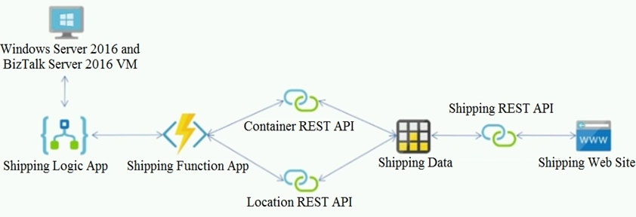
Requirements -
Shipping Logic app -
The Shipping Logic app must meet the following requirements:
Support the ocean transport and inland transport workflows by using a Logic App.
Support industry-standard protocol X12 message format for various messages including vessel content details and arrival notices.
Secure resources to the corporate VNet and use dedicated storage resources with a fixed costing model.
Maintain on-premises connectivity to support legacy applications and final BizTalk migrations.
Shipping Function app -
Implement secure function endpoints by using app-level security and include Azure Active Directory (Azure AD).
REST APIs -
The REST API's that support the solution must meet the following requirements:
Secure resources to the corporate VNet.
Allow deployment to a testing location within Azure while not incurring additional costs.
Automatically scale to double capacity during peak shipping times while not causing application downtime.
Minimize costs when selecting an Azure payment model.
Shipping data -
Data migration from on-premises to Azure must minimize costs and downtime.
Shipping website -
Use Azure Content Delivery Network (CDN) and ensure maximum performance for dynamic content while minimizing latency and costs.
Issues -
Windows Server 2016 VM -
The VM shows high network latency, jitter, and high CPU utilization. The VM is critical and has not been backed up in the past. The VM must enable a quick restore from a 7-day snapshot to include in-place restore of disks in case of failure.
Shipping website and REST APIs -
The following error message displays while you are testing the website:
Failed to load http://test-shippingapi.wideworldimporters.com/: No 'Access-Control-Allow-Origin' header is present on the requested resource. Origin 'http://test.wideworldimporters.com/' is therefore not allowed access.QuestionDRAG DROP -
You need to support the message processing for the ocean transport workflow.
Which four actions should you perform in sequence? To answer, move the appropriate actions from the list of actions to the answer area and arrange them in the correct order.
Select and Place:
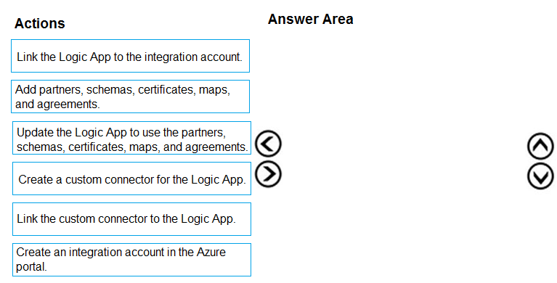

Question #2Topic 23
Introductory InfoCase study -
This is a case study. Case studies are not timed separately. You can use as much exam time as you would like to complete each case. However, there may be additional case studies and sections on this exam. You must manage your time to ensure that you are able to complete all questions included on this exam in the time provided.
To answer the questions included in a case study, you will need to reference information that is provided in the case study. Case studies might contain exhibits and other resources that provide more information about the scenario that is described in the case study. Each question is independent of the other questions in this case study.
At the end of this case study, a review screen will appear. This screen allows you to review your answers and to make changes before you move to the next section of the exam. After you begin a new section, you cannot return to this section.
To start the case study -
To display the first question in this case study, click the Next button. Use the buttons in the left pane to explore the content of the case study before you answer the questions. Clicking these buttons displays information such as business requirements, existing environment, and problem statements. When you are ready to answer a question, click the Question button to return to the question.
Background -
Wide World Importers is moving all their datacenters to Azure. The company has developed several applications and services to support supply chain operations and would like to leverage serverless computing where possible.
Current environment -
Windows Server 2016 virtual machine
This virtual machine (VM) runs BizTalk Server 2016. The VM runs the following workflows:
Ocean Transport `" This workflow gathers and validates container information including container contents and arrival notices at various shipping ports.
Inland Transport `" This workflow gathers and validates trucking information including fuel usage, number of stops, and routes.
The VM supports the following REST API calls:
Container API `" This API provides container information including weight, contents, and other attributes.
Location API `" This API provides location information regarding shipping ports of call and trucking stops.
Shipping REST API `" This API provides shipping information for use and display on the shipping website.
Shipping Data -
The application uses MongoDB JSON document storage database for all container and transport information.
Shipping Web Site -
The site displays shipping container tracking information and container contents. The site is located at http://shipping.wideworldimporters.com/
Proposed solution -
The on-premises shipping application must be moved to Azure. The VM has been migrated to a new Standard_D16s_v3 Azure VM by using Azure Site Recovery and must remain running in Azure to complete the BizTalk component migrations. You create a Standard_D16s_v3 Azure VM to host BizTalk Server. The Azure architecture diagram for the proposed solution is shown below:
Requirements -
Shipping Logic app -
The Shipping Logic app must meet the following requirements:
Support the ocean transport and inland transport workflows by using a Logic App.
Support industry-standard protocol X12 message format for various messages including vessel content details and arrival notices.
Secure resources to the corporate VNet and use dedicated storage resources with a fixed costing model.
Maintain on-premises connectivity to support legacy applications and final BizTalk migrations.
Shipping Function app -
Implement secure function endpoints by using app-level security and include Azure Active Directory (Azure AD).
REST APIs -
The REST API's that support the solution must meet the following requirements:
Secure resources to the corporate VNet.
Allow deployment to a testing location within Azure while not incurring additional costs.
Automatically scale to double capacity during peak shipping times while not causing application downtime.
Minimize costs when selecting an Azure payment model.
Shipping data -
Data migration from on-premises to Azure must minimize costs and downtime.
Shipping website -
Use Azure Content Delivery Network (CDN) and ensure maximum performance for dynamic content while minimizing latency and costs.
Issues -
Windows Server 2016 VM -
The VM shows high network latency, jitter, and high CPU utilization. The VM is critical and has not been backed up in the past. The VM must enable a quick restore from a 7-day snapshot to include in-place restore of disks in case of failure.
Shipping website and REST APIs -
The following error message displays while you are testing the website:
Failed to load http://test-shippingapi.wideworldimporters.com/: No 'Access-Control-Allow-Origin' header is present on the requested resource. Origin 'http://test.wideworldimporters.com/' is therefore not allowed access.QuestionYou need to support the requirements for the Shipping Logic App.
What should you use?
- A. Azure Active Directory Application Proxy
- B. Site-to-Site (S2S) VPN connection
- C. On-premises Data Gateway
- D. Point-to-Site (P2S) VPN connection

Topic 24 - Testlet 25
Question #1Topic 24
Introductory InfoCase study -
This is a case study. Case studies are not timed separately. You can use as much exam time as you would like to complete each case. However, there may be additional case studies and sections on this exam. You must manage your time to ensure that you are able to complete all questions included on this exam in the time provided.
To answer the questions included in a case study, you will need to reference information that is provided in the case study. Case studies might contain exhibits and other resources that provide more information about the scenario that is described in the case study. Each question is independent of the other questions in this case study.
At the end of this case study, a review screen will appear. This screen allows you to review your answers and to make changes before you move to the next section of the exam. After you begin a new section, you cannot return to this section.
To start the case study -
To display the first question in this case study, click the Next button. Use the buttons in the left pane to explore the content of the case study before you answer the questions. Clicking these buttons displays information such as business requirements, existing environment, and problem statements. When you are ready to answer a question, click the Question button to return to the question.
Background -
City Power & Light company provides electrical infrastructure monitoring solutions for homes and businesses. The company is migrating solutions to Azure.
Current environment -
Architecture overview -
The company has a public website located at http://www.cpandl.com/. The site is a single-page web application that runs in Azure App Service on Linux. The website uses files stored in Azure Storage and cached in Azure Content Delivery Network (CDN) to serve static content.
API Management and Azure Function App functions are used to process and store data in Azure Database for PostgreSQL. API Management is used to broker communications to the Azure Function app functions for Logic app integration. Logic apps are used to orchestrate the data processing while Service Bus and
Event Grid handle messaging and events.
The solution uses Application Insights, Azure Monitor, and Azure Key Vault.
Architecture diagram -
The company has several applications and services that support their business. The company plans to implement serverless computing where possible. The overall architecture is shown below.
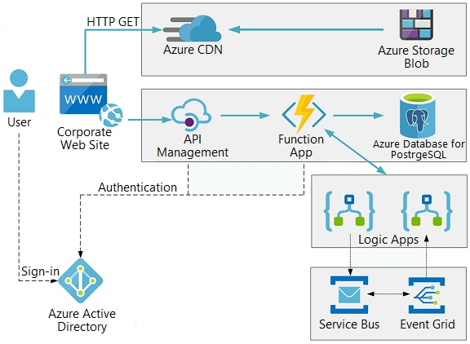
User authentication -
The following steps detail the user authentication process:
1. The user selects Sign in in the website.
2. The browser redirects the user to the Azure Active Directory (Azure AD) sign in page.
3. The user signs in.
4. Azure AD redirects the user's session back to the web application. The URL includes an access token.
5. The web application calls an API and includes the access token in the authentication header. The application ID is sent as the audience ('aud') claim in the access token.
6. The back-end API validates the access token.
Requirements -
Corporate website -
Communications and content must be secured by using SSL.
Communications must use HTTPS.
Data must be replicated to a secondary region and three availability zones.
Data storage costs must be minimized.
Azure Database for PostgreSQL -
The database connection string is stored in Azure Key Vault with the following attributes:
Azure Key Vault name: cpandlkeyvault
Secret name: PostgreSQLConn
Id: 80df3e46ffcd4f1cb187f79905e9a1e8
The connection information is updated frequently. The application must always use the latest information to connect to the database.
Azure Service Bus and Azure Event Grid
Azure Event Grid must use Azure Service Bus for queue-based load leveling.
Events in Azure Event Grid must be routed directly to Service Bus queues for use in buffering.
Events from Azure Service Bus and other Azure services must continue to be routed to Azure Event Grid for processing.
Security -
All SSL certificates and credentials must be stored in Azure Key Vault.
File access must restrict access by IP, protocol, and Azure AD rights.
All user accounts and processes must receive only those privileges which are essential to perform their intended function.
Compliance -
Auditing of the file updates and transfers must be enabled to comply with General Data Protection Regulation (GDPR). The file updates must be read-only, stored in the order in which they occurred, include only create, update, delete, and copy operations, and be retained for compliance reasons.
Issues -
Corporate website -
While testing the site, the following error message displays:
CryptographicException: The system cannot find the file specified.
Function app -
You perform local testing for the RequestUserApproval function. The following error message displays:
'Timeout value of 00:10:00 exceeded by function: RequestUserApproval'
The same error message displays when you test the function in an Azure development environment when you run the following Kusto query:
FunctionAppLogs -
| where FunctionName = = "RequestUserApproval"
Logic app -
You test the Logic app in a development environment. The following error message displays:
'400 Bad Request'
Troubleshooting of the error shows an HttpTrigger action to call the RequestUserApproval function.
Code -
Corporate website -
Security.cs:
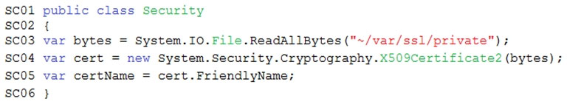
Function app -
RequestUserApproval.cs:
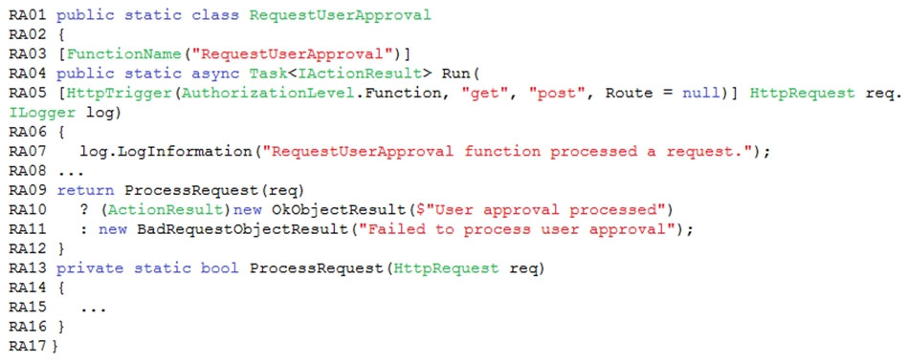QuestionHOTSPOT -
You need to configure the integration for Azure Service Bus and Azure Event Grid.
How should you complete the CLI statement? To answer, select the appropriate options in the answer area.
NOTE: Each correct selection is worth one point.
Hot Area:
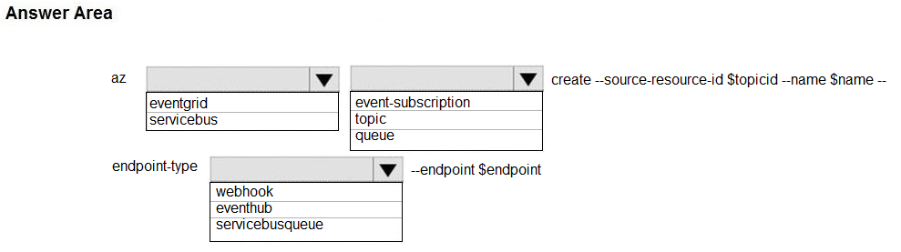

Question #2Topic 24
Introductory InfoCase study -
This is a case study. Case studies are not timed separately. You can use as much exam time as you would like to complete each case. However, there may be additional case studies and sections on this exam. You must manage your time to ensure that you are able to complete all questions included on this exam in the time provided.
To answer the questions included in a case study, you will need to reference information that is provided in the case study. Case studies might contain exhibits and other resources that provide more information about the scenario that is described in the case study. Each question is independent of the other questions in this case study.
At the end of this case study, a review screen will appear. This screen allows you to review your answers and to make changes before you move to the next section of the exam. After you begin a new section, you cannot return to this section.
To start the case study -
To display the first question in this case study, click the Next button. Use the buttons in the left pane to explore the content of the case study before you answer the questions. Clicking these buttons displays information such as business requirements, existing environment, and problem statements. When you are ready to answer a question, click the Question button to return to the question.
Background -
City Power & Light company provides electrical infrastructure monitoring solutions for homes and businesses. The company is migrating solutions to Azure.
Current environment -
Architecture overview -
The company has a public website located at http://www.cpandl.com/. The site is a single-page web application that runs in Azure App Service on Linux. The website uses files stored in Azure Storage and cached in Azure Content Delivery Network (CDN) to serve static content.
API Management and Azure Function App functions are used to process and store data in Azure Database for PostgreSQL. API Management is used to broker communications to the Azure Function app functions for Logic app integration. Logic apps are used to orchestrate the data processing while Service Bus and
Event Grid handle messaging and events.
The solution uses Application Insights, Azure Monitor, and Azure Key Vault.
Architecture diagram -
The company has several applications and services that support their business. The company plans to implement serverless computing where possible. The overall architecture is shown below.
User authentication -
The following steps detail the user authentication process:
1. The user selects Sign in in the website.
2. The browser redirects the user to the Azure Active Directory (Azure AD) sign in page.
3. The user signs in.
4. Azure AD redirects the user's session back to the web application. The URL includes an access token.
5. The web application calls an API and includes the access token in the authentication header. The application ID is sent as the audience ('aud') claim in the access token.
6. The back-end API validates the access token.
Requirements -
Corporate website -
Communications and content must be secured by using SSL.
Communications must use HTTPS.
Data must be replicated to a secondary region and three availability zones.
Data storage costs must be minimized.
Azure Database for PostgreSQL -
The database connection string is stored in Azure Key Vault with the following attributes:
Azure Key Vault name: cpandlkeyvault
Secret name: PostgreSQLConn
Id: 80df3e46ffcd4f1cb187f79905e9a1e8
The connection information is updated frequently. The application must always use the latest information to connect to the database.
Azure Service Bus and Azure Event Grid
Azure Event Grid must use Azure Service Bus for queue-based load leveling.
Events in Azure Event Grid must be routed directly to Service Bus queues for use in buffering.
Events from Azure Service Bus and other Azure services must continue to be routed to Azure Event Grid for processing.
Security -
All SSL certificates and credentials must be stored in Azure Key Vault.
File access must restrict access by IP, protocol, and Azure AD rights.
All user accounts and processes must receive only those privileges which are essential to perform their intended function.
Compliance -
Auditing of the file updates and transfers must be enabled to comply with General Data Protection Regulation (GDPR). The file updates must be read-only, stored in the order in which they occurred, include only create, update, delete, and copy operations, and be retained for compliance reasons.
Issues -
Corporate website -
While testing the site, the following error message displays:
CryptographicException: The system cannot find the file specified.
Function app -
You perform local testing for the RequestUserApproval function. The following error message displays:
'Timeout value of 00:10:00 exceeded by function: RequestUserApproval'
The same error message displays when you test the function in an Azure development environment when you run the following Kusto query:
FunctionAppLogs -
| where FunctionName = = "RequestUserApproval"
Logic app -
You test the Logic app in a development environment. The following error message displays:
'400 Bad Request'
Troubleshooting of the error shows an HttpTrigger action to call the RequestUserApproval function.
Code -
Corporate website -
Security.cs:
Function app -
RequestUserApproval.cs:
QuestionYou need to ensure that all messages from Azure Event Grid are processed.
What should you use?
- A. Azure Event Grid topic
- B. Azure Service Bus topic
- C. Azure Service Bus queue
- D. Azure Storage queue
- E. Azure Logic App custom connector

Topic 25 - Testlet 26
Question #1Topic 25
Introductory InfoCase study -
This is a case study. Case studies are not timed separately. You can use as much exam time as you would like to complete each case. However, there may be additional case studies and sections on this exam. You must manage your time to ensure that you are able to complete all questions included on this exam in the time provided.
To answer the questions included in a case study, you will need to reference information that is provided in the case study. Case studies might contain exhibits and other resources that provide more information about the scenario that is described in the case study. Each question is independent of the other questions in this case study.
At the end of this case study, a review screen will appear. This screen allows you to review your answers and to make changes before you move to the next section of the exam. After you begin a new section, you cannot return to this section.
To start the case study -
To display the first question in this case study, click the Next button. Use the buttons in the left pane to explore the content of the case study before you answer the questions. Clicking these buttons displays information such as business requirements, existing environment, and problem statements. When you are ready to answer a question, click the Question button to return to the question.
Background -
You are a developer for Proseware, Inc. You are developing an application that applies a set of governance policies for Proseware's internal services, external services, and applications. The application will also provide a shared library for common functionality.
Requirements -
Policy service -
You develop and deploy a stateful ASP.NET Core 2.1 web application named Policy service to an Azure App Service Web App. The application reacts to events from Azure Event Grid and performs policy actions based on those events.
The application must include the Event Grid Event ID field in all Application Insights telemetry.
Policy service must use Application Insights to automatically scale with the number of policy actions that it is performing.
Policies -
Log policy -
All Azure App Service Web Apps must write logs to Azure Blob storage. All log files should be saved to a container named logdrop. Logs must remain in the container for 15 days.
Authentication events -
Authentication events are used to monitor users signing in and signing out. All authentication events must be processed by Policy service. Sign outs must be processed as quickly as possible.
PolicyLib -
You have a shared library named PolicyLib that contains functionality common to all ASP.NET Core web services and applications. The PolicyLib library must:
Exclude non-user actions from Application Insights telemetry.
Provide methods that allow a web service to scale itself.
Ensure that scaling actions do not disrupt application usage.
Other -
Anomaly detection service -
You have an anomaly detection service that analyzes log information for anomalies. It is implemented as an Azure Machine Learning model. The model is deployed as a web service. If an anomaly is detected, an Azure Function that emails administrators is called by using an HTTP WebHook.
Health monitoring -
All web applications and services have health monitoring at the /health service endpoint.
Issues -
Policy loss -
When you deploy Policy service, policies may not be applied if they were in the process of being applied during the deployment.
Performance issue -
When under heavy load, the anomaly detection service undergoes slowdowns and rejects connections.
Notification latency -
Users report that anomaly detection emails can sometimes arrive several minutes after an anomaly is detected.
App code -
EventGridController.cs -
Relevant portions of the app files are shown below. Line numbers are included for reference only and include a two-character prefix that denotes the specific file to which they belong.
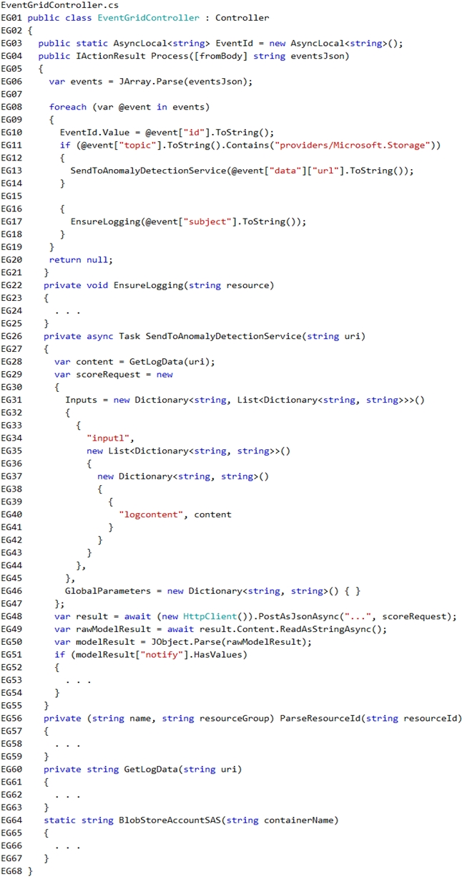
LoginEvent.cs -
Relevant portions of the app files are shown below. Line numbers are included for reference only and include a two-character prefix that denotes the specific file to which they belong.
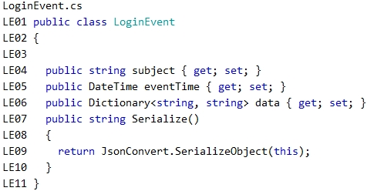QuestionDRAG DROP -
You need to add code at line EG15 in EventGridController.cs to ensure that the Log policy applies to all services.
How should you complete the code? To answer, drag the appropriate code segments to the correct locations. Each code segment may be used once, more than once, or not at all. You may need to drag the split bar between panes or scroll to view content.
NOTE: Each correct selection is worth one point.
Select and Place:
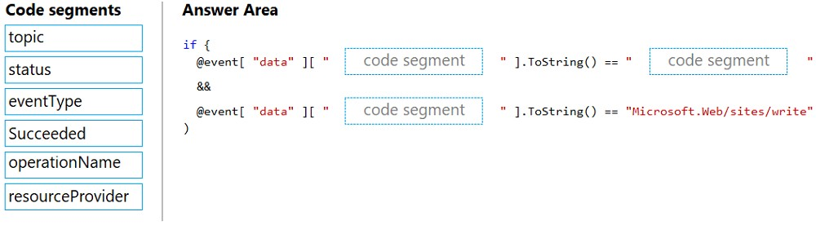

Question #2Topic 25
Introductory InfoCase study -
This is a case study. Case studies are not timed separately. You can use as much exam time as you would like to complete each case. However, there may be additional case studies and sections on this exam. You must manage your time to ensure that you are able to complete all questions included on this exam in the time provided.
To answer the questions included in a case study, you will need to reference information that is provided in the case study. Case studies might contain exhibits and other resources that provide more information about the scenario that is described in the case study. Each question is independent of the other questions in this case study.
At the end of this case study, a review screen will appear. This screen allows you to review your answers and to make changes before you move to the next section of the exam. After you begin a new section, you cannot return to this section.
To start the case study -
To display the first question in this case study, click the Next button. Use the buttons in the left pane to explore the content of the case study before you answer the questions. Clicking these buttons displays information such as business requirements, existing environment, and problem statements. When you are ready to answer a question, click the Question button to return to the question.
Background -
You are a developer for Proseware, Inc. You are developing an application that applies a set of governance policies for Proseware's internal services, external services, and applications. The application will also provide a shared library for common functionality.
Requirements -
Policy service -
You develop and deploy a stateful ASP.NET Core 2.1 web application named Policy service to an Azure App Service Web App. The application reacts to events from Azure Event Grid and performs policy actions based on those events.
The application must include the Event Grid Event ID field in all Application Insights telemetry.
Policy service must use Application Insights to automatically scale with the number of policy actions that it is performing.
Policies -
Log policy -
All Azure App Service Web Apps must write logs to Azure Blob storage. All log files should be saved to a container named logdrop. Logs must remain in the container for 15 days.
Authentication events -
Authentication events are used to monitor users signing in and signing out. All authentication events must be processed by Policy service. Sign outs must be processed as quickly as possible.
PolicyLib -
You have a shared library named PolicyLib that contains functionality common to all ASP.NET Core web services and applications. The PolicyLib library must:
Exclude non-user actions from Application Insights telemetry.
Provide methods that allow a web service to scale itself.
Ensure that scaling actions do not disrupt application usage.
Other -
Anomaly detection service -
You have an anomaly detection service that analyzes log information for anomalies. It is implemented as an Azure Machine Learning model. The model is deployed as a web service. If an anomaly is detected, an Azure Function that emails administrators is called by using an HTTP WebHook.
Health monitoring -
All web applications and services have health monitoring at the /health service endpoint.
Issues -
Policy loss -
When you deploy Policy service, policies may not be applied if they were in the process of being applied during the deployment.
Performance issue -
When under heavy load, the anomaly detection service undergoes slowdowns and rejects connections.
Notification latency -
Users report that anomaly detection emails can sometimes arrive several minutes after an anomaly is detected.
App code -
EventGridController.cs -
Relevant portions of the app files are shown below. Line numbers are included for reference only and include a two-character prefix that denotes the specific file to which they belong.
LoginEvent.cs -
Relevant portions of the app files are shown below. Line numbers are included for reference only and include a two-character prefix that denotes the specific file to which they belong.
QuestionHOTSPOT -
You need to insert code at line LE03 of LoginEvent.cs to ensure that all authentication events are processed correctly.
How should you complete the code? To answer, select the appropriate options in the answer area.
NOTE: Each correct selection is worth one point.
Hot Area:
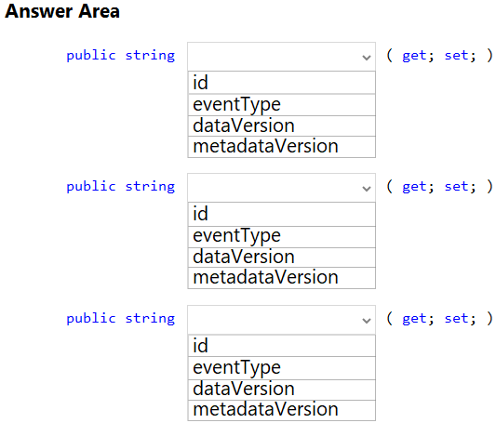

Question #3Topic 25
Introductory InfoCase study -
This is a case study. Case studies are not timed separately. You can use as much exam time as you would like to complete each case. However, there may be additional case studies and sections on this exam. You must manage your time to ensure that you are able to complete all questions included on this exam in the time provided.
To answer the questions included in a case study, you will need to reference information that is provided in the case study. Case studies might contain exhibits and other resources that provide more information about the scenario that is described in the case study. Each question is independent of the other questions in this case study.
At the end of this case study, a review screen will appear. This screen allows you to review your answers and to make changes before you move to the next section of the exam. After you begin a new section, you cannot return to this section.
To start the case study -
To display the first question in this case study, click the Next button. Use the buttons in the left pane to explore the content of the case study before you answer the questions. Clicking these buttons displays information such as business requirements, existing environment, and problem statements. When you are ready to answer a question, click the Question button to return to the question.
Background -
You are a developer for Proseware, Inc. You are developing an application that applies a set of governance policies for Proseware's internal services, external services, and applications. The application will also provide a shared library for common functionality.
Requirements -
Policy service -
You develop and deploy a stateful ASP.NET Core 2.1 web application named Policy service to an Azure App Service Web App. The application reacts to events from Azure Event Grid and performs policy actions based on those events.
The application must include the Event Grid Event ID field in all Application Insights telemetry.
Policy service must use Application Insights to automatically scale with the number of policy actions that it is performing.
Policies -
Log policy -
All Azure App Service Web Apps must write logs to Azure Blob storage. All log files should be saved to a container named logdrop. Logs must remain in the container for 15 days.
Authentication events -
Authentication events are used to monitor users signing in and signing out. All authentication events must be processed by Policy service. Sign outs must be processed as quickly as possible.
PolicyLib -
You have a shared library named PolicyLib that contains functionality common to all ASP.NET Core web services and applications. The PolicyLib library must:
Exclude non-user actions from Application Insights telemetry.
Provide methods that allow a web service to scale itself.
Ensure that scaling actions do not disrupt application usage.
Other -
Anomaly detection service -
You have an anomaly detection service that analyzes log information for anomalies. It is implemented as an Azure Machine Learning model. The model is deployed as a web service. If an anomaly is detected, an Azure Function that emails administrators is called by using an HTTP WebHook.
Health monitoring -
All web applications and services have health monitoring at the /health service endpoint.
Issues -
Policy loss -
When you deploy Policy service, policies may not be applied if they were in the process of being applied during the deployment.
Performance issue -
When under heavy load, the anomaly detection service undergoes slowdowns and rejects connections.
Notification latency -
Users report that anomaly detection emails can sometimes arrive several minutes after an anomaly is detected.
App code -
EventGridController.cs -
Relevant portions of the app files are shown below. Line numbers are included for reference only and include a two-character prefix that denotes the specific file to which they belong.
LoginEvent.cs -
Relevant portions of the app files are shown below. Line numbers are included for reference only and include a two-character prefix that denotes the specific file to which they belong.
QuestionHOTSPOT -
You need to implement the Log policy.
How should you complete the EnsureLogging method in EventGridController.cs? To answer, select the appropriate options in the answer area.
NOTE: Each correct selection is worth one point.
Hot Area:
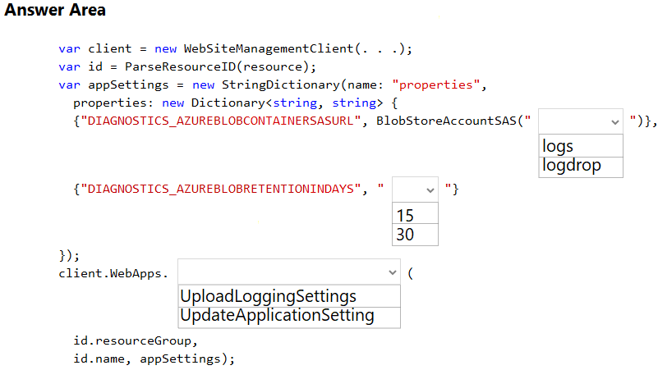

Topic 26 - Testlet 3
Question #1Topic 26
Introductory InfoCase study -
This is a case study. Case studies are not timed separately. You can use as much exam time as you would like to complete each case. However, there may be additional case studies and sections on this exam. You must manage your time to ensure that you are able to complete all questions included on this exam in the time provided.
To answer the questions included in a case study, you will need to reference information that is provided in the case study. Case studies might contain exhibits and other resources that provide more information about the scenario that is described in the case study. Each question is independent of the other questions in this case study.
At the end of this case study, a review screen will appear. This screen allows you to review your answers and to make changes before you move to the next section of the exam. After you begin a new section, you cannot return to this section.
To start the case study -
To display the first question in this case study, click the Next button. Use the buttons in the left pane to explore the content of the case study before you answer the questions. Clicking these buttons displays information such as business requirements, existing environment, and problem statements. When you are ready to answer a question, click the Question button to return to the question.
Background -
You are a developer for Proseware, Inc. You are developing an application that applies a set of governance policies for Proseware's internal services, external services, and applications. The application will also provide a shared library for common functionality.
Requirements -
Policy service -
You develop and deploy a stateful ASP.NET Core 2.1 web application named Policy service to an Azure App Service Web App. The application reacts to events from Azure Event Grid and performs policy actions based on those events.
The application must include the Event Grid Event ID field in all Application Insights telemetry.
Policy service must use Application Insights to automatically scale with the number of policy actions that it is performing.
Policies -
Log policy -
All Azure App Service Web Apps must write logs to Azure Blob storage. All log files should be saved to a container named logdrop. Logs must remain in the container for 15 days.
Authentication events -
Authentication events are used to monitor users signing in and signing out. All authentication events must be processed by Policy service. Sign outs must be processed as quickly as possible.
PolicyLib -
You have a shared library named PolicyLib that contains functionality common to all ASP.NET Core web services and applications. The PolicyLib library must:
Exclude non-user actions from Application Insights telemetry.
Provide methods that allow a web service to scale itself.
Ensure that scaling actions do not disrupt application usage.
Other -
Anomaly detection service -
You have an anomaly detection service that analyzes log information for anomalies. It is implemented as an Azure Machine Learning model. The model is deployed as a web service. If an anomaly is detected, an Azure Function that emails administrators is called by using an HTTP WebHook.
Health monitoring -
All web applications and services have health monitoring at the /health service endpoint.
Issues -
Policy loss -
When you deploy Policy service, policies may not be applied if they were in the process of being applied during the deployment.
Performance issue -
When under heavy load, the anomaly detection service undergoes slowdowns and rejects connections.
Notification latency -
Users report that anomaly detection emails can sometimes arrive several minutes after an anomaly is detected.
App code -
EventGridController.cs -
Relevant portions of the app files are shown below. Line numbers are included for reference only and include a two-character prefix that denotes the specific file to which they belong.
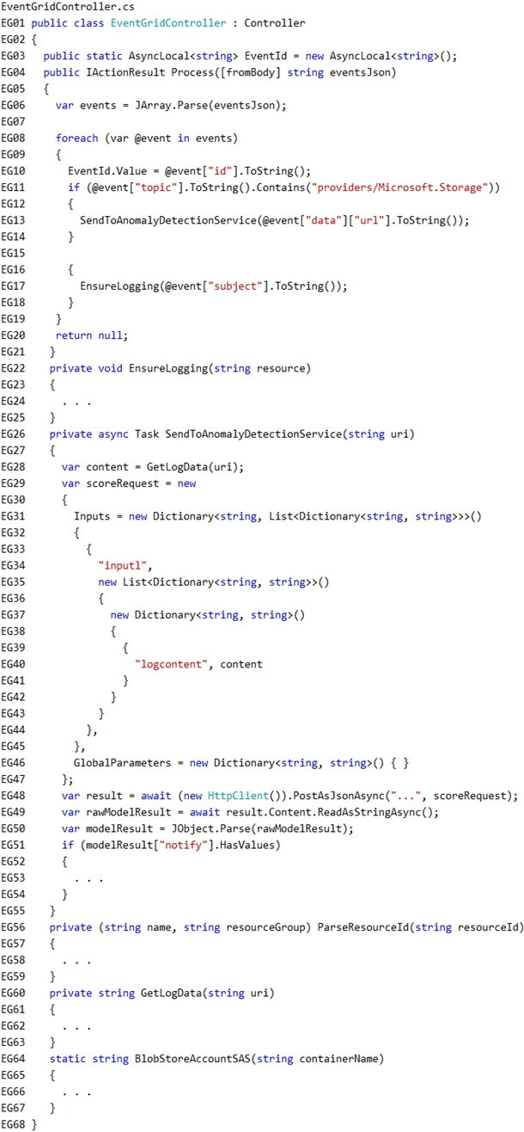
LoginEvent.cs -
Relevant portions of the app files are shown below. Line numbers are included for reference only and include a two-character prefix that denotes the specific file to which they belong.
QuestionYou need to resolve a notification latency issue.
Which two actions should you perform? Each correct answer presents part of the solution.
NOTE: Each correct selection is worth one point.
- A. Set Always On to true.
- B. Ensure that the Azure Function is using an App Service plan.
- C. Set Always On to false.
- D. Ensure that the Azure Function is set to use a consumption plan.

Topic 27 - Testlet 4
Question #1Topic 27
Introductory InfoCase study -
This is a case study. Case studies are not timed separately. You can use as much exam time as you would like to complete each case. However, there may be additional case studies and sections on this exam. You must manage your time to ensure that you are able to complete all questions included on this exam in the time provided.
To answer the questions included in a case study, you will need to reference information that is provided in the case study. Case studies might contain exhibits and other resources that provide more information about the scenario that is described in the case study. Each question is independent of the other questions in this case study.
At the end of this case study, a review screen will appear. This screen allows you to review your answers and to make changes before you move to the next section of the exam. After you begin a new section, you cannot return to this section.
To start the case study -
To display the first question in this case study, click the Next button. Use the buttons in the left pane to explore the content of the case study before you answer the questions. Clicking these buttons displays information such as business requirements, existing environment, and problem statements. When you are ready to answer a question, click the Question button to return to the question.
Background -
Overview -
You are a developer for Contoso, Ltd. The company has a social networking website that is developed as a Single Page Application (SPA). The main web application for the social networking website loads user uploaded content from blob storage.
You are developing a solution to monitor uploaded data for inappropriate content. The following process occurs when users upload content by using the SPA:
Messages are sent to ContentUploadService.
Content is processed by ContentAnalysisService.
After processing is complete, the content is posted to the social network or a rejection message is posted in its place.
The ContentAnalysisService is deployed with Azure Container Instances from a private Azure Container Registry named contosoimages.
The solution will use eight CPU cores.
Azure Active Directory -
Contoso, Ltd. uses Azure Active Directory (Azure AD) for both internal and guest accounts.
Requirements -
ContentAnalysisService -
The company's data science group built ContentAnalysisService which accepts user generated content as a string and returns a probable value for inappropriate content. Any values over a specific threshold must be reviewed by an employee of Contoso, Ltd.
You must create an Azure Function named CheckUserContent to perform the content checks.
Costs -
You must minimize costs for all Azure services.
Manual review -
To review content, the user must authenticate to the website portion of the ContentAnalysisService using their Azure AD credentials. The website is built using
React and all pages and API endpoints require authentication. In order to review content a user must be part of a ContentReviewer role. All completed reviews must include the reviewer's email address for auditing purposes.
High availability -
All services must run in multiple regions. The failure of any service in a region must not impact overall application availability.
Monitoring -
An alert must be raised if the ContentUploadService uses more than 80 percent of available CPU cores.
Security -
You have the following security requirements:
Any web service accessible over the Internet must be protected from cross site scripting attacks.
All websites and services must use SSL from a valid root certificate authority.
Azure Storage access keys must only be stored in memory and must be available only to the service.
All Internal services must only be accessible from internal Virtual Networks (VNets).
All parts of the system must support inbound and outbound traffic restrictions.
All service calls must be authenticated by using Azure AD.
User agreements -
When a user submits content, they must agree to a user agreement. The agreement allows employees of Contoso, Ltd. to review content, store cookies on user devices, and track user's IP addresses.
Information regarding agreements is used by multiple divisions within Contoso, Ltd.
User responses must not be lost and must be available to all parties regardless of individual service uptime. The volume of agreements is expected to be in the millions per hour.
Validation testing -
When a new version of the ContentAnalysisService is available the previous seven days of content must be processed with the new version to verify that the new version does not significantly deviate from the old version.
Issues -
Users of the ContentUploadService report that they occasionally see HTTP 502 responses on specific pages.
Code -
ContentUploadService -
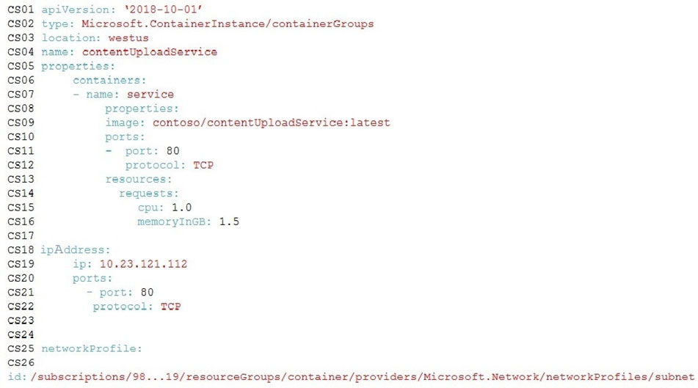
ApplicationManifest -
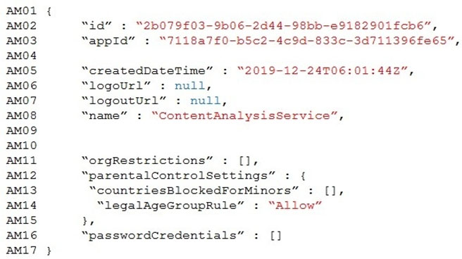QuestionHOTSPOT -
You need to ensure that validation testing is triggered per the requirements.
How should you complete the code segment? To answer, select the appropriate values in the answer area.
NOTE: Each correct selection is worth one point.
Hot Area:
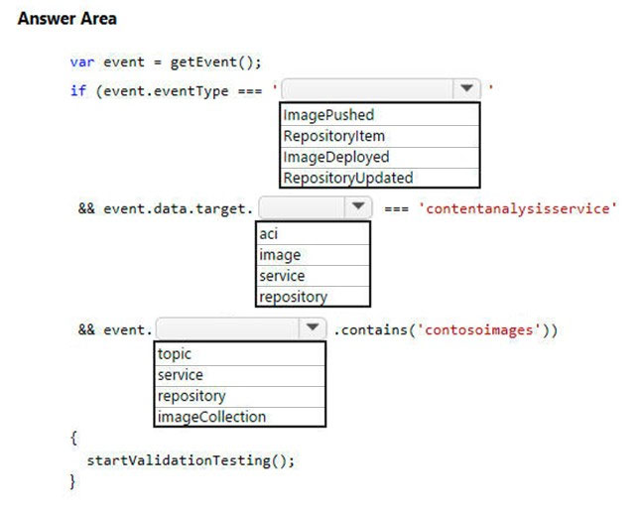

Question #2Topic 27
Introductory InfoCase study -
This is a case study. Case studies are not timed separately. You can use as much exam time as you would like to complete each case. However, there may be additional case studies and sections on this exam. You must manage your time to ensure that you are able to complete all questions included on this exam in the time provided.
To answer the questions included in a case study, you will need to reference information that is provided in the case study. Case studies might contain exhibits and other resources that provide more information about the scenario that is described in the case study. Each question is independent of the other questions in this case study.
At the end of this case study, a review screen will appear. This screen allows you to review your answers and to make changes before you move to the next section of the exam. After you begin a new section, you cannot return to this section.
To start the case study -
To display the first question in this case study, click the Next button. Use the buttons in the left pane to explore the content of the case study before you answer the questions. Clicking these buttons displays information such as business requirements, existing environment, and problem statements. When you are ready to answer a question, click the Question button to return to the question.
Background -
Overview -
You are a developer for Contoso, Ltd. The company has a social networking website that is developed as a Single Page Application (SPA). The main web application for the social networking website loads user uploaded content from blob storage.
You are developing a solution to monitor uploaded data for inappropriate content. The following process occurs when users upload content by using the SPA:
Messages are sent to ContentUploadService.
Content is processed by ContentAnalysisService.
After processing is complete, the content is posted to the social network or a rejection message is posted in its place.
The ContentAnalysisService is deployed with Azure Container Instances from a private Azure Container Registry named contosoimages.
The solution will use eight CPU cores.
Azure Active Directory -
Contoso, Ltd. uses Azure Active Directory (Azure AD) for both internal and guest accounts.
Requirements -
ContentAnalysisService -
The company's data science group built ContentAnalysisService which accepts user generated content as a string and returns a probable value for inappropriate content. Any values over a specific threshold must be reviewed by an employee of Contoso, Ltd.
You must create an Azure Function named CheckUserContent to perform the content checks.
Costs -
You must minimize costs for all Azure services.
Manual review -
To review content, the user must authenticate to the website portion of the ContentAnalysisService using their Azure AD credentials. The website is built using
React and all pages and API endpoints require authentication. In order to review content a user must be part of a ContentReviewer role. All completed reviews must include the reviewer's email address for auditing purposes.
High availability -
All services must run in multiple regions. The failure of any service in a region must not impact overall application availability.
Monitoring -
An alert must be raised if the ContentUploadService uses more than 80 percent of available CPU cores.
Security -
You have the following security requirements:
Any web service accessible over the Internet must be protected from cross site scripting attacks.
All websites and services must use SSL from a valid root certificate authority.
Azure Storage access keys must only be stored in memory and must be available only to the service.
All Internal services must only be accessible from internal Virtual Networks (VNets).
All parts of the system must support inbound and outbound traffic restrictions.
All service calls must be authenticated by using Azure AD.
User agreements -
When a user submits content, they must agree to a user agreement. The agreement allows employees of Contoso, Ltd. to review content, store cookies on user devices, and track user's IP addresses.
Information regarding agreements is used by multiple divisions within Contoso, Ltd.
User responses must not be lost and must be available to all parties regardless of individual service uptime. The volume of agreements is expected to be in the millions per hour.
Validation testing -
When a new version of the ContentAnalysisService is available the previous seven days of content must be processed with the new version to verify that the new version does not significantly deviate from the old version.
Issues -
Users of the ContentUploadService report that they occasionally see HTTP 502 responses on specific pages.
Code -
ContentUploadService -
ApplicationManifest -
QuestionYou need to deploy the CheckUserContent Azure Function. The solution must meet the security and cost requirements.
Which hosting model should you use?
- A. Premium plan
- B. App Service plan
- C. Consumption plan

Topic 28 - Testlet 5
Question #1Topic 28
Introductory InfoCase study -
This is a case study. Case studies are not timed separately. You can use as much exam time as you would like to complete each case. However, there may be additional case studies and sections on this exam. You must manage your time to ensure that you are able to complete all questions included on this exam in the time provided.
To answer the questions included in a case study, you will need to reference information that is provided in the case study. Case studies might contain exhibits and other resources that provide more information about the scenario that is described in the case study. Each question is independent of the other questions in this case study.
At the end of this case study, a review screen will appear. This screen allows you to review your answers and to make changes before you move to the next section of the exam. After you begin a new section, you cannot return to this section.
To start the case study -
To display the first question in this case study, click the Next button. Use the buttons in the left pane to explore the content of the case study before you answer the questions. Clicking these buttons displays information such as business requirements, existing environment, and problem statements. When you are ready to answer a question, click the Question button to return to the question.
LabelMaker app -
Coho Winery produces, bottles, and distributes a variety of wines globally. You are a developer implementing highly scalable and resilient applications to support online order processing by using Azure solutions.
Coho Winery has a LabelMaker application that prints labels for wine bottles. The application sends data to several printers. The application consists of five modules that run independently on virtual machines (VMs). Coho Winery plans to move the application to Azure and continue to support label creation.
External partners send data to the LabelMaker application to include artwork and text for custom label designs.
Requirements. Data -
You identify the following requirements for data management and manipulation:
Order data is stored as nonrelational JSON and must be queried using SQL.
Changes to the Order data must reflect immediately across all partitions. All reads to the Order data must fetch the most recent writes.
Requirements. Security -
You have the following security requirements:
Users of Coho Winery applications must be able to provide access to documents, resources, and applications to external partners.
External partners must use their own credentials and authenticate with their organization's identity management solution.
External partner logins must be audited monthly for application use by a user account administrator to maintain company compliance.
Storage of e-commerce application settings must be maintained in Azure Key Vault.
E-commerce application sign-ins must be secured by using Azure App Service authentication and Azure Active Directory (AAD).
Conditional access policies must be applied at the application level to protect company content.
The LabelMaker application must be secured by using an AAD account that has full access to all namespaces of the Azure Kubernetes Service (AKS) cluster.
Requirements. LabelMaker app -
Azure Monitor Container Health must be used to monitor the performance of workloads that are deployed to Kubernetes environments and hosted on Azure
Kubernetes Service (AKS).
You must use Azure Container Registry to publish images that support the AKS deployment.
Architecture -
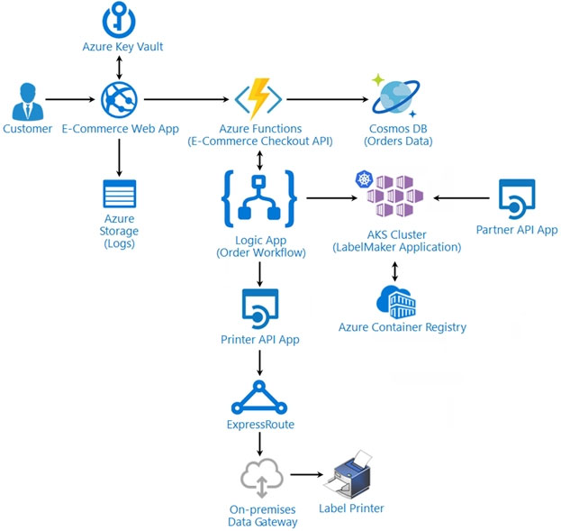
Issues -
Calls to the Printer API App fail periodically due to printer communication timeouts.
Printer communication timeouts occur after 10 seconds. The label printer must only receive up to 5 attempts within one minute.
The order workflow fails to run upon initial deployment to Azure.
Order.json -
Relevant portions of the app files are shown below. Line numbers are included for reference only.
This JSON file contains a representation of the data for an order that includes a single item.
Order.json -
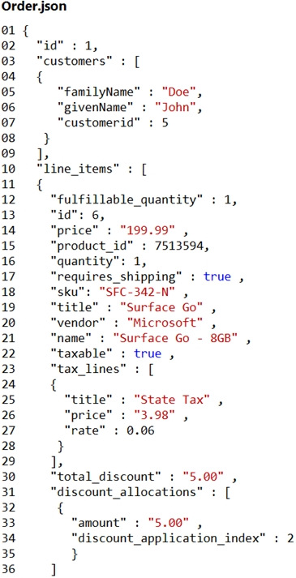QuestionDRAG DROP -
You need to deploy a new version of the LabelMaker application to ACR.
Which three actions should you perform in sequence? To answer, move the appropriate actions from the list of actions to the answer area and arrange them in the correct order.
Select and Place:
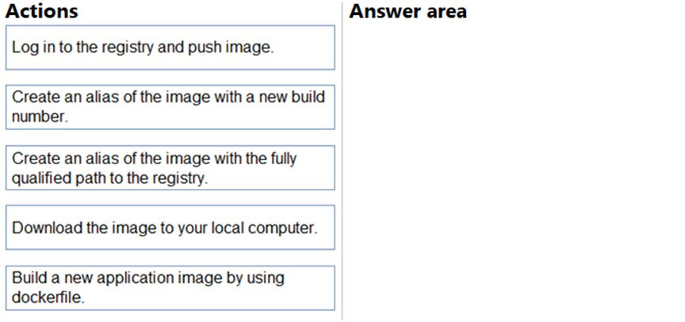

Question #2Topic 28
Introductory InfoCase study -
This is a case study. Case studies are not timed separately. You can use as much exam time as you would like to complete each case. However, there may be additional case studies and sections on this exam. You must manage your time to ensure that you are able to complete all questions included on this exam in the time provided.
To answer the questions included in a case study, you will need to reference information that is provided in the case study. Case studies might contain exhibits and other resources that provide more information about the scenario that is described in the case study. Each question is independent of the other questions in this case study.
At the end of this case study, a review screen will appear. This screen allows you to review your answers and to make changes before you move to the next section of the exam. After you begin a new section, you cannot return to this section.
To start the case study -
To display the first question in this case study, click the Next button. Use the buttons in the left pane to explore the content of the case study before you answer the questions. Clicking these buttons displays information such as business requirements, existing environment, and problem statements. When you are ready to answer a question, click the Question button to return to the question.
LabelMaker app -
Coho Winery produces, bottles, and distributes a variety of wines globally. You are a developer implementing highly scalable and resilient applications to support online order processing by using Azure solutions.
Coho Winery has a LabelMaker application that prints labels for wine bottles. The application sends data to several printers. The application consists of five modules that run independently on virtual machines (VMs). Coho Winery plans to move the application to Azure and continue to support label creation.
External partners send data to the LabelMaker application to include artwork and text for custom label designs.
Requirements. Data -
You identify the following requirements for data management and manipulation:
Order data is stored as nonrelational JSON and must be queried using SQL.
Changes to the Order data must reflect immediately across all partitions. All reads to the Order data must fetch the most recent writes.
Requirements. Security -
You have the following security requirements:
Users of Coho Winery applications must be able to provide access to documents, resources, and applications to external partners.
External partners must use their own credentials and authenticate with their organization's identity management solution.
External partner logins must be audited monthly for application use by a user account administrator to maintain company compliance.
Storage of e-commerce application settings must be maintained in Azure Key Vault.
E-commerce application sign-ins must be secured by using Azure App Service authentication and Azure Active Directory (AAD).
Conditional access policies must be applied at the application level to protect company content.
The LabelMaker application must be secured by using an AAD account that has full access to all namespaces of the Azure Kubernetes Service (AKS) cluster.
Requirements. LabelMaker app -
Azure Monitor Container Health must be used to monitor the performance of workloads that are deployed to Kubernetes environments and hosted on Azure
Kubernetes Service (AKS).
You must use Azure Container Registry to publish images that support the AKS deployment.
Architecture -
Issues -
Calls to the Printer API App fail periodically due to printer communication timeouts.
Printer communication timeouts occur after 10 seconds. The label printer must only receive up to 5 attempts within one minute.
The order workflow fails to run upon initial deployment to Azure.
Order.json -
Relevant portions of the app files are shown below. Line numbers are included for reference only.
This JSON file contains a representation of the data for an order that includes a single item.
Order.json -
QuestionYou need to access data from the user claim object in the e-commerce web app.
What should you do first?
- A. Write custom code to make a Microsoft Graph API call from the e-commerce web app.
- B. Assign the Contributor RBAC role to the e-commerce web app by using the Resource Manager create role assignment API.
- C. Update the e-commerce web app to read the HTTP request header values.
- D. Using the Azure CLI, enable Cross-origin resource sharing (CORS) from the e-commerce checkout API to the e-commerce web app.

Topic 29 - Testlet 6

Question #1Topic 29
Introductory InfoCase study -
This is a case study. Case studies are not timed separately. You can use as much exam time as you would like to complete each case. However, there may be additional case studies and sections on this exam. You must manage your time to ensure that you are able to complete all questions included on this exam in the time provided.
To answer the questions included in a case study, you will need to reference information that is provided in the case study. Case studies might contain exhibits and other resources that provide more information about the scenario that is described in the case study. Each question is independent of the other questions in this case study.
At the end of this case study, a review screen will appear. This screen allows you to review your answers and to make changes before you move to the next section of the exam. After you begin a new section, you cannot return to this section.
To start the case study -
To display the first question in this case study, click the Next button. Use the buttons in the left pane to explore the content of the case study before you answer the questions. Clicking these buttons displays information such as business requirements, existing environment, and problem statements. When you are ready to answer a question, click the Question button to return to the question.
Background -
VanArsdel, Ltd. is a global office supply company. The company is based in Canada and has retail store locations across the world. The company is developing several cloud-based solutions to support their stores, distributors, suppliers, and delivery services.
Current environment -
Corporate website -
The company provides a public website located at http://www.vanarsdelltd.com. The website consists of a React JavaScript user interface, HTML, CSS, image assets, and several APIs hosted in Azure Functions.
Retail Store Locations -
The company supports thousands of store locations globally. Store locations send data every hour to an Azure Blob storage account to support inventory, purchasing and delivery services. Each record includes a location identifier and sales transaction information.
Requirements -
The application components must meet the following requirements:
Corporate website -
Secure the website by using SSL.
Minimize costs for data storage and hosting.
Implement native GitHub workflows for continuous integration and continuous deployment (CI/CD).
Distribute the website content globally for local use.
Implement monitoring by using Application Insights and availability web tests including SSL certificate validity and custom header value verification.
The website must have 99.95 percent uptime.
Retail store locations -
Azure Functions must process data immediately when data is uploaded to Blob storage. Azure Functions must update Azure Cosmos DB by using native SQL language queries.
Audit store sale transaction information nightly to validate data, process sales financials, and reconcile inventory.
Delivery services -
Store service telemetry data in Azure Cosmos DB by using an Azure Function. Data must include an item id, the delivery vehicle license plate, vehicle package capacity, and current vehicle location coordinates.
Store delivery driver profile information in Azure Active Directory (Azure AD) by using an Azure Function called from the corporate website.
Inventory services -
The company has contracted a third-party to develop an API for inventory processing that requires access to a specific blob within the retail store storage account for three months to include read-only access to the data.
Security -
All Azure Functions must centralize management and distribution of configuration data for different environments and geographies, encrypted by using a company-provided RSA-HSM key.
Authentication and authorization must use Azure AD and services must use managed identities where possible.
Issues -
Retail Store Locations -
You must perform a point-in-time restoration of the retail store location data due to an unexpected and accidental deletion of data.
Azure Cosmos DB queries from the Azure Function exhibit high Request Unit (RU) usage and contain multiple, complex queries that exhibit high point read latency for large items as the function app is scaling.QuestionHOTSPOT -
You need to implement the retail store location Azure Function.
How should you configure the solution? To answer, select the appropriate options in the answer area.
NOTE: Each correct selection is worth one point.
Hot Area:
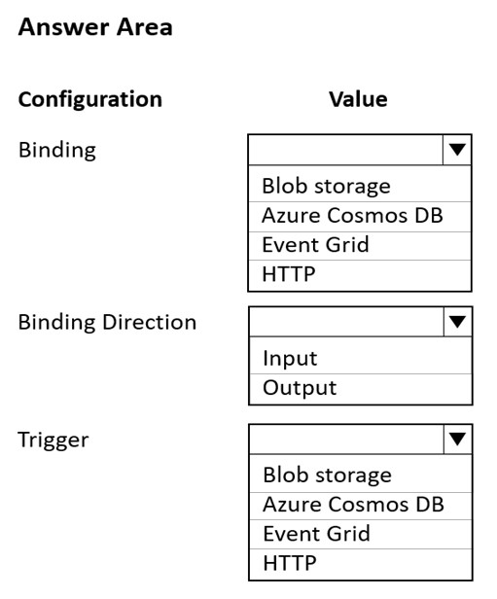

Question #2Topic 29
Introductory InfoCase study -
This is a case study. Case studies are not timed separately. You can use as much exam time as you would like to complete each case. However, there may be additional case studies and sections on this exam. You must manage your time to ensure that you are able to complete all questions included on this exam in the time provided.
To answer the questions included in a case study, you will need to reference information that is provided in the case study. Case studies might contain exhibits and other resources that provide more information about the scenario that is described in the case study. Each question is independent of the other questions in this case study.
At the end of this case study, a review screen will appear. This screen allows you to review your answers and to make changes before you move to the next section of the exam. After you begin a new section, you cannot return to this section.
To start the case study -
To display the first question in this case study, click the Next button. Use the buttons in the left pane to explore the content of the case study before you answer the questions. Clicking these buttons displays information such as business requirements, existing environment, and problem statements. When you are ready to answer a question, click the Question button to return to the question.
Background -
VanArsdel, Ltd. is a global office supply company. The company is based in Canada and has retail store locations across the world. The company is developing several cloud-based solutions to support their stores, distributors, suppliers, and delivery services.
Current environment -
Corporate website -
The company provides a public website located at http://www.vanarsdelltd.com. The website consists of a React JavaScript user interface, HTML, CSS, image assets, and several APIs hosted in Azure Functions.
Retail Store Locations -
The company supports thousands of store locations globally. Store locations send data every hour to an Azure Blob storage account to support inventory, purchasing and delivery services. Each record includes a location identifier and sales transaction information.
Requirements -
The application components must meet the following requirements:
Corporate website -
Secure the website by using SSL.
Minimize costs for data storage and hosting.
Implement native GitHub workflows for continuous integration and continuous deployment (CI/CD).
Distribute the website content globally for local use.
Implement monitoring by using Application Insights and availability web tests including SSL certificate validity and custom header value verification.
The website must have 99.95 percent uptime.
Retail store locations -
Azure Functions must process data immediately when data is uploaded to Blob storage. Azure Functions must update Azure Cosmos DB by using native SQL language queries.
Audit store sale transaction information nightly to validate data, process sales financials, and reconcile inventory.
Delivery services -
Store service telemetry data in Azure Cosmos DB by using an Azure Function. Data must include an item id, the delivery vehicle license plate, vehicle package capacity, and current vehicle location coordinates.
Store delivery driver profile information in Azure Active Directory (Azure AD) by using an Azure Function called from the corporate website.
Inventory services -
The company has contracted a third-party to develop an API for inventory processing that requires access to a specific blob within the retail store storage account for three months to include read-only access to the data.
Security -
All Azure Functions must centralize management and distribution of configuration data for different environments and geographies, encrypted by using a company-provided RSA-HSM key.
Authentication and authorization must use Azure AD and services must use managed identities where possible.
Issues -
Retail Store Locations -
You must perform a point-in-time restoration of the retail store location data due to an unexpected and accidental deletion of data.
Azure Cosmos DB queries from the Azure Function exhibit high Request Unit (RU) usage and contain multiple, complex queries that exhibit high point read latency for large items as the function app is scaling.QuestionHOTSPOT -
You need to implement the corporate website.
How should you configure the solution? To answer, select the appropriate options in the answer area.
NOTE: Each correct selection is worth one point.
Hot Area:
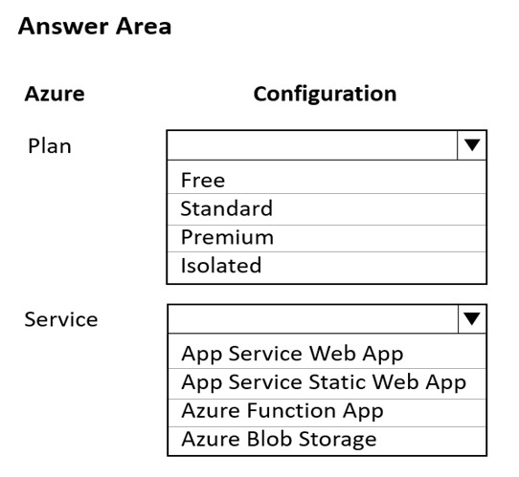

Topic 30 - Testlet 7
Question #1Topic 30
Introductory InfoCase study -
This is a case study. Case studies are not timed separately. You can use as much exam time as you would like to complete each case. However, there may be additional case studies and sections on this exam. You must manage your time to ensure that you are able to complete all questions included on this exam in the time provided.
To answer the questions included in a case study, you will need to reference information that is provided in the case study. Case studies might contain exhibits and other resources that provide more information about the scenario that is described in the case study. Each question is independent of the other questions in this case study.
At the end of this case study, a review screen will appear. This screen allows you to review your answers and to make changes before you move to the next section of the exam. After you begin a new section, you cannot return to this section.
To start the case study -
To display the first question in this case study, click the Next button. Use the buttons in the left pane to explore the content of the case study before you answer the questions. Clicking these buttons displays information such as business requirements, existing environment, and problem statements. When you are ready to answer a question, click the Question button to return to the question.
Background -
VanArsdel, Ltd. is a global office supply company. The company is based in Canada and has retail store locations across the world. The company is developing several cloud-based solutions to support their stores, distributors, suppliers, and delivery services.
Current environment -
Corporate website -
The company provides a public website located at http://www.vanarsdelltd.com. The website consists of a React JavaScript user interface, HTML, CSS, image assets, and several APIs hosted in Azure Functions.
Retail Store Locations -
The company supports thousands of store locations globally. Store locations send data every hour to an Azure Blob storage account to support inventory, purchasing and delivery services. Each record includes a location identifier and sales transaction information.
Requirements -
The application components must meet the following requirements:
Corporate website -
Secure the website by using SSL.
Minimize costs for data storage and hosting.
Implement native GitHub workflows for continuous integration and continuous deployment (CI/CD).
Distribute the website content globally for local use.
Implement monitoring by using Application Insights and availability web tests including SSL certificate validity and custom header value verification.
The website must have 99.95 percent uptime.
Retail store locations -
Azure Functions must process data immediately when data is uploaded to Blob storage. Azure Functions must update Azure Cosmos DB by using native SQL language queries.
Audit store sale transaction information nightly to validate data, process sales financials, and reconcile inventory.
Delivery services -
Store service telemetry data in Azure Cosmos DB by using an Azure Function. Data must include an item id, the delivery vehicle license plate, vehicle package capacity, and current vehicle location coordinates.
Store delivery driver profile information in Azure Active Directory (Azure AD) by using an Azure Function called from the corporate website.
Inventory services -
The company has contracted a third-party to develop an API for inventory processing that requires access to a specific blob within the retail store storage account for three months to include read-only access to the data.
Security -
All Azure Functions must centralize management and distribution of configuration data for different environments and geographies, encrypted by using a company-provided RSA-HSM key.
Authentication and authorization must use Azure AD and services must use managed identities where possible.
Issues -
Retail Store Locations -
You must perform a point-in-time restoration of the retail store location data due to an unexpected and accidental deletion of data.
Azure Cosmos DB queries from the Azure Function exhibit high Request Unit (RU) usage and contain multiple, complex queries that exhibit high point read latency for large items as the function app is scaling.QuestionYou need to implement a solution to resolve the retail store location data issue.
Which three Azure Blob features should you enable? Each correct answer presents part of the solution.
NOTE: Each correct selection is worth one point.
- A. Soft delete
- B. Change feed
- C. Snapshots
- D. Versioning
- E. Object replication
- F. Immutability

Topic 31 - Testlet 8
Question #1Topic 31
Introductory InfoCase study -
This is a case study. Case studies are not timed separately. You can use as much exam time as you would like to complete each case. However, there may be additional case studies and sections on this exam. You must manage your time to ensure that you are able to complete all questions included on this exam in the time provided.
To answer the questions included in a case study, you will need to reference information that is provided in the case study. Case studies might contain exhibits and other resources that provide more information about the scenario that is described in the case study. Each question is independent of the other questions in this case study.
At the end of this case study, a review screen will appear. This screen allows you to review your answers and to make changes before you move to the next section of the exam. After you begin a new section, you cannot return to this section.
To start the case study -
To display the first question in this case study, click the Next button. Use the buttons in the left pane to explore the content of the case study before you answer the questions. Clicking these buttons displays information such as business requirements, existing environment, and problem statements. When you are ready to answer a question, click the Question button to return to the question.
Background -
Overview -
You are a developer for Contoso, Ltd. The company has a social networking website that is developed as a Single Page Application (SPA). The main web application for the social networking website loads user uploaded content from blob storage.
You are developing a solution to monitor uploaded data for inappropriate content. The following process occurs when users upload content by using the SPA:
* Messages are sent to ContentUploadService.
* Content is processed by ContentAnalysisService.
* After processing is complete, the content is posted to the social network or a rejection message is posted in its place.
The ContentAnalysisService is deployed with Azure Container Instances from a private Azure Container Registry named contosoimages.
The solution will use eight CPU cores.
Azure Active Directory -
Contoso, Ltd. uses Azure Active Directory (Azure AD) for both internal and guest accounts.
Requirements -
ContentAnalysisService -
The company's data science group built ContentAnalysisService which accepts user generated content as a string and returns a probable value for inappropriate content. Any values over a specific threshold must be reviewed by an employee of Contoso, Ltd.
You must create an Azure Function named CheckUserContent to perform the content checks.
Costs -
You must minimize costs for all Azure services.
Manual review -
To review content, the user must authenticate to the website portion of the ContentAnalysisService using their Azure AD credentials. The website is built using
React and all pages and API endpoints require authentication. In order to review content a user must be part of a ContentReviewer role. All completed reviews must include the reviewer's email address for auditing purposes.
High availability -
All services must run in multiple regions. The failure of any service in a region must not impact overall application availability.
Monitoring -
An alert must be raised if the ContentUploadService uses more than 80 percent of available CPU cores.
Security -
You have the following security requirements:
Any web service accessible over the Internet must be protected from cross site scripting attacks.
All websites and services must use SSL from a valid root certificate authority.
Azure Storage access keys must only be stored in memory and must be available only to the service.
All Internal services must only be accessible from internal Virtual Networks (VNets).
All parts of the system must support inbound and outbound traffic restrictions.
All service calls must be authenticated by using Azure AD.
User agreements -
When a user submits content, they must agree to a user agreement. The agreement allows employees of Contoso, Ltd. to review content, store cookies on user devices, and track user's IP addresses.
Information regarding agreements is used by multiple divisions within Contoso, Ltd.
User responses must not be lost and must be available to all parties regardless of individual service uptime. The volume of agreements is expected to be in the millions per hour.
Validation testing -
When a new version of the ContentAnalysisService is available the previous seven days of content must be processed with the new version to verify that the new version does not significantly deviate from the old version.
Issues -
Users of the ContentUploadService report that they occasionally see HTTP 502 responses on specific pages.
Code -
ContentUploadService -
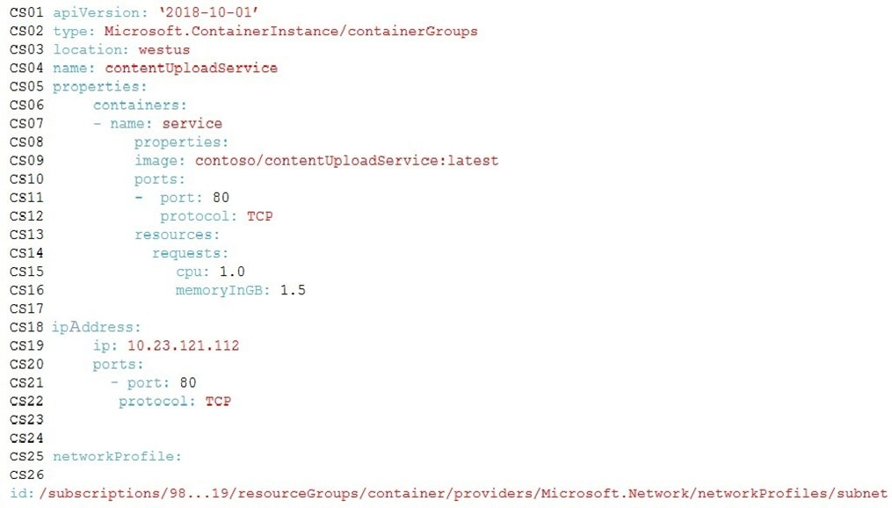
ApplicationManifest -
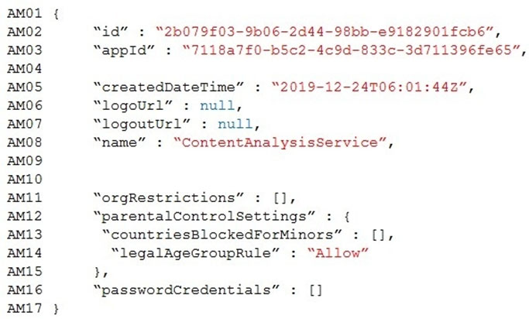
QuestionYou need to store the user agreements.
Where should you store the agreement after it is completed?
- A. Azure Storage queue
- B. Azure Event Hub
- C. Azure Service Bus topic
- D. Azure Event Grid topic

Question #2Topic 31
Introductory InfoCase study -
This is a case study. Case studies are not timed separately. You can use as much exam time as you would like to complete each case. However, there may be additional case studies and sections on this exam. You must manage your time to ensure that you are able to complete all questions included on this exam in the time provided.
To answer the questions included in a case study, you will need to reference information that is provided in the case study. Case studies might contain exhibits and other resources that provide more information about the scenario that is described in the case study. Each question is independent of the other questions in this case study.
At the end of this case study, a review screen will appear. This screen allows you to review your answers and to make changes before you move to the next section of the exam. After you begin a new section, you cannot return to this section.
To start the case study -
To display the first question in this case study, click the Next button. Use the buttons in the left pane to explore the content of the case study before you answer the questions. Clicking these buttons displays information such as business requirements, existing environment, and problem statements. When you are ready to answer a question, click the Question button to return to the question.
Background -
Overview -
You are a developer for Contoso, Ltd. The company has a social networking website that is developed as a Single Page Application (SPA). The main web application for the social networking website loads user uploaded content from blob storage.
You are developing a solution to monitor uploaded data for inappropriate content. The following process occurs when users upload content by using the SPA:
* Messages are sent to ContentUploadService.
* Content is processed by ContentAnalysisService.
* After processing is complete, the content is posted to the social network or a rejection message is posted in its place.
The ContentAnalysisService is deployed with Azure Container Instances from a private Azure Container Registry named contosoimages.
The solution will use eight CPU cores.
Azure Active Directory -
Contoso, Ltd. uses Azure Active Directory (Azure AD) for both internal and guest accounts.
Requirements -
ContentAnalysisService -
The company's data science group built ContentAnalysisService which accepts user generated content as a string and returns a probable value for inappropriate content. Any values over a specific threshold must be reviewed by an employee of Contoso, Ltd.
You must create an Azure Function named CheckUserContent to perform the content checks.
Costs -
You must minimize costs for all Azure services.
Manual review -
To review content, the user must authenticate to the website portion of the ContentAnalysisService using their Azure AD credentials. The website is built using
React and all pages and API endpoints require authentication. In order to review content a user must be part of a ContentReviewer role. All completed reviews must include the reviewer's email address for auditing purposes.
High availability -
All services must run in multiple regions. The failure of any service in a region must not impact overall application availability.
Monitoring -
An alert must be raised if the ContentUploadService uses more than 80 percent of available CPU cores.
Security -
You have the following security requirements:
Any web service accessible over the Internet must be protected from cross site scripting attacks.
All websites and services must use SSL from a valid root certificate authority.
Azure Storage access keys must only be stored in memory and must be available only to the service.
All Internal services must only be accessible from internal Virtual Networks (VNets).
All parts of the system must support inbound and outbound traffic restrictions.
All service calls must be authenticated by using Azure AD.
User agreements -
When a user submits content, they must agree to a user agreement. The agreement allows employees of Contoso, Ltd. to review content, store cookies on user devices, and track user's IP addresses.
Information regarding agreements is used by multiple divisions within Contoso, Ltd.
User responses must not be lost and must be available to all parties regardless of individual service uptime. The volume of agreements is expected to be in the millions per hour.
Validation testing -
When a new version of the ContentAnalysisService is available the previous seven days of content must be processed with the new version to verify that the new version does not significantly deviate from the old version.
Issues -
Users of the ContentUploadService report that they occasionally see HTTP 502 responses on specific pages.
Code -
ContentUploadService -
ApplicationManifest -
QuestionHOTSPOT -
You need to implement the bindings for the CheckUserContent function.
How should you complete the code segment? To answer, select the appropriate options in the answer area.
NOTE: Each correct selection is worth one point.
Hot Area:
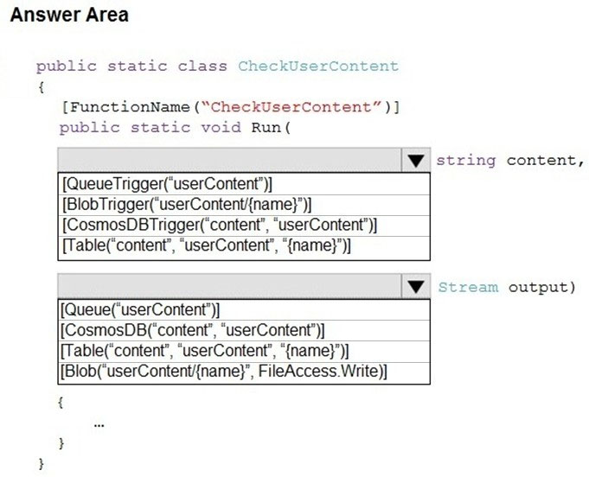

Question #3Topic 31
Introductory InfoCase study -
This is a case study. Case studies are not timed separately. You can use as much exam time as you would like to complete each case. However, there may be additional case studies and sections on this exam. You must manage your time to ensure that you are able to complete all questions included on this exam in the time provided.
To answer the questions included in a case study, you will need to reference information that is provided in the case study. Case studies might contain exhibits and other resources that provide more information about the scenario that is described in the case study. Each question is independent of the other questions in this case study.
At the end of this case study, a review screen will appear. This screen allows you to review your answers and to make changes before you move to the next section of the exam. After you begin a new section, you cannot return to this section.
To start the case study -
To display the first question in this case study, click the Next button. Use the buttons in the left pane to explore the content of the case study before you answer the questions. Clicking these buttons displays information such as business requirements, existing environment, and problem statements. When you are ready to answer a question, click the Question button to return to the question.
Background -
Overview -
You are a developer for Contoso, Ltd. The company has a social networking website that is developed as a Single Page Application (SPA). The main web application for the social networking website loads user uploaded content from blob storage.
You are developing a solution to monitor uploaded data for inappropriate content. The following process occurs when users upload content by using the SPA:
* Messages are sent to ContentUploadService.
* Content is processed by ContentAnalysisService.
* After processing is complete, the content is posted to the social network or a rejection message is posted in its place.
The ContentAnalysisService is deployed with Azure Container Instances from a private Azure Container Registry named contosoimages.
The solution will use eight CPU cores.
Azure Active Directory -
Contoso, Ltd. uses Azure Active Directory (Azure AD) for both internal and guest accounts.
Requirements -
ContentAnalysisService -
The company's data science group built ContentAnalysisService which accepts user generated content as a string and returns a probable value for inappropriate content. Any values over a specific threshold must be reviewed by an employee of Contoso, Ltd.
You must create an Azure Function named CheckUserContent to perform the content checks.
Costs -
You must minimize costs for all Azure services.
Manual review -
To review content, the user must authenticate to the website portion of the ContentAnalysisService using their Azure AD credentials. The website is built using
React and all pages and API endpoints require authentication. In order to review content a user must be part of a ContentReviewer role. All completed reviews must include the reviewer's email address for auditing purposes.
High availability -
All services must run in multiple regions. The failure of any service in a region must not impact overall application availability.
Monitoring -
An alert must be raised if the ContentUploadService uses more than 80 percent of available CPU cores.
Security -
You have the following security requirements:
Any web service accessible over the Internet must be protected from cross site scripting attacks.
All websites and services must use SSL from a valid root certificate authority.
Azure Storage access keys must only be stored in memory and must be available only to the service.
All Internal services must only be accessible from internal Virtual Networks (VNets).
All parts of the system must support inbound and outbound traffic restrictions.
All service calls must be authenticated by using Azure AD.
User agreements -
When a user submits content, they must agree to a user agreement. The agreement allows employees of Contoso, Ltd. to review content, store cookies on user devices, and track user's IP addresses.
Information regarding agreements is used by multiple divisions within Contoso, Ltd.
User responses must not be lost and must be available to all parties regardless of individual service uptime. The volume of agreements is expected to be in the millions per hour.
Validation testing -
When a new version of the ContentAnalysisService is available the previous seven days of content must be processed with the new version to verify that the new version does not significantly deviate from the old version.
Issues -
Users of the ContentUploadService report that they occasionally see HTTP 502 responses on specific pages.
Code -
ContentUploadService -
ApplicationManifest -
QuestionYou need to configure the ContentUploadService deployment.
Which two actions should you perform? Each correct answer presents part of the solution.
NOTE: Each correct selection is worth one point.
- A. Add the following markup to line CS23: type: Private
- B. Add the following markup to line CS24: osType: Windows
- C. Add the following markup to line CS24: osType: Linux
- D. Add the following markup to line CS23: type: Public
- Topic 32 - Testlet 9
- Question #1Topic 32
- Introductory InfoCase study -
This is a case study. Case studies are not timed separately. You can use as much exam time as you would like to complete each case. However, there may be additional case studies and sections on this exam. You must manage your time to ensure that you are able to complete all questions included on this exam in the time provided.
To answer the questions included in a case study, you will need to reference information that is provided in the case study. Case studies might contain exhibits and other resources that provide more information about the scenario that is described in the case study. Each question is independent of the other questions in this case study.
At the end of this case study, a review screen will appear. This screen allows you to review your answers and to make changes before you move to the next section of the exam. After you begin a new section, you cannot return to this section.
To start the case study -
To display the first question in this case study, click the Next button. Use the buttons in the left pane to explore the content of the case study before you answer the questions. Clicking these buttons displays information such as business requirements, existing environment, and problem statements. When you are ready to answer a question, click the Question button to return to the question.
Background -
City Power & Light company provides electrical infrastructure monitoring solutions for homes and businesses. The company is migrating solutions to Azure.
Current environment -
Architecture overview -
The company has a public website located at http://www.cpandl.com/. The site is a single-page web application that runs in Azure App Service on Linux. The website uses files stored in Azure Storage and cached in Azure Content Delivery Network (CDN) to serve static content.
API Management and Azure Function App functions are used to process and store data in Azure Database for PostgreSQL. API Management is used to broker communications to the Azure Function app functions for Logic app integration. Logic apps are used to orchestrate the data processing while Service Bus and
Event Grid handle messaging and events.
The solution uses Application Insights, Azure Monitor, and Azure Key Vault.
Architecture diagram -
The company has several applications and services that support their business. The company plans to implement serverless computing where possible. The overall architecture is shown below.
User authentication -
The following steps detail the user authentication process:
1. The user selects Sign in in the website.
2. The browser redirects the user to the Azure Active Directory (Azure AD) sign in page.
3. The user signs in.
4. Azure AD redirects the user's session back to the web application. The URL includes an access token.
5. The web application calls an API and includes the access token in the authentication header. The application ID is sent as the audience ('aud') claim in the access token.
6. The back-end API validates the access token.
Requirements -
Corporate website -
Communications and content must be secured by using SSL.
Communications must use HTTPS.
Data must be replicated to a secondary region and three availability zones.
Data storage costs must be minimized.
Azure Database for PostgreSQL -
The database connection string is stored in Azure Key Vault with the following attributes:
Azure Key Vault name: cpandlkeyvault
Secret name: PostgreSQLConn
Id: 80df3e46ffcd4f1cb187f79905e9a1e8
The connection information is updated frequently. The application must always use the latest information to connect to the database.
Azure Service Bus and Azure Event Grid
Azure Event Grid must use Azure Service Bus for queue-based load leveling.
Events in Azure Event Grid must be routed directly to Service Bus queues for use in buffering.
Events from Azure Service Bus and other Azure services must continue to be routed to Azure Event Grid for processing.
Security -
All SSL certificates and credentials must be stored in Azure Key Vault.
File access must restrict access by IP, protocol, and Azure AD rights.
All user accounts and processes must receive only those privileges which are essential to perform their intended function.
Compliance -
Auditing of the file updates and transfers must be enabled to comply with General Data Protection Regulation (GDPR). The file updates must be read-only, stored in the order in which they occurred, include only create, update, delete, and copy operations, and be retained for compliance reasons.
Issues -
Corporate website -
While testing the site, the following error message displays:
CryptographicException: The system cannot find the file specified.
Function app -
You perform local testing for the RequestUserApproval function. The following error message displays:
'Timeout value of 00:10:00 exceeded by function: RequestUserApproval'
The same error message displays when you test the function in an Azure development environment when you run the following Kusto query:
FunctionAppLogs -
| where FunctionName = = "RequestUserApproval"
Logic app -
You test the Logic app in a development environment. The following error message displays:
'400 Bad Request'
Troubleshooting of the error shows an HttpTrigger action to call the RequestUserApproval function.
Code -
Corporate website -
Security.cs:
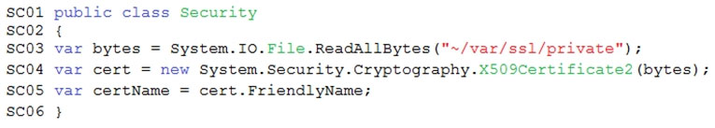
Function app -
RequestUserApproval.cs:
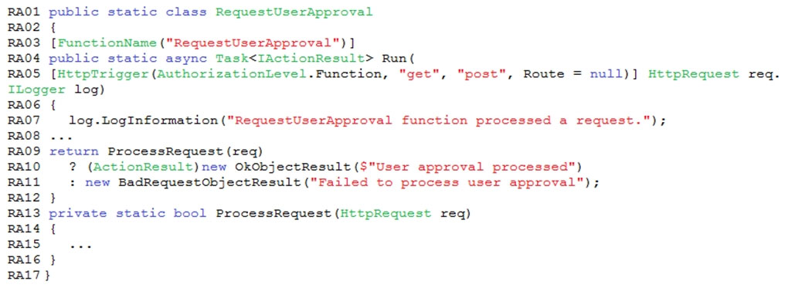QuestionHOTSPOT -
You need to configure the Account Kind, Replication, and Access tier options for the corporate website's Azure Storage account.
How should you complete the configuration? To answer, select the appropriate options in the dialog box in the answer area.
NOTE: Each correct selection is worth one point.
Hot Area:
