Question #25Topic 5
HOTSPOT -
You are developing an ASP.NET Core time sheet application that runs as an Azure Web App. Users of the application enter their time sheet information on the first day of every month.
The application uses a third-party web service to validate data.
The application encounters periodic server errors due to errors that result from calling a third-party web server. Each request to the third-party server has the same chance of failure.
You need to configure an Azure Monitor alert to detect server errors unrelated to the third-party service. You must minimize false-positive alerts.
How should you complete the Azure Resource Manager template? To answer, select the appropriate options in the answer area.
NOTE: Each correct selection is worth one point.
Hot Area:
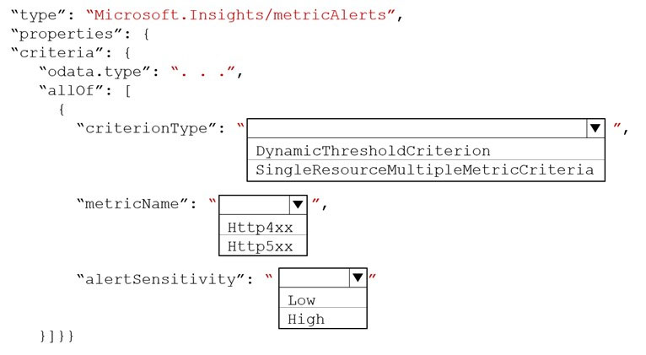

DynamicThresgoldCriterion
Http5xx
Low

Question #27Topic 5
DRAG DROP -
An organization has web apps hosted in Azure.
The organization wants to track events and telemetry data in the web apps by using Application Insights.
You need to configure the web apps for Application Insights.
Which three actions should you perform in sequence? To answer, move the appropriate actions from the list of actions to the answer area and arrange them in the correct order.
Select and Place:
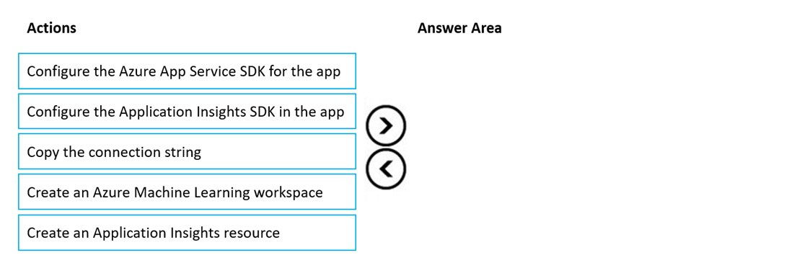

Create an Application insight resource
Copy the connection string
Configure the Application Insights SDK in the app

Question #8Topic 6
DRAG DROP -
You develop software solutions for a mobile delivery service. You are developing a mobile app that users can use to order from a restaurant in their area. The app uses the following workflow:
1. A driver selects the restaurants for which they will deliver orders.
2. Orders are sent to all available drivers in an area.
3. Only orders for the selected restaurants will appear for the driver.
4. The first driver to accept an order removes it from the list of available orders.
You need to implement an Azure Service Bus solution.
Which three actions should you perform in sequence? To answer, move the appropriate actions from the list of actions to the answer area and arrange them in the correct order.
Select and Place:
