Question #2Topic 1
DRAG DROP -
You have downloaded an Azure Resource Manager template to deploy numerous virtual machines. The template is based on a current virtual machine, but must be adapted to reference an administrative password.
You need to make sure that the password is not stored in plain text.
You are preparing to create the necessary components to achieve your goal.
Which of the following should you create to achieve your goal? Answer by dragging the correct option from the list to the answer area.
Select and Place:
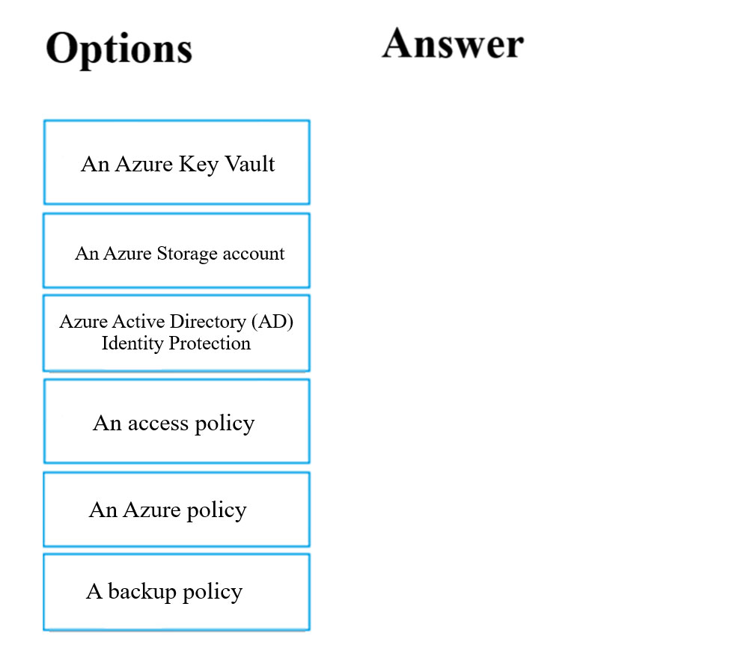
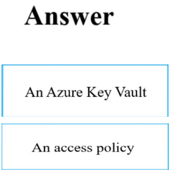

Question #8Topic 1
DRAG DROP -
You are creating an Azure Cosmos DB account that makes use of the SQL API. Data will be added to the account every day by a web application.
You need to ensure that an email notification is sent when information is received from IoT devices, and that compute cost is reduced.
You decide to deploy a function app.
Which of the following should you configure the function app to use? Answer by dragging the correct options from the list to the answer area.
Select and Place:
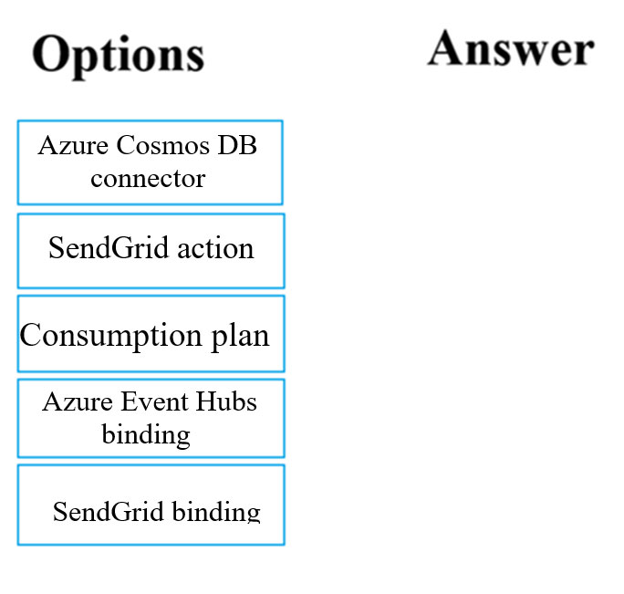

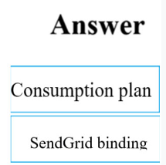

Question #13Topic 1
HOTSPOT -
You have an Azure Active Directory (Azure AD) tenant.
You want to implement multi-factor authentication by making use of a conditional access policy. The conditional access policy must be applied to all users when they access the Azure portal.
Which three settings should you configure? To answer, select the appropriate settings in the answer area.
NOTE: Each correct selection is worth one point.
Hot Area:
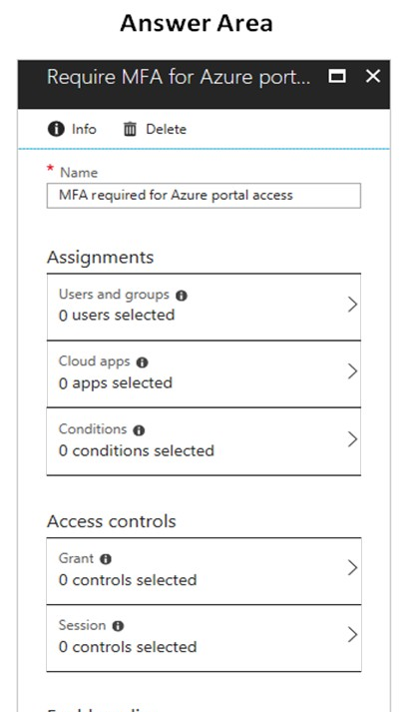

Question #16Topic 1
HOTSPOT -
You have developed a Web App for your company. The Web App provides services and must run in multiple regions.
You want to be notified whenever the Web App uses more than 85 percent of the available CPU cores over a 5 minute period. Your solution must minimize costs.
Which command should you use? To answer, select the appropriate settings in the answer area.
NOTE: Each correct selection is worth one point.
Hot Area:
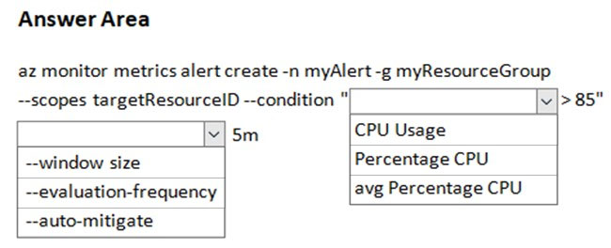
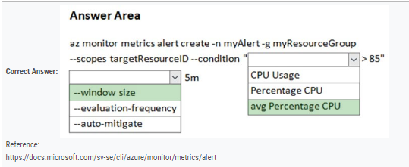

Question #30Topic 1
DRAG DROP -
You are a developer for a company that provides a bookings management service in the tourism industry. You are implementing Azure Search for the tour agencies listed in your company's solution.
You create the index in Azure Search. You now need to use the Azure Search .NET SDK to import the relevant data into the Azure Search service.
Which three actions should you perform in sequence? To answer, move the appropriate actions from the list of actions from left to right and arrange them in the correct order.
Select and Place:
