William Thomason

Assignment 1.5

WEB-330

<https://mishunov.me/>

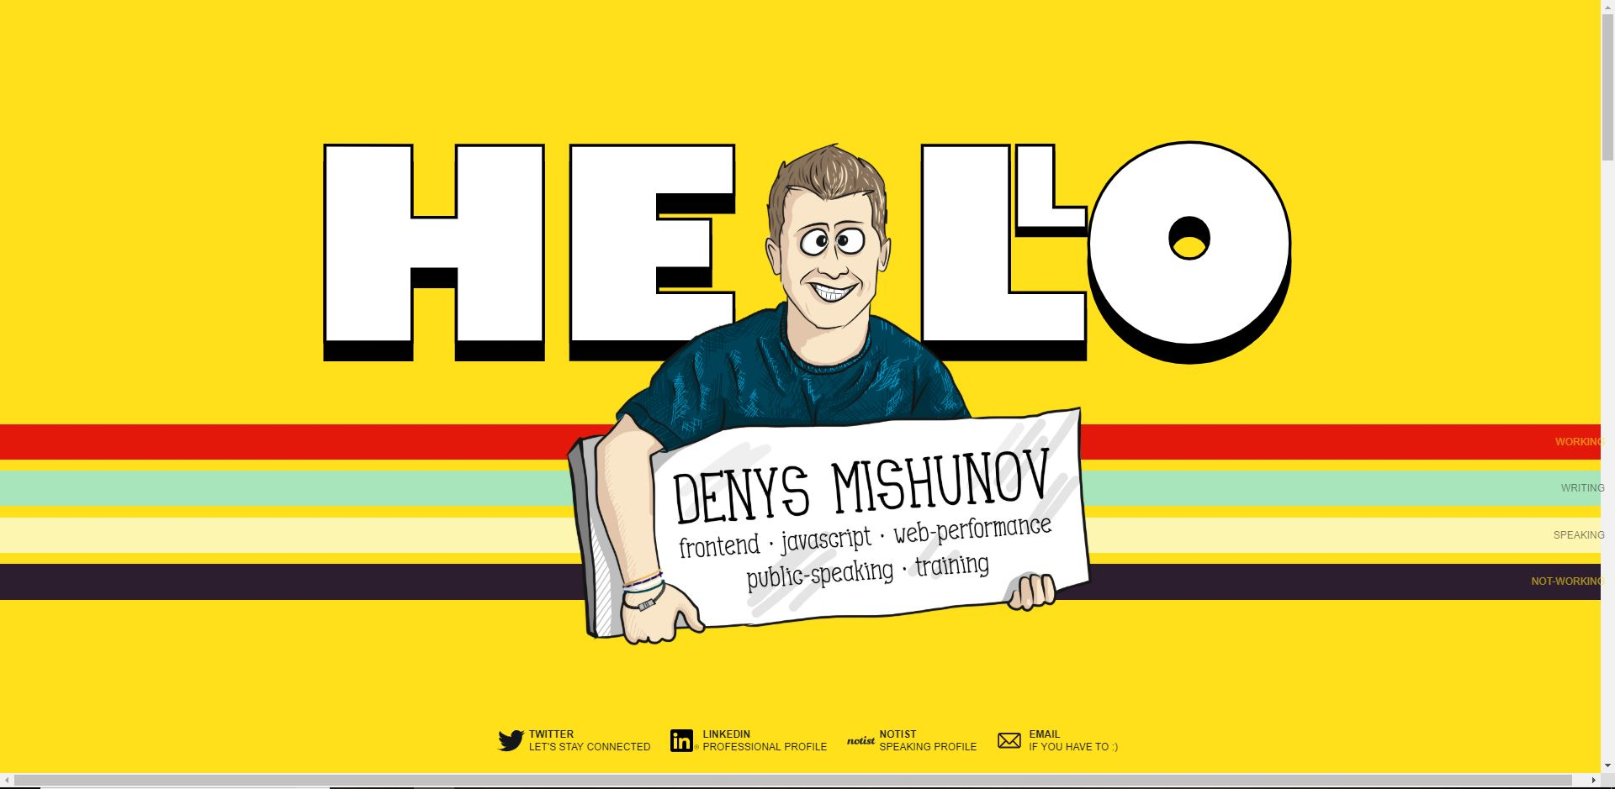

This is a great single page portfolio site. It has bright color pallet with a very well-planned layout. This site has some impressive animations when the landing page loads. Just the right amount of content on each section, that makes it easy to read. I like how each section if you stop scrolling half way from on section to the next it will finish the scroll and fill the window. The social media accounts are very well laid out on the landing page. I think the designer had a unique idea about the navigation bar with the background colors going all the way across the screen and the buttons on the right. However, the navigation bar needs some work. The buttons are going off the screen on the right. The background colors scroll with the content which is fine, but the buttons stay fixed. The navigation bar for mobile devices needs some work as well, the nav bar and the content display in different directions. I think it would be better either to have the background colors stay fixed with the buttons and give it a different z-index or make the buttons display none when not on top of the background color. Another disadvantage to this site it although the animations are awesome, it slows down the site’s load time drastically. I experienced it freezing a few times and seem a little jumpy. This can hurt the overall experience drastically. Great concept and execution on graphics, just need some fine tuning with animations and load time.

<https://www.christopher-ware.com/>

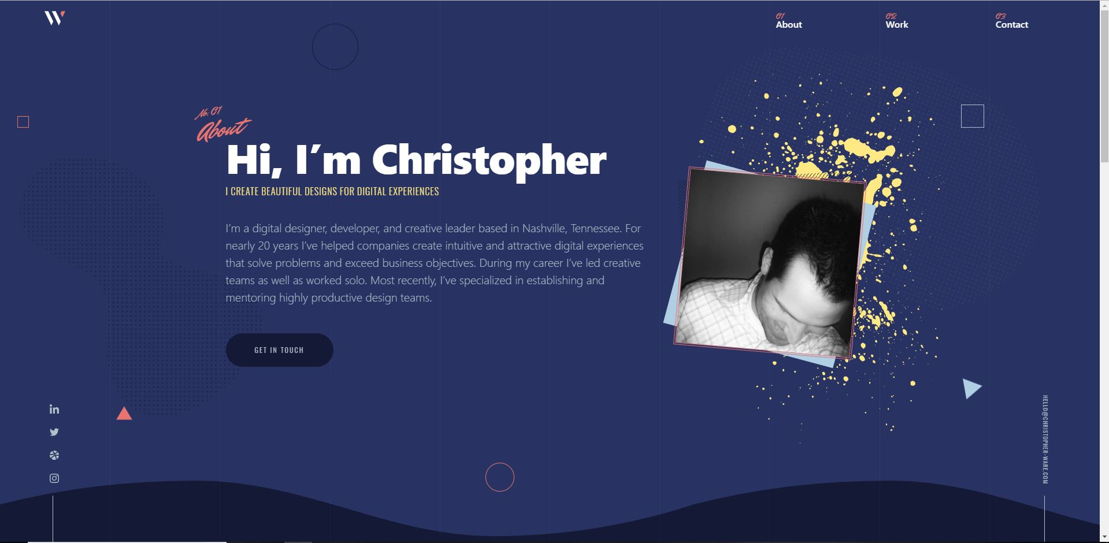

I really like this single page portfolio page as well. The color pallet and colored shapes for some reason remind me of the tv show Saved by The Bell. The load animations are well thought out and not over the top. The sites load time isn’t the fastest but it's not bad either. I like the parallax effect when you scroll, some of the page content scrolls at different rates to give a 3D effect. The hover effects for the navigation bar look really good and I like how the mobile navigation bar fades in and out full screen with social media icons. I also like the lazy scroll effect when you click a link in the navigation bar it slowly scrolls to that section instead of jumping there. With all the great things this site has going for it I do feel there are some disadvantages. The contrast between the main body text and some of the background color makes it hard to read. Another thing it the site address that is displayed vertically on the bottom right side of the page is very small and hard to read.

<https://www.cisco.com/c/m/en_us/solutions/enterprise-networks/digital-network-architecture/dna-mobility-infographic.html>

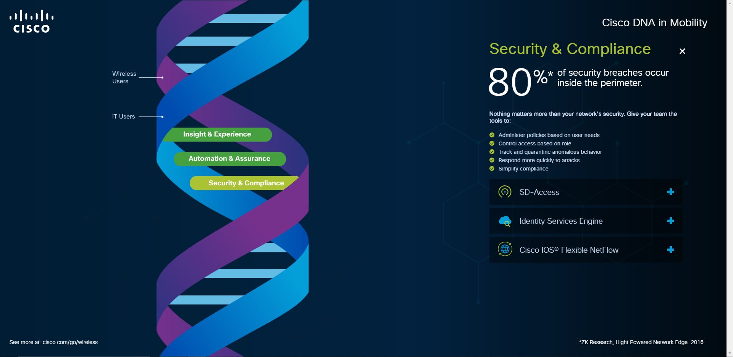

This single page site is a unique Idea. I do like the concept and how the content loads dynamically from the side versus scrolling to a different section. The load time is great and is very fast. The colors are put together very well and the contrast between the text and background work’s well together. I do like the animation when the landing page loads. The animations when the content loads are very cool and pulls the users attention to the content. The animations aren’t too fast to where you will miss what’s going on but isn’t slow enough that the user gets board. One down disadvantage I do see with this site it that there is very little room to place your content. Each section can’t be very long, some ways around this is you could have the div the content is in be scrollable instead of the whole page. However, I think this might not look very good. The DNA string could be pushed to the left a little to create more room for content. Another disadvantage is on mobile devices the site as a different feel than the main site. It uses the same content and DNA image but doesn’t have the content and navigation bar on the screen. Instead it has a dialog box with the content and to get back to the navigation bar you must close out the dialog box.