William Thomason

WEB-335

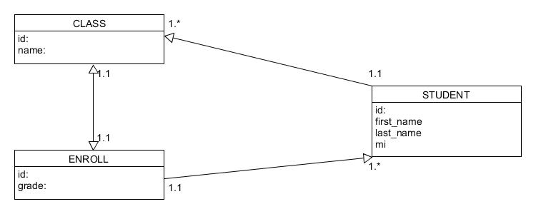Assignment 2.3

