William Thomason

nodeQuiz

Technical Design Document

WEB-450

1. Introduction
   1. Purpose

The purpose of this application is to test the user’s knowledge over pre-determined topics in the area of web development. The application will have the user sign in using their employee Id to track what tests the user takes and the score they get on those tests. Each test will have a presentation the user will view before taking the test. This presentation will cover all the questions on the test to set the user up for success. This application will track the score every time the test is taken and give you a cumulative score for each test. This allows you to see overall what your strong and weak areas are.

* 1. Terminology

API - An application programming interface is an interface or communication protocol between a client and a server intended to simplify the building of client-side software.

* 1. User Personas

Name: Lisa

Age: 24

Position: JR Developer

Description: New to the company within 6 months and recently graduated with her associates in Web development. Always looking to expand her knowledge base.



Name: Tom

Age: 42

Position: SR Developer

Description: Been with the company a while over 6 years with his bachelors in Web development. Has worked in the web development world a while and has a vast knowledge of the development process.



Name: Larry

Age: 33

Position: DevOps Team member

Description: Been with the company 2 years with his bachelors in Web development. Has worked in the DevOps for three years.

* 1. User Stories

User requirements

1.As a user, I want a way to go back and view the test presentation after taking the test.

2.As a user, I want to be able to see how I stand compared to the cumulative score.

3.As a user, I want to be able to keep track of my highest score if I have taken the test more than once.

4.As a user, see the questions and my answers so I can see what questions I got wrong.

5.As a user, I would like there to be guided through the platform and its

features after registration, so that I know how to use the system.

Developer requirements.

1.As a developer, I need to know all the UI specifications in order to build and

style the website properly.

2.As a developer, I need to know the timeline for the project so I can create and

manage my schedule.

3.As a developer, I need to develop UI components to add employee

user account.

4.As a developer, I need to design and create the UI and functionality

necessary to “guide” the user on how to use our application.

5.As a developer, I need to work on UI designs, produce a user-friendly UI

prototype, and put it into production.

* 1. Time Estimations

1. Process Design
   1. Prototypes

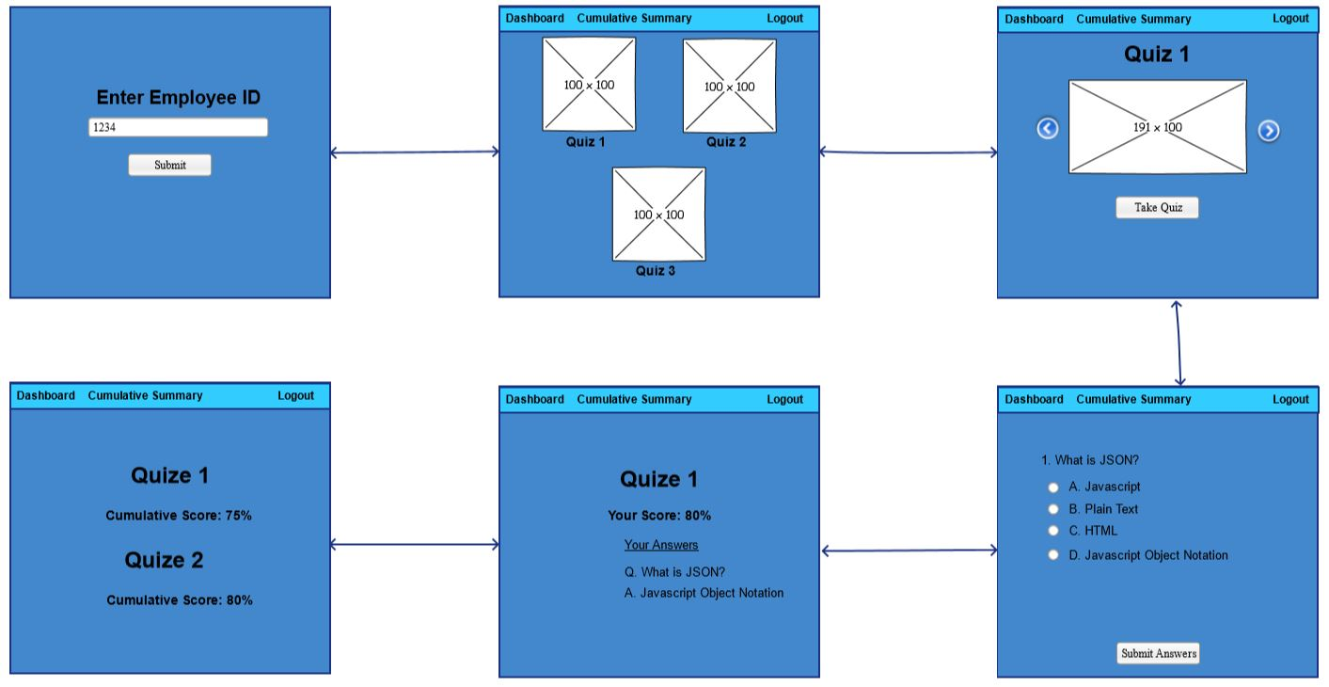

* 1. ORD

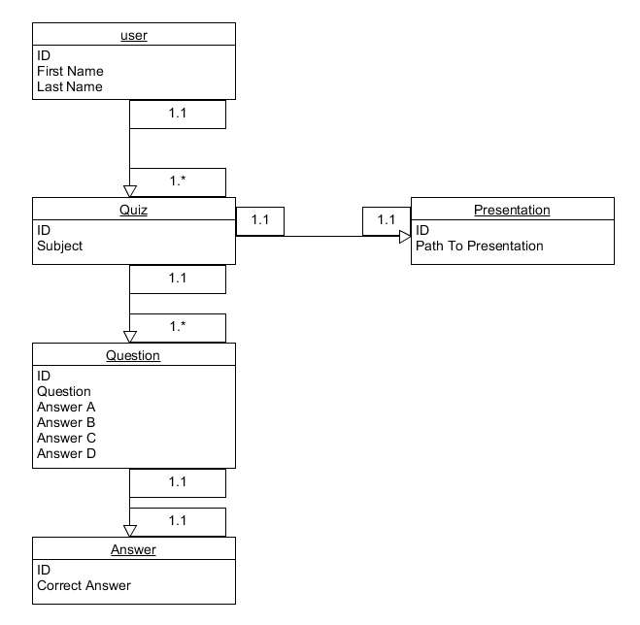

* 1. NoSQL Document Diagram

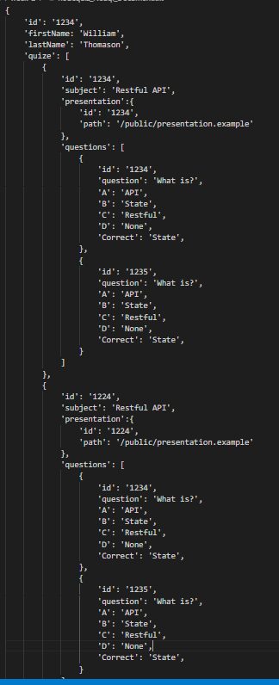

* 1. NoSQL data structure

1. QA Testing
   1. QA Testing Plan
      * 1. Test all API routes
        2. Test application page routes.
        3. Test Login form Validation
        4. Test quiz form validation and submission
        5. Check quiz selection page for proper display of quizzes
        6. Check presentation page for proper display of selected quiz
        7. Check quiz page for proper display of selected quiz.
        8. Check quiz page to ensure proper display or quiz results
        9. Check cumulative summary page for proper display of quizzes taken and scores.
        10. Ensure all desired routes are protected and only authenticated users can view them.
   2. Unit Tests

|  |  |  |  |  |  |
| --- | --- | --- | --- | --- | --- |
| **Step** | **Test Steps** | **Expected** | **Actual Results** | **(Pass/Fail)** | **Notes** |
| 1 | Visit Quiz selection page | Display quizzes for user to select | all quizzes diplayed and linked to presentations | Pass |  |
| 2 | visit Quiz slide show is available | slideshow works with button to take quiz | Diplays as expected | Pass |  |
| 3 | visit Quiz page | Quiz displays questions with radio buttons | Bind did not work | Pass |  |
| 4 | Run SoapUI test on API routes | SoapUI tests return expected data from mongoDB | All api routes worked as expected | Pass |  |
| 5 |  |  |  |  |  |
| 6 |  |  |  |  |  |
| 7 |  |  |  |  |  |
| 8 |  |  |  |  |  |
| 9 |  |  |  |  |  |
| 10 |  |  |  |  |  |