William Thomason

nodeQuiz

Technical Design Document

WEB-450

1. Introduction
   1. Purpose

The purpose of this application is to test the user’s knowledge over pre-determined topics in the area of web development. The application will have the user sign in using their employee Id to track what tests the user takes and the score they get on those tests. Each test will have a presentation the user will view before taking the test. This presentation will cover all the questions on the test to set the user up for success. This application will track the score every time the test is taken and give you a cumulative score for each test. This allows you to see overall what your strong and weak areas are.

* 1. Terminology

API - An application programming interface is an interface or communication protocol between a client and a server intended to simplify the building of client-side software.

* 1. User Personas

Name: Lisa

Age: 24

Position: JR Developer

Description: New to the company within 6 months and recently graduated with her associates in Web development. Always looking to expand her knowledge base.



Name: Tom

Age: 42

Position: SR Developer

Description: Been with the company a while over 6 years with his bachelors in Web development. Has worked in the web development world a while and has a vast knowledge of the development process.



Name: Larry

Age: 33

Position: DevOps Team member

Description: Been with the company 2 years with his bachelors in Web development. Has worked in the DevOps for three years.

* 1. User Stories

User requirements

1.As a user, I want a way to go back and view the test presentation after taking the test.

2.As a user, I want to be able to see how I stand compared to the cumulative score.

3.As a user, I want to be able to keep track of my highest score if I have taken the test more than once.

4.As a user, see the questions and my answers so I can see what questions I got wrong.

5.As a user, I would like there to be guided through the platform and its

features after registration, so that I know how to use the system.

Developer requirements.

1.As a developer, I need to know all the UI specifications in order to build and

style the website properly.

2.As a developer, I need to know the timeline for the project so I can create and

manage my schedule.

3.As a developer, I need to develop UI components to add employee

user account.

4.As a developer, I need to design and create the UI and functionality

necessary to “guide” the user on how to use our application.

5.As a developer, I need to work on UI designs, produce a user-friendly UI

prototype, and put it into production.

* 1. Time Estimations

1. Process Design
   1. Prototypes

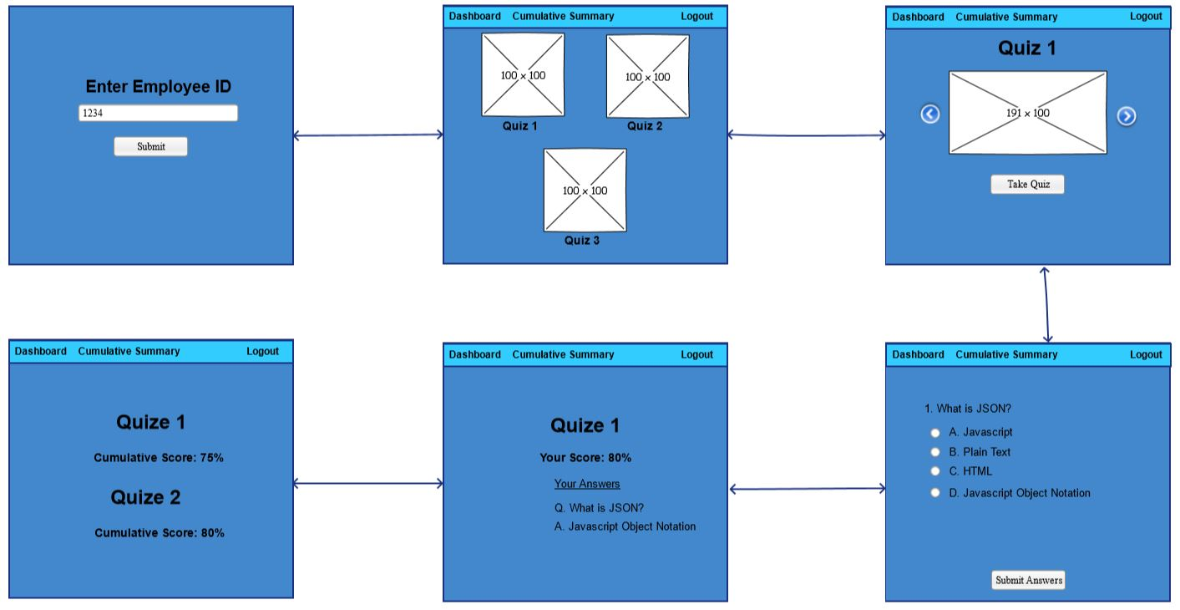

* 1. ORD

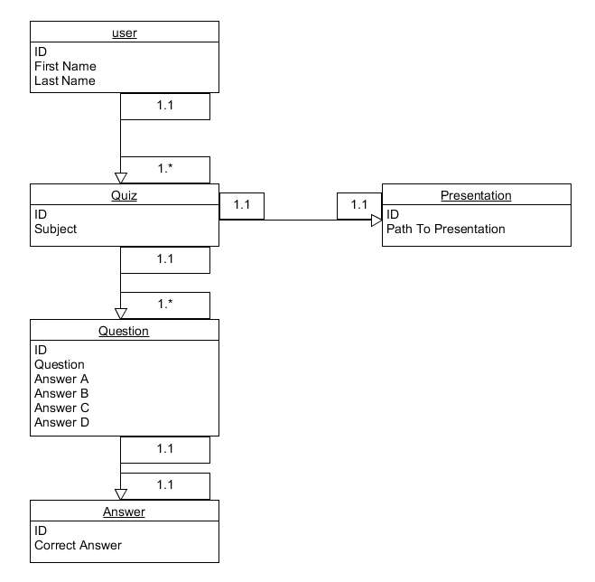

* 1. NoSQL Document Diagram

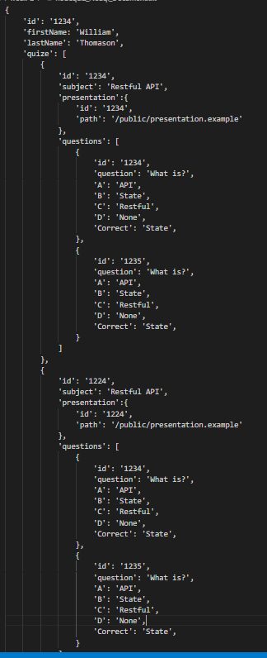

* 1. NoSQL data structure

1. QA Testing
   1. QA Testing Plan
      * 1. Test all API routes
        2. Test application page routes.
        3. Test Login form Validation
        4. Test quiz form validation and submission
        5. Check quiz selection page for proper display of quizzes
        6. Check presentation page for proper display of selected quiz
        7. Check quiz page for proper display of selected quiz.
        8. Check quiz page to ensure proper display or quiz results
        9. Check cumulative summary page for proper display of quizzes taken and scores.
        10. Ensure all desired routes are protected and only authenticated users can view them.
   2. Unit Tests

|  |  |  |  |  |  |
| --- | --- | --- | --- | --- | --- |
| **Step** | **Test Steps** | **Expected** | **Actual Results** | **(Pass/Fail)** | **Notes** |
| 1 | Run SoapUI test on API routes | Using SoapUI check all POST and GET API route create and retrieve documents form Database | All API routes worked as expected. The POST API routes created documents and the GET returned desired documents. | Pass |  |
| 2 | Visit page routes and ensure values are being passed | Routes take you to proper pages with proper parameters | All routes worked as expected and passed desired parameters | Pass |  |
| 3 | Login Form validation | Login form wont submit without the proper value | Form only accepts numbers and won’t continue without proper employee Id | Pass |  |
| 4 | Quiz Form Validation | Form will not submit unless all answers have been selected | Form didn’t submit unless all questions were answered | Pass |  |
| 5 | Visit Quiz selection page | Display quizzes for user to select | All quizzes displayed as expected | Pass |  |
| 6 | Visit Quiz Presentation page | slideshow works with button to take quiz | Desired quiz slide show displayed and user is able to navigate through presentation | Pass |  |
| 7 | Visit Quiz page | Quiz displays questions with radio buttons | Quiz displayed as expected and radio button grouped properly | Pass |  |
| 8 | Visit Quiz with quiz Results page | Quiz Results when quiz is submitted and answers checked | Results displayed as expected to the user with coloring for correct and incorrect answers. | Pass |  |
| 9 | Visit Quiz Cumulative Summary Page | Cumulative summary page pulls data from Database and displays to the user. | All data pulls and displays to the user correctly. | Pass |  |
| 10 | Visit protected routes while NOT signed into application | While not signed into the application all routes other than login page are protected. | All protected routes when visited by un authenticated users get routed to login form. | Pass |  |