HOW TO FIND FACEBOOK PAGE ID

1.       once you find a valid facebook profile, right click on the page.  You should see an option similar to “View Page Source”.  If you don’t see that option in the right click menu, check the “view” menu at the top of the browser window.  This will display all the html and javascript code used to display the page.

2.       Search the text for “page_id=”.  It should find quite a few instances.  Find one that looks like

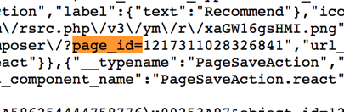

3.       You want to copy the number after the “=” sign into the csv file.