Finding the Google Place Id

In order to scrape these google “places”, we need to add the “place_id” to the Subject_Site_Identifiers.csv file.

How to find the google Place ID:

* 1. Do a normal google search for the doctor. Modify the search terms until you find the correct google place on the google map or the correct side-bar profile information shows up on the search results page.
  2. Use the Google Place ID finder: <https://developers.google.com/places/place-id>
  3. You will want to type the name of the place you found in the step above the exactly. You will then see your place on the map with an info box containing the Place ID.

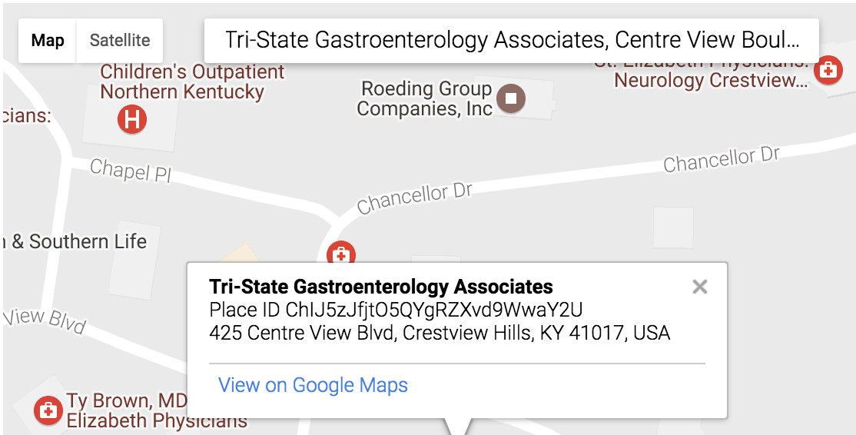

* 1. Put ONLY the value after “Place ID” in the above image into the Subject_site_Identifier.csv file.