Brackets (LESS)

1. Start Bracket
2. Click Extension manager
3. Search (LESS AutoCompile)
4. Install the extension  
   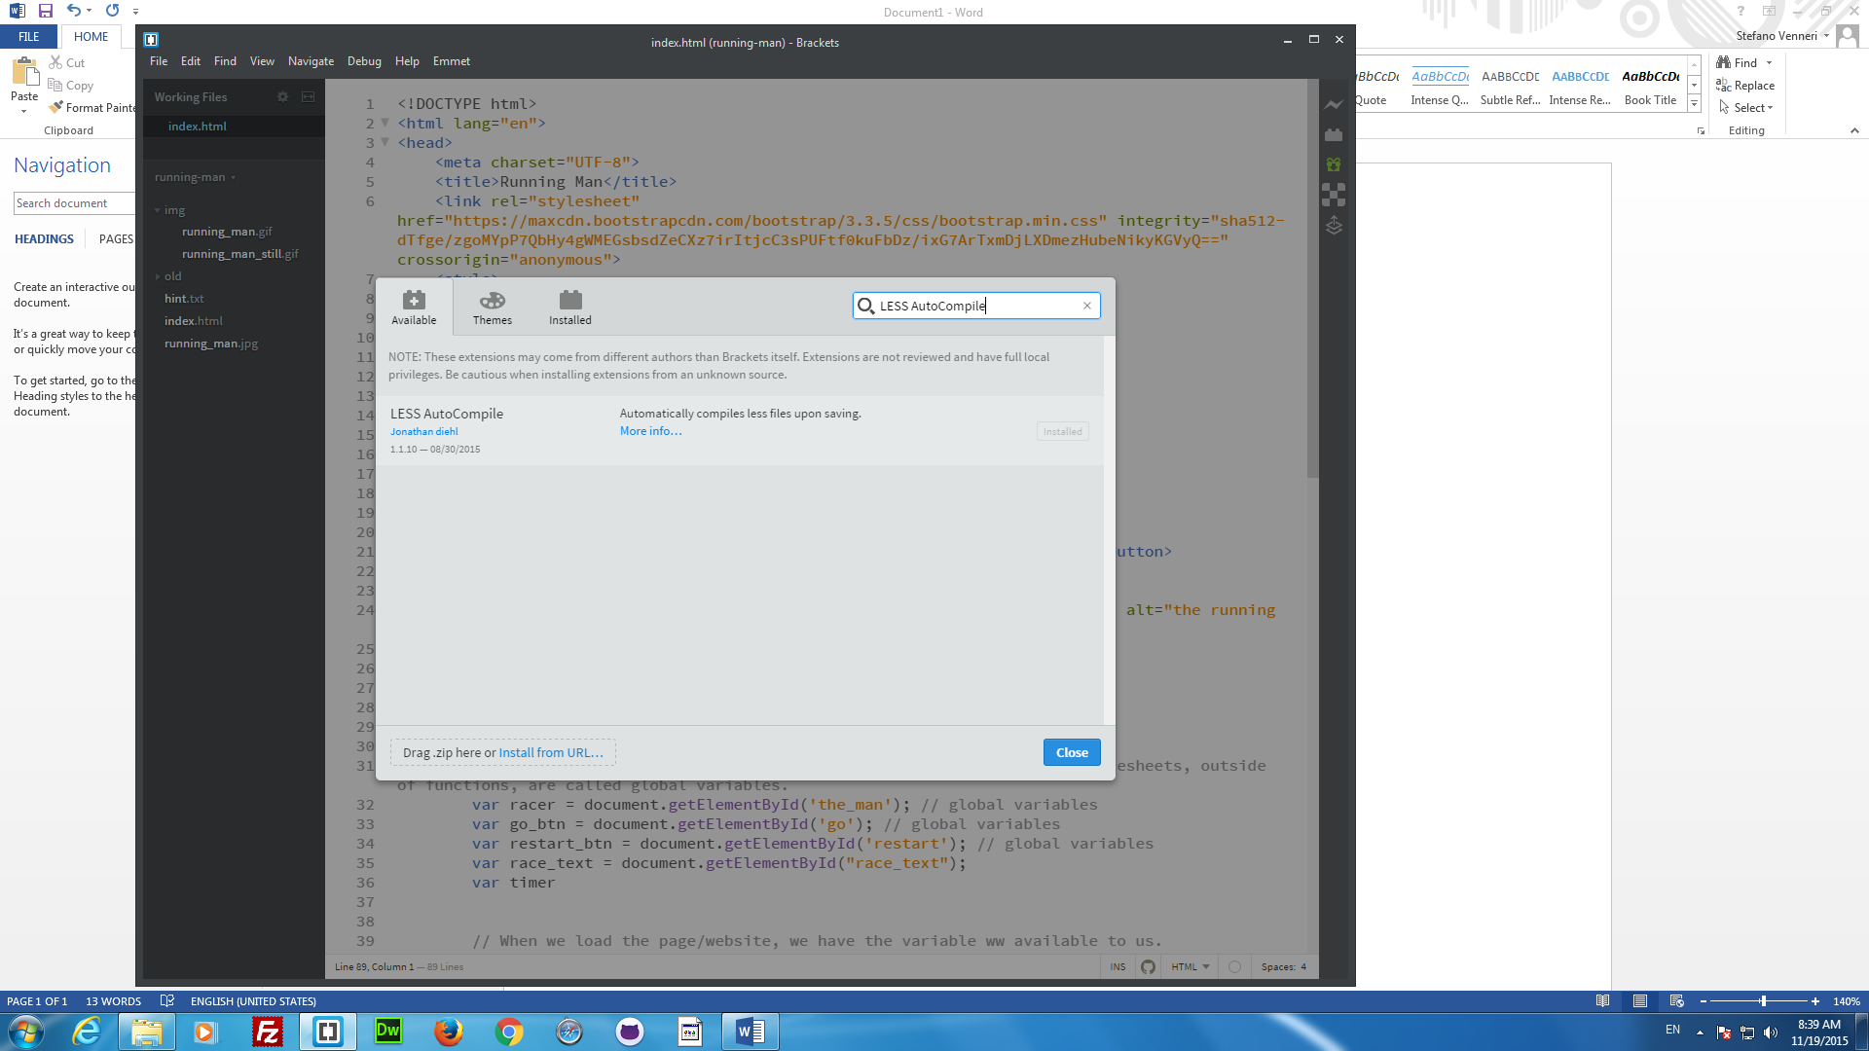
5. Start a new document in Bracket
6. Save the document
7. Html:5 🡪Tab
8. Attach the style.css stylesheet
9. 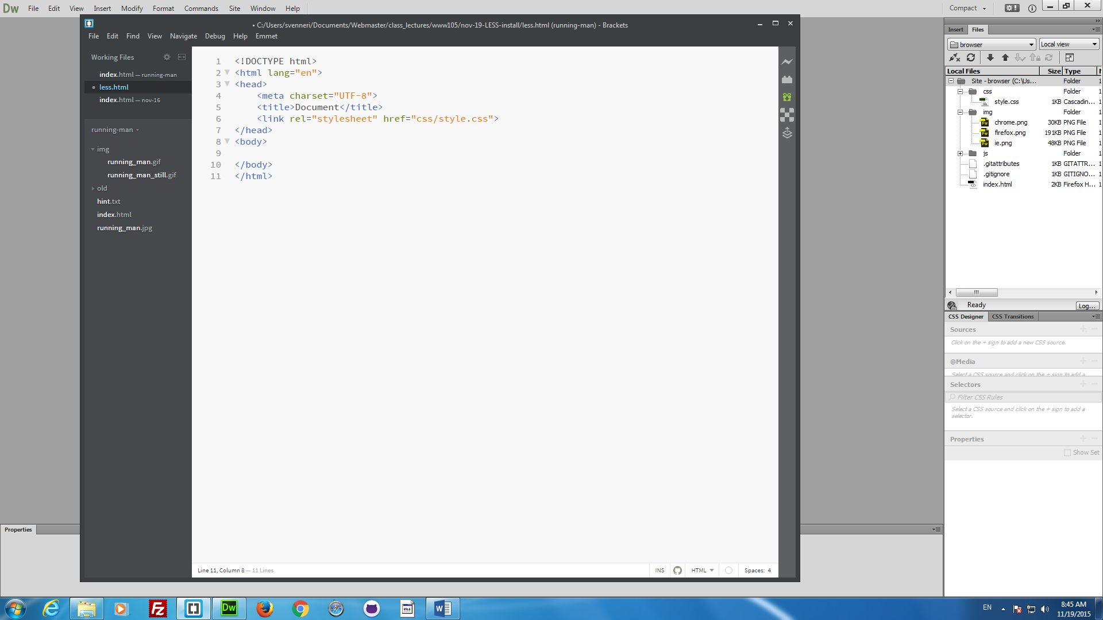
10. Start a new document
    1. Save it as style.less  
       