ELECTRONIC SUPPLEMENTARY MATERIAL
Manuscript: Are species’ responses to global change predicted by past niche evolution?

Table S1. Description of the variables used to depict species habitat and trophic niches. Each species was coded with 0/1 in each of the breeding habitats, foraging habitats, food source, foraging behaviour, and foraging period, meaning that a species could be coded to have several breeding habitats, foraging habitats etc...

 | Characteristics | Number of  possible states | List of possible states
Type of niche
Habitat | Breeding habitat | 9 | wet meadows, dry grasslands, banks, rocky outcrops or cliffs, beach or lake shore, fresh water marshes, forests, open forests or shrublands, urban or garden
 | Foraging habitat | 14 | wet grasslands, dry grasslands, rocky habitats, lotic systems, sea near shore, beach, salt marshes, freshwater marshes, mud or silt, forest, habitat edge, shrubs or bushes, urban or gardens, high air
Trophic | Food type | 9 | seeds or nuts, fruits, leaf or vegetative tissues, invertebrates, fishes, mammals, herptiles, birds, bones or carrions
 | Foraging strategy | 7 | pursuing, sallying, gleaning or pouncing, grazing, picking or probing, digging, overturning
 | Foraging period | 3 | nocturnal, crepuscular, diurnal

Table S2. Family-level estimates of evolutionary rates of niche evolution, inferred for climatic, habitat and trophic niches. Family richness (species number) within Europe is also given.

 | Family richness | Climatic niche rate | Habitat niche rate | trophic niche rate
Accipitridae | 25 | 4.5 | 3.4 | 2.5
Alaudidae | 9 | 0.7 | 0.5 | 0.5
Anatidae | 34 | 9.2 | 4.9 | 2.9
Ardeidae | 9 | 15.1 | 47.7 | 7.8
Charadriidae | 9 | 409.6 | 15.1 | 23.1
Corvidae | 11 | 0.9 | 3.0 | 3.5
Emberizidae | 14 | 3.0 | 1.0 | 0.4
Falconidae | 10 | 36.0 | 12.9 | 17.3
Fringillidae | 18 | 22.4 | 10.1 | 1.3
Laridae | 14 | 166.6 | 192.2 | 272.0
Motacillidae | 10 | 4.3 | 5.7 | 0.7
Paridae | 8 | 4.6 | 2.0 | 1.3
Phasianidae | 10 | 1.9 | 0.4 | 0.5
Picidae | 10 | 0.8 | 0.6 | 0.4
Rallidae | 8 | 9.9 | 2.9 | 23.3
Scolopacidae | 26 | 1.1 | 0.6 | 0.4
Sternidae | 9 | 1.1 | 1.1 | 0.6
Strigidae | 12 | 0.7 | 0.7 | 0.5
Sylviidae | 40 | 21.2 | 3.5 | 2.3
Tetraonidae | 6 | 3.8 | 0.6 | 0.4
Turdidae | 26 | 4.8 | 3.2 | 0.8

Table S3. Influence of both life-history traits and ecological characteristics, and species' evolutionary rates on the probability of species decline during 1970-1990 and 1990-2000, and the probability of species being rescued between the two time periods. Effects were assessed through bayesian MCMCglmm models fitted with a binomial error and a correlation structure taking into account species phylogenetic relationships. Explanatory variables were species life-history and ecological characteristics, and rates of niche evolution, estimated for climatic, habitat and trophic niches. The 2.5% and 97.5% quantiles of the highest posterior density (HPD) interval of each parameter are given, along with its posterior mean (pMean) computed across MCMC samples.

 |  | Declining species  1970-1990 |  |  | Declining species  1990-2000 |  |  | Rescued species  1970-2000
Predictors |  | pMean | HPD |  | pMean | HPD |  | pMean | HPD
Life-history / ecological covariates
lower thermal tolerance |  | -0.22 | -0.44/0.08 |  | -0.29 | -0.49/-0.06 |  | -0.31 | -0.69/0.09
grassland specialization |  | 0.43 | -0.45/1.16 |  | 0.58 | 0.74/1.05 |  | 0.01 | -0.81/0.74
migration strategy |  | -0.80 | -1.50/-0.19 |  | -0.99 | -1.47/-0.52 |  | 0.50 | -0.35/1.22
generation length |  | -0.17 | -0.33/-0.01 |  | -0.03 | -0.13/0.05 |  | -0.08 | -0.28/0.05
EU directive status |  | 1.27 | 0.51/2.04 |  | 0.37 | -0.28/0.86 |  | 0.68 | 0.06/1.75
Evolutionary rates |  | pMean | HPD |  | pMean | HPD |  | pMean | HPD
climatic niches |  | 0.10 | -0.66/0.91 |  | 0.16 | -0.43/0.73 |  | -0.73 | -1.61/0.14
habitat niches |  | -1.13 | -2.37/-0.02 |  | -0.74 | -1.59/-0.10 |  | 0.13 | -0.90/1.52
trophic niches |  | -0.73 | -2.7/0.51 |  | 0.03 | -0.83/0.92 |  | -0.54 | -1.62/0.59

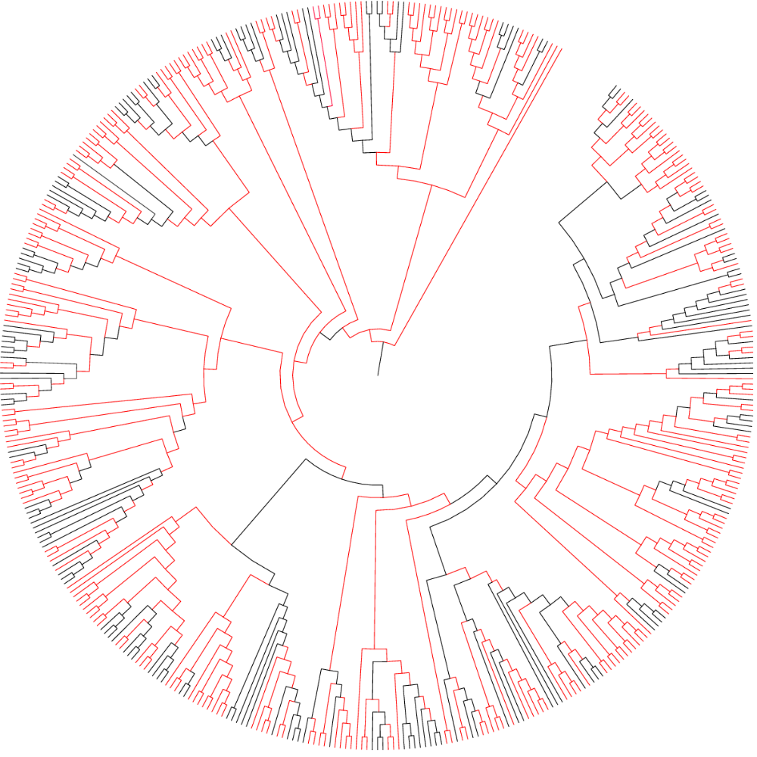

Figure S1. Radial phylogenetic tree of the 409 European bird species included in this study. Branch colours indicate node support based on bootstrap analyses, with red branches having a high support (>70%) and black branches lower support.

