**Usage**

./<compiled_binary> <unsol_puz> <sol_puz> <minisat_binary>

**Program Workflow**

1. Read <unsol_puz> and parse
2. For each cell, make required cls
   1. if prefilled,
      1. make r,c,n true
   2. else,
      1. make at least once clause.
      2. make at most once clause.
3. For each row, col, block
   1. make at least once clause.
   2. make at most once clause.
4. save to <unsol_sat> file and call outside minisat binary
5. check <sol_sat> to see if solvable
   1. if yes
      1. parse result from and <sol_puz> output
   2. if no
      1. output NO ANSWER
6. close the rest file and clean up <unsol_sat> and <sol_sat>

**Some detail**

**Encoding**

r,c,n will encode to r*N*N + c*N + n + 1 in orderto make NxNxN sudoku puzze to N^3 vars.

**Files**

including four major file

<unsol_puz> **→** <unsol_sat> → <sol_sat>→ <sol_puz>

each transition are mapped to some specific steps of the program workflow.

**At least once clause**

use below condition to make at least once clause.

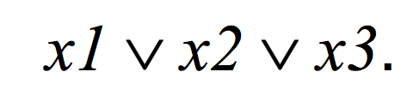

**At most once clause**

use below condition to make C(n, 2) at most once clause

