Will McNeill
11 April 2012
HPSC Lab 7

1. The speedup we see in the OMP parallelized matrix-vector multiplication implementation is decent for smaller numbers of threads, but tapers off quickly when the threading overhead starts becoming significant compared to the work each thread does. With larger problem sizes, I would expect the speedup to improve.

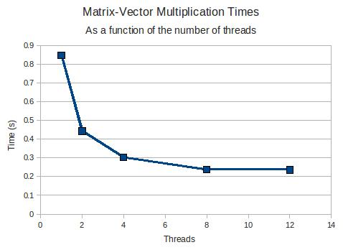
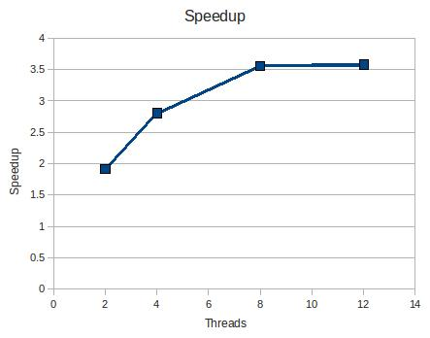
Threads | Time (s) | Speedup
0 | 0.8488
2 | 0.4440 | 1.9116
4 | 0.3028 | 2.8034
8 | 0.2385 | 3.5595
12 | 0.2370 | 3.5815

2. When running with 24 threads on two nodes, we see a big performance decrease. It takes 0.3039 seconds to run, which is on par with running it with only 4 threads on a single node. The speedup is merely 2.7931, which is not very good considering the number of threads we are using. I attribute this to the two nodes not actually sharing memory the way for which Open MP is designed.

