Housing Authority of the City & County of San Francisco

Thursday, April 25, 2024
https://sanfrancisco.granicus.com/player/clip/45978?view_id=229&redirect=true
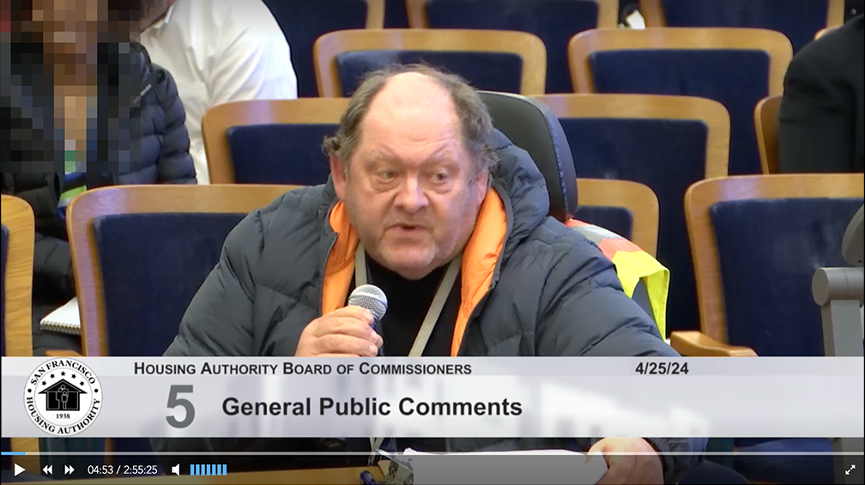

BOARD PRESIDENT TORRES
The next written public comment is from Francis Hayward thank you very much
HARWOOD
thank you very much my name is Francis Harwood I'm a board member of CCSD and that I need to show you that I've been advised to tell you about there was a vote taken today regarding the acting president of CCSD and I need to show you this this is for the record that the 6 to 0 vote was taken today at the board meeting regarding the acting president of CCSD Margaret [McNulty] and that she's been recalled so just wanted to inform you of that.

BOARD PRESIDENT TORRES
Thank you very much.

HARWOOD:
No problem. So right now we have a an acting president Martha Smith. She's taking over that position and that Margaret [McNulty] has been officially been removed from the CCSD board. Thank you.

BOARD PRESIDENT TORRES
Great thank you.

