**Flux Solar Car Crush Zone**

My first project on the solar car team was to create and attach a crush zone to our car as per American Solar Challenge regulations for driver safety. The crush zone was designed by teammates.

We first had to decide how to attach the crush zone to the car without ruining it by sticking bolts through the middle. We decided to embed nuts in the crush zone so that the bolts could be screwed in from the inside of the driver cage.

To test if our idea would work, we made a prototype with a mock crush zone.

Teammates created and added a transition piece so that the flat crush zone would fit against the car smoothly.

Next we had to decide how to do the layup (covering the crush zone with carbon fiber for stability and aerodynamic purposes). Doing the layup on the car would allow for a smoother transition but would risk damaging the car and would be more difficult than doing the layup on a flat surface. We decided to do the layup on the car.

Some problems we ran into:

* When we tried to attach the crush zone to the car, the bolts had to be perfectly angled and we had trouble screwing them into the nuts. We ended up taking the nuts out and embedding the heads of the bolts in the crush zone backwards so that the nuts could be screwed on from the inside of the driver cage.
* The transition piece did not fit perfectly to the car, leaving gaps that would cause problems when creating the vacuum against the car. We fixed this by filling in the gaps with vacuum tape and using Bondo putty to smooth over the transition.

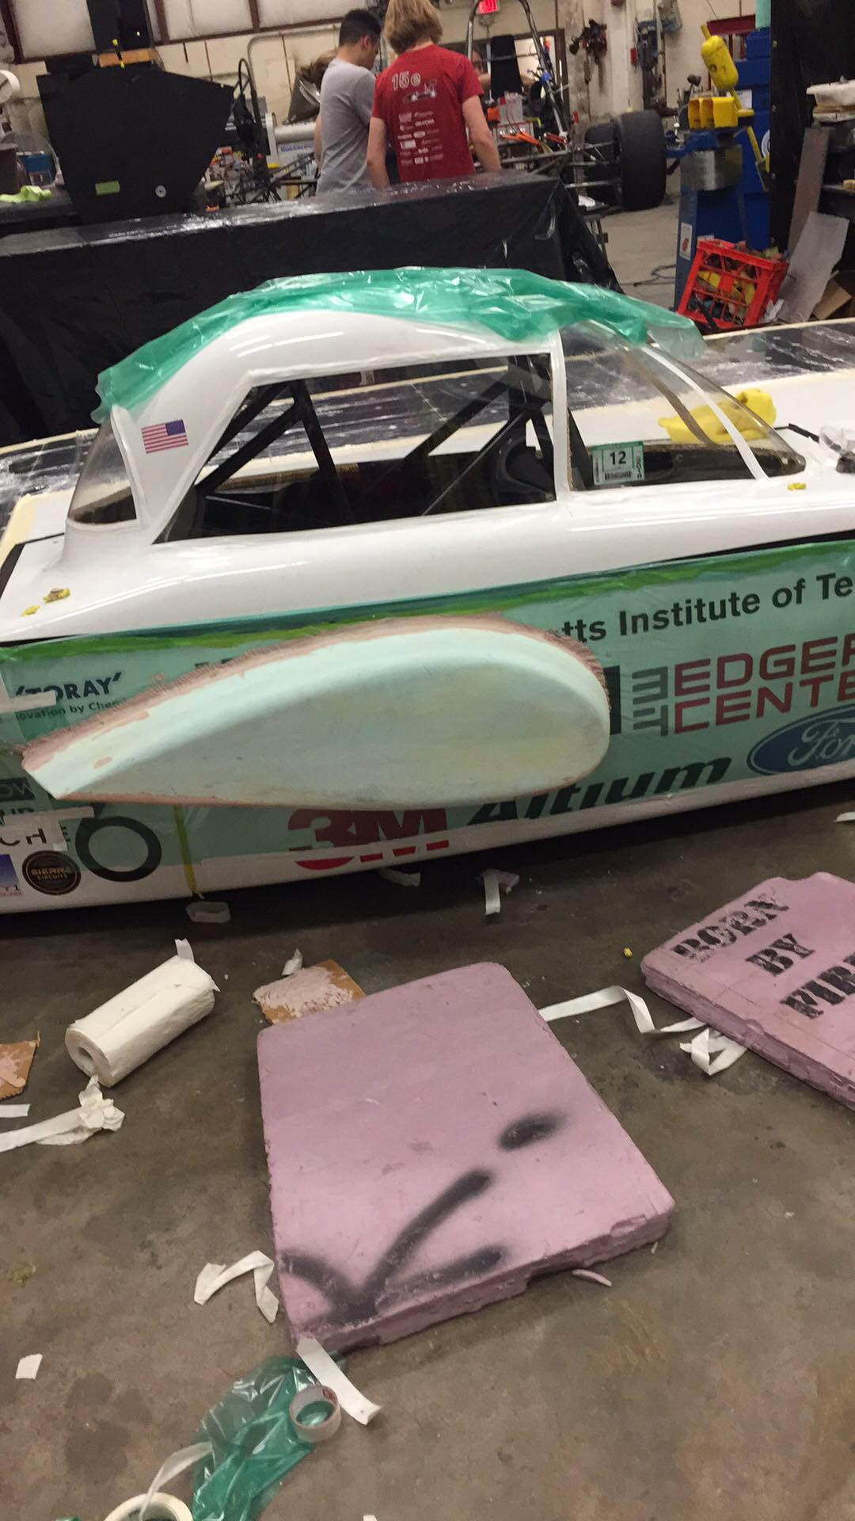

Next we did the layup and hoped that it would work.

1. Tape vacuum bag onto car

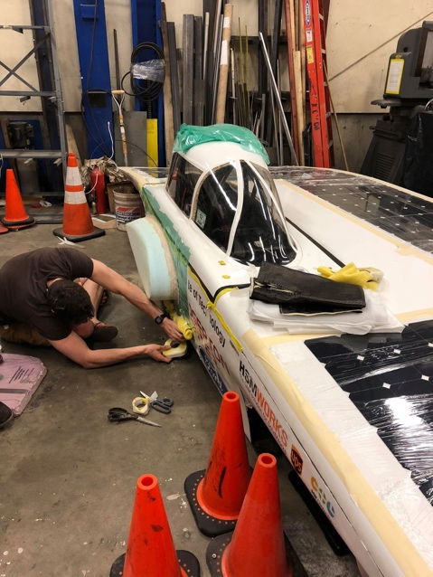

1. Cover with epoxy-soaked carbon fiber

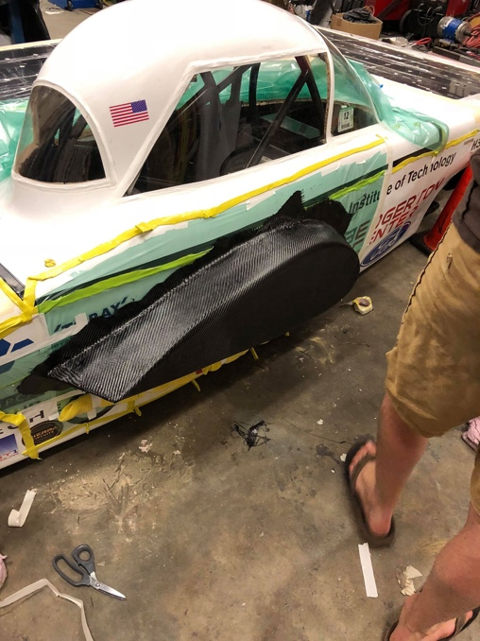

1. Apply peel-ply and breather

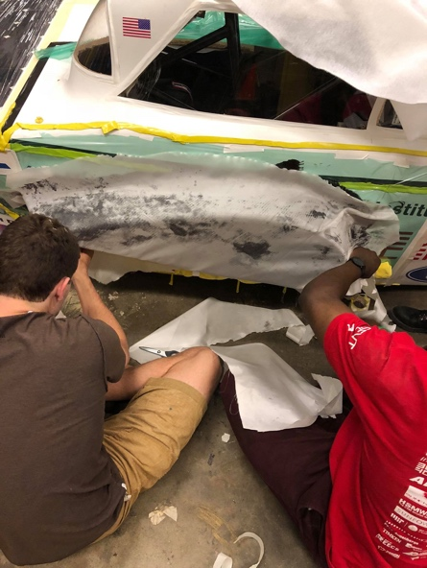

1. Vacuum

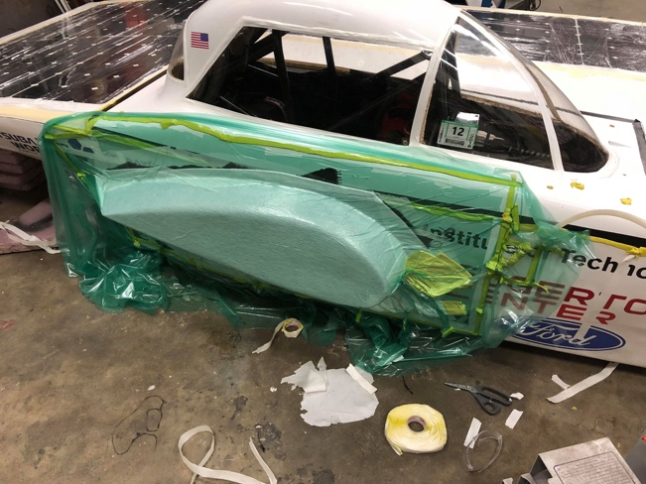

Turns out, this was not super aerodynamic, so we did it all again on a smaller version which met regulations. The second time, the process was much faster.

