Md.Akib Ali Sardar

DEC 6 2012

Report + UML

**UML diagram**

Report

I have made two classes in total , CarDealer, Car. In the CarDealer Class there is the main() methods that executes and creates is the class that executes the methods the class and the Car is a class that contains the information about each car object.

The Car class contains the information about the car which was given in the requirements like lotNumber : int, model : String, productYear : int , purchaseValue : double, currentValue : double. This Class.

The CarDealer Class contains the functions of the program and an Array that stores all the cars that was stored there.

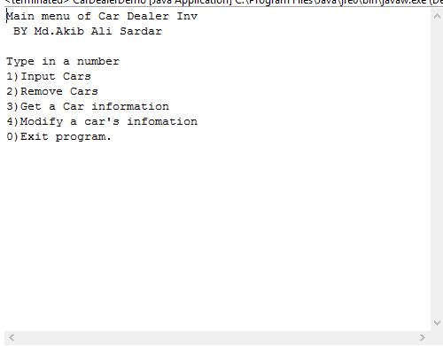

//Main menu.

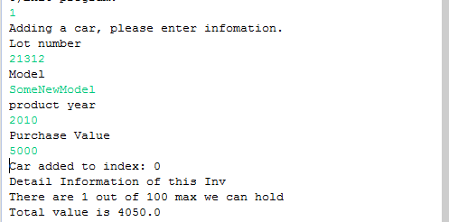

//Adding a Car

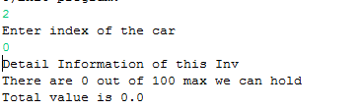

//Removing a Car

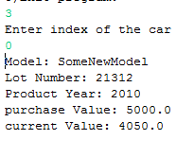

//Get a Car information.

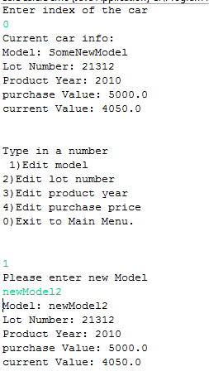

//editing a car, and editing menu.