Md.Akib Ali Sardar

DEC 6 2012

Report + UML

**UML diagram**

Report

I have made three classes in total, CarDealerDemo, CarDealer, Car. The CarDealerDemo class is the class that executes the methods in the CarDealer class and the Car is a class that contains the information about each car object.

The Car class contains the information about the car which was given in the requirements like lotNumber : int, model : String, productYear : int , purchaseValue : double, currentValue : double. This Class.

The CarDealer Class contains the functions of the program and an Array that stores all the cars that was stored there.

The CarDealerDemo Car is the main loop than handles the menu and executes the methods in Car Dealer Class.

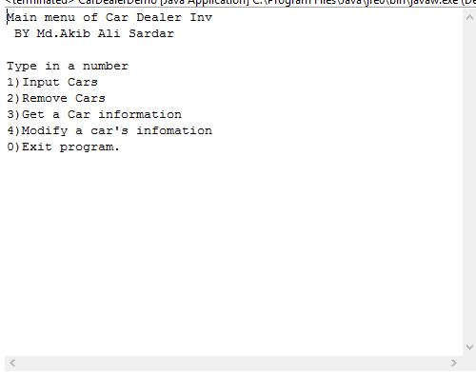

//Main menu.

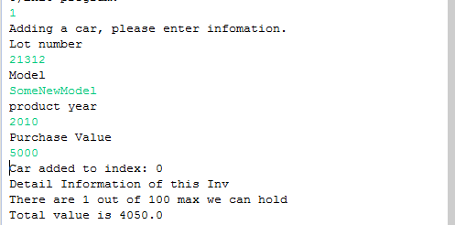

//Adding a Car

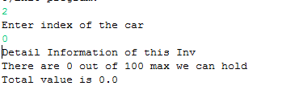

//Removing a Car

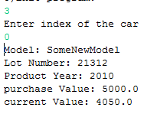

//Get a Car information.

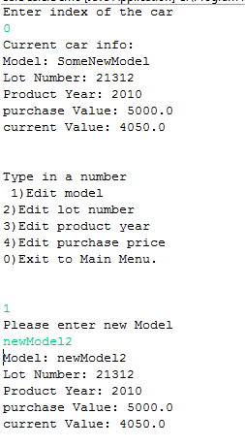

//editing a car, and editing menu.