Coverage
- Management Tester
1.1 Test Case
public void testIPAddrSetGet(){
mana.setIpAddr(7777, "192.168.0.23");
IPAddress ipa = mana.getIpAddr();
assertEquals(7777,ipa.getPort());
assertEquals("192.168.0.23",ipa.getIp());
}

public void testMediaSetGet(){
mana.setMedia("E:\\ireland\\", "test.mp4");
Media med = mana.getMedia();
assertEquals("E:\\ireland\\",med.getSavePath());
assertEquals("test.mp4",med.getName());
}

public void testIpSetGet()
{
mana.setIpAddr(7777, "192.168.0.23");
IPAddress ipa = mana.getIpAddr();
ipa.setIp("192.168.0.77");
assertEquals("192.168.0.77",ipa.getIp());
}

public void testSavePathSetGet()
{
mana.setMedia("E:\\ireland\\", "test.mp4");
Media med = mana.getMedia();
med.setSavePath("E:\\ireland\\File\\");
assertEquals("E:\\ireland\\File\\",med.getSavePath());
}
public void testFileNameSetGet(){
mana.setMedia("E:\\ireland\\", "test.mp4");
Media med = mana.getMedia();
med.setName("testName.mp4");
assertEquals("testName.mp4",med.getName());
}

public void testPortSetGet1()
{
mana.setIpAddr(7777, "192.168.0.23");
IPAddress ipa = mana.getIpAddr();
assertEquals(1,ipa.setPort(1024));
assertEquals(1024,ipa.getPort());
}
public void testPortSetGet2()
{
mana.setIpAddr(7777, "192.168.0.23");
IPAddress ipa = mana.getIpAddr();
assertEquals(1,ipa.setPort(49151));
assertEquals(49151,ipa.getPort());
}
public void testPortSetGet3()
{
mana.setIpAddr(7777, "192.168.0.23");
IPAddress ipa = mana.getIpAddr();
assertEquals(2,ipa.setPort(-1));
}
public void testPortSetGet4()
{
mana.setIpAddr(7777, "192.168.0.23");
IPAddress ipa = mana.getIpAddr();
assertEquals(3,ipa.setPort(0));
}
public void testPortSetGet5()
{
mana.setIpAddr(7777, "192.168.0.23");
IPAddress ipa = mana.getIpAddr();
assertEquals(3,ipa.setPort(1023));
}
public void testPortSetGet6()
{
mana.setIpAddr(7777, "192.168.0.23");
IPAddress ipa = mana.getIpAddr();
assertEquals(4,ipa.setPort(49152));
}
public void testPortSetGet7()
{
mana.setIpAddr(7777, "192.168.0.23");
IPAddress ipa = mana.getIpAddr();
assertEquals(4,ipa.setPort(65535));
}
public void testPortSetGet8()
{
mana.setIpAddr(7777, "192.168.0.23");
IPAddress ipa = mana.getIpAddr();
assertEquals(5,ipa.setPort(65536));
}
1.2 Coverage result
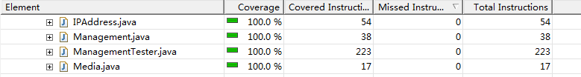
1.3 JUnit test result
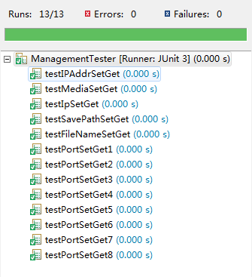
- SocketServer Tester
2.1 Test case
public void testConnect1(){
Boolean result = ss.connectServer(8888, "localhost");
assertEquals("true",result.toString());
}
public void testConnect2(){
Boolean result = ss.connectServer(8888, "ssss");
assertEquals("false",result.toString());
}
public void testConnect3(){
Boolean result = ss.connectServer(8889, "localhost");
assertEquals("false",result.toString());
}

public void testDisconnect1(){
ss.connectServer(8888, "localhost");
Boolean result = ss.disconnectServer();
assertEquals("true",result.toString());
}
public void testDisconnect2(){
ss.connectServer(8899, "localhost");
Boolean result = ss.disconnectServer();
assertEquals("false",result.toString());
}

public void testacceptFile1(){
ss.connectServer(8888, "localhost");
Boolean result = ss.acceptFile("E:\\ireland\\", "");
assertEquals("false",result.toString());
}
public void testacceptFile2(){
ss.connectServer(8888, "localhost");
Boolean result = ss.acceptFile("E:\\ireland\\File\\", "hi.mp4");
assertEquals("true",result.toString());
}
2.2 Coverage result
2.3 JUnit test result
