Hardware
1. Samsung television (PPD550)

2. Remoter (BN59-00862A)
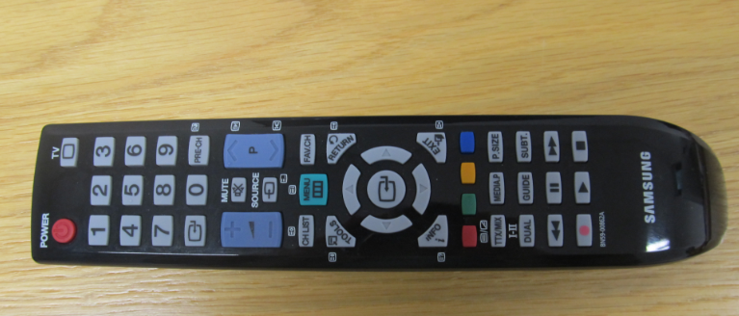
3. Kinect for Windows
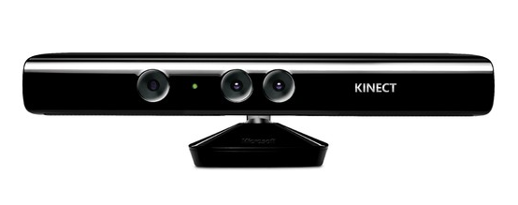

4. Infrared receiver and sender
a. 1 x USB cable
b. 1 x Breadboard, 840 tie points
c. 1 x 940nm wavelength Blue Lens Infrared LED
d. 1 x 2.4-5.5v Infrared Receiver Module 38 kHz
e. 1 x 100uF electrolytic capacitor 25Vdc
f. 2 x 220 Resistors 1/4W (red, red, brown, gold)
g. 1 x 2.2K Resistor 1/4 W (red, red, red, gold)
h. 1 x Arduino UNO Board
i. 1 x Set of 70 breadboard jumper wires
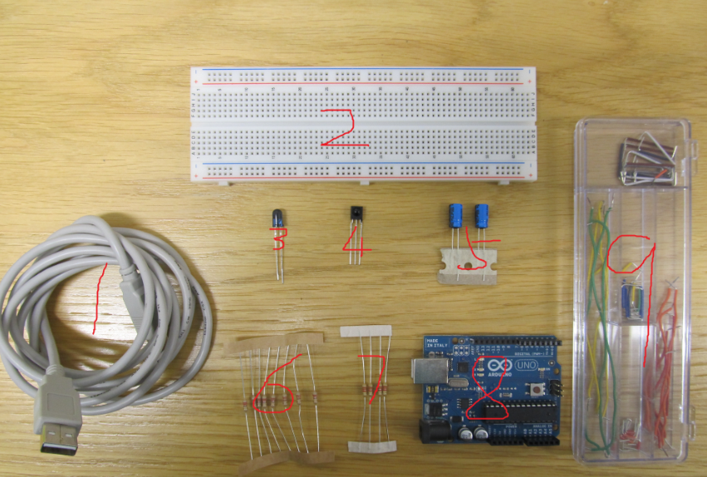

4.1 Infrared Sender
Recommended circuit:
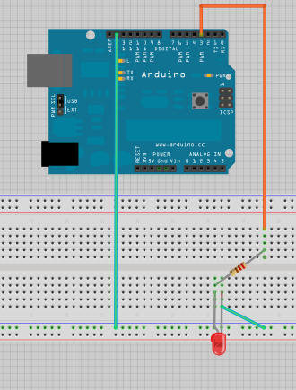
The long pin of the LED is positive wire, and the short pin of the LED is negative wire.
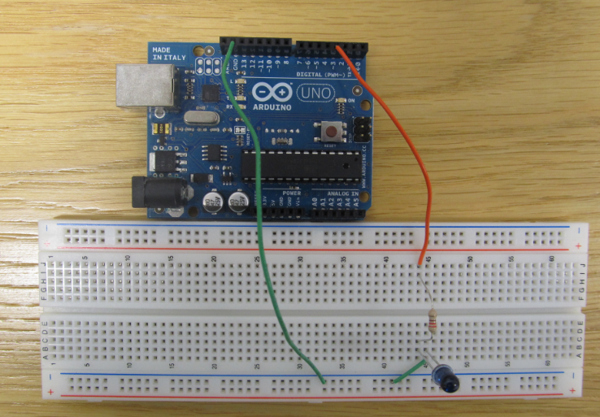

4.2 Infrared Receiver
Recommended circuit:
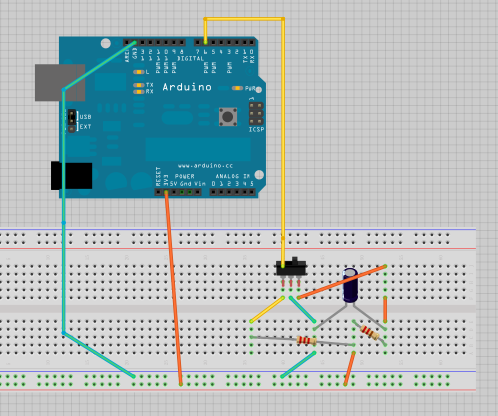
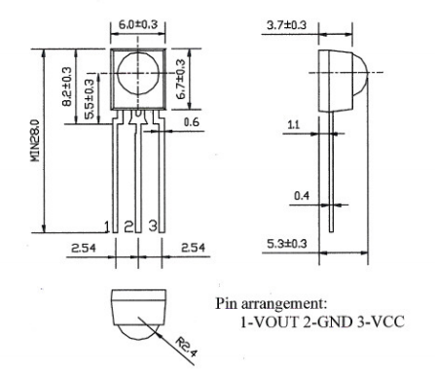
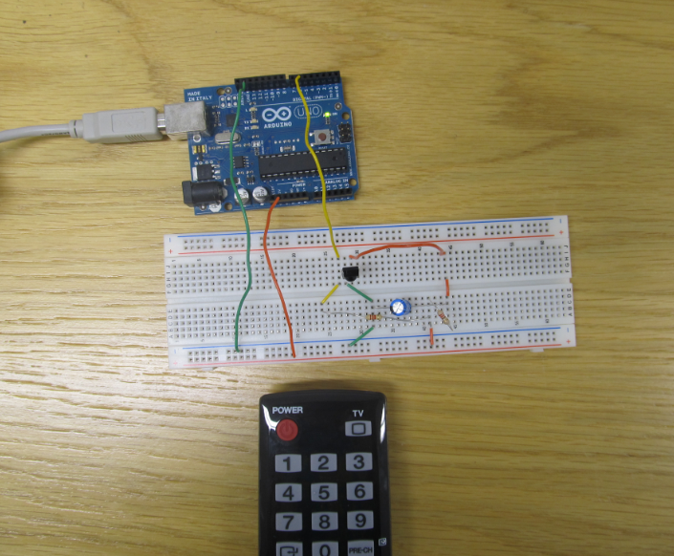
Development Environment
Software
1. Windows 7
2. Microsoft Visual Studio Express 2010 Express
(http://www.microsoft.com/en-us/kinectforwindows/develop/developer-downloads.aspx)
3. Kinect for Windows SDK Version 1.5 (available in the server)
(http://www.microsoft.com/en-us/kinectforwindows/develop/developer-downloads.aspx)
4. Arduino IDE windows v1.0.1 (available in the server)
(http://arduino.cc/hu/Main/Software)
Libraries
- 20120608HandTrackingLibrary.dll
Add this quote in the Kinect application.
- Microsoft.Kinect.dll
Add this quote in the Kinect application.
- Microsoft.Speech.dll
Add this quote in the Kinect application.
- IRremote
Put this file in this path (C:\Users\*****\Documents\Arduino\Libraries). If there has not a file named “Libraries”, please create it.
Set up
- Set up infrared sending system
Components:
(1) 1 x USB cable
(2) 1 x Breadboard, 840 tie points
(3) 1 x 940nm wavelength Blue Lens Infrared LED
(4) 1 x 220 Resistors 1/4W (red, red, brown, gold)
(5) 1 x Set of 70 breadboard jumper wires
(6) 1 x Arduino UNO Board

- Use Arduino IDE tool to load the Arduino code “TVRemoteSend.ino” into the Arduino board.
  - Open Arduino IDE
  - Find and open the code of “TVRemoteSend.ino”
  - Connecting the Arduino board to the computer and then upload the code to the board

- Connect the Arduino and Kinect on your computer.

- Set up and run the KinectTV project.
  - Open the project “20120718KinectTV” in Visual Studio 2010
  - Add all three “.dll” files
  - Run it

Note: If you need any other detail information, please see my thesis.

