Managalas Clan Land Mapping
The completed boundaries
Version 1.15 · 12 October 2026
9 of 49 clans have a boundary that closes on the ground the Clan Stewards walked. Their maps are finished: the area is measured from the walk, with no straight line anywhere in it that nobody walked.
Together they hold 6,103 ha, walked over 297 km.
This is the short companion to the full report, which carries all 49 clans including the 40 whose maps are not yet finished. Nothing here is estimated, so nothing here needs the cautions that document carries.

The completed boundaries
Clan | Zone | Clan Stewards | Walked (km) | Area (ha) | Sacred sites
Sukandi | Zone 2 | Rodney Ajinko, Millinton Beso | 39.7 | 1,901 | 3
Rondi | Zone 2 | Jefferson Amunisa, Humphrey Poto | 59.0 | 1,569 | 5
Manuvoora | Zone 6 | Egobeyas Kuarisi, Granville Nepo | 61.5 | 1,058 | none
Kasaki | Zone 2 | Ananias Masua | 15.1 | 541 | none
Sahirut | Zone 6 | Solomon Makanisa, Lenard Urami | 23.0 | 345 | none
Majanko | Zone 2 | Gilford Amakana | 7.5 | 276 | none
Murai (Z2) | Zone 2 | Nehemiah Nindori | 7.3 | 199 | none
Asingi | Zone 2 | Jethro Akse | 6.4 | 166 | none
Natang | Zone 7B | Stafford Gidiri, Dickson Hoe | 77.3 | 49 | none
Sacred sites are reported by number only here, and by area on each clan's page. Locations are not shared and appear on no map in this document.

Sukandi
Zone 2 · version 1.15, 12 October 2026
Clan Stewards | Walked (km) | Pieces | Parcels | Area (ha)
2 | 39.7 | 3 | 1 | 1,901
Clan Stewards
Clan Steward | Tracks | Days | First | Last | Walked (km)
Rodney Ajinko | 1 | 1 | 2025-04-24 | 2025-04-24 | 29.1
Millinton Beso | 3 | 2 | 2025-04-24 | 2025-04-25 | 10.6
Sacred sites
3 recorded. Locations are not shared.
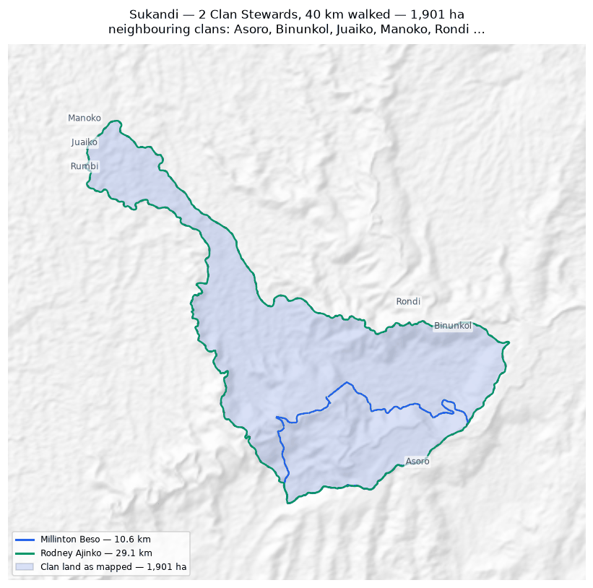
1,901 ha, measured from 39.7 km walked. Nothing in this boundary was inferred.

Rondi
Zone 2 · version 1.15, 12 October 2026
Clan Stewards | Walked (km) | Pieces | Parcels | Area (ha)
2 | 59.0 | 14 | 1 | 1,569
Clan Stewards
Clan Steward | Tracks | Days | First | Last | Walked (km)
Jefferson Amunisa | 28 | 5 | 2025-04-25 | 2025-04-29 | 29.7
Humphrey Poto | 29 | 5 | 2025-04-25 | 2025-04-29 | 29.3
Sacred sites
5 recorded, covering 5.4 ha — 0.3% of this clan's land. Locations are not shared.
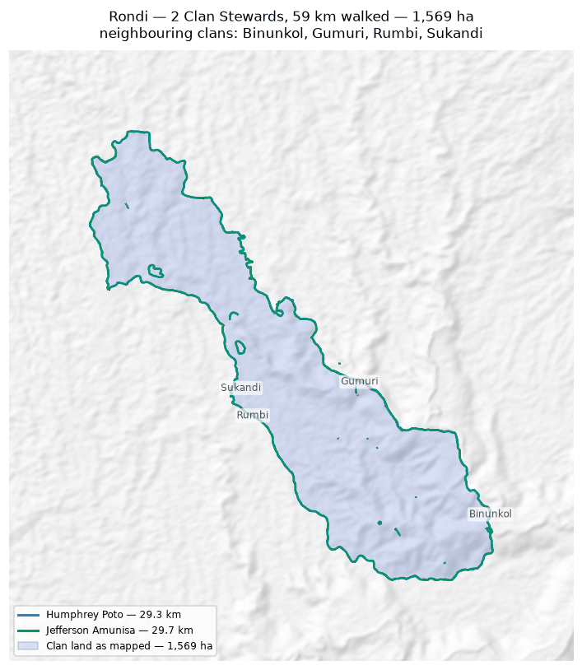
1,569 ha, measured from 59.0 km walked. Nothing in this boundary was inferred.

Manuvoora
Zone 6 · version 1.15, 12 October 2026
Clan Stewards | Walked (km) | Pieces | Parcels | Area (ha)
2 | 61.5 | 5 | 1 | 1,058
Clan Stewards
Clan Steward | Tracks | Days | First | Last | Walked (km)
Egobeyas Kuarisi | 18 | 11 | 2026-06-18 | 2026-07-26 | 31.2
Granville Nepo | 11 | 8 | 2026-06-18 | 2026-07-21 | 30.2
Sacred sites
None recorded.
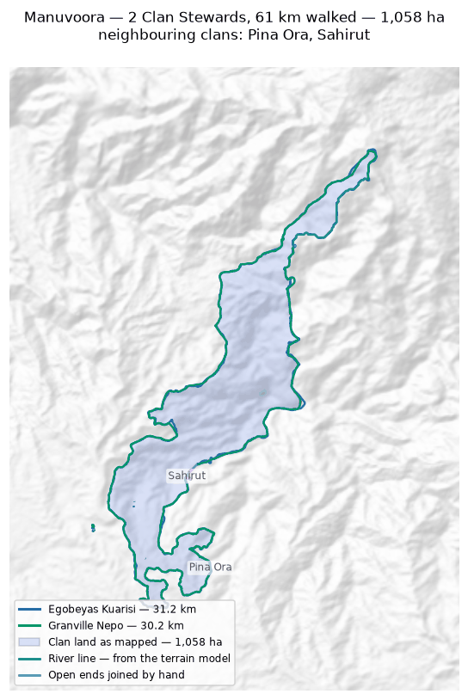
1,058 ha, measured from 61.5 km walked. Nothing in this boundary was inferred.

Kasaki
Zone 2 · version 1.15, 12 October 2026
Clan Stewards | Walked (km) | Pieces | Parcels | Area (ha)
1 | 15.1 | 1 | 1 | 541
Clan Stewards
Clan Steward | Tracks | Days | First | Last | Walked (km)
Ananias Masua | 1 | 1 | 2026-02-05 | 2026-02-05 | 15.1
Sacred sites
None recorded.
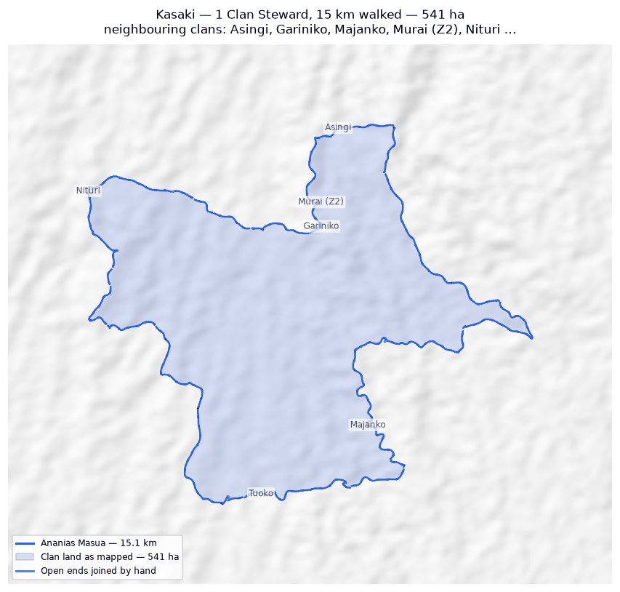
541 ha, measured from 15.1 km walked. Nothing in this boundary was inferred.

Sahirut
Zone 6 · version 1.15, 12 October 2026
Clan Stewards | Walked (km) | Pieces | Parcels | Area (ha)
2 | 23.0 | 1 | 1 | 345
Clan Stewards
Clan Steward | Tracks | Days | First | Last | Walked (km)
Solomon Makanisa | 5 | 3 | 2026-06-22 | 2026-06-25 | 18.1
Lenard Urami | 2 | 2 | 2026-06-22 | 2026-06-23 | 4.9
Sacred sites
None recorded.
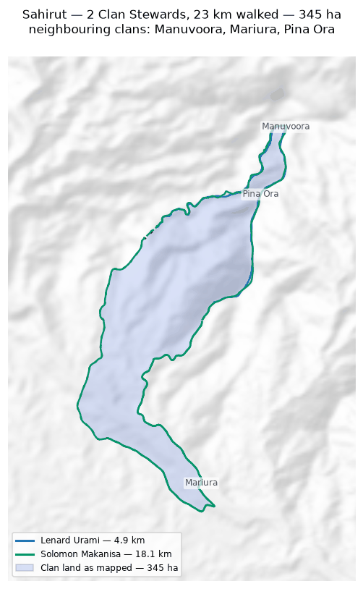
345 ha, measured from 23.0 km walked. Nothing in this boundary was inferred.

Majanko
Zone 2 · version 1.15, 12 October 2026
Clan Stewards | Walked (km) | Pieces | Parcels | Area (ha)
1 | 7.5 | 1 | 1 | 276
Clan Stewards
Clan Steward | Tracks | Days | First | Last | Walked (km)
Gilford Amakana | 4 | 1 | 2026-02-26 | 2026-02-26 | 7.5
Sacred sites
None recorded.
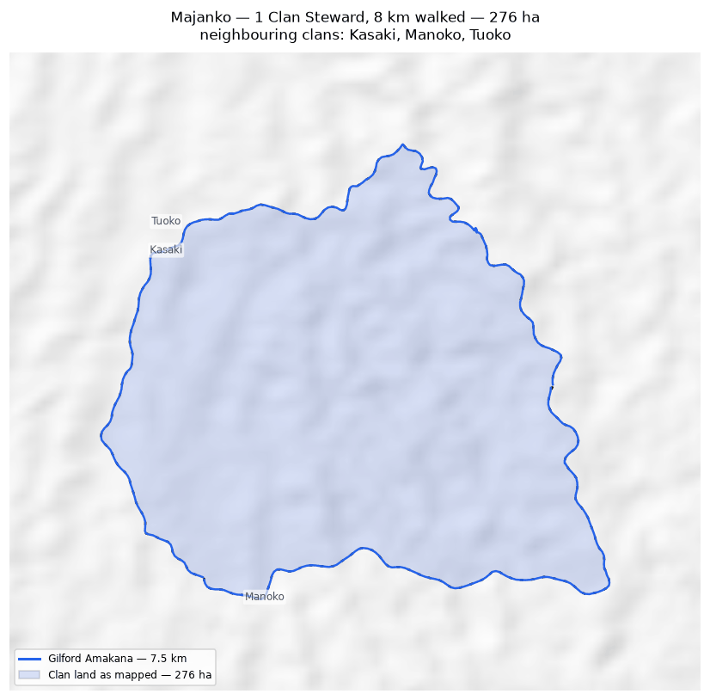
276 ha, measured from 7.5 km walked. Nothing in this boundary was inferred.

Murai (Z2)
Zone 2 · version 1.15, 12 October 2026
Clan Stewards | Walked (km) | Pieces | Parcels | Area (ha)
1 | 7.3 | 2 | 1 | 199
Clan Stewards
Clan Steward | Tracks | Days | First | Last | Walked (km)
Nehemiah Nindori | 32 | 6 | 2025-11-27 | 2026-02-17 | 7.3
Sacred sites
None recorded.
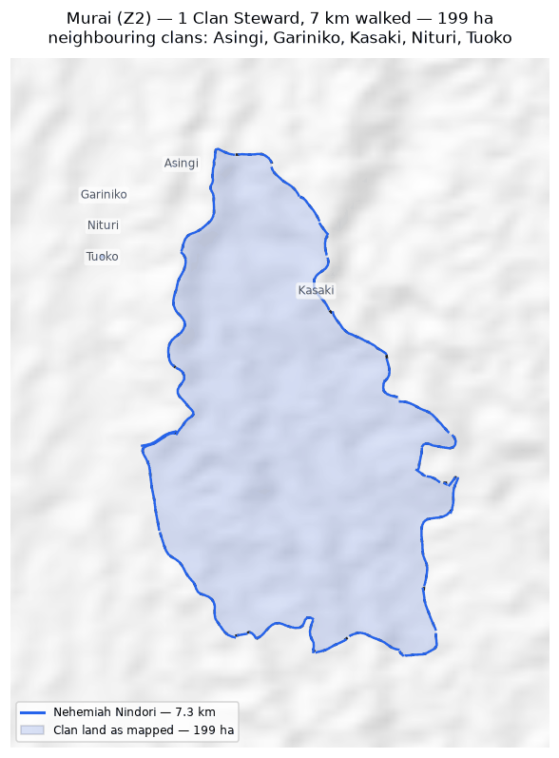
199 ha, measured from 7.3 km walked. Nothing in this boundary was inferred.

Asingi
Zone 2 · version 1.15, 12 October 2026
Clan Stewards | Walked (km) | Pieces | Parcels | Area (ha)
1 | 6.4 | 2 | 1 | 166
Clan Stewards
Clan Steward | Tracks | Days | First | Last | Walked (km)
Jethro Akse | 5 | 5 | 2025-02-18 | 2026-02-05 | 6.4
Sacred sites
None recorded.
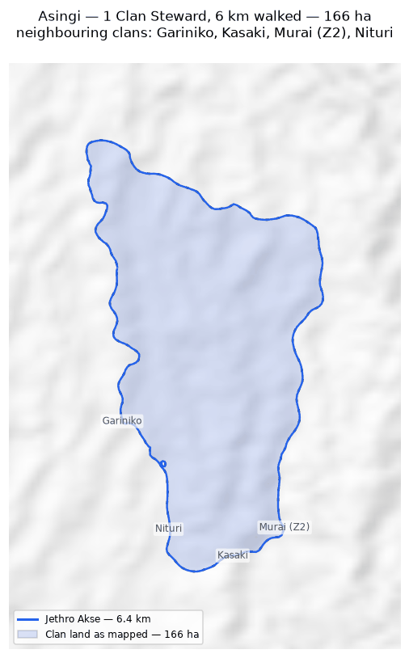
166 ha, measured from 6.4 km walked. Nothing in this boundary was inferred.

Natang
Zone 7B · version 1.15, 12 October 2026
Clan Stewards | Walked (km) | Pieces | Parcels | Area (ha)
2 | 77.3 | 2 | 1 | 49
Clan Stewards
Clan Steward | Tracks | Days | First | Last | Walked (km)
Stafford Gidiri | 2 | 1 | 2025-11-10 | 2025-11-10 | 46.5
Dickson Hoe | 4 | 3 | 2025-11-06 | 2026-02-16 | 30.8
Sacred sites
None recorded.
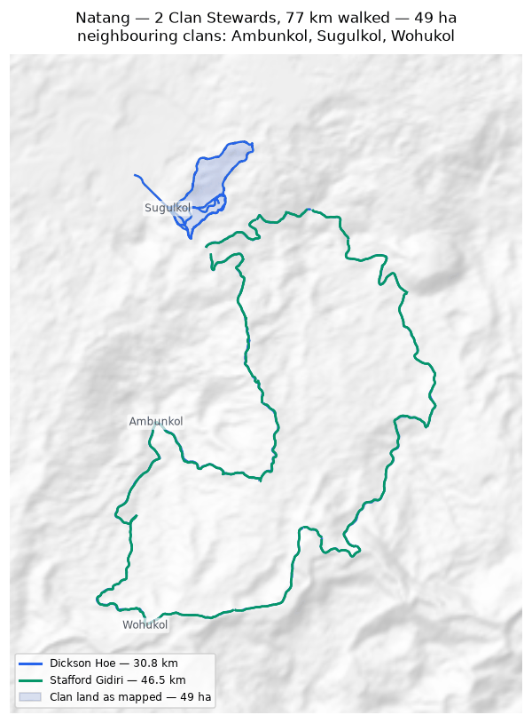
49 ha, measured from 77.3 km walked. Nothing in this boundary was inferred.

