Managalas Clan Land Mapping
Survey results, per-clan detail, and queries for the field
Version 1.1 · 16 August 2026
Clan land boundaries in the Managalas Conservation Area, Oro Province, Papua New Guinea. Mapped by Clan Stewards at the request of clan elders through the Clan Elder Workshops. Each community decides whether to map; where a boundary is disputed the community decides whether to resolve it or leave the area aside.
Sacred site locations are not shared. They are reported by area and share of clan land only, and appear in no map or layer in this document.
This document is regenerated from the survey data on each run. Every figure and every map in it comes from the same run, so the text and the maps cannot disagree. Quote it by version and date; a later version supersedes it entirely.
This version | Detail
Version | 1.1
Generated | 16 August 2026
Data through | 2026-08-13
Surveys included | 69
Code revision | 45bfd30

What changed in version 1.1
- Overlap between clans is now reported twice: strictly, and again with shared strips narrower than 100 m removed. Two lines recorded closer than that are the same line, not two claims. The allowance changes little, which is the point of making it.
- Where clans **agree** is reported for the first time: pairs whose recorded lines run within 100 m of each other. Deari and Nui share 94% of Deari's line and appear in no overlap figure at all.
- Corrected how disconnected pieces of a survey are joined into a ring. Taking a piece the wrong way round made the joining lines cross, enclosing two slivers instead of one block. Tuoko gains 394 ha, Bimkol gains an area it previously had none of, and every polygon is now geometrically valid.
- The straight lines nobody walked are drawn in pink on every map, written as their own layer, and reported per clan. They are not boundary.
- Every clan now has a map and its own page, with its neighbours and the ground they share drawn on it.
- Land held in more than one parcel is kept and counted; the parcel count appears on each clan's page.
- New document: **Managalas Walker Days** — who walked, on which days, and how far, from the GPS record rather than file names.
- Documents carry a version and date in the file name, on the title page and in the footer of every page. Earlier builds are never overwritten.
- Embedded maps keep their true proportions.
Figures move between versions because the method improves as well as because new surveys arrive. Where a correction changed a number materially, the change says so.

Contents

Right-click and choose “Update field” to build the contents list, or press Ctrl+A then F9.

1. What has been mapped
Measure | Value
Clans with data | 47
Custodians who walked | 67
Individual surveys | 69
Clan boundaries assessed (walkers joined) | 36
Days on the ground | 118
Walker-days recorded | 233
First and last walk recorded | 2025-02-18 to 2026-08-13
Distance walked | 1,112.9 km
Boundary walked (excl. access legs and non-boundary) | 924.5 km
Boundary distance excludes surveys that are not land boundaries, and the legs walked in to reach a boundary and out again. Who walked on which day, and how far, is a separate document: Managalas Walker Days.

Land area
Basis | Boundaries | Hectares
Walked and closed | 5 | 2,542
Closure inferred (gap bridged) | 31 | 30,566
Total mapped | 36 | 33,109
Footprint (overlaps counted once) |  | 28,032
Conservation area |  | 213,269
92% of the mapped area rests on an inferred closure — the boundary was not walked the whole way round and the gap has been bridged with a straight line. Those areas are estimates and are labelled as such throughout.

The straight lines are not boundary
169.7 km of the outlines in this document was never walked — 26% of the 652.9 km of outline drawn around the mapped areas. These are the long straight lines that cut across the landscape on the maps. They are not where anyone said a boundary runs: they mark where a receiver was switched off at the end of one walk and switched on again somewhere else, and the straight line between is this pipeline joining the pieces up so an area can be given at all.
They are drawn in pink on every map, apart from the walked line, so they can never be mistaken for a surveyed edge. Where a clan's outline carries a long straight line, the area behind it is a guess across that gap, and the query on that clan's page asks for the missing stretch to be walked.
Which order the recorded pieces are joined in, and which way round each piece is taken, changes the result substantially. Taking a piece the wrong way round makes the joining lines cross, and a crossed outline encloses two slivers where the real walk encloses one block — Tuoko lost 394 ha to exactly that before it was corrected. The pieces are now ordered and oriented to make the joining as short as possible, which leaves no crossings.
The mapped footprint is 13.1% of the conservation area.

Land held in more than one piece
A clan's land does not have to be one block. Where a clan's walks enclose several separate parcels, all of them are kept and all of them are counted — the mapped area is the sum, and the map shows each piece. 10 of 35 mapped clans hold land in more than one parcel on the evidence so far.
Clan | Parcels | Total area (ha)
Abuankol | 2 | 1
Ambunkol | 3 | 592
Borori | 2 | 639
Giroiko | 4 | 10
Jariji | 2 | 696
Madukol | 2 | 1
Manuvoora | 3 | 828
Natang | 2 | 1,533
Nituri | 2 | 5,275
Wohukol | 3 | 701
Only parcels of at least 2% of the clan's largest are kept. Below that a loop is a track crossing itself rather than a separate holding. If a clan knows of a parcel that is missing here, that is a survey to add, not a limit of the method.

By zone
Zone | Clans | Custodians | Surveys | Walked (km) | Boundary (km) | Area (ha)
Zone 2 | 15 | 18 | 20 | 320.5 | 257.4 | 18,907
Zone 3 | 4 | 8 | 8 | 48.7 | 42.0 | 10
Zone 6 | 5 | 7 | 7 | 151.6 | 125.9 | 3,089
Zone 7A | 3 | 6 | 6 | 73.7 | 53.9 | 1,385
Zone 7B | 12 | 18 | 18 | 282.3 | 230.6 | 6,693
Zone 8 | 8 | 10 | 10 | 236.1 | 214.8 | 3,026

Overlap between clans
This is the finding with the widest implications. The PNG Incorporated Land Group system rests on land being held by a single clan, undisputed. On this evidence that assumption does not describe the Managalas.

Two readings: strict, and beyond a 100 m tolerance
Overlap is reported twice. The strict figure counts every square metre two clans both claim, and is the exact measurement. The second figure removes any strip of shared ground narrower than 100 m: where two recorded lines run closer together than that, the ground between them is not a competing claim but the ordinary imprecision of the work — GPS fixes landing ten metres apart, canopy pushing them further, and a boundary followed on foot wandering around the terrain. 100 m is inconsequential here.
Measure | Strict | Beyond 100 m
Clans with a mapped area | 35 | 35
Clans whose land overlaps another clan's | 32 | 27
Clans with no overlap | 3 | 8
Pairs of clans sharing ground | 54 | 34
Area claimed by more than one clan (ha) | 4,712 | 4,649
— as a share of the mapped footprint | 17% | 17%
The tolerance changes very little: 63 ha of the 4,712 ha falls away, and 5 clan(s) drop out of the overlapping group. 20 of the 54 pairs turn out to be two clans describing the same line rather than claiming the same ground. The finding survives the allowance — which is the point of making it.
Read with care: most boundaries rest on inferred closures, so some overlap is an artefact of straight-line bridging rather than a competing claim. It does not disappear when only walked boundaries are counted, but the headline share is inflated by the inferred ones.
Overlaps are recorded as mapped. They are not reconciled, and clans are never merged.
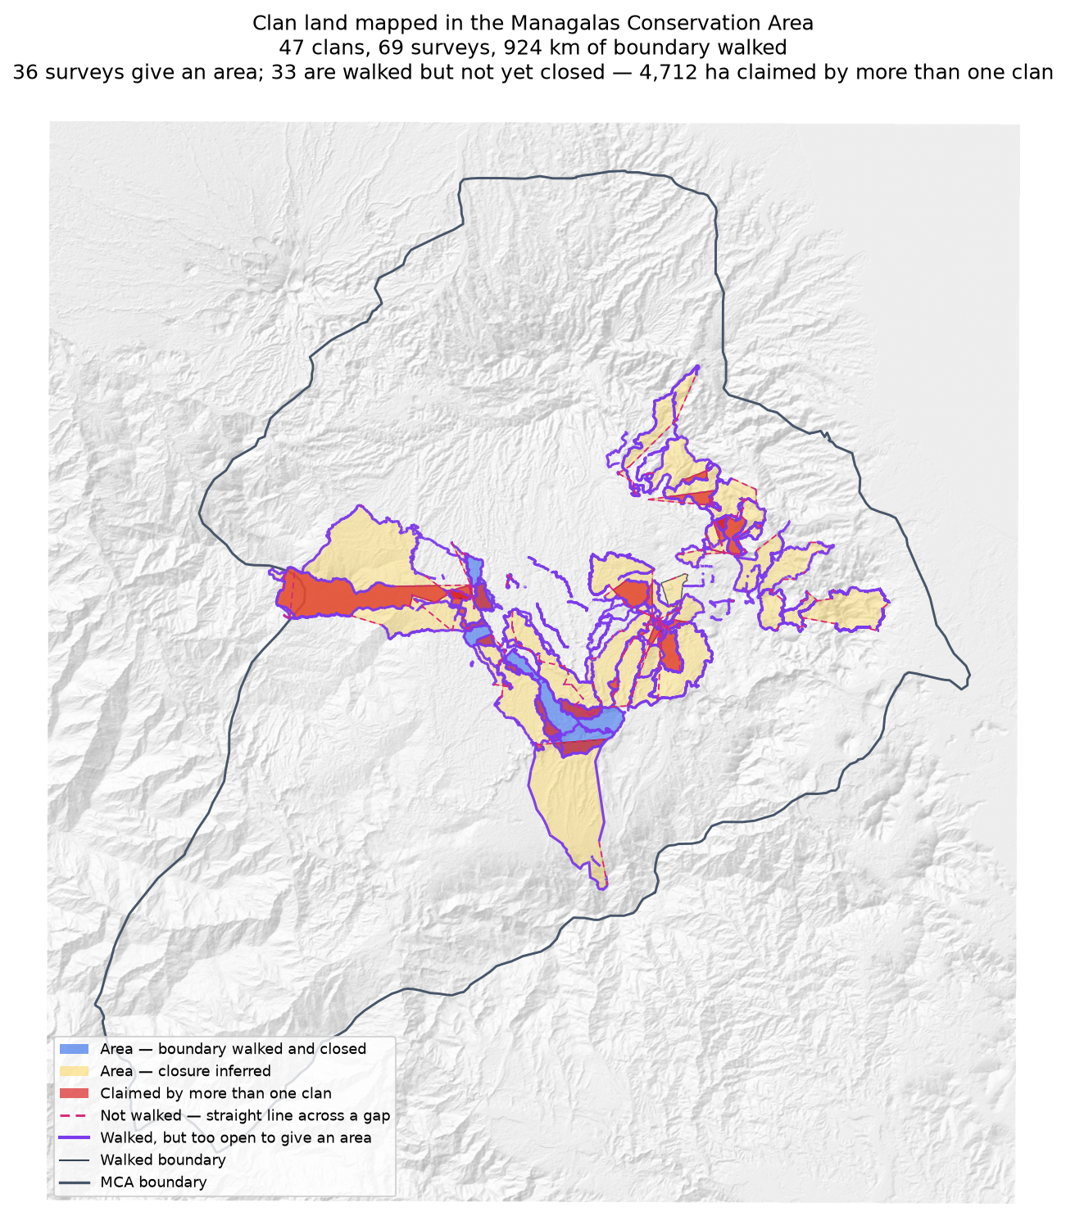
Blue: boundary walked and closed. Amber: closure inferred. Red: claimed by more than one clan. Purple: walked but too open to give an area.

Where clans agree
The mirror image of the overlap figures, and just as important. 112 pairs of clans have recorded lines that run within 100 m of each other — they walked the same edge. That is agreement on a boundary, and it does not show up in an overlap table at all. Some of the pairs below share almost their whole recorded line while enclosing no contested ground whatsoever.
Clan | Clan | Shared line (km) | % of the first's line | % of the second's
Ambunkol | Natang | 20.3 | 59.2% | 37.6%
Deari | Nui | 15.0 | 94.2% | 64.0%
Nituri | Tuoko | 14.4 | 24.0% | 30.2%
Borori | Darekikol | 13.9 | 32.0% | 48.4%
Rondi | Rumbi | 10.5 | 17.7% | 33.5%
Gumuri | Rondi | 9.2 | 63.0% | 15.5%
Natang | Wohukol | 8.8 | 16.0% | 25.1%
Jariji | Wohukol | 8.6 | 35.6% | 24.6%
Borori | Mariura | 8.4 | 25.7% | 20.5%
Rumbi | Sukandi | 8.0 | 49.8% | 20.2%
Mariura | Naharaura | 7.9 | 49.8% | 28.3%
Mungaikol | Uremkol | 7.6 | 51.2% | 67.2%
Rondi | Sukandi | 7.0 | 11.8% | 8.7%
Manuvoora | Pina Ora | 7.0 | 11.3% | 19.0%
Ambunkol | Sugulkol | 5.9 | 15.1% | 24.4%
Read alongside the overlap table. A pair appearing here and not there has agreed a boundary; a pair appearing in both has agreed part of one and disputes the rest.

Sacred sites
Reported by area and share of clan land only; locations are not shared. Three sites across two mapped units, covering an estimated 313–456 ha, being 16–24% of the host clan's land. The range reflects that neither walk closed, so the area can only be bracketed.

2. How to read the clan entries
Each clan starts on a new page, so a single clan's pages can be taken out and discussed with that clan without the rest of the document going with them.
Each clan is assessed as one boundary within one zone. Where several custodians walked, their tracks are joined into a single survey — walkers of one clan are joined; different clans never are.
Term | Meaning
Walked | Distance recorded, after smoothing
Access legs | Dead-end walks in to the boundary and back out; excluded from boundary distance
Pieces | Disconnected runs of track; one means a single continuous boundary
Parcels | Separate blocks of land the walks enclose; more than one is normal
Not walked | Straight line joining the pieces into a ring — nobody walked it, and it is not boundary
Walked and closed | The tracks ring the land; area is measured, not assumed
Inferred | Open ends bridged with straight lines; area is an estimate
No area | Gap exceeds half the distance walked — too open to estimate honestly
Overlap (strict) | Every square metre two clans both claim
Overlap (beyond tolerance) | The same, with strips narrower than 100 m removed
Shared line | Where this clan's line runs within 100 m of another clan's
A clan name that appears in more than one zone carries a zone code, for example Murai (Z2) and Murai (Z7B). This is expected — language spreads between zones and clans that split may keep an ancestral name — but the two are not the same landholding group and their land is never combined.

Reading the map on each clan's page
- Each custodian's walk is a solid coloured line, and the area that walk gives on its own is the matching dashed outline.
- The survey those walks combine into is a dotted black outline, drawn underneath the walkers' lines. Where it follows a walk you see the walker's colour; where it strikes out on its own, that stretch was not walked by anyone — it is the straight line bridging a gap.
- Pink dashes are the stretches nobody walked: the receiver was off, and the straight line is this pipeline joining the pieces up. Do not read them as boundary.
- Neighbouring clans' mapped land is pale grey and labelled. Ground both clans claim is shaded red.
- Where a clan's walk does not close, and so has no area to compare, any other clan's line running alongside it is drawn in grey instead — that is the most useful context such a map can carry.

3. Clans
47 clan boundaries, in zone order. Each begins on its own page.

Zone 2

Asingi
Zone 2 · version 1.1, 16 August 2026
Walkers | Surveys | Walked (km) | Access legs (km) | Pieces | Not walked (km) | Parcels | Area (ha) | Basis
1 | 1 | 6.4 | 0.0 | 2 | — | 1 | 166 | surveyed
Custodians
Custodian | Tracks | Days | First | Last | Walked (km)
Jethro Akse | 5 | 5 | 2025-02-18 | 2026-02-05 | 6.4
Ground also claimed by another clan
Clan | Shared (ha) | % of this clan | Beyond 100 m (ha) | Verdict
Murai (Z2) | 6 | 3.6% | 5 | overlap
Gariniko | 4 | 2.5% | 3 | overlap
Kasaki | 0 | 0.0% | 0 | within tolerance
Boundary walked alongside another clan
Clan | Shared line (km) | % of this clan's line
Gariniko | 3.5 | 52.4%
Murai (Z2) | 0.6 | 9.6%
Kasaki | 0.6 | 8.0%
Bujevi | 0.4 | 6.7%
Tuoko | 0.3 | 3.6%
Nituri | 0.6 | 3.5%
Zambiko | 0.4 | 3.5%
Problems
- The boundary closes on its own. 166 ha is measured from the walk, with nothing inferred.
- Overlaps 2 other clans by more than the 100 m tolerance: Murai (Z2) (6 ha, 4% of this clan's land); Gariniko (4 ha, 3% of this clan's land).
- A further 1 clan (Kasaki) share ground only in strips narrower than 100 m. That is the two lines being the same line, not a competing claim, and it is not counted as overlap.
Queries for the field
- Is the ground shared with Murai (Z2), Gariniko disputed, shared by agreement, or recorded wrongly? No change will be made to either boundary without the community's decision.
- 52% of this clan's line runs alongside Gariniko's. Is that a boundary the two clans share and agree on?
Map
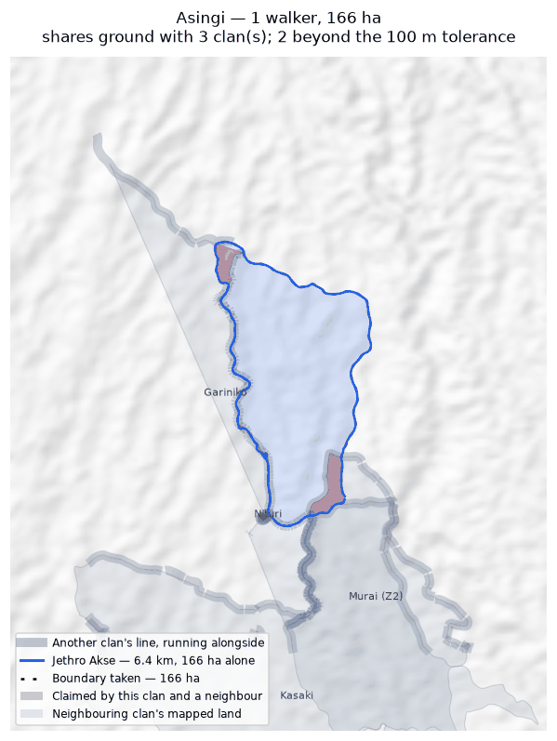
The walk, the area it gives (dotted), the stretches nobody walked in pink; neighbouring clans in grey, ground both claim in red.

Asoro
Zone 2 · version 1.1, 16 August 2026
Walkers | Surveys | Walked (km) | Access legs (km) | Pieces | Not walked (km) | Parcels | Area (ha) | Basis
1 | 1 | 22.8 | 3.5 | 2 | 8.0 | 1 | 3,507 | inferred
Custodians
Custodian | Tracks | Days | First | Last | Walked (km)
Gilford Amakana | 10 | 3 | 2026-01-29 | 2026-01-31 | 22.8
Ground also claimed by another clan
Clan | Shared (ha) | % of this clan | Beyond 100 m (ha) | Verdict
Sukandi | 232 | 6.6% | 231 | overlap
Juaiko | 15 | 0.4% | 15 | overlap
Boundary walked alongside another clan
Clan | Shared line (km) | % of this clan's line
Sukandi | 0.8 | 3.2%
Juaiko | 0.7 | 1.2%
Zambiko | 0.1 | 0.2%
Problems
- The boundary does not close. 8.0 km in 2 stretches was bridged with straight lines nobody walked — 38% of the distance walked, so 3,507 ha is an estimate rather than a measured area. On the map those stretches are pink.
- Overlaps 2 other clans by more than the 100 m tolerance: Sukandi (232 ha, 7% of this clan's land); Juaiko (15 ha, 0% of this clan's land).
Queries for the field
- 38% of this outline was not walked — 8.0 km of straight line, shown in pink. Does the boundary in fact run along those straight lines, or somewhere else? Can the missing stretches be walked?
- Is the ground shared with Sukandi, Juaiko disputed, shared by agreement, or recorded wrongly? No change will be made to either boundary without the community's decision.
Map
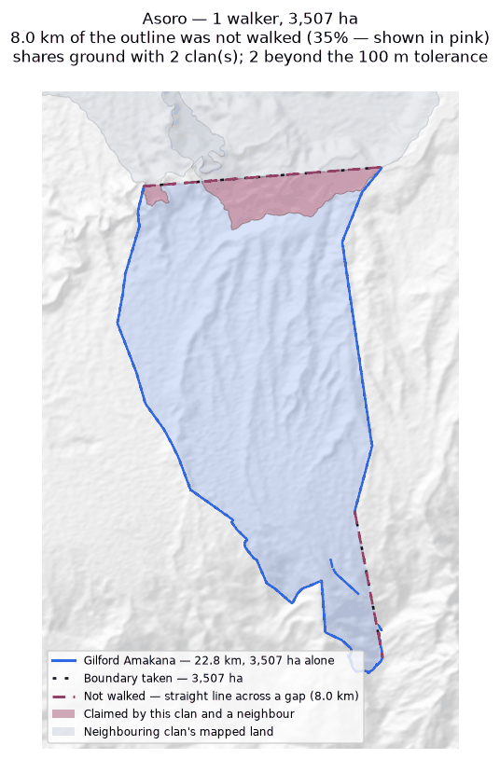
The walk, the area it gives (dotted), the stretches nobody walked in pink; neighbouring clans in grey, ground both claim in red.

Bujevi
Zone 2 · version 1.1, 16 August 2026
Walkers | Surveys | Walked (km) | Access legs (km) | Pieces | Not walked (km) | Parcels | Area (ha) | Basis
1 | 1 | 5.8 | 1.1 | 1 | 4.5 | — | none | no area
Custodians
Custodian | Tracks | Days | First | Last | Walked (km)
Abel Kajari | 2 | 2 | 2026-02-08 | 2026-02-09 | 5.8
Boundary walked alongside another clan
Clan | Shared line (km) | % of this clan's line
Nituri | 0.9 | 10.4%
Gariniko | 0.5 | 6.3%
Asingi | 0.4 | 4.9%
Problems
- No area can be given. The tracks are in 1 disconnected piece and 4.5 km of straight-line joining would be needed to make a ring — 84% of the distance walked. That is beyond the 50% limit, above which an area would be more assumption than survey.
- No overlapping area, but 10% of this clan's recorded line runs within 100 m of Nituri's. The two describe the same edge on the ground.
Queries for the field
- Can the missing stretches be walked so this boundary closes? If any gap is deliberate — a river, a road, an agreed open edge — please say what runs along it.
Map
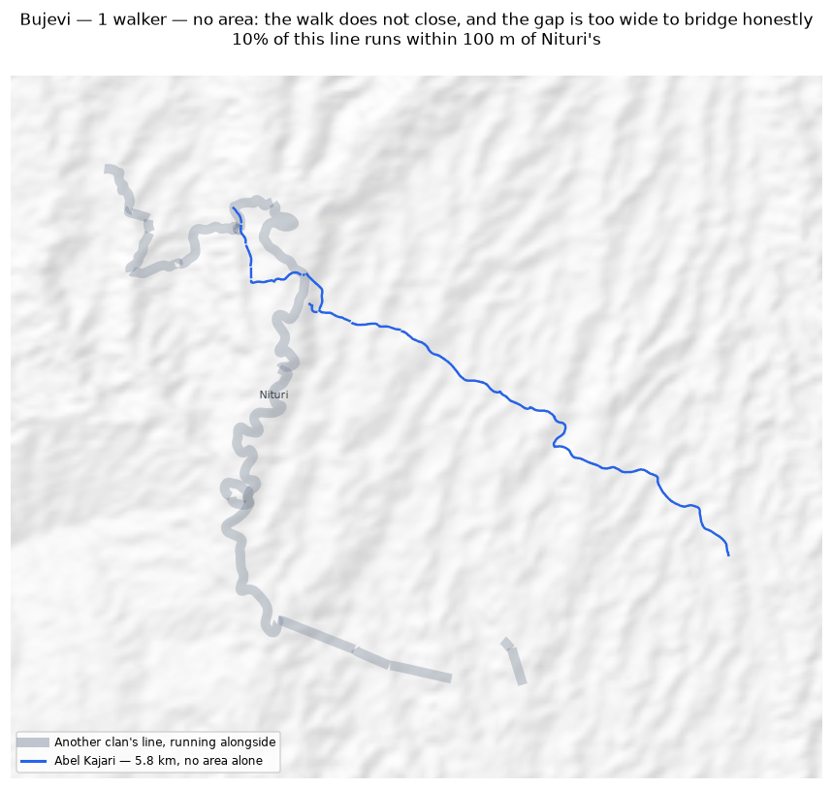
The walk, the area it gives (dotted), the stretches nobody walked in pink; neighbouring clans in grey, ground both claim in red.

Gariniko
Zone 2 · version 1.1, 16 August 2026
Walkers | Surveys | Walked (km) | Access legs (km) | Pieces | Not walked (km) | Parcels | Area (ha) | Basis
1 | 1 | 10.1 | 1.5 | 4 | 4.8 | 1 | 107 | inferred
Custodians
Custodian | Tracks | Days | First | Last | Walked (km)
Lance Sake | 6 | 3 | 2025-11-28 | 2026-02-07 | 10.1
Ground also claimed by another clan
Clan | Shared (ha) | % of this clan | Beyond 100 m (ha) | Verdict
Tuoko | 7 | 6.2% | 5 | overlap
Asingi | 4 | 3.9% | 3 | overlap
Nituri | 3 | 3.1% | 2 | overlap
Kasaki | 2 | 1.8% | 0 | within tolerance
Murai (Z2) | 1 | 0.5% | 0 | within tolerance
Boundary walked alongside another clan
Clan | Shared line (km) | % of this clan's line
Asingi | 3.5 | 58.5%
Murai (Z2) | 1.8 | 30.6%
Kasaki | 1.4 | 22.6%
Tuoko | 0.6 | 10.2%
Nituri | 0.6 | 8.7%
Zambiko | 0.5 | 8.7%
Bujevi | 0.5 | 7.6%
Problems
- The boundary does not close. 4.8 km in 4 stretches was bridged with straight lines nobody walked — 50% of the distance walked, so 107 ha is an estimate rather than a measured area. On the map those stretches are pink.
- Overlaps 3 other clans by more than the 100 m tolerance: Tuoko (7 ha, 6% of this clan's land); Asingi (4 ha, 4% of this clan's land); Nituri (3 ha, 3% of this clan's land).
- A further 2 clans (Kasaki, Murai (Z2)) share ground only in strips narrower than 100 m. That is the two lines being the same line, not a competing claim, and it is not counted as overlap.
Queries for the field
- 50% of this outline was not walked — 4.8 km of straight line, shown in pink. Does the boundary in fact run along those straight lines, or somewhere else? Can the missing stretches be walked?
- Is the ground shared with Tuoko, Asingi, Nituri disputed, shared by agreement, or recorded wrongly? No change will be made to either boundary without the community's decision.
- 59% of this clan's line runs alongside Asingi's. Is that a boundary the two clans share and agree on?
- This boundary is recorded in 4 separate pieces. Were the connecting stretches walked but not recorded, or not yet walked?
Map
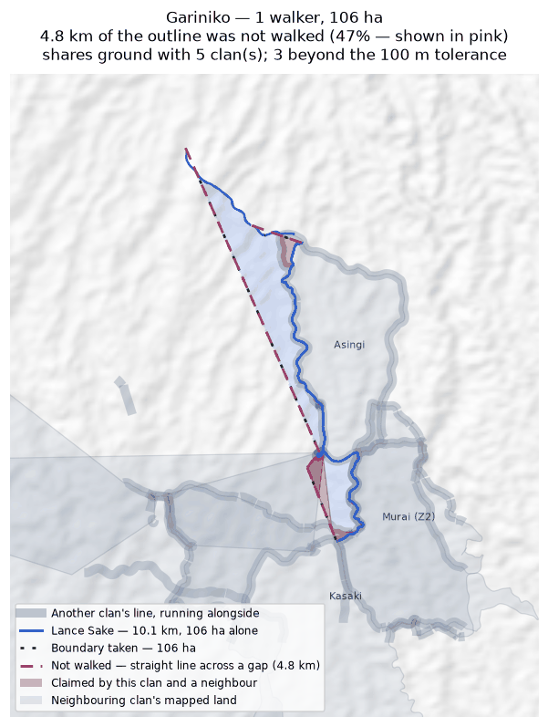
The walk, the area it gives (dotted), the stretches nobody walked in pink; neighbouring clans in grey, ground both claim in red.

Juaiko
Zone 2 · version 1.1, 16 August 2026
Walkers | Surveys | Walked (km) | Access legs (km) | Pieces | Not walked (km) | Parcels | Area (ha) | Basis
1 | 1 | 24.3 | 5.8 | 7 | 1.9 | 1 | 1,293 | inferred
Custodians
Custodian | Tracks | Days | First | Last | Walked (km)
Gasper K Philip J | 10 | 5 | 2025-04-22 | 2025-04-28 | 24.3
Ground also claimed by another clan
Clan | Shared (ha) | % of this clan | Beyond 100 m (ha) | Verdict
Sukandi | 205 | 15.8% | 202 | overlap
Asoro | 15 | 1.2% | 15 | overlap
Manoko | 12 | 0.9% | 7 | overlap
Boundary walked alongside another clan
Clan | Shared line (km) | % of this clan's line
Manoko | 4.9 | 20.3%
Sukandi | 4.2 | 17.3%
Zambiko | 2.6 | 10.6%
Rumbi | 2.1 | 8.6%
Asoro | 0.7 | 2.7%
Problems
- The boundary does not close. 1.9 km in 7 stretches was bridged with straight lines nobody walked — 9% of the distance walked, so 1,293 ha is an estimate rather than a measured area. On the map those stretches are pink.
- Overlaps 3 other clans by more than the 100 m tolerance: Sukandi (205 ha, 16% of this clan's land); Asoro (15 ha, 1% of this clan's land); Manoko (12 ha, 1% of this clan's land).
Queries for the field
- Is the ground shared with Sukandi, Asoro, Manoko disputed, shared by agreement, or recorded wrongly? No change will be made to either boundary without the community's decision.
- This boundary is recorded in 7 separate pieces. Were the connecting stretches walked but not recorded, or not yet walked?
Map
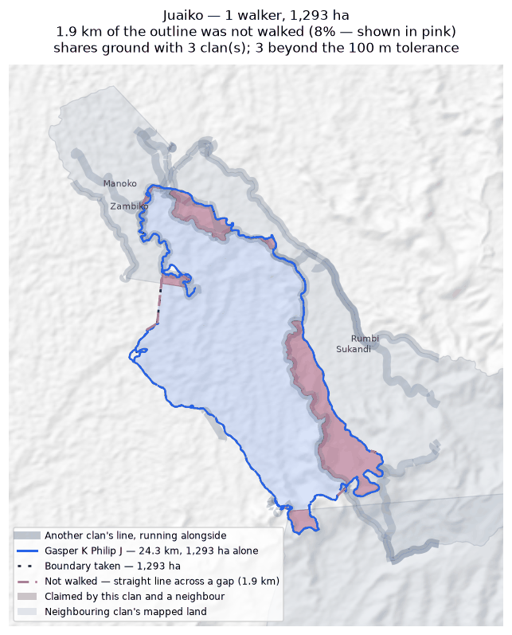
The walk, the area it gives (dotted), the stretches nobody walked in pink; neighbouring clans in grey, ground both claim in red.

Kasaki
Zone 2 · version 1.1, 16 August 2026
Walkers | Surveys | Walked (km) | Access legs (km) | Pieces | Not walked (km) | Parcels | Area (ha) | Basis
1 | 1 | 15.1 | 3.1 | 4 | 1.3 | 1 | 541 | inferred
Custodians
Custodian | Tracks | Days | First | Last | Walked (km)
Ananias Masua | 1 | 1 | 2026-02-05 | 2026-02-05 | 15.1
Ground also claimed by another clan
Clan | Shared (ha) | % of this clan | Beyond 100 m (ha) | Verdict
Tuoko | 157 | 29.0% | 155 | overlap
Murai (Z2) | 154 | 28.5% | 154 | overlap
Nituri | 59 | 11.0% | 59 | overlap
Majanko | 40 | 7.4% | 39 | overlap
Gariniko | 2 | 0.3% | 0 | within tolerance
Asingi | 0 | 0.0% | 0 | within tolerance
Boundary walked alongside another clan
Clan | Shared line (km) | % of this clan's line
Murai (Z2) | 3.4 | 21.2%
Tuoko | 1.5 | 9.6%
Majanko | 1.2 | 7.8%
Gariniko | 1.4 | 7.7%
Nituri | 1.1 | 5.7%
Asingi | 0.6 | 3.6%
Problems
- The boundary does not close. 1.3 km in 4 stretches was bridged with straight lines nobody walked — 10% of the distance walked, so 541 ha is an estimate rather than a measured area. On the map those stretches are pink.
- Overlaps 4 other clans by more than the 100 m tolerance: Tuoko (157 ha, 29% of this clan's land); Murai (Z2) (154 ha, 29% of this clan's land); Nituri (59 ha, 11% of this clan's land); Majanko (40 ha, 7% of this clan's land).
- A further 2 clans (Gariniko, Asingi) share ground only in strips narrower than 100 m. That is the two lines being the same line, not a competing claim, and it is not counted as overlap.
Queries for the field
- Is the ground shared with Tuoko, Murai (Z2), Nituri disputed, shared by agreement, or recorded wrongly? No change will be made to either boundary without the community's decision.
- This boundary is recorded in 4 separate pieces. Were the connecting stretches walked but not recorded, or not yet walked?
Map
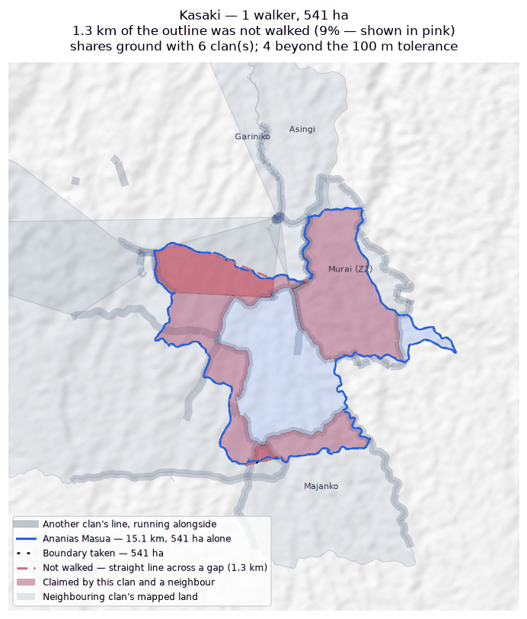
The walk, the area it gives (dotted), the stretches nobody walked in pink; neighbouring clans in grey, ground both claim in red.

Majanko
Zone 2 · version 1.1, 16 August 2026
Walkers | Surveys | Walked (km) | Access legs (km) | Pieces | Not walked (km) | Parcels | Area (ha) | Basis
1 | 1 | 7.5 | 0.0 | 1 | — | 1 | 276 | surveyed
Custodians
Custodian | Tracks | Days | First | Last | Walked (km)
Gilford Amakana | 4 | 1 | 2026-02-26 | 2026-02-26 | 7.5
Ground also claimed by another clan
Clan | Shared (ha) | % of this clan | Beyond 100 m (ha) | Verdict
Manoko | 65 | 23.6% | 65 | overlap
Kasaki | 40 | 14.5% | 39 | overlap
Tuoko | 13 | 4.5% | 12 | overlap
Boundary walked alongside another clan
Clan | Shared line (km) | % of this clan's line
Manoko | 1.6 | 20.7%
Kasaki | 1.2 | 16.4%
Zambiko | 0.6 | 8.5%
Tuoko | 0.5 | 6.3%
Problems
- The boundary closes on its own. 276 ha is measured from the walk, with nothing inferred.
- Overlaps 3 other clans by more than the 100 m tolerance: Manoko (65 ha, 24% of this clan's land); Kasaki (40 ha, 15% of this clan's land); Tuoko (13 ha, 5% of this clan's land).
Queries for the field
- Is the ground shared with Manoko, Kasaki, Tuoko disputed, shared by agreement, or recorded wrongly? No change will be made to either boundary without the community's decision.
Map
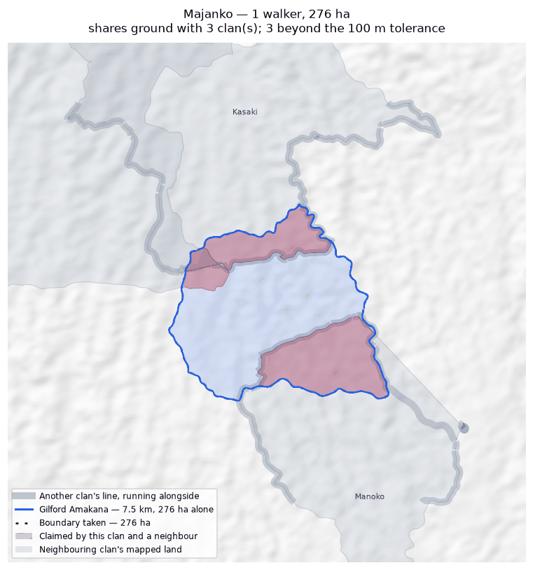
The walk, the area it gives (dotted), the stretches nobody walked in pink; neighbouring clans in grey, ground both claim in red.

Manoko
Zone 2 · version 1.1, 16 August 2026
Walkers | Surveys | Walked (km) | Access legs (km) | Pieces | Not walked (km) | Parcels | Area (ha) | Basis
1 | 1 | 12.2 | 1.8 | 3 | 3.9 | 1 | 404 | inferred
Custodians
Custodian | Tracks | Days | First | Last | Walked (km)
Gilford Amakana | 7 | 3 | 2025-08-31 | 2026-02-14 | 12.2
Ground also claimed by another clan
Clan | Shared (ha) | % of this clan | Beyond 100 m (ha) | Verdict
Majanko | 65 | 16.1% | 65 | overlap
Juaiko | 12 | 2.9% | 7 | overlap
Boundary walked alongside another clan
Clan | Shared line (km) | % of this clan's line
Juaiko | 4.9 | 35.2%
Majanko | 1.6 | 13.0%
Zambiko | 1.1 | 9.2%
Rumbi | 0.8 | 5.4%
Tuoko | 0.5 | 4.3%
Sukandi | 0.2 | 2.0%
Problems
- The boundary does not close. 3.9 km in 3 stretches was bridged with straight lines nobody walked — 32% of the distance walked, so 404 ha is an estimate rather than a measured area. On the map those stretches are pink.
- Overlaps 2 other clans by more than the 100 m tolerance: Majanko (65 ha, 16% of this clan's land); Juaiko (12 ha, 3% of this clan's land).
Queries for the field
- 32% of this outline was not walked — 3.9 km of straight line, shown in pink. Does the boundary in fact run along those straight lines, or somewhere else? Can the missing stretches be walked?
- Is the ground shared with Majanko, Juaiko disputed, shared by agreement, or recorded wrongly? No change will be made to either boundary without the community's decision.
Map
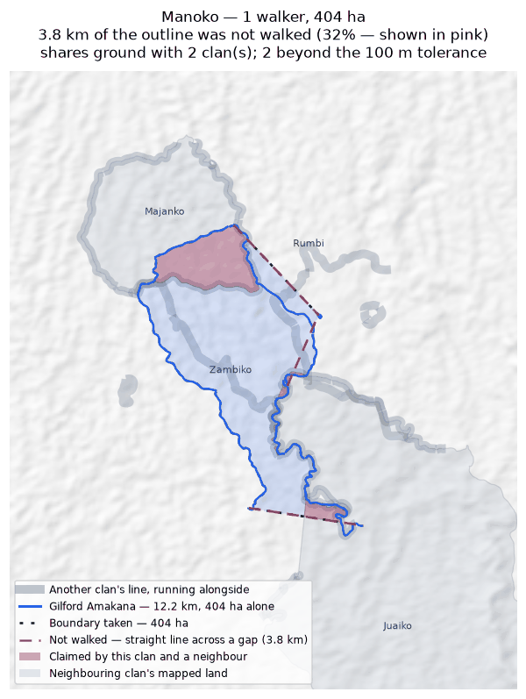
The walk, the area it gives (dotted), the stretches nobody walked in pink; neighbouring clans in grey, ground both claim in red.

Murai (Z2)
Zone 2 · version 1.1, 16 August 2026
Walkers | Surveys | Walked (km) | Access legs (km) | Pieces | Not walked (km) | Parcels | Area (ha) | Basis
1 | 1 | 7.3 | 0.2 | 2 | — | 1 | 199 | surveyed
Custodians
Custodian | Tracks | Days | First | Last | Walked (km)
Nehemiah Nindori | 32 | 6 | 2025-11-27 | 2026-02-17 | 7.3
Ground also claimed by another clan
Clan | Shared (ha) | % of this clan | Beyond 100 m (ha) | Verdict
Kasaki | 154 | 77.6% | 154 | overlap
Asingi | 6 | 3.0% | 5 | overlap
Gariniko | 1 | 0.3% | 0 | within tolerance
Boundary walked alongside another clan
Clan | Shared line (km) | % of this clan's line
Kasaki | 3.4 | 46.4%
Gariniko | 1.8 | 20.9%
Tuoko | 1.0 | 10.8%
Asingi | 0.6 | 7.7%
Nituri | 0.6 | 0.4%
Zambiko | 0.4 | 0.4%
Problems
- The boundary closes on its own. 199 ha is measured from the walk, with nothing inferred.
- Overlaps 2 other clans by more than the 100 m tolerance: Kasaki (154 ha, 78% of this clan's land); Asingi (6 ha, 3% of this clan's land).
- A further 1 clan (Gariniko) share ground only in strips narrower than 100 m. That is the two lines being the same line, not a competing claim, and it is not counted as overlap.
Queries for the field
- Is the ground shared with Kasaki, Asingi disputed, shared by agreement, or recorded wrongly? No change will be made to either boundary without the community's decision.
Map
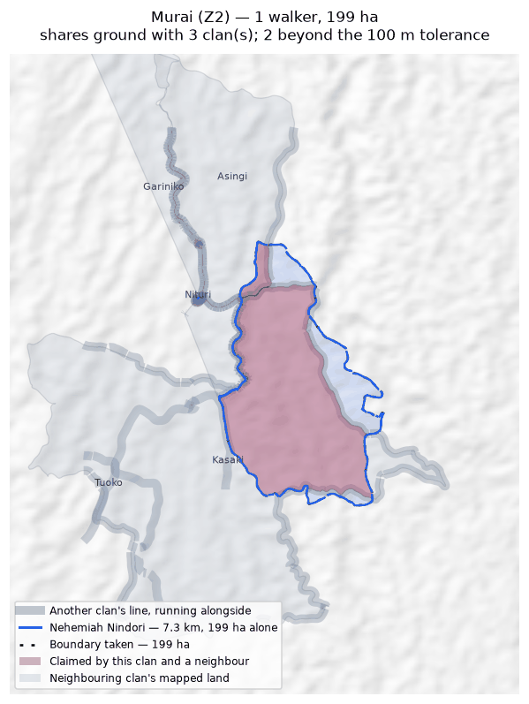
The walk, the area it gives (dotted), the stretches nobody walked in pink; neighbouring clans in grey, ground both claim in red.

Nituri
Zone 2 · version 1.1, 16 August 2026
Walkers | Surveys | Walked (km) | Access legs (km) | Pieces | Not walked (km) | Parcels | Area (ha) | Basis
3 | 3 | 41.8 | 10.5 | 14 | 11.1 | 2 | 5,275 | inferred
Custodians
Custodian | Tracks | Days | First | Last | Walked (km)
Graham Naopi | 7 | 3 | 2025-11-27 | 2026-02-09 | 18.7
Christoper Visua | 19 | 7 | 2025-05-11 | 2026-02-11 | 17.8
Newton Muraba | 13 | 6 | 2025-11-27 | 2026-02-16 | 5.3
Ground also claimed by another clan
Clan | Shared (ha) | % of this clan | Beyond 100 m (ha) | Verdict
Tuoko | 2,199 | 41.7% | 2,198 | overlap
Kasaki | 59 | 1.1% | 59 | overlap
Gariniko | 3 | 0.1% | 2 | overlap
Boundary walked alongside another clan
Clan | Shared line (km) | % of this clan's line
Tuoko | 14.4 | 24.0%
Kasaki | 1.1 | 2.7%
Bujevi | 0.9 | 2.1%
Gariniko | 0.6 | 1.5%
Zambiko | 0.6 | 1.5%
Murai (Z2) | 0.6 | 1.5%
Asingi | 0.6 | 1.5%
Problems
- The boundary does not close. 11.1 km in 14 stretches was bridged with straight lines nobody walked — 29% of the distance walked, so 5,275 ha is an estimate rather than a measured area. On the map those stretches are pink.
- The walks enclose 2 separate parcels, totalling 5,275 ha. All of them are counted. Whether they are all this clan's land, or whether one belongs to a neighbour, is a question for the clan.
- Joining the 3 walkers adds 5,275 ha: separately 0 ha, joined 5,275 ha. The walkers covered different stretches of one boundary.
- Overlaps 3 other clans by more than the 100 m tolerance: Tuoko (2,199 ha, 42% of this clan's land); Kasaki (59 ha, 1% of this clan's land); Gariniko (3 ha, 0% of this clan's land).
Queries for the field
- 29% of this outline was not walked — 11.1 km of straight line, shown in pink. Does the boundary in fact run along those straight lines, or somewhere else? Can the missing stretches be walked?
- This clan's land is recorded as 2 separate pieces. Is that right, and does each piece belong to this clan?
- Is the ground shared with Tuoko, Kasaki, Gariniko disputed, shared by agreement, or recorded wrongly? No change will be made to either boundary without the community's decision.
- This boundary is recorded in 14 separate pieces. Were the connecting stretches walked but not recorded, or not yet walked?
Map
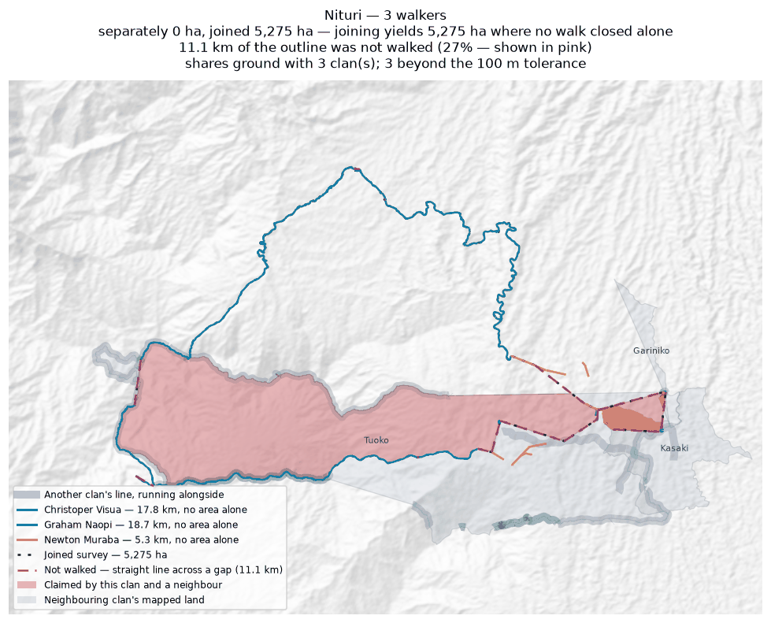
Each walker's line and the area it gives alone (dashed); the survey they combine into, dotted; the stretches nobody walked in pink; neighbouring clans in grey, ground both claim in red.

Rondi
Zone 2 · version 1.1, 16 August 2026
Walkers | Surveys | Walked (km) | Access legs (km) | Pieces | Not walked (km) | Parcels | Area (ha) | Basis
2 | 2 | 59.0 | 0.4 | 14 | 12.4 | 1 | 1,563 | inferred
Custodians
Custodian | Tracks | Days | First | Last | Walked (km)
Jefferson Amunisa | 28 | 5 | 2025-04-25 | 2025-04-29 | 29.7
Humphrey Poto | 29 | 5 | 2025-04-25 | 2025-04-29 | 29.3
Ground also claimed by another clan
Clan | Shared (ha) | % of this clan | Beyond 100 m (ha) | Verdict
Sukandi | 212 | 13.5% | 211 | overlap
Binunkol | 1 | 0.0% | 0 | within tolerance
Boundary walked alongside another clan
Clan | Shared line (km) | % of this clan's line
Rumbi | 10.5 | 17.7%
Gumuri | 9.2 | 15.5%
Sukandi | 7.0 | 11.8%
Binunkol | 3.8 | 6.5%
Deari | 0.4 | 0.6%
Nui | 0.4 | 0.6%
Problems
- The boundary does not close. 12.4 km in 14 stretches was bridged with straight lines nobody walked — 21% of the distance walked, so 1,563 ha is an estimate rather than a measured area. On the map those stretches are pink.
- Joining the 2 walkers adds 307 ha: separately 1,256 ha, joined 1,563 ha. The walkers covered different stretches of one boundary.
- Overlaps 1 other clan by more than the 100 m tolerance: Sukandi (212 ha, 14% of this clan's land).
- A further 1 clan (Binunkol) share ground only in strips narrower than 100 m. That is the two lines being the same line, not a competing claim, and it is not counted as overlap.
Queries for the field
- Is the ground shared with Sukandi disputed, shared by agreement, or recorded wrongly? No change will be made to either boundary without the community's decision.
- This boundary is recorded in 14 separate pieces. Were the connecting stretches walked but not recorded, or not yet walked?
Map
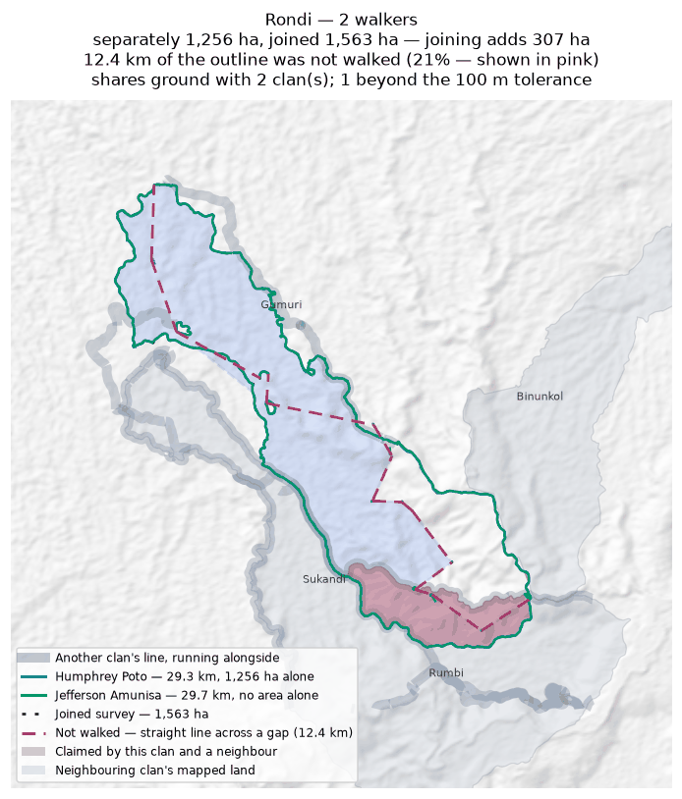
Each walker's line and the area it gives alone (dashed); the survey they combine into, dotted; the stretches nobody walked in pink; neighbouring clans in grey, ground both claim in red.

Rumbi
Zone 2 · version 1.1, 16 August 2026
Walkers | Surveys | Walked (km) | Access legs (km) | Pieces | Not walked (km) | Parcels | Area (ha) | Basis
1 | 1 | 15.1 | 3.7 | 3 | 9.9 | — | none | no area
Custodians
Custodian | Tracks | Days | First | Last | Walked (km)
Joel Mamata | 9 | 5 | 2025-04-15 | 2025-04-28 | 15.1
Boundary walked alongside another clan
Clan | Shared line (km) | % of this clan's line
Sukandi | 8.0 | 49.8%
Rondi | 10.5 | 33.5%
Juaiko | 2.1 | 11.8%
Manoko | 0.8 | 5.4%
Problems
- No area can be given. The tracks are in 3 disconnected pieces and 9.9 km of straight-line joining would be needed to make a ring — 73% of the distance walked. That is beyond the 50% limit, above which an area would be more assumption than survey.
- No overlapping area, but 50% of this clan's recorded line runs within 100 m of Sukandi's. The two describe the same edge on the ground.
Queries for the field
- Can the missing stretches be walked so this boundary closes? If any gap is deliberate — a river, a road, an agreed open edge — please say what runs along it.
Map
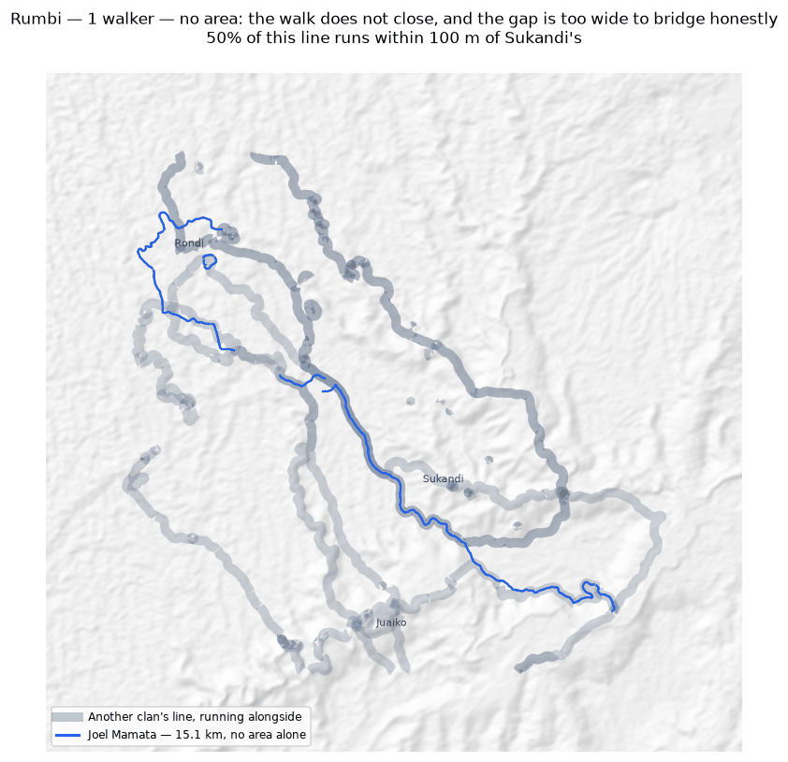
The walk, the area it gives (dotted), the stretches nobody walked in pink; neighbouring clans in grey, ground both claim in red.

Sukandi
Zone 2 · version 1.1, 16 August 2026
Walkers | Surveys | Walked (km) | Access legs (km) | Pieces | Not walked (km) | Parcels | Area (ha) | Basis
2 | 2 | 39.7 | 9.0 | 3 | — | 1 | 1,901 | surveyed
Custodians
Custodian | Tracks | Days | First | Last | Walked (km)
Rodney Ajinko | 1 | 1 | 2025-04-24 | 2025-04-24 | 29.1
Millinton Beso | 3 | 2 | 2025-04-24 | 2025-04-25 | 10.6
Ground also claimed by another clan
Clan | Shared (ha) | % of this clan | Beyond 100 m (ha) | Verdict
Asoro | 232 | 12.2% | 231 | overlap
Rondi | 212 | 11.1% | 211 | overlap
Juaiko | 205 | 10.8% | 202 | overlap
Jariji | 0 | 0.0% | 0 | within tolerance
Binunkol | 0 | 0.0% | 0 | within tolerance
Boundary walked alongside another clan
Clan | Shared line (km) | % of this clan's line
Rumbi | 8.0 | 20.2%
Juaiko | 4.2 | 10.6%
Rondi | 7.0 | 8.7%
Binunkol | 1.0 | 2.5%
Asoro | 0.8 | 2.1%
Jariji | 0.3 | 0.7%
Manoko | 0.2 | 0.6%
Problems
- The boundary closes on its own. 1,901 ha is measured from the walk, with nothing inferred.
- Joining the 2 walkers costs 467 ha: separately they give 2,368 ha, joined 1,901 ha. This happens where walkers each walked the same ring rather than different stretches — the two rings cross and the joined network encloses less than either walk did alone.
- Overlaps 3 other clans by more than the 100 m tolerance: Asoro (232 ha, 12% of this clan's land); Rondi (212 ha, 11% of this clan's land); Juaiko (205 ha, 11% of this clan's land).
- A further 2 clans (Jariji, Binunkol) share ground only in strips narrower than 100 m. That is the two lines being the same line, not a competing claim, and it is not counted as overlap.
Queries for the field
- Did the 2 custodians walk the same boundary, or different parts of it? If they walked the same ring, their surveys should be treated as separate accounts rather than joined.
- Is the ground shared with Asoro, Rondi, Juaiko disputed, shared by agreement, or recorded wrongly? No change will be made to either boundary without the community's decision.
Map
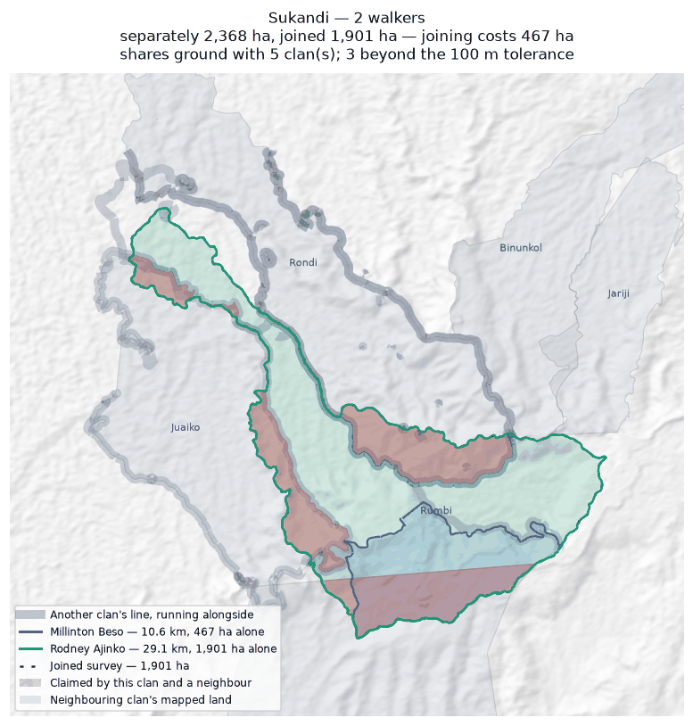
Each walker's line and the area it gives alone (dashed); the survey they combine into, dotted; the stretches nobody walked in pink; neighbouring clans in grey, ground both claim in red.

Tuoko
Zone 2 · version 1.1, 16 August 2026
Walkers | Surveys | Walked (km) | Access legs (km) | Pieces | Not walked (km) | Parcels | Area (ha) | Basis
2 | 2 | 47.7 | 9.5 | 8 | 17.1 | 1 | 3,676 | inferred
Custodians
Custodian | Tracks | Days | First | Last | Walked (km)
Terrence Dobija | 3 | 3 | 2025-08-31 | 2025-12-09 | 36.5
Kaupa Dota | 6 | 3 | 2025-02-24 | 2025-12-09 | 11.2
Ground also claimed by another clan
Clan | Shared (ha) | % of this clan | Beyond 100 m (ha) | Verdict
Nituri | 2,199 | 59.8% | 2,198 | overlap
Kasaki | 157 | 4.3% | 155 | overlap
Majanko | 13 | 0.3% | 12 | overlap
Gariniko | 7 | 0.2% | 5 | overlap
Boundary walked alongside another clan
Clan | Shared line (km) | % of this clan's line
Nituri | 14.4 | 30.2%
Kasaki | 1.5 | 2.7%
Murai (Z2) | 1.0 | 2.1%
Gariniko | 0.6 | 1.1%
Majanko | 0.5 | 1.0%
Zambiko | 0.4 | 0.6%
Asingi | 0.3 | 0.6%
Manoko | 0.5 | 0.5%
Problems
- The boundary does not close. 17.1 km in 8 stretches was bridged with straight lines nobody walked — 38% of the distance walked, so 3,676 ha is an estimate rather than a measured area. On the map those stretches are pink.
- Joining the 2 walkers adds 1,995 ha: separately 1,681 ha, joined 3,676 ha. The walkers covered different stretches of one boundary.
- Overlaps 4 other clans by more than the 100 m tolerance: Nituri (2,199 ha, 60% of this clan's land); Kasaki (157 ha, 4% of this clan's land); Majanko (13 ha, 0% of this clan's land); Gariniko (7 ha, 0% of this clan's land).
Queries for the field
- 38% of this outline was not walked — 17.1 km of straight line, shown in pink. Does the boundary in fact run along those straight lines, or somewhere else? Can the missing stretches be walked?
- Is the ground shared with Nituri, Kasaki, Majanko disputed, shared by agreement, or recorded wrongly? No change will be made to either boundary without the community's decision.
- This boundary is recorded in 8 separate pieces. Were the connecting stretches walked but not recorded, or not yet walked?
Map
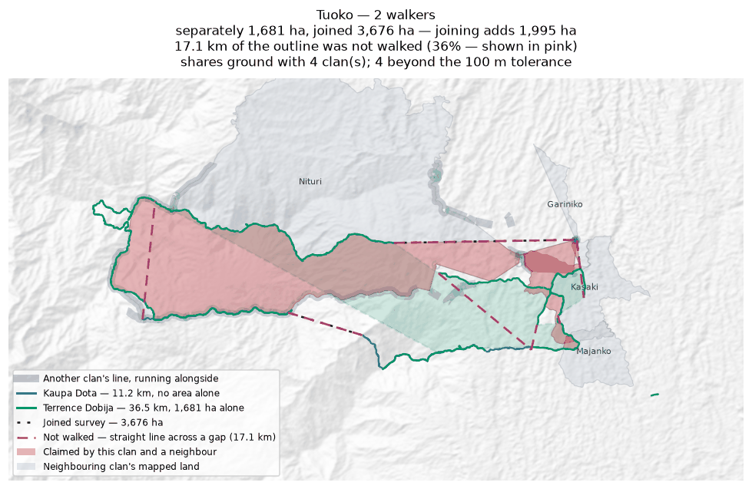
Each walker's line and the area it gives alone (dashed); the survey they combine into, dotted; the stretches nobody walked in pink; neighbouring clans in grey, ground both claim in red.

Zambiko
Zone 2 · version 1.1, 16 August 2026
Walkers | Surveys | Walked (km) | Access legs (km) | Pieces | Not walked (km) | Parcels | Area (ha) | Basis
1 | 1 | 5.7 | 1.2 | 5 | 21.6 | — | none | no area
Custodians
Custodian | Tracks | Days | First | Last | Walked (km)
Sylvester Anai | 8 | 3 | 2025-11-27 | 2026-02-12 | 5.7
Boundary walked alongside another clan
Clan | Shared line (km) | % of this clan's line
Juaiko | 2.6 | 26.8%
Manoko | 1.1 | 17.4%
Majanko | 0.6 | 8.8%
Nituri | 0.6 | 6.4%
Gariniko | 0.5 | 6.4%
Tuoko | 0.4 | 6.4%
Murai (Z2) | 0.4 | 6.4%
Asingi | 0.4 | 6.4%
Asoro | 0.1 | 0.6%
Problems
- No area can be given. The tracks are in 5 disconnected pieces and 21.6 km of straight-line joining would be needed to make a ring — 420% of the distance walked. That is beyond the 50% limit, above which an area would be more assumption than survey.
- No overlapping area, but 27% of this clan's recorded line runs within 100 m of Juaiko's. The two describe the same edge on the ground.
Queries for the field
- Can the missing stretches be walked so this boundary closes? If any gap is deliberate — a river, a road, an agreed open edge — please say what runs along it.
Map
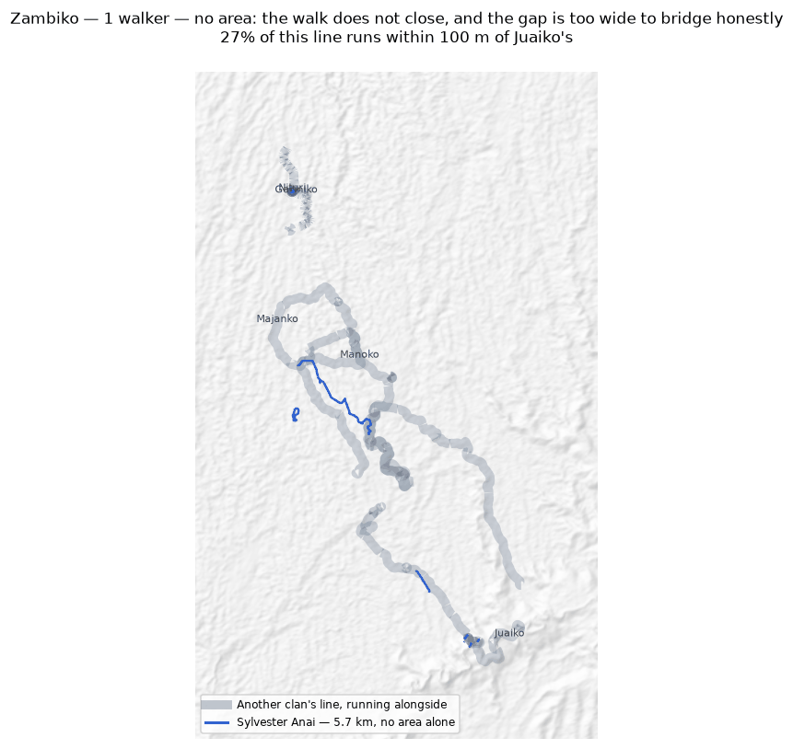
The walk, the area it gives (dotted), the stretches nobody walked in pink; neighbouring clans in grey, ground both claim in red.

Zone 3

Deari
Zone 3 · version 1.1, 16 August 2026
Walkers | Surveys | Walked (km) | Access legs (km) | Pieces | Not walked (km) | Parcels | Area (ha) | Basis
2 | 2 | 13.1 | 2.2 | 3 | 8.7 | — | none | no area
Custodians
Custodian | Tracks | Days | First | Last | Walked (km)
Patrick Dirise | 3 | 2 | 2026-06-09 | 2026-06-15 | 7.8
Anthony Irimari | 2 | 2 | 2026-06-09 | 2026-06-15 | 5.3
Boundary walked alongside another clan
Clan | Shared line (km) | % of this clan's line
Nui | 15.0 | 94.2%
Binunkol | 0.2 | 1.0%
Rondi | 0.4 | 0.7%
Problems
- No area can be given. The tracks are in 3 disconnected pieces and 8.7 km of straight-line joining would be needed to make a ring — 70% of the distance walked. That is beyond the 50% limit, above which an area would be more assumption than survey.
- No overlapping area, but 94% of this clan's recorded line runs within 100 m of Nui's. The two describe the same edge on the ground.
Queries for the field
- Can the missing stretches be walked so this boundary closes? If any gap is deliberate — a river, a road, an agreed open edge — please say what runs along it.
- 94% of this clan's line runs alongside Nui's. Is that a boundary the two clans share and agree on?
Map
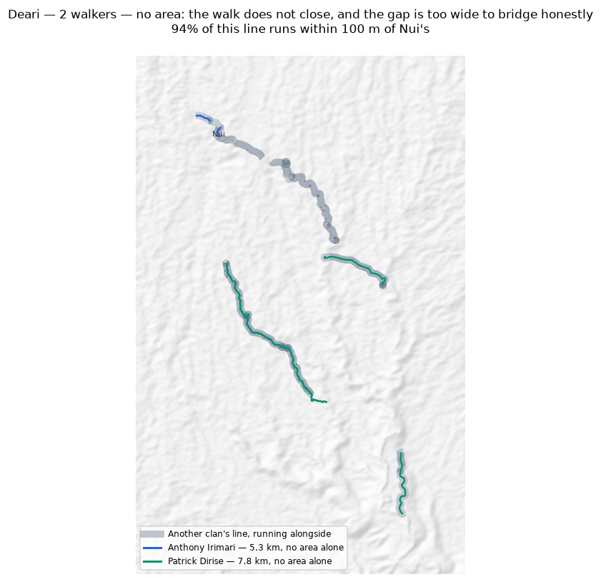
Each walker's line and the area it gives alone (dashed); the survey they combine into, dotted; the stretches nobody walked in pink; neighbouring clans in grey, ground both claim in red.

Giroiko
Zone 3 · version 1.1, 16 August 2026
Walkers | Surveys | Walked (km) | Access legs (km) | Pieces | Not walked (km) | Parcels | Area (ha) | Basis
2 | 2 | 5.4 | 0.4 | 2 | 1.3 | 4 | 10 | inferred
Custodians
Custodian | Tracks | Days | First | Last | Walked (km)
Mark Samba | 2 | 1 | 2026-06-11 | 2026-06-11 | 2.8
Eddie Sioro | 1 | 1 | 2026-06-11 | 2026-06-11 | 2.7
Problems
- The boundary does not close. 1.3 km in 2 stretches was bridged with straight lines nobody walked — 25% of the distance walked, so 10 ha is an estimate rather than a measured area. On the map those stretches are pink.
- The walks enclose 4 separate parcels, totalling 10 ha. All of them are counted. Whether they are all this clan's land, or whether one belongs to a neighbour, is a question for the clan.
- Joining the 2 walkers costs 69 ha: separately they give 78 ha, joined 10 ha. This happens where walkers each walked the same ring rather than different stretches — the two rings cross and the joined network encloses less than either walk did alone.
Queries for the field
- 25% of this outline was not walked — 1.3 km of straight line, shown in pink. Does the boundary in fact run along those straight lines, or somewhere else? Can the missing stretches be walked?
- This clan's land is recorded as 4 separate pieces. Is that right, and does each piece belong to this clan?
- Did the 2 custodians walk the same boundary, or different parts of it? If they walked the same ring, their surveys should be treated as separate accounts rather than joined.
Map
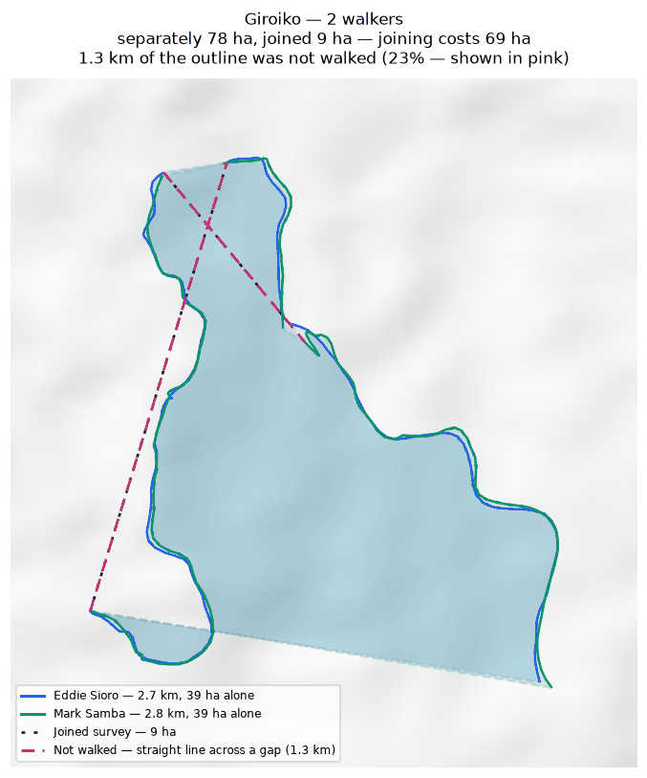
Each walker's line and the area it gives alone (dashed); the survey they combine into, dotted; the stretches nobody walked in pink; neighbouring clans in grey, ground both claim in red.

Gumuri
Zone 3 · version 1.1, 16 August 2026
Walkers | Surveys | Walked (km) | Access legs (km) | Pieces | Not walked (km) | Parcels | Area (ha) | Basis
2 | 2 | 6.8 | 0.3 | 1 | 5.5 | — | none | no area
Custodians
Custodian | Tracks | Days | First | Last | Walked (km)
Gray Saui | 1 | 1 | 2026-06-15 | 2026-06-15 | 6.8
Monty Stanford | 1 | 0 | — | — | 0.0
Boundary walked alongside another clan
Clan | Shared line (km) | % of this clan's line
Rondi | 9.2 | 63.0%
Problems
- No area can be given. The tracks are in 1 disconnected piece and 5.5 km of straight-line joining would be needed to make a ring — 84% of the distance walked. That is beyond the 50% limit, above which an area would be more assumption than survey.
- No overlapping area, but 63% of this clan's recorded line runs within 100 m of Rondi's. The two describe the same edge on the ground.
Queries for the field
- Can the missing stretches be walked so this boundary closes? If any gap is deliberate — a river, a road, an agreed open edge — please say what runs along it.
- 63% of this clan's line runs alongside Rondi's. Is that a boundary the two clans share and agree on?
Map
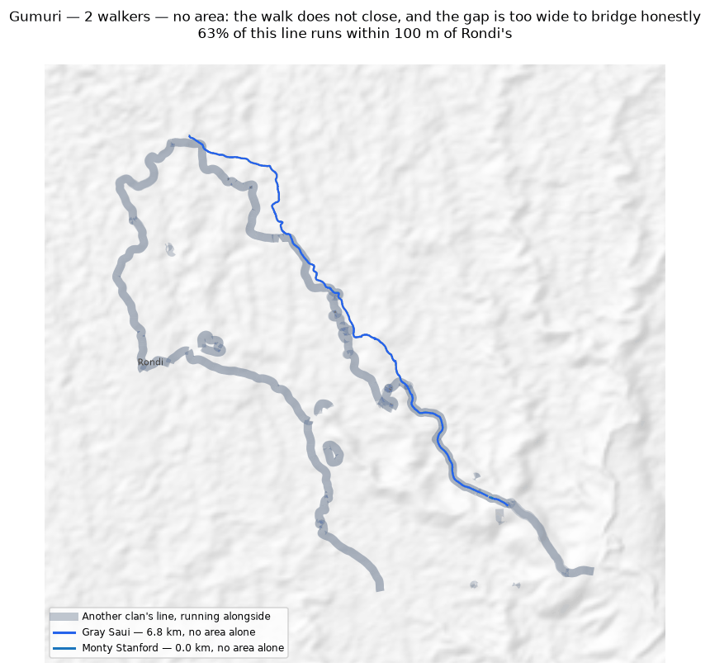
Each walker's line and the area it gives alone (dashed); the survey they combine into, dotted; the stretches nobody walked in pink; neighbouring clans in grey, ground both claim in red.

Nui
Zone 3 · version 1.1, 16 August 2026
Walkers | Surveys | Walked (km) | Access legs (km) | Pieces | Not walked (km) | Parcels | Area (ha) | Basis
2 | 2 | 23.4 | 5.7 | 6 | 14.7 | — | none | no area
Custodians
Custodian | Tracks | Days | First | Last | Walked (km)
Iman Nakina | 4 | 2 | 2026-06-09 | 2026-06-15 | 12.0
Bobby Aneba | 3 | 2 | 2026-06-09 | 2026-06-15 | 11.5
Boundary walked alongside another clan
Clan | Shared line (km) | % of this clan's line
Deari | 15.0 | 64.0%
Binunkol | 0.2 | 0.5%
Rondi | 0.4 | 0.4%
Problems
- No area can be given. The tracks are in 6 disconnected pieces and 14.7 km of straight-line joining would be needed to make a ring — 66% of the distance walked. That is beyond the 50% limit, above which an area would be more assumption than survey.
- No overlapping area, but 64% of this clan's recorded line runs within 100 m of Deari's. The two describe the same edge on the ground.
Queries for the field
- Can the missing stretches be walked so this boundary closes? If any gap is deliberate — a river, a road, an agreed open edge — please say what runs along it.
- 64% of this clan's line runs alongside Deari's. Is that a boundary the two clans share and agree on?
Map
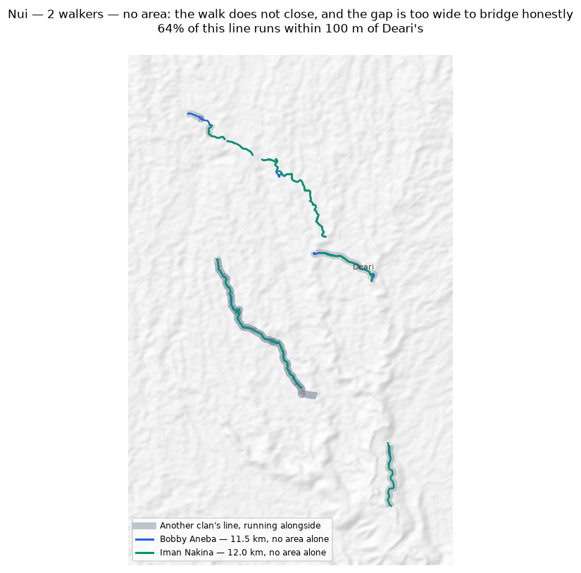
Each walker's line and the area it gives alone (dashed); the survey they combine into, dotted; the stretches nobody walked in pink; neighbouring clans in grey, ground both claim in red.

Zone 6

Manuvoora
Zone 6 · version 1.1, 16 August 2026
Walkers | Surveys | Walked (km) | Access legs (km) | Pieces | Not walked (km) | Parcels | Area (ha) | Basis
2 | 2 | 61.5 | 10.0 | 6 | 11.4 | 3 | 828 | inferred
Custodians
Custodian | Tracks | Days | First | Last | Walked (km)
Egobeyas Kuarisi | 18 | 11 | 2026-06-18 | 2026-07-26 | 31.2
Granville Nepo | 11 | 8 | 2026-06-18 | 2026-07-21 | 30.2
Boundary walked alongside another clan
Clan | Shared line (km) | % of this clan's line
Pina Ora | 7.0 | 11.3%
Nupa Ora | 0.6 | 1.0%
Problems
- The boundary does not close. 11.4 km in 6 stretches was bridged with straight lines nobody walked — 20% of the distance walked, so 828 ha is an estimate rather than a measured area. On the map those stretches are pink.
- The walks enclose 3 separate parcels, totalling 828 ha. All of them are counted. Whether they are all this clan's land, or whether one belongs to a neighbour, is a question for the clan.
- Joining the 2 walkers costs 1,238 ha: separately they give 2,066 ha, joined 828 ha. This happens where walkers each walked the same ring rather than different stretches — the two rings cross and the joined network encloses less than either walk did alone.
- No overlapping area, but 11% of this clan's recorded line runs within 100 m of Pina Ora's. The two describe the same edge on the ground.
Queries for the field
- This clan's land is recorded as 3 separate pieces. Is that right, and does each piece belong to this clan?
- Did the 2 custodians walk the same boundary, or different parts of it? If they walked the same ring, their surveys should be treated as separate accounts rather than joined.
- This boundary is recorded in 6 separate pieces. Were the connecting stretches walked but not recorded, or not yet walked?
Map
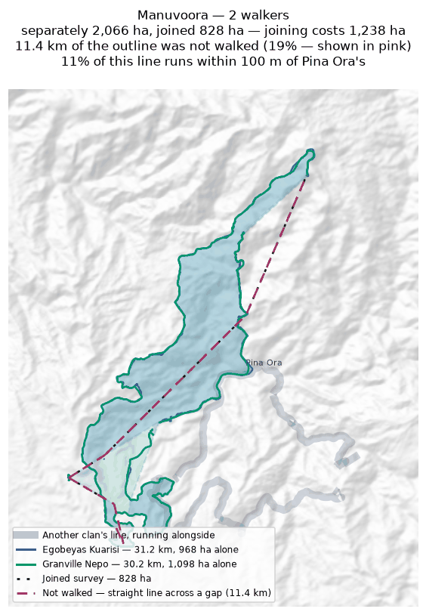
Each walker's line and the area it gives alone (dashed); the survey they combine into, dotted; the stretches nobody walked in pink; neighbouring clans in grey, ground both claim in red.

Mariura
Zone 6 · version 1.1, 16 August 2026
Walkers | Surveys | Walked (km) | Access legs (km) | Pieces | Not walked (km) | Parcels | Area (ha) | Basis
2 | 2 | 33.7 | 0.0 | 13 | 14.3 | 1 | 855 | inferred
Custodians
Custodian | Tracks | Days | First | Last | Walked (km)
Fabian Justin | 22 | 6 | 2026-06-26 | 2026-07-09 | 17.9
Livingstone Nisavora | 21 | 6 | 2026-06-26 | 2026-07-09 | 15.9
Ground also claimed by another clan
Clan | Shared (ha) | % of this clan | Beyond 100 m (ha) | Verdict
Naharaura | 148 | 17.4% | 144 | overlap
Borori | 56 | 6.6% | 52 | overlap
Darekikol | 50 | 5.9% | 50 | overlap
Boundary walked alongside another clan
Clan | Shared line (km) | % of this clan's line
Naharaura | 7.9 | 49.8%
Borori | 8.4 | 20.5%
Darekikol | 0.7 | 3.0%
Problems
- The boundary does not close. 14.3 km in 13 stretches was bridged with straight lines nobody walked — 42% of the distance walked, so 855 ha is an estimate rather than a measured area. On the map those stretches are pink.
- Joining the 2 walkers adds 855 ha: separately 0 ha, joined 855 ha. The walkers covered different stretches of one boundary.
- Overlaps 3 other clans by more than the 100 m tolerance: Naharaura (148 ha, 17% of this clan's land); Borori (56 ha, 7% of this clan's land); Darekikol (50 ha, 6% of this clan's land).
Queries for the field
- 42% of this outline was not walked — 14.3 km of straight line, shown in pink. Does the boundary in fact run along those straight lines, or somewhere else? Can the missing stretches be walked?
- Is the ground shared with Naharaura, Borori, Darekikol disputed, shared by agreement, or recorded wrongly? No change will be made to either boundary without the community's decision.
- This boundary is recorded in 13 separate pieces. Were the connecting stretches walked but not recorded, or not yet walked?
Map
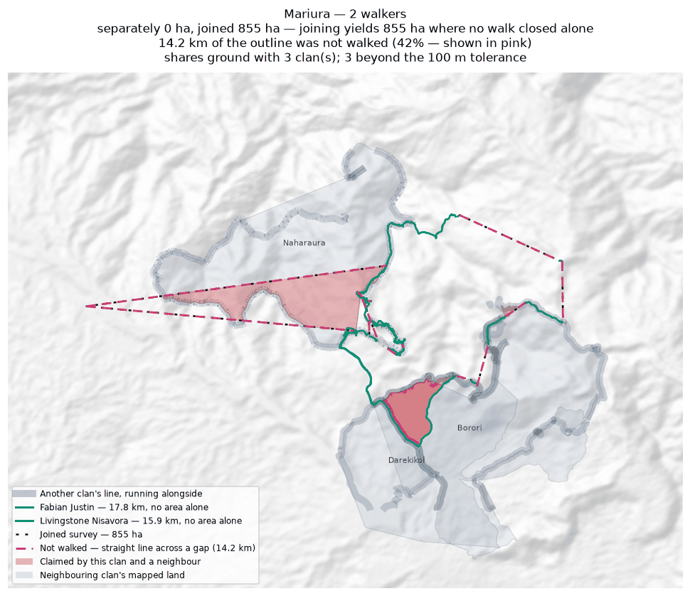
Each walker's line and the area it gives alone (dashed); the survey they combine into, dotted; the stretches nobody walked in pink; neighbouring clans in grey, ground both claim in red.

Naharaura
Zone 6 · version 1.1, 16 August 2026
Walkers | Surveys | Walked (km) | Access legs (km) | Pieces | Not walked (km) | Parcels | Area (ha) | Basis
1 | 1 | 32.6 | 0.0 | 4 | 2.5 | 1 | 594 | inferred
Custodians
Custodian | Tracks | Days | First | Last | Walked (km)
Zechariah Sasavo | 2 | 1 | 2026-06-26 | 2026-06-26 | 32.6
Ground also claimed by another clan
Clan | Shared (ha) | % of this clan | Beyond 100 m (ha) | Verdict
Mariura | 148 | 25.0% | 144 | overlap
Pina Ora | 60 | 10.0% | 59 | overlap
Boundary walked alongside another clan
Clan | Shared line (km) | % of this clan's line
Pina Ora | 5.8 | 34.2%
Mariura | 7.9 | 28.3%
Problems
- The boundary does not close. 2.5 km in 4 stretches was bridged with straight lines nobody walked — 8% of the distance walked, so 594 ha is an estimate rather than a measured area. On the map those stretches are pink.
- Overlaps 2 other clans by more than the 100 m tolerance: Mariura (148 ha, 25% of this clan's land); Pina Ora (60 ha, 10% of this clan's land).
Queries for the field
- Is the ground shared with Mariura, Pina Ora disputed, shared by agreement, or recorded wrongly? No change will be made to either boundary without the community's decision.
- This boundary is recorded in 4 separate pieces. Were the connecting stretches walked but not recorded, or not yet walked?
Map
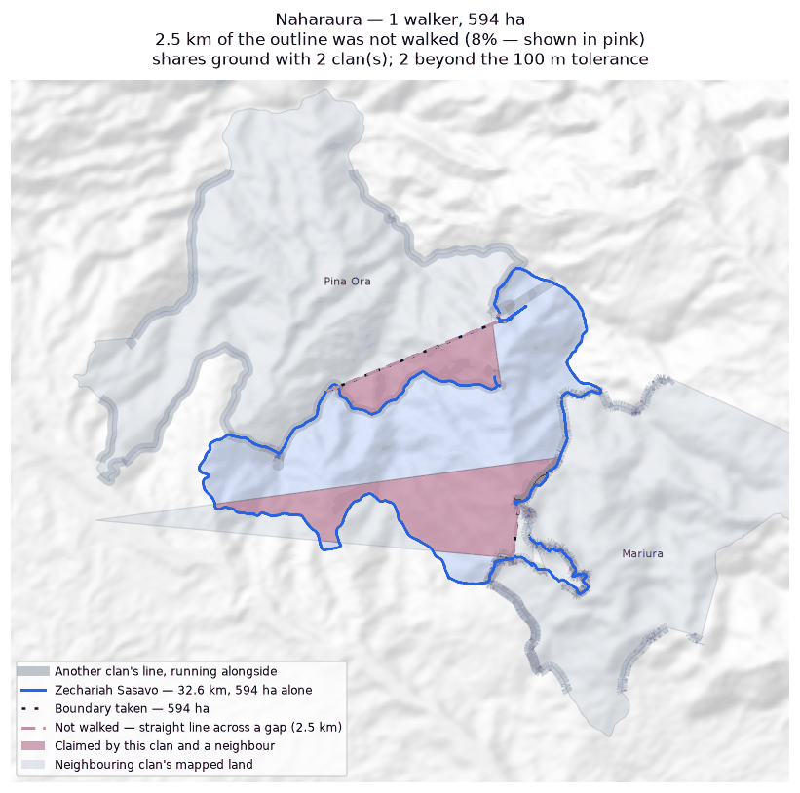
The walk, the area it gives (dotted), the stretches nobody walked in pink; neighbouring clans in grey, ground both claim in red.

Nupa Ora
Zone 6 · version 1.1, 16 August 2026
Walkers | Surveys | Walked (km) | Access legs (km) | Pieces | Not walked (km) | Parcels | Area (ha) | Basis
1 | 1 | 4.9 | 0.6 | 2 | 3.6 | — | none | no area
Custodians
Custodian | Tracks | Days | First | Last | Walked (km)
Benjamin Marijah | 3 | 3 | 2026-06-18 | 2026-06-25 | 4.9
Boundary walked alongside another clan
Clan | Shared line (km) | % of this clan's line
Manuvoora | 0.6 | 3.3%
Problems
- No area can be given. The tracks are in 2 disconnected pieces and 3.6 km of straight-line joining would be needed to make a ring — 72% of the distance walked. That is beyond the 50% limit, above which an area would be more assumption than survey.
- No overlapping area, but 3% of this clan's recorded line runs within 100 m of Manuvoora's. The two describe the same edge on the ground.
Queries for the field
- Can the missing stretches be walked so this boundary closes? If any gap is deliberate — a river, a road, an agreed open edge — please say what runs along it.
Map
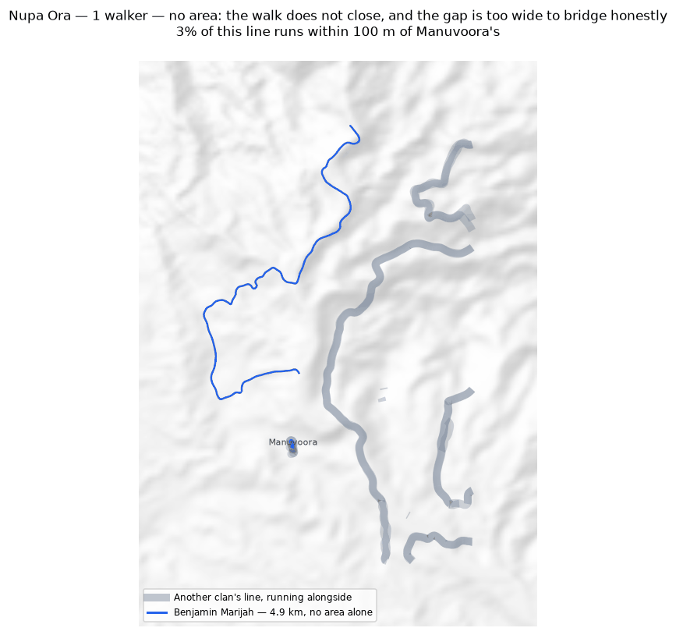
The walk, the area it gives (dotted), the stretches nobody walked in pink; neighbouring clans in grey, ground both claim in red.

Pina Ora
Zone 6 · version 1.1, 16 August 2026
Walkers | Surveys | Walked (km) | Access legs (km) | Pieces | Not walked (km) | Parcels | Area (ha) | Basis
1 | 1 | 18.9 | 3.9 | 4 | 1.4 | 1 | 812 | inferred
Custodians
Custodian | Tracks | Days | First | Last | Walked (km)
Alban Ezekiel | 3 | 3 | 2026-06-23 | 2026-06-25 | 18.9
Ground also claimed by another clan
Clan | Shared (ha) | % of this clan | Beyond 100 m (ha) | Verdict
Naharaura | 60 | 7.3% | 59 | overlap
Boundary walked alongside another clan
Clan | Shared line (km) | % of this clan's line
Naharaura | 5.8 | 30.8%
Manuvoora | 7.0 | 19.0%
Problems
- The boundary does not close. 1.4 km in 4 stretches was bridged with straight lines nobody walked — 8% of the distance walked, so 812 ha is an estimate rather than a measured area. On the map those stretches are pink.
- Overlaps 1 other clan by more than the 100 m tolerance: Naharaura (60 ha, 7% of this clan's land).
Queries for the field
- Is the ground shared with Naharaura disputed, shared by agreement, or recorded wrongly? No change will be made to either boundary without the community's decision.
- This boundary is recorded in 4 separate pieces. Were the connecting stretches walked but not recorded, or not yet walked?
Map
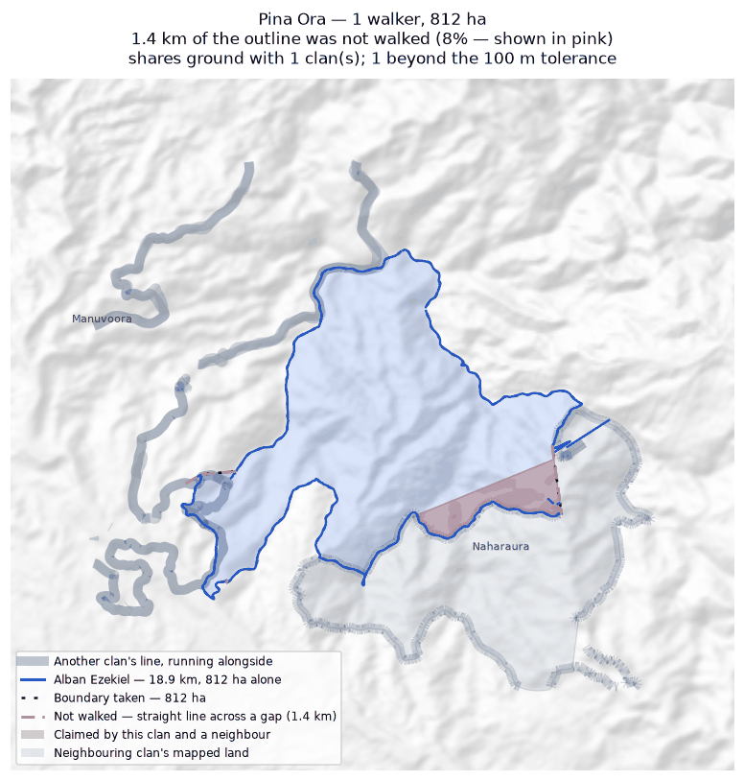
The walk, the area it gives (dotted), the stretches nobody walked in pink; neighbouring clans in grey, ground both claim in red.

Zone 7A

Bimkol
Zone 7A · version 1.1, 16 August 2026
Walkers | Surveys | Walked (km) | Access legs (km) | Pieces | Not walked (km) | Parcels | Area (ha) | Basis
1 | 1 | 8.0 | 1.8 | 3 | 4.0 | 1 | 158 | inferred
Custodians
Custodian | Tracks | Days | First | Last | Walked (km)
Kennedy Wosa | 5 | 4 | 2026-05-25 | 2026-08-13 | 8.0
Ground also claimed by another clan
Clan | Shared (ha) | % of this clan | Beyond 100 m (ha) | Verdict
Darekikol | 1 | 0.3% | 0 | within tolerance
Boundary walked alongside another clan
Clan | Shared line (km) | % of this clan's line
Darekikol | 1.4 | 9.3%
Borori | 0.1 | 1.4%
Problems
- The boundary does not close. 4.0 km in 3 stretches was bridged with straight lines nobody walked — 54% of the distance walked, so 158 ha is an estimate rather than a measured area. On the map those stretches are pink.
- A further 1 clan (Darekikol) share ground only in strips narrower than 100 m. That is the two lines being the same line, not a competing claim, and it is not counted as overlap.
Queries for the field
- 54% of this outline was not walked — 4.0 km of straight line, shown in pink. Does the boundary in fact run along those straight lines, or somewhere else? Can the missing stretches be walked?
Map
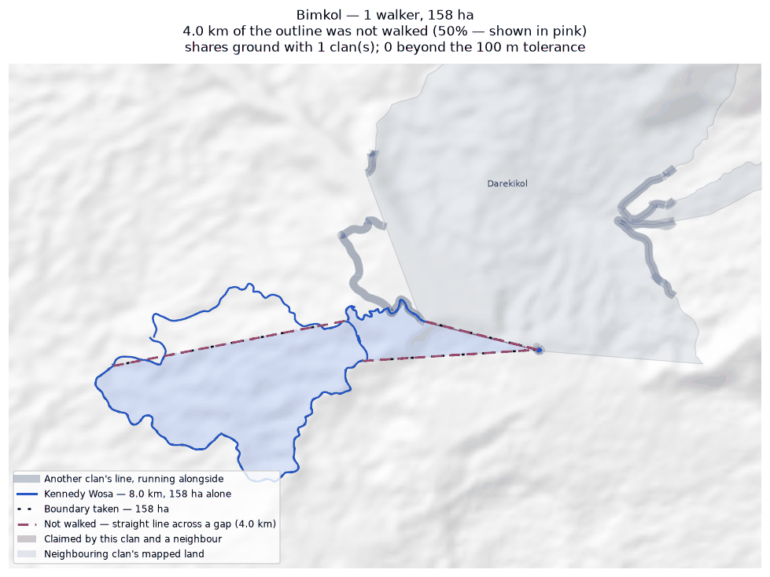
The walk, the area it gives (dotted), the stretches nobody walked in pink; neighbouring clans in grey, ground both claim in red.

Borori
Zone 7A · version 1.1, 16 August 2026
Walkers | Surveys | Walked (km) | Access legs (km) | Pieces | Not walked (km) | Parcels | Area (ha) | Basis
2 | 2 | 32.7 | 8.0 | 10 | 7.0 | 2 | 639 | inferred
Custodians
Custodian | Tracks | Days | First | Last | Walked (km)
John Saini | 5 | 5 | 2026-06-10 | 2026-07-07 | 22.8
Hagahi Semo | 6 | 5 | 2026-05-25 | 2026-07-07 | 9.9
Ground also claimed by another clan
Clan | Shared (ha) | % of this clan | Beyond 100 m (ha) | Verdict
Darekikol | 333 | 52.1% | 329 | overlap
Mariura | 56 | 8.8% | 52 | overlap
Mungaikol | 0 | 0.0% | 0 | within tolerance
Boundary walked alongside another clan
Clan | Shared line (km) | % of this clan's line
Darekikol | 13.9 | 32.0%
Mariura | 8.4 | 25.7%
Mungaikol | 0.4 | 1.3%
Bimkol | 0.1 | 0.3%
Problems
- The boundary does not close. 7.0 km in 10 stretches was bridged with straight lines nobody walked — 24% of the distance walked, so 639 ha is an estimate rather than a measured area. On the map those stretches are pink.
- The walks enclose 2 separate parcels, totalling 639 ha. All of them are counted. Whether they are all this clan's land, or whether one belongs to a neighbour, is a question for the clan.
- Joining the 2 walkers costs 38 ha: separately they give 677 ha, joined 639 ha. This happens where walkers each walked the same ring rather than different stretches — the two rings cross and the joined network encloses less than either walk did alone.
- Overlaps 2 other clans by more than the 100 m tolerance: Darekikol (333 ha, 52% of this clan's land); Mariura (56 ha, 9% of this clan's land).
- A further 1 clan (Mungaikol) share ground only in strips narrower than 100 m. That is the two lines being the same line, not a competing claim, and it is not counted as overlap.
Queries for the field
- This clan's land is recorded as 2 separate pieces. Is that right, and does each piece belong to this clan?
- Did the 2 custodians walk the same boundary, or different parts of it? If they walked the same ring, their surveys should be treated as separate accounts rather than joined.
- Is the ground shared with Darekikol, Mariura disputed, shared by agreement, or recorded wrongly? No change will be made to either boundary without the community's decision.
- This boundary is recorded in 10 separate pieces. Were the connecting stretches walked but not recorded, or not yet walked?
Map
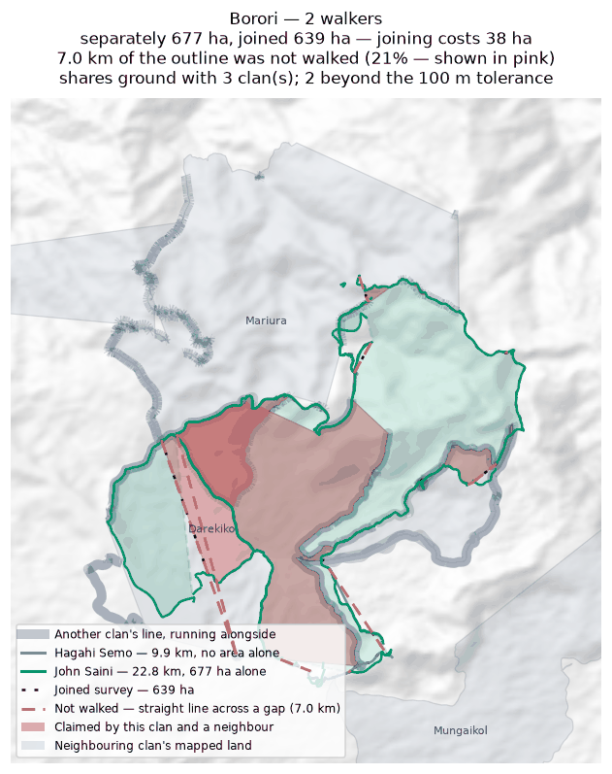
Each walker's line and the area it gives alone (dashed); the survey they combine into, dotted; the stretches nobody walked in pink; neighbouring clans in grey, ground both claim in red.

Darekikol
Zone 7A · version 1.1, 16 August 2026
Walkers | Surveys | Walked (km) | Access legs (km) | Pieces | Not walked (km) | Parcels | Area (ha) | Basis
2 | 2 | 28.8 | 6.7 | 7 | 5.9 | 1 | 588 | inferred
Custodians
Custodian | Tracks | Days | First | Last | Walked (km)
George Kopoi | 6 | 3 | 2026-05-25 | 2026-07-02 | 15.4
Garex Sevesi | 2 | 2 | 2026-05-25 | 2026-06-02 | 13.4
Ground also claimed by another clan
Clan | Shared (ha) | % of this clan | Beyond 100 m (ha) | Verdict
Borori | 333 | 56.7% | 329 | overlap
Mariura | 50 | 8.6% | 50 | overlap
Bimkol | 1 | 0.1% | 0 | within tolerance
Boundary walked alongside another clan
Clan | Shared line (km) | % of this clan's line
Borori | 13.9 | 48.4%
Bimkol | 1.4 | 4.8%
Mariura | 0.7 | 2.5%
Problems
- The boundary does not close. 5.9 km in 7 stretches was bridged with straight lines nobody walked — 23% of the distance walked, so 588 ha is an estimate rather than a measured area. On the map those stretches are pink.
- Joining the 2 walkers costs 639 ha: separately they give 1,227 ha, joined 588 ha. This happens where walkers each walked the same ring rather than different stretches — the two rings cross and the joined network encloses less than either walk did alone.
- Overlaps 2 other clans by more than the 100 m tolerance: Borori (333 ha, 57% of this clan's land); Mariura (50 ha, 9% of this clan's land).
- A further 1 clan (Bimkol) share ground only in strips narrower than 100 m. That is the two lines being the same line, not a competing claim, and it is not counted as overlap.
Queries for the field
- Did the 2 custodians walk the same boundary, or different parts of it? If they walked the same ring, their surveys should be treated as separate accounts rather than joined.
- Is the ground shared with Borori, Mariura disputed, shared by agreement, or recorded wrongly? No change will be made to either boundary without the community's decision.
- This boundary is recorded in 7 separate pieces. Were the connecting stretches walked but not recorded, or not yet walked?
Map
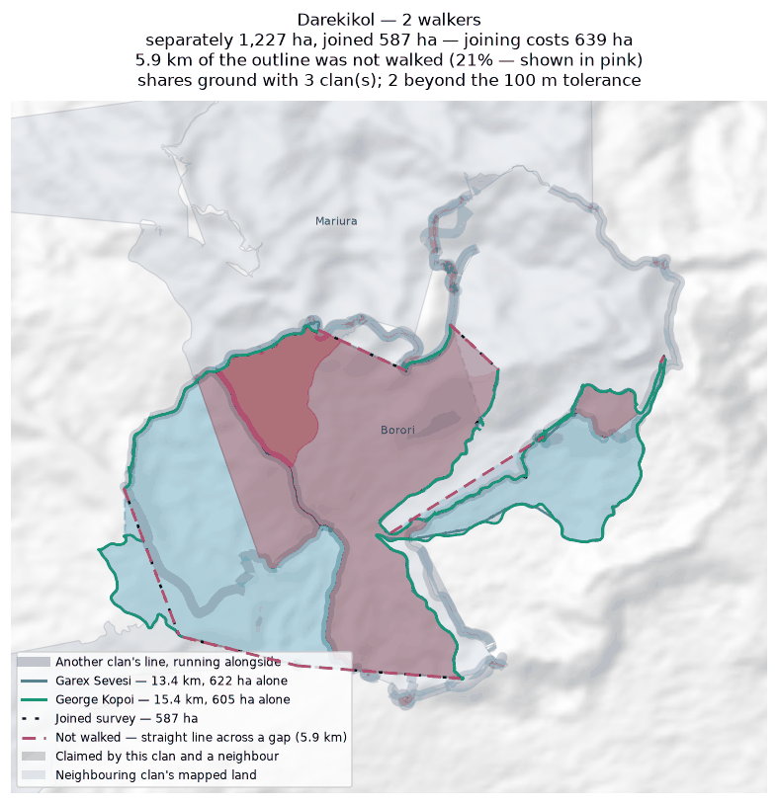
Each walker's line and the area it gives alone (dashed); the survey they combine into, dotted; the stretches nobody walked in pink; neighbouring clans in grey, ground both claim in red.

Zone 7B

Abuankol
Zone 7B · version 1.1, 16 August 2026
Walkers | Surveys | Walked (km) | Access legs (km) | Pieces | Not walked (km) | Parcels | Area (ha) | Basis
1 | 1 | 0.5 | 0.0 | 3 | — | 2 | 1 | surveyed
Custodians
Custodian | Tracks | Days | First | Last | Walked (km)
Simeon Pasip | 4 | 3 | 2025-10-21 | 2025-10-28 | 0.5
Ground also claimed by another clan
Clan | Shared (ha) | % of this clan | Beyond 100 m (ha) | Verdict
Sugulkol | 1 | 92.2% | 0 | within tolerance
Jariji | 0 | 0.1% | 0 | within tolerance
Wohukol | 0 | 3.4% | 0 | within tolerance
Ambunkol | 0 | 0.1% | 0 | within tolerance
Boundary walked alongside another clan
Clan | Shared line (km) | % of this clan's line
Sugulkol | 1.8 | 100.0%
Murai (Z7B) | 1.0 | 100.0%
Wohukol | 0.5 | 100.0%
Ambunkol | 0.5 | 58.0%
Jariji | 0.3 | 58.0%
Binunkol | 0.4 | 42.0%
Ginangi | 0.4 | 42.0%
Marijabimkol | 0.2 | 42.0%
Natang | 0.0 | 1.8%
Problems
- The boundary closes on its own. 1 ha is measured from the walk, with nothing inferred.
- The walks enclose 2 separate parcels, totalling 1 ha. All of them are counted. Whether they are all this clan's land, or whether one belongs to a neighbour, is a question for the clan.
- A further 4 clans (Sugulkol, Jariji, Wohukol, Ambunkol) share ground only in strips narrower than 100 m. That is the two lines being the same line, not a competing claim, and it is not counted as overlap.
Queries for the field
- This clan's land is recorded as 2 separate pieces. Is that right, and does each piece belong to this clan?
- 100% of this clan's line runs alongside Sugulkol's. Is that a boundary the two clans share and agree on?
Map
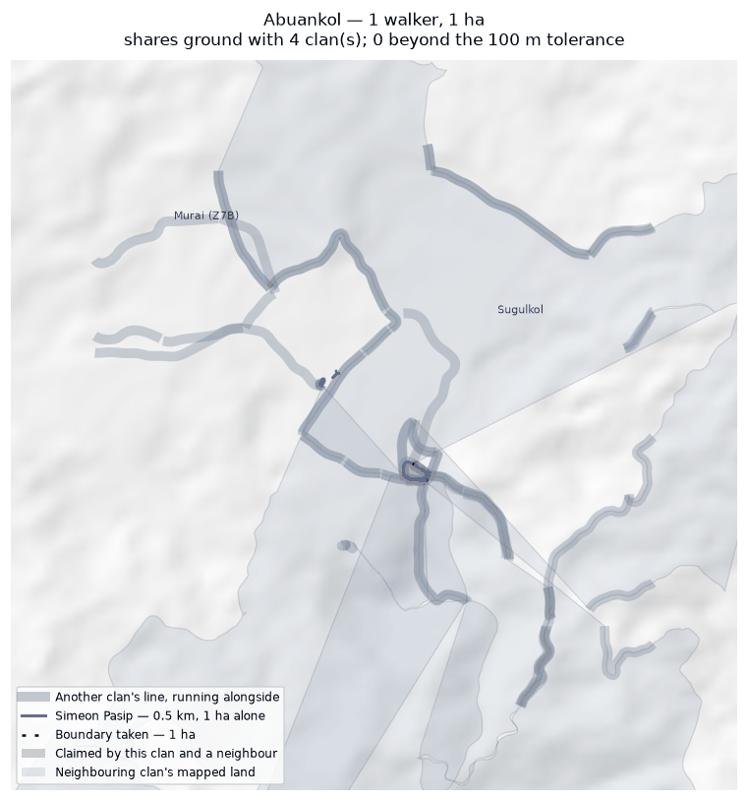
The walk, the area it gives (dotted), the stretches nobody walked in pink; neighbouring clans in grey, ground both claim in red.

Ambunkol
Zone 7B · version 1.1, 16 August 2026
Walkers | Surveys | Walked (km) | Access legs (km) | Pieces | Not walked (km) | Parcels | Area (ha) | Basis
1 | 1 | 18.6 | 4.0 | 6 | 4.5 | 3 | 592 | inferred
Custodians
Custodian | Tracks | Days | First | Last | Walked (km)
Peter Awako | 1 | 1 | 2025-10-28 | 2025-10-28 | 18.6
Ground also claimed by another clan
Clan | Shared (ha) | % of this clan | Beyond 100 m (ha) | Verdict
Natang | 345 | 58.4% | 340 | overlap
Sugulkol | 5 | 0.9% | 0 | within tolerance
Wohukol | 3 | 0.5% | 1 | overlap
Jariji | 1 | 0.1% | 0 | within tolerance
Abuankol | 0 | 0.0% | 0 | within tolerance
Boundary walked alongside another clan
Clan | Shared line (km) | % of this clan's line
Natang | 20.3 | 59.2%
Sugulkol | 5.9 | 15.1%
Wohukol | 2.2 | 9.4%
Murai (Z7B) | 1.0 | 3.9%
Abuankol | 0.5 | 2.9%
Jariji | 0.4 | 1.8%
Problems
- The boundary does not close. 4.5 km in 6 stretches was bridged with straight lines nobody walked — 26% of the distance walked, so 592 ha is an estimate rather than a measured area. On the map those stretches are pink.
- The walks enclose 3 separate parcels, totalling 592 ha. All of them are counted. Whether they are all this clan's land, or whether one belongs to a neighbour, is a question for the clan.
- Overlaps 2 other clans by more than the 100 m tolerance: Natang (345 ha, 58% of this clan's land); Wohukol (3 ha, 1% of this clan's land).
- A further 3 clans (Sugulkol, Jariji, Abuankol) share ground only in strips narrower than 100 m. That is the two lines being the same line, not a competing claim, and it is not counted as overlap.
Queries for the field
- 26% of this outline was not walked — 4.5 km of straight line, shown in pink. Does the boundary in fact run along those straight lines, or somewhere else? Can the missing stretches be walked?
- This clan's land is recorded as 3 separate pieces. Is that right, and does each piece belong to this clan?
- Is the ground shared with Natang, Wohukol disputed, shared by agreement, or recorded wrongly? No change will be made to either boundary without the community's decision.
- 59% of this clan's line runs alongside Natang's. Is that a boundary the two clans share and agree on?
- This boundary is recorded in 6 separate pieces. Were the connecting stretches walked but not recorded, or not yet walked?
Map
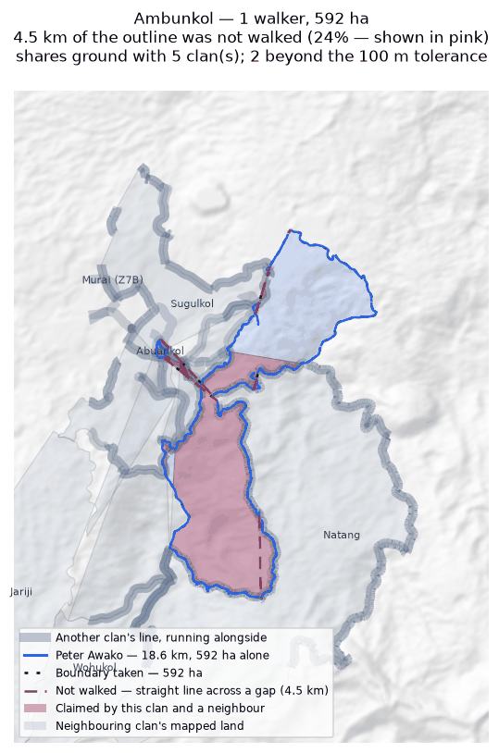
The walk, the area it gives (dotted), the stretches nobody walked in pink; neighbouring clans in grey, ground both claim in red.

Binunkol
Zone 7B · version 1.1, 16 August 2026
Walkers | Surveys | Walked (km) | Access legs (km) | Pieces | Not walked (km) | Parcels | Area (ha) | Basis
1 | 1 | 17.8 | 4.1 | 19 | 6.4 | 1 | 1,032 | inferred
Custodians
Custodian | Tracks | Days | First | Last | Walked (km)
Moses Garui | 10 | 5 | 2026-05-23 | 2026-06-16 | 17.8
Ground also claimed by another clan
Clan | Shared (ha) | % of this clan | Beyond 100 m (ha) | Verdict
Jariji | 45 | 4.4% | 42 | overlap
Wohukol | 29 | 2.8% | 27 | overlap
Sugulkol | 2 | 0.1% | 1 | overlap
Rondi | 1 | 0.1% | 0 | within tolerance
Ginangi | 0 | 0.0% | 0 | within tolerance
Sukandi | 0 | 0.0% | 0 | within tolerance
Boundary walked alongside another clan
Clan | Shared line (km) | % of this clan's line
Jariji | 5.2 | 27.4%
Rondi | 3.8 | 7.1%
Sugulkol | 1.1 | 6.3%
Marang | 1.1 | 6.0%
Sukandi | 1.0 | 5.4%
Murai (Z7B) | 0.9 | 5.1%
Wohukol | 0.8 | 4.5%
Ginangi | 0.7 | 4.1%
Abuankol | 0.4 | 2.3%
Marijabimkol | 0.4 | 2.2%
Deari | 0.2 | 1.0%
Nui | 0.2 | 1.0%
Problems
- The boundary does not close. 6.4 km in 19 stretches was bridged with straight lines nobody walked — 40% of the distance walked, so 1,032 ha is an estimate rather than a measured area. On the map those stretches are pink.
- Overlaps 3 other clans by more than the 100 m tolerance: Jariji (45 ha, 4% of this clan's land); Wohukol (29 ha, 3% of this clan's land); Sugulkol (2 ha, 0% of this clan's land).
- A further 3 clans (Rondi, Ginangi, Sukandi) share ground only in strips narrower than 100 m. That is the two lines being the same line, not a competing claim, and it is not counted as overlap.
Queries for the field
- 40% of this outline was not walked — 6.4 km of straight line, shown in pink. Does the boundary in fact run along those straight lines, or somewhere else? Can the missing stretches be walked?
- Is the ground shared with Jariji, Wohukol, Sugulkol disputed, shared by agreement, or recorded wrongly? No change will be made to either boundary without the community's decision.
- This boundary is recorded in 19 separate pieces. Were the connecting stretches walked but not recorded, or not yet walked?
Map
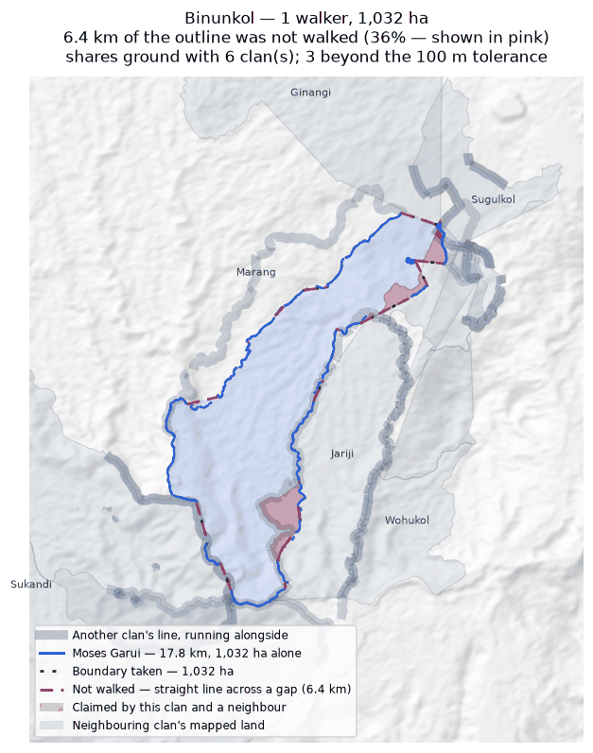
The walk, the area it gives (dotted), the stretches nobody walked in pink; neighbouring clans in grey, ground both claim in red.

Ginangi
Zone 7B · version 1.1, 16 August 2026
Walkers | Surveys | Walked (km) | Access legs (km) | Pieces | Not walked (km) | Parcels | Area (ha) | Basis
2 | 2 | 36.7 | 4.2 | 7 | 7.2 | 1 | 1,234 | inferred
Custodians
Custodian | Tracks | Days | First | Last | Walked (km)
Job Mokondo | 7 | 3 | 2026-05-23 | 2026-06-22 | 21.8
Joshua Mokondo | 6 | 4 | 2026-06-03 | 2026-06-24 | 14.9
Ground also claimed by another clan
Clan | Shared (ha) | % of this clan | Beyond 100 m (ha) | Verdict
Manang | 312 | 25.2% | 311 | overlap
Sugulkol | 52 | 4.2% | 51 | overlap
Binunkol | 0 | 0.0% | 0 | within tolerance
Wohukol | 0 | 0.0% | 0 | within tolerance
Boundary walked alongside another clan
Clan | Shared line (km) | % of this clan's line
Murai (Z7B) | 1.5 | 5.0%
Manang | 1.1 | 3.7%
Binunkol | 0.7 | 1.4%
Sugulkol | 0.6 | 1.4%
Abuankol | 0.4 | 1.2%
Marijabimkol | 0.3 | 1.1%
Wohukol | 0.3 | 1.1%
Problems
- The boundary does not close. 7.2 km in 7 stretches was bridged with straight lines nobody walked — 21% of the distance walked, so 1,234 ha is an estimate rather than a measured area. On the map those stretches are pink.
- Joining the 2 walkers costs 2 ha: separately they give 1,236 ha, joined 1,234 ha. This happens where walkers each walked the same ring rather than different stretches — the two rings cross and the joined network encloses less than either walk did alone.
- Overlaps 2 other clans by more than the 100 m tolerance: Manang (312 ha, 25% of this clan's land); Sugulkol (52 ha, 4% of this clan's land).
- A further 2 clans (Binunkol, Wohukol) share ground only in strips narrower than 100 m. That is the two lines being the same line, not a competing claim, and it is not counted as overlap.
Queries for the field
- Did the 2 custodians walk the same boundary, or different parts of it? If they walked the same ring, their surveys should be treated as separate accounts rather than joined.
- Is the ground shared with Manang, Sugulkol disputed, shared by agreement, or recorded wrongly? No change will be made to either boundary without the community's decision.
- This boundary is recorded in 7 separate pieces. Were the connecting stretches walked but not recorded, or not yet walked?
Map
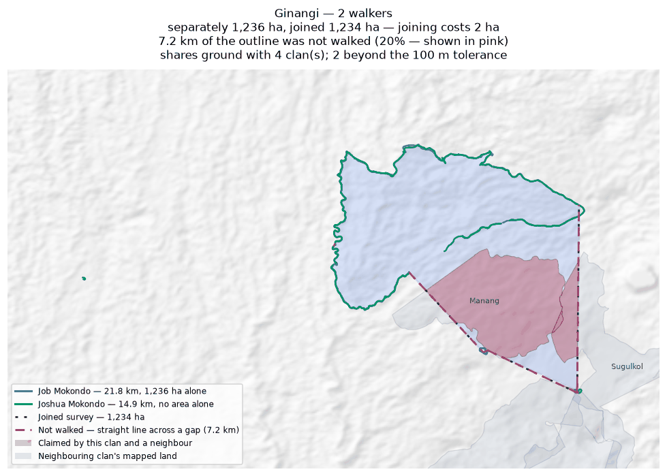
Each walker's line and the area it gives alone (dashed); the survey they combine into, dotted; the stretches nobody walked in pink; neighbouring clans in grey, ground both claim in red.

Jariji
Zone 7B · version 1.1, 16 August 2026
Walkers | Surveys | Walked (km) | Access legs (km) | Pieces | Not walked (km) | Parcels | Area (ha) | Basis
2 | 2 | 27.5 | 5.8 | 6 | 9.0 | 2 | 696 | inferred
Custodians
Custodian | Tracks | Days | First | Last | Walked (km)
Clement Viri | 1 | 1 | 2025-11-09 | 2025-11-09 | 13.8
Newton Giwai | 3 | 2 | 2025-11-06 | 2025-11-09 | 13.7
Ground also claimed by another clan
Clan | Shared (ha) | % of this clan | Beyond 100 m (ha) | Verdict
Wohukol | 62 | 8.9% | 59 | overlap
Binunkol | 45 | 6.5% | 42 | overlap
Sugulkol | 8 | 1.1% | 7 | overlap
Ambunkol | 1 | 0.1% | 0 | within tolerance
Sukandi | 0 | 0.0% | 0 | within tolerance
Abuankol | 0 | 0.0% | 0 | within tolerance
Boundary walked alongside another clan
Clan | Shared line (km) | % of this clan's line
Wohukol | 8.6 | 35.6%
Binunkol | 5.2 | 24.0%
Sugulkol | 2.2 | 4.0%
Murai (Z7B) | 0.8 | 2.5%
Ambunkol | 0.4 | 1.6%
Abuankol | 0.3 | 1.6%
Sukandi | 0.3 | 0.9%
Natang | 0.2 | 0.5%
Problems
- The boundary does not close. 9.0 km in 6 stretches was bridged with straight lines nobody walked — 37% of the distance walked, so 696 ha is an estimate rather than a measured area. On the map those stretches are pink.
- The walks enclose 2 separate parcels, totalling 696 ha. All of them are counted. Whether they are all this clan's land, or whether one belongs to a neighbour, is a question for the clan.
- Joining the 2 walkers adds 76 ha: separately 620 ha, joined 696 ha. The walkers covered different stretches of one boundary.
- Overlaps 3 other clans by more than the 100 m tolerance: Wohukol (62 ha, 9% of this clan's land); Binunkol (45 ha, 7% of this clan's land); Sugulkol (8 ha, 1% of this clan's land).
- A further 3 clans (Ambunkol, Sukandi, Abuankol) share ground only in strips narrower than 100 m. That is the two lines being the same line, not a competing claim, and it is not counted as overlap.
Queries for the field
- 37% of this outline was not walked — 9.0 km of straight line, shown in pink. Does the boundary in fact run along those straight lines, or somewhere else? Can the missing stretches be walked?
- This clan's land is recorded as 2 separate pieces. Is that right, and does each piece belong to this clan?
- Is the ground shared with Wohukol, Binunkol, Sugulkol disputed, shared by agreement, or recorded wrongly? No change will be made to either boundary without the community's decision.
- This boundary is recorded in 6 separate pieces. Were the connecting stretches walked but not recorded, or not yet walked?
Map
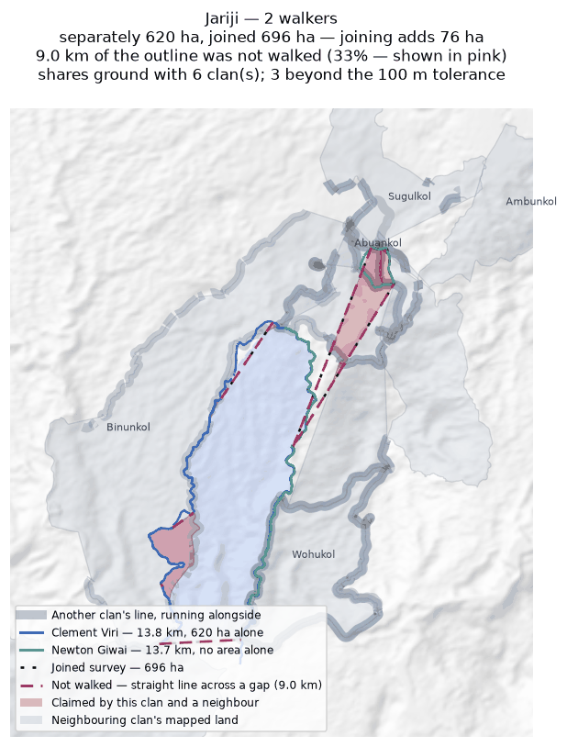
Each walker's line and the area it gives alone (dashed); the survey they combine into, dotted; the stretches nobody walked in pink; neighbouring clans in grey, ground both claim in red.

Manang
Zone 7B · version 1.1, 16 August 2026
Walkers | Surveys | Walked (km) | Access legs (km) | Pieces | Not walked (km) | Parcels | Area (ha) | Basis
1 | 1 | 7.1 | 0.0 | 1 | 1.8 | 1 | 353 | inferred
Custodians
Custodian | Tracks | Days | First | Last | Walked (km)
Kelly Wahamo | 1 | 1 | 2026-07-01 | 2026-07-01 | 7.1
Ground also claimed by another clan
Clan | Shared (ha) | % of this clan | Beyond 100 m (ha) | Verdict
Ginangi | 312 | 88.3% | 311 | overlap
Sugulkol | 3 | 0.8% | 0 | within tolerance
Boundary walked alongside another clan
Clan | Shared line (km) | % of this clan's line
Murai (Z7B) | 2.7 | 37.0%
Sugulkol | 1.2 | 13.9%
Marang | 0.6 | 7.9%
Ginangi | 1.1 | 4.4%
Problems
- The boundary does not close. 1.8 km in 1 stretch was bridged with straight lines nobody walked — 25% of the distance walked, so 353 ha is an estimate rather than a measured area. On the map those stretches are pink.
- Overlaps 1 other clan by more than the 100 m tolerance: Ginangi (312 ha, 88% of this clan's land).
- A further 1 clan (Sugulkol) share ground only in strips narrower than 100 m. That is the two lines being the same line, not a competing claim, and it is not counted as overlap.
Queries for the field
- 25% of this outline was not walked — 1.8 km of straight line, shown in pink. Does the boundary in fact run along those straight lines, or somewhere else? Can the missing stretches be walked?
- Is the ground shared with Ginangi disputed, shared by agreement, or recorded wrongly? No change will be made to either boundary without the community's decision.
Map
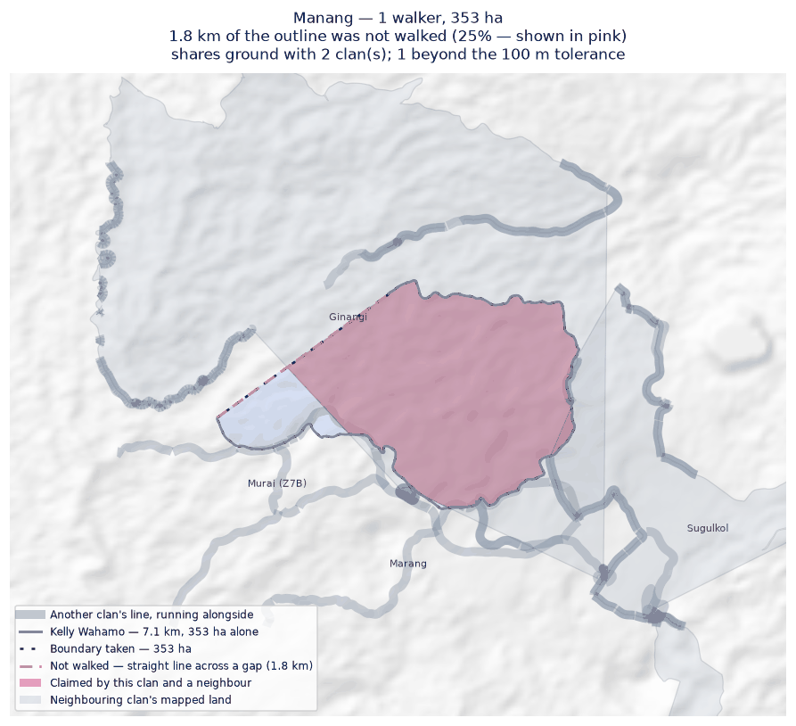
The walk, the area it gives (dotted), the stretches nobody walked in pink; neighbouring clans in grey, ground both claim in red.

Marang
Zone 7B · version 1.1, 16 August 2026
Walkers | Surveys | Walked (km) | Access legs (km) | Pieces | Not walked (km) | Parcels | Area (ha) | Basis
1 | 1 | 8.3 | 1.3 | 2 | 5.5 | — | none | no area
Custodians
Custodian | Tracks | Days | First | Last | Walked (km)
Henry Manderi | 2 | 2 | 2026-06-05 | 2026-06-06 | 8.3
Boundary walked alongside another clan
Clan | Shared line (km) | % of this clan's line
Marijabimkol | 4.1 | 48.5%
Murai (Z7B) | 1.9 | 14.5%
Binunkol | 1.1 | 12.9%
Manang | 0.6 | 6.3%
Problems
- No area can be given. The tracks are in 2 disconnected pieces and 5.5 km of straight-line joining would be needed to make a ring — 67% of the distance walked. That is beyond the 50% limit, above which an area would be more assumption than survey.
- No overlapping area, but 49% of this clan's recorded line runs within 100 m of Marijabimkol's. The two describe the same edge on the ground.
Queries for the field
- Can the missing stretches be walked so this boundary closes? If any gap is deliberate — a river, a road, an agreed open edge — please say what runs along it.
Map
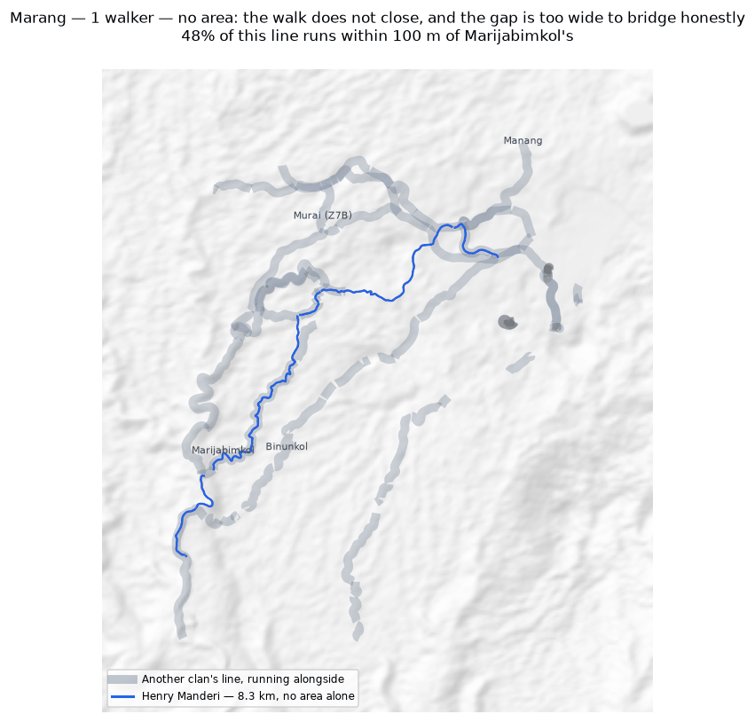
The walk, the area it gives (dotted), the stretches nobody walked in pink; neighbouring clans in grey, ground both claim in red.

Marijabimkol
Zone 7B · version 1.1, 16 August 2026
Walkers | Surveys | Walked (km) | Access legs (km) | Pieces | Not walked (km) | Parcels | Area (ha) | Basis
1 | 1 | 11.0 | 2.5 | 4 | 6.1 | — | none | no area
Custodians
Custodian | Tracks | Days | First | Last | Walked (km)
Japhet Nagura | 7 | 4 | 2025-10-21 | 2025-11-05 | 11.0
Boundary walked alongside another clan
Clan | Shared line (km) | % of this clan's line
Marang | 4.1 | 37.7%
Murai (Z7B) | 1.3 | 11.5%
Sugulkol | 0.4 | 1.8%
Binunkol | 0.4 | 1.8%
Ginangi | 0.3 | 1.8%
Abuankol | 0.2 | 1.8%
Wohukol | 0.2 | 1.8%
Problems
- No area can be given. The tracks are in 4 disconnected pieces and 6.1 km of straight-line joining would be needed to make a ring — 61% of the distance walked. That is beyond the 50% limit, above which an area would be more assumption than survey.
- No overlapping area, but 38% of this clan's recorded line runs within 100 m of Marang's. The two describe the same edge on the ground.
Queries for the field
- Can the missing stretches be walked so this boundary closes? If any gap is deliberate — a river, a road, an agreed open edge — please say what runs along it.
Map
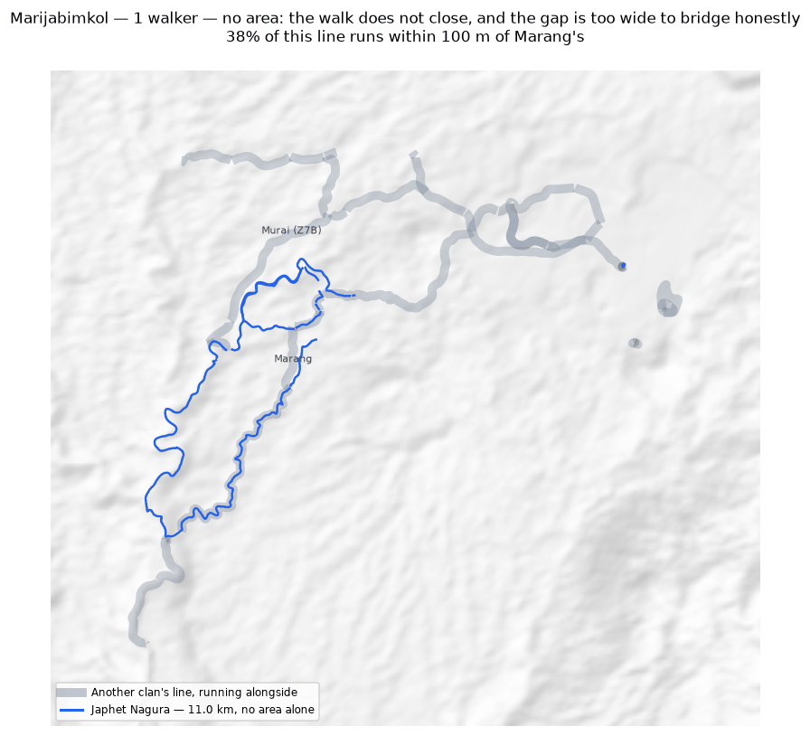
The walk, the area it gives (dotted), the stretches nobody walked in pink; neighbouring clans in grey, ground both claim in red.

Murai (Z7B)
Zone 7B · version 1.1, 16 August 2026
Walkers | Surveys | Walked (km) | Access legs (km) | Pieces | Not walked (km) | Parcels | Area (ha) | Basis
1 | 1 | 12.4 | 2.9 | 5 | 7.2 | — | none | no area
Custodians
Custodian | Tracks | Days | First | Last | Walked (km)
James Iroti | 8 | 6 | 2025-10-21 | 2026-03-11 | 12.4
Boundary walked alongside another clan
Clan | Shared line (km) | % of this clan's line
Manang | 2.7 | 21.9%
Marang | 1.9 | 15.1%
Sugulkol | 3.0 | 14.1%
Wohukol | 1.2 | 9.3%
Marijabimkol | 1.3 | 8.9%
Abuankol | 1.0 | 8.4%
Ambunkol | 1.0 | 8.1%
Binunkol | 0.9 | 6.6%
Jariji | 0.8 | 6.1%
Ginangi | 1.5 | 4.4%
Natang | 0.4 | 3.6%
Problems
- No area can be given. The tracks are in 5 disconnected pieces and 7.2 km of straight-line joining would be needed to make a ring — 64% of the distance walked. That is beyond the 50% limit, above which an area would be more assumption than survey.
- No overlapping area, but 22% of this clan's recorded line runs within 100 m of Manang's. The two describe the same edge on the ground.
Queries for the field
- Can the missing stretches be walked so this boundary closes? If any gap is deliberate — a river, a road, an agreed open edge — please say what runs along it.
Map
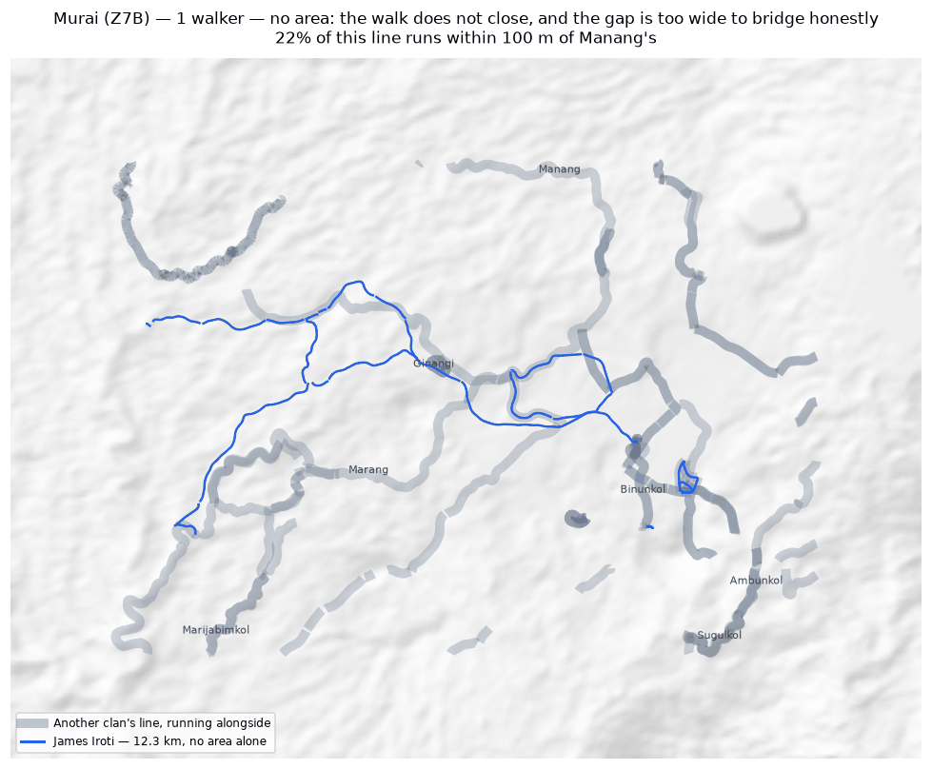
The walk, the area it gives (dotted), the stretches nobody walked in pink; neighbouring clans in grey, ground both claim in red.

Natang
Zone 7B · version 1.1, 16 August 2026
Walkers | Surveys | Walked (km) | Access legs (km) | Pieces | Not walked (km) | Parcels | Area (ha) | Basis
2 | 2 | 77.3 | 3.4 | 2 | 6.5 | 2 | 1,533 | inferred
Custodians
Custodian | Tracks | Days | First | Last | Walked (km)
Stafford Gidiri | 2 | 1 | 2025-11-10 | 2025-11-10 | 46.5
Dickson Hoe | 4 | 3 | 2025-11-06 | 2026-02-16 | 30.8
Ground also claimed by another clan
Clan | Shared (ha) | % of this clan | Beyond 100 m (ha) | Verdict
Ambunkol | 345 | 22.5% | 340 | overlap
Sugulkol | 32 | 2.1% | 29 | overlap
Wohukol | 4 | 0.3% | 1 | overlap
Boundary walked alongside another clan
Clan | Shared line (km) | % of this clan's line
Ambunkol | 20.3 | 37.6%
Wohukol | 8.8 | 16.0%
Sugulkol | 3.6 | 5.3%
Murai (Z7B) | 0.4 | 0.7%
Jariji | 0.2 | 0.3%
Abuankol | 0.0 | 0.0%
Problems
- The boundary does not close. 6.5 km in 2 stretches was bridged with straight lines nobody walked — 9% of the distance walked, so 1,533 ha is an estimate rather than a measured area. On the map those stretches are pink.
- The walks enclose 2 separate parcels, totalling 1,533 ha. All of them are counted. Whether they are all this clan's land, or whether one belongs to a neighbour, is a question for the clan.
- Joining the 2 walkers costs 822 ha: separately they give 2,355 ha, joined 1,533 ha. This happens where walkers each walked the same ring rather than different stretches — the two rings cross and the joined network encloses less than either walk did alone.
- Overlaps 3 other clans by more than the 100 m tolerance: Ambunkol (345 ha, 23% of this clan's land); Sugulkol (32 ha, 2% of this clan's land); Wohukol (4 ha, 0% of this clan's land).
Queries for the field
- This clan's land is recorded as 2 separate pieces. Is that right, and does each piece belong to this clan?
- Did the 2 custodians walk the same boundary, or different parts of it? If they walked the same ring, their surveys should be treated as separate accounts rather than joined.
- Is the ground shared with Ambunkol, Sugulkol, Wohukol disputed, shared by agreement, or recorded wrongly? No change will be made to either boundary without the community's decision.
Map
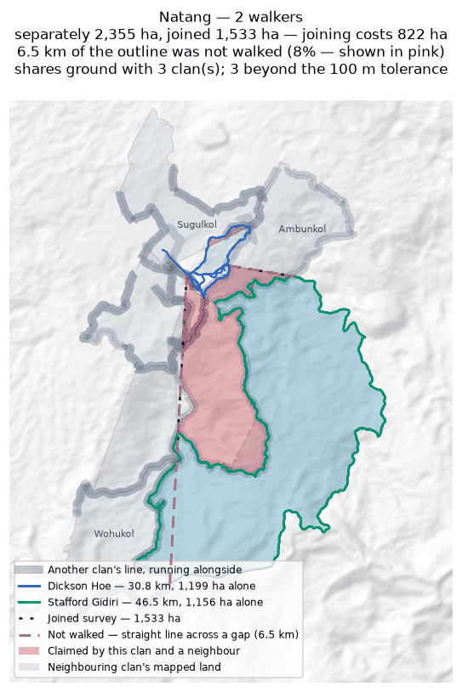
Each walker's line and the area it gives alone (dashed); the survey they combine into, dotted; the stretches nobody walked in pink; neighbouring clans in grey, ground both claim in red.

Sugulkol
Zone 7B · version 1.1, 16 August 2026
Walkers | Surveys | Walked (km) | Access legs (km) | Pieces | Not walked (km) | Parcels | Area (ha) | Basis
2 | 2 | 24.0 | 1.3 | 6 | 3.7 | 1 | 314 | inferred
Custodians
Custodian | Tracks | Days | First | Last | Walked (km)
Emmanuel Fufus | 6 | 6 | 2025-11-06 | 2026-03-02 | 13.4
Chris Idua | 6 | 3 | 2025-11-06 | 2025-11-08 | 10.6
Ground also claimed by another clan
Clan | Shared (ha) | % of this clan | Beyond 100 m (ha) | Verdict
Ginangi | 52 | 16.4% | 51 | overlap
Natang | 32 | 10.3% | 29 | overlap
Wohukol | 21 | 6.7% | 19 | overlap
Jariji | 8 | 2.4% | 7 | overlap
Ambunkol | 5 | 1.7% | 0 | within tolerance
Manang | 3 | 0.9% | 0 | within tolerance
Binunkol | 2 | 0.5% | 1 | overlap
Abuankol | 1 | 0.2% | 0 | within tolerance
Boundary walked alongside another clan
Clan | Shared line (km) | % of this clan's line
Ambunkol | 5.9 | 24.4%
Natang | 3.6 | 15.0%
Wohukol | 3.2 | 13.3%
Murai (Z7B) | 3.0 | 12.4%
Jariji | 2.2 | 9.1%
Abuankol | 1.8 | 7.4%
Manang | 1.2 | 5.1%
Binunkol | 1.1 | 4.4%
Ginangi | 0.6 | 2.5%
Marijabimkol | 0.4 | 1.7%
Problems
- The boundary does not close. 3.7 km in 6 stretches was bridged with straight lines nobody walked — 16% of the distance walked, so 314 ha is an estimate rather than a measured area. On the map those stretches are pink.
- Joining the 2 walkers costs 317 ha: separately they give 630 ha, joined 314 ha. This happens where walkers each walked the same ring rather than different stretches — the two rings cross and the joined network encloses less than either walk did alone.
- Overlaps 5 other clans by more than the 100 m tolerance: Ginangi (52 ha, 16% of this clan's land); Natang (32 ha, 10% of this clan's land); Wohukol (21 ha, 7% of this clan's land); Jariji (8 ha, 2% of this clan's land).
- A further 3 clans (Ambunkol, Manang, Abuankol) share ground only in strips narrower than 100 m. That is the two lines being the same line, not a competing claim, and it is not counted as overlap.
Queries for the field
- Did the 2 custodians walk the same boundary, or different parts of it? If they walked the same ring, their surveys should be treated as separate accounts rather than joined.
- Is the ground shared with Ginangi, Natang, Wohukol disputed, shared by agreement, or recorded wrongly? No change will be made to either boundary without the community's decision.
- This boundary is recorded in 6 separate pieces. Were the connecting stretches walked but not recorded, or not yet walked?
Map
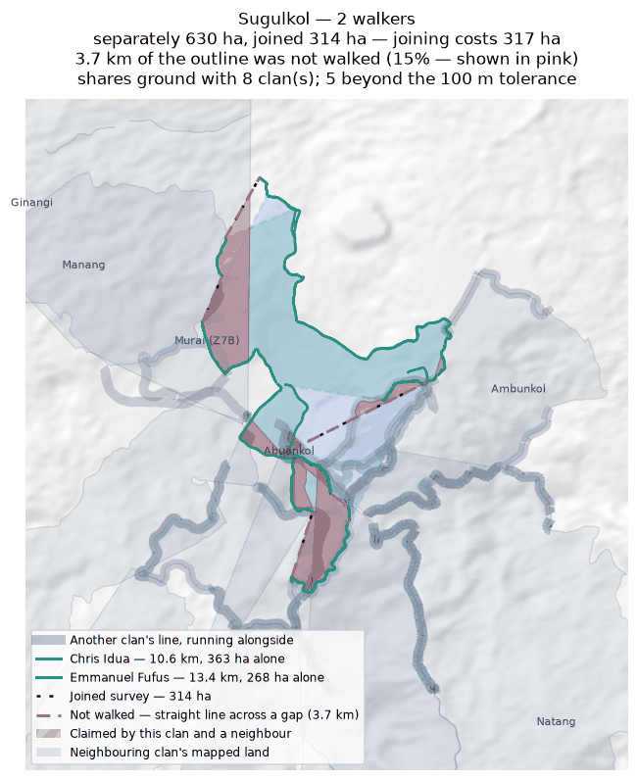
Each walker's line and the area it gives alone (dashed); the survey they combine into, dotted; the stretches nobody walked in pink; neighbouring clans in grey, ground both claim in red.

Wohukol
Zone 7B · version 1.1, 16 August 2026
Walkers | Surveys | Walked (km) | Access legs (km) | Pieces | Not walked (km) | Parcels | Area (ha) | Basis
2 | 2 | 34.9 | 4.9 | 4 | 8.3 | 3 | 701 | inferred
Custodians
Custodian | Tracks | Days | First | Last | Walked (km)
Nelson Runage | 4 | 2 | 2025-11-06 | 2025-11-10 | 17.8
Darline Walele | 5 | 4 | 2025-10-25 | 2025-11-10 | 17.1
Ground also claimed by another clan
Clan | Shared (ha) | % of this clan | Beyond 100 m (ha) | Verdict
Jariji | 62 | 8.8% | 59 | overlap
Binunkol | 29 | 4.2% | 27 | overlap
Sugulkol | 21 | 3.0% | 19 | overlap
Natang | 4 | 0.6% | 1 | overlap
Ambunkol | 3 | 0.4% | 1 | overlap
Abuankol | 0 | 0.0% | 0 | within tolerance
Ginangi | 0 | 0.0% | 0 | within tolerance
Boundary walked alongside another clan
Clan | Shared line (km) | % of this clan's line
Natang | 8.8 | 25.1%
Jariji | 8.6 | 24.6%
Ambunkol | 2.2 | 6.2%
Sugulkol | 3.2 | 5.3%
Murai (Z7B) | 1.2 | 1.6%
Abuankol | 0.5 | 0.9%
Binunkol | 0.8 | 0.7%
Ginangi | 0.3 | 0.1%
Marijabimkol | 0.2 | 0.1%
Problems
- The boundary does not close. 8.3 km in 4 stretches was bridged with straight lines nobody walked — 25% of the distance walked, so 701 ha is an estimate rather than a measured area. On the map those stretches are pink.
- The walks enclose 3 separate parcels, totalling 701 ha. All of them are counted. Whether they are all this clan's land, or whether one belongs to a neighbour, is a question for the clan.
- Joining the 2 walkers adds 86 ha: separately 615 ha, joined 701 ha. The walkers covered different stretches of one boundary.
- Overlaps 5 other clans by more than the 100 m tolerance: Jariji (62 ha, 9% of this clan's land); Binunkol (29 ha, 4% of this clan's land); Sugulkol (21 ha, 3% of this clan's land); Natang (4 ha, 1% of this clan's land).
- A further 2 clans (Abuankol, Ginangi) share ground only in strips narrower than 100 m. That is the two lines being the same line, not a competing claim, and it is not counted as overlap.
Queries for the field
- 25% of this outline was not walked — 8.3 km of straight line, shown in pink. Does the boundary in fact run along those straight lines, or somewhere else? Can the missing stretches be walked?
- This clan's land is recorded as 3 separate pieces. Is that right, and does each piece belong to this clan?
- Is the ground shared with Jariji, Binunkol, Sugulkol disputed, shared by agreement, or recorded wrongly? No change will be made to either boundary without the community's decision.
- This boundary is recorded in 4 separate pieces. Were the connecting stretches walked but not recorded, or not yet walked?
Map
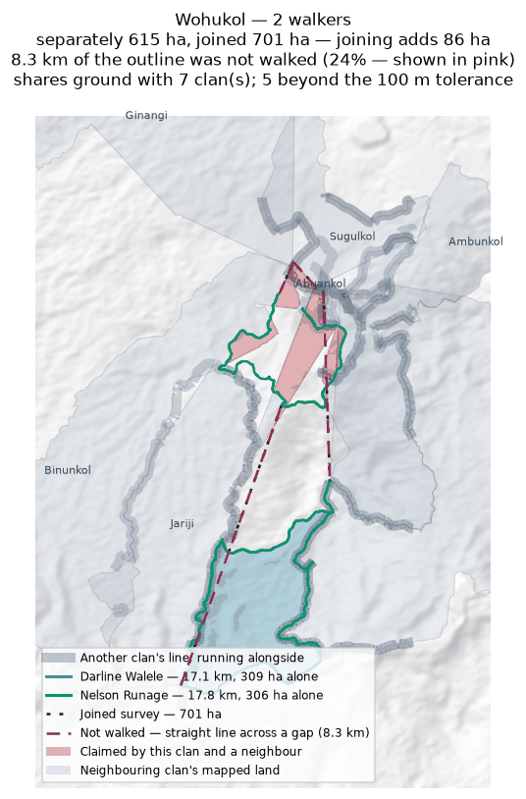
Each walker's line and the area it gives alone (dashed); the survey they combine into, dotted; the stretches nobody walked in pink; neighbouring clans in grey, ground both claim in red.

Zone 8

Duribip
Zone 8 · version 1.1, 16 August 2026
Walkers | Surveys | Walked (km) | Access legs (km) | Pieces | Not walked (km) | Parcels | Area (ha) | Basis
1 | 1 | 4.5 | 0.2 | 3 | 5.9 | — | none | no area
Custodians
Custodian | Tracks | Days | First | Last | Walked (km)
Beven Naive | 4 | 2 | 2025-07-11 | 2025-07-21 | 4.5
Boundary walked alongside another clan
Clan | Shared line (km) | % of this clan's line
Riribudeh | 0.5 | 5.4%
Madukol | 0.0 | 0.4%
Problems
- No area can be given. The tracks are in 3 disconnected pieces and 5.9 km of straight-line joining would be needed to make a ring — 139% of the distance walked. That is beyond the 50% limit, above which an area would be more assumption than survey.
- No overlapping area, but 5% of this clan's recorded line runs within 100 m of Riribudeh's. The two describe the same edge on the ground.
Queries for the field
- Can the missing stretches be walked so this boundary closes? If any gap is deliberate — a river, a road, an agreed open edge — please say what runs along it.
Map
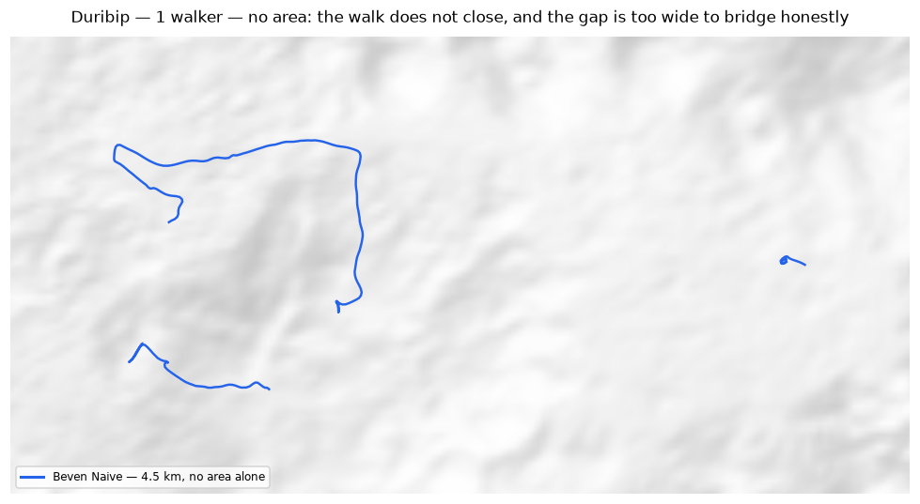
The walk, the area it gives (dotted), the stretches nobody walked in pink; neighbouring clans in grey, ground both claim in red.

Dusi
Zone 8 · version 1.1, 16 August 2026
Walkers | Surveys | Walked (km) | Access legs (km) | Pieces | Not walked (km) | Parcels | Area (ha) | Basis
1 | 1 | 33.0 | 7.4 | 4 | 1.9 | 1 | 219 | inferred
Custodians
Custodian | Tracks | Days | First | Last | Walked (km)
Max Mamo | 52 | 3 | 2025-06-05 | 2025-06-19 | 33.0
Ground also claimed by another clan
Clan | Shared (ha) | % of this clan | Beyond 100 m (ha) | Verdict
Riribudeh | 7 | 3.0% | 6 | overlap
Gubai | 2 | 0.7% | 0 | within tolerance
Boundary walked alongside another clan
Clan | Shared line (km) | % of this clan's line
Gubai | 2.4 | 22.4%
Riribudeh | 3.0 | 18.4%
Problems
- The boundary does not close. 1.9 km in 4 stretches was bridged with straight lines nobody walked — 6% of the distance walked, so 219 ha is an estimate rather than a measured area. On the map those stretches are pink.
- Overlaps 1 other clan by more than the 100 m tolerance: Riribudeh (7 ha, 3% of this clan's land).
- A further 1 clan (Gubai) share ground only in strips narrower than 100 m. That is the two lines being the same line, not a competing claim, and it is not counted as overlap.
Queries for the field
- Is the ground shared with Riribudeh disputed, shared by agreement, or recorded wrongly? No change will be made to either boundary without the community's decision.
- This boundary is recorded in 4 separate pieces. Were the connecting stretches walked but not recorded, or not yet walked?
Map
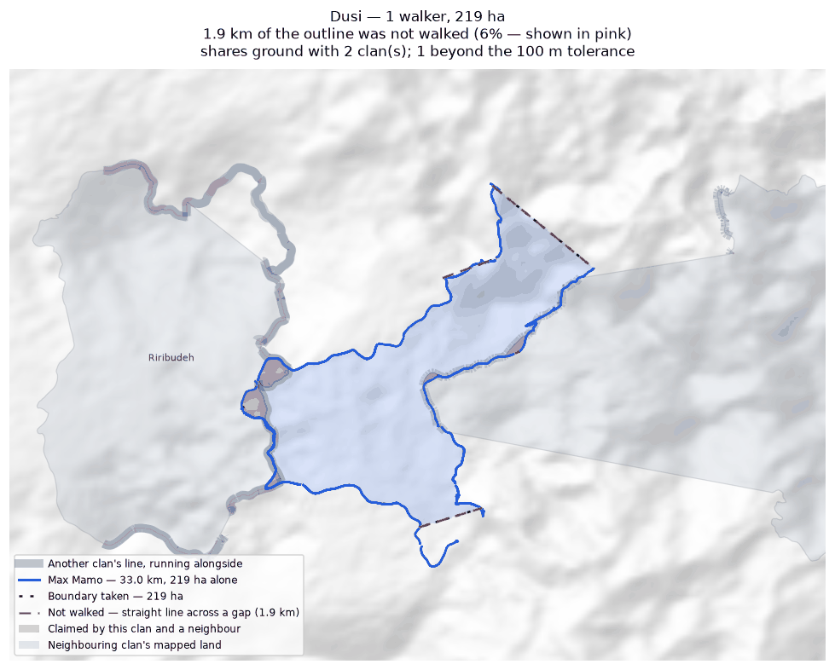
The walk, the area it gives (dotted), the stretches nobody walked in pink; neighbouring clans in grey, ground both claim in red.

Gubai
Zone 8 · version 1.1, 16 August 2026
Walkers | Surveys | Walked (km) | Access legs (km) | Pieces | Not walked (km) | Parcels | Area (ha) | Basis
2 | 2 | 134.5 | 0.0 | 7 | 5.0 | 1 | 1,173 | inferred
Custodians
Custodian | Tracks | Days | First | Last | Walked (km)
Kenny Noi | 55 | 5 | 2025-05-22 | 2025-07-19 | 91.9
Fordy Igai | 20 | 2 | 2025-05-22 | 2025-06-03 | 42.7
Ground also claimed by another clan
Clan | Shared (ha) | % of this clan | Beyond 100 m (ha) | Verdict
Dusi | 2 | 0.1% | 0 | within tolerance
Boundary walked alongside another clan
Clan | Shared line (km) | % of this clan's line
Dusi | 2.4 | 9.2%
Problems
- The boundary does not close. 5.0 km in 7 stretches was bridged with straight lines nobody walked — 4% of the distance walked, so 1,173 ha is an estimate rather than a measured area. On the map those stretches are pink.
- Joining the 2 walkers costs 493 ha: separately they give 1,667 ha, joined 1,173 ha. This happens where walkers each walked the same ring rather than different stretches — the two rings cross and the joined network encloses less than either walk did alone.
- A further 1 clan (Dusi) share ground only in strips narrower than 100 m. That is the two lines being the same line, not a competing claim, and it is not counted as overlap.
Queries for the field
- Did the 2 custodians walk the same boundary, or different parts of it? If they walked the same ring, their surveys should be treated as separate accounts rather than joined.
- This boundary is recorded in 7 separate pieces. Were the connecting stretches walked but not recorded, or not yet walked?
Map
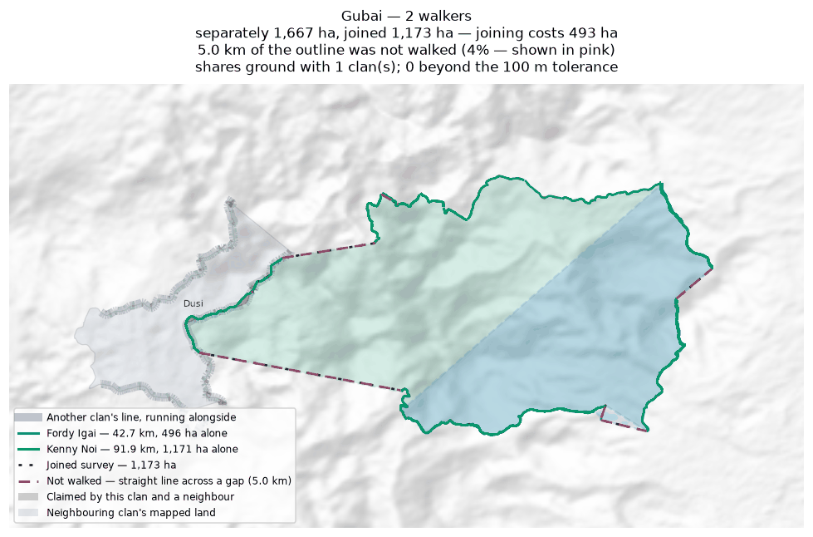
Each walker's line and the area it gives alone (dashed); the survey they combine into, dotted; the stretches nobody walked in pink; neighbouring clans in grey, ground both claim in red.

Gumuyude
Zone 8 · version 1.1, 16 August 2026
Walkers | Surveys | Walked (km) | Access legs (km) | Pieces | Not walked (km) | Parcels | Area (ha) | Basis
1 | 1 | 16.8 | 3.9 | 7 | 2.3 | 1 | 691 | inferred
Custodians
Custodian | Tracks | Days | First | Last | Walked (km)
Philip Igai | 6 | 6 | 2025-05-19 | 2025-06-04 | 16.8
Ground also claimed by another clan
Clan | Shared (ha) | % of this clan | Beyond 100 m (ha) | Verdict
Riribudeh | 4 | 0.5% | 0 | within tolerance
Mungaikol | 1 | 0.1% | 0 | within tolerance
Boundary walked alongside another clan
Clan | Shared line (km) | % of this clan's line
Mungaikol | 1.8 | 10.7%
Uremkol | 1.8 | 10.2%
Riribudeh | 2.4 | 6.9%
Problems
- The boundary does not close. 2.3 km in 7 stretches was bridged with straight lines nobody walked — 15% of the distance walked, so 691 ha is an estimate rather than a measured area. On the map those stretches are pink.
- A further 2 clans (Riribudeh, Mungaikol) share ground only in strips narrower than 100 m. That is the two lines being the same line, not a competing claim, and it is not counted as overlap.
Queries for the field
- This boundary is recorded in 7 separate pieces. Were the connecting stretches walked but not recorded, or not yet walked?
Map
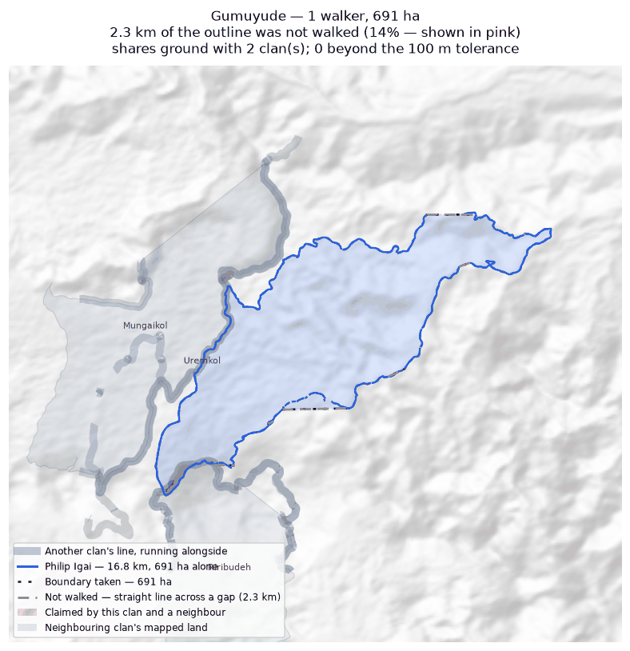
The walk, the area it gives (dotted), the stretches nobody walked in pink; neighbouring clans in grey, ground both claim in red.

Madukol
Zone 8 · version 1.1, 16 August 2026
Walkers | Surveys | Walked (km) | Access legs (km) | Pieces | Not walked (km) | Parcels | Area (ha) | Basis
1 | 1 | 1.1 | 0.0 | 2 | 0.3 | 2 | 1 | inferred
Custodians
Custodian | Tracks | Days | First | Last | Walked (km)
Gibs Ginave | 5 | 3 | 2025-07-15 | 2025-08-04 | 1.1
Boundary walked alongside another clan
Clan | Shared line (km) | % of this clan's line
Duribip | 0.0 | 3.9%
Problems
- The boundary does not close. 0.3 km in 2 stretches was bridged with straight lines nobody walked — 27% of the distance walked, so 1 ha is an estimate rather than a measured area. On the map those stretches are pink.
- The walks enclose 2 separate parcels, totalling 1 ha. All of them are counted. Whether they are all this clan's land, or whether one belongs to a neighbour, is a question for the clan.
- No overlapping area, but 4% of this clan's recorded line runs within 100 m of Duribip's. The two describe the same edge on the ground.
Queries for the field
- 27% of this outline was not walked — 0.3 km of straight line, shown in pink. Does the boundary in fact run along those straight lines, or somewhere else? Can the missing stretches be walked?
- This clan's land is recorded as 2 separate pieces. Is that right, and does each piece belong to this clan?
Map
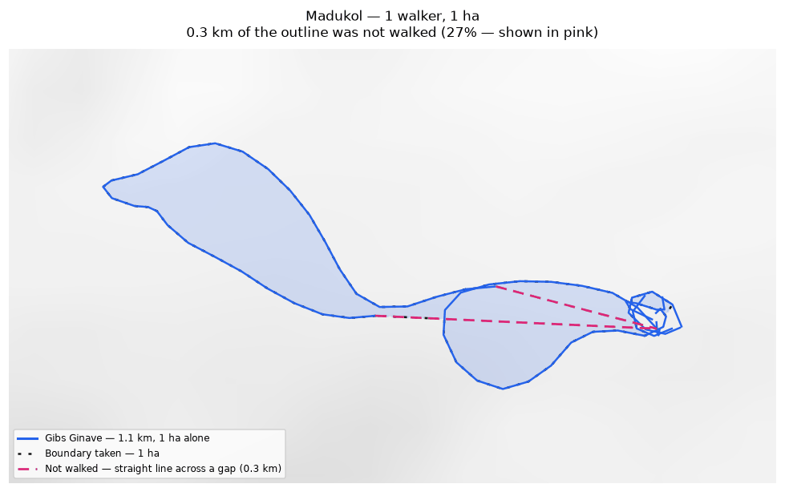
The walk, the area it gives (dotted), the stretches nobody walked in pink; neighbouring clans in grey, ground both claim in red.

Mungaikol
Zone 8 · version 1.1, 16 August 2026
Walkers | Surveys | Walked (km) | Access legs (km) | Pieces | Not walked (km) | Parcels | Area (ha) | Basis
1 | 1 | 14.8 | 2.8 | 3 | 2.3 | 1 | 570 | inferred
Custodians
Custodian | Tracks | Days | First | Last | Walked (km)
Graham Ekiawa | 5 | 5 | 2025-07-13 | 2025-07-21 | 14.8
Ground also claimed by another clan
Clan | Shared (ha) | % of this clan | Beyond 100 m (ha) | Verdict
Gumuyude | 1 | 0.1% | 0 | within tolerance
Borori | 0 | 0.0% | 0 | within tolerance
Boundary walked alongside another clan
Clan | Shared line (km) | % of this clan's line
Uremkol | 7.6 | 51.2%
Gumuyude | 1.8 | 12.1%
Borori | 0.4 | 1.5%
Problems
- The boundary does not close. 2.3 km in 3 stretches was bridged with straight lines nobody walked — 17% of the distance walked, so 570 ha is an estimate rather than a measured area. On the map those stretches are pink.
- A further 2 clans (Gumuyude, Borori) share ground only in strips narrower than 100 m. That is the two lines being the same line, not a competing claim, and it is not counted as overlap.
Queries for the field
- 51% of this clan's line runs alongside Uremkol's. Is that a boundary the two clans share and agree on?
Map
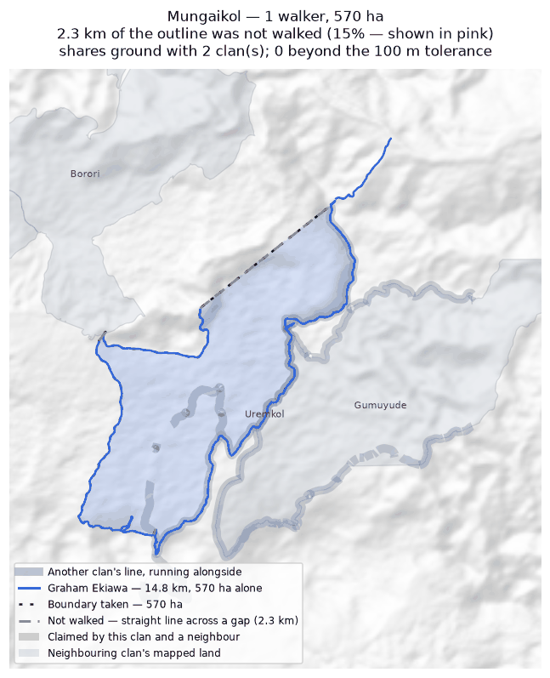
The walk, the area it gives (dotted), the stretches nobody walked in pink; neighbouring clans in grey, ground both claim in red.

Riribudeh
Zone 8 · version 1.1, 16 August 2026
Walkers | Surveys | Walked (km) | Access legs (km) | Pieces | Not walked (km) | Parcels | Area (ha) | Basis
2 | 2 | 20.4 | 0.3 | 3 | 1.6 | 1 | 372 | inferred
Custodians
Custodian | Tracks | Days | First | Last | Walked (km)
Prut Buitari | 7 | 3 | 2025-07-15 | 2025-07-23 | 10.4
Unido Ose | 28 | 3 | 2025-07-15 | 2025-07-23 | 10.0
Ground also claimed by another clan
Clan | Shared (ha) | % of this clan | Beyond 100 m (ha) | Verdict
Dusi | 7 | 1.8% | 6 | overlap
Gumuyude | 4 | 1.0% | 0 | within tolerance
Boundary walked alongside another clan
Clan | Shared line (km) | % of this clan's line
Dusi | 3.0 | 14.7%
Gumuyude | 2.4 | 11.6%
Duribip | 0.5 | 2.3%
Problems
- The boundary does not close. 1.6 km in 3 stretches was bridged with straight lines nobody walked — 8% of the distance walked, so 372 ha is an estimate rather than a measured area. On the map those stretches are pink.
- Joining the 2 walkers costs 398 ha: separately they give 770 ha, joined 372 ha. This happens where walkers each walked the same ring rather than different stretches — the two rings cross and the joined network encloses less than either walk did alone.
- Overlaps 1 other clan by more than the 100 m tolerance: Dusi (7 ha, 2% of this clan's land).
- A further 1 clan (Gumuyude) share ground only in strips narrower than 100 m. That is the two lines being the same line, not a competing claim, and it is not counted as overlap.
Queries for the field
- Did the 2 custodians walk the same boundary, or different parts of it? If they walked the same ring, their surveys should be treated as separate accounts rather than joined.
- Is the ground shared with Dusi disputed, shared by agreement, or recorded wrongly? No change will be made to either boundary without the community's decision.
Map
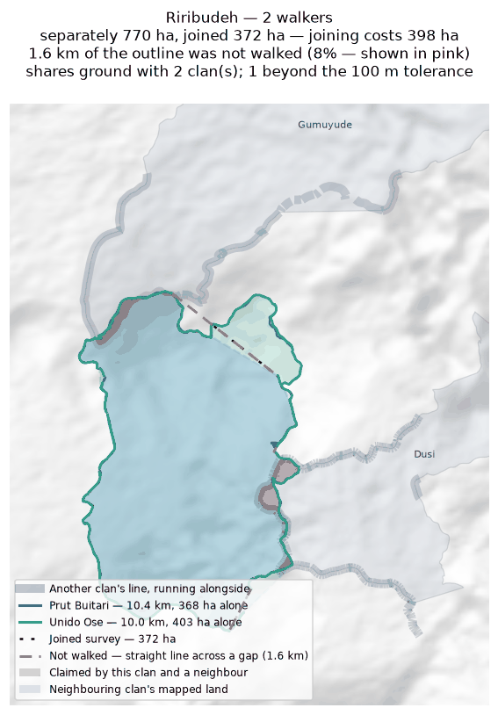
Each walker's line and the area it gives alone (dashed); the survey they combine into, dotted; the stretches nobody walked in pink; neighbouring clans in grey, ground both claim in red.

Uremkol
Zone 8 · version 1.1, 16 August 2026
Walkers | Surveys | Walked (km) | Access legs (km) | Pieces | Not walked (km) | Parcels | Area (ha) | Basis
1 | 1 | 11.2 | 2.4 | 4 | 6.3 | — | none | no area
Custodians
Custodian | Tracks | Days | First | Last | Walked (km)
Cyprian Sirami | 3 | 2 | 2025-07-16 | 2025-07-25 | 11.2
Boundary walked alongside another clan
Clan | Shared line (km) | % of this clan's line
Mungaikol | 7.6 | 67.2%
Gumuyude | 1.8 | 16.1%
Problems
- No area can be given. The tracks are in 4 disconnected pieces and 6.3 km of straight-line joining would be needed to make a ring — 58% of the distance walked. That is beyond the 50% limit, above which an area would be more assumption than survey.
- No overlapping area, but 67% of this clan's recorded line runs within 100 m of Mungaikol's. The two describe the same edge on the ground.
Queries for the field
- Can the missing stretches be walked so this boundary closes? If any gap is deliberate — a river, a road, an agreed open edge — please say what runs along it.
- 67% of this clan's line runs alongside Mungaikol's. Is that a boundary the two clans share and agree on?
Map
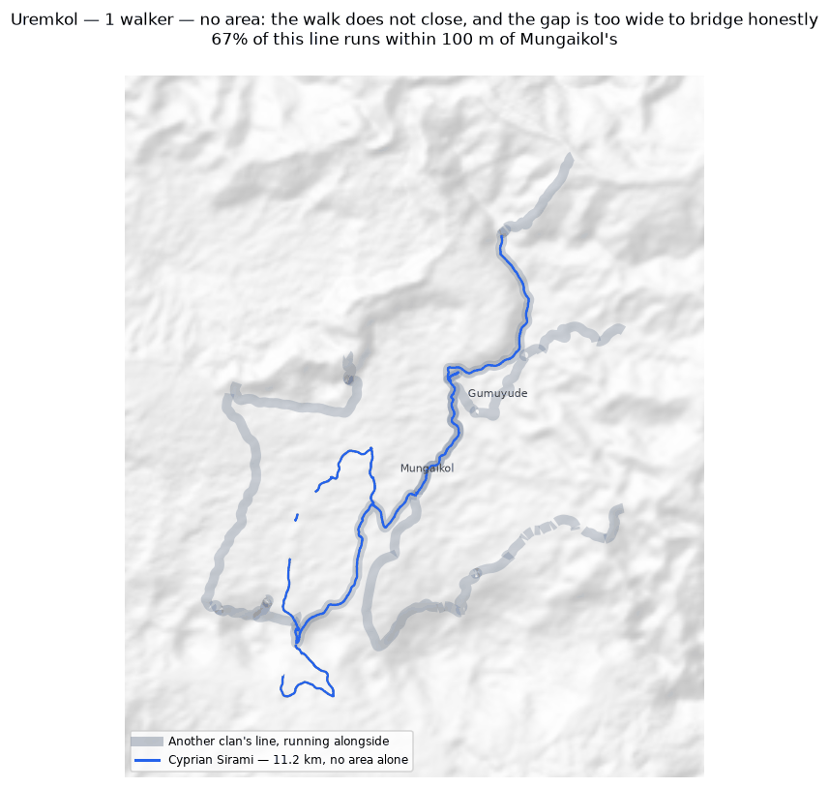
The walk, the area it gives (dotted), the stretches nobody walked in pink; neighbouring clans in grey, ground both claim in red.

4. Every overlapping pair
All 54 pairs of clans whose mapped land intersects, strictly and beyond the 100 m tolerance. A pair marked “within tolerance” shares only strips narrower than that, and is not counted as an overlap.
Clan | Clan | Shared (ha) | % of first | % of second | Beyond 100 m (ha) | Verdict
Nituri | Tuoko | 2,199 | 41.7% | 59.8% | 2,198 | overlap
Ambunkol | Natang | 345 | 58.4% | 22.5% | 340 | overlap
Borori | Darekikol | 333 | 52.1% | 56.7% | 329 | overlap
Ginangi | Manang | 312 | 25.2% | 88.3% | 311 | overlap
Asoro | Sukandi | 232 | 6.6% | 12.2% | 231 | overlap
Rondi | Sukandi | 212 | 13.5% | 11.1% | 211 | overlap
Juaiko | Sukandi | 205 | 15.8% | 10.8% | 202 | overlap
Kasaki | Tuoko | 157 | 29.0% | 4.3% | 155 | overlap
Kasaki | Murai (Z2) | 154 | 28.5% | 77.6% | 154 | overlap
Mariura | Naharaura | 148 | 17.4% | 25.0% | 144 | overlap
Majanko | Manoko | 65 | 23.6% | 16.1% | 65 | overlap
Jariji | Wohukol | 62 | 8.9% | 8.8% | 59 | overlap
Naharaura | Pina Ora | 60 | 10.0% | 7.3% | 59 | overlap
Kasaki | Nituri | 59 | 11.0% | 1.1% | 59 | overlap
Borori | Mariura | 56 | 8.8% | 6.6% | 52 | overlap
Ginangi | Sugulkol | 52 | 4.2% | 16.4% | 51 | overlap
Darekikol | Mariura | 50 | 8.6% | 5.9% | 50 | overlap
Binunkol | Jariji | 45 | 4.4% | 6.5% | 42 | overlap
Kasaki | Majanko | 40 | 7.4% | 14.5% | 39 | overlap
Natang | Sugulkol | 32 | 2.1% | 10.3% | 29 | overlap
Binunkol | Wohukol | 29 | 2.8% | 4.2% | 27 | overlap
Sugulkol | Wohukol | 21 | 6.7% | 3.0% | 19 | overlap
Asoro | Juaiko | 15 | 0.4% | 1.2% | 15 | overlap
Majanko | Tuoko | 13 | 4.5% | 0.3% | 12 | overlap
Juaiko | Manoko | 12 | 0.9% | 2.9% | 7 | overlap
Jariji | Sugulkol | 8 | 1.1% | 2.4% | 7 | overlap
Gariniko | Tuoko | 7 | 6.2% | 0.2% | 5 | overlap
Dusi | Riribudeh | 7 | 3.0% | 1.8% | 6 | overlap
Asingi | Murai (Z2) | 6 | 3.6% | 3.0% | 5 | overlap
Ambunkol | Sugulkol | 5 | 0.9% | 1.7% | 0 | within tolerance
Natang | Wohukol | 4 | 0.3% | 0.6% | 1 | overlap
Asingi | Gariniko | 4 | 2.5% | 3.9% | 3 | overlap
Gumuyude | Riribudeh | 4 | 0.5% | 1.0% | 0 | within tolerance
Gariniko | Nituri | 3 | 3.1% | 0.1% | 2 | overlap
Ambunkol | Wohukol | 3 | 0.5% | 0.4% | 1 | overlap
Manang | Sugulkol | 3 | 0.8% | 0.9% | 0 | within tolerance
Gariniko | Kasaki | 2 | 1.8% | 0.3% | 0 | within tolerance
Binunkol | Sugulkol | 2 | 0.1% | 0.5% | 1 | overlap
Dusi | Gubai | 2 | 0.7% | 0.1% | 0 | within tolerance
Binunkol | Rondi | 1 | 0.1% | 0.0% | 0 | within tolerance
Abuankol | Sugulkol | 1 | 92.2% | 0.2% | 0 | within tolerance
Gumuyude | Mungaikol | 1 | 0.1% | 0.1% | 0 | within tolerance
Gariniko | Murai (Z2) | 1 | 0.5% | 0.3% | 0 | within tolerance
Bimkol | Darekikol | 1 | 0.3% | 0.1% | 0 | within tolerance
Ambunkol | Jariji | 1 | 0.1% | 0.1% | 0 | within tolerance
Binunkol | Ginangi | 0 | 0.0% | 0.0% | 0 | within tolerance
Jariji | Sukandi | 0 | 0.0% | 0.0% | 0 | within tolerance
Binunkol | Sukandi | 0 | 0.0% | 0.0% | 0 | within tolerance
Abuankol | Jariji | 0 | 0.1% | 0.0% | 0 | within tolerance
Abuankol | Wohukol | 0 | 3.4% | 0.0% | 0 | within tolerance
Abuankol | Ambunkol | 0 | 0.1% | 0.0% | 0 | within tolerance
Asingi | Kasaki | 0 | 0.0% | 0.0% | 0 | within tolerance
Ginangi | Wohukol | 0 | 0.0% | 0.0% | 0 | within tolerance
Borori | Mungaikol | 0 | 0.0% | 0.0% | 0 | within tolerance

How these figures were produced
Setting | Value
Measurement CRS | EPSG:32755 (UTM 55S)
Smoothing | one point every 20 m
Clipped to | within 10 km of the conservation area
Track ends joined within | 25.0 m
Widest gap still given an area | 50% of the distance walked
Overlap tolerance | 100 m
Code revision | 45bfd30
The full method, with every parameter and the reasoning behind it, is in docs/METHODS.md in the project repository. The raw survey data is never edited; everything here is derived from it and can be rebuilt from it.

