Managalas Clan Land Mapping
Survey results, per-clan detail, and queries for the field
Clan land boundaries in the Managalas Conservation Area, Oro Province, Papua New Guinea. Mapped by Clan Stewards at the request of clan elders through the Clan Elder Workshops. Each community decides whether to map; where a boundary is disputed the community decides whether to resolve it or leave the area aside.
Sacred site locations are not shared. They are reported by area and share of clan land only, and appear in no map or layer in this document.

Contents

1. What has been mapped
Measure | Value
Clans with data | 47
Custodians who walked | 67
Individual surveys | 69
Clan boundaries assessed (walkers joined) | 35
Distance walked | 1,112.9 km
Boundary walked (excl. access legs and non-boundary) | 924.5 km
Boundary distance excludes surveys that are not land boundaries, and the legs walked in to reach a boundary and out again.

Land area
Basis | Boundaries | Hectares
Walked and closed | 5 | 2,542
Closure inferred (gap bridged) | 30 | 29,989
Total mapped | 35 | 32,531
Footprint (overlaps counted once) |  | 27,713
Conservation area |  | 213,269
92% of the mapped area rests on an inferred closure — the boundary was not walked the whole way round and the gap has been bridged with a straight line. Those areas are estimates and are labelled as such throughout.
The mapped footprint is 13.0% of the conservation area.

By zone
Zone | Clans | Custodians | Surveys | Walked (km) | Boundary (km) | Area (ha)
Zone 2 | 15 | 18 | 20 | 320.5 | 257.4 | 18,583
Zone 3 | 4 | 8 | 8 | 48.7 | 42.0 | 10
Zone 6 | 5 | 7 | 7 | 151.6 | 125.9 | 3,089
Zone 7A | 3 | 6 | 6 | 73.7 | 53.9 | 1,167
Zone 7B | 12 | 18 | 18 | 282.3 | 230.6 | 6,657
Zone 8 | 8 | 10 | 10 | 236.1 | 214.8 | 3,026

Overlap between clans
Measure | Value
Clans with a mapped area | 34
Clans whose land overlaps another clan's | 31
Clans with no overlap | 3
Area claimed by more than one clan | 4,454 ha
This is the finding with the widest implications. The PNG Incorporated Land Group system rests on land being held by a single clan, undisputed. On this evidence that assumption does not describe the Managalas.
Read with care: most boundaries rest on inferred closures, so some overlap is an artefact of straight-line bridging rather than a competing claim. It does not disappear when only walked boundaries are counted, but the headline share is inflated by the inferred ones.
Overlaps are recorded as mapped. They are not reconciled, and clans are never merged.
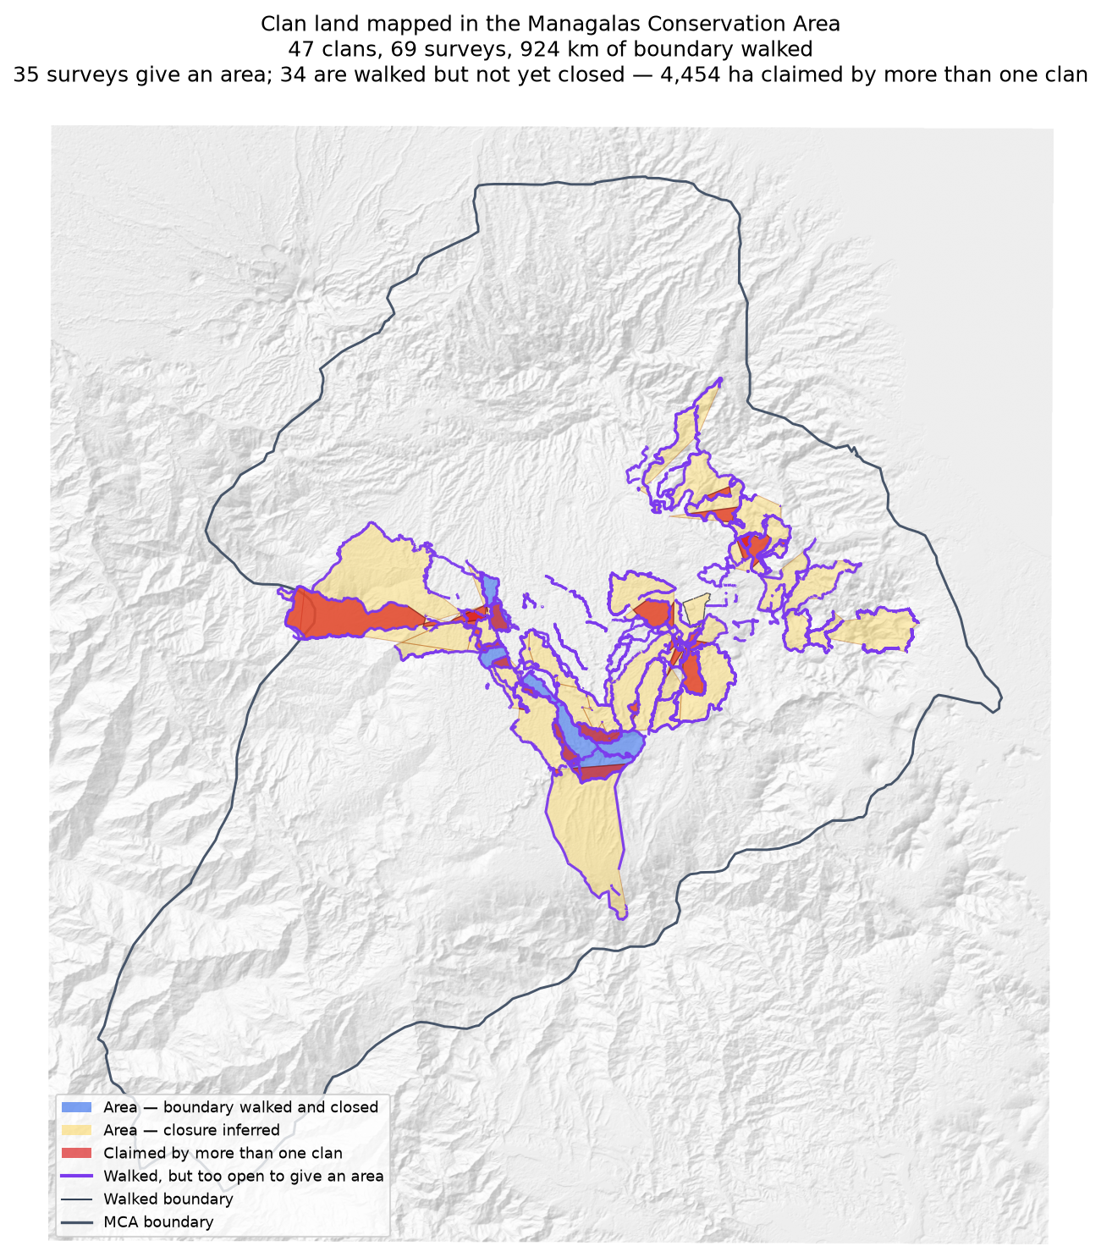
Blue: boundary walked and closed. Amber: closure inferred. Red: claimed by more than one clan. Purple: walked but too open to give an area.

Sacred sites
Reported by area and share of clan land only; locations are not shared. Three sites across two mapped units, covering an estimated 313–456 ha, being 16–24% of the host clan's land. The range reflects that neither walk closed, so the area can only be bracketed.

2. How to read the clan entries
Each clan is assessed as one boundary within one zone. Where several custodians walked, their tracks are joined into a single survey — walkers of one clan are joined; different clans never are.
Term | Meaning
Walked | Distance recorded, after smoothing
Access legs | Dead-end walks in to the boundary and back out; excluded from boundary distance
Pieces | Disconnected runs of track; one means a single continuous boundary
Gap to close | Straight-line distance still needed to make the pieces one ring
Walked and closed | The tracks ring the land; area is measured, not assumed
Inferred | Open ends bridged with straight lines; area is an estimate
No area | Gap exceeds half the distance walked — too open to estimate honestly
A clan name that appears in more than one zone carries a zone code, for example Murai (Z2) and Murai (Z7B). This is expected — language spreads between zones and clans that split may keep an ancestral name — but the two are not the same landholding group and their land is never combined.

3. Clans

Zone 2

Asingi
Walkers | Surveys | Walked (km) | Access legs (km) | Pieces | Gap to close (km) | Area (ha) | Basis
1 | 1 | 6.4 | 0.0 | 2 | — | 166 | surveyed
Custodians
Custodian | Tracks | Walked (km) | Type
Jethro Akse | 5 | 6.4 | Land Boundary
Problems
- The boundary closes on its own. 166 ha is measured from the walk, with nothing inferred.
- Overlaps 3 other clans: Murai (Z2) (6 ha, 4% of this clan's land); Gariniko (4 ha, 3% of this clan's land); Kasaki (0 ha, 0% of this clan's land).
Queries for the field
- Is the ground shared with Murai (Z2), Gariniko, Kasaki disputed, shared by agreement, or recorded wrongly? No change will be made to either boundary without the community's decision.

Asoro
Walkers | Surveys | Walked (km) | Access legs (km) | Pieces | Gap to close (km) | Area (ha) | Basis
1 | 1 | 22.8 | 3.5 | 2 | 8.0 | 3,507 | inferred
Custodians
Custodian | Tracks | Walked (km) | Type
Gilford Amakana | 10 | 22.8 | Land Boundary
Problems
- The boundary does not close. 8.0 km was bridged with straight lines (38% of the distance walked), so 3,507 ha is an estimate rather than a measured area.
- Overlaps 2 other clans: Sukandi (232 ha, 7% of this clan's land); Juaiko (15 ha, 0% of this clan's land).
Queries for the field
- 38% of this boundary was not walked. Can the remaining 8.0 km be completed, so the area is measured rather than estimated?
- Is the ground shared with Sukandi, Juaiko disputed, shared by agreement, or recorded wrongly? No change will be made to either boundary without the community's decision.

Bujevi
Walkers | Surveys | Walked (km) | Access legs (km) | Pieces | Gap to close (km) | Area (ha) | Basis
1 | 1 | 5.8 | 1.1 | 1 | 4.5 | none | no area
Custodians
Custodian | Tracks | Walked (km) | Type
Abel Kajari | 2 | 5.8 | Land Boundary
Problems
- No area can be given. The tracks are in 1 disconnected piece and 4.5 km of straight-line joining would be needed to make a ring — 84% of the distance walked. That is beyond the 50% limit, above which an area would be more assumption than survey.
Queries for the field
- Can the missing stretches be walked so this boundary closes? If any gap is deliberate — a river, a road, an agreed open edge — please say what runs along it.

Gariniko
Walkers | Surveys | Walked (km) | Access legs (km) | Pieces | Gap to close (km) | Area (ha) | Basis
1 | 1 | 10.1 | 1.5 | 4 | 5.0 | 128 | inferred
Custodians
Custodian | Tracks | Walked (km) | Type
Lance Sake | 6 | 10.1 | Land Boundary
Problems
- The boundary does not close. 5.0 km was bridged with straight lines (52% of the distance walked), so 128 ha is an estimate rather than a measured area.
- Overlaps 5 other clans: Asingi (4 ha, 3% of this clan's land); Kasaki (2 ha, 1% of this clan's land); Tuoko (1 ha, 1% of this clan's land); Nituri (1 ha, 1% of this clan's land).
Queries for the field
- 52% of this boundary was not walked. Can the remaining 5.0 km be completed, so the area is measured rather than estimated?
- Is the ground shared with Asingi, Kasaki, Tuoko disputed, shared by agreement, or recorded wrongly? No change will be made to either boundary without the community's decision.
- This boundary is recorded in 4 separate pieces. Were the connecting stretches walked but not recorded, or not yet walked?

Juaiko
Walkers | Surveys | Walked (km) | Access legs (km) | Pieces | Gap to close (km) | Area (ha) | Basis
1 | 1 | 24.3 | 5.8 | 7 | 1.9 | 1,293 | inferred
Custodians
Custodian | Tracks | Walked (km) | Type
Gasper K Philip J | 10 | 24.3 | Land Boundary
Problems
- The boundary does not close. 1.9 km was bridged with straight lines (9% of the distance walked), so 1,293 ha is an estimate rather than a measured area.
- Overlaps 3 other clans: Sukandi (205 ha, 16% of this clan's land); Asoro (15 ha, 1% of this clan's land); Manoko (12 ha, 1% of this clan's land).
Queries for the field
- Is the ground shared with Sukandi, Asoro, Manoko disputed, shared by agreement, or recorded wrongly? No change will be made to either boundary without the community's decision.
- This boundary is recorded in 7 separate pieces. Were the connecting stretches walked but not recorded, or not yet walked?

Kasaki
Walkers | Surveys | Walked (km) | Access legs (km) | Pieces | Gap to close (km) | Area (ha) | Basis
1 | 1 | 15.1 | 3.1 | 4 | 1.3 | 541 | inferred
Custodians
Custodian | Tracks | Walked (km) | Type
Ananias Masua | 1 | 15.1 | Land Boundary
Problems
- The boundary does not close. 1.3 km was bridged with straight lines (10% of the distance walked), so 541 ha is an estimate rather than a measured area.
- Overlaps 6 other clans: Murai (Z2) (154 ha, 29% of this clan's land); Tuoko (147 ha, 27% of this clan's land); Nituri (71 ha, 13% of this clan's land); Majanko (40 ha, 7% of this clan's land).
Queries for the field
- Is the ground shared with Murai (Z2), Tuoko, Nituri disputed, shared by agreement, or recorded wrongly? No change will be made to either boundary without the community's decision.
- This boundary is recorded in 4 separate pieces. Were the connecting stretches walked but not recorded, or not yet walked?

Majanko
Walkers | Surveys | Walked (km) | Access legs (km) | Pieces | Gap to close (km) | Area (ha) | Basis
1 | 1 | 7.5 | 0.0 | 1 | — | 276 | surveyed
Custodians
Custodian | Tracks | Walked (km) | Type
Gilford Amakana | 4 | 7.5 | Land Boundary
Problems
- The boundary closes on its own. 276 ha is measured from the walk, with nothing inferred.
- Overlaps 3 other clans: Manoko (65 ha, 24% of this clan's land); Kasaki (40 ha, 15% of this clan's land); Tuoko (13 ha, 5% of this clan's land).
Queries for the field
- Is the ground shared with Manoko, Kasaki, Tuoko disputed, shared by agreement, or recorded wrongly? No change will be made to either boundary without the community's decision.

Manoko
Walkers | Surveys | Walked (km) | Access legs (km) | Pieces | Gap to close (km) | Area (ha) | Basis
1 | 1 | 12.2 | 1.8 | 3 | 3.9 | 404 | inferred
Custodians
Custodian | Tracks | Walked (km) | Type
Gilford Amakana | 7 | 12.2 | Land Boundary
Problems
- The boundary does not close. 3.9 km was bridged with straight lines (32% of the distance walked), so 404 ha is an estimate rather than a measured area.
- Overlaps 2 other clans: Majanko (65 ha, 16% of this clan's land); Juaiko (12 ha, 3% of this clan's land).
Queries for the field
- 32% of this boundary was not walked. Can the remaining 3.9 km be completed, so the area is measured rather than estimated?
- Is the ground shared with Majanko, Juaiko disputed, shared by agreement, or recorded wrongly? No change will be made to either boundary without the community's decision.

Murai (Z2)
Walkers | Surveys | Walked (km) | Access legs (km) | Pieces | Gap to close (km) | Area (ha) | Basis
1 | 1 | 7.3 | 0.2 | 2 | — | 199 | surveyed
Custodians
Custodian | Tracks | Walked (km) | Type
Nehemiah Nindori | 32 | 7.3 | Land Boundary
Problems
- The boundary closes on its own. 199 ha is measured from the walk, with nothing inferred.
- Overlaps 3 other clans: Kasaki (154 ha, 78% of this clan's land); Asingi (6 ha, 3% of this clan's land); Gariniko (1 ha, 0% of this clan's land).
Queries for the field
- Is the ground shared with Kasaki, Asingi, Gariniko disputed, shared by agreement, or recorded wrongly? No change will be made to either boundary without the community's decision.

Nituri
Walkers | Surveys | Walked (km) | Access legs (km) | Pieces | Gap to close (km) | Area (ha) | Basis
3 | 3 | 41.8 | 10.2 | 14 | 17.5 | 5,323 | inferred
Custodians
Custodian | Tracks | Walked (km) | Type
Christoper Visua | 19 | 17.8 | Land Boundary
Graham Naopi | 7 | 18.7 | Land Boundary
Newton Muraba | 13 | 5.3 | Land Boundary
Problems
- The boundary does not close. 17.5 km was bridged with straight lines (46% of the distance walked), so 5,323 ha is an estimate rather than a measured area.
- Joining the 3 walkers adds 5,323 ha: separately 0 ha, joined 5,323 ha. The walkers covered different stretches of one boundary.
- Overlaps 3 other clans: Tuoko (2,000 ha, 38% of this clan's land); Kasaki (71 ha, 1% of this clan's land); Gariniko (1 ha, 0% of this clan's land).
Queries for the field
- 46% of this boundary was not walked. Can the remaining 17.5 km be completed, so the area is measured rather than estimated?
- Is the ground shared with Tuoko, Kasaki, Gariniko disputed, shared by agreement, or recorded wrongly? No change will be made to either boundary without the community's decision.
- This boundary is recorded in 14 separate pieces. Were the connecting stretches walked but not recorded, or not yet walked?
Effect of joining the walkers
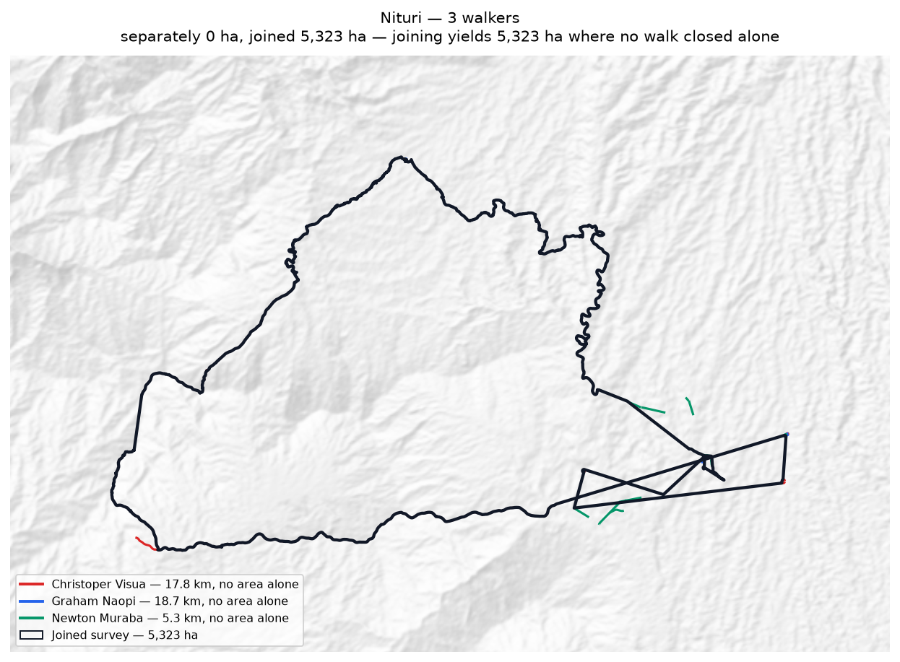
Each walker's line and the area it gives alone (dashed); the joined survey outlined in black.

Rondi
Walkers | Surveys | Walked (km) | Access legs (km) | Pieces | Gap to close (km) | Area (ha) | Basis
2 | 2 | 59.0 | 9.3 | 14 | 13.2 | 1,563 | inferred
Custodians
Custodian | Tracks | Walked (km) | Type
Humphrey Poto | 29 | 29.3 | Land Boundary
Jefferson Amunisa | 28 | 29.7 | Land Boundary
Problems
- The boundary does not close. 13.2 km was bridged with straight lines (23% of the distance walked), so 1,563 ha is an estimate rather than a measured area.
- Joining the 2 walkers adds 339 ha: separately 1,224 ha, joined 1,563 ha. The walkers covered different stretches of one boundary.
- Overlaps 2 other clans: Sukandi (212 ha, 14% of this clan's land); Binunkol (1 ha, 0% of this clan's land).
Queries for the field
- Is the ground shared with Sukandi, Binunkol disputed, shared by agreement, or recorded wrongly? No change will be made to either boundary without the community's decision.
- This boundary is recorded in 14 separate pieces. Were the connecting stretches walked but not recorded, or not yet walked?
Effect of joining the walkers
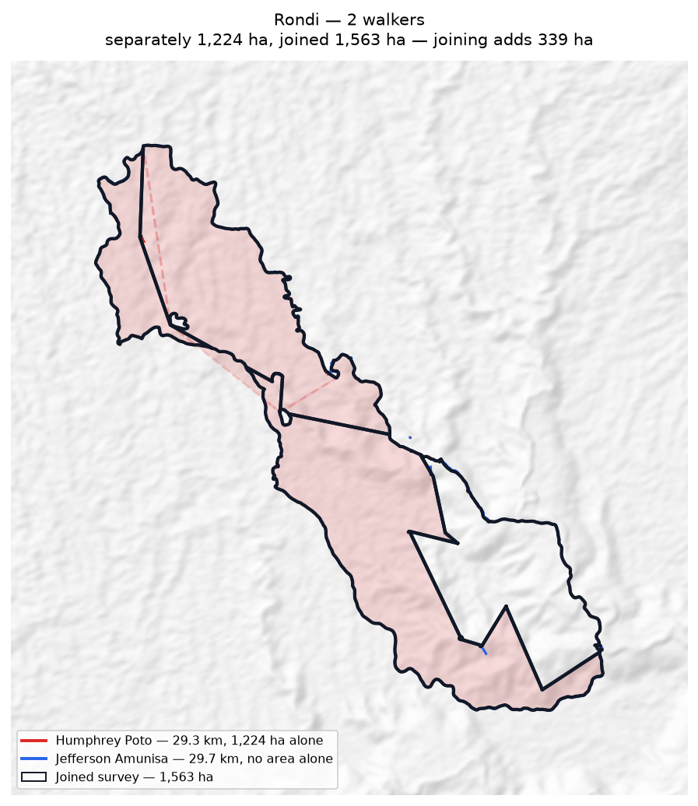
Each walker's line and the area it gives alone (dashed); the joined survey outlined in black.

Rumbi
Walkers | Surveys | Walked (km) | Access legs (km) | Pieces | Gap to close (km) | Area (ha) | Basis
1 | 1 | 15.1 | 3.7 | 3 | 10.1 | none | no area
Custodians
Custodian | Tracks | Walked (km) | Type
Joel Mamata | 9 | 15.1 | Land Boundary
Problems
- No area can be given. The tracks are in 3 disconnected pieces and 10.1 km of straight-line joining would be needed to make a ring — 73% of the distance walked. That is beyond the 50% limit, above which an area would be more assumption than survey.
Queries for the field
- Can the missing stretches be walked so this boundary closes? If any gap is deliberate — a river, a road, an agreed open edge — please say what runs along it.

Sukandi
Walkers | Surveys | Walked (km) | Access legs (km) | Pieces | Gap to close (km) | Area (ha) | Basis
2 | 2 | 39.7 | 2.4 | 3 | — | 1,901 | surveyed
Custodians
Custodian | Tracks | Walked (km) | Type
Millinton Beso | 3 | 10.6 | Sacred Site
Rodney Ajinko | 1 | 29.1 | Land Boundary
Problems
- The boundary closes on its own. 1,901 ha is measured from the walk, with nothing inferred.
- Joining the 2 walkers costs 467 ha: separately they give 2,368 ha, joined 1,901 ha. This happens where walkers each walked the same ring rather than different stretches — the two rings cross and the joined network encloses less than either walk did alone.
- Overlaps 5 other clans: Asoro (232 ha, 12% of this clan's land); Rondi (212 ha, 11% of this clan's land); Juaiko (205 ha, 11% of this clan's land); Jariji (0 ha, 0% of this clan's land).
Queries for the field
- Did the 2 custodians walk the same boundary, or different parts of it? If they walked the same ring, their surveys should be treated as separate accounts rather than joined.
- Is the ground shared with Asoro, Rondi, Juaiko disputed, shared by agreement, or recorded wrongly? No change will be made to either boundary without the community's decision.
Effect of joining the walkers
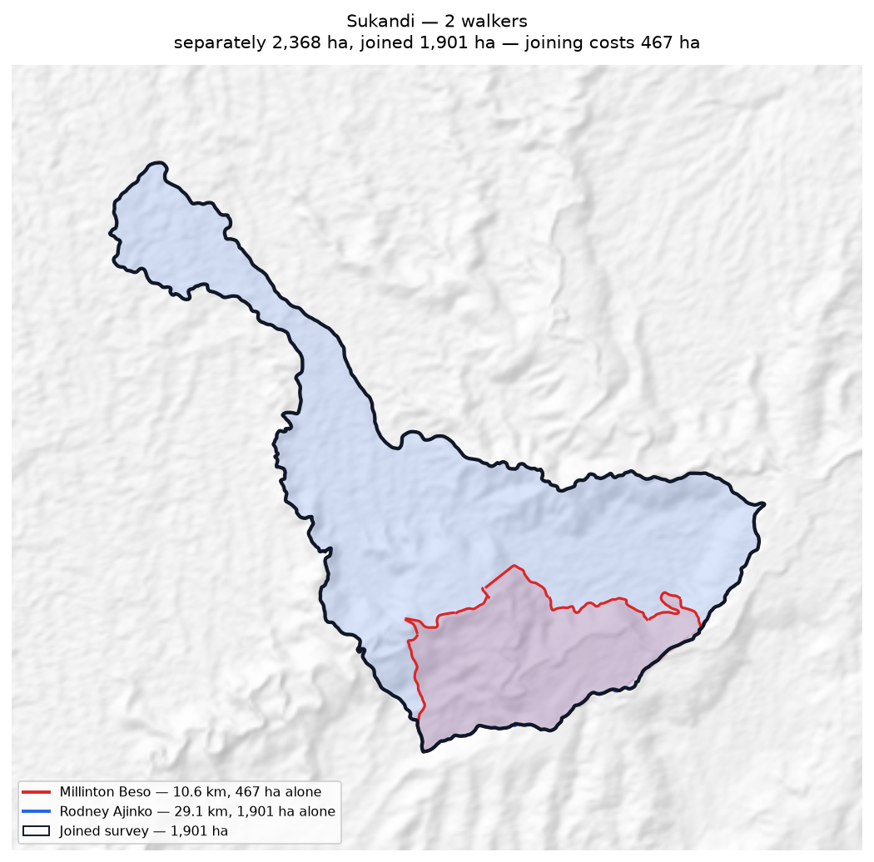
Each walker's line and the area it gives alone (dashed); the joined survey outlined in black.

Tuoko
Walkers | Surveys | Walked (km) | Access legs (km) | Pieces | Gap to close (km) | Area (ha) | Basis
2 | 2 | 47.7 | 11.1 | 8 | 21.5 | 3,283 | inferred
Custodians
Custodian | Tracks | Walked (km) | Type
Kaupa Dota | 6 | 11.2 | Land Boundary
Terrence Dobija | 3 | 36.5 | Land Boundary
Problems
- The boundary does not close. 21.5 km was bridged with straight lines (48% of the distance walked), so 3,283 ha is an estimate rather than a measured area.
- Joining the 2 walkers adds 1,673 ha: separately 1,610 ha, joined 3,283 ha. The walkers covered different stretches of one boundary.
- Overlaps 4 other clans: Nituri (2,000 ha, 61% of this clan's land); Kasaki (147 ha, 5% of this clan's land); Majanko (13 ha, 0% of this clan's land); Gariniko (1 ha, 0% of this clan's land).
Queries for the field
- 48% of this boundary was not walked. Can the remaining 21.5 km be completed, so the area is measured rather than estimated?
- Is the ground shared with Nituri, Kasaki, Majanko disputed, shared by agreement, or recorded wrongly? No change will be made to either boundary without the community's decision.
- This boundary is recorded in 8 separate pieces. Were the connecting stretches walked but not recorded, or not yet walked?
Effect of joining the walkers
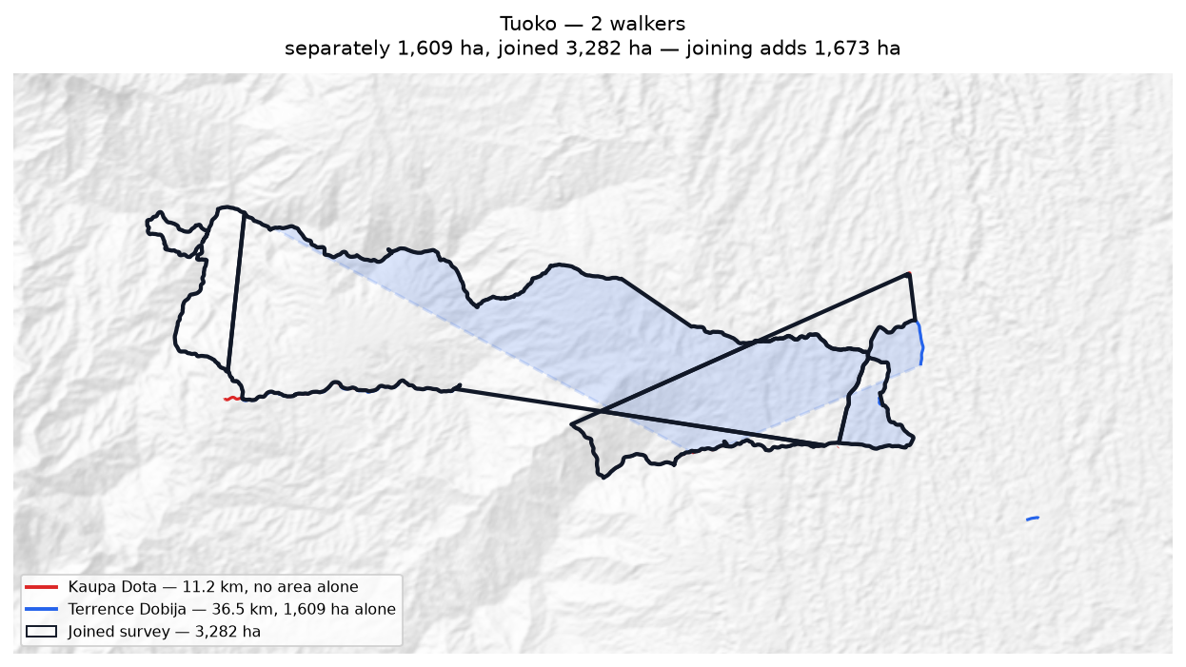
Each walker's line and the area it gives alone (dashed); the joined survey outlined in black.

Zambiko
Walkers | Surveys | Walked (km) | Access legs (km) | Pieces | Gap to close (km) | Area (ha) | Basis
1 | 1 | 5.7 | 1.2 | 5 | 24.4 | none | no area
Custodians
Custodian | Tracks | Walked (km) | Type
Sylvester Anai | 8 | 5.7 | Land Boundary
Problems
- No area can be given. The tracks are in 5 disconnected pieces and 24.4 km of straight-line joining would be needed to make a ring — 475% of the distance walked. That is beyond the 50% limit, above which an area would be more assumption than survey.
Queries for the field
- Can the missing stretches be walked so this boundary closes? If any gap is deliberate — a river, a road, an agreed open edge — please say what runs along it.

Zone 3

Deari
Walkers | Surveys | Walked (km) | Access legs (km) | Pieces | Gap to close (km) | Area (ha) | Basis
2 | 2 | 13.1 | 2.2 | 3 | 8.7 | none | no area
Custodians
Custodian | Tracks | Walked (km) | Type
Anthony Irimari | 2 | 5.3 | Land Boundary
Patrick Dirise | 3 | 7.8 | Land Boundary
Problems
- No area can be given. The tracks are in 3 disconnected pieces and 8.7 km of straight-line joining would be needed to make a ring — 70% of the distance walked. That is beyond the 50% limit, above which an area would be more assumption than survey.
Queries for the field
- Can the missing stretches be walked so this boundary closes? If any gap is deliberate — a river, a road, an agreed open edge — please say what runs along it.
Effect of joining the walkers
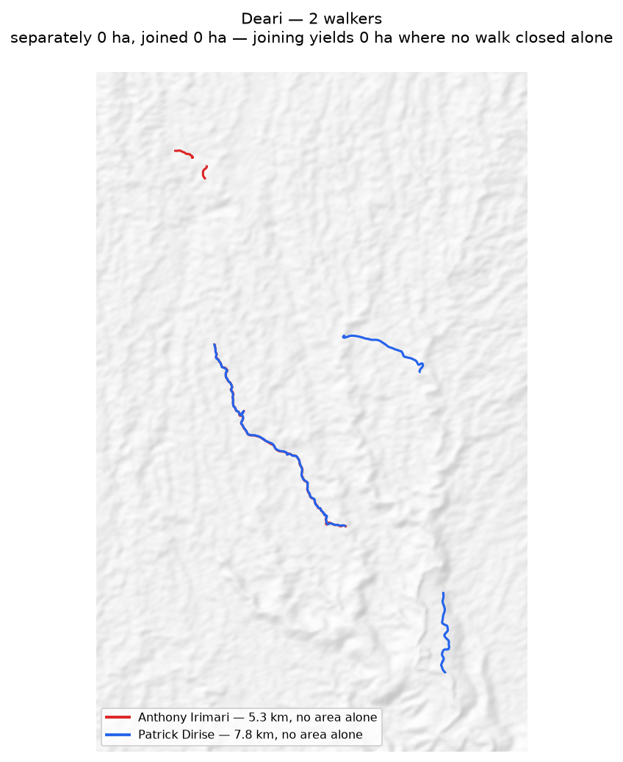
Each walker's line and the area it gives alone (dashed); the joined survey outlined in black.

Giroiko
Walkers | Surveys | Walked (km) | Access legs (km) | Pieces | Gap to close (km) | Area (ha) | Basis
2 | 2 | 5.4 | 0.4 | 2 | 1.3 | 10 | inferred
Custodians
Custodian | Tracks | Walked (km) | Type
Eddie Sioro | 1 | 2.7 | Land Boundary
Mark Samba | 2 | 2.8 | Land Boundary
Problems
- The boundary does not close. 1.3 km was bridged with straight lines (25% of the distance walked), so 10 ha is an estimate rather than a measured area.
- Joining the 2 walkers costs 69 ha: separately they give 78 ha, joined 10 ha. This happens where walkers each walked the same ring rather than different stretches — the two rings cross and the joined network encloses less than either walk did alone.
Queries for the field
- 25% of this boundary was not walked. Can the remaining 1.3 km be completed, so the area is measured rather than estimated?
- Did the 2 custodians walk the same boundary, or different parts of it? If they walked the same ring, their surveys should be treated as separate accounts rather than joined.
Effect of joining the walkers
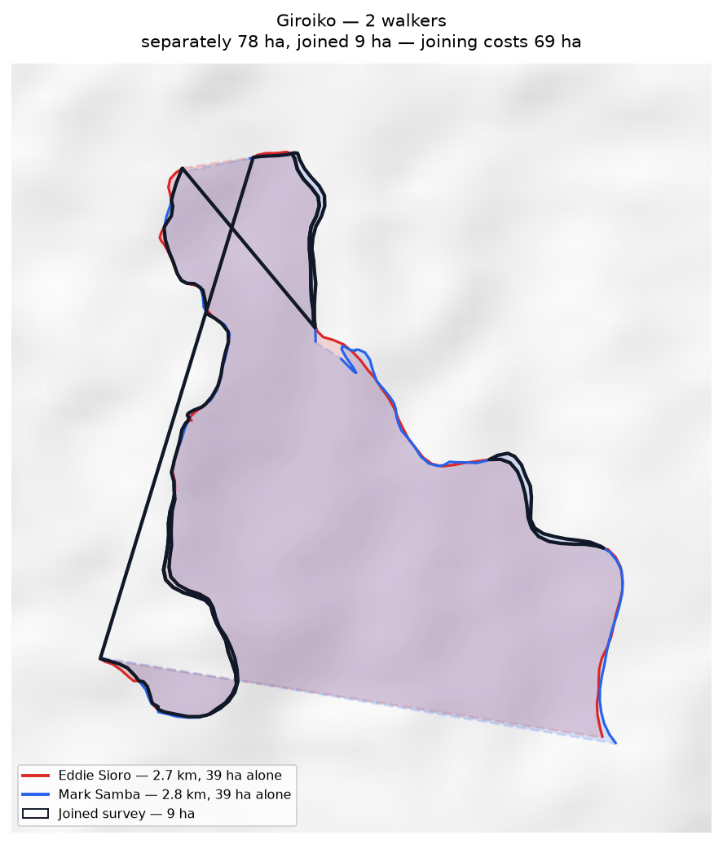
Each walker's line and the area it gives alone (dashed); the joined survey outlined in black.

Gumuri
Walkers | Surveys | Walked (km) | Access legs (km) | Pieces | Gap to close (km) | Area (ha) | Basis
2 | 2 | 6.8 | 0.3 | 1 | 5.5 | none | no area
Custodians
Custodian | Tracks | Walked (km) | Type
Gray Saui | 1 | 6.8 | Land Boundary
Monty Stanford | 1 | 0.0 | Land Boundary
Problems
- No area can be given. The tracks are in 1 disconnected piece and 5.5 km of straight-line joining would be needed to make a ring — 84% of the distance walked. That is beyond the 50% limit, above which an area would be more assumption than survey.
Queries for the field
- Can the missing stretches be walked so this boundary closes? If any gap is deliberate — a river, a road, an agreed open edge — please say what runs along it.
Effect of joining the walkers
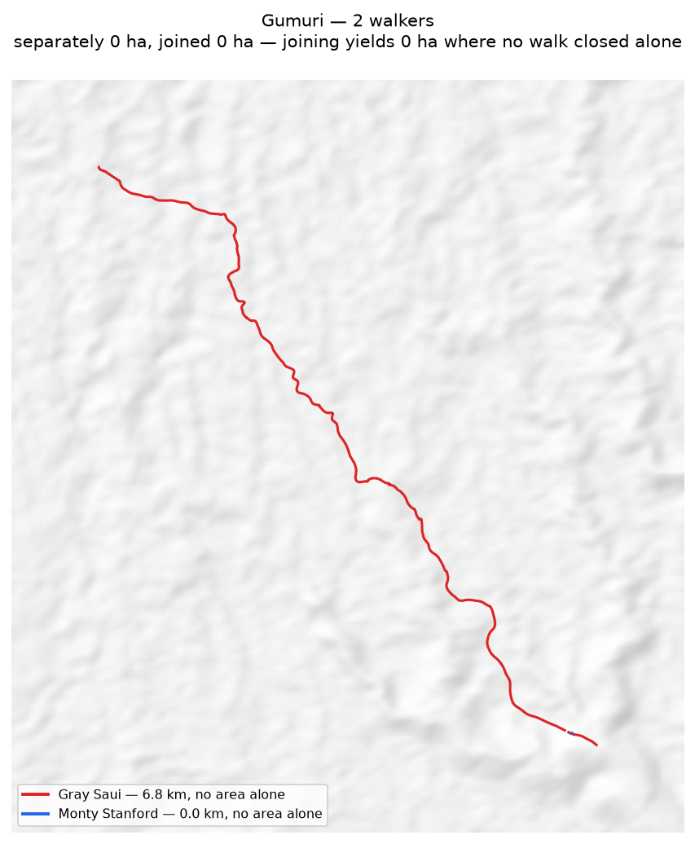
Each walker's line and the area it gives alone (dashed); the joined survey outlined in black.

Nui
Walkers | Surveys | Walked (km) | Access legs (km) | Pieces | Gap to close (km) | Area (ha) | Basis
2 | 2 | 23.4 | 3.9 | 6 | 15.5 | none | no area
Custodians
Custodian | Tracks | Walked (km) | Type
Bobby Aneba | 3 | 11.5 | Land Boundary
Iman Nakina | 4 | 12.0 | Land Boundary
Problems
- No area can be given. The tracks are in 6 disconnected pieces and 15.5 km of straight-line joining would be needed to make a ring — 70% of the distance walked. That is beyond the 50% limit, above which an area would be more assumption than survey.
Queries for the field
- Can the missing stretches be walked so this boundary closes? If any gap is deliberate — a river, a road, an agreed open edge — please say what runs along it.
Effect of joining the walkers
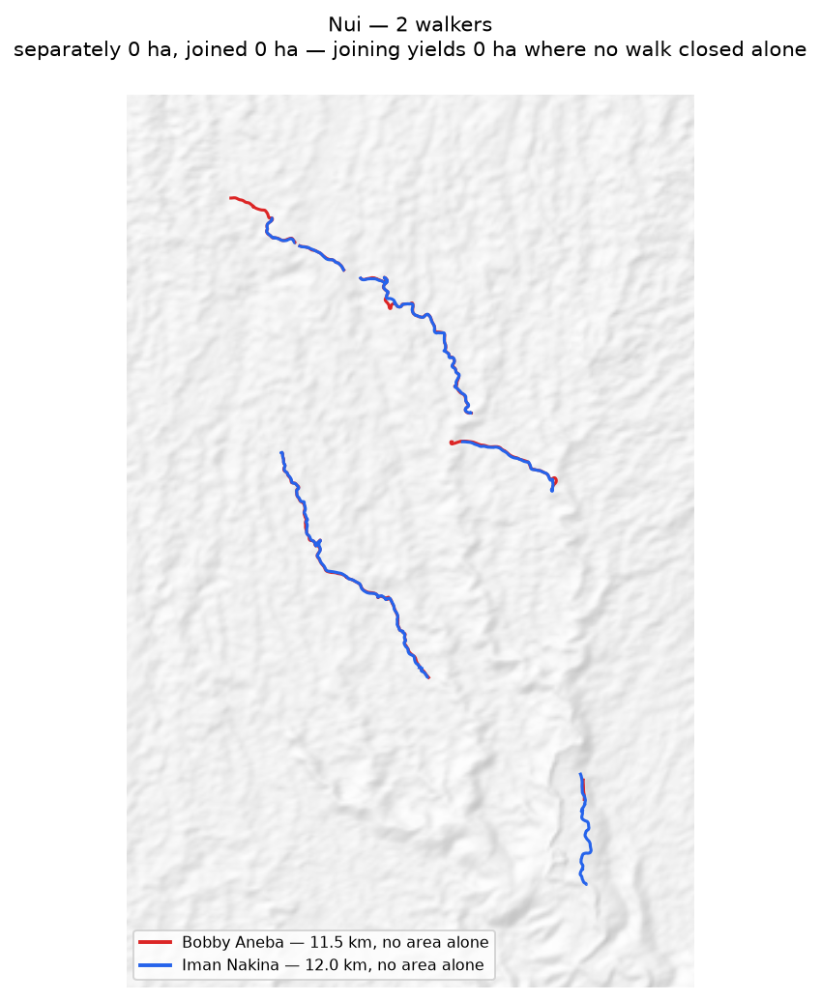
Each walker's line and the area it gives alone (dashed); the joined survey outlined in black.

Zone 6

Manuvoora
Walkers | Surveys | Walked (km) | Access legs (km) | Pieces | Gap to close (km) | Area (ha) | Basis
2 | 2 | 61.5 | 13.8 | 6 | 11.4 | 828 | inferred
Custodians
Custodian | Tracks | Walked (km) | Type
Egobeyas Kuarisi | 18 | 31.2 | Land Boundary
Granville Nepo | 11 | 30.2 | Land Boundary
Problems
- The boundary does not close. 11.4 km was bridged with straight lines (20% of the distance walked), so 828 ha is an estimate rather than a measured area.
- Joining the 2 walkers costs 1,238 ha: separately they give 2,066 ha, joined 828 ha. This happens where walkers each walked the same ring rather than different stretches — the two rings cross and the joined network encloses less than either walk did alone.
Queries for the field
- Did the 2 custodians walk the same boundary, or different parts of it? If they walked the same ring, their surveys should be treated as separate accounts rather than joined.
- This boundary is recorded in 6 separate pieces. Were the connecting stretches walked but not recorded, or not yet walked?
Effect of joining the walkers
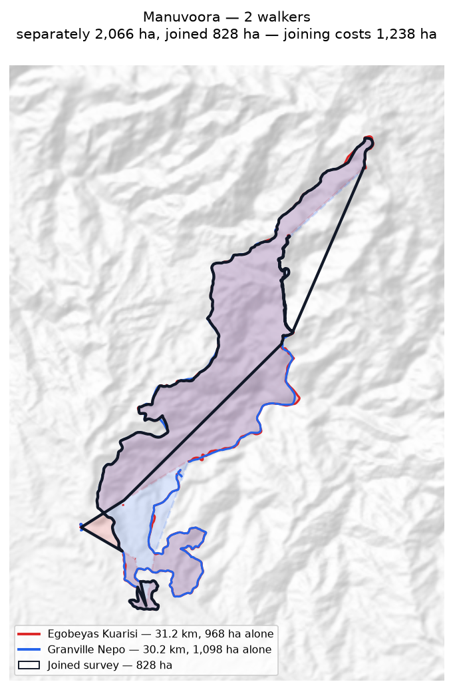
Each walker's line and the area it gives alone (dashed); the joined survey outlined in black.

Mariura
Walkers | Surveys | Walked (km) | Access legs (km) | Pieces | Gap to close (km) | Area (ha) | Basis
2 | 2 | 33.7 | 7.4 | 13 | 14.3 | 855 | inferred
Custodians
Custodian | Tracks | Walked (km) | Type
Fabian Justin | 22 | 17.9 | Land Boundary
Livingstone Nisavora | 21 | 15.9 | Land Boundary
Problems
- The boundary does not close. 14.3 km was bridged with straight lines (42% of the distance walked), so 855 ha is an estimate rather than a measured area.
- Joining the 2 walkers adds 855 ha: separately 0 ha, joined 855 ha. The walkers covered different stretches of one boundary.
- Overlaps 3 other clans: Naharaura (148 ha, 17% of this clan's land); Borori (56 ha, 7% of this clan's land); Darekikol (50 ha, 6% of this clan's land).
Queries for the field
- 42% of this boundary was not walked. Can the remaining 14.3 km be completed, so the area is measured rather than estimated?
- Is the ground shared with Naharaura, Borori, Darekikol disputed, shared by agreement, or recorded wrongly? No change will be made to either boundary without the community's decision.
- This boundary is recorded in 13 separate pieces. Were the connecting stretches walked but not recorded, or not yet walked?
Effect of joining the walkers
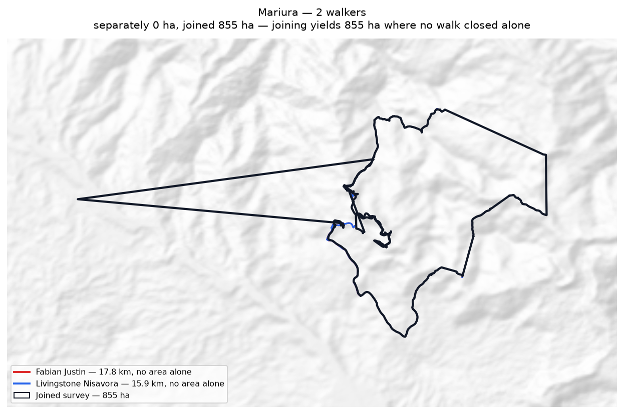
Each walker's line and the area it gives alone (dashed); the joined survey outlined in black.

Naharaura
Walkers | Surveys | Walked (km) | Access legs (km) | Pieces | Gap to close (km) | Area (ha) | Basis
1 | 1 | 32.6 | 0.0 | 4 | 2.5 | 594 | inferred
Custodians
Custodian | Tracks | Walked (km) | Type
Zechariah Sasavo | 2 | 32.6 | Land Boundary
Problems
- The boundary does not close. 2.5 km was bridged with straight lines (8% of the distance walked), so 594 ha is an estimate rather than a measured area.
- Overlaps 2 other clans: Mariura (148 ha, 25% of this clan's land); Pina Ora (60 ha, 10% of this clan's land).
Queries for the field
- Is the ground shared with Mariura, Pina Ora disputed, shared by agreement, or recorded wrongly? No change will be made to either boundary without the community's decision.
- This boundary is recorded in 4 separate pieces. Were the connecting stretches walked but not recorded, or not yet walked?

Nupa Ora
Walkers | Surveys | Walked (km) | Access legs (km) | Pieces | Gap to close (km) | Area (ha) | Basis
1 | 1 | 4.9 | 0.6 | 2 | 3.6 | none | no area
Custodians
Custodian | Tracks | Walked (km) | Type
Benjamin Marijah | 3 | 4.9 | Land Boundary
Problems
- No area can be given. The tracks are in 2 disconnected pieces and 3.6 km of straight-line joining would be needed to make a ring — 72% of the distance walked. That is beyond the 50% limit, above which an area would be more assumption than survey.
Queries for the field
- Can the missing stretches be walked so this boundary closes? If any gap is deliberate — a river, a road, an agreed open edge — please say what runs along it.

Pina Ora
Walkers | Surveys | Walked (km) | Access legs (km) | Pieces | Gap to close (km) | Area (ha) | Basis
1 | 1 | 18.9 | 3.9 | 4 | 1.4 | 812 | inferred
Custodians
Custodian | Tracks | Walked (km) | Type
Alban Ezekiel | 3 | 18.9 | Land Boundary
Problems
- The boundary does not close. 1.4 km was bridged with straight lines (8% of the distance walked), so 812 ha is an estimate rather than a measured area.
- Overlaps 1 other clan: Naharaura (60 ha, 7% of this clan's land).
Queries for the field
- Is the ground shared with Naharaura disputed, shared by agreement, or recorded wrongly? No change will be made to either boundary without the community's decision.
- This boundary is recorded in 4 separate pieces. Were the connecting stretches walked but not recorded, or not yet walked?

Zone 7A

(no clan recorded)
Walkers | Surveys | Walked (km) | Access legs (km) | Pieces | Gap to close (km) | Area (ha) | Basis
1 | 1 | 4.3 | 0.9 | 9 | 15.1 | none | no area
Custodians
Custodian | Tracks | Walked (km) | Type
Paul Digori | 13 | 4.3 | Road
Problems
- No area can be given. The tracks are in 9 disconnected pieces and 15.1 km of straight-line joining would be needed to make a ring — 385% of the distance walked. That is beyond the 50% limit, above which an area would be more assumption than survey.
Queries for the field
- Can the missing stretches be walked so this boundary closes? If any gap is deliberate — a river, a road, an agreed open edge — please say what runs along it.

Bimkol
Walkers | Surveys | Walked (km) | Access legs (km) | Pieces | Gap to close (km) | Area (ha) | Basis
1 | 1 | 8.0 | 1.8 | 3 | 4.4 | none | no area
Custodians
Custodian | Tracks | Walked (km) | Type
Kennedy Wosa | 5 | 8.0 | Land Boundary
Problems
- No area can be given. The tracks are in 3 disconnected pieces and 4.4 km of straight-line joining would be needed to make a ring — 60% of the distance walked. That is beyond the 50% limit, above which an area would be more assumption than survey.
Queries for the field
- Can the missing stretches be walked so this boundary closes? If any gap is deliberate — a river, a road, an agreed open edge — please say what runs along it.

Borori
Walkers | Surveys | Walked (km) | Access legs (km) | Pieces | Gap to close (km) | Area (ha) | Basis
2 | 2 | 32.7 | 7.6 | 10 | 7.0 | 639 | inferred
Custodians
Custodian | Tracks | Walked (km) | Type
Hagahi Semo | 6 | 9.9 | Land Boundary
John Saini | 5 | 22.8 | Land Boundary
Problems
- The boundary does not close. 7.0 km was bridged with straight lines (24% of the distance walked), so 639 ha is an estimate rather than a measured area.
- Joining the 2 walkers costs 38 ha: separately they give 677 ha, joined 639 ha. This happens where walkers each walked the same ring rather than different stretches — the two rings cross and the joined network encloses less than either walk did alone.
- Overlaps 3 other clans: Darekikol (283 ha, 44% of this clan's land); Mariura (56 ha, 9% of this clan's land); Mungaikol (0 ha, 0% of this clan's land).
Queries for the field
- Did the 2 custodians walk the same boundary, or different parts of it? If they walked the same ring, their surveys should be treated as separate accounts rather than joined.
- Is the ground shared with Darekikol, Mariura, Mungaikol disputed, shared by agreement, or recorded wrongly? No change will be made to either boundary without the community's decision.
- This boundary is recorded in 10 separate pieces. Were the connecting stretches walked but not recorded, or not yet walked?
Effect of joining the walkers
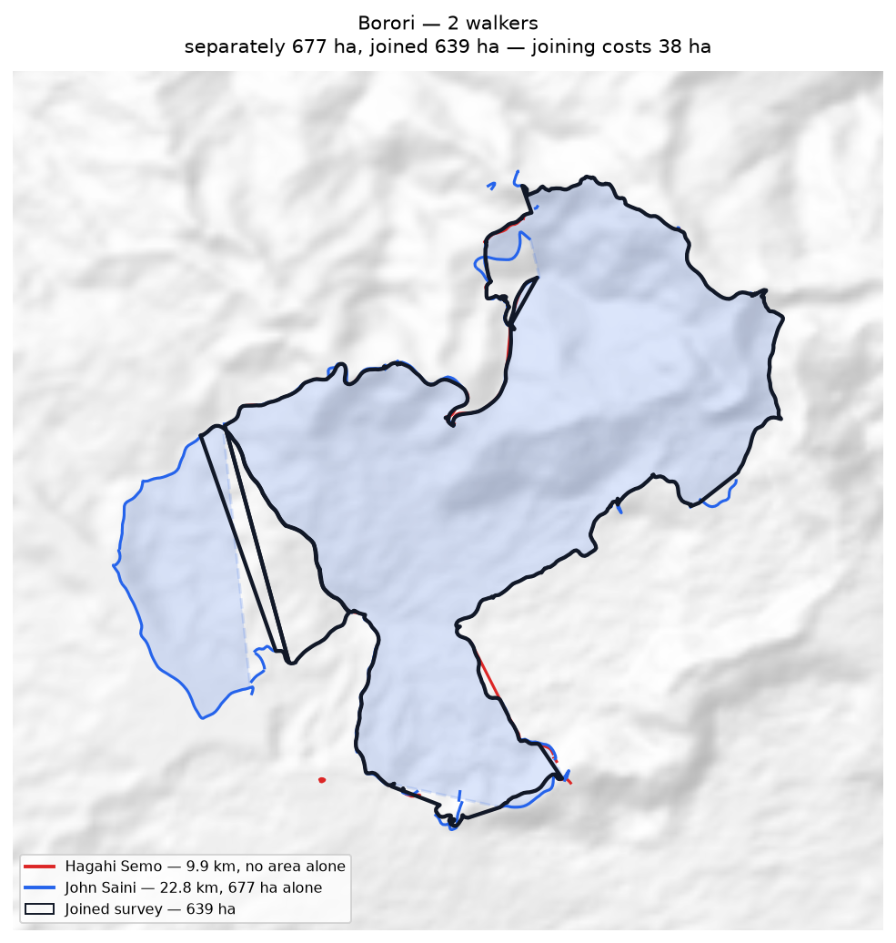
Each walker's line and the area it gives alone (dashed); the joined survey outlined in black.

Darekikol
Walkers | Surveys | Walked (km) | Access legs (km) | Pieces | Gap to close (km) | Area (ha) | Basis
2 | 2 | 28.8 | 6.2 | 7 | 7.1 | 528 | inferred
Custodians
Custodian | Tracks | Walked (km) | Type
Garex Sevesi | 2 | 13.4 | Land Boundary
George Kopoi | 6 | 15.4 | Land Boundary
Problems
- The boundary does not close. 7.1 km was bridged with straight lines (27% of the distance walked), so 528 ha is an estimate rather than a measured area.
- Joining the 2 walkers costs 631 ha: separately they give 1,160 ha, joined 528 ha. This happens where walkers each walked the same ring rather than different stretches — the two rings cross and the joined network encloses less than either walk did alone.
- Overlaps 2 other clans: Borori (283 ha, 54% of this clan's land); Mariura (50 ha, 10% of this clan's land).
Queries for the field
- 27% of this boundary was not walked. Can the remaining 7.1 km be completed, so the area is measured rather than estimated?
- Did the 2 custodians walk the same boundary, or different parts of it? If they walked the same ring, their surveys should be treated as separate accounts rather than joined.
- Is the ground shared with Borori, Mariura disputed, shared by agreement, or recorded wrongly? No change will be made to either boundary without the community's decision.
- This boundary is recorded in 7 separate pieces. Were the connecting stretches walked but not recorded, or not yet walked?
Effect of joining the walkers
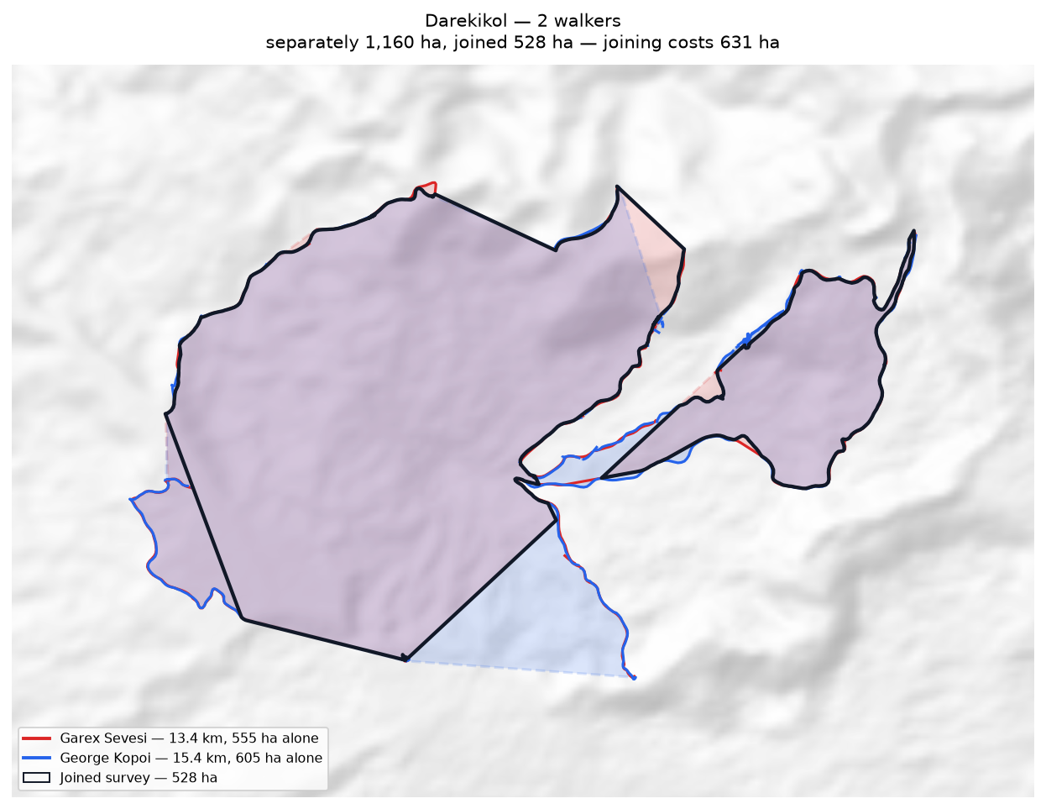
Each walker's line and the area it gives alone (dashed); the joined survey outlined in black.

Zone 7B

(no clan recorded)
Walkers | Surveys | Walked (km) | Access legs (km) | Pieces | Gap to close (km) | Area (ha) | Basis
1 | 1 | 6.3 | 1.3 | 6 | 0.8 | 237 | inferred
Custodians
Custodian | Tracks | Walked (km) | Type
Ruth Makisa | 1 | 6.3 | Steward Block
Problems
- The boundary does not close. 0.8 km was bridged with straight lines (14% of the distance walked), so 237 ha is an estimate rather than a measured area.
Queries for the field
- This boundary is recorded in 6 separate pieces. Were the connecting stretches walked but not recorded, or not yet walked?

Abuankol
Walkers | Surveys | Walked (km) | Access legs (km) | Pieces | Gap to close (km) | Area (ha) | Basis
1 | 1 | 0.5 | 0.0 | 3 | — | 1 | surveyed
Custodians
Custodian | Tracks | Walked (km) | Type
Simeon Pasip | 4 | 0.5 | Land Boundary
Problems
- The boundary closes on its own. 1 ha is measured from the walk, with nothing inferred.
- Overlaps 3 other clans: Sugulkol (0 ha, 55% of this clan's land); Jariji (0 ha, 0% of this clan's land); Ambunkol (0 ha, 0% of this clan's land).
Queries for the field
- Is the ground shared with Sugulkol, Jariji, Ambunkol disputed, shared by agreement, or recorded wrongly? No change will be made to either boundary without the community's decision.

Ambunkol
Walkers | Surveys | Walked (km) | Access legs (km) | Pieces | Gap to close (km) | Area (ha) | Basis
1 | 1 | 18.6 | 4.0 | 6 | 4.5 | 592 | inferred
Custodians
Custodian | Tracks | Walked (km) | Type
Peter Awako | 1 | 18.6 | Land Boundary
Problems
- The boundary does not close. 4.5 km was bridged with straight lines (26% of the distance walked), so 592 ha is an estimate rather than a measured area.
- Overlaps 5 other clans: Natang (345 ha, 58% of this clan's land); Sugulkol (7 ha, 1% of this clan's land); Wohukol (2 ha, 0% of this clan's land); Jariji (1 ha, 0% of this clan's land).
Queries for the field
- 26% of this boundary was not walked. Can the remaining 4.5 km be completed, so the area is measured rather than estimated?
- Is the ground shared with Natang, Sugulkol, Wohukol disputed, shared by agreement, or recorded wrongly? No change will be made to either boundary without the community's decision.
- This boundary is recorded in 6 separate pieces. Were the connecting stretches walked but not recorded, or not yet walked?

Binunkol
Walkers | Surveys | Walked (km) | Access legs (km) | Pieces | Gap to close (km) | Area (ha) | Basis
1 | 1 | 17.8 | 4.1 | 19 | 7.2 | 1,008 | inferred
Custodians
Custodian | Tracks | Walked (km) | Type
Moses Garui | 10 | 17.8 | Land Boundary
Problems
- The boundary does not close. 7.2 km was bridged with straight lines (45% of the distance walked), so 1,008 ha is an estimate rather than a measured area.
- Overlaps 5 other clans: Jariji (44 ha, 4% of this clan's land); Wohukol (20 ha, 2% of this clan's land); Sugulkol (2 ha, 0% of this clan's land); Rondi (1 ha, 0% of this clan's land).
Queries for the field
- 45% of this boundary was not walked. Can the remaining 7.2 km be completed, so the area is measured rather than estimated?
- Is the ground shared with Jariji, Wohukol, Sugulkol disputed, shared by agreement, or recorded wrongly? No change will be made to either boundary without the community's decision.
- This boundary is recorded in 19 separate pieces. Were the connecting stretches walked but not recorded, or not yet walked?

Ginangi
Walkers | Surveys | Walked (km) | Access legs (km) | Pieces | Gap to close (km) | Area (ha) | Basis
2 | 2 | 36.7 | 7.9 | 7 | 7.3 | 1,224 | inferred
Custodians
Custodian | Tracks | Walked (km) | Type
Joshua Mokondo | 6 | 14.9 | Land Boundary
Job Mokondo | 7 | 21.8 | Land Boundary
Problems
- The boundary does not close. 7.3 km was bridged with straight lines (22% of the distance walked), so 1,224 ha is an estimate rather than a measured area.
- Joining the 2 walkers adds 152 ha: separately 1,072 ha, joined 1,224 ha. The walkers covered different stretches of one boundary.
- Overlaps 2 other clans: Manang (311 ha, 25% of this clan's land); Sugulkol (51 ha, 4% of this clan's land).
Queries for the field
- Is the ground shared with Manang, Sugulkol disputed, shared by agreement, or recorded wrongly? No change will be made to either boundary without the community's decision.
- This boundary is recorded in 7 separate pieces. Were the connecting stretches walked but not recorded, or not yet walked?
Effect of joining the walkers
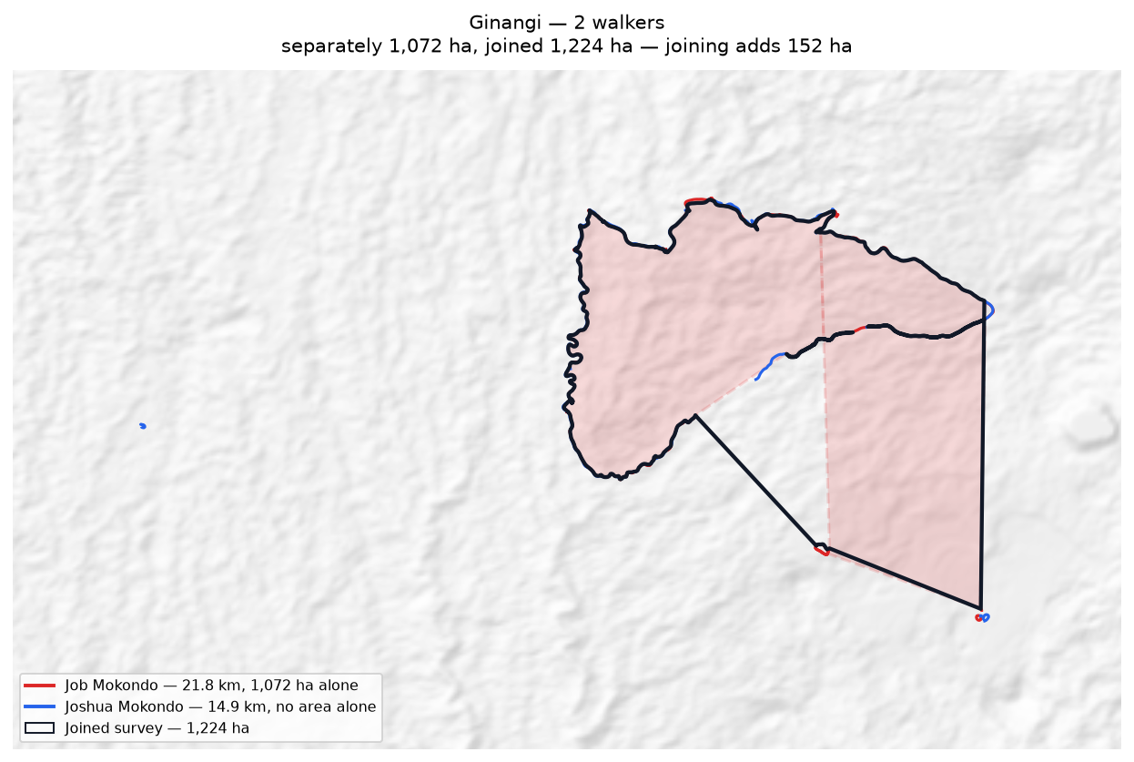
Each walker's line and the area it gives alone (dashed); the joined survey outlined in black.

Jariji
Walkers | Surveys | Walked (km) | Access legs (km) | Pieces | Gap to close (km) | Area (ha) | Basis
2 | 2 | 27.5 | 3.1 | 6 | 9.0 | 696 | inferred
Custodians
Custodian | Tracks | Walked (km) | Type
Clement Viri | 1 | 13.8 | Land Boundary
Newton Giwai | 3 | 13.7 | Land Boundary
Problems
- The boundary does not close. 9.0 km was bridged with straight lines (37% of the distance walked), so 696 ha is an estimate rather than a measured area.
- Joining the 2 walkers adds 76 ha: separately 620 ha, joined 696 ha. The walkers covered different stretches of one boundary.
- Overlaps 6 other clans: Wohukol (55 ha, 8% of this clan's land); Binunkol (44 ha, 6% of this clan's land); Ambunkol (1 ha, 0% of this clan's land); Sugulkol (0 ha, 0% of this clan's land).
Queries for the field
- 37% of this boundary was not walked. Can the remaining 9.0 km be completed, so the area is measured rather than estimated?
- Is the ground shared with Wohukol, Binunkol, Ambunkol disputed, shared by agreement, or recorded wrongly? No change will be made to either boundary without the community's decision.
- This boundary is recorded in 6 separate pieces. Were the connecting stretches walked but not recorded, or not yet walked?
Effect of joining the walkers
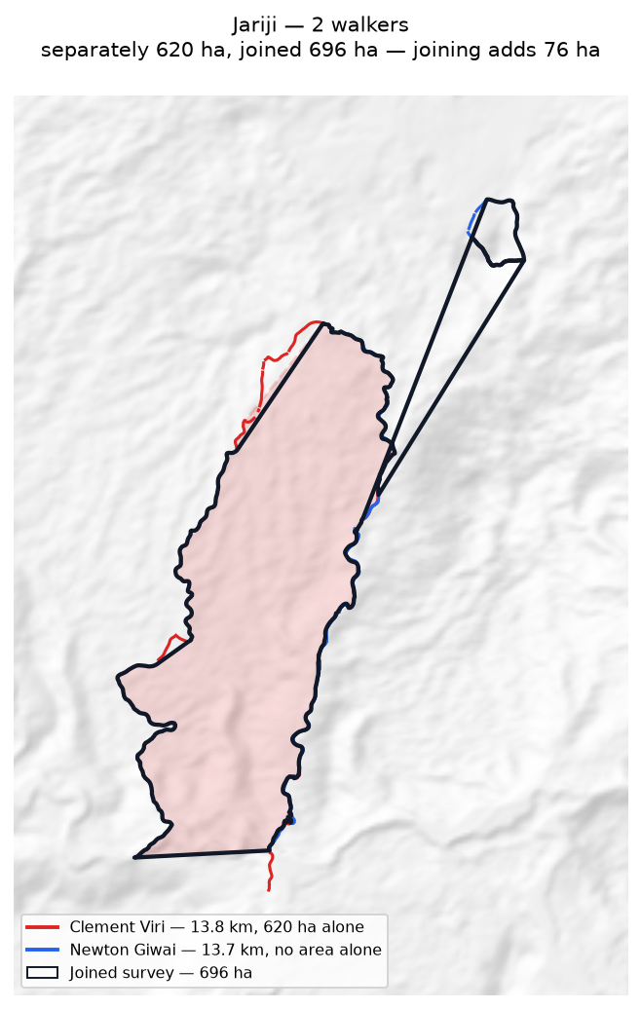
Each walker's line and the area it gives alone (dashed); the joined survey outlined in black.

Manang
Walkers | Surveys | Walked (km) | Access legs (km) | Pieces | Gap to close (km) | Area (ha) | Basis
1 | 1 | 7.1 | 0.0 | 1 | 1.8 | 353 | inferred
Custodians
Custodian | Tracks | Walked (km) | Type
Kelly Wahamo | 1 | 7.1 | Land Boundary
Problems
- The boundary does not close. 1.8 km was bridged with straight lines (25% of the distance walked), so 353 ha is an estimate rather than a measured area.
- Overlaps 2 other clans: Ginangi (311 ha, 88% of this clan's land); Sugulkol (3 ha, 1% of this clan's land).
Queries for the field
- 25% of this boundary was not walked. Can the remaining 1.8 km be completed, so the area is measured rather than estimated?
- Is the ground shared with Ginangi, Sugulkol disputed, shared by agreement, or recorded wrongly? No change will be made to either boundary without the community's decision.

Marang
Walkers | Surveys | Walked (km) | Access legs (km) | Pieces | Gap to close (km) | Area (ha) | Basis
1 | 1 | 8.3 | 1.3 | 2 | 5.5 | none | no area
Custodians
Custodian | Tracks | Walked (km) | Type
Henry Manderi | 2 | 8.3 | Land Boundary
Problems
- No area can be given. The tracks are in 2 disconnected pieces and 5.5 km of straight-line joining would be needed to make a ring — 67% of the distance walked. That is beyond the 50% limit, above which an area would be more assumption than survey.
Queries for the field
- Can the missing stretches be walked so this boundary closes? If any gap is deliberate — a river, a road, an agreed open edge — please say what runs along it.

Marijabimkol
Walkers | Surveys | Walked (km) | Access legs (km) | Pieces | Gap to close (km) | Area (ha) | Basis
1 | 1 | 11.0 | 2.5 | 4 | 6.1 | none | no area
Custodians
Custodian | Tracks | Walked (km) | Type
Japhet Nagura | 7 | 11.0 | Land Boundary
Problems
- No area can be given. The tracks are in 4 disconnected pieces and 6.1 km of straight-line joining would be needed to make a ring — 61% of the distance walked. That is beyond the 50% limit, above which an area would be more assumption than survey.
Queries for the field
- Can the missing stretches be walked so this boundary closes? If any gap is deliberate — a river, a road, an agreed open edge — please say what runs along it.

Murai (Z7B)
Walkers | Surveys | Walked (km) | Access legs (km) | Pieces | Gap to close (km) | Area (ha) | Basis
1 | 1 | 12.4 | 2.9 | 5 | 7.8 | none | no area
Custodians
Custodian | Tracks | Walked (km) | Type
James Iroti | 8 | 12.4 | Land Boundary
Problems
- No area can be given. The tracks are in 5 disconnected pieces and 7.8 km of straight-line joining would be needed to make a ring — 70% of the distance walked. That is beyond the 50% limit, above which an area would be more assumption than survey.
Queries for the field
- Can the missing stretches be walked so this boundary closes? If any gap is deliberate — a river, a road, an agreed open edge — please say what runs along it.

Natang
Walkers | Surveys | Walked (km) | Access legs (km) | Pieces | Gap to close (km) | Area (ha) | Basis
2 | 2 | 77.3 | 7.2 | 2 | 6.5 | 1,533 | inferred
Custodians
Custodian | Tracks | Walked (km) | Type
Dickson Hoe | 4 | 30.8 | Land Boundary
Stafford Gidiri | 2 | 46.5 | Land Boundary
Problems
- The boundary does not close. 6.5 km was bridged with straight lines (9% of the distance walked), so 1,533 ha is an estimate rather than a measured area.
- Joining the 2 walkers costs 801 ha: separately they give 2,333 ha, joined 1,533 ha. This happens where walkers each walked the same ring rather than different stretches — the two rings cross and the joined network encloses less than either walk did alone.
- Overlaps 3 other clans: Ambunkol (345 ha, 23% of this clan's land); Sugulkol (57 ha, 4% of this clan's land); Wohukol (4 ha, 0% of this clan's land).
Queries for the field
- Did the 2 custodians walk the same boundary, or different parts of it? If they walked the same ring, their surveys should be treated as separate accounts rather than joined.
- Is the ground shared with Ambunkol, Sugulkol, Wohukol disputed, shared by agreement, or recorded wrongly? No change will be made to either boundary without the community's decision.
Effect of joining the walkers
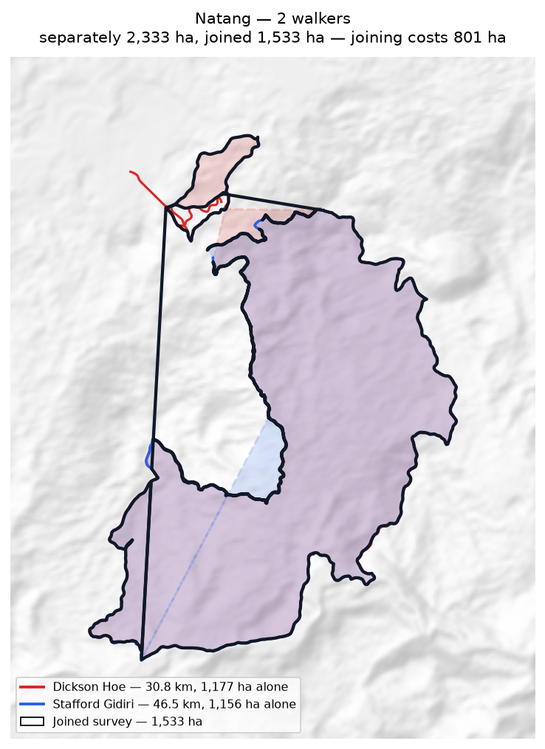
Each walker's line and the area it gives alone (dashed); the joined survey outlined in black.

Sugulkol
Walkers | Surveys | Walked (km) | Access legs (km) | Pieces | Gap to close (km) | Area (ha) | Basis
2 | 2 | 24.0 | 5.2 | 6 | 4.3 | 350 | inferred
Custodians
Custodian | Tracks | Walked (km) | Type
Chris Idua | 6 | 10.6 | Land Boundary
Emmanuel Fufus | 6 | 13.4 | Land Boundary
Problems
- The boundary does not close. 4.3 km was bridged with straight lines (19% of the distance walked), so 350 ha is an estimate rather than a measured area.
- Joining the 2 walkers costs 281 ha: separately they give 630 ha, joined 350 ha. This happens where walkers each walked the same ring rather than different stretches — the two rings cross and the joined network encloses less than either walk did alone.
- Overlaps 8 other clans: Natang (57 ha, 16% of this clan's land); Ginangi (51 ha, 15% of this clan's land); Wohukol (18 ha, 5% of this clan's land); Ambunkol (7 ha, 2% of this clan's land).
Queries for the field
- Did the 2 custodians walk the same boundary, or different parts of it? If they walked the same ring, their surveys should be treated as separate accounts rather than joined.
- Is the ground shared with Natang, Ginangi, Wohukol disputed, shared by agreement, or recorded wrongly? No change will be made to either boundary without the community's decision.
- This boundary is recorded in 6 separate pieces. Were the connecting stretches walked but not recorded, or not yet walked?
Effect of joining the walkers
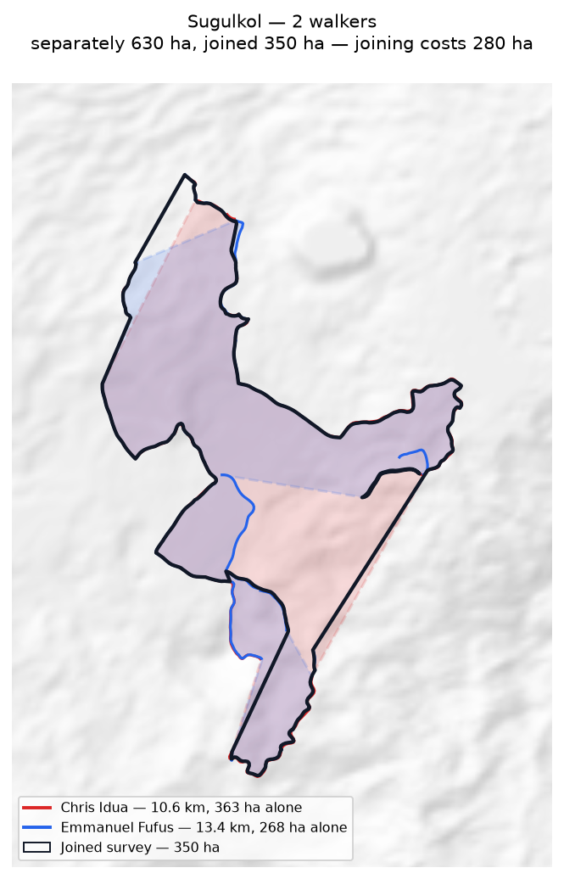
Each walker's line and the area it gives alone (dashed); the joined survey outlined in black.

Wohukol
Walkers | Surveys | Walked (km) | Access legs (km) | Pieces | Gap to close (km) | Area (ha) | Basis
2 | 2 | 34.9 | 7.3 | 4 | 8.7 | 664 | inferred
Custodians
Custodian | Tracks | Walked (km) | Type
Darline Walele | 5 | 17.1 | Land Boundary
Nelson Runage | 4 | 17.8 | Land Boundary
Problems
- The boundary does not close. 8.7 km was bridged with straight lines (26% of the distance walked), so 664 ha is an estimate rather than a measured area.
- Joining the 2 walkers adds 49 ha: separately 615 ha, joined 664 ha. The walkers covered different stretches of one boundary.
- Overlaps 5 other clans: Jariji (55 ha, 8% of this clan's land); Binunkol (20 ha, 3% of this clan's land); Sugulkol (18 ha, 3% of this clan's land); Natang (4 ha, 1% of this clan's land).
Queries for the field
- 26% of this boundary was not walked. Can the remaining 8.7 km be completed, so the area is measured rather than estimated?
- Is the ground shared with Jariji, Binunkol, Sugulkol disputed, shared by agreement, or recorded wrongly? No change will be made to either boundary without the community's decision.
- This boundary is recorded in 4 separate pieces. Were the connecting stretches walked but not recorded, or not yet walked?
Effect of joining the walkers
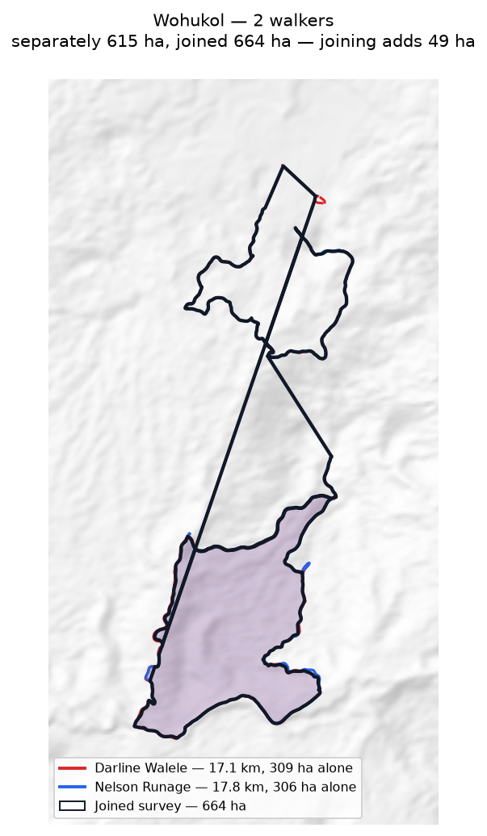
Each walker's line and the area it gives alone (dashed); the joined survey outlined in black.

Zone 8

Duribip
Walkers | Surveys | Walked (km) | Access legs (km) | Pieces | Gap to close (km) | Area (ha) | Basis
1 | 1 | 4.5 | 0.2 | 3 | 5.9 | none | no area
Custodians
Custodian | Tracks | Walked (km) | Type
Beven Naive | 4 | 4.5 | Land Boundary
Problems
- No area can be given. The tracks are in 3 disconnected pieces and 5.9 km of straight-line joining would be needed to make a ring — 139% of the distance walked. That is beyond the 50% limit, above which an area would be more assumption than survey.
Queries for the field
- Can the missing stretches be walked so this boundary closes? If any gap is deliberate — a river, a road, an agreed open edge — please say what runs along it.

Dusi
Walkers | Surveys | Walked (km) | Access legs (km) | Pieces | Gap to close (km) | Area (ha) | Basis
1 | 1 | 33.0 | 7.4 | 4 | 1.9 | 219 | inferred
Custodians
Custodian | Tracks | Walked (km) | Type
Max Mamo | 52 | 33.0 | Land Boundary
Problems
- The boundary does not close. 1.9 km was bridged with straight lines (6% of the distance walked), so 219 ha is an estimate rather than a measured area.
- Overlaps 2 other clans: Riribudeh (7 ha, 3% of this clan's land); Gubai (2 ha, 1% of this clan's land).
Queries for the field
- Is the ground shared with Riribudeh, Gubai disputed, shared by agreement, or recorded wrongly? No change will be made to either boundary without the community's decision.
- This boundary is recorded in 4 separate pieces. Were the connecting stretches walked but not recorded, or not yet walked?

Gubai
Walkers | Surveys | Walked (km) | Access legs (km) | Pieces | Gap to close (km) | Area (ha) | Basis
2 | 2 | 134.5 | 0.4 | 7 | 5.0 | 1,173 | inferred
Custodians
Custodian | Tracks | Walked (km) | Type
Fordy Igai | 20 | 42.7 | Land Boundary
Kenny Noi | 55 | 91.9 | Land Boundary
Problems
- The boundary does not close. 5.0 km was bridged with straight lines (4% of the distance walked), so 1,173 ha is an estimate rather than a measured area.
- Joining the 2 walkers costs 493 ha: separately they give 1,667 ha, joined 1,173 ha. This happens where walkers each walked the same ring rather than different stretches — the two rings cross and the joined network encloses less than either walk did alone.
- Overlaps 1 other clan: Dusi (2 ha, 0% of this clan's land).
Queries for the field
- Did the 2 custodians walk the same boundary, or different parts of it? If they walked the same ring, their surveys should be treated as separate accounts rather than joined.
- Is the ground shared with Dusi disputed, shared by agreement, or recorded wrongly? No change will be made to either boundary without the community's decision.
- This boundary is recorded in 7 separate pieces. Were the connecting stretches walked but not recorded, or not yet walked?
Effect of joining the walkers
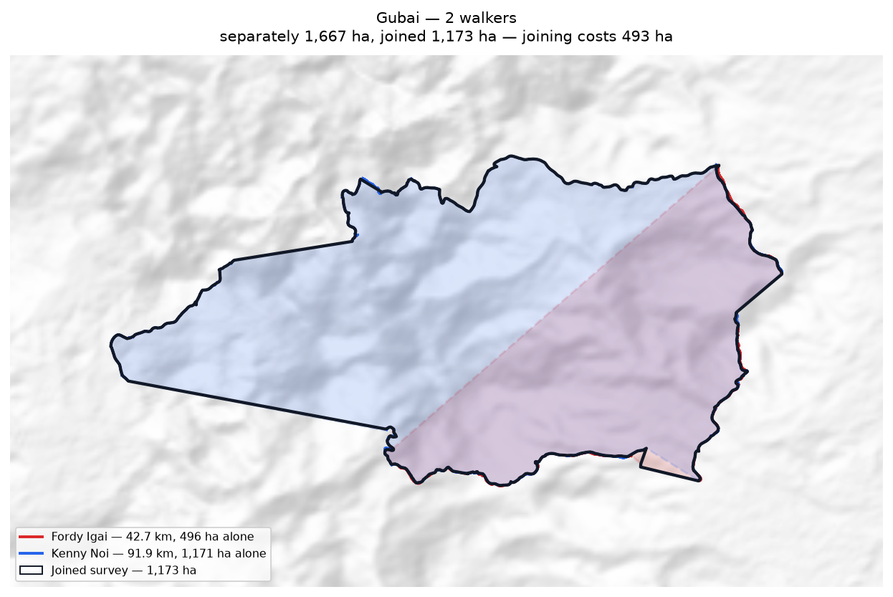
Each walker's line and the area it gives alone (dashed); the joined survey outlined in black.

Gumuyude
Walkers | Surveys | Walked (km) | Access legs (km) | Pieces | Gap to close (km) | Area (ha) | Basis
1 | 1 | 16.8 | 3.9 | 7 | 2.3 | 691 | inferred
Custodians
Custodian | Tracks | Walked (km) | Type
Philip Igai | 6 | 16.8 | Land Boundary
Problems
- The boundary does not close. 2.3 km was bridged with straight lines (15% of the distance walked), so 691 ha is an estimate rather than a measured area.
- Overlaps 2 other clans: Riribudeh (4 ha, 1% of this clan's land); Mungaikol (1 ha, 0% of this clan's land).
Queries for the field
- Is the ground shared with Riribudeh, Mungaikol disputed, shared by agreement, or recorded wrongly? No change will be made to either boundary without the community's decision.
- This boundary is recorded in 7 separate pieces. Were the connecting stretches walked but not recorded, or not yet walked?

Madukol
Walkers | Surveys | Walked (km) | Access legs (km) | Pieces | Gap to close (km) | Area (ha) | Basis
1 | 1 | 1.1 | 0.0 | 2 | 0.3 | 1 | inferred
Custodians
Custodian | Tracks | Walked (km) | Type
Gibs Ginave | 5 | 1.1 | Land Boundary
Problems
- The boundary does not close. 0.3 km was bridged with straight lines (27% of the distance walked), so 1 ha is an estimate rather than a measured area.
Queries for the field
- 27% of this boundary was not walked. Can the remaining 0.3 km be completed, so the area is measured rather than estimated?

Mungaikol
Walkers | Surveys | Walked (km) | Access legs (km) | Pieces | Gap to close (km) | Area (ha) | Basis
1 | 1 | 14.8 | 2.8 | 3 | 2.3 | 570 | inferred
Custodians
Custodian | Tracks | Walked (km) | Type
Graham Ekiawa | 5 | 14.8 | Land Boundary
Problems
- The boundary does not close. 2.3 km was bridged with straight lines (17% of the distance walked), so 570 ha is an estimate rather than a measured area.
- Overlaps 2 other clans: Gumuyude (1 ha, 0% of this clan's land); Borori (0 ha, 0% of this clan's land).
Queries for the field
- Is the ground shared with Gumuyude, Borori disputed, shared by agreement, or recorded wrongly? No change will be made to either boundary without the community's decision.

Riribudeh
Walkers | Surveys | Walked (km) | Access legs (km) | Pieces | Gap to close (km) | Area (ha) | Basis
2 | 2 | 20.4 | 4.2 | 3 | 1.6 | 372 | inferred
Custodians
Custodian | Tracks | Walked (km) | Type
Prut Buitari | 7 | 10.4 | Land Boundary
Unido Ose | 28 | 10.0 | Land Boundary
Problems
- The boundary does not close. 1.6 km was bridged with straight lines (8% of the distance walked), so 372 ha is an estimate rather than a measured area.
- Joining the 2 walkers costs 398 ha: separately they give 770 ha, joined 372 ha. This happens where walkers each walked the same ring rather than different stretches — the two rings cross and the joined network encloses less than either walk did alone.
- Overlaps 2 other clans: Dusi (7 ha, 2% of this clan's land); Gumuyude (4 ha, 1% of this clan's land).
Queries for the field
- Did the 2 custodians walk the same boundary, or different parts of it? If they walked the same ring, their surveys should be treated as separate accounts rather than joined.
- Is the ground shared with Dusi, Gumuyude disputed, shared by agreement, or recorded wrongly? No change will be made to either boundary without the community's decision.
Effect of joining the walkers
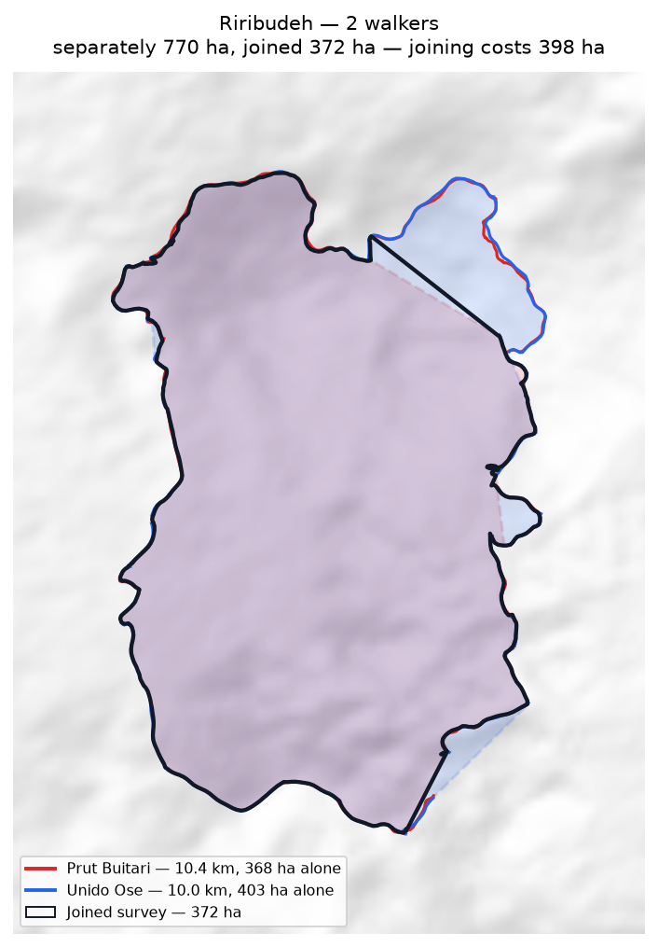
Each walker's line and the area it gives alone (dashed); the joined survey outlined in black.

Uremkol
Walkers | Surveys | Walked (km) | Access legs (km) | Pieces | Gap to close (km) | Area (ha) | Basis
1 | 1 | 11.2 | 2.4 | 4 | 6.3 | none | no area
Custodians
Custodian | Tracks | Walked (km) | Type
Cyprian Sirami | 3 | 11.2 | Land Boundary
Problems
- No area can be given. The tracks are in 4 disconnected pieces and 6.3 km of straight-line joining would be needed to make a ring — 58% of the distance walked. That is beyond the 50% limit, above which an area would be more assumption than survey.
Queries for the field
- Can the missing stretches be walked so this boundary closes? If any gap is deliberate — a river, a road, an agreed open edge — please say what runs along it.

