Managalas Clan Land Mapping
Survey results, per-clan detail, and queries for the field
Version 1.14 · 10 October 2026
Clan land boundaries in the Managalas Conservation Area, Oro Province, Papua New Guinea. Mapped by Clan Stewards at the request of clan elders through the Clan Elder Workshops. Each community decides whether to map; where a boundary is disputed the community decides whether to resolve it or leave the area aside.
Sacred site locations are not shared. They are reported by area and share of clan land only, and appear in no map or layer in this document.
This document is regenerated from the survey data on each run. Every figure and every map in it comes from the same run, so the text and the maps cannot disagree. Quote it by version and date; a later version supersedes it entirely.
This version | Detail
Version | 1.14
Generated | 10 October 2026
Data through | 2026-08-13
Surveys included | 72
Code revision | 8d59f94

What changed in version 1.14
- The land inside a sacred site's boundary goes back to the clan. Where a Clan Steward walked around a named place, the circuit came through as a closed ring inside the outer boundary, and the pipeline cut the ground inside it out of the clan's land and drew a hole on the map at that spot. Both were wrong: the clan holds that ground, and the hole marked a location that is not ours to share. 253 rings are filled back in across 29 surveys, returning 24.6 ha.
- New, shorter document: "The completed boundaries". Only the clans whose boundary closes on the ground their stewards walked, with nothing inferred in the area. The full report carries all 49 clans and a finished map is hard to find among the unfinished ones.
- A steward's own spelling of "sacred site" is now read as one when counting. Recorded as a reading of the words, not a change to them: the raw files are never edited, and what any steward wrote about these places stays out of this document.
Figures move between versions because the method improves as well as because new surveys arrive. Where a correction changed a number materially, the change says so.

Contents

Right-click and choose “Update field” to build the contents list, or press Ctrl+A then F9.

1. What has been mapped
Measure | Value
Clans with data | 49
Clan Stewards who walked | 70
Individual surveys | 72
Clan boundaries assessed (stewards joined) | 36
Days on the ground | 119
Steward-days recorded | 241
First and last walk recorded | 2025-02-18 to 2026-08-13
Distance walked | 1,139.9 km
Boundary walked (excl. access legs and non-boundary) | 948.5 km
Boundary distance excludes surveys that are not land boundaries, and the legs walked in to reach a boundary and out again. Who walked on which day, and how far, is a separate document: Managalas Steward Days.

Land area
Basis | Boundaries | Hectares
Walked and closed | 6 | 5,168
Closure inferred (gap bridged) | 30 | 28,539
Total mapped | 36 | 33,707
Footprint (overlaps counted once) |  | 28,529
Conservation area |  | 213,269
85% of the mapped area rests on an inferred closure — the boundary was not walked the whole way round and the gap has been bridged with a straight line. Those areas are estimates and are labelled as such throughout.

The straight lines are not boundary
146.1 km of the outlines in this document was never walked — 23% of the 632.6 km of outline drawn around the mapped areas. These are the long straight lines that cut across the landscape on the maps. They are not where anyone said a boundary runs: they mark where a receiver was switched off at the end of one walk and switched on again somewhere else, and the straight line between is this pipeline joining the pieces up so an area can be given at all.
They are drawn in pink on every map, apart from the walked line, so they can never be mistaken for a surveyed edge. Where a clan's outline carries a long straight line, the area behind it is a guess across that gap, and the query on that clan's page asks for the missing stretch to be walked.
Which order the recorded pieces are joined in, and which way round each piece is taken, changes the result substantially. Taking a piece the wrong way round makes the joining lines cross, and a crossed outline encloses two slivers where the real walk encloses one block — Tuoko lost 394 ha to exactly that before it was corrected. The pieces are now ordered and oriented to make the joining as short as possible, which leaves no crossings.
The mapped footprint is 13.4% of the conservation area.

Land held in more than one piece
A clan's land does not have to be one block. Where a clan's walks enclose several separate parcels, all of them are kept and all of them are counted — the mapped area is the sum, and the map shows each piece. 8 of 35 mapped clans hold land in more than one parcel on the evidence so far.
Clan | Parcels | Total area (ha)
Ambunkol | 3 | 592
Borori | 2 | 639
Giroiko | 4 | 10
Jariji | 2 | 696
Madukol | 2 | 1
Natang | 2 | 1,535
Nituri | 2 | 5,277
Wohukol | 3 | 701
Only parcels of at least 2% of the clan's largest are kept. Below that a loop is a track crossing itself rather than a separate holding. If a clan knows of a parcel that is missing here, that is a survey to add, not a limit of the method.

By zone
Zone | Clans | Clan Stewards | Surveys | Walked (km) | Boundary (km) | Area (ha)
Zone 2 | 15 | 18 | 20 | 320.5 | 257.4 | 18,920
Zone 3 | 5 | 9 | 9 | 52.8 | 46.0 | 10
Zone 6 | 6 | 9 | 9 | 174.6 | 145.8 | 3,671
Zone 7A | 3 | 6 | 6 | 73.7 | 53.9 | 1,385
Zone 7B | 12 | 18 | 18 | 282.3 | 230.6 | 6,696
Zone 8 | 8 | 10 | 10 | 236.1 | 214.8 | 3,027

Overlap between clans
This is the finding with the widest implications. The PNG Incorporated Land Group system rests on land being held by a single clan, undisputed. On this evidence that assumption does not describe the Managalas.

Two readings: strict, and beyond a 100 m tolerance
Overlap is reported twice. The strict figure counts every square metre two clans both claim, and is the exact measurement. The second figure removes any strip of shared ground narrower than 100 m: where two recorded lines run closer together than that, the ground between them is not a competing claim but the ordinary imprecision of the work — GPS fixes landing ten metres apart, canopy pushing them further, and a boundary followed on foot wandering around the terrain. 100 m is inconsequential here.
Measure | Strict | Beyond 100 m
Clans with a mapped area | 35 | 35
Clans whose land overlaps another clan's | 33 | 29
Clans with no overlap | 2 | 6
Pairs of clans sharing ground | 54 | 37
Area claimed by more than one clan (ha) | 4,801 | 4,733
— as a share of the mapped footprint | 17% | 17%
The tolerance changes very little: 68 ha of the 4,801 ha falls away, and 4 clan(s) drop out of the overlapping group. 17 of the 54 pairs turn out to be two clans describing the same line rather than claiming the same ground. The finding survives the allowance — which is the point of making it.
Read with care: most boundaries rest on inferred closures, so some overlap is an artefact of straight-line bridging rather than a competing claim. It does not disappear when only walked boundaries are counted, but the headline share is inflated by the inferred ones.
Overlaps are recorded exactly as mapped. They are not reconciled, and clans are never merged.

What an overlap here is not
An overlap in these figures is a statement about two surveys, not about two clans. Most boundaries here are incomplete — a quarter of the outline drawn around the mapped areas is straight line nobody walked — and where a survey is unfinished, the area attributed to it is bounded by those straight lines rather than by anything anyone walked or said.
So an overlap between two unfinished surveys is first of all a sign that both need finishing. It is recorded because it is what the data shows, and because the pattern across the whole area is the point; it is not evidence that anybody disputes anything, and nothing in this document should be read as saying so.
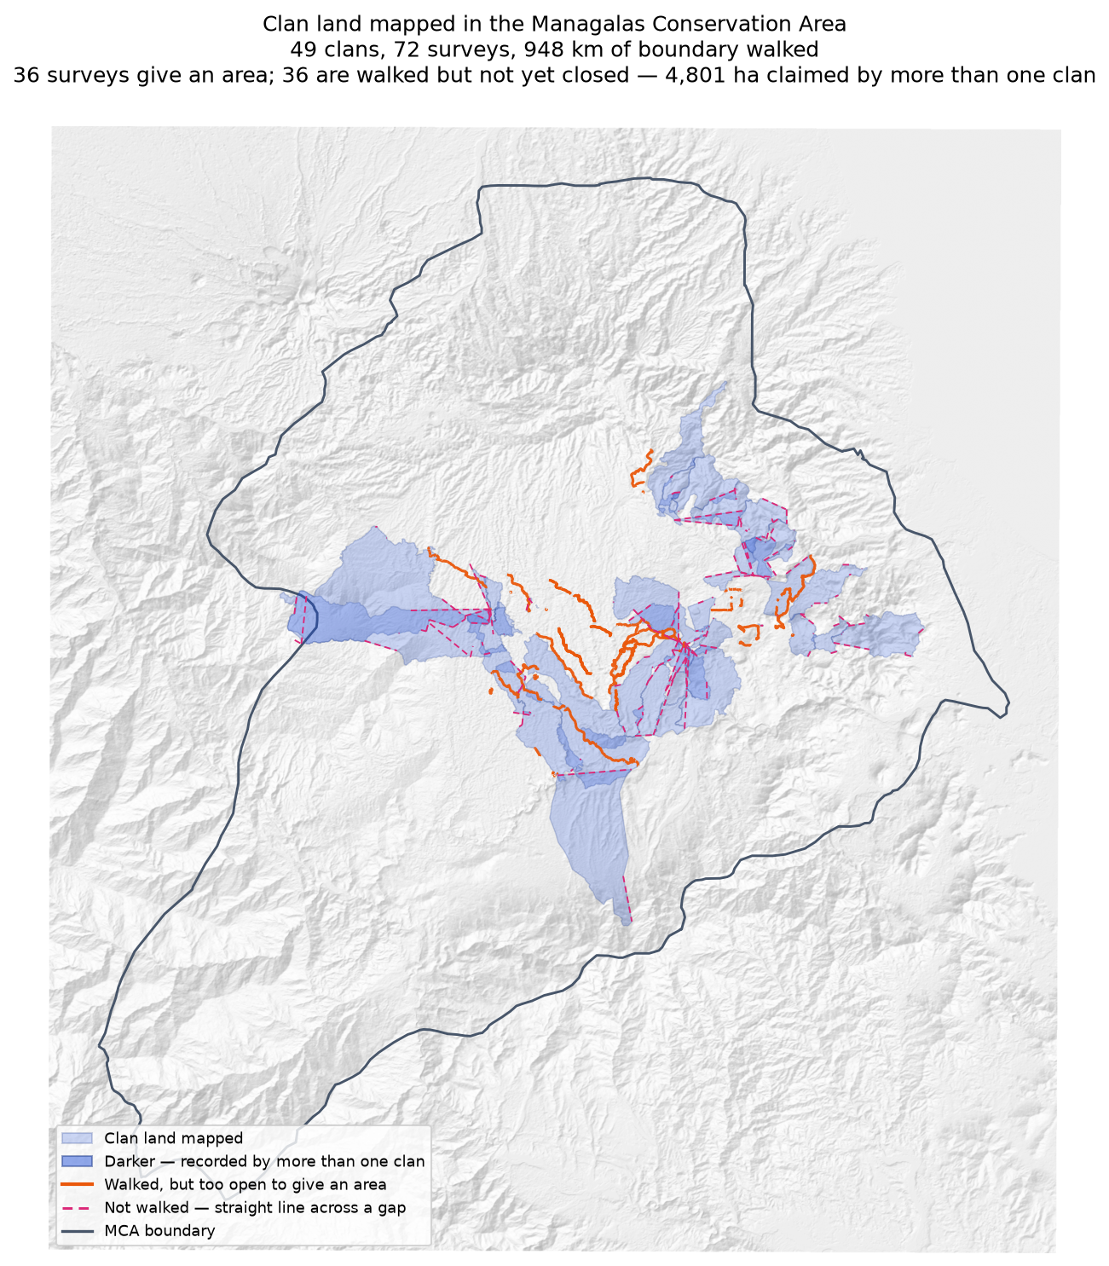
One wash for every mapped area, whether the boundary closed on its own or the closure was inferred. The washes are transparent and are not merged, so where two clans have recorded the same ground it simply reads darker, and darker again where three have. Orange: walked, but still too open to give an area. Pink dashes: nobody walked this — a straight line across a gap.

Zone Boundaries based on clan boundary mapping
Each zone in one colour, used twice: a wash for the land mapped, and the same colour solid for the boundaries walked but not yet closed. It answers a different question from the map above — not what the survey shows, but how far each zone has got.
These are not surveyed zone boundaries. Nobody walked one. What a zone covers here is the sum of the clan surveys inside it, so its edge moves every time a clan finishes a boundary — the shape is a record of mapping progress, not a line anyone has agreed.
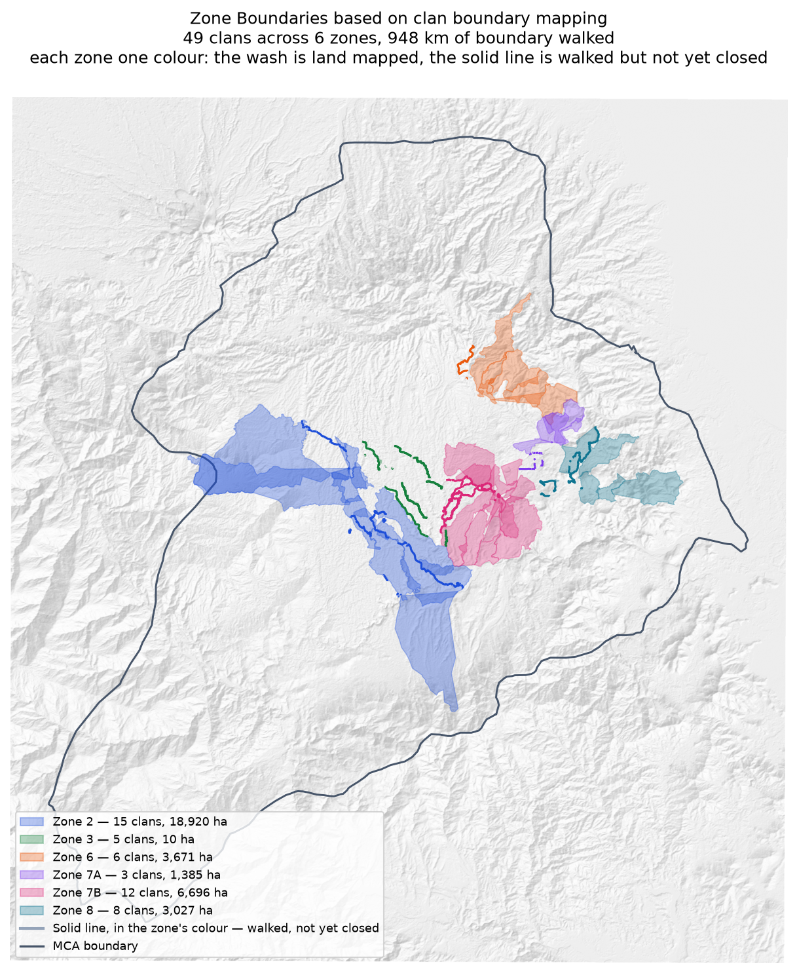
Zone 2 has by far the most land mapped; Zone 3 has walked 42 km of boundary and closed almost none of it, which is why it appears as lines with no wash behind them.

Neighbouring clans walking the same edge
The mirror image of the overlap figures, and just as important. 117 pairs of clans have recorded lines that run within 100 m of each other — they walked the same edge. That is agreement on a boundary, and it does not show up in an overlap table at all. Some of the pairs below share almost their whole recorded line while sharing no ground at all.
Clan | Clan | Shared line (km) | % of the first's line | % of the second's
Ambunkol | Natang | 20.3 | 59.2% | 37.6%
Deari | Nui | 15.0 | 94.2% | 64.0%
Nituri | Tuoko | 14.4 | 24.0% | 30.2%
Borori | Darekikol | 13.9 | 32.0% | 48.4%
Manuvoora | Sahirut | 12.6 | 20.5% | 50.5%
Rondi | Rumbi | 10.5 | 17.7% | 33.5%
Gumuri | Rondi | 9.2 | 63.0% | 15.5%
Natang | Wohukol | 8.8 | 16.0% | 25.1%
Jariji | Wohukol | 8.6 | 35.6% | 24.6%
Borori | Mariura | 8.4 | 25.7% | 20.5%
Rumbi | Sukandi | 8.0 | 49.8% | 20.2%
Mariura | Naharaura | 7.9 | 49.8% | 28.3%
Mungaikol | Uremkol | 7.6 | 51.2% | 67.2%
Rondi | Sukandi | 7.0 | 11.8% | 8.7%
Manuvoora | Pina Ora | 7.0 | 11.3% | 19.0%
Read alongside the overlap table. A pair appearing here and not there has walked one edge together; a pair appearing in both has walked part of an edge together and has more still to walk.

Giving the survey back
Each clan has a GPX file of its own, named on that clan's page and supplied alongside this document. It is meant to go back to the Clan Stewards who walked the boundary, on the phone or handheld they mapped with: their own tracks, the gaps drawn as straight lines named so they cannot be mistaken for boundary, and a waypoint at each end of every gap.
178 gaps are marked across 49 clans, 260.7 km still to walk. A steward can select the waypoint for a gap, walk to it, and record from there.
Joins shorter than 100 m are not marked. Two track ends that close are the same place to anyone standing there, and flagging them would bury the gaps that matter.

Sacred sites
Reported by area and share of clan land only; locations are not shared. Three sites across two mapped units, covering an estimated 313–456 ha, being 16–24% of the host clan's land. The range reflects that neither walk closed, so the area can only be bracketed.

2. How to read the clan entries
Each clan starts on a new page, so a single clan's pages can be taken out and discussed with that clan without the rest of the document going with them.
Each clan is assessed as one boundary within one zone. Where several stewards walked, their tracks are joined into a single survey — stewards of one clan are joined; different clans never are.
Term | Meaning
Walked | Distance recorded, after smoothing
Access legs | Dead-end walks in to the boundary and back out; excluded from boundary distance
Pieces | Disconnected runs of track; one means a single continuous boundary
Parcels | Separate blocks of land the walks enclose; more than one is normal
Not walked | Straight line joining the pieces into a ring — nobody walked it, and it is not boundary
Walked and closed | The tracks ring the land; area is measured, not assumed
Inferred | Open ends bridged with straight lines; area is an estimate
No area | Gap exceeds half the distance walked — too open to estimate honestly
Overlap (strict) | Every square metre inside the area recorded for two clans
Overlap (beyond tolerance) | The same, with strips narrower than 100 m removed
Neighbouring clan | A clan whose recorded line runs within 100 m of this one's
A clan name that appears in more than one zone carries a zone code, for example Murai (Z2) and Murai (Z7B). This is expected — language spreads between zones and clans that split may keep an ancestral name — but the two are not the same landholding group and their land is never combined.

What the field has told us about all of this
- Large rivers cannot reasonably be walked. Boulders, rapids and steep drops make it physically difficult and unsafe, so a gap that follows one is not a gap anybody should be asked to close on foot.
- Where a boundary is a large river, the survey team will complete that stretch themselves by editing. How to draw a robust river boundary is an open decision, not yet made.
Field advice, 23 August 2026. Where a clan's boundary is known to follow a large river, this document does not ask for that stretch to be walked, and says so on the clan's page. 2 clan(s) are marked that way so far.

Reading the map on each clan's page
- Each steward's walk is a solid coloured line, and the area that walk gives on its own is the matching dashed outline.
- The survey those walks combine into is a dotted black outline, drawn underneath the stewards' lines. Where it follows a walk you see the steward's colour; where it strikes out on its own, that stretch was not walked by anyone — it is the straight line bridging a gap.
- Pink dashes are the stretches nobody walked: the receiver was off, and the straight line is this pipeline joining the pieces up. Do not read them as boundary.
- Neighbouring clans are named where they lie. Their boundaries are not drawn — this page is about one clan's survey, and what two surveys share is in the tables, not on the map.

3. Clans
49 clan boundaries, in zone order. Each begins on its own page.

Zone 2

Asingi
Zone 2 · version 1.14, 10 October 2026
Stewards | Surveys | Walked (km) | Access legs (km) | Pieces | Not walked (km) | Parcels | Area (ha) | Basis
1 | 1 | 6.4 | 0.0 | 2 | — | 1 | 166 | surveyed
Clan Stewards
Clan Steward | Tracks | Days | First | Last | Walked (km)
Jethro Akse | 5 | 5 | 2025-02-18 | 2026-02-05 | 6.4
Ground also claimed by another clan
Clan | Shared (ha) | % of this clan | Beyond 100 m (ha) | Verdict
Murai (Z2) | 6 | 3.6% | 5 | overlap
Gariniko | 4 | 2.5% | 3 | overlap
Kasaki | 0 | 0.0% | 0 | within tolerance
Neighbouring clans
Clan | Boundary walked alongside (km) | % of this clan's line
Gariniko | 3.5 | 52.4%
Murai (Z2) | 0.6 | 9.6%
Kasaki | 0.6 | 8.0%
Bujevi | 0.4 | 6.7%
Tuoko | 0.3 | 3.6%
Nituri | 0.6 | 3.5%
Zambiko | 0.4 | 3.5%
Where the two clans' recorded lines run within 100 m of each other. Two neighbours walking the same edge is the ordinary case.
Sacred sites
None recorded. The Clan Stewards were asked for the outer boundary and the sacred sites; nothing in this clan's files is marked as one.
What the survey shows
- The boundary closes on its own. 166 ha is measured from the walk, with nothing inferred.
- Ground here is also inside the area recorded for 2 other clans: Murai (Z2) (6 ha); Gariniko (4 ha).
- A further 1 clan (Kasaki) shares ground only in strips narrower than 100 m — the two lines being the same line, which is not counted as overlap.
Queries for the field
- Nothing outstanding. The boundary closes on its own and the survey is complete.
To take back to the ground
A GPX file for this clan is supplied as Asingi_Zone_2.gpx. Loaded onto the phone or handheld the boundary was mapped with, it shows the stewards' own tracks and confirms the boundary closes with no gaps to walk.
Map
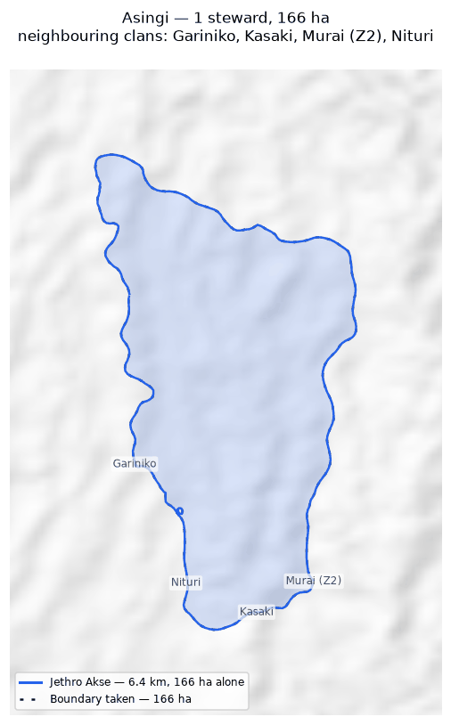
The walk and the area it gives (dotted), with the stretches nobody walked in pink. Neighbouring clans are named where they lie; their boundaries are not drawn.

Asoro
Zone 2 · version 1.14, 10 October 2026
Stewards | Surveys | Walked (km) | Access legs (km) | Pieces | Not walked (km) | Parcels | Area (ha) | Basis
1 | 1 | 22.8 | 3.5 | 2 | 8.0 | 1 | 3,507 | inferred
Clan Stewards
Clan Steward | Tracks | Days | First | Last | Walked (km)
Gilford Amakana | 10 | 3 | 2026-01-29 | 2026-01-31 | 22.8
Ground also claimed by another clan
Clan | Shared (ha) | % of this clan | Beyond 100 m (ha) | Verdict
Sukandi | 232 | 6.6% | 231 | overlap
Juaiko | 15 | 0.4% | 15 | overlap
Neighbouring clans
Clan | Boundary walked alongside (km) | % of this clan's line
Sukandi | 0.8 | 3.2%
Juaiko | 0.7 | 1.2%
Zambiko | 0.1 | 0.2%
Where the two clans' recorded lines run within 100 m of each other. Two neighbours walking the same edge is the ordinary case.
Sacred sites
None recorded. The Clan Stewards were asked for the outer boundary and the sacred sites; nothing in this clan's files is marked as one.
What the survey shows
- The boundary does not close. 8.0 km in 2 stretches was bridged with straight lines nobody walked — 38% of the distance walked, so 3,507 ha is an estimate rather than a measured area. On the map those stretches are pink.
- Ground here is also inside the area recorded for 2 other clans: Sukandi (232 ha); Juaiko (15 ha). These figures are provisional while this boundary is incomplete: the unwalked stretches are drawn as straight lines, and those lines are what the overlap is measured against.
Queries for the field
- 38% of this outline was not walked — 8.0 km of straight line, shown in pink. Does the boundary in fact run along those straight lines, or somewhere else? Can the missing stretches be walked?
To take back to the ground
A GPX file for this clan is supplied as Asoro_Zone_2.gpx. Loaded onto the phone or handheld the boundary was mapped with, it shows the stewards' own tracks, the 2 gaps drawn as straight lines, and a waypoint at each end of every gap so a steward can navigate to where the walking stopped and carry on.
Map
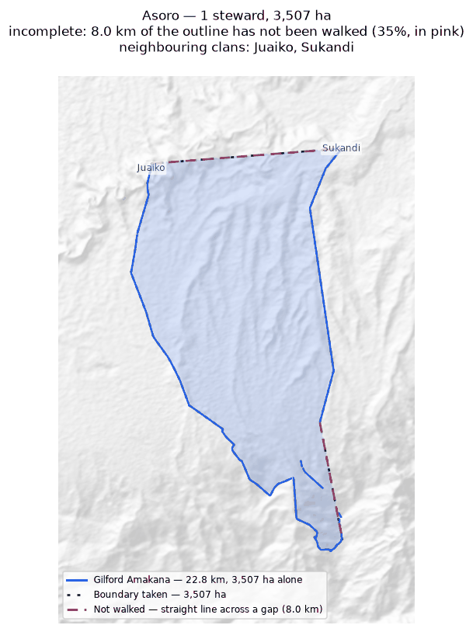
The walk and the area it gives (dotted), with the stretches nobody walked in pink. Neighbouring clans are named where they lie; their boundaries are not drawn.

Bujevi
Zone 2 · version 1.14, 10 October 2026
Stewards | Surveys | Walked (km) | Access legs (km) | Pieces | Not walked (km) | Parcels | Area (ha) | Basis
1 | 1 | 5.8 | 1.1 | 1 | 4.5 | — | none | no area
Clan Stewards
Clan Steward | Tracks | Days | First | Last | Walked (km)
Abel Kajari | 2 | 2 | 2026-02-08 | 2026-02-09 | 5.8
Neighbouring clans
Clan | Boundary walked alongside (km) | % of this clan's line
Nituri | 0.9 | 10.4%
Gariniko | 0.5 | 6.3%
Asingi | 0.4 | 4.9%
Where the two clans' recorded lines run within 100 m of each other. Two neighbours walking the same edge is the ordinary case.
Sacred sites
None recorded. The Clan Stewards were asked for the outer boundary and the sacred sites; nothing in this clan's files is marked as one.
What the survey shows
- No area can be given. The tracks are in 1 disconnected piece and 4.5 km of straight-line joining would be needed to make a ring — 84% of the distance walked. That is beyond the 50% limit, above which an area would be more assumption than survey.
- 10% of this clan's recorded line runs within 100 m of Nituri's: the two walked the same edge.
Queries for the field
- Can the missing stretches be walked so this boundary closes? If any gap is deliberate — a river, a road, an agreed open edge — please say what runs along it.
To take back to the ground
A GPX file for this clan is supplied as Bujevi_Zone_2.gpx. Loaded onto the phone or handheld the boundary was mapped with, it shows the stewards' own tracks, the 1 gap drawn as straight lines, and a waypoint at each end of every gap so a steward can navigate to where the walking stopped and carry on.
Map
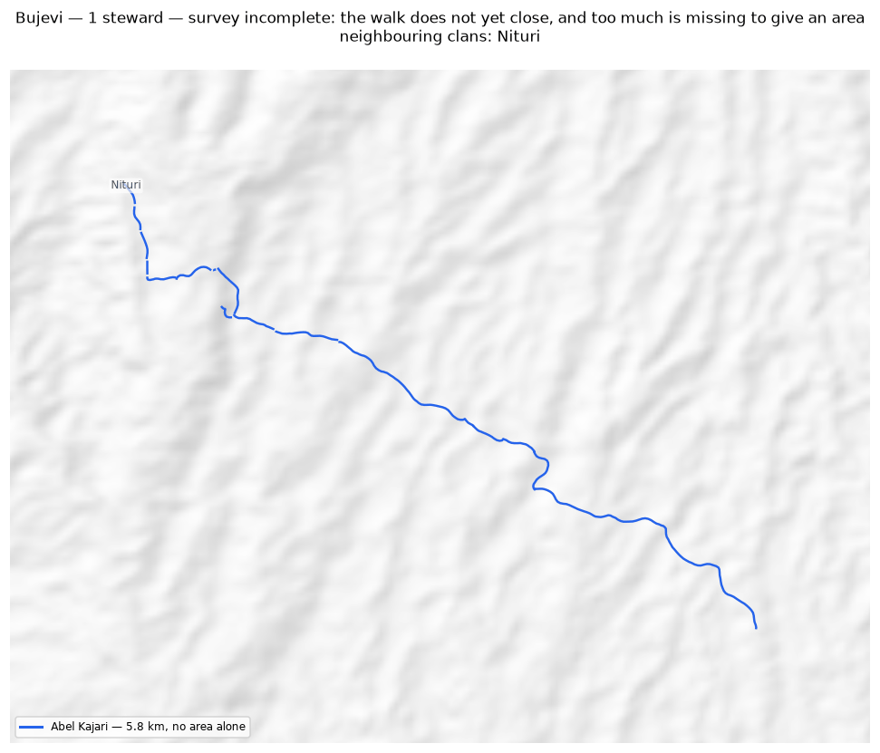
The walk and the area it gives (dotted), with the stretches nobody walked in pink. Neighbouring clans are named where they lie; their boundaries are not drawn.

Gariniko
Zone 2 · version 1.14, 10 October 2026
Stewards | Surveys | Walked (km) | Access legs (km) | Pieces | Not walked (km) | Parcels | Area (ha) | Basis
1 | 1 | 10.1 | 1.5 | 4 | 4.8 | 1 | 107 | inferred
Clan Stewards
Clan Steward | Tracks | Days | First | Last | Walked (km)
Lance Sake | 6 | 3 | 2025-11-28 | 2026-02-07 | 10.1
Ground also claimed by another clan
Clan | Shared (ha) | % of this clan | Beyond 100 m (ha) | Verdict
Tuoko | 7 | 6.3% | 5 | overlap
Asingi | 4 | 3.9% | 3 | overlap
Nituri | 3 | 3.2% | 2 | overlap
Kasaki | 2 | 1.8% | 0 | within tolerance
Murai (Z2) | 1 | 0.5% | 0 | within tolerance
Neighbouring clans
Clan | Boundary walked alongside (km) | % of this clan's line
Asingi | 3.5 | 58.5%
Murai (Z2) | 1.8 | 30.6%
Kasaki | 1.4 | 22.6%
Tuoko | 0.6 | 10.2%
Nituri | 0.6 | 8.7%
Zambiko | 0.5 | 8.7%
Bujevi | 0.5 | 7.6%
Where the two clans' recorded lines run within 100 m of each other. Two neighbours walking the same edge is the ordinary case.
Sacred sites
None recorded. The Clan Stewards were asked for the outer boundary and the sacred sites; nothing in this clan's files is marked as one.
What the survey shows
- The boundary does not close. 4.8 km in 4 stretches was bridged with straight lines nobody walked — 50% of the distance walked, so 107 ha is an estimate rather than a measured area. On the map those stretches are pink.
- Ground here is also inside the area recorded for 3 other clans: Tuoko (7 ha); Asingi (4 ha); Nituri (3 ha). These figures are provisional while this boundary is incomplete: the unwalked stretches are drawn as straight lines, and those lines are what the overlap is measured against.
- A further 2 clans (Kasaki, Murai (Z2)) share ground only in strips narrower than 100 m — the two lines being the same line, which is not counted as overlap.
Queries for the field
- 50% of this outline was not walked — 4.8 km of straight line, shown in pink. Does the boundary in fact run along those straight lines, or somewhere else? Can the missing stretches be walked?
- This boundary is recorded in 4 separate pieces. Were the connecting stretches walked but not recorded, or not yet walked?
To take back to the ground
A GPX file for this clan is supplied as Gariniko_Zone_2.gpx. Loaded onto the phone or handheld the boundary was mapped with, it shows the stewards' own tracks, the 4 gaps drawn as straight lines, and a waypoint at each end of every gap so a steward can navigate to where the walking stopped and carry on.
Map
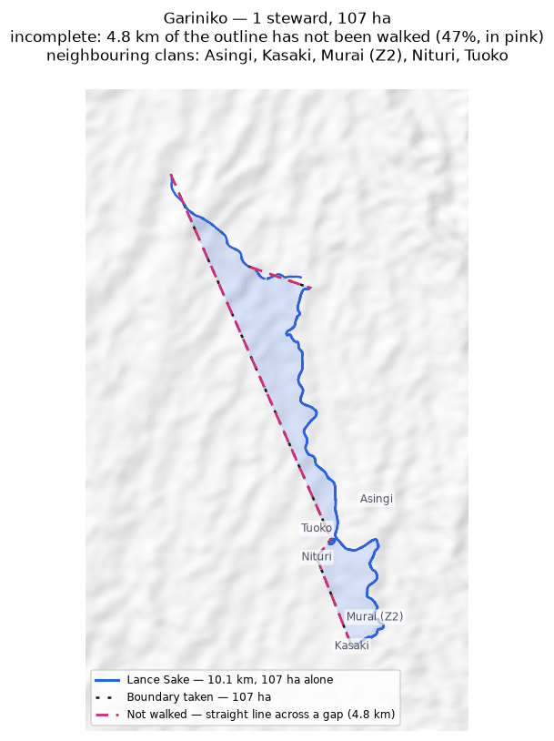
The walk and the area it gives (dotted), with the stretches nobody walked in pink. Neighbouring clans are named where they lie; their boundaries are not drawn.

Juaiko
Zone 2 · version 1.14, 10 October 2026
Stewards | Surveys | Walked (km) | Access legs (km) | Pieces | Not walked (km) | Parcels | Area (ha) | Basis
1 | 1 | 24.3 | 5.8 | 7 | 1.9 | 1 | 1,298 | inferred
Clan Stewards
Clan Steward | Tracks | Days | First | Last | Walked (km)
Gasper K Philip J | 10 | 5 | 2025-04-22 | 2025-04-28 | 24.3
Ground also claimed by another clan
Clan | Shared (ha) | % of this clan | Beyond 100 m (ha) | Verdict
Sukandi | 205 | 15.8% | 202 | overlap
Asoro | 15 | 1.2% | 15 | overlap
Manoko | 13 | 1.0% | 7 | overlap
Neighbouring clans
Clan | Boundary walked alongside (km) | % of this clan's line
Manoko | 4.9 | 20.3%
Sukandi | 4.2 | 17.3%
Zambiko | 2.6 | 10.6%
Rumbi | 2.1 | 8.6%
Asoro | 0.7 | 2.7%
Where the two clans' recorded lines run within 100 m of each other. Two neighbours walking the same edge is the ordinary case.
Sacred sites
Recorded: 4 — 4 recorded as a boundary walked around a named place, covering 4.6 ha — 0.4% of this clan's land.
Locations are not shared and appear on no map or layer in this document. A sacred site is usually recorded the way the rest of the land is, as a boundary walked around it, so it is counted from what the steward wrote beside the track.
What the survey shows
- The boundary does not close. 1.9 km in 7 stretches was bridged with straight lines nobody walked — 9% of the distance walked, so 1,298 ha is an estimate rather than a measured area. On the map those stretches are pink.
- Ground here is also inside the area recorded for 3 other clans: Sukandi (205 ha); Asoro (15 ha); Manoko (13 ha).
Queries for the field
- This boundary is recorded in 7 separate pieces. Were the connecting stretches walked but not recorded, or not yet walked?
To take back to the ground
A GPX file for this clan is supplied as Juaiko_Zone_2.gpx. Loaded onto the phone or handheld the boundary was mapped with, it shows the stewards' own tracks, the 6 gaps drawn as straight lines, and a waypoint at each end of every gap so a steward can navigate to where the walking stopped and carry on.
Map
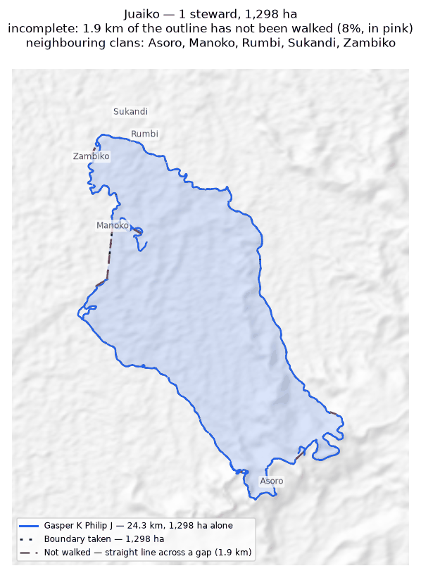
The walk and the area it gives (dotted), with the stretches nobody walked in pink. Neighbouring clans are named where they lie; their boundaries are not drawn.

Kasaki
Zone 2 · version 1.14, 10 October 2026
Stewards | Surveys | Walked (km) | Access legs (km) | Pieces | Not walked (km) | Parcels | Area (ha) | Basis
1 | 1 | 15.1 | 3.1 | 4 | 1.3 | 1 | 541 | inferred
Clan Stewards
Clan Steward | Tracks | Days | First | Last | Walked (km)
Ananias Masua | 1 | 1 | 2026-02-05 | 2026-02-05 | 15.1
Ground also claimed by another clan
Clan | Shared (ha) | % of this clan | Beyond 100 m (ha) | Verdict
Tuoko | 157 | 29.0% | 155 | overlap
Murai (Z2) | 154 | 28.5% | 154 | overlap
Nituri | 59 | 11.0% | 59 | overlap
Majanko | 40 | 7.4% | 39 | overlap
Gariniko | 2 | 0.3% | 0 | within tolerance
Asingi | 0 | 0.0% | 0 | within tolerance
Neighbouring clans
Clan | Boundary walked alongside (km) | % of this clan's line
Murai (Z2) | 3.4 | 21.2%
Tuoko | 1.5 | 9.6%
Majanko | 1.2 | 7.8%
Gariniko | 1.4 | 7.7%
Nituri | 1.1 | 5.7%
Asingi | 0.6 | 3.6%
Where the two clans' recorded lines run within 100 m of each other. Two neighbours walking the same edge is the ordinary case.
Sacred sites
None recorded. The Clan Stewards were asked for the outer boundary and the sacred sites; nothing in this clan's files is marked as one.
What the survey shows
- The boundary does not close. 1.3 km in 4 stretches was bridged with straight lines nobody walked — 10% of the distance walked, so 541 ha is an estimate rather than a measured area. On the map those stretches are pink.
- Ground here is also inside the area recorded for 4 other clans: Tuoko (157 ha); Murai (Z2) (154 ha); Nituri (59 ha); Majanko (40 ha).
- A further 2 clans (Gariniko, Asingi) share ground only in strips narrower than 100 m — the two lines being the same line, which is not counted as overlap.
Queries for the field
- This boundary is recorded in 4 separate pieces. Were the connecting stretches walked but not recorded, or not yet walked?
To take back to the ground
A GPX file for this clan is supplied as Kasaki_Zone_2.gpx. Loaded onto the phone or handheld the boundary was mapped with, it shows the stewards' own tracks, the 2 gaps drawn as straight lines, and a waypoint at each end of every gap so a steward can navigate to where the walking stopped and carry on.
Map
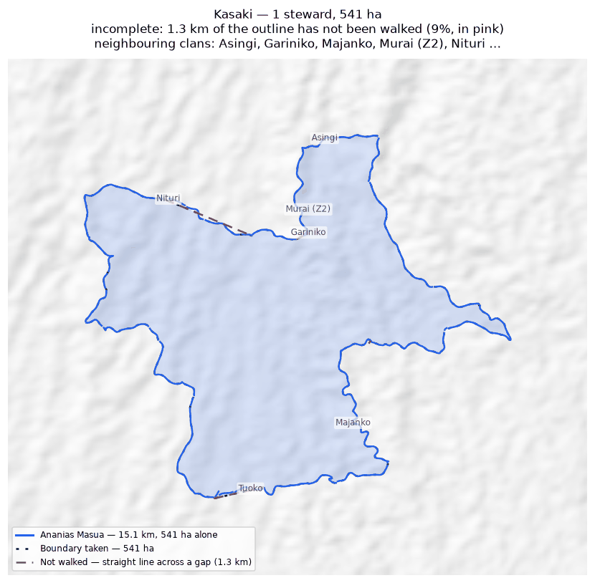
The walk and the area it gives (dotted), with the stretches nobody walked in pink. Neighbouring clans are named where they lie; their boundaries are not drawn.

Majanko
Zone 2 · version 1.14, 10 October 2026
Stewards | Surveys | Walked (km) | Access legs (km) | Pieces | Not walked (km) | Parcels | Area (ha) | Basis
1 | 1 | 7.5 | 0.0 | 1 | — | 1 | 276 | surveyed
Clan Stewards
Clan Steward | Tracks | Days | First | Last | Walked (km)
Gilford Amakana | 4 | 1 | 2026-02-26 | 2026-02-26 | 7.5
Ground also claimed by another clan
Clan | Shared (ha) | % of this clan | Beyond 100 m (ha) | Verdict
Manoko | 65 | 23.6% | 65 | overlap
Kasaki | 40 | 14.5% | 39 | overlap
Tuoko | 13 | 4.5% | 12 | overlap
Neighbouring clans
Clan | Boundary walked alongside (km) | % of this clan's line
Manoko | 1.6 | 20.7%
Kasaki | 1.2 | 16.4%
Zambiko | 0.6 | 8.5%
Tuoko | 0.5 | 6.3%
Where the two clans' recorded lines run within 100 m of each other. Two neighbours walking the same edge is the ordinary case.
Sacred sites
None recorded. The Clan Stewards were asked for the outer boundary and the sacred sites; nothing in this clan's files is marked as one.
What the survey shows
- The boundary closes on its own. 276 ha is measured from the walk, with nothing inferred.
- Ground here is also inside the area recorded for 3 other clans: Manoko (65 ha); Kasaki (40 ha); Tuoko (13 ha).
Queries for the field
- Nothing outstanding. The boundary closes on its own and the survey is complete.
To take back to the ground
A GPX file for this clan is supplied as Majanko_Zone_2.gpx. Loaded onto the phone or handheld the boundary was mapped with, it shows the stewards' own tracks and confirms the boundary closes with no gaps to walk.
Map
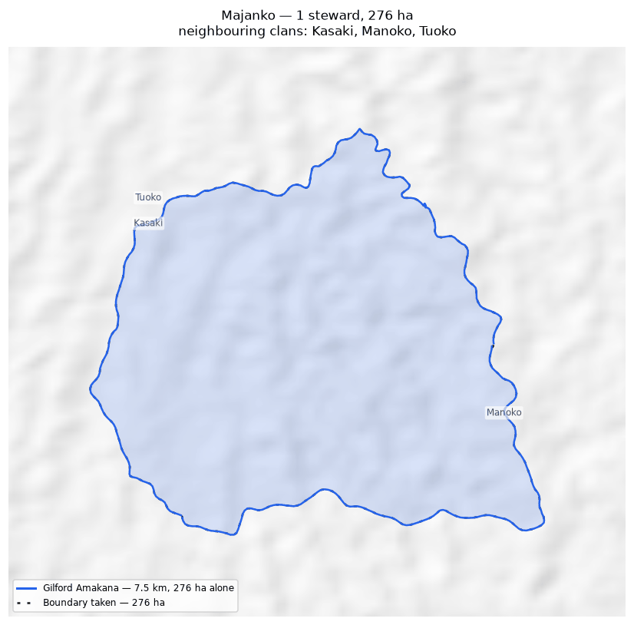
The walk and the area it gives (dotted), with the stretches nobody walked in pink. Neighbouring clans are named where they lie; their boundaries are not drawn.

Manoko
Zone 2 · version 1.14, 10 October 2026
Stewards | Surveys | Walked (km) | Access legs (km) | Pieces | Not walked (km) | Parcels | Area (ha) | Basis
1 | 1 | 12.2 | 1.8 | 3 | 3.9 | 1 | 404 | inferred
Clan Stewards
Clan Steward | Tracks | Days | First | Last | Walked (km)
Gilford Amakana | 7 | 3 | 2025-08-31 | 2026-02-14 | 12.2
Ground also claimed by another clan
Clan | Shared (ha) | % of this clan | Beyond 100 m (ha) | Verdict
Majanko | 65 | 16.1% | 65 | overlap
Juaiko | 13 | 3.1% | 7 | overlap
Neighbouring clans
Clan | Boundary walked alongside (km) | % of this clan's line
Juaiko | 4.9 | 35.2%
Majanko | 1.6 | 13.0%
Zambiko | 1.1 | 9.2%
Rumbi | 0.8 | 5.4%
Tuoko | 0.5 | 4.3%
Sukandi | 0.2 | 2.0%
Where the two clans' recorded lines run within 100 m of each other. Two neighbours walking the same edge is the ordinary case.
Sacred sites
None recorded. The Clan Stewards were asked for the outer boundary and the sacred sites; nothing in this clan's files is marked as one.
What the survey shows
- The boundary does not close. 3.9 km in 3 stretches was bridged with straight lines nobody walked — 32% of the distance walked, so 404 ha is an estimate rather than a measured area. On the map those stretches are pink.
- Ground here is also inside the area recorded for 2 other clans: Majanko (65 ha); Juaiko (13 ha). These figures are provisional while this boundary is incomplete: the unwalked stretches are drawn as straight lines, and those lines are what the overlap is measured against.
Queries for the field
- 32% of this outline was not walked — 3.9 km of straight line, shown in pink. Does the boundary in fact run along those straight lines, or somewhere else? Can the missing stretches be walked?
To take back to the ground
A GPX file for this clan is supplied as Manoko_Zone_2.gpx. Loaded onto the phone or handheld the boundary was mapped with, it shows the stewards' own tracks, the 3 gaps drawn as straight lines, and a waypoint at each end of every gap so a steward can navigate to where the walking stopped and carry on.
Map
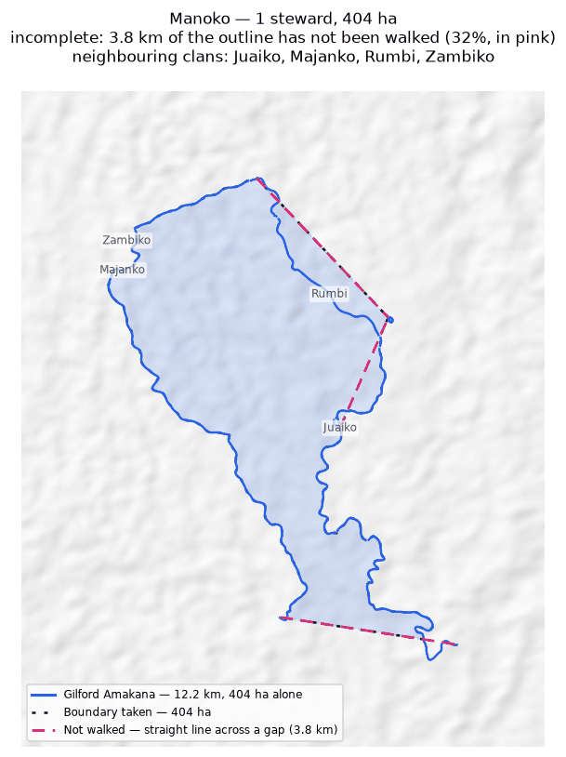
The walk and the area it gives (dotted), with the stretches nobody walked in pink. Neighbouring clans are named where they lie; their boundaries are not drawn.

Murai (Z2)
Zone 2 · version 1.14, 10 October 2026
Stewards | Surveys | Walked (km) | Access legs (km) | Pieces | Not walked (km) | Parcels | Area (ha) | Basis
1 | 1 | 7.3 | 0.2 | 2 | — | 1 | 199 | surveyed
Clan Stewards
Clan Steward | Tracks | Days | First | Last | Walked (km)
Nehemiah Nindori | 32 | 6 | 2025-11-27 | 2026-02-17 | 7.3
Ground also claimed by another clan
Clan | Shared (ha) | % of this clan | Beyond 100 m (ha) | Verdict
Kasaki | 154 | 77.6% | 154 | overlap
Asingi | 6 | 3.0% | 5 | overlap
Gariniko | 1 | 0.3% | 0 | within tolerance
Neighbouring clans
Clan | Boundary walked alongside (km) | % of this clan's line
Kasaki | 3.4 | 46.4%
Gariniko | 1.8 | 20.9%
Tuoko | 1.0 | 10.8%
Asingi | 0.6 | 7.7%
Nituri | 0.6 | 0.4%
Zambiko | 0.4 | 0.4%
Where the two clans' recorded lines run within 100 m of each other. Two neighbours walking the same edge is the ordinary case.
Sacred sites
None recorded. The Clan Stewards were asked for the outer boundary and the sacred sites; nothing in this clan's files is marked as one.
What the survey shows
- The boundary closes on its own. 199 ha is measured from the walk, with nothing inferred.
- Ground here is also inside the area recorded for 2 other clans: Kasaki (154 ha); Asingi (6 ha).
- A further 1 clan (Gariniko) shares ground only in strips narrower than 100 m — the two lines being the same line, which is not counted as overlap.
Queries for the field
- Nothing outstanding. The boundary closes on its own and the survey is complete.
To take back to the ground
A GPX file for this clan is supplied as Murai_Z2_Zone_2.gpx. Loaded onto the phone or handheld the boundary was mapped with, it shows the stewards' own tracks and confirms the boundary closes with no gaps to walk.
Map
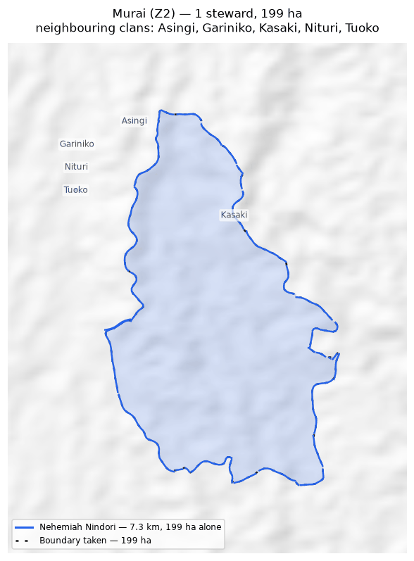
The walk and the area it gives (dotted), with the stretches nobody walked in pink. Neighbouring clans are named where they lie; their boundaries are not drawn.

Nituri
Zone 2 · version 1.14, 10 October 2026
Stewards | Surveys | Walked (km) | Access legs (km) | Pieces | Not walked (km) | Parcels | Area (ha) | Basis
3 | 3 | 41.8 | 10.5 | 14 | 11.1 | 2 | 5,277 | inferred
Clan Stewards
Clan Steward | Tracks | Days | First | Last | Walked (km)
Graham Naopi | 7 | 3 | 2025-11-27 | 2026-02-09 | 18.7
Christoper Visua | 19 | 7 | 2025-05-11 | 2026-02-11 | 17.8
Newton Muraba | 13 | 6 | 2025-11-27 | 2026-02-16 | 5.3
Ground also claimed by another clan
Clan | Shared (ha) | % of this clan | Beyond 100 m (ha) | Verdict
Tuoko | 2,199 | 41.7% | 2,198 | overlap
Kasaki | 59 | 1.1% | 59 | overlap
Gariniko | 3 | 0.1% | 2 | overlap
Neighbouring clans
Clan | Boundary walked alongside (km) | % of this clan's line
Tuoko | 14.4 | 24.0%
Kasaki | 1.1 | 2.7%
Bujevi | 0.9 | 2.1%
Gariniko | 0.6 | 1.5%
Murai (Z2) | 0.6 | 1.5%
Zambiko | 0.6 | 1.5%
Asingi | 0.6 | 1.5%
Where the two clans' recorded lines run within 100 m of each other. Two neighbours walking the same edge is the ordinary case.
Sacred sites
None recorded. The Clan Stewards were asked for the outer boundary and the sacred sites; nothing in this clan's files is marked as one.
What the survey shows
- The boundary does not close. 11.1 km in 14 stretches was bridged with straight lines nobody walked — 29% of the distance walked, so 5,277 ha is an estimate rather than a measured area. On the map those stretches are pink.
- The walks enclose 2 separate parcels, totalling 5,277 ha. All of them are counted. Whether they are all this clan's land, or whether one belongs to a neighbour, is a question for the clan.
- Joining the 3 stewards adds 5,277 ha: separately 0 ha, joined 5,277 ha. The stewards covered different stretches of one boundary.
- Ground here is also inside the area recorded for 3 other clans: Tuoko (2,199 ha); Kasaki (59 ha); Gariniko (3 ha). These figures are provisional while this boundary is incomplete: the unwalked stretches are drawn as straight lines, and those lines are what the overlap is measured against.
Queries for the field
- 29% of this outline was not walked — 11.1 km of straight line, shown in pink. Does the boundary in fact run along those straight lines, or somewhere else? Can the missing stretches be walked?
- This clan's land is recorded as 2 separate pieces. Is that right, and does each piece belong to this clan?
- This boundary is recorded in 14 separate pieces. Were the connecting stretches walked but not recorded, or not yet walked?
To take back to the ground
A GPX file for this clan is supplied as Nituri_Zone_2.gpx. Loaded onto the phone or handheld the boundary was mapped with, it shows the stewards' own tracks, the 12 gaps drawn as straight lines, and a waypoint at each end of every gap so a steward can navigate to where the walking stopped and carry on.
Map
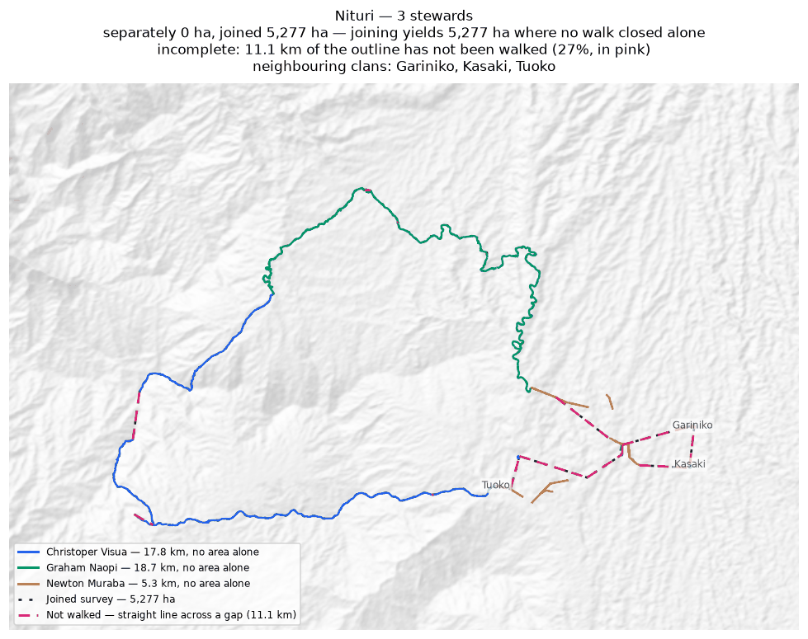
Each steward's line and the area it gives alone (dashed); the survey they combine into, dotted; the stretches nobody walked in pink. Neighbouring clans are named where they lie; their boundaries are not drawn.

Rondi
Zone 2 · version 1.14, 10 October 2026
Stewards | Surveys | Walked (km) | Access legs (km) | Pieces | Not walked (km) | Parcels | Area (ha) | Basis
2 | 2 | 59.0 | 0.4 | 14 | — | 1 | 1,569 | surveyed
Clan Stewards
Clan Steward | Tracks | Days | First | Last | Walked (km)
Jefferson Amunisa | 28 | 5 | 2025-04-25 | 2025-04-29 | 29.7
Humphrey Poto | 29 | 5 | 2025-04-25 | 2025-04-29 | 29.3
Ground also claimed by another clan
Clan | Shared (ha) | % of this clan | Beyond 100 m (ha) | Verdict
Sukandi | 212 | 13.5% | 211 | overlap
Binunkol | 1 | 0.0% | 0 | within tolerance
Neighbouring clans
Clan | Boundary walked alongside (km) | % of this clan's line
Rumbi | 10.5 | 17.7%
Gumuri | 9.2 | 15.5%
Sukandi | 7.0 | 11.8%
Binunkol | 3.8 | 6.5%
Deari | 0.4 | 0.6%
Nui | 0.4 | 0.6%
Where the two clans' recorded lines run within 100 m of each other. Two neighbours walking the same edge is the ordinary case.
Sacred sites
Recorded: 5 — 5 recorded as a boundary walked around a named place, covering 5.4 ha — 0.3% of this clan's land.
Locations are not shared and appear on no map or layer in this document. A sacred site is usually recorded the way the rest of the land is, as a boundary walked around it, so it is counted from what the steward wrote beside the track.
What the survey shows
- The boundary closes on its own. 1,569 ha is measured from the walk, with nothing inferred.
- Joining the 2 stewards adds 307 ha: separately 1,261 ha, joined 1,569 ha. The stewards covered different stretches of one boundary.
- Ground here is also inside the area recorded for 1 other clan: Sukandi (212 ha).
- A further 1 clan (Binunkol) shares ground only in strips narrower than 100 m — the two lines being the same line, which is not counted as overlap.
Queries for the field
- This boundary is recorded in 14 separate pieces. Were the connecting stretches walked but not recorded, or not yet walked?
To take back to the ground
A GPX file for this clan is supplied as Rondi_Zone_2.gpx. Loaded onto the phone or handheld the boundary was mapped with, it shows the stewards' own tracks and confirms the boundary closes with no gaps to walk.
Map
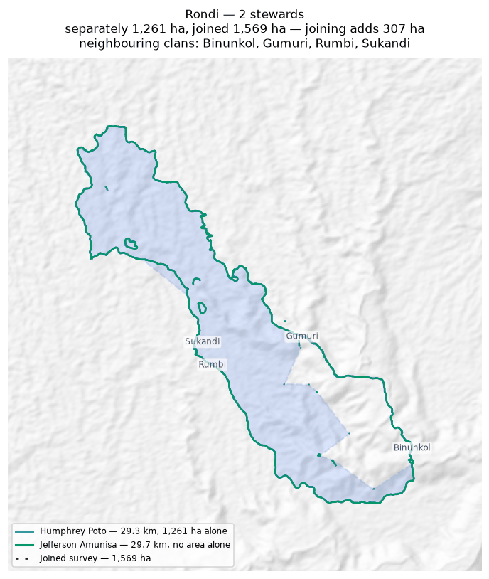
Each steward's line and the area it gives alone (dashed); the survey they combine into, dotted; the stretches nobody walked in pink. Neighbouring clans are named where they lie; their boundaries are not drawn.

Rumbi
Zone 2 · version 1.14, 10 October 2026
Stewards | Surveys | Walked (km) | Access legs (km) | Pieces | Not walked (km) | Parcels | Area (ha) | Basis
1 | 1 | 15.1 | 3.7 | 3 | 9.9 | — | none | no area
Clan Stewards
Clan Steward | Tracks | Days | First | Last | Walked (km)
Joel Mamata | 9 | 5 | 2025-04-15 | 2025-04-28 | 15.1
Neighbouring clans
Clan | Boundary walked alongside (km) | % of this clan's line
Sukandi | 8.0 | 49.8%
Rondi | 10.5 | 33.5%
Juaiko | 2.1 | 11.8%
Manoko | 0.8 | 5.4%
Where the two clans' recorded lines run within 100 m of each other. Two neighbours walking the same edge is the ordinary case.
Sacred sites
None recorded. The Clan Stewards were asked for the outer boundary and the sacred sites; nothing in this clan's files is marked as one.
What the survey shows
- No area can be given. The tracks are in 3 disconnected pieces and 9.9 km of straight-line joining would be needed to make a ring — 73% of the distance walked. That is beyond the 50% limit, above which an area would be more assumption than survey.
- 50% of this clan's recorded line runs within 100 m of Sukandi's: the two walked the same edge.
Queries for the field
- Can the missing stretches be walked so this boundary closes? If any gap is deliberate — a river, a road, an agreed open edge — please say what runs along it.
To take back to the ground
A GPX file for this clan is supplied as Rumbi_Zone_2.gpx. Loaded onto the phone or handheld the boundary was mapped with, it shows the stewards' own tracks, the 3 gaps drawn as straight lines, and a waypoint at each end of every gap so a steward can navigate to where the walking stopped and carry on.
Map
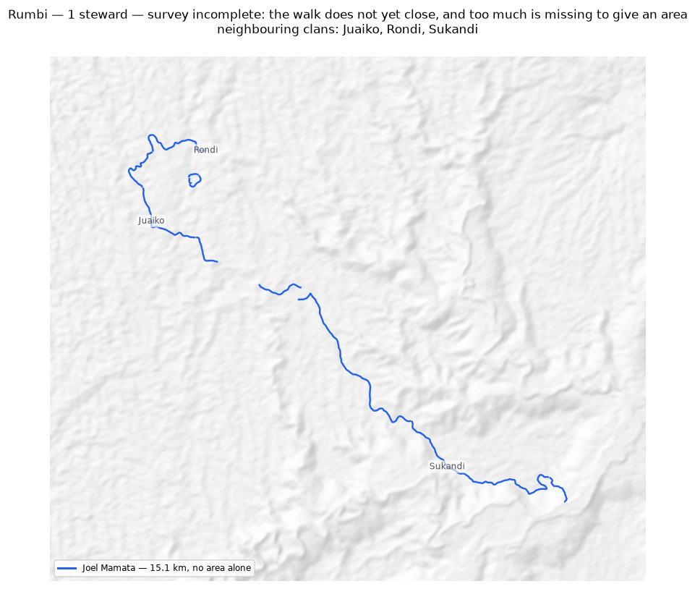
The walk and the area it gives (dotted), with the stretches nobody walked in pink. Neighbouring clans are named where they lie; their boundaries are not drawn.

Sukandi
Zone 2 · version 1.14, 10 October 2026
Stewards | Surveys | Walked (km) | Access legs (km) | Pieces | Not walked (km) | Parcels | Area (ha) | Basis
2 | 2 | 39.7 | 9.0 | 3 | — | 1 | 1,901 | surveyed
Clan Stewards
Clan Steward | Tracks | Days | First | Last | Walked (km)
Rodney Ajinko | 1 | 1 | 2025-04-24 | 2025-04-24 | 29.1
Millinton Beso | 3 | 2 | 2025-04-24 | 2025-04-25 | 10.6
Ground also claimed by another clan
Clan | Shared (ha) | % of this clan | Beyond 100 m (ha) | Verdict
Asoro | 232 | 12.2% | 231 | overlap
Rondi | 212 | 11.1% | 211 | overlap
Juaiko | 205 | 10.8% | 202 | overlap
Jariji | 0 | 0.0% | 0 | within tolerance
Binunkol | 0 | 0.0% | 0 | within tolerance
Neighbouring clans
Clan | Boundary walked alongside (km) | % of this clan's line
Rumbi | 8.0 | 20.2%
Juaiko | 4.2 | 10.6%
Rondi | 7.0 | 8.7%
Binunkol | 1.0 | 2.5%
Asoro | 0.8 | 2.1%
Jariji | 0.3 | 0.7%
Manoko | 0.2 | 0.6%
Where the two clans' recorded lines run within 100 m of each other. Two neighbours walking the same edge is the ordinary case.
Sacred sites
Recorded: 3 — 3 marked as a sacred site.
Locations are not shared and appear on no map or layer in this document. A sacred site is usually recorded the way the rest of the land is, as a boundary walked around it, so it is counted from what the steward wrote beside the track.
What the survey shows
- The boundary closes on its own. 1,901 ha is measured from the walk, with nothing inferred.
- Joining the 2 stewards costs 467 ha: separately they give 2,368 ha, joined 1,901 ha. This happens where stewards each walked the same ring rather than different stretches — the two rings cross and the joined network encloses less than either walk did alone.
- Ground here is also inside the area recorded for 3 other clans: Asoro (232 ha); Rondi (212 ha); Juaiko (205 ha).
- A further 2 clans (Jariji, Binunkol) share ground only in strips narrower than 100 m — the two lines being the same line, which is not counted as overlap.
Queries for the field
- Did the 2 stewards walk the same boundary, or different parts of it? If they walked the same ring, their surveys should be treated as separate accounts rather than joined.
To take back to the ground
A GPX file for this clan is supplied as Sukandi_Zone_2.gpx. Loaded onto the phone or handheld the boundary was mapped with, it shows the stewards' own tracks and confirms the boundary closes with no gaps to walk.
Map
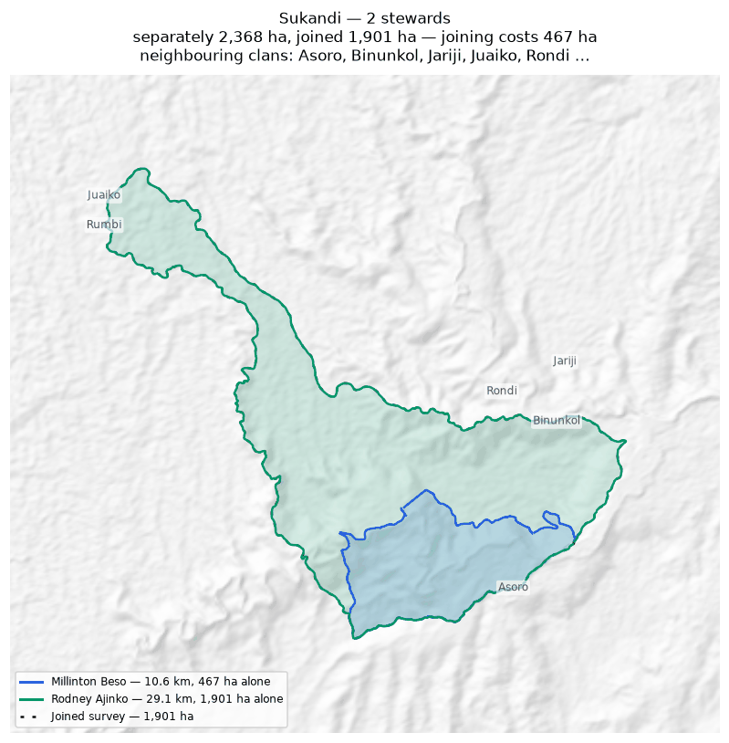
Each steward's line and the area it gives alone (dashed); the survey they combine into, dotted; the stretches nobody walked in pink. Neighbouring clans are named where they lie; their boundaries are not drawn.

Tuoko
Zone 2 · version 1.14, 10 October 2026
Stewards | Surveys | Walked (km) | Access legs (km) | Pieces | Not walked (km) | Parcels | Area (ha) | Basis
2 | 2 | 47.7 | 9.5 | 8 | 17.1 | 1 | 3,677 | inferred
Clan Stewards
Clan Steward | Tracks | Days | First | Last | Walked (km)
Terrence Dobija | 3 | 3 | 2025-08-31 | 2025-12-09 | 36.5
Kaupa Dota | 6 | 3 | 2025-02-24 | 2025-12-09 | 11.2
Ground also claimed by another clan
Clan | Shared (ha) | % of this clan | Beyond 100 m (ha) | Verdict
Nituri | 2,199 | 59.8% | 2,198 | overlap
Kasaki | 157 | 4.3% | 155 | overlap
Majanko | 13 | 0.3% | 12 | overlap
Gariniko | 7 | 0.2% | 5 | overlap
Neighbouring clans
Clan | Boundary walked alongside (km) | % of this clan's line
Nituri | 14.4 | 30.2%
Kasaki | 1.5 | 2.7%
Murai (Z2) | 1.0 | 2.1%
Gariniko | 0.6 | 1.1%
Majanko | 0.5 | 1.0%
Zambiko | 0.4 | 0.6%
Asingi | 0.3 | 0.6%
Manoko | 0.5 | 0.5%
Where the two clans' recorded lines run within 100 m of each other. Two neighbours walking the same edge is the ordinary case.
Sacred sites
None recorded. The Clan Stewards were asked for the outer boundary and the sacred sites; nothing in this clan's files is marked as one.
What the survey shows
- The boundary does not close. 17.1 km in 8 stretches was bridged with straight lines nobody walked — 38% of the distance walked, so 3,677 ha is an estimate rather than a measured area. On the map those stretches are pink.
- Joining the 2 stewards adds 1,995 ha: separately 1,681 ha, joined 3,677 ha. The stewards covered different stretches of one boundary.
- Ground here is also inside the area recorded for 4 other clans: Nituri (2,199 ha); Kasaki (157 ha); Majanko (13 ha); Gariniko (7 ha). These figures are provisional while this boundary is incomplete: the unwalked stretches are drawn as straight lines, and those lines are what the overlap is measured against.
Queries for the field
- 38% of this outline was not walked — 17.1 km of straight line, shown in pink. Does the boundary in fact run along those straight lines, or somewhere else? Can the missing stretches be walked?
- This boundary is recorded in 8 separate pieces. Were the connecting stretches walked but not recorded, or not yet walked?
To take back to the ground
A GPX file for this clan is supplied as Tuoko_Zone_2.gpx. Loaded onto the phone or handheld the boundary was mapped with, it shows the stewards' own tracks, the 7 gaps drawn as straight lines, and a waypoint at each end of every gap so a steward can navigate to where the walking stopped and carry on.
Map
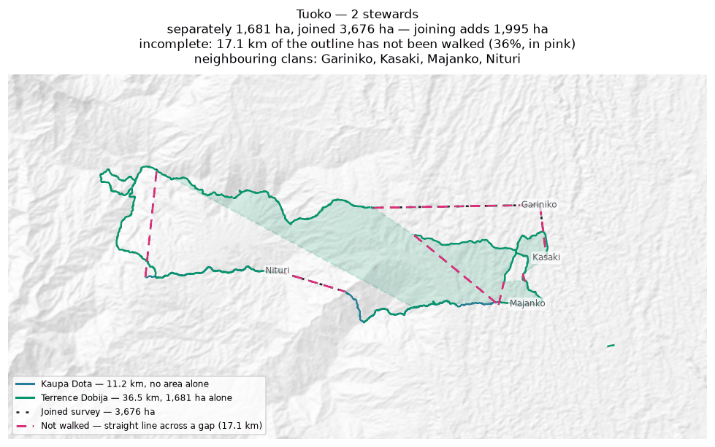
Each steward's line and the area it gives alone (dashed); the survey they combine into, dotted; the stretches nobody walked in pink. Neighbouring clans are named where they lie; their boundaries are not drawn.

Zambiko
Zone 2 · version 1.14, 10 October 2026
Stewards | Surveys | Walked (km) | Access legs (km) | Pieces | Not walked (km) | Parcels | Area (ha) | Basis
1 | 1 | 5.7 | 1.2 | 5 | 21.6 | — | none | no area
Clan Stewards
Clan Steward | Tracks | Days | First | Last | Walked (km)
Sylvester Anai | 8 | 3 | 2025-11-27 | 2026-02-12 | 5.7
Neighbouring clans
Clan | Boundary walked alongside (km) | % of this clan's line
Juaiko | 2.6 | 26.8%
Manoko | 1.1 | 17.4%
Majanko | 0.6 | 8.8%
Nituri | 0.6 | 6.4%
Gariniko | 0.5 | 6.4%
Asingi | 0.4 | 6.4%
Tuoko | 0.4 | 6.4%
Murai (Z2) | 0.4 | 6.4%
Asoro | 0.1 | 0.6%
Where the two clans' recorded lines run within 100 m of each other. Two neighbours walking the same edge is the ordinary case.
Sacred sites
None recorded. The Clan Stewards were asked for the outer boundary and the sacred sites; nothing in this clan's files is marked as one.
What the survey shows
- No area can be given. The tracks are in 5 disconnected pieces and 21.6 km of straight-line joining would be needed to make a ring — 420% of the distance walked. That is beyond the 50% limit, above which an area would be more assumption than survey.
- 27% of this clan's recorded line runs within 100 m of Juaiko's: the two walked the same edge.
Queries for the field
- Can the missing stretches be walked so this boundary closes? If any gap is deliberate — a river, a road, an agreed open edge — please say what runs along it.
To take back to the ground
A GPX file for this clan is supplied as Zambiko_Zone_2.gpx. Loaded onto the phone or handheld the boundary was mapped with, it shows the stewards' own tracks, the 5 gaps drawn as straight lines, and a waypoint at each end of every gap so a steward can navigate to where the walking stopped and carry on.
Map
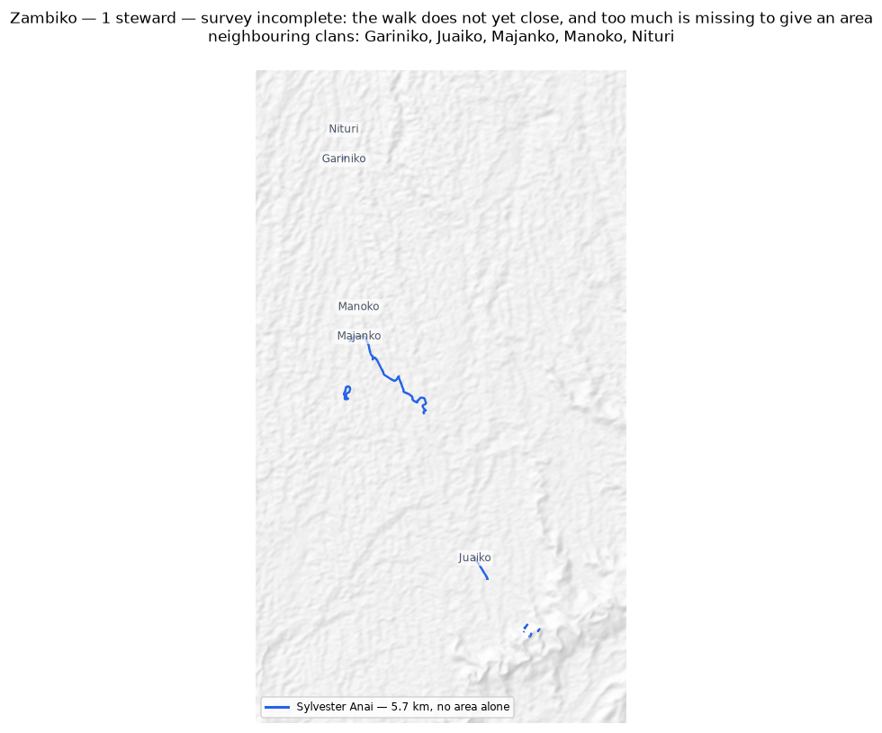
The walk and the area it gives (dotted), with the stretches nobody walked in pink. Neighbouring clans are named where they lie; their boundaries are not drawn.

Zone 3

Deari
Zone 3 · version 1.14, 10 October 2026
Stewards | Surveys | Walked (km) | Access legs (km) | Pieces | Not walked (km) | Parcels | Area (ha) | Basis
2 | 2 | 13.1 | 2.2 | 3 | 8.7 | — | none | no area
Clan Stewards
Clan Steward | Tracks | Days | First | Last | Walked (km)
Patrick Dirise | 3 | 2 | 2026-06-09 | 2026-06-15 | 7.8
Anthony Irimari | 2 | 2 | 2026-06-09 | 2026-06-15 | 5.3
Neighbouring clans
Clan | Boundary walked alongside (km) | % of this clan's line
Nui | 15.0 | 94.2%
Binunkol | 0.2 | 1.0%
Rondi | 0.4 | 0.7%
Where the two clans' recorded lines run within 100 m of each other. Two neighbours walking the same edge is the ordinary case.
Sacred sites
None recorded. The Clan Stewards were asked for the outer boundary and the sacred sites; nothing in this clan's files is marked as one.
What the survey shows
- No area can be given. The tracks are in 3 disconnected pieces and 8.7 km of straight-line joining would be needed to make a ring — 70% of the distance walked. That is beyond the 50% limit, above which an area would be more assumption than survey.
- 94% of this clan's recorded line runs within 100 m of Nui's: the two walked the same edge.
Queries for the field
- Can the missing stretches be walked so this boundary closes? If any gap is deliberate — a river, a road, an agreed open edge — please say what runs along it.
To take back to the ground
A GPX file for this clan is supplied as Deari_Zone_3.gpx. Loaded onto the phone or handheld the boundary was mapped with, it shows the stewards' own tracks, the 3 gaps drawn as straight lines, and a waypoint at each end of every gap so a steward can navigate to where the walking stopped and carry on.
Map
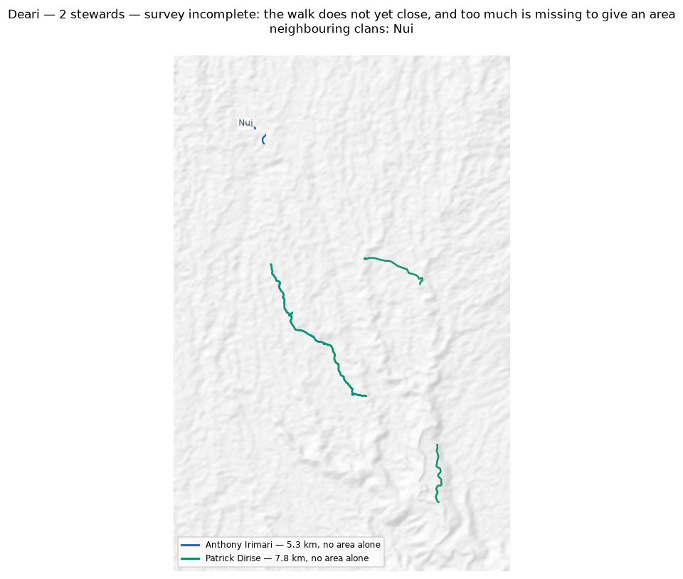
Each steward's line and the area it gives alone (dashed); the survey they combine into, dotted; the stretches nobody walked in pink. Neighbouring clans are named where they lie; their boundaries are not drawn.

Giroiko
Zone 3 · version 1.14, 10 October 2026
Stewards | Surveys | Walked (km) | Access legs (km) | Pieces | Not walked (km) | Parcels | Area (ha) | Basis
2 | 2 | 5.4 | 0.4 | 2 | 1.3 | 4 | 10 | inferred
Clan Stewards
Clan Steward | Tracks | Days | First | Last | Walked (km)
Mark Samba | 2 | 1 | 2026-06-11 | 2026-06-11 | 2.8
Eddie Sioro | 1 | 1 | 2026-06-11 | 2026-06-11 | 2.7
Neighbouring clans
Clan | Boundary walked alongside (km) | % of this clan's line
Savasi | 2.6 | 47.2%
Where the two clans' recorded lines run within 100 m of each other. Two neighbours walking the same edge is the ordinary case.
Sacred sites
None recorded. The Clan Stewards were asked for the outer boundary and the sacred sites; nothing in this clan's files is marked as one.
What the survey shows
- The boundary does not close. 1.3 km in 2 stretches was bridged with straight lines nobody walked — 25% of the distance walked, so 10 ha is an estimate rather than a measured area. On the map those stretches are pink.
- The walks enclose 4 separate parcels, totalling 10 ha. All of them are counted. Whether they are all this clan's land, or whether one belongs to a neighbour, is a question for the clan.
- Joining the 2 stewards costs 69 ha: separately they give 78 ha, joined 10 ha. This happens where stewards each walked the same ring rather than different stretches — the two rings cross and the joined network encloses less than either walk did alone.
- 47% of this clan's recorded line runs within 100 m of Savasi's: the two walked the same edge.
Queries for the field
- 25% of this outline was not walked — 1.3 km of straight line, shown in pink. Does the boundary in fact run along those straight lines, or somewhere else? Can the missing stretches be walked?
- This clan's land is recorded as 4 separate pieces. Is that right, and does each piece belong to this clan?
- Did the 2 stewards walk the same boundary, or different parts of it? If they walked the same ring, their surveys should be treated as separate accounts rather than joined.
To take back to the ground
A GPX file for this clan is supplied as Giroiko_Zone_3.gpx. Loaded onto the phone or handheld the boundary was mapped with, it shows the stewards' own tracks, the 2 gaps drawn as straight lines, and a waypoint at each end of every gap so a steward can navigate to where the walking stopped and carry on.
Map
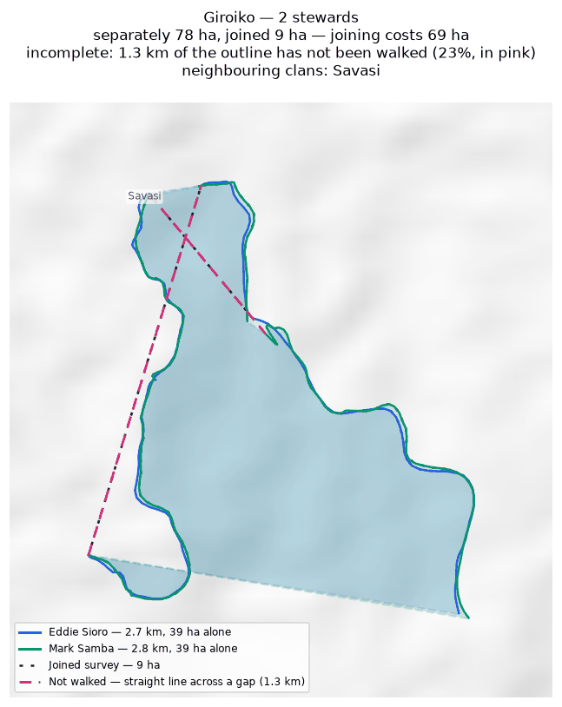
Each steward's line and the area it gives alone (dashed); the survey they combine into, dotted; the stretches nobody walked in pink. Neighbouring clans are named where they lie; their boundaries are not drawn.

Gumuri
Zone 3 · version 1.14, 10 October 2026
Stewards | Surveys | Walked (km) | Access legs (km) | Pieces | Not walked (km) | Parcels | Area (ha) | Basis
2 | 2 | 6.8 | 0.3 | 1 | 5.5 | — | none | no area
Clan Stewards
Clan Steward | Tracks | Days | First | Last | Walked (km)
Gray Saui | 1 | 1 | 2026-06-15 | 2026-06-15 | 6.8
Monty Stanford | 1 | 0 | — | — | 0.0
Neighbouring clans
Clan | Boundary walked alongside (km) | % of this clan's line
Rondi | 9.2 | 63.0%
Where the two clans' recorded lines run within 100 m of each other. Two neighbours walking the same edge is the ordinary case.
Sacred sites
None recorded. The Clan Stewards were asked for the outer boundary and the sacred sites; nothing in this clan's files is marked as one.
What the survey shows
- No area can be given. The tracks are in 1 disconnected piece and 5.5 km of straight-line joining would be needed to make a ring — 84% of the distance walked. That is beyond the 50% limit, above which an area would be more assumption than survey.
- 63% of this clan's recorded line runs within 100 m of Rondi's: the two walked the same edge.
Queries for the field
- Can the missing stretches be walked so this boundary closes? If any gap is deliberate — a river, a road, an agreed open edge — please say what runs along it.
To take back to the ground
A GPX file for this clan is supplied as Gumuri_Zone_3.gpx. Loaded onto the phone or handheld the boundary was mapped with, it shows the stewards' own tracks, the 1 gap drawn as straight lines, and a waypoint at each end of every gap so a steward can navigate to where the walking stopped and carry on.
Map
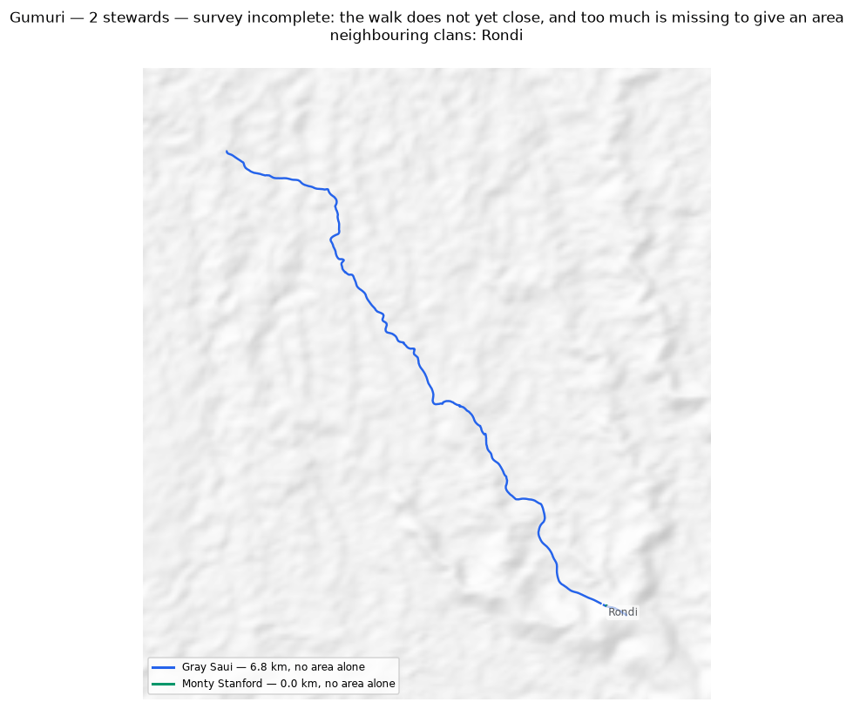
Each steward's line and the area it gives alone (dashed); the survey they combine into, dotted; the stretches nobody walked in pink. Neighbouring clans are named where they lie; their boundaries are not drawn.

Nui
Zone 3 · version 1.14, 10 October 2026
Stewards | Surveys | Walked (km) | Access legs (km) | Pieces | Not walked (km) | Parcels | Area (ha) | Basis
2 | 2 | 23.4 | 5.7 | 6 | 14.7 | — | none | no area
Clan Stewards
Clan Steward | Tracks | Days | First | Last | Walked (km)
Iman Nakina | 4 | 2 | 2026-06-09 | 2026-06-15 | 12.0
Bobby Aneba | 3 | 2 | 2026-06-09 | 2026-06-15 | 11.5
Neighbouring clans
Clan | Boundary walked alongside (km) | % of this clan's line
Deari | 15.0 | 64.0%
Binunkol | 0.2 | 0.5%
Rondi | 0.4 | 0.4%
Where the two clans' recorded lines run within 100 m of each other. Two neighbours walking the same edge is the ordinary case.
Sacred sites
None recorded. The Clan Stewards were asked for the outer boundary and the sacred sites; nothing in this clan's files is marked as one.
What the survey shows
- No area can be given. The tracks are in 6 disconnected pieces and 14.7 km of straight-line joining would be needed to make a ring — 66% of the distance walked. That is beyond the 50% limit, above which an area would be more assumption than survey.
- 64% of this clan's recorded line runs within 100 m of Deari's: the two walked the same edge.
Queries for the field
- Can the missing stretches be walked so this boundary closes? If any gap is deliberate — a river, a road, an agreed open edge — please say what runs along it.
To take back to the ground
A GPX file for this clan is supplied as Nui_Zone_3.gpx. Loaded onto the phone or handheld the boundary was mapped with, it shows the stewards' own tracks, the 5 gaps drawn as straight lines, and a waypoint at each end of every gap so a steward can navigate to where the walking stopped and carry on.
Map
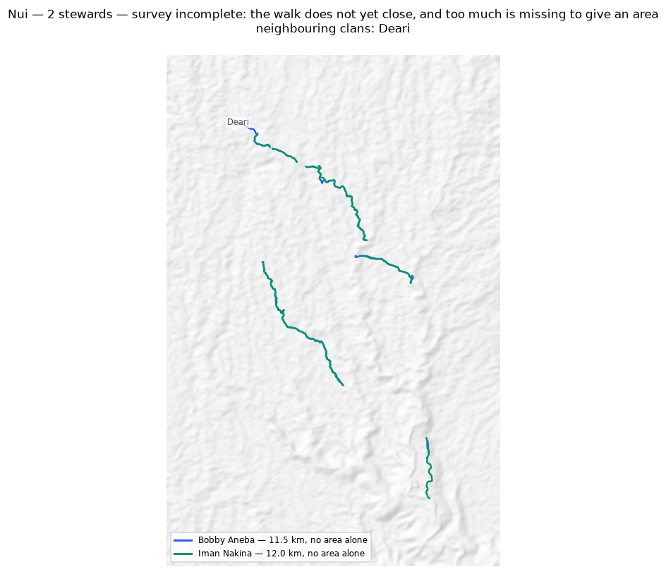
Each steward's line and the area it gives alone (dashed); the survey they combine into, dotted; the stretches nobody walked in pink. Neighbouring clans are named where they lie; their boundaries are not drawn.

Savasi
Zone 3 · version 1.14, 10 October 2026
Stewards | Surveys | Walked (km) | Access legs (km) | Pieces | Not walked (km) | Parcels | Area (ha) | Basis
1 | 1 | 4.0 | 0.0 | 3 | 5.1 | — | none | no area
Clan Stewards
Clan Steward | Tracks | Days | First | Last | Walked (km)
Oscar Isuni | 3 | 3 | 2026-05-27 | 2026-07-01 | 4.0
Neighbouring clans
Clan | Boundary walked alongside (km) | % of this clan's line
Giroiko | 2.6 | 30.7%
Ginangi | 0.1 | 2.4%
Where the two clans' recorded lines run within 100 m of each other. Two neighbours walking the same edge is the ordinary case.
Sacred sites
None recorded. The Clan Stewards were asked for the outer boundary and the sacred sites; nothing in this clan's files is marked as one.
From the field
- The eastern border of Savasi's clan land is along the Baraje river.
- The mapping is not finished: the northern and southern ends have yet to be closed off.
Field advice, 23 August 2026. Recorded as told to us. Nothing here has been turned into a line or an area — a river named as a boundary is knowledge the GPS cannot supply, and drawing it would be this pipeline inventing a boundary rather than recording one.
What the survey shows
- No area can be given. The tracks are in 3 disconnected pieces and 5.1 km of straight-line joining would be needed to make a ring — 127% of the distance walked. That is beyond the 50% limit, above which an area would be more assumption than survey.
- 31% of this clan's recorded line runs within 100 m of Giroiko's: the two walked the same edge.
Queries for the field
- No stretch of this boundary should be walked to close it where it follows a large river. That stretch will be completed by editing, once it is decided how a river boundary is to be drawn. What would help instead: where does the river stop being the boundary, at each end?
To take back to the ground
A GPX file for this clan is supplied as Savasi_Zone_3.gpx. Loaded onto the phone or handheld the boundary was mapped with, it shows the stewards' own tracks, the 3 gaps drawn as straight lines, and a waypoint at each end of every gap so a steward can navigate to where the walking stopped and carry on.
Map
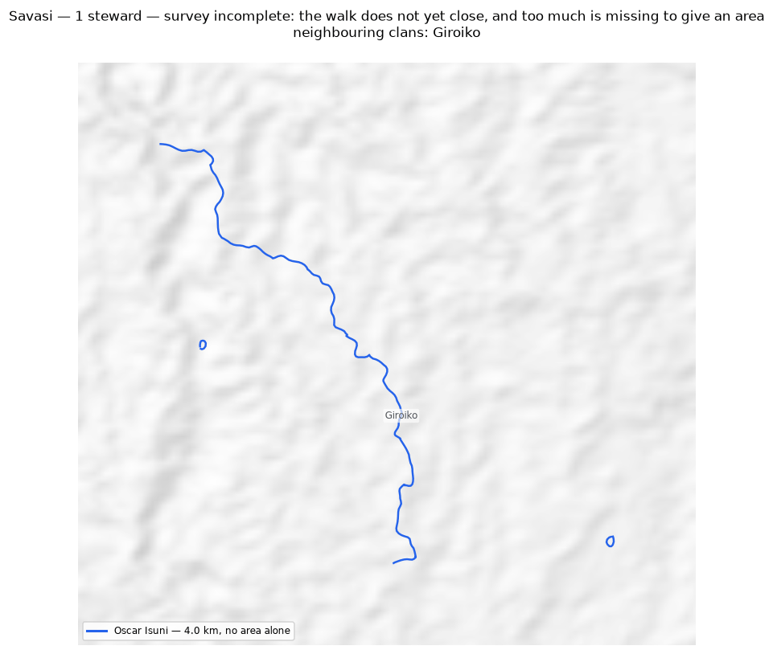
The walk and the area it gives (dotted), with the stretches nobody walked in pink. Neighbouring clans are named where they lie; their boundaries are not drawn.

Zone 6

Manuvoora
Zone 6 · version 1.14, 10 October 2026
Stewards | Surveys | Walked (km) | Access legs (km) | Pieces | Not walked (km) | Parcels | Area (ha) | Basis
2 | 2 | 61.5 | 10.0 | 5 | — | 1 | 1,058 | surveyed
Clan Stewards
Clan Steward | Tracks | Days | First | Last | Walked (km)
Egobeyas Kuarisi | 18 | 11 | 2026-06-18 | 2026-07-26 | 31.2
Granville Nepo | 11 | 8 | 2026-06-18 | 2026-07-21 | 30.2
Ground also claimed by another clan
Clan | Shared (ha) | % of this clan | Beyond 100 m (ha) | Verdict
Sahirut | 80 | 7.5% | 75 | overlap
Pina Ora | 14 | 1.3% | 10 | overlap
Neighbouring clans
Clan | Boundary walked alongside (km) | % of this clan's line
Sahirut | 12.6 | 20.5%
Pina Ora | 7.0 | 11.3%
Nupa Ora | 0.6 | 1.0%
Where the two clans' recorded lines run within 100 m of each other. Two neighbours walking the same edge is the ordinary case.
Sacred sites
None recorded. The Clan Stewards were asked for the outer boundary and the sacred sites; nothing in this clan's files is marked as one.
From the field
- Four waterfalls lie along the boundary. From the north they are Ija, Taram, Pururi and Parari.
- The river line itself is impassable because of those waterfalls, but the boundary follows the river line. That stretch is not to be walked; it will be completed by editing.
- The smaller gap is a gorge at the Jarahe waterfall, and the two ends may be joined by a straight line. The straight line there is the boundary, not an assumption.
- The river is resolved: it runs along the modelled drainage (2.48 km, kind river_routed). The Jarahe gorge is NOT resolved. A 1.86 km line adopted for it was withdrawn: it was not a break in the walk at all, but the span the closing step drew between two arbitrary points, running past all four open ends without joining any of them. The real open ends in Granville Nepo's walk are 44 m at the river, four ends 117-342 m apart where the western and north-eastern pieces fail to meet, and a 52 m stub.
- Egobeyas Kuarisi and Granville Nepo walked this boundary together, both recording: 98% of each line runs within 50 m of the other. It is one walk recorded twice, not two walks to be joined. Joined, the linework doubles and the survey encloses 556 ha; taken as Granville Nepo recorded it, it encloses 1,099 ha and is closed but for 40 m.
Field advice, 24 August 2026, on an annotated printout. Recorded as told to us. Nothing here has been turned into a line or an area — a river named as a boundary is knowledge the GPS cannot supply, and drawing it would be this pipeline inventing a boundary rather than recording one.
What the survey shows
- The boundary closes on its own. 1,058 ha is measured from the walk, with nothing inferred.
- Joining the 2 stewards costs 1,236 ha: separately they give 2,066 ha, joined 830 ha. This happens where stewards each walked the same ring rather than different stretches — the two rings cross and the joined network encloses less than either walk did alone.
- Ground here is also inside the area recorded for 2 other clans: Sahirut (80 ha); Pina Ora (14 ha).
Queries for the field
- No stretch of this boundary should be walked to close it where it follows a large river. That stretch will be completed by editing, once it is decided how a river boundary is to be drawn. What would help instead: where does the river stop being the boundary, at each end?
- Did the 2 stewards walk the same boundary, or different parts of it? If they walked the same ring, their surveys should be treated as separate accounts rather than joined.
- This boundary is recorded in 5 separate pieces. Were the connecting stretches walked but not recorded, or not yet walked?
To take back to the ground
A GPX file for this clan is supplied as Manuvoora_Zone_6.gpx. Loaded onto the phone or handheld the boundary was mapped with, it shows the stewards' own tracks, the 6 gaps drawn as straight lines, and a waypoint at each end of every gap so a steward can navigate to where the walking stopped and carry on.
Map
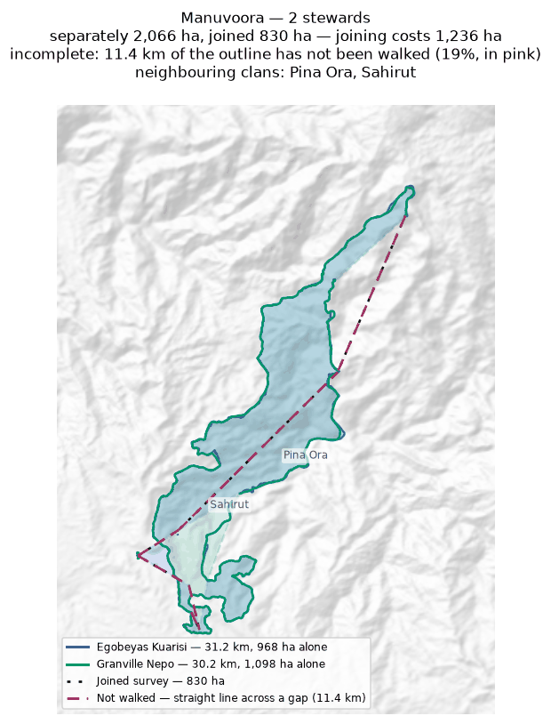
Each steward's line and the area it gives alone (dashed); the survey they combine into, dotted; the stretches nobody walked in pink. Neighbouring clans are named where they lie; their boundaries are not drawn.

Mariura
Zone 6 · version 1.14, 10 October 2026
Stewards | Surveys | Walked (km) | Access legs (km) | Pieces | Not walked (km) | Parcels | Area (ha) | Basis
2 | 2 | 33.7 | 0.0 | 13 | 14.3 | 1 | 861 | inferred
Clan Stewards
Clan Steward | Tracks | Days | First | Last | Walked (km)
Fabian Justin | 22 | 6 | 2026-06-26 | 2026-07-09 | 17.9
Livingstone Nisavora | 21 | 6 | 2026-06-26 | 2026-07-09 | 15.9
Ground also claimed by another clan
Clan | Shared (ha) | % of this clan | Beyond 100 m (ha) | Verdict
Naharaura | 149 | 17.3% | 147 | overlap
Borori | 56 | 6.5% | 52 | overlap
Darekikol | 50 | 5.8% | 50 | overlap
Sahirut | 2 | 0.2% | 0 | within tolerance
Neighbouring clans
Clan | Boundary walked alongside (km) | % of this clan's line
Naharaura | 7.9 | 49.8%
Borori | 8.4 | 20.5%
Darekikol | 0.7 | 3.0%
Sahirut | 0.2 | 0.0%
Where the two clans' recorded lines run within 100 m of each other. Two neighbours walking the same edge is the ordinary case.
Sacred sites
None recorded. The Clan Stewards were asked for the outer boundary and the sacred sites; nothing in this clan's files is marked as one.
What the survey shows
- The boundary does not close. 14.3 km in 13 stretches was bridged with straight lines nobody walked — 42% of the distance walked, so 861 ha is an estimate rather than a measured area. On the map those stretches are pink.
- Joining the 2 stewards adds 861 ha: separately 0 ha, joined 861 ha. The stewards covered different stretches of one boundary.
- Ground here is also inside the area recorded for 3 other clans: Naharaura (149 ha); Borori (56 ha); Darekikol (50 ha). These figures are provisional while this boundary is incomplete: the unwalked stretches are drawn as straight lines, and those lines are what the overlap is measured against.
- A further 1 clan (Sahirut) shares ground only in strips narrower than 100 m — the two lines being the same line, which is not counted as overlap.
Queries for the field
- 42% of this outline was not walked — 14.3 km of straight line, shown in pink. Does the boundary in fact run along those straight lines, or somewhere else? Can the missing stretches be walked?
- This boundary is recorded in 13 separate pieces. Were the connecting stretches walked but not recorded, or not yet walked?
To take back to the ground
A GPX file for this clan is supplied as Mariura_Zone_6.gpx. Loaded onto the phone or handheld the boundary was mapped with, it shows the stewards' own tracks, the 11 gaps drawn as straight lines, and a waypoint at each end of every gap so a steward can navigate to where the walking stopped and carry on.
Map
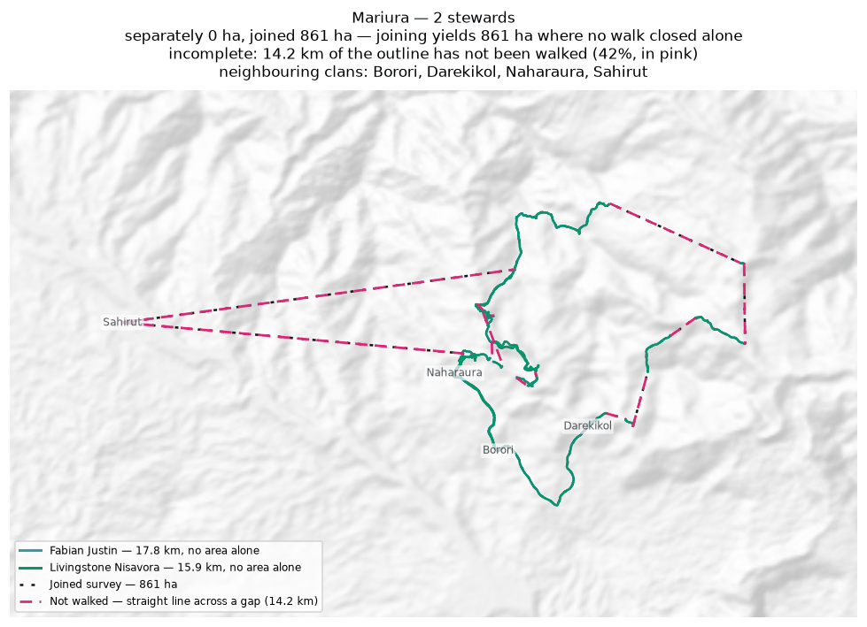
Each steward's line and the area it gives alone (dashed); the survey they combine into, dotted; the stretches nobody walked in pink. Neighbouring clans are named where they lie; their boundaries are not drawn.

Naharaura
Zone 6 · version 1.14, 10 October 2026
Stewards | Surveys | Walked (km) | Access legs (km) | Pieces | Not walked (km) | Parcels | Area (ha) | Basis
1 | 1 | 32.6 | 0.0 | 4 | 2.5 | 1 | 594 | inferred
Clan Stewards
Clan Steward | Tracks | Days | First | Last | Walked (km)
Zechariah Sasavo | 2 | 1 | 2026-06-26 | 2026-06-26 | 32.6
Ground also claimed by another clan
Clan | Shared (ha) | % of this clan | Beyond 100 m (ha) | Verdict
Mariura | 149 | 25.1% | 147 | overlap
Pina Ora | 60 | 10.0% | 59 | overlap
Neighbouring clans
Clan | Boundary walked alongside (km) | % of this clan's line
Pina Ora | 5.8 | 34.2%
Mariura | 7.9 | 28.3%
Where the two clans' recorded lines run within 100 m of each other. Two neighbours walking the same edge is the ordinary case.
Sacred sites
None recorded. The Clan Stewards were asked for the outer boundary and the sacred sites; nothing in this clan's files is marked as one.
What the survey shows
- The boundary does not close. 2.5 km in 4 stretches was bridged with straight lines nobody walked — 8% of the distance walked, so 594 ha is an estimate rather than a measured area. On the map those stretches are pink.
- Ground here is also inside the area recorded for 2 other clans: Mariura (149 ha); Pina Ora (60 ha).
Queries for the field
- This boundary is recorded in 4 separate pieces. Were the connecting stretches walked but not recorded, or not yet walked?
To take back to the ground
A GPX file for this clan is supplied as Naharaura_Zone_6.gpx. Loaded onto the phone or handheld the boundary was mapped with, it shows the stewards' own tracks, the 2 gaps drawn as straight lines, and a waypoint at each end of every gap so a steward can navigate to where the walking stopped and carry on.
Map
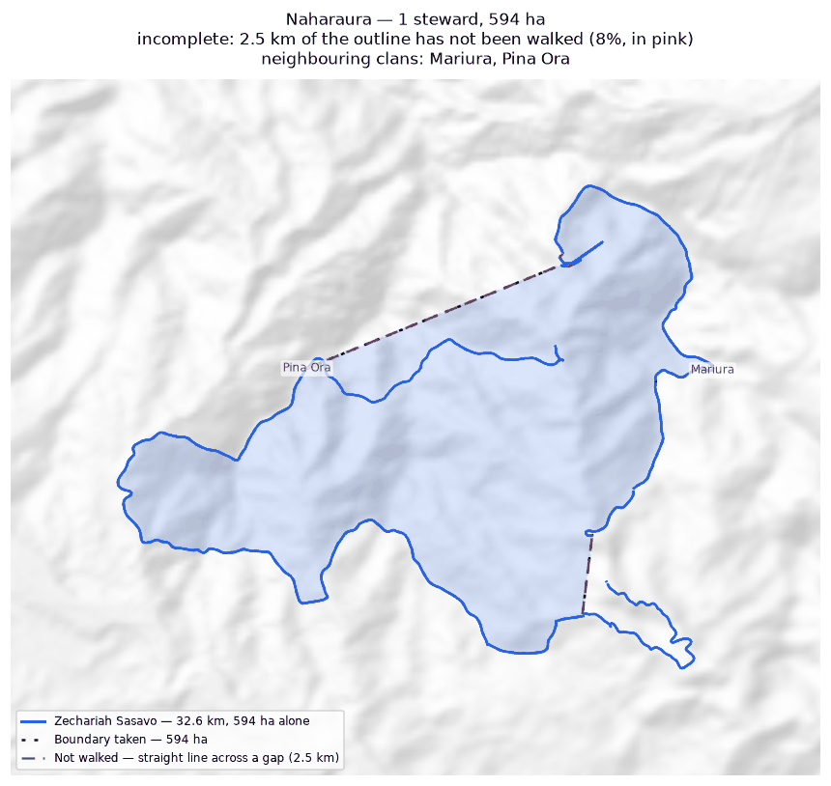
The walk and the area it gives (dotted), with the stretches nobody walked in pink. Neighbouring clans are named where they lie; their boundaries are not drawn.

Nupa Ora
Zone 6 · version 1.14, 10 October 2026
Stewards | Surveys | Walked (km) | Access legs (km) | Pieces | Not walked (km) | Parcels | Area (ha) | Basis
1 | 1 | 4.9 | 0.6 | 2 | 3.6 | — | none | no area
Clan Stewards
Clan Steward | Tracks | Days | First | Last | Walked (km)
Benjamin Marijah | 3 | 3 | 2026-06-18 | 2026-06-25 | 4.9
Neighbouring clans
Clan | Boundary walked alongside (km) | % of this clan's line
Manuvoora | 0.6 | 3.3%
Where the two clans' recorded lines run within 100 m of each other. Two neighbours walking the same edge is the ordinary case.
Sacred sites
None recorded. The Clan Stewards were asked for the outer boundary and the sacred sites; nothing in this clan's files is marked as one.
What the survey shows
- No area can be given. The tracks are in 2 disconnected pieces and 3.6 km of straight-line joining would be needed to make a ring — 72% of the distance walked. That is beyond the 50% limit, above which an area would be more assumption than survey.
- 3% of this clan's recorded line runs within 100 m of Manuvoora's: the two walked the same edge.
Queries for the field
- Can the missing stretches be walked so this boundary closes? If any gap is deliberate — a river, a road, an agreed open edge — please say what runs along it.
To take back to the ground
A GPX file for this clan is supplied as Nupa_Ora_Zone_6.gpx. Loaded onto the phone or handheld the boundary was mapped with, it shows the stewards' own tracks, the 2 gaps drawn as straight lines, and a waypoint at each end of every gap so a steward can navigate to where the walking stopped and carry on.
Map
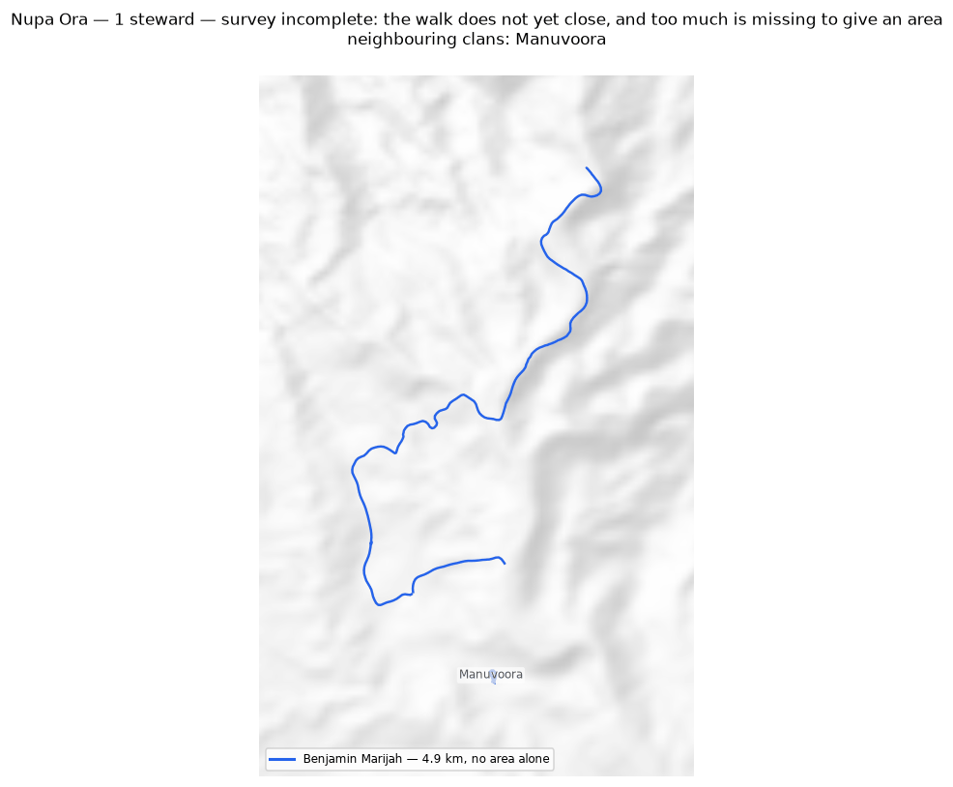
The walk and the area it gives (dotted), with the stretches nobody walked in pink. Neighbouring clans are named where they lie; their boundaries are not drawn.

Pina Ora
Zone 6 · version 1.14, 10 October 2026
Stewards | Surveys | Walked (km) | Access legs (km) | Pieces | Not walked (km) | Parcels | Area (ha) | Basis
1 | 1 | 18.9 | 3.9 | 4 | 1.4 | 1 | 812 | inferred
Clan Stewards
Clan Steward | Tracks | Days | First | Last | Walked (km)
Alban Ezekiel | 3 | 3 | 2026-06-23 | 2026-06-25 | 18.9
Ground also claimed by another clan
Clan | Shared (ha) | % of this clan | Beyond 100 m (ha) | Verdict
Naharaura | 60 | 7.3% | 59 | overlap
Sahirut | 15 | 1.8% | 13 | overlap
Manuvoora | 14 | 1.7% | 10 | overlap
Neighbouring clans
Clan | Boundary walked alongside (km) | % of this clan's line
Naharaura | 5.8 | 30.8%
Sahirut | 6.4 | 20.5%
Manuvoora | 7.0 | 19.0%
Where the two clans' recorded lines run within 100 m of each other. Two neighbours walking the same edge is the ordinary case.
Sacred sites
None recorded. The Clan Stewards were asked for the outer boundary and the sacred sites; nothing in this clan's files is marked as one.
What the survey shows
- The boundary does not close. 1.4 km in 4 stretches was bridged with straight lines nobody walked — 8% of the distance walked, so 812 ha is an estimate rather than a measured area. On the map those stretches are pink.
- Ground here is also inside the area recorded for 3 other clans: Naharaura (60 ha); Sahirut (15 ha); Manuvoora (14 ha).
Queries for the field
- This boundary is recorded in 4 separate pieces. Were the connecting stretches walked but not recorded, or not yet walked?
To take back to the ground
A GPX file for this clan is supplied as Pina_Ora_Zone_6.gpx. Loaded onto the phone or handheld the boundary was mapped with, it shows the stewards' own tracks, the 3 gaps drawn as straight lines, and a waypoint at each end of every gap so a steward can navigate to where the walking stopped and carry on.
Map
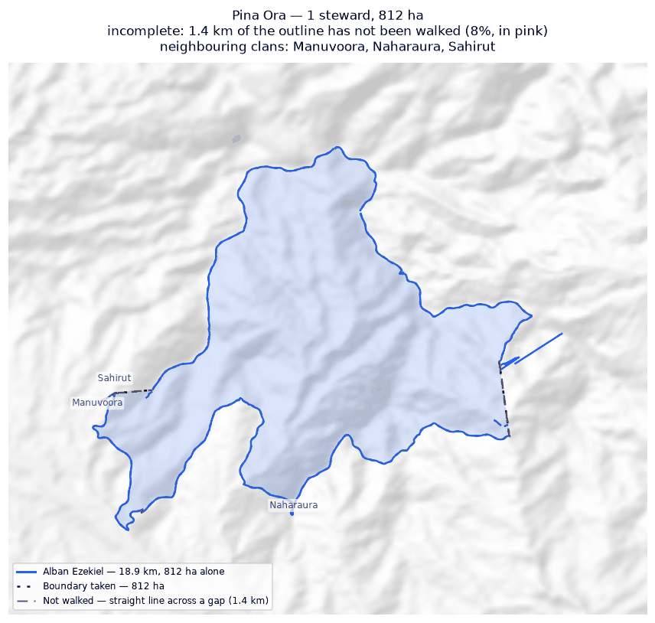
The walk and the area it gives (dotted), with the stretches nobody walked in pink. Neighbouring clans are named where they lie; their boundaries are not drawn.

Sahirut
Zone 6 · version 1.14, 10 October 2026
Stewards | Surveys | Walked (km) | Access legs (km) | Pieces | Not walked (km) | Parcels | Area (ha) | Basis
2 | 2 | 23.0 | 3.0 | 1 | 0.2 | 1 | 345 | inferred
Clan Stewards
Clan Steward | Tracks | Days | First | Last | Walked (km)
Solomon Makanisa | 5 | 3 | 2026-06-22 | 2026-06-25 | 18.1
Lenard Urami | 2 | 2 | 2026-06-22 | 2026-06-23 | 4.9
Ground also claimed by another clan
Clan | Shared (ha) | % of this clan | Beyond 100 m (ha) | Verdict
Manuvoora | 80 | 23.1% | 75 | overlap
Pina Ora | 15 | 4.2% | 13 | overlap
Mariura | 2 | 0.5% | 0 | within tolerance
Neighbouring clans
Clan | Boundary walked alongside (km) | % of this clan's line
Manuvoora | 12.6 | 50.5%
Pina Ora | 6.4 | 35.4%
Mariura | 0.2 | 1.1%
Where the two clans' recorded lines run within 100 m of each other. Two neighbours walking the same edge is the ordinary case.
Sacred sites
None recorded. The Clan Stewards were asked for the outer boundary and the sacred sites; nothing in this clan's files is marked as one.
What the survey shows
- The boundary does not close. 0.2 km in 1 stretch was bridged with straight lines nobody walked — 1% of the distance walked, so 345 ha is an estimate rather than a measured area. On the map those stretches are pink.
- Joining the 2 stewards costs 113 ha: separately they give 458 ha, joined 345 ha. This happens where stewards each walked the same ring rather than different stretches — the two rings cross and the joined network encloses less than either walk did alone.
- Ground here is also inside the area recorded for 2 other clans: Manuvoora (80 ha); Pina Ora (15 ha).
- A further 1 clan (Mariura) shares ground only in strips narrower than 100 m — the two lines being the same line, which is not counted as overlap.
Queries for the field
- Did the 2 stewards walk the same boundary, or different parts of it? If they walked the same ring, their surveys should be treated as separate accounts rather than joined.
To take back to the ground
A GPX file for this clan is supplied as Sahirut_Zone_6.gpx. Loaded onto the phone or handheld the boundary was mapped with, it shows the stewards' own tracks, the 1 gap drawn as straight lines, and a waypoint at each end of every gap so a steward can navigate to where the walking stopped and carry on.
Map
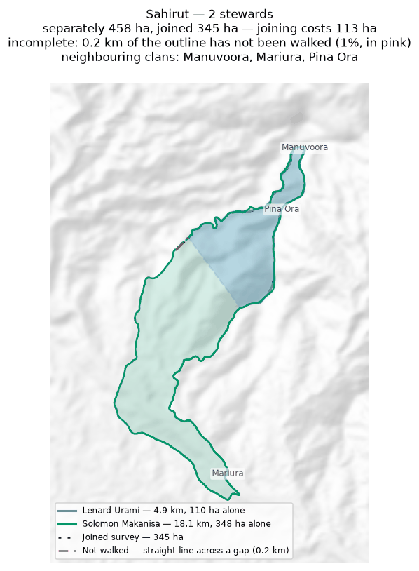
Each steward's line and the area it gives alone (dashed); the survey they combine into, dotted; the stretches nobody walked in pink. Neighbouring clans are named where they lie; their boundaries are not drawn.

Zone 7A

Bimkol
Zone 7A · version 1.14, 10 October 2026
Stewards | Surveys | Walked (km) | Access legs (km) | Pieces | Not walked (km) | Parcels | Area (ha) | Basis
1 | 1 | 8.0 | 1.8 | 3 | 4.0 | 1 | 159 | inferred
Clan Stewards
Clan Steward | Tracks | Days | First | Last | Walked (km)
Kennedy Wosa | 5 | 4 | 2026-05-25 | 2026-08-13 | 8.0
Ground also claimed by another clan
Clan | Shared (ha) | % of this clan | Beyond 100 m (ha) | Verdict
Darekikol | 1 | 0.3% | 0 | within tolerance
Neighbouring clans
Clan | Boundary walked alongside (km) | % of this clan's line
Darekikol | 1.4 | 9.3%
Borori | 0.1 | 1.4%
Where the two clans' recorded lines run within 100 m of each other. Two neighbours walking the same edge is the ordinary case.
Sacred sites
None recorded. The Clan Stewards were asked for the outer boundary and the sacred sites; nothing in this clan's files is marked as one.
What the survey shows
- The boundary does not close. 4.0 km in 3 stretches was bridged with straight lines nobody walked — 54% of the distance walked, so 159 ha is an estimate rather than a measured area. On the map those stretches are pink.
- A further 1 clan (Darekikol) shares ground only in strips narrower than 100 m — the two lines being the same line, which is not counted as overlap.
- 9% of this clan's recorded line runs within 100 m of Darekikol's: the two walked the same edge.
Queries for the field
- 54% of this outline was not walked — 4.0 km of straight line, shown in pink. Does the boundary in fact run along those straight lines, or somewhere else? Can the missing stretches be walked?
To take back to the ground
A GPX file for this clan is supplied as Bimkol_Zone_7A.gpx. Loaded onto the phone or handheld the boundary was mapped with, it shows the stewards' own tracks, the 3 gaps drawn as straight lines, and a waypoint at each end of every gap so a steward can navigate to where the walking stopped and carry on.
Map
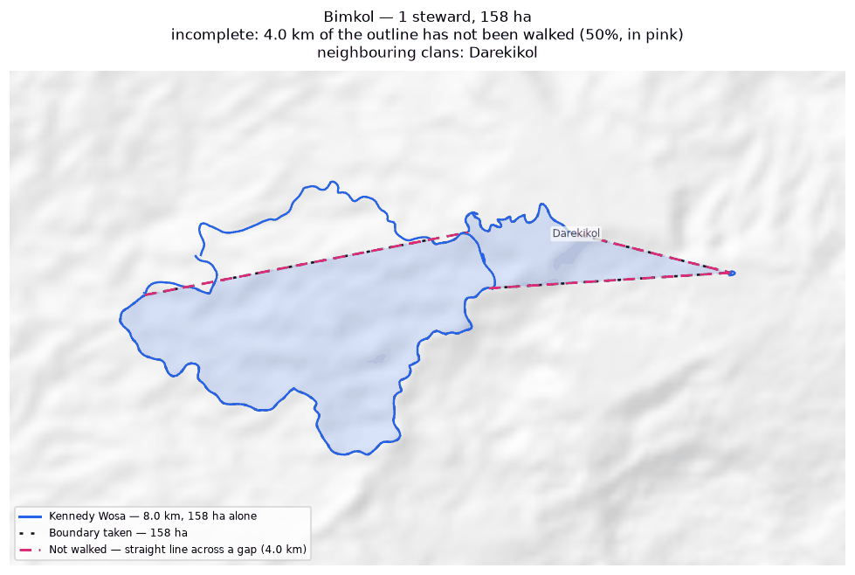
The walk and the area it gives (dotted), with the stretches nobody walked in pink. Neighbouring clans are named where they lie; their boundaries are not drawn.

Borori
Zone 7A · version 1.14, 10 October 2026
Stewards | Surveys | Walked (km) | Access legs (km) | Pieces | Not walked (km) | Parcels | Area (ha) | Basis
2 | 2 | 32.7 | 8.0 | 10 | 7.0 | 2 | 639 | inferred
Clan Stewards
Clan Steward | Tracks | Days | First | Last | Walked (km)
John Saini | 5 | 5 | 2026-06-10 | 2026-07-07 | 22.8
Hagahi Semo | 6 | 5 | 2026-05-25 | 2026-07-07 | 9.9
Ground also claimed by another clan
Clan | Shared (ha) | % of this clan | Beyond 100 m (ha) | Verdict
Darekikol | 333 | 52.1% | 329 | overlap
Mariura | 56 | 8.8% | 52 | overlap
Mungaikol | 0 | 0.0% | 0 | within tolerance
Neighbouring clans
Clan | Boundary walked alongside (km) | % of this clan's line
Darekikol | 13.9 | 32.0%
Mariura | 8.4 | 25.7%
Mungaikol | 0.4 | 1.3%
Bimkol | 0.1 | 0.3%
Where the two clans' recorded lines run within 100 m of each other. Two neighbours walking the same edge is the ordinary case.
Sacred sites
None recorded. The Clan Stewards were asked for the outer boundary and the sacred sites; nothing in this clan's files is marked as one.
What the survey shows
- The boundary does not close. 7.0 km in 10 stretches was bridged with straight lines nobody walked — 24% of the distance walked, so 639 ha is an estimate rather than a measured area. On the map those stretches are pink.
- The walks enclose 2 separate parcels, totalling 639 ha. All of them are counted. Whether they are all this clan's land, or whether one belongs to a neighbour, is a question for the clan.
- Joining the 2 stewards costs 38 ha: separately they give 677 ha, joined 639 ha. This happens where stewards each walked the same ring rather than different stretches — the two rings cross and the joined network encloses less than either walk did alone.
- Ground here is also inside the area recorded for 2 other clans: Darekikol (333 ha); Mariura (56 ha). These figures are provisional while this boundary is incomplete: the unwalked stretches are drawn as straight lines, and those lines are what the overlap is measured against.
- A further 1 clan (Mungaikol) shares ground only in strips narrower than 100 m — the two lines being the same line, which is not counted as overlap.
Queries for the field
- This clan's land is recorded as 2 separate pieces. Is that right, and does each piece belong to this clan?
- Did the 2 stewards walk the same boundary, or different parts of it? If they walked the same ring, their surveys should be treated as separate accounts rather than joined.
- This boundary is recorded in 10 separate pieces. Were the connecting stretches walked but not recorded, or not yet walked?
To take back to the ground
A GPX file for this clan is supplied as Borori_Zone_7A.gpx. Loaded onto the phone or handheld the boundary was mapped with, it shows the stewards' own tracks, the 7 gaps drawn as straight lines, and a waypoint at each end of every gap so a steward can navigate to where the walking stopped and carry on.
Map
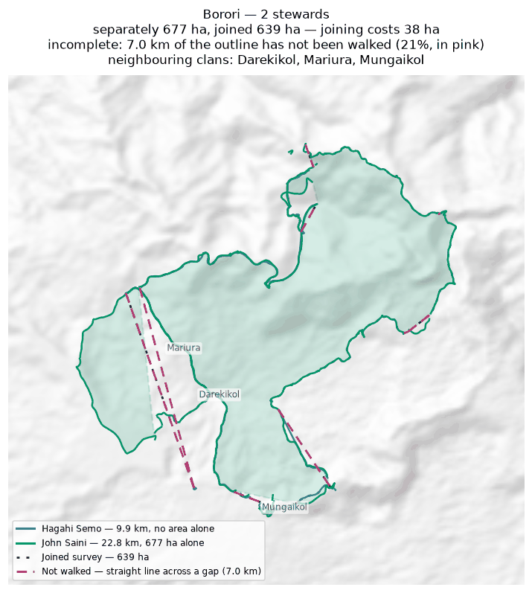
Each steward's line and the area it gives alone (dashed); the survey they combine into, dotted; the stretches nobody walked in pink. Neighbouring clans are named where they lie; their boundaries are not drawn.

Darekikol
Zone 7A · version 1.14, 10 October 2026
Stewards | Surveys | Walked (km) | Access legs (km) | Pieces | Not walked (km) | Parcels | Area (ha) | Basis
2 | 2 | 28.8 | 6.7 | 7 | 5.9 | 1 | 588 | inferred
Clan Stewards
Clan Steward | Tracks | Days | First | Last | Walked (km)
George Kopoi | 6 | 3 | 2026-05-25 | 2026-07-02 | 15.4
Garex Sevesi | 2 | 2 | 2026-05-25 | 2026-06-02 | 13.4
Ground also claimed by another clan
Clan | Shared (ha) | % of this clan | Beyond 100 m (ha) | Verdict
Borori | 333 | 56.7% | 329 | overlap
Mariura | 50 | 8.6% | 50 | overlap
Bimkol | 1 | 0.1% | 0 | within tolerance
Neighbouring clans
Clan | Boundary walked alongside (km) | % of this clan's line
Borori | 13.9 | 48.4%
Bimkol | 1.4 | 4.8%
Mariura | 0.7 | 2.5%
Where the two clans' recorded lines run within 100 m of each other. Two neighbours walking the same edge is the ordinary case.
Sacred sites
None recorded. The Clan Stewards were asked for the outer boundary and the sacred sites; nothing in this clan's files is marked as one.
What the survey shows
- The boundary does not close. 5.9 km in 7 stretches was bridged with straight lines nobody walked — 23% of the distance walked, so 588 ha is an estimate rather than a measured area. On the map those stretches are pink.
- Joining the 2 stewards costs 639 ha: separately they give 1,227 ha, joined 588 ha. This happens where stewards each walked the same ring rather than different stretches — the two rings cross and the joined network encloses less than either walk did alone.
- Ground here is also inside the area recorded for 2 other clans: Borori (333 ha); Mariura (50 ha). These figures are provisional while this boundary is incomplete: the unwalked stretches are drawn as straight lines, and those lines are what the overlap is measured against.
- A further 1 clan (Bimkol) shares ground only in strips narrower than 100 m — the two lines being the same line, which is not counted as overlap.
Queries for the field
- Did the 2 stewards walk the same boundary, or different parts of it? If they walked the same ring, their surveys should be treated as separate accounts rather than joined.
- This boundary is recorded in 7 separate pieces. Were the connecting stretches walked but not recorded, or not yet walked?
To take back to the ground
A GPX file for this clan is supplied as Darekikol_Zone_7A.gpx. Loaded onto the phone or handheld the boundary was mapped with, it shows the stewards' own tracks, the 6 gaps drawn as straight lines, and a waypoint at each end of every gap so a steward can navigate to where the walking stopped and carry on.
Map
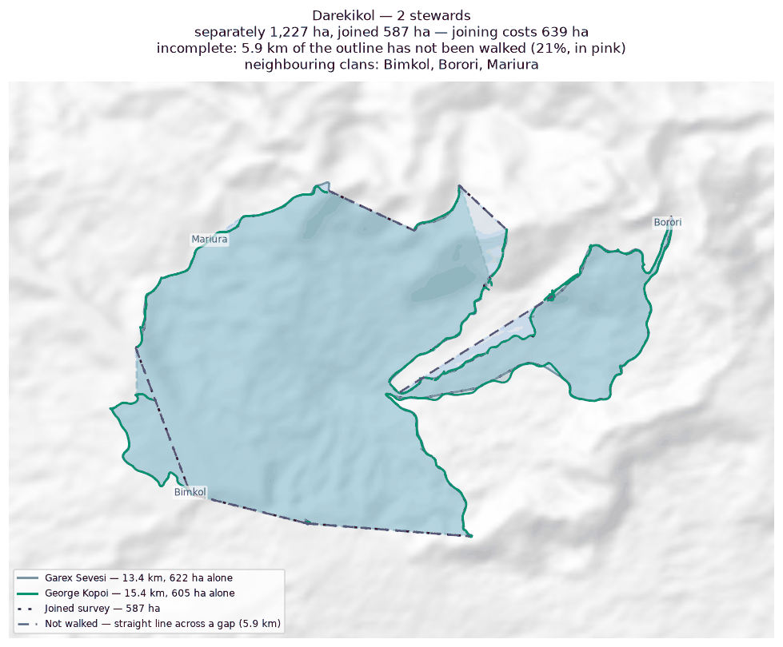
Each steward's line and the area it gives alone (dashed); the survey they combine into, dotted; the stretches nobody walked in pink. Neighbouring clans are named where they lie; their boundaries are not drawn.

Zone 7B

Abuankol
Zone 7B · version 1.14, 10 October 2026
Stewards | Surveys | Walked (km) | Access legs (km) | Pieces | Not walked (km) | Parcels | Area (ha) | Basis
1 | 1 | 0.5 | 0.0 | 3 | 1.3 | — | none | no area
Clan Stewards
Clan Steward | Tracks | Days | First | Last | Walked (km)
Simeon Pasip | 4 | 3 | 2025-10-21 | 2025-10-28 | 0.5
Neighbouring clans
Clan | Boundary walked alongside (km) | % of this clan's line
Sugulkol | 1.8 | 100.0%
Murai (Z7B) | 1.0 | 100.0%
Wohukol | 0.5 | 100.0%
Ambunkol | 0.5 | 58.0%
Jariji | 0.3 | 58.0%
Binunkol | 0.4 | 42.0%
Ginangi | 0.4 | 42.0%
Marijabimkol | 0.2 | 42.0%
Natang | 0.0 | 1.8%
Where the two clans' recorded lines run within 100 m of each other. Two neighbours walking the same edge is the ordinary case.
Sacred sites
None recorded. The Clan Stewards were asked for the outer boundary and the sacred sites; nothing in this clan's files is marked as one.
What the survey shows
- No area can be given. The tracks are in 3 disconnected pieces and 1.3 km of straight-line joining would be needed to make a ring — 245% of the distance walked. That is beyond the 50% limit, above which an area would be more assumption than survey.
- 100% of this clan's recorded line runs within 100 m of Sugulkol's: the two walked the same edge.
Queries for the field
- Can the missing stretches be walked so this boundary closes? If any gap is deliberate — a river, a road, an agreed open edge — please say what runs along it.
To take back to the ground
A GPX file for this clan is supplied as Abuankol_Zone_7B.gpx. Loaded onto the phone or handheld the boundary was mapped with, it shows the stewards' own tracks, the 2 gaps drawn as straight lines, and a waypoint at each end of every gap so a steward can navigate to where the walking stopped and carry on.
Map
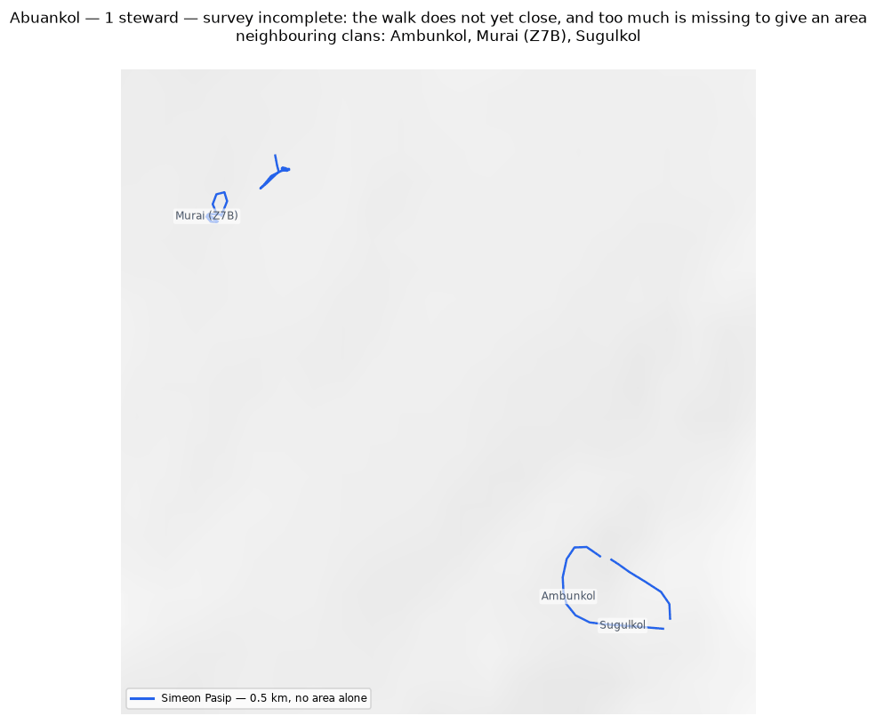
The walk and the area it gives (dotted), with the stretches nobody walked in pink. Neighbouring clans are named where they lie; their boundaries are not drawn.

Ambunkol
Zone 7B · version 1.14, 10 October 2026
Stewards | Surveys | Walked (km) | Access legs (km) | Pieces | Not walked (km) | Parcels | Area (ha) | Basis
1 | 1 | 18.6 | 4.0 | 6 | 4.5 | 3 | 592 | inferred
Clan Stewards
Clan Steward | Tracks | Days | First | Last | Walked (km)
Peter Awako | 1 | 1 | 2025-10-28 | 2025-10-28 | 18.6
Ground also claimed by another clan
Clan | Shared (ha) | % of this clan | Beyond 100 m (ha) | Verdict
Natang | 346 | 58.5% | 342 | overlap
Sugulkol | 5 | 0.9% | 0 | within tolerance
Wohukol | 3 | 0.5% | 1 | overlap
Jariji | 1 | 0.1% | 0 | within tolerance
Neighbouring clans
Clan | Boundary walked alongside (km) | % of this clan's line
Natang | 20.3 | 59.2%
Sugulkol | 5.9 | 15.1%
Wohukol | 2.2 | 9.4%
Murai (Z7B) | 1.0 | 3.9%
Abuankol | 0.5 | 2.9%
Jariji | 0.4 | 1.8%
Where the two clans' recorded lines run within 100 m of each other. Two neighbours walking the same edge is the ordinary case.
Sacred sites
None recorded. The Clan Stewards were asked for the outer boundary and the sacred sites; nothing in this clan's files is marked as one.
What the survey shows
- The boundary does not close. 4.5 km in 6 stretches was bridged with straight lines nobody walked — 26% of the distance walked, so 592 ha is an estimate rather than a measured area. On the map those stretches are pink.
- The walks enclose 3 separate parcels, totalling 592 ha. All of them are counted. Whether they are all this clan's land, or whether one belongs to a neighbour, is a question for the clan.
- Ground here is also inside the area recorded for 2 other clans: Natang (346 ha); Wohukol (3 ha). These figures are provisional while this boundary is incomplete: the unwalked stretches are drawn as straight lines, and those lines are what the overlap is measured against.
- A further 2 clans (Sugulkol, Jariji) share ground only in strips narrower than 100 m — the two lines being the same line, which is not counted as overlap.
Queries for the field
- 26% of this outline was not walked — 4.5 km of straight line, shown in pink. Does the boundary in fact run along those straight lines, or somewhere else? Can the missing stretches be walked?
- This clan's land is recorded as 3 separate pieces. Is that right, and does each piece belong to this clan?
- This boundary is recorded in 6 separate pieces. Were the connecting stretches walked but not recorded, or not yet walked?
To take back to the ground
A GPX file for this clan is supplied as Ambunkol_Zone_7B.gpx. Loaded onto the phone or handheld the boundary was mapped with, it shows the stewards' own tracks, the 5 gaps drawn as straight lines, and a waypoint at each end of every gap so a steward can navigate to where the walking stopped and carry on.
Map
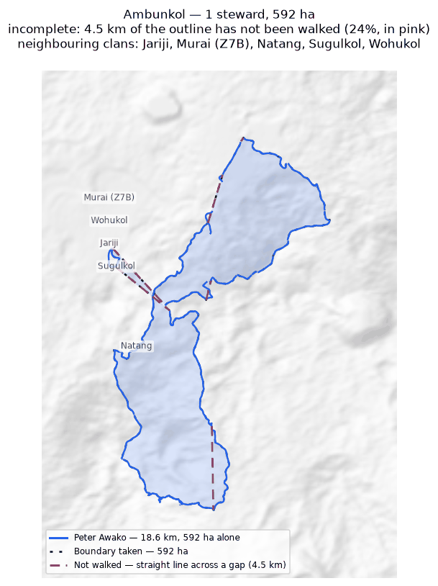
The walk and the area it gives (dotted), with the stretches nobody walked in pink. Neighbouring clans are named where they lie; their boundaries are not drawn.

Binunkol
Zone 7B · version 1.14, 10 October 2026
Stewards | Surveys | Walked (km) | Access legs (km) | Pieces | Not walked (km) | Parcels | Area (ha) | Basis
1 | 1 | 17.8 | 4.1 | 19 | 6.4 | 1 | 1,033 | inferred
Clan Stewards
Clan Steward | Tracks | Days | First | Last | Walked (km)
Moses Garui | 10 | 5 | 2026-05-23 | 2026-06-16 | 17.8
Ground also claimed by another clan
Clan | Shared (ha) | % of this clan | Beyond 100 m (ha) | Verdict
Jariji | 45 | 4.4% | 42 | overlap
Wohukol | 29 | 2.8% | 28 | overlap
Sugulkol | 2 | 0.1% | 1 | overlap
Rondi | 1 | 0.1% | 0 | within tolerance
Ginangi | 0 | 0.0% | 0 | within tolerance
Sukandi | 0 | 0.0% | 0 | within tolerance
Neighbouring clans
Clan | Boundary walked alongside (km) | % of this clan's line
Jariji | 5.2 | 27.4%
Rondi | 3.8 | 7.1%
Sugulkol | 1.1 | 6.3%
Marang | 1.1 | 6.0%
Sukandi | 1.0 | 5.4%
Murai (Z7B) | 0.9 | 5.1%
Wohukol | 0.8 | 4.5%
Ginangi | 0.7 | 4.1%
Abuankol | 0.4 | 2.3%
Marijabimkol | 0.4 | 2.2%
Nui | 0.2 | 1.0%
Deari | 0.2 | 1.0%
Where the two clans' recorded lines run within 100 m of each other. Two neighbours walking the same edge is the ordinary case.
Sacred sites
None recorded. The Clan Stewards were asked for the outer boundary and the sacred sites; nothing in this clan's files is marked as one.
What the survey shows
- The boundary does not close. 6.4 km in 19 stretches was bridged with straight lines nobody walked — 40% of the distance walked, so 1,033 ha is an estimate rather than a measured area. On the map those stretches are pink.
- Ground here is also inside the area recorded for 3 other clans: Jariji (45 ha); Wohukol (29 ha); Sugulkol (2 ha). These figures are provisional while this boundary is incomplete: the unwalked stretches are drawn as straight lines, and those lines are what the overlap is measured against.
- A further 3 clans (Rondi, Ginangi, Sukandi) share ground only in strips narrower than 100 m — the two lines being the same line, which is not counted as overlap.
Queries for the field
- 40% of this outline was not walked — 6.4 km of straight line, shown in pink. Does the boundary in fact run along those straight lines, or somewhere else? Can the missing stretches be walked?
- This boundary is recorded in 19 separate pieces. Were the connecting stretches walked but not recorded, or not yet walked?
To take back to the ground
A GPX file for this clan is supplied as Binunkol_Zone_7B.gpx. Loaded onto the phone or handheld the boundary was mapped with, it shows the stewards' own tracks, the 15 gaps drawn as straight lines, and a waypoint at each end of every gap so a steward can navigate to where the walking stopped and carry on.
Map
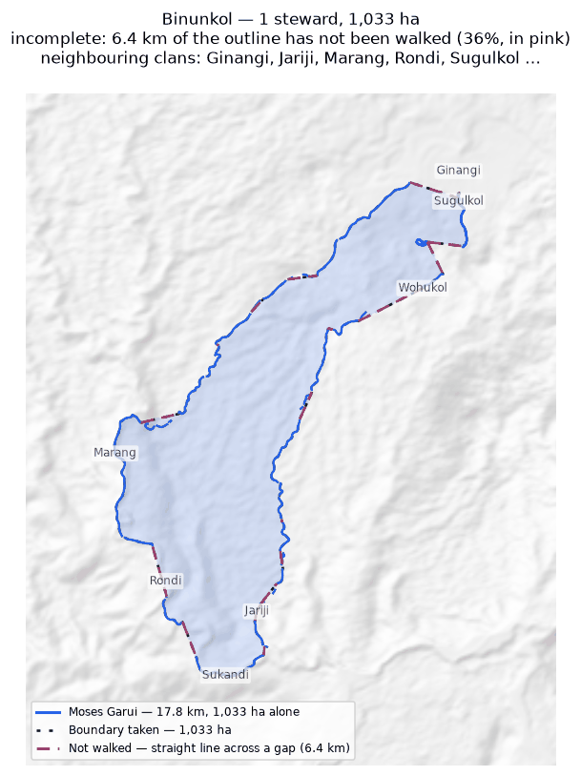
The walk and the area it gives (dotted), with the stretches nobody walked in pink. Neighbouring clans are named where they lie; their boundaries are not drawn.

Ginangi
Zone 7B · version 1.14, 10 October 2026
Stewards | Surveys | Walked (km) | Access legs (km) | Pieces | Not walked (km) | Parcels | Area (ha) | Basis
2 | 2 | 36.7 | 4.2 | 7 | 7.2 | 1 | 1,235 | inferred
Clan Stewards
Clan Steward | Tracks | Days | First | Last | Walked (km)
Job Mokondo | 7 | 3 | 2026-05-23 | 2026-06-22 | 21.8
Joshua Mokondo | 6 | 4 | 2026-06-03 | 2026-06-24 | 14.9
Ground also claimed by another clan
Clan | Shared (ha) | % of this clan | Beyond 100 m (ha) | Verdict
Manang | 312 | 25.2% | 311 | overlap
Sugulkol | 52 | 4.2% | 51 | overlap
Binunkol | 0 | 0.0% | 0 | within tolerance
Wohukol | 0 | 0.0% | 0 | within tolerance
Neighbouring clans
Clan | Boundary walked alongside (km) | % of this clan's line
Murai (Z7B) | 1.5 | 5.0%
Manang | 1.1 | 3.7%
Binunkol | 0.7 | 1.4%
Sugulkol | 0.6 | 1.4%
Abuankol | 0.4 | 1.2%
Marijabimkol | 0.3 | 1.1%
Wohukol | 0.3 | 1.1%
Savasi | 0.1 | 0.4%
Where the two clans' recorded lines run within 100 m of each other. Two neighbours walking the same edge is the ordinary case.
Sacred sites
None recorded. The Clan Stewards were asked for the outer boundary and the sacred sites; nothing in this clan's files is marked as one.
What the survey shows
- The boundary does not close. 7.2 km in 7 stretches was bridged with straight lines nobody walked — 21% of the distance walked, so 1,235 ha is an estimate rather than a measured area. On the map those stretches are pink.
- Joining the 2 stewards costs 1 ha: separately they give 1,236 ha, joined 1,235 ha. This happens where stewards each walked the same ring rather than different stretches — the two rings cross and the joined network encloses less than either walk did alone.
- Ground here is also inside the area recorded for 2 other clans: Manang (312 ha); Sugulkol (52 ha). These figures are provisional while this boundary is incomplete: the unwalked stretches are drawn as straight lines, and those lines are what the overlap is measured against.
- A further 2 clans (Binunkol, Wohukol) share ground only in strips narrower than 100 m — the two lines being the same line, which is not counted as overlap.
Queries for the field
- Did the 2 stewards walk the same boundary, or different parts of it? If they walked the same ring, their surveys should be treated as separate accounts rather than joined.
- This boundary is recorded in 7 separate pieces. Were the connecting stretches walked but not recorded, or not yet walked?
To take back to the ground
A GPX file for this clan is supplied as Ginangi_Zone_7B.gpx. Loaded onto the phone or handheld the boundary was mapped with, it shows the stewards' own tracks, the 3 gaps drawn as straight lines, and a waypoint at each end of every gap so a steward can navigate to where the walking stopped and carry on.
Map
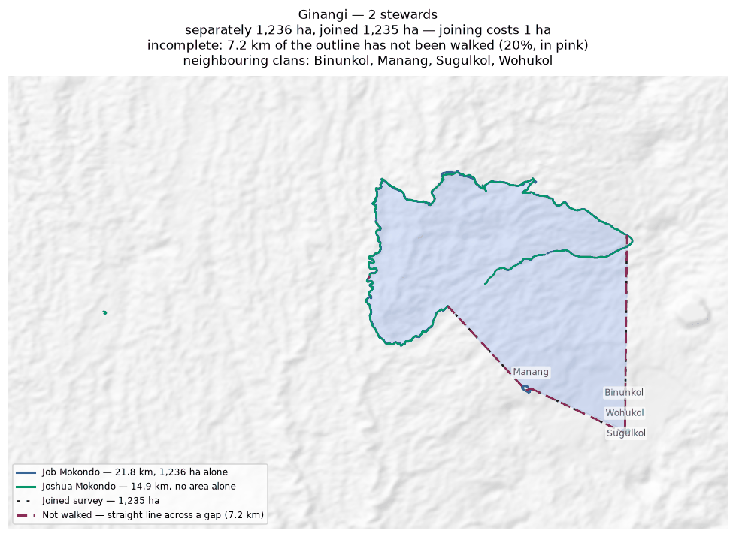
Each steward's line and the area it gives alone (dashed); the survey they combine into, dotted; the stretches nobody walked in pink. Neighbouring clans are named where they lie; their boundaries are not drawn.

Jariji
Zone 7B · version 1.14, 10 October 2026
Stewards | Surveys | Walked (km) | Access legs (km) | Pieces | Not walked (km) | Parcels | Area (ha) | Basis
2 | 2 | 27.5 | 5.8 | 6 | 9.0 | 2 | 696 | inferred
Clan Stewards
Clan Steward | Tracks | Days | First | Last | Walked (km)
Clement Viri | 1 | 1 | 2025-11-09 | 2025-11-09 | 13.8
Newton Giwai | 3 | 2 | 2025-11-06 | 2025-11-09 | 13.7
Ground also claimed by another clan
Clan | Shared (ha) | % of this clan | Beyond 100 m (ha) | Verdict
Wohukol | 62 | 8.9% | 59 | overlap
Binunkol | 45 | 6.5% | 42 | overlap
Sugulkol | 8 | 1.1% | 7 | overlap
Ambunkol | 1 | 0.1% | 0 | within tolerance
Sukandi | 0 | 0.0% | 0 | within tolerance
Neighbouring clans
Clan | Boundary walked alongside (km) | % of this clan's line
Wohukol | 8.6 | 35.6%
Binunkol | 5.2 | 24.0%
Sugulkol | 2.2 | 4.0%
Murai (Z7B) | 0.8 | 2.5%
Ambunkol | 0.4 | 1.6%
Abuankol | 0.3 | 1.6%
Sukandi | 0.3 | 0.9%
Natang | 0.2 | 0.5%
Where the two clans' recorded lines run within 100 m of each other. Two neighbours walking the same edge is the ordinary case.
Sacred sites
None recorded. The Clan Stewards were asked for the outer boundary and the sacred sites; nothing in this clan's files is marked as one.
What the survey shows
- The boundary does not close. 9.0 km in 6 stretches was bridged with straight lines nobody walked — 37% of the distance walked, so 696 ha is an estimate rather than a measured area. On the map those stretches are pink.
- The walks enclose 2 separate parcels, totalling 696 ha. All of them are counted. Whether they are all this clan's land, or whether one belongs to a neighbour, is a question for the clan.
- Joining the 2 stewards adds 76 ha: separately 620 ha, joined 696 ha. The stewards covered different stretches of one boundary.
- Ground here is also inside the area recorded for 3 other clans: Wohukol (62 ha); Binunkol (45 ha); Sugulkol (8 ha). These figures are provisional while this boundary is incomplete: the unwalked stretches are drawn as straight lines, and those lines are what the overlap is measured against.
- A further 2 clans (Ambunkol, Sukandi) share ground only in strips narrower than 100 m — the two lines being the same line, which is not counted as overlap.
Queries for the field
- 37% of this outline was not walked — 9.0 km of straight line, shown in pink. Does the boundary in fact run along those straight lines, or somewhere else? Can the missing stretches be walked?
- This clan's land is recorded as 2 separate pieces. Is that right, and does each piece belong to this clan?
- This boundary is recorded in 6 separate pieces. Were the connecting stretches walked but not recorded, or not yet walked?
To take back to the ground
A GPX file for this clan is supplied as Jariji_Zone_7B.gpx. Loaded onto the phone or handheld the boundary was mapped with, it shows the stewards' own tracks, the 5 gaps drawn as straight lines, and a waypoint at each end of every gap so a steward can navigate to where the walking stopped and carry on.
Map
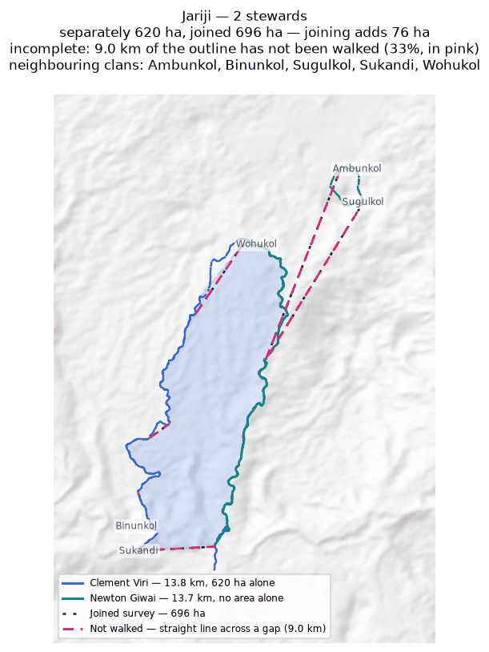
Each steward's line and the area it gives alone (dashed); the survey they combine into, dotted; the stretches nobody walked in pink. Neighbouring clans are named where they lie; their boundaries are not drawn.

Manang
Zone 7B · version 1.14, 10 October 2026
Stewards | Surveys | Walked (km) | Access legs (km) | Pieces | Not walked (km) | Parcels | Area (ha) | Basis
1 | 1 | 7.1 | 0.0 | 1 | 1.8 | 1 | 353 | inferred
Clan Stewards
Clan Steward | Tracks | Days | First | Last | Walked (km)
Kelly Wahamo | 1 | 1 | 2026-07-01 | 2026-07-01 | 7.1
Ground also claimed by another clan
Clan | Shared (ha) | % of this clan | Beyond 100 m (ha) | Verdict
Ginangi | 312 | 88.3% | 311 | overlap
Sugulkol | 3 | 0.8% | 0 | within tolerance
Neighbouring clans
Clan | Boundary walked alongside (km) | % of this clan's line
Murai (Z7B) | 2.7 | 37.0%
Sugulkol | 1.2 | 13.9%
Marang | 0.6 | 7.9%
Ginangi | 1.1 | 4.4%
Where the two clans' recorded lines run within 100 m of each other. Two neighbours walking the same edge is the ordinary case.
Sacred sites
None recorded. The Clan Stewards were asked for the outer boundary and the sacred sites; nothing in this clan's files is marked as one.
What the survey shows
- The boundary does not close. 1.8 km in 1 stretch was bridged with straight lines nobody walked — 25% of the distance walked, so 353 ha is an estimate rather than a measured area. On the map those stretches are pink.
- Ground here is also inside the area recorded for 1 other clan: Ginangi (312 ha). These figures are provisional while this boundary is incomplete: the unwalked stretches are drawn as straight lines, and those lines are what the overlap is measured against.
- A further 1 clan (Sugulkol) shares ground only in strips narrower than 100 m — the two lines being the same line, which is not counted as overlap.
Queries for the field
- 25% of this outline was not walked — 1.8 km of straight line, shown in pink. Does the boundary in fact run along those straight lines, or somewhere else? Can the missing stretches be walked?
To take back to the ground
A GPX file for this clan is supplied as Manang_Zone_7B.gpx. Loaded onto the phone or handheld the boundary was mapped with, it shows the stewards' own tracks, the 1 gap drawn as straight lines, and a waypoint at each end of every gap so a steward can navigate to where the walking stopped and carry on.
Map
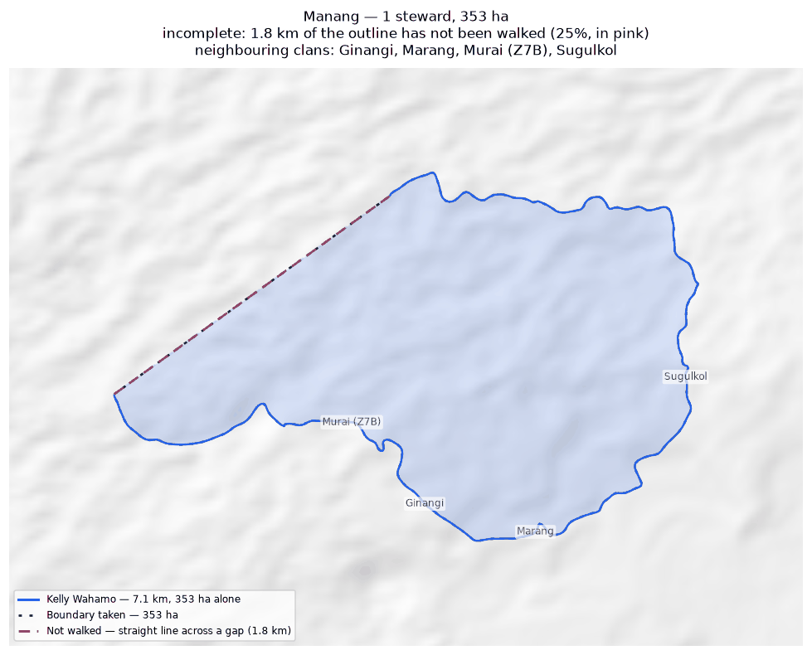
The walk and the area it gives (dotted), with the stretches nobody walked in pink. Neighbouring clans are named where they lie; their boundaries are not drawn.

Marang
Zone 7B · version 1.14, 10 October 2026
Stewards | Surveys | Walked (km) | Access legs (km) | Pieces | Not walked (km) | Parcels | Area (ha) | Basis
1 | 1 | 8.3 | 1.3 | 2 | 5.5 | — | none | no area
Clan Stewards
Clan Steward | Tracks | Days | First | Last | Walked (km)
Henry Manderi | 2 | 2 | 2026-06-05 | 2026-06-06 | 8.3
Neighbouring clans
Clan | Boundary walked alongside (km) | % of this clan's line
Marijabimkol | 4.1 | 48.5%
Murai (Z7B) | 1.9 | 14.5%
Binunkol | 1.1 | 12.9%
Manang | 0.6 | 6.3%
Where the two clans' recorded lines run within 100 m of each other. Two neighbours walking the same edge is the ordinary case.
Sacred sites
None recorded. The Clan Stewards were asked for the outer boundary and the sacred sites; nothing in this clan's files is marked as one.
What the survey shows
- No area can be given. The tracks are in 2 disconnected pieces and 5.5 km of straight-line joining would be needed to make a ring — 67% of the distance walked. That is beyond the 50% limit, above which an area would be more assumption than survey.
- 49% of this clan's recorded line runs within 100 m of Marijabimkol's: the two walked the same edge.
Queries for the field
- Can the missing stretches be walked so this boundary closes? If any gap is deliberate — a river, a road, an agreed open edge — please say what runs along it.
To take back to the ground
A GPX file for this clan is supplied as Marang_Zone_7B.gpx. Loaded onto the phone or handheld the boundary was mapped with, it shows the stewards' own tracks, the 2 gaps drawn as straight lines, and a waypoint at each end of every gap so a steward can navigate to where the walking stopped and carry on.
Map
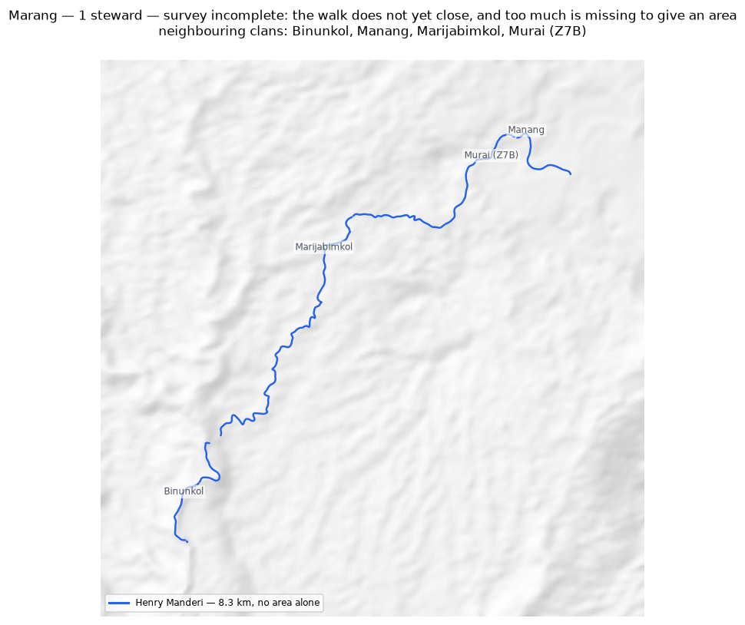
The walk and the area it gives (dotted), with the stretches nobody walked in pink. Neighbouring clans are named where they lie; their boundaries are not drawn.

Marijabimkol
Zone 7B · version 1.14, 10 October 2026
Stewards | Surveys | Walked (km) | Access legs (km) | Pieces | Not walked (km) | Parcels | Area (ha) | Basis
1 | 1 | 11.0 | 2.5 | 4 | 6.1 | — | none | no area
Clan Stewards
Clan Steward | Tracks | Days | First | Last | Walked (km)
Japhet Nagura | 7 | 4 | 2025-10-21 | 2025-11-05 | 11.0
Neighbouring clans
Clan | Boundary walked alongside (km) | % of this clan's line
Marang | 4.1 | 37.7%
Murai (Z7B) | 1.3 | 11.5%
Sugulkol | 0.4 | 1.8%
Binunkol | 0.4 | 1.8%
Ginangi | 0.3 | 1.8%
Abuankol | 0.2 | 1.8%
Wohukol | 0.2 | 1.8%
Where the two clans' recorded lines run within 100 m of each other. Two neighbours walking the same edge is the ordinary case.
Sacred sites
None recorded. The Clan Stewards were asked for the outer boundary and the sacred sites; nothing in this clan's files is marked as one.
What the survey shows
- No area can be given. The tracks are in 4 disconnected pieces and 6.1 km of straight-line joining would be needed to make a ring — 61% of the distance walked. That is beyond the 50% limit, above which an area would be more assumption than survey.
- 38% of this clan's recorded line runs within 100 m of Marang's: the two walked the same edge.
Queries for the field
- Can the missing stretches be walked so this boundary closes? If any gap is deliberate — a river, a road, an agreed open edge — please say what runs along it.
To take back to the ground
A GPX file for this clan is supplied as Marijabimkol_Zone_7B.gpx. Loaded onto the phone or handheld the boundary was mapped with, it shows the stewards' own tracks, the 3 gaps drawn as straight lines, and a waypoint at each end of every gap so a steward can navigate to where the walking stopped and carry on.
Map
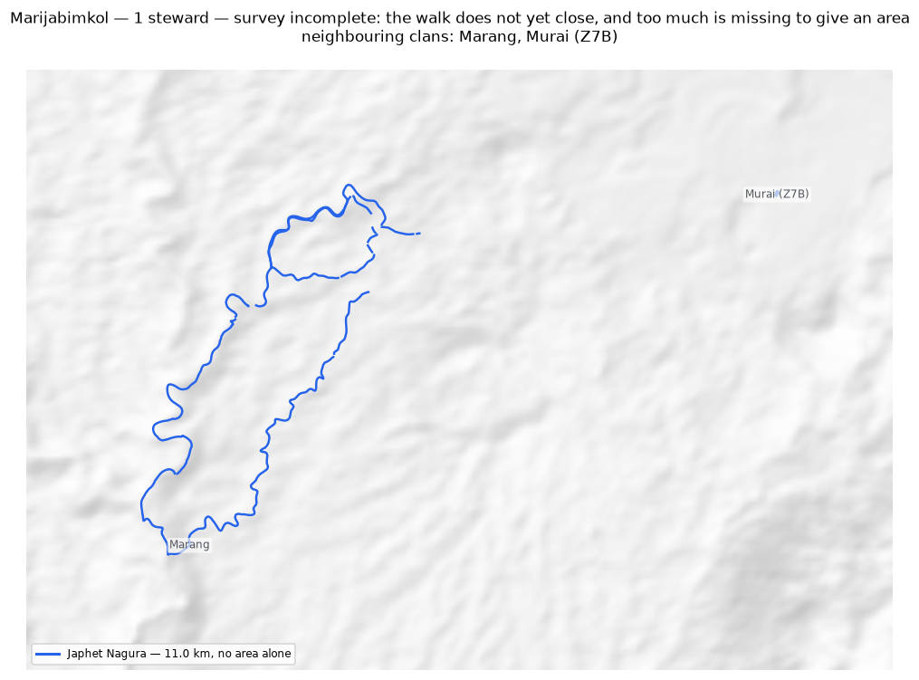
The walk and the area it gives (dotted), with the stretches nobody walked in pink. Neighbouring clans are named where they lie; their boundaries are not drawn.

Murai (Z7B)
Zone 7B · version 1.14, 10 October 2026
Stewards | Surveys | Walked (km) | Access legs (km) | Pieces | Not walked (km) | Parcels | Area (ha) | Basis
1 | 1 | 12.4 | 2.9 | 5 | 7.2 | — | none | no area
Clan Stewards
Clan Steward | Tracks | Days | First | Last | Walked (km)
James Iroti | 8 | 6 | 2025-10-21 | 2026-03-11 | 12.4
Neighbouring clans
Clan | Boundary walked alongside (km) | % of this clan's line
Manang | 2.7 | 21.9%
Marang | 1.9 | 15.1%
Sugulkol | 3.0 | 14.1%
Wohukol | 1.2 | 9.3%
Marijabimkol | 1.3 | 8.9%
Abuankol | 1.0 | 8.4%
Ambunkol | 1.0 | 8.1%
Binunkol | 0.9 | 6.6%
Jariji | 0.8 | 6.1%
Ginangi | 1.5 | 4.4%
Natang | 0.4 | 3.6%
Where the two clans' recorded lines run within 100 m of each other. Two neighbours walking the same edge is the ordinary case.
Sacred sites
None recorded. The Clan Stewards were asked for the outer boundary and the sacred sites; nothing in this clan's files is marked as one.
What the survey shows
- No area can be given. The tracks are in 5 disconnected pieces and 7.2 km of straight-line joining would be needed to make a ring — 64% of the distance walked. That is beyond the 50% limit, above which an area would be more assumption than survey.
- 22% of this clan's recorded line runs within 100 m of Manang's: the two walked the same edge.
Queries for the field
- Can the missing stretches be walked so this boundary closes? If any gap is deliberate — a river, a road, an agreed open edge — please say what runs along it.
To take back to the ground
A GPX file for this clan is supplied as Murai_Z7B_Zone_7B.gpx. Loaded onto the phone or handheld the boundary was mapped with, it shows the stewards' own tracks, the 5 gaps drawn as straight lines, and a waypoint at each end of every gap so a steward can navigate to where the walking stopped and carry on.
Map
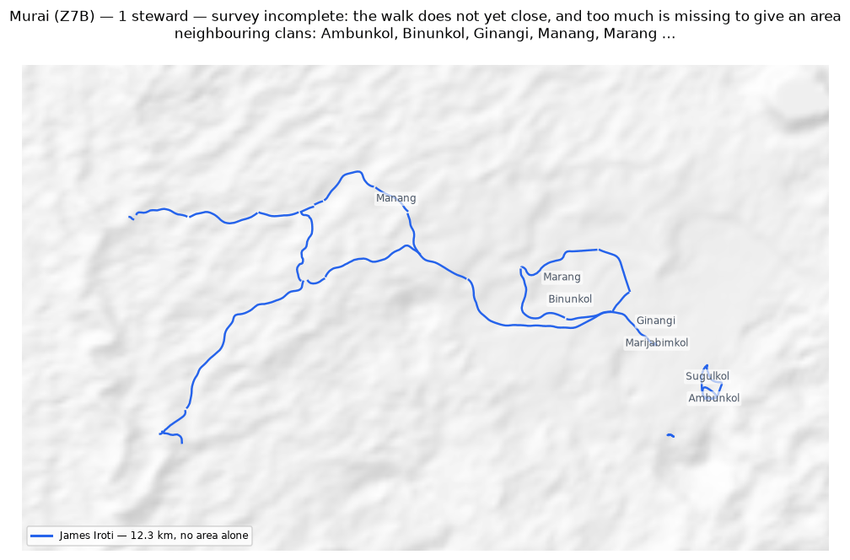
The walk and the area it gives (dotted), with the stretches nobody walked in pink. Neighbouring clans are named where they lie; their boundaries are not drawn.

Natang
Zone 7B · version 1.14, 10 October 2026
Stewards | Surveys | Walked (km) | Access legs (km) | Pieces | Not walked (km) | Parcels | Area (ha) | Basis
2 | 2 | 77.3 | 3.4 | 2 | 6.5 | 2 | 1,535 | inferred
Clan Stewards
Clan Steward | Tracks | Days | First | Last | Walked (km)
Stafford Gidiri | 2 | 1 | 2025-11-10 | 2025-11-10 | 46.5
Dickson Hoe | 4 | 3 | 2025-11-06 | 2026-02-16 | 30.8
Ground also claimed by another clan
Clan | Shared (ha) | % of this clan | Beyond 100 m (ha) | Verdict
Ambunkol | 346 | 22.6% | 342 | overlap
Sugulkol | 32 | 2.1% | 29 | overlap
Wohukol | 4 | 0.3% | 1 | overlap
Neighbouring clans
Clan | Boundary walked alongside (km) | % of this clan's line
Ambunkol | 20.3 | 37.6%
Wohukol | 8.8 | 16.0%
Sugulkol | 3.6 | 5.3%
Murai (Z7B) | 0.4 | 0.7%
Jariji | 0.2 | 0.3%
Abuankol | 0.0 | 0.0%
Where the two clans' recorded lines run within 100 m of each other. Two neighbours walking the same edge is the ordinary case.
Sacred sites
None recorded. The Clan Stewards were asked for the outer boundary and the sacred sites; nothing in this clan's files is marked as one.
What the survey shows
- The boundary does not close. 6.5 km in 2 stretches was bridged with straight lines nobody walked — 9% of the distance walked, so 1,535 ha is an estimate rather than a measured area. On the map those stretches are pink.
- The walks enclose 2 separate parcels, totalling 1,535 ha. All of them are counted. Whether they are all this clan's land, or whether one belongs to a neighbour, is a question for the clan.
- Joining the 2 stewards costs 820 ha: separately they give 2,355 ha, joined 1,535 ha. This happens where stewards each walked the same ring rather than different stretches — the two rings cross and the joined network encloses less than either walk did alone.
- Ground here is also inside the area recorded for 3 other clans: Ambunkol (346 ha); Sugulkol (32 ha); Wohukol (4 ha).
Queries for the field
- This clan's land is recorded as 2 separate pieces. Is that right, and does each piece belong to this clan?
- Did the 2 stewards walk the same boundary, or different parts of it? If they walked the same ring, their surveys should be treated as separate accounts rather than joined.
To take back to the ground
A GPX file for this clan is supplied as Natang_Zone_7B.gpx. Loaded onto the phone or handheld the boundary was mapped with, it shows the stewards' own tracks, the 2 gaps drawn as straight lines, and a waypoint at each end of every gap so a steward can navigate to where the walking stopped and carry on.
Map
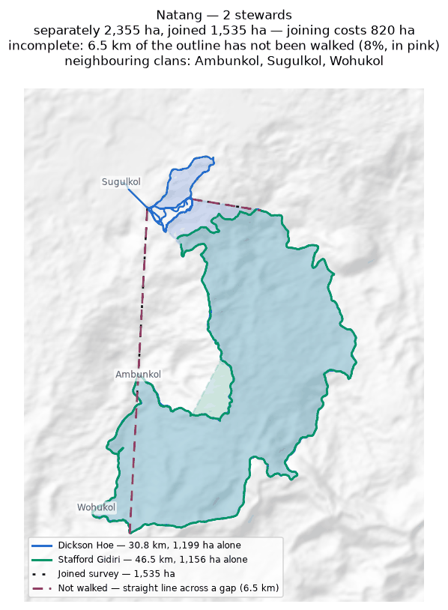
Each steward's line and the area it gives alone (dashed); the survey they combine into, dotted; the stretches nobody walked in pink. Neighbouring clans are named where they lie; their boundaries are not drawn.

Sugulkol
Zone 7B · version 1.14, 10 October 2026
Stewards | Surveys | Walked (km) | Access legs (km) | Pieces | Not walked (km) | Parcels | Area (ha) | Basis
2 | 2 | 24.0 | 1.3 | 6 | 3.7 | 1 | 314 | inferred
Clan Stewards
Clan Steward | Tracks | Days | First | Last | Walked (km)
Emmanuel Fufus | 6 | 6 | 2025-11-06 | 2026-03-02 | 13.4
Chris Idua | 6 | 3 | 2025-11-06 | 2025-11-08 | 10.6
Ground also claimed by another clan
Clan | Shared (ha) | % of this clan | Beyond 100 m (ha) | Verdict
Ginangi | 52 | 16.4% | 51 | overlap
Natang | 32 | 10.3% | 29 | overlap
Wohukol | 21 | 6.7% | 19 | overlap
Jariji | 8 | 2.4% | 7 | overlap
Ambunkol | 5 | 1.7% | 0 | within tolerance
Manang | 3 | 0.9% | 0 | within tolerance
Binunkol | 2 | 0.5% | 1 | overlap
Neighbouring clans
Clan | Boundary walked alongside (km) | % of this clan's line
Ambunkol | 5.9 | 24.4%
Natang | 3.6 | 15.0%
Wohukol | 3.2 | 13.3%
Murai (Z7B) | 3.0 | 12.4%
Jariji | 2.2 | 9.1%
Abuankol | 1.8 | 7.4%
Manang | 1.2 | 5.1%
Binunkol | 1.1 | 4.4%
Ginangi | 0.6 | 2.5%
Marijabimkol | 0.4 | 1.7%
Where the two clans' recorded lines run within 100 m of each other. Two neighbours walking the same edge is the ordinary case.
Sacred sites
None recorded. The Clan Stewards were asked for the outer boundary and the sacred sites; nothing in this clan's files is marked as one.
What the survey shows
- The boundary does not close. 3.7 km in 6 stretches was bridged with straight lines nobody walked — 16% of the distance walked, so 314 ha is an estimate rather than a measured area. On the map those stretches are pink.
- Joining the 2 stewards costs 316 ha: separately they give 630 ha, joined 314 ha. This happens where stewards each walked the same ring rather than different stretches — the two rings cross and the joined network encloses less than either walk did alone.
- Ground here is also inside the area recorded for 5 other clans: Ginangi (52 ha); Natang (32 ha); Wohukol (21 ha); Jariji (8 ha). These figures are provisional while this boundary is incomplete: the unwalked stretches are drawn as straight lines, and those lines are what the overlap is measured against.
- A further 2 clans (Ambunkol, Manang) share ground only in strips narrower than 100 m — the two lines being the same line, which is not counted as overlap.
Queries for the field
- Did the 2 stewards walk the same boundary, or different parts of it? If they walked the same ring, their surveys should be treated as separate accounts rather than joined.
- This boundary is recorded in 6 separate pieces. Were the connecting stretches walked but not recorded, or not yet walked?
To take back to the ground
A GPX file for this clan is supplied as Sugulkol_Zone_7B.gpx. Loaded onto the phone or handheld the boundary was mapped with, it shows the stewards' own tracks, the 5 gaps drawn as straight lines, and a waypoint at each end of every gap so a steward can navigate to where the walking stopped and carry on.
Map
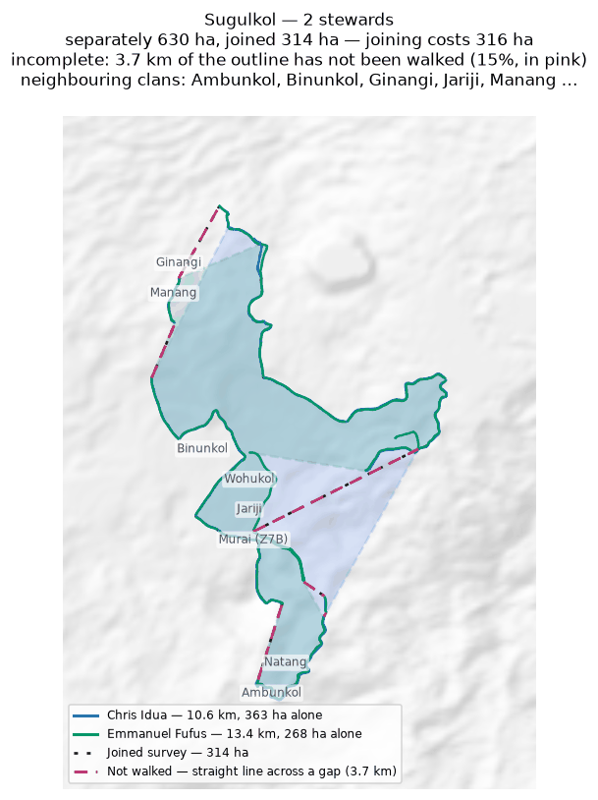
Each steward's line and the area it gives alone (dashed); the survey they combine into, dotted; the stretches nobody walked in pink. Neighbouring clans are named where they lie; their boundaries are not drawn.

Wohukol
Zone 7B · version 1.14, 10 October 2026
Stewards | Surveys | Walked (km) | Access legs (km) | Pieces | Not walked (km) | Parcels | Area (ha) | Basis
2 | 2 | 34.9 | 4.9 | 4 | 8.3 | 3 | 701 | inferred
Clan Stewards
Clan Steward | Tracks | Days | First | Last | Walked (km)
Nelson Runage | 4 | 2 | 2025-11-06 | 2025-11-10 | 17.8
Darline Walele | 5 | 4 | 2025-10-25 | 2025-11-10 | 17.1
Ground also claimed by another clan
Clan | Shared (ha) | % of this clan | Beyond 100 m (ha) | Verdict
Jariji | 62 | 8.8% | 59 | overlap
Binunkol | 29 | 4.2% | 28 | overlap
Sugulkol | 21 | 3.0% | 19 | overlap
Natang | 4 | 0.6% | 1 | overlap
Ambunkol | 3 | 0.4% | 1 | overlap
Ginangi | 0 | 0.0% | 0 | within tolerance
Neighbouring clans
Clan | Boundary walked alongside (km) | % of this clan's line
Natang | 8.8 | 25.1%
Jariji | 8.6 | 24.6%
Ambunkol | 2.2 | 6.2%
Sugulkol | 3.2 | 5.3%
Murai (Z7B) | 1.2 | 1.6%
Abuankol | 0.5 | 0.9%
Binunkol | 0.8 | 0.7%
Ginangi | 0.3 | 0.1%
Marijabimkol | 0.2 | 0.1%
Where the two clans' recorded lines run within 100 m of each other. Two neighbours walking the same edge is the ordinary case.
Sacred sites
None recorded. The Clan Stewards were asked for the outer boundary and the sacred sites; nothing in this clan's files is marked as one.
What the survey shows
- The boundary does not close. 8.3 km in 4 stretches was bridged with straight lines nobody walked — 25% of the distance walked, so 701 ha is an estimate rather than a measured area. On the map those stretches are pink.
- The walks enclose 3 separate parcels, totalling 701 ha. All of them are counted. Whether they are all this clan's land, or whether one belongs to a neighbour, is a question for the clan.
- Joining the 2 stewards costs 574 ha: separately they give 1,276 ha, joined 701 ha. This happens where stewards each walked the same ring rather than different stretches — the two rings cross and the joined network encloses less than either walk did alone.
- Ground here is also inside the area recorded for 5 other clans: Jariji (62 ha); Binunkol (29 ha); Sugulkol (21 ha); Natang (4 ha). These figures are provisional while this boundary is incomplete: the unwalked stretches are drawn as straight lines, and those lines are what the overlap is measured against.
- A further 1 clan (Ginangi) shares ground only in strips narrower than 100 m — the two lines being the same line, which is not counted as overlap.
Queries for the field
- 25% of this outline was not walked — 8.3 km of straight line, shown in pink. Does the boundary in fact run along those straight lines, or somewhere else? Can the missing stretches be walked?
- This clan's land is recorded as 3 separate pieces. Is that right, and does each piece belong to this clan?
- Did the 2 stewards walk the same boundary, or different parts of it? If they walked the same ring, their surveys should be treated as separate accounts rather than joined.
- This boundary is recorded in 4 separate pieces. Were the connecting stretches walked but not recorded, or not yet walked?
To take back to the ground
A GPX file for this clan is supplied as Wohukol_Zone_7B.gpx. Loaded onto the phone or handheld the boundary was mapped with, it shows the stewards' own tracks, the 4 gaps drawn as straight lines, and a waypoint at each end of every gap so a steward can navigate to where the walking stopped and carry on.
Map
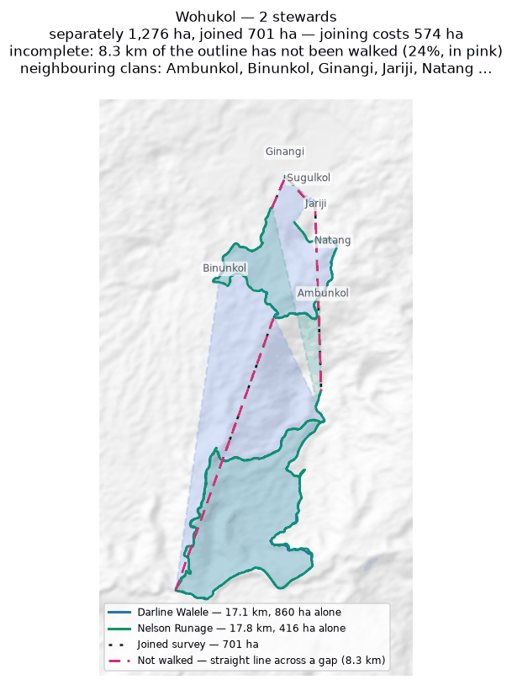
Each steward's line and the area it gives alone (dashed); the survey they combine into, dotted; the stretches nobody walked in pink. Neighbouring clans are named where they lie; their boundaries are not drawn.

Zone 8

Duribip
Zone 8 · version 1.14, 10 October 2026
Stewards | Surveys | Walked (km) | Access legs (km) | Pieces | Not walked (km) | Parcels | Area (ha) | Basis
1 | 1 | 4.5 | 0.2 | 3 | 5.9 | — | none | no area
Clan Stewards
Clan Steward | Tracks | Days | First | Last | Walked (km)
Beven Naive | 4 | 2 | 2025-07-11 | 2025-07-21 | 4.5
Neighbouring clans
Clan | Boundary walked alongside (km) | % of this clan's line
Riribudeh | 0.5 | 5.4%
Madukol | 0.0 | 0.4%
Where the two clans' recorded lines run within 100 m of each other. Two neighbours walking the same edge is the ordinary case.
Sacred sites
None recorded. The Clan Stewards were asked for the outer boundary and the sacred sites; nothing in this clan's files is marked as one.
What the survey shows
- No area can be given. The tracks are in 3 disconnected pieces and 5.9 km of straight-line joining would be needed to make a ring — 139% of the distance walked. That is beyond the 50% limit, above which an area would be more assumption than survey.
- 5% of this clan's recorded line runs within 100 m of Riribudeh's: the two walked the same edge.
Queries for the field
- Can the missing stretches be walked so this boundary closes? If any gap is deliberate — a river, a road, an agreed open edge — please say what runs along it.
To take back to the ground
A GPX file for this clan is supplied as Duribip_Zone_8.gpx. Loaded onto the phone or handheld the boundary was mapped with, it shows the stewards' own tracks, the 3 gaps drawn as straight lines, and a waypoint at each end of every gap so a steward can navigate to where the walking stopped and carry on.
Map
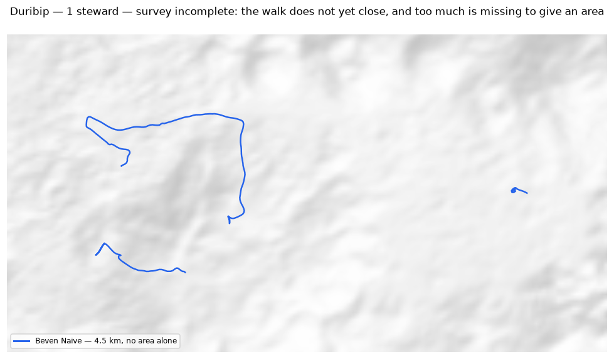
The walk and the area it gives (dotted), with the stretches nobody walked in pink. Neighbouring clans are named where they lie; their boundaries are not drawn.

Dusi
Zone 8 · version 1.14, 10 October 2026
Stewards | Surveys | Walked (km) | Access legs (km) | Pieces | Not walked (km) | Parcels | Area (ha) | Basis
1 | 1 | 33.0 | 7.4 | 4 | 1.9 | 1 | 219 | inferred
Clan Stewards
Clan Steward | Tracks | Days | First | Last | Walked (km)
Max Mamo | 52 | 3 | 2025-06-05 | 2025-06-19 | 33.0
Ground also claimed by another clan
Clan | Shared (ha) | % of this clan | Beyond 100 m (ha) | Verdict
Riribudeh | 7 | 3.0% | 6 | overlap
Gubai | 2 | 0.7% | 0 | within tolerance
Neighbouring clans
Clan | Boundary walked alongside (km) | % of this clan's line
Gubai | 2.4 | 22.4%
Riribudeh | 3.0 | 18.4%
Where the two clans' recorded lines run within 100 m of each other. Two neighbours walking the same edge is the ordinary case.
Sacred sites
None recorded. The Clan Stewards were asked for the outer boundary and the sacred sites; nothing in this clan's files is marked as one.
What the survey shows
- The boundary does not close. 1.9 km in 4 stretches was bridged with straight lines nobody walked — 6% of the distance walked, so 219 ha is an estimate rather than a measured area. On the map those stretches are pink.
- Ground here is also inside the area recorded for 1 other clan: Riribudeh (7 ha).
- A further 1 clan (Gubai) shares ground only in strips narrower than 100 m — the two lines being the same line, which is not counted as overlap.
Queries for the field
- This boundary is recorded in 4 separate pieces. Were the connecting stretches walked but not recorded, or not yet walked?
To take back to the ground
A GPX file for this clan is supplied as Dusi_Zone_8.gpx. Loaded onto the phone or handheld the boundary was mapped with, it shows the stewards' own tracks, the 3 gaps drawn as straight lines, and a waypoint at each end of every gap so a steward can navigate to where the walking stopped and carry on.
Map
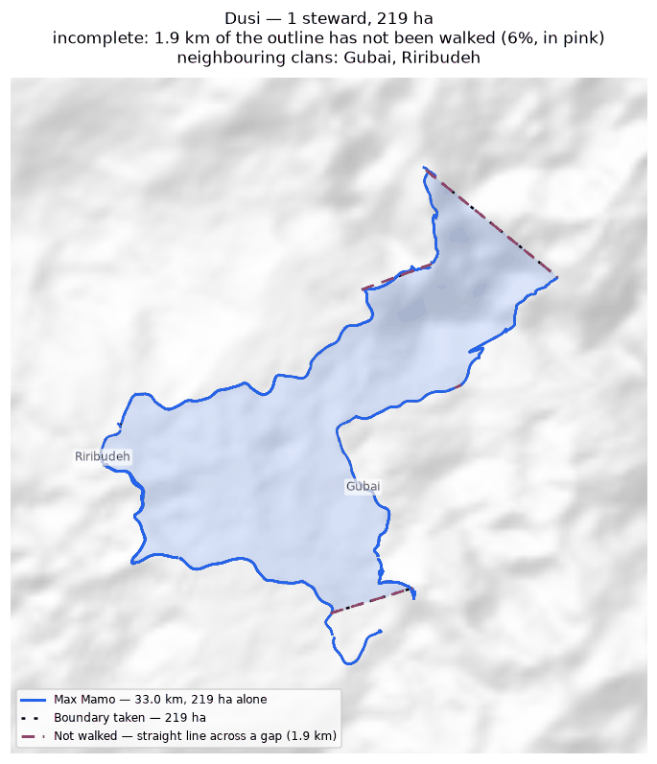
The walk and the area it gives (dotted), with the stretches nobody walked in pink. Neighbouring clans are named where they lie; their boundaries are not drawn.

Gubai
Zone 8 · version 1.14, 10 October 2026
Stewards | Surveys | Walked (km) | Access legs (km) | Pieces | Not walked (km) | Parcels | Area (ha) | Basis
2 | 2 | 134.5 | 0.0 | 7 | 5.0 | 1 | 1,173 | inferred
Clan Stewards
Clan Steward | Tracks | Days | First | Last | Walked (km)
Kenny Noi | 55 | 5 | 2025-05-22 | 2025-07-19 | 91.9
Fordy Igai | 20 | 2 | 2025-05-22 | 2025-06-03 | 42.7
Ground also claimed by another clan
Clan | Shared (ha) | % of this clan | Beyond 100 m (ha) | Verdict
Dusi | 2 | 0.1% | 0 | within tolerance
Neighbouring clans
Clan | Boundary walked alongside (km) | % of this clan's line
Dusi | 2.4 | 9.2%
Where the two clans' recorded lines run within 100 m of each other. Two neighbours walking the same edge is the ordinary case.
Sacred sites
None recorded. The Clan Stewards were asked for the outer boundary and the sacred sites; nothing in this clan's files is marked as one.
What the survey shows
- The boundary does not close. 5.0 km in 7 stretches was bridged with straight lines nobody walked — 4% of the distance walked, so 1,173 ha is an estimate rather than a measured area. On the map those stretches are pink.
- Joining the 2 stewards costs 493 ha: separately they give 1,667 ha, joined 1,173 ha. This happens where stewards each walked the same ring rather than different stretches — the two rings cross and the joined network encloses less than either walk did alone.
- A further 1 clan (Dusi) shares ground only in strips narrower than 100 m — the two lines being the same line, which is not counted as overlap.
- 9% of this clan's recorded line runs within 100 m of Dusi's: the two walked the same edge.
Queries for the field
- Did the 2 stewards walk the same boundary, or different parts of it? If they walked the same ring, their surveys should be treated as separate accounts rather than joined.
- This boundary is recorded in 7 separate pieces. Were the connecting stretches walked but not recorded, or not yet walked?
To take back to the ground
A GPX file for this clan is supplied as Gubai_Zone_8.gpx. Loaded onto the phone or handheld the boundary was mapped with, it shows the stewards' own tracks, the 6 gaps drawn as straight lines, and a waypoint at each end of every gap so a steward can navigate to where the walking stopped and carry on.
Map
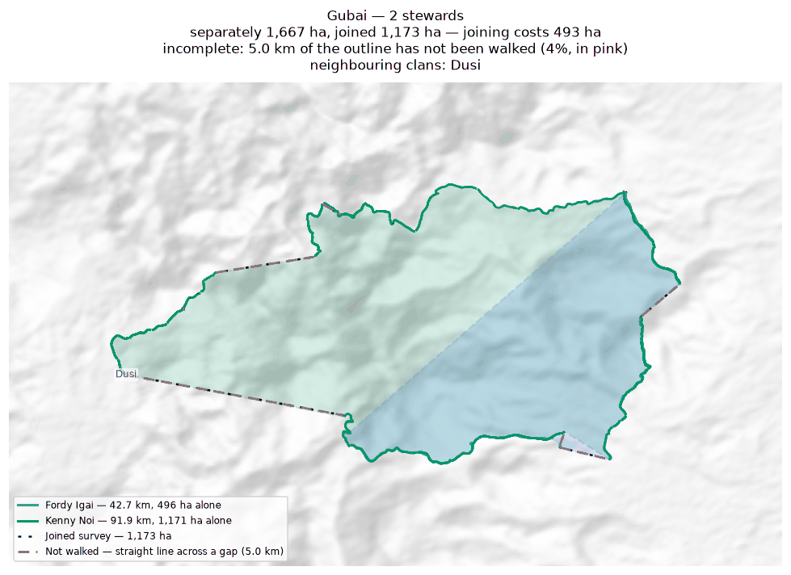
Each steward's line and the area it gives alone (dashed); the survey they combine into, dotted; the stretches nobody walked in pink. Neighbouring clans are named where they lie; their boundaries are not drawn.

Gumuyude
Zone 8 · version 1.14, 10 October 2026
Stewards | Surveys | Walked (km) | Access legs (km) | Pieces | Not walked (km) | Parcels | Area (ha) | Basis
1 | 1 | 16.8 | 3.9 | 7 | 2.3 | 1 | 692 | inferred
Clan Stewards
Clan Steward | Tracks | Days | First | Last | Walked (km)
Philip Igai | 6 | 6 | 2025-05-19 | 2025-06-04 | 16.8
Ground also claimed by another clan
Clan | Shared (ha) | % of this clan | Beyond 100 m (ha) | Verdict
Riribudeh | 4 | 0.5% | 0 | within tolerance
Mungaikol | 1 | 0.1% | 0 | within tolerance
Neighbouring clans
Clan | Boundary walked alongside (km) | % of this clan's line
Mungaikol | 1.8 | 10.7%
Uremkol | 1.8 | 10.2%
Riribudeh | 2.4 | 6.9%
Where the two clans' recorded lines run within 100 m of each other. Two neighbours walking the same edge is the ordinary case.
Sacred sites
None recorded. The Clan Stewards were asked for the outer boundary and the sacred sites; nothing in this clan's files is marked as one.
What the survey shows
- The boundary does not close. 2.3 km in 7 stretches was bridged with straight lines nobody walked — 15% of the distance walked, so 692 ha is an estimate rather than a measured area. On the map those stretches are pink.
- A further 2 clans (Riribudeh, Mungaikol) share ground only in strips narrower than 100 m — the two lines being the same line, which is not counted as overlap.
- 11% of this clan's recorded line runs within 100 m of Mungaikol's: the two walked the same edge.
Queries for the field
- This boundary is recorded in 7 separate pieces. Were the connecting stretches walked but not recorded, or not yet walked?
To take back to the ground
A GPX file for this clan is supplied as Gumuyude_Zone_8.gpx. Loaded onto the phone or handheld the boundary was mapped with, it shows the stewards' own tracks, the 5 gaps drawn as straight lines, and a waypoint at each end of every gap so a steward can navigate to where the walking stopped and carry on.
Map
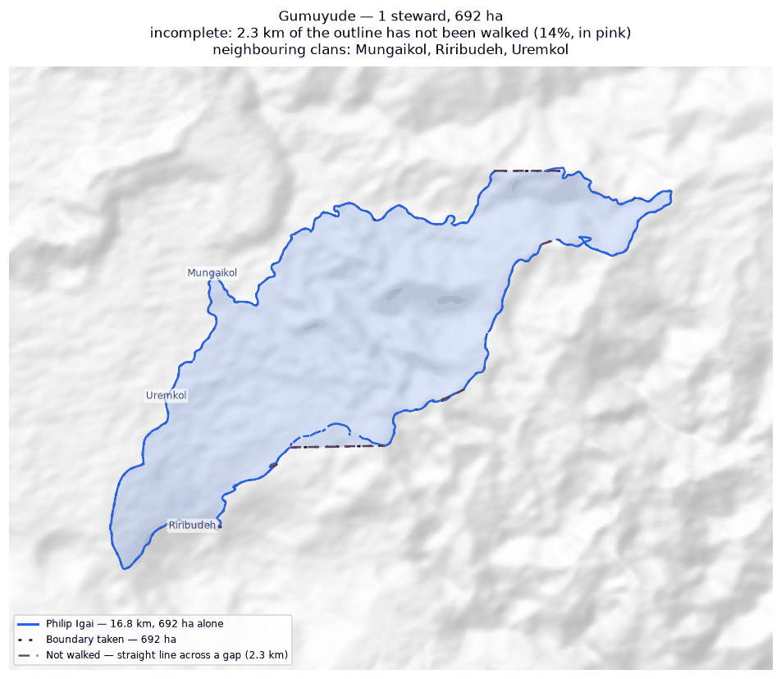
The walk and the area it gives (dotted), with the stretches nobody walked in pink. Neighbouring clans are named where they lie; their boundaries are not drawn.

Madukol
Zone 8 · version 1.14, 10 October 2026
Stewards | Surveys | Walked (km) | Access legs (km) | Pieces | Not walked (km) | Parcels | Area (ha) | Basis
1 | 1 | 1.1 | 0.0 | 2 | 0.3 | 2 | 1 | inferred
Clan Stewards
Clan Steward | Tracks | Days | First | Last | Walked (km)
Gibs Ginave | 5 | 3 | 2025-07-15 | 2025-08-04 | 1.1
Neighbouring clans
Clan | Boundary walked alongside (km) | % of this clan's line
Duribip | 0.0 | 3.9%
Where the two clans' recorded lines run within 100 m of each other. Two neighbours walking the same edge is the ordinary case.
Sacred sites
None recorded. The Clan Stewards were asked for the outer boundary and the sacred sites; nothing in this clan's files is marked as one.
What the survey shows
- The boundary does not close. 0.3 km in 2 stretches was bridged with straight lines nobody walked — 27% of the distance walked, so 1 ha is an estimate rather than a measured area. On the map those stretches are pink.
- The walks enclose 2 separate parcels, totalling 1 ha. All of them are counted. Whether they are all this clan's land, or whether one belongs to a neighbour, is a question for the clan.
- 4% of this clan's recorded line runs within 100 m of Duribip's: the two walked the same edge.
Queries for the field
- 27% of this outline was not walked — 0.3 km of straight line, shown in pink. Does the boundary in fact run along those straight lines, or somewhere else? Can the missing stretches be walked?
- This clan's land is recorded as 2 separate pieces. Is that right, and does each piece belong to this clan?
To take back to the ground
A GPX file for this clan is supplied as Madukol_Zone_8.gpx. Loaded onto the phone or handheld the boundary was mapped with, it shows the stewards' own tracks, the 2 gaps drawn as straight lines, and a waypoint at each end of every gap so a steward can navigate to where the walking stopped and carry on.
Map
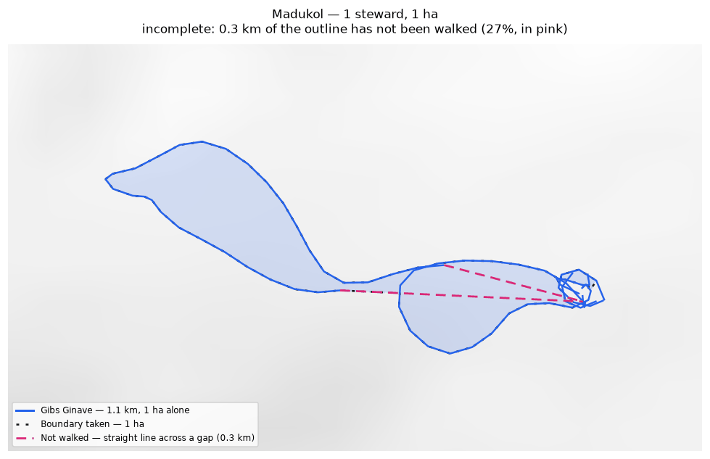
The walk and the area it gives (dotted), with the stretches nobody walked in pink. Neighbouring clans are named where they lie; their boundaries are not drawn.

Mungaikol
Zone 8 · version 1.14, 10 October 2026
Stewards | Surveys | Walked (km) | Access legs (km) | Pieces | Not walked (km) | Parcels | Area (ha) | Basis
1 | 1 | 14.8 | 2.8 | 3 | 2.3 | 1 | 570 | inferred
Clan Stewards
Clan Steward | Tracks | Days | First | Last | Walked (km)
Graham Ekiawa | 5 | 5 | 2025-07-13 | 2025-07-21 | 14.8
Ground also claimed by another clan
Clan | Shared (ha) | % of this clan | Beyond 100 m (ha) | Verdict
Gumuyude | 1 | 0.1% | 0 | within tolerance
Borori | 0 | 0.0% | 0 | within tolerance
Neighbouring clans
Clan | Boundary walked alongside (km) | % of this clan's line
Uremkol | 7.6 | 51.2%
Gumuyude | 1.8 | 12.1%
Borori | 0.4 | 1.5%
Where the two clans' recorded lines run within 100 m of each other. Two neighbours walking the same edge is the ordinary case.
Sacred sites
None recorded. The Clan Stewards were asked for the outer boundary and the sacred sites; nothing in this clan's files is marked as one.
What the survey shows
- The boundary does not close. 2.3 km in 3 stretches was bridged with straight lines nobody walked — 17% of the distance walked, so 570 ha is an estimate rather than a measured area. On the map those stretches are pink.
- A further 2 clans (Gumuyude, Borori) share ground only in strips narrower than 100 m — the two lines being the same line, which is not counted as overlap.
- 51% of this clan's recorded line runs within 100 m of Uremkol's: the two walked the same edge.
Queries for the field
- Nothing outstanding. The boundary closes on its own and the survey is complete.
To take back to the ground
A GPX file for this clan is supplied as Mungaikol_Zone_8.gpx. Loaded onto the phone or handheld the boundary was mapped with, it shows the stewards' own tracks, the 2 gaps drawn as straight lines, and a waypoint at each end of every gap so a steward can navigate to where the walking stopped and carry on.
Map
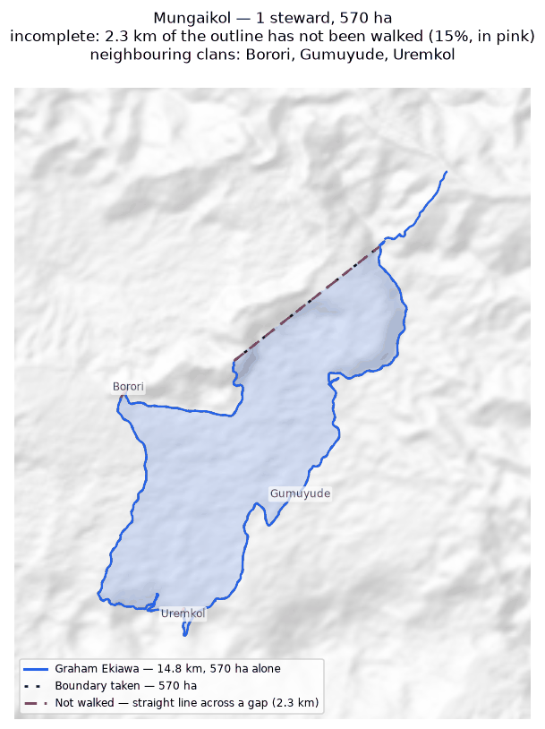
The walk and the area it gives (dotted), with the stretches nobody walked in pink. Neighbouring clans are named where they lie; their boundaries are not drawn.

Riribudeh
Zone 8 · version 1.14, 10 October 2026
Stewards | Surveys | Walked (km) | Access legs (km) | Pieces | Not walked (km) | Parcels | Area (ha) | Basis
2 | 2 | 20.4 | 0.3 | 3 | 1.6 | 1 | 372 | inferred
Clan Stewards
Clan Steward | Tracks | Days | First | Last | Walked (km)
Prut Buitari | 7 | 3 | 2025-07-15 | 2025-07-23 | 10.4
Unido Ose | 28 | 3 | 2025-07-15 | 2025-07-23 | 10.0
Ground also claimed by another clan
Clan | Shared (ha) | % of this clan | Beyond 100 m (ha) | Verdict
Dusi | 7 | 1.8% | 6 | overlap
Gumuyude | 4 | 1.0% | 0 | within tolerance
Neighbouring clans
Clan | Boundary walked alongside (km) | % of this clan's line
Dusi | 3.0 | 14.7%
Gumuyude | 2.4 | 11.6%
Duribip | 0.5 | 2.3%
Where the two clans' recorded lines run within 100 m of each other. Two neighbours walking the same edge is the ordinary case.
Sacred sites
None recorded. The Clan Stewards were asked for the outer boundary and the sacred sites; nothing in this clan's files is marked as one.
What the survey shows
- The boundary does not close. 1.6 km in 3 stretches was bridged with straight lines nobody walked — 8% of the distance walked, so 372 ha is an estimate rather than a measured area. On the map those stretches are pink.
- Joining the 2 stewards costs 398 ha: separately they give 770 ha, joined 372 ha. This happens where stewards each walked the same ring rather than different stretches — the two rings cross and the joined network encloses less than either walk did alone.
- Ground here is also inside the area recorded for 1 other clan: Dusi (7 ha).
- A further 1 clan (Gumuyude) shares ground only in strips narrower than 100 m — the two lines being the same line, which is not counted as overlap.
Queries for the field
- Did the 2 stewards walk the same boundary, or different parts of it? If they walked the same ring, their surveys should be treated as separate accounts rather than joined.
To take back to the ground
A GPX file for this clan is supplied as Riribudeh_Zone_8.gpx. Loaded onto the phone or handheld the boundary was mapped with, it shows the stewards' own tracks, the 2 gaps drawn as straight lines, and a waypoint at each end of every gap so a steward can navigate to where the walking stopped and carry on.
Map
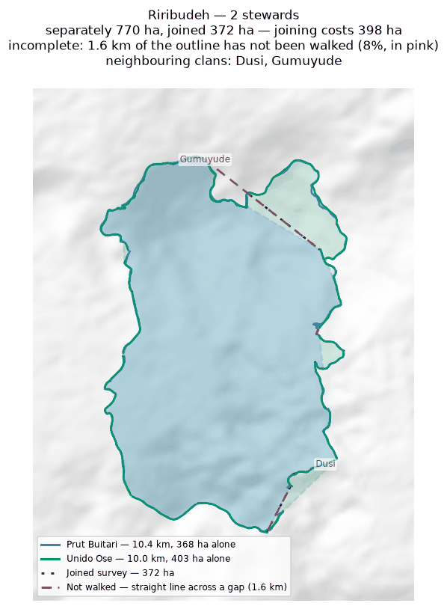
Each steward's line and the area it gives alone (dashed); the survey they combine into, dotted; the stretches nobody walked in pink. Neighbouring clans are named where they lie; their boundaries are not drawn.

Uremkol
Zone 8 · version 1.14, 10 October 2026
Stewards | Surveys | Walked (km) | Access legs (km) | Pieces | Not walked (km) | Parcels | Area (ha) | Basis
1 | 1 | 11.2 | 2.4 | 4 | 6.3 | — | none | no area
Clan Stewards
Clan Steward | Tracks | Days | First | Last | Walked (km)
Cyprian Sirami | 3 | 2 | 2025-07-16 | 2025-07-25 | 11.2
Neighbouring clans
Clan | Boundary walked alongside (km) | % of this clan's line
Mungaikol | 7.6 | 67.2%
Gumuyude | 1.8 | 16.1%
Where the two clans' recorded lines run within 100 m of each other. Two neighbours walking the same edge is the ordinary case.
Sacred sites
None recorded. The Clan Stewards were asked for the outer boundary and the sacred sites; nothing in this clan's files is marked as one.
What the survey shows
- No area can be given. The tracks are in 4 disconnected pieces and 6.3 km of straight-line joining would be needed to make a ring — 58% of the distance walked. That is beyond the 50% limit, above which an area would be more assumption than survey.
- 67% of this clan's recorded line runs within 100 m of Mungaikol's: the two walked the same edge.
Queries for the field
- Can the missing stretches be walked so this boundary closes? If any gap is deliberate — a river, a road, an agreed open edge — please say what runs along it.
To take back to the ground
A GPX file for this clan is supplied as Uremkol_Zone_8.gpx. Loaded onto the phone or handheld the boundary was mapped with, it shows the stewards' own tracks, the 3 gaps drawn as straight lines, and a waypoint at each end of every gap so a steward can navigate to where the walking stopped and carry on.
Map
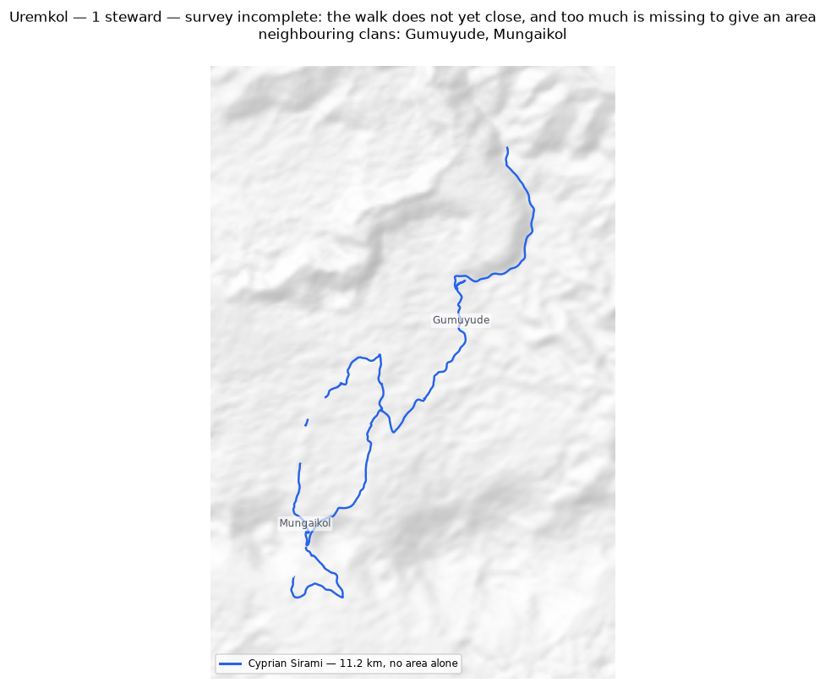
The walk and the area it gives (dotted), with the stretches nobody walked in pink. Neighbouring clans are named where they lie; their boundaries are not drawn.

4. Every overlapping pair
All 54 pairs of clans whose mapped land intersects, strictly and beyond the 100 m tolerance. A pair marked “within tolerance” shares only strips narrower than that, and is not counted as an overlap.
Clan | Clan | Shared (ha) | % of first | % of second | Beyond 100 m (ha) | Verdict
Nituri | Tuoko | 2,199 | 41.7% | 59.8% | 2,198 | overlap
Ambunkol | Natang | 346 | 58.5% | 22.6% | 342 | overlap
Borori | Darekikol | 333 | 52.1% | 56.7% | 329 | overlap
Ginangi | Manang | 312 | 25.2% | 88.3% | 311 | overlap
Asoro | Sukandi | 232 | 6.6% | 12.2% | 231 | overlap
Rondi | Sukandi | 212 | 13.5% | 11.1% | 211 | overlap
Juaiko | Sukandi | 205 | 15.8% | 10.8% | 202 | overlap
Kasaki | Tuoko | 157 | 29.0% | 4.3% | 155 | overlap
Kasaki | Murai (Z2) | 154 | 28.5% | 77.6% | 154 | overlap
Mariura | Naharaura | 149 | 17.3% | 25.1% | 147 | overlap
Manuvoora | Sahirut | 80 | 7.5% | 23.1% | 75 | overlap
Majanko | Manoko | 65 | 23.6% | 16.1% | 65 | overlap
Jariji | Wohukol | 62 | 8.9% | 8.8% | 59 | overlap
Naharaura | Pina Ora | 60 | 10.0% | 7.3% | 59 | overlap
Kasaki | Nituri | 59 | 11.0% | 1.1% | 59 | overlap
Borori | Mariura | 56 | 8.8% | 6.5% | 52 | overlap
Ginangi | Sugulkol | 52 | 4.2% | 16.4% | 51 | overlap
Darekikol | Mariura | 50 | 8.6% | 5.8% | 50 | overlap
Binunkol | Jariji | 45 | 4.4% | 6.5% | 42 | overlap
Kasaki | Majanko | 40 | 7.4% | 14.5% | 39 | overlap
Natang | Sugulkol | 32 | 2.1% | 10.3% | 29 | overlap
Binunkol | Wohukol | 29 | 2.8% | 4.2% | 28 | overlap
Sugulkol | Wohukol | 21 | 6.7% | 3.0% | 19 | overlap
Asoro | Juaiko | 15 | 0.4% | 1.2% | 15 | overlap
Pina Ora | Sahirut | 15 | 1.8% | 4.2% | 13 | overlap
Manuvoora | Pina Ora | 14 | 1.3% | 1.7% | 10 | overlap
Majanko | Tuoko | 13 | 4.5% | 0.3% | 12 | overlap
Juaiko | Manoko | 13 | 1.0% | 3.1% | 7 | overlap
Jariji | Sugulkol | 8 | 1.1% | 2.4% | 7 | overlap
Gariniko | Tuoko | 7 | 6.3% | 0.2% | 5 | overlap
Dusi | Riribudeh | 7 | 3.0% | 1.8% | 6 | overlap
Asingi | Murai (Z2) | 6 | 3.6% | 3.0% | 5 | overlap
Ambunkol | Sugulkol | 5 | 0.9% | 1.7% | 0 | within tolerance
Natang | Wohukol | 4 | 0.3% | 0.6% | 1 | overlap
Asingi | Gariniko | 4 | 2.5% | 3.9% | 3 | overlap
Gumuyude | Riribudeh | 4 | 0.5% | 1.0% | 0 | within tolerance
Gariniko | Nituri | 3 | 3.2% | 0.1% | 2 | overlap
Ambunkol | Wohukol | 3 | 0.5% | 0.4% | 1 | overlap
Manang | Sugulkol | 3 | 0.8% | 0.9% | 0 | within tolerance
Gariniko | Kasaki | 2 | 1.8% | 0.3% | 0 | within tolerance
Mariura | Sahirut | 2 | 0.2% | 0.5% | 0 | within tolerance
Dusi | Gubai | 2 | 0.7% | 0.1% | 0 | within tolerance
Binunkol | Sugulkol | 2 | 0.1% | 0.5% | 1 | overlap
Binunkol | Rondi | 1 | 0.1% | 0.0% | 0 | within tolerance
Gumuyude | Mungaikol | 1 | 0.1% | 0.1% | 0 | within tolerance
Bimkol | Darekikol | 1 | 0.3% | 0.1% | 0 | within tolerance
Ambunkol | Jariji | 1 | 0.1% | 0.1% | 0 | within tolerance
Gariniko | Murai (Z2) | 1 | 0.5% | 0.3% | 0 | within tolerance
Binunkol | Ginangi | 0 | 0.0% | 0.0% | 0 | within tolerance
Jariji | Sukandi | 0 | 0.0% | 0.0% | 0 | within tolerance
Borori | Mungaikol | 0 | 0.0% | 0.0% | 0 | within tolerance
Binunkol | Sukandi | 0 | 0.0% | 0.0% | 0 | within tolerance
Asingi | Kasaki | 0 | 0.0% | 0.0% | 0 | within tolerance
Ginangi | Wohukol | 0 | 0.0% | 0.0% | 0 | within tolerance

How these figures were produced
Setting | Value
Measurement CRS | EPSG:32755 (UTM 55S)
Smoothing | one point every 20 m
Clipped to | within 10 km of the conservation area
Track ends joined within | 25.0 m
Widest gap still given an area | 50% of the distance walked
Overlap tolerance | 100 m
Code revision | 8d59f94
The full method, with every parameter and the reasoning behind it, is in docs/METHODS.md in the project repository. The raw survey data is never edited; everything here is derived from it and can be rebuilt from it.

