Waves of Conservation in Papua New Guinea
From circumstance, to imposition, to transaction — and towards consent
A background paper for the Practitioner Symposium
“Conservation in the Context of Customary Land Ownership in Papua New Guinea” — Popondetta, Oro Province
Prepared by CIFOR–ICRAF Papua New Guinea for the Managalas and Oro Province Project (MOPP). This work is delivered under the European Union Forestry, Climate Change and Biodiversity (EU–FCCB) Nexus Programme and is funded by the European Union.
Contents
To build page numbers, open in Word and choose Update Field (right-click the table, or References ▸ Update Table).

1. Introduction: why the history matters
Papua New Guinea is, in a formal sense, one of the least protected of the world’s great forest nations, and in a substantive sense one of the best: it still holds one of the largest expanses of intact tropical forest on Earth, the great majority of it on land its people have never surrendered. Roughly 97 per cent of its land is held under customary tenure (Sekhran 1996), and that extensive standing forest is, in good part, a consequence of that ownership rather than of formal protection. Almost every decision about whether a forest stands or falls rests not with the state but with the clans and families who own it. The country therefore cannot conserve by decree. It can only conserve by consent. That has shaped every attempt to protect nature here for the past half-century, and it is what this symposium exists to confront.
The Kunming–Montreal Global Biodiversity Framework asks every country to bring 30 per cent of its land and sea under effective conservation by 2030. This is Target 3, the commitment now widely known as 30x30 (IUCN 2023). For a state that owns almost none of its own land, it is not a target that can be met by drawing new lines on a map. It requires the willing and informed consent of hundreds of thousands of customary owners, sustained over time. Understanding why some past attempts to win that consent failed, and why a small number have begun to succeed, is the most practical preparation possible for the conversation ahead.
This paper traces conservation in Papua New Guinea as a sequence of overlapping waves. Each was led, in its day, by international conservation thinking, and each broke onto the same distinctive shore: a country whose land belongs to its people rather than its state. The waves carried different theories of how nature might be protected. The first held that protection happened as a by-product of how people already lived; the second, that it could be imposed by the state; the third, that it could be purchased through development; the fourth, and most recent, that it might be built on consent. They are not tidy successive eras. Each left sediment that the next built upon or around, and elements of all four are visible in the field today. Read this way, Papua New Guinea’s experience is a local instance of a global shift, from the exclusionary “fortress” model, through community-based development, towards a rights-based paradigm that puts local people first (Phillips 2003; Mace 2014), refracted at every turn through the fact of customary ownership. The purpose here is not to settle the argument but to be candid about past successes and failures, so that the symposium can turn to the harder question of how to move forward, and to do so with Papua New Guinean examples, several of them from Oro Province itself.
A note on precedent. In September 1997, conservation practitioners gathered at Motupore Island to compare, candidly, what was and was not working. The proceedings, The Motupore Conference: ICAD Practitioners’ Views from the Field (Saulei and Ellis 1997), remain one of the frankest records of practice this country has produced. This symposium stands in that tradition, and draws on Motupore’s testimony throughout.
A note on scope, and on a word. This paper concerns terrestrial conservation. Papua New Guinea’s marine and coastal conservation, including the locally managed marine areas among Melanesia’s real successes, is a parallel story beyond its scope. It also uses the word conservation throughout without ever grounding it in a definition that a community, a practitioner and a donor would each recognise as the same thing. That absence is not an oversight but a live problem, and settling it is, this paper will argue, the first task the symposium must take up (Section 7).
Scope: terrestrial, and why the marine realm matters no less. This paper is about terrestrial conservation: the forests, rivers and customary land that make up the great bulk of Papua New Guinea’s protected estate and all of the cases discussed here. That focus is deliberate, and it is where the symposium’s two days should stay. It is not a judgement about importance. The country’s marine and coastal realm, its reefs, seagrass and mangroves, and the locally managed marine areas that are among Melanesia’s genuine conservation successes, is at least as significant, ecologically and economically, and rests on the same foundation of customary ownership and consent. It is a parallel story, with its own instruments, evidence and lessons, and it deserves a forum of its own rather than a subordinate mention in this one.
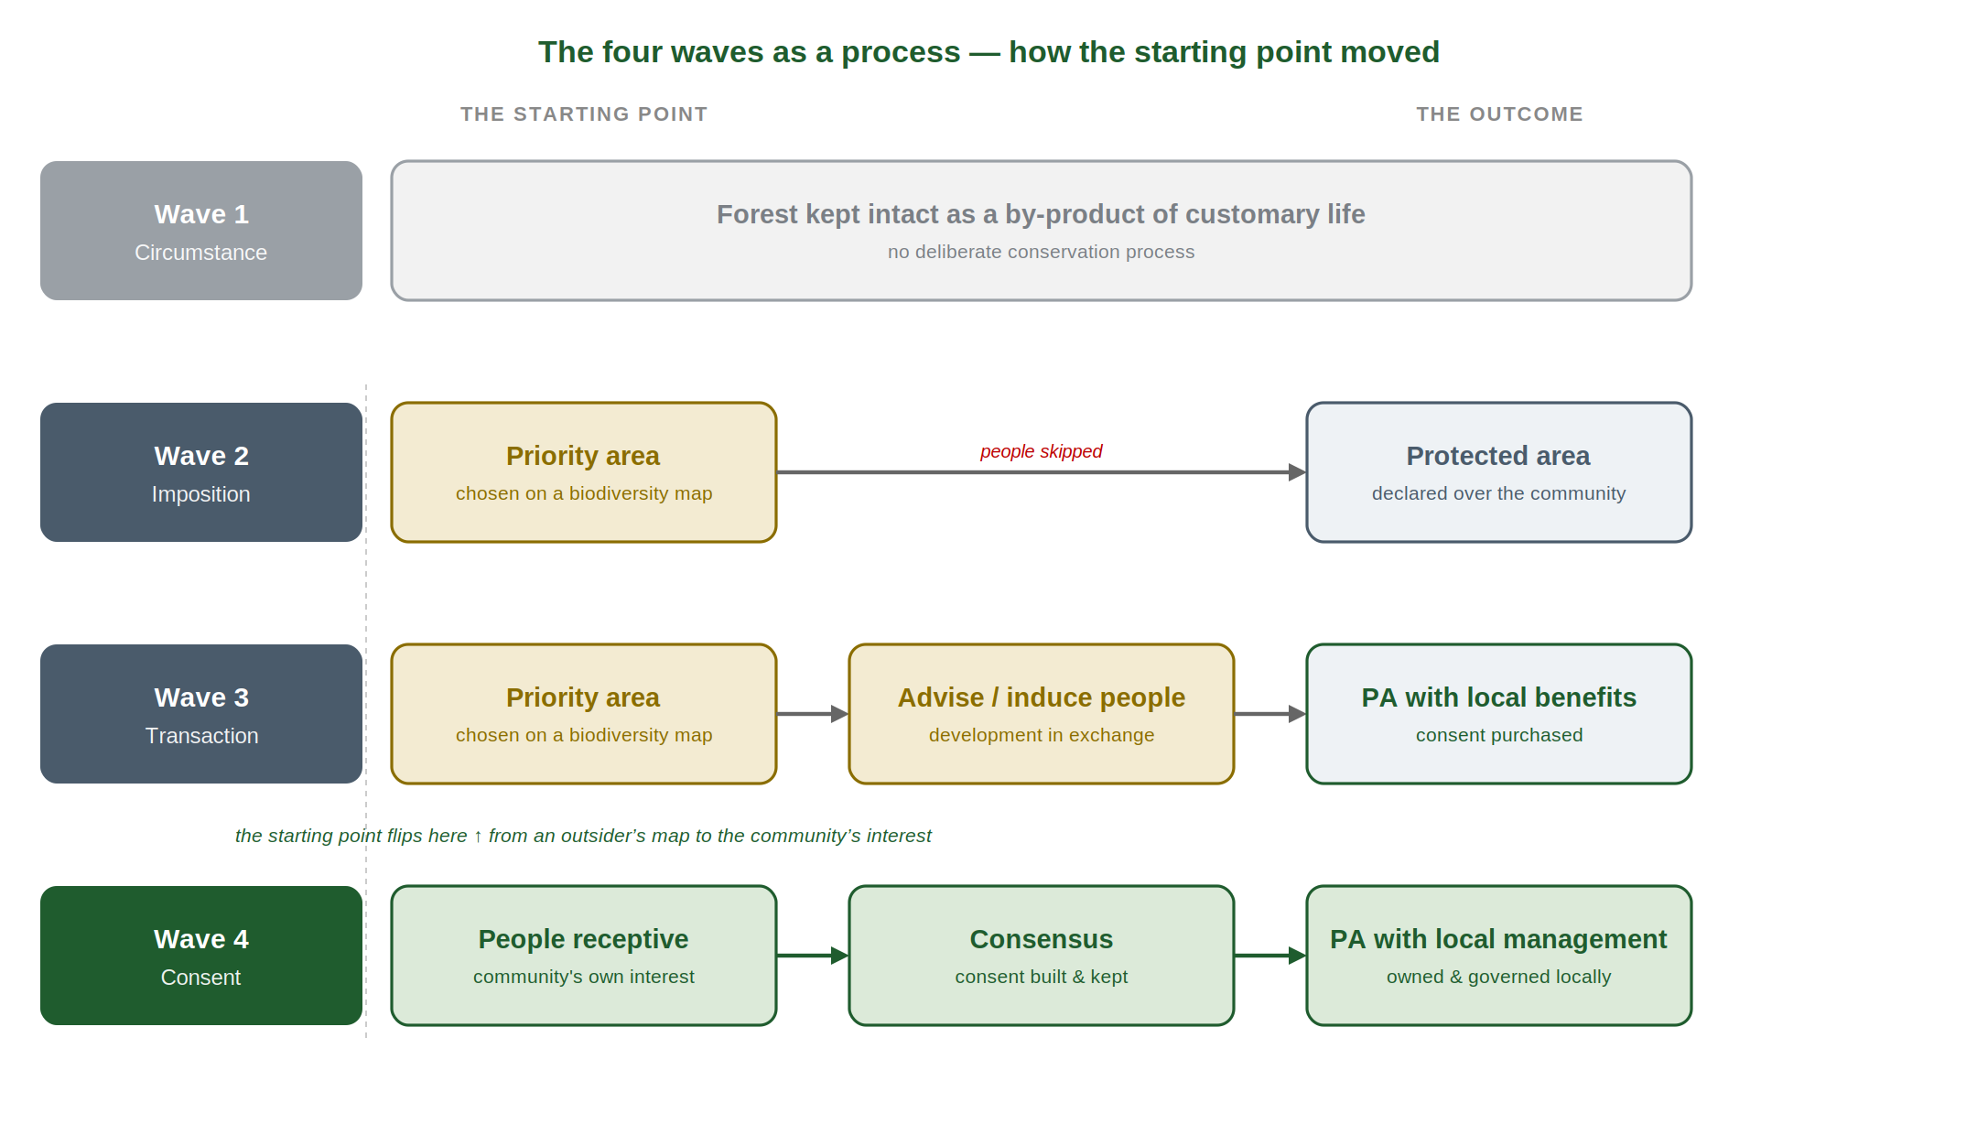
Figure 1. The four waves as a process. The starting point moves from a protected area chosen on an outsider’s biodiversity map (Waves 2–3) to one that begins with a community’s own interest (Wave 4); and the outcome deepens from a bare designation, through one with benefits, to an area under durable local management.

2. Wave One — Conservation by circumstance
Before sustained outside contact, the forests of New Guinea were, by most measures, intact. It is tempting to read that intactness as evidence of a deliberate conservation ethic, and a good deal of well-meaning policy has done exactly that. The evidence does not support it. As Sekhran (1996) and Bulmer (1982) argued, what looked like conservation was for the most part contextually functional rather than intentionally conservationist. Low population densities, a subsistence economy without commercial outlets for timber or wildlife, and the hard territorial discipline of inter-clan relations, including the demographic weight of warfare, together produced a landscape that changed slowly. Forests persisted because the pressures that now consume them did not yet exist.
This distinction matters for reasons that are practical, not merely academic. Customary practices such as reserved sacred groves, seasonal taboos and rotational garden fallows did, and still do, carry real ecological weight. But they evolved to sustain a way of life, not to hold biodiversity at a target level, and the conditions that made them effective (small populations, no cash economy, enforced territorial limits) have largely gone. Filer (2004a) makes the sharper point that the country’s forests are indeed the product of indigenous resource-management regimes refined over forty thousand years, yet warns against collapsing that long history into a claim that pre-contact practice can simply be reactivated to deliver modern conservation outcomes.
The lesson of Wave One is double-edged. Customary knowledge and institutions are genuine assets that any credible approach must build on; but romanticising them, treating ‘traditional’ society as a conservation model waiting to be switched back on, misreads the past. The task is not to restore an imagined equilibrium but to construct a new one under conditions of cash, roads, population growth and logging that the old one never faced.

3. Wave Two — Protected areas by imposition (1970s–1990s)
The first modern conservation wave arrived with the state. From the 1970s, government established national parks and reserves on the classic international model: land set aside, managed by an agency, with people held at the boundary. On customary land the model contained a contradiction it could never resolve: the state owned almost none of the land it wished to protect, so its parks were either small islands on alienated land or depended on customary owners given little reason to cooperate and often not meaningfully consulted. Exclusion from the demarcation of areas the community still owned bred resentment, and resentment bred the very degradation the parks were meant to prevent.
Papua New Guinea’s legislators recognised the problem early and legislated a different path. The Wildlife Management Area (WMA), established under the Fauna (Protection and Control) Act, was a deliberately different instrument: it left ownership and management authority with customary landowners, who set their own rules through a management committee. As Sekhran (1996) observed, the WMA was an attempt to build conservation on customary tenure rather than against it, an idea decades ahead of its international moment, even where implementation later faltered.
At Independence in 1975, the Constitution embedded the same tension in the country’s foundations. Its Fourth National Goal commits the nation to conserve its natural resources and environment for the collective benefit of all and for future generations; the same constitutional order entrenches customary land ownership over the great majority of the country, commonly cited as about 97 per cent. Conservation and customary tenure were written into the national project together, as partners and as a problem to be worked out in practice.
By the mid-1990s the arithmetic of imposition was plain. Sekhran (1996) records that some 13,000 square kilometres (about 2.8 per cent of the land area) held designated protected-area status, and that most of these areas were too small to be ecologically viable. Nor was there money to manage them: gazettal conferred a status but rarely a budget, so most areas existed on paper without the recurrent funding that active management requires. This was no passing impression. A 1999 review had found that 89 per cent of the country’s protected areas had no or minimal management structure, and the 2006 assessment using WWF’s Rapid Assessment and Prioritisation of Protected Area Management (RAPPAM) methodology confirmed a system that was, in effect, not being managed: existing protected areas “were not working”, logging and mining concessions were being declared over the top of them, and no resources were being allocated to their management (Chatterton et al. 2006). Two decades of the state-led model had produced a scattering of paper parks and a hard lesson: on customary land, protection that is imposed rather than owned, and unfunded once declared, does not hold.
This period also planted a habit of thought worth naming, because it has proved remarkably durable. When protection is achieved by drawing a boundary and gazetting it, conservation comes to be imagined as an event, a line secured and a declaration signed, rather than as the ongoing management of a living relationship between people and land. On customary ground, where rights are exercised continuously and renegotiated across generations, a conservation area that is treated as a finished act rather than a standing commitment is already halfway to failure. That confusion between the moment of declaration and the work of management recurs in every wave that follows, and it set the stage for a wave that promised to solve the consent problem by buying it.

4. Wave Three — Conservation by transaction: the ICAD era (1986–2010s)
The Integrated Conservation and Development Project (ICDP), known in its Papua New Guinean legal form as the Integrated Conservation and Development Area (ICAD), was introduced internationally by WWF in the mid-1980s and spread through the country in the 1990s, largely through the UNDP/GEF-funded Biodiversity Conservation and Resource Management Programme. Its logic was elegant and, on paper, irresistible. If customary owners would not conserve for nothing, then conservation would be exchanged for development: schools, aid posts, roads, ecotourism income, small enterprise. Protect the forest, and development would follow. A generation of projects was built on that bargain: the Oro Butterfly Project, Lak, Bismarck–Ramu, Crater Mountain, Kamiali, Kikori Basin and the Hunstein Range among them. Enough have now run their course that their record can be read honestly, and it is the richest source of practical instruction this country possesses.
Before any of these projects reached a village, a more fundamental choice had already been made: where to work. The answer came not from communities but from a map. ICAD sites were chosen for their biodiversity value as judged by outside science: a list of “priority forest areas” of “exceptional biodiversity values… under immediate threat by commercial logging”, formalised nationally in the Conservation Needs Assessment (Alcorn and Beehler 1993). Filer (2004a) named the reasoning the “hotspot mentality”: conservation money should be spent where biodiversity is most abundant and most threatened, and cooperation would then be secured, through the “handouts” of development, from whoever happened to live there. The starting point of an ICAD was thus an outsider’s biodiversity priority, not a community’s wish to conserve, so local interest had to be manufactured after the site was chosen. That single fact, conservation beginning from a map rather than from the people who owned the place, is the root from which most of the failures below grow, and the sharpest line between the ICAD era and what came after.
It is worth pausing on the flaw at the centre of the bargain, because a Papua New Guinean review named it while the wave was still cresting. The very title of Sekhran’s (1996) paper, Pursuing the ‘D’, points at the difficulty: the assumed link between delivering development and achieving conservation was the part that kept failing. Sekhran (1996) saw it plainly: “material incentives alone are unlikely to achieve conservation objectives”, since communities who aspire to more than a project can supply will “either sell out to the highest bidder or increase extraction… beyond sustainable levels”. Non-material, “moral” incentives were needed to reinforce the economic ones. The ICAD wave inverted that advice: it led with the money and left the meaning to look after itself.

4.1 The Oro Butterfly Project — a local case, in this province
No example will be closer to this symposium’s participants than the Oro Butterfly Project, reported at Motupore by two of its own officers, Koneha and Tambari (1997). Established in 1991 by the Nature Conservation Branch of the Department of Environment and Conservation, and incorporated from 1995 with the Oro Provincial Government and AusAID, its object was to sustain a viable population of the Queen Alexandra’s Birdwing Butterfly, the world’s largest butterfly, found only in Oro Province and carried on the provincial flag, in its natural habitat on the Popondetta Plains and the Managalas Plateau. This is the same landscape in which the Managalas Conservation Area would later be gazetted.
Its record is a compact anatomy of the whole ICAD wave. On the success side, Koneha and Tambari (1997) describe tangible, locally-valued gains: an ecotourism guesthouse funded for one landowner, a water well for another, small cash allowances for twelve “landowner conservationists” who monitored the butterfly and reported at six-monthly workshops, and enterprise experiments to build alternative income. On the failure side, they are equally frank: the project could not fund guesthouses for every owner in the ‘hot spot’ without becoming unviable; land-tenure disputes had to be resolved by the parties before the project could even engage; manpower to monitor the butterfly was chronically short; and, most tellingly, a “cargo cult mentality” took hold on the Managalas Plateau, where the project was imagined as a multi-national operation that ought to deliver large-scale investment overnight. The mismatch between what a conservation project could realistically provide and what a development bargain had led people to expect is the single thread that runs through every case in this section.

4.2 Lak, New Ireland — when logging out-runs conservation
The Lak project in southern New Ireland is the era’s most fully documented case, evaluated at length in Race for the Rainforest (McCallum and Sekhran 1997). Its account is unusually candid. Because Lak was an ICAD, it centred on a development alternative to logging, a community sustainable-forestry enterprise, but a commercial logging operation was already under way, and the resource base for the sustainable option “diminished rapidly” as a result. The project “turned out to be unviable and did not result in the establishment of a conservation area” (McCallum and Sekhran 1997). Conservation, offered as a slower and smaller return, simply could not out-compete the cash and speed of the chainsaw.
The evaluators’ framing is instructive: the result was negative but the outcome positive, because the lessons were documented so thoroughly that they could travel. Chief among them, that a development inducement cannot compete with logging already under way, and that consent must be built before a project is designed rather than purchased after, fed directly into the participatory method later trialled at Bismarck–Ramu.

4.3 Bismarck–Ramu — from failed project to a different model
Bismarck–Ramu began within the same programme and, in its first incarnation, embodied its characteristic errors. Filer (2000) records the founding scene with some irony: an expert task force that helicoptered into the area, “decamped… with a vague promise to return with a map”, and never came back. What made Bismarck–Ramu significant is what its practitioners did next. They abandoned the delivery-of-development template in favour of a slower method built around what they called genuine community conviction, engaging communities in deciding whether they wanted conservation at all, before anything was offered or built.
Out of that shift came an institution rather than a project. Anderson (2005) documents how the effort gave rise to the Bismarck Ramu Group (BRG), a Papua New Guinean organisation that broke away to pursue community partnership and self-reliance, rejecting the idea that conservation should be traded for material handouts and centring instead on empowering communities to decide for themselves. The donor project ended; the BRG endured. It is the pivotal case: the point at which some practitioners stopped trying to buy consent and began trying to build it.

4.4 Crater Mountain — participation, monitoring, and its limits
Crater Mountain, run by the Research and Conservation Foundation with WCS and remembered as the era’s flagship, generated real innovation in community participation and monitoring, reported first-hand at Motupore (Saulei and Ellis 1997). Yet Filer (2004a) uses it to show the era’s recurring weakness: the “cooperative endeavour” often stayed superficial, each side holding a different, unspoken theory of what it was for. Communities read the project as another kind of developer, a source of goods, while staff read it as a shared mission. When the goods slowed, so did the cooperation.

4.5 Kamiali and the common pattern of failure
The Kamiali experience in Morobe (Zibe-Kokino and Girard 1997) rounds out a picture whose regularities are by now unmistakable. Across the cases the same mechanisms recur: development inducements bred cargo-style expectations no project could satisfy; conservation returns could not out-compete timber royalties (Filer 2004a); cooperation was often superficial and mutually misunderstood; communities slid into dependency; and younger people, drawn towards cash and away from custom, were alienated from both.
Vojtech Novotny (2010) gave the pattern its most uncomfortable formulation, in a paper whose title says almost everything: “Why Forest Dwellers Prefer Loggers to Conservationists.” His point is not that communities do not value their forests, but that without a competitive alternative they will rationally take the logger who pays now over the conservationist who promises later. His remedy, direct payments, a conservation royalty that meets the opportunity cost of foregone logging, reframes the problem as one of honest competition rather than persuasion, and points directly at the financing question this symposium will have to answer.
Papua New Guinea’s disappointment was not unique. By the time the ICAD wave crested, conservation scholarship globally had conceded that the celebrated “win–win” of conservation and development was an assumption, not a demonstrated result; Fisher and colleagues (2008), in a landmark IUCN synthesis, warned that trade-offs are real and their costs too often “borne by the” local poor. The local cases above are less a record of Papua New Guinean failure than a well-documented chapter in a worldwide learning curve.
A boundary worth drawing. It should be stated plainly, because it is often blurred: the Managalas Conservation Area is not an ICAD. It did not arise from a donor project offering development in exchange for protection. It was built under the Conservation Areas Act through a consent process that preceded, rather than followed, any project design, which places it in the wave described next, not this one. The distinction is temporal as well as legal: the Oro Conservation Project of the 1990s did not itself gazette anything; Managalas was gazetted only in 2017, two decades later, a reminder that on customary land secure conservation is the slow outcome of a consent process, not the deliverable of a project cycle.

5. Wave Four — Towards conservation by consent (2009–present)
The current wave is defined less by a new technique than by an inverted sequence. Where the ICAD offered development first and hoped consent would follow, the emerging model treats consent as the foundation on which everything else is built, and it is being carried, increasingly, by Papua New Guinean institutions rather than foreign projects. In practice it begins with an act of communication: telling communities, broadly and without steering, that conservation is an option they may choose for their own land, and then letting those who are interested come forward, rather than selecting them from a map. Three landmarks mark the shift.
The YUS Conservation Area (Morobe), gazetted in 2009 as the country’s first Conservation Area under that instrument, showed that a durable, community-owned protected area could be assembled by long, patient consent-building led by an organisation, the Tree Kangaroo Conservation Program, embedded in the community over many years. Its architects are candid that the country still has “few proven models”, and that field projects are best understood as “working experiments” rather than finished templates (Beehler and Kirkman 2013).
The Managalas Conservation Area, gazetted in 2017 under the Conservation Areas Act 1978 and covering 214,696 hectares of Oro Province, is the largest expression of this approach. It was the product of some thirty years of consent-building among the customary owners of the plateau, led by Partners with Melanesians and supported over the long term by the Rainforest Foundation Norway. Its defining feature is precisely the one the ICAD era lacked: the agreement of the landowners came first, and the legal area followed from it. It is offered here as both the largest expression of consent-led conservation and, as the next paragraphs make plain, the clearest illustration of its central risk.
Indigenous-led models have matured alongside these. The Mount Wilhelm–centred community conservation of MENCERTC in Simbu, recognised with a UNDP Equator Prize in 2022, and the conservation deeds now spreading among Papua New Guinean landowners, voluntary, legally-binding contracts by which clans place their own land off-limits to logging and mining without surrendering it into a state protected-area category, show landowners and Papua New Guinean organisations designing and holding conservation on their own terms. Zeriga and Jimbudo (2024) describe why clans increasingly prefer the deed to gazettal: the process is led by the community; the rules are made and policed locally, which they call “more effective governance”; the contract is written “in a language that the community can understand”; and the mapping it requires validates clan boundaries in the bargain. It began with Wanang in Madang in 2000, where eleven clans banded together to refuse logging; such areas are now forming, on their reckoning, at about 1.5 a year. The deed’s honest limit is the one a funder would press: the approach is, as they say, “yet to be documented and evaluated”. Running through all of them is a quieter continuity with Wave One: the recognition, as Sheil, Boissière and Beaudoin (2015) put it, that local people are the “unseen sentinels” who actually monitor and control these landscapes, and that formal conservation succeeds only where it works through, rather than around, that local authority.
It is worth being candid about how these cases arise, because none is the clean archetype the label “Wave Four” implies. Most began targeted, around a single flagship species, and broadened only later. YUS and the Torricelli programme both grew from tree kangaroos (the Tenkile that gives the Tenkile Conservation Alliance its name); the Oro Butterfly began with the Queen Alexandra’s Birdwing. Torricelli is instructive twice over: some fifty villages and thirteen thousand landowners have consented to a conservation area of roughly 1,250 square kilometres, yet the proposal, first lodged in 2008, remains ungazetted, held up not by the communities but by the logging politics around them. Only Managalas began from land rights rather than a species, and even it matured over some thirty years. Wave Four is less a finished template than an evolving trajectory, which is why the recognition question, below, is the sharper one.
It would be premature to call these successes. YUS and Managalas are young, gazetted in 2009 and 2017, and their durability is unproven; the 2017 national assessment found management across the system still “patchy and problematic” (Leverington, Peterson and Peterson 2017). They are best read not as proof that the consent model works, but as the most promising evidence so far that it might: a hypothesis this symposium is convened to test, not a finding to be reported.
There is a harder candour still, and it goes to the centre of what this symposium must weigh. The consent model has now been pursued for the better part of two decades, and it has not yet delivered the shared conservation vision it takes for granted. The project’s own experience in the Managalas Conservation Area is instructive, and is offered here as evidence for the debate rather than as complaint: the clans genuinely consented, refusing logging, mining and oil palm across 214,696 hectares, but what they consented to was the protection of their customary land and the pursuit of development on their own terms, not a conservation programme as an outside agency would define one. Consent to keep the forest standing is not the same as agreement on why it should stand, or on what is being conserved and for whom; and where those visions are never reconciled, the agreement comes under strain as the years pass and the expected benefits are slow to arrive. This is not a Managalas problem. It is the structural risk of a model that can secure a decision without securing a shared purpose behind it.
The recent spread of conservation deeds should be read in that light. A deed is, in truth, closer to recognition than to consent: it records and formalises a decision a community has already reached for its own reasons, rather than building a new agreement from a blank sheet. That is its strength, and also its limit. As presently constituted a deed does not, by itself, produce the durable, bounded and governed protected area that the 30x30 accounting, and the long-term funding that follows from it, currently require. The distance between a recognised local decision and a fundable protected area is not a detail; it is one of the central problems the symposium inherits, and it is where the question of a fifth wave, taken up below, begins.
The legal architecture has now caught up with the ambition. The 2014 Policy on Protected Areas set the framework, five pillars for a national system, and the Protected Areas Act 2024 gave it statutory force, establishing a national Protected Area Network and a Biodiversity and Climate Fund and aligning the country with the 30x30 commitment. It repeals the earlier Conservation Areas Act 1978 and the Fauna (Protection and Control) Act rather than replacing them instrument for instrument, providing transitional and savings arrangements and a five-year window for existing protected areas to be brought onto the new Protected Area Network Register (Protected Areas Act 2024, Part IX). The gap it must close is stark. Formal protected-area coverage stood at about 2.8 per cent of the land in the mid-1990s (Sekhran 1996) and, on the most recent national figures, has crept only to around 4 per cent, some 61 areas, more than nine in ten of them Wildlife Management Areas (Melick et al. 2012), well short of the 30 per cent that Target 3 envisages for 2030. And that is merely designated area; the share under genuinely effective management is far smaller, put by Zeriga and Jimbudo (2024) at under 1 per cent. The distance between a few effective per cent and thirty is not an incidental shortfall to be made up with a few more gazettals. On land that is 97 per cent customary, it is a structural challenge that can only be met one act of consent at a time.
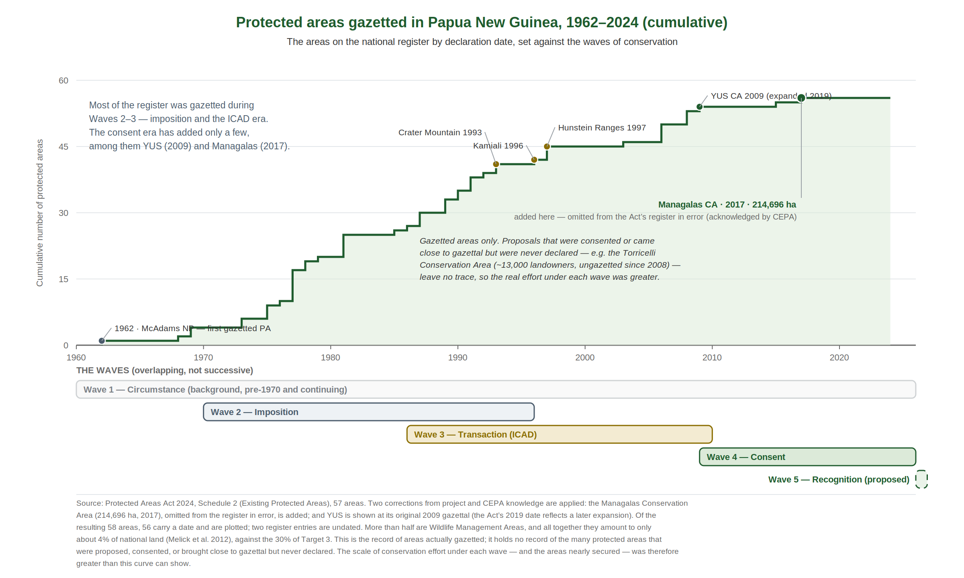
Figure 2. Protected areas gazetted in Papua New Guinea, 1962–2024 (cumulative), from the Protected Areas Act 2024 register, set against the waves of conservation. Most of the estate was gazetted during the imposition and ICAD eras; the consent era has added only a few. The register records only areas actually gazetted, not the many that were proposed, consented or brought close to gazettal but never declared, so the real effort under each wave was greater.
Coverage, in any case, is only half of what Target 3 asks. It calls for conservation that is effective, and effectiveness is precisely where the global record is weakest: Leverington and colleagues (2010), synthesising more than 8,000 assessments worldwide, found that around 40 per cent of protected areas had major management deficiencies. Papua New Guinea is no exception. The most recent national assessment, Leverington, Peterson and Peterson (2017), applying a locally adapted tracking tool (the PNG-METT) to the country’s 57 gazetted protected areas, put it starkly: “while protected areas were established on paper, their management has remained patchy and problematic”. Establishment was “by far the strongest theme, with resource management the weakest”; and most of the recommendations of the 2006 RAPPAM study had gone unimplemented, several areas having since been wholly or partly cleared and lost much of their value; forest loss inside many Wildlife Management Areas has run no lower than outside them (Melick et al. 2012). That is, in current data, the clearest possible restatement of the problem this paper has traced: Papua New Guinea has become reasonably good at the event of declaring a protected area, and remains weak at the long management that is supposed to follow. Reaching 30x30 by adding hectares while that gap persists would enlarge the map without protecting much more forest.
Consent, moreover, is not a signature but a relationship sustained for decades, and sustaining it costs money. Here Wave Four still shares a difficulty with Wave Three: a landowner who agrees not to log has foregone a real income, and unless that opportunity cost is honestly met the agreement will erode as the ICAD bargains did. Novotny’s (2010) conservation royalty, payment for ecosystem services, and the Biodiversity and Climate Fund under the Protected Areas Act 2024 are all attempts at an answer. The unresolved question is whether any can deliver reliable, long-term finance to hundreds of thousands of owners, the difference between consent bought once and consent kept.
[ Placeholder — to be completed by Lester Seri. A short account of the emerging national conservation-finance architecture — the Biodiversity and Climate Fund and the BIOFIN (Biodiversity Finance Initiative) process — and what a shift from project-by-project finance towards a national financing system would mean for customary landowners. Detail and sourcing to be supplied. ]
Table 1. The waves of conservation in Papua New Guinea: tools and outcomes. The fifth row is left open deliberately — its tools and expected outcomes are for the symposium to agree.
Wave
Theory / starting point
Main tools & instruments
Outcomes
1 — Circumstance
Protection as a by-product of how people lived
None deliberate: customary practice (sacred groves, taboos, fallows), low population, subsistence economy, territorial limits
Extensive intact forest persisted — most of what still stands — but as a by-product, not an achieved outcome
2 — Imposition (1970s–90s)
The state sets land aside and manages it
National parks and reserves; Wildlife Management Areas (Fauna (Protection and Control) Act); 1975 Constitution, Fourth Goal
~2.8% designated by the mid-1990s, mostly too small; ~89% with no or minimal management (1999); “paper parks” — but the WMA established the community-tenure principle
3 — Transaction (ICAD, 1986–2010s)
Development exchanged for conservation
ICAD/ICDP projects; development inducements; Conservation Needs Assessment site selection; UNDP–GEF funding
Few durable protected areas; cargo expectations; could not out-compete logging. Legacy: the Bismarck Ramu Group, a documented body of lessons, and partial local gains
4 — Consent (2009–present)
Consent is the foundation, built first
Conservation Areas Act 1978 gazettal (YUS, Managalas); conservation deeds; FPIC; 2014 PA Policy; Protected Areas Act 2024; payment for ecosystem services
First gazetted Conservation Areas (YUS 2009; Managalas 2017, 214,696 ha). Coverage ~4%, under ~1% effectively managed; consent secured but the shared vision not yet delivered
5 — Recognition? (proposed)
Recognising what the first wave still holds
To be defined by the symposium — candidate tools: OECMs, participatory mapping, recognised community-conserved areas, and private-sector and sub-national instruments
To be defined by the symposium

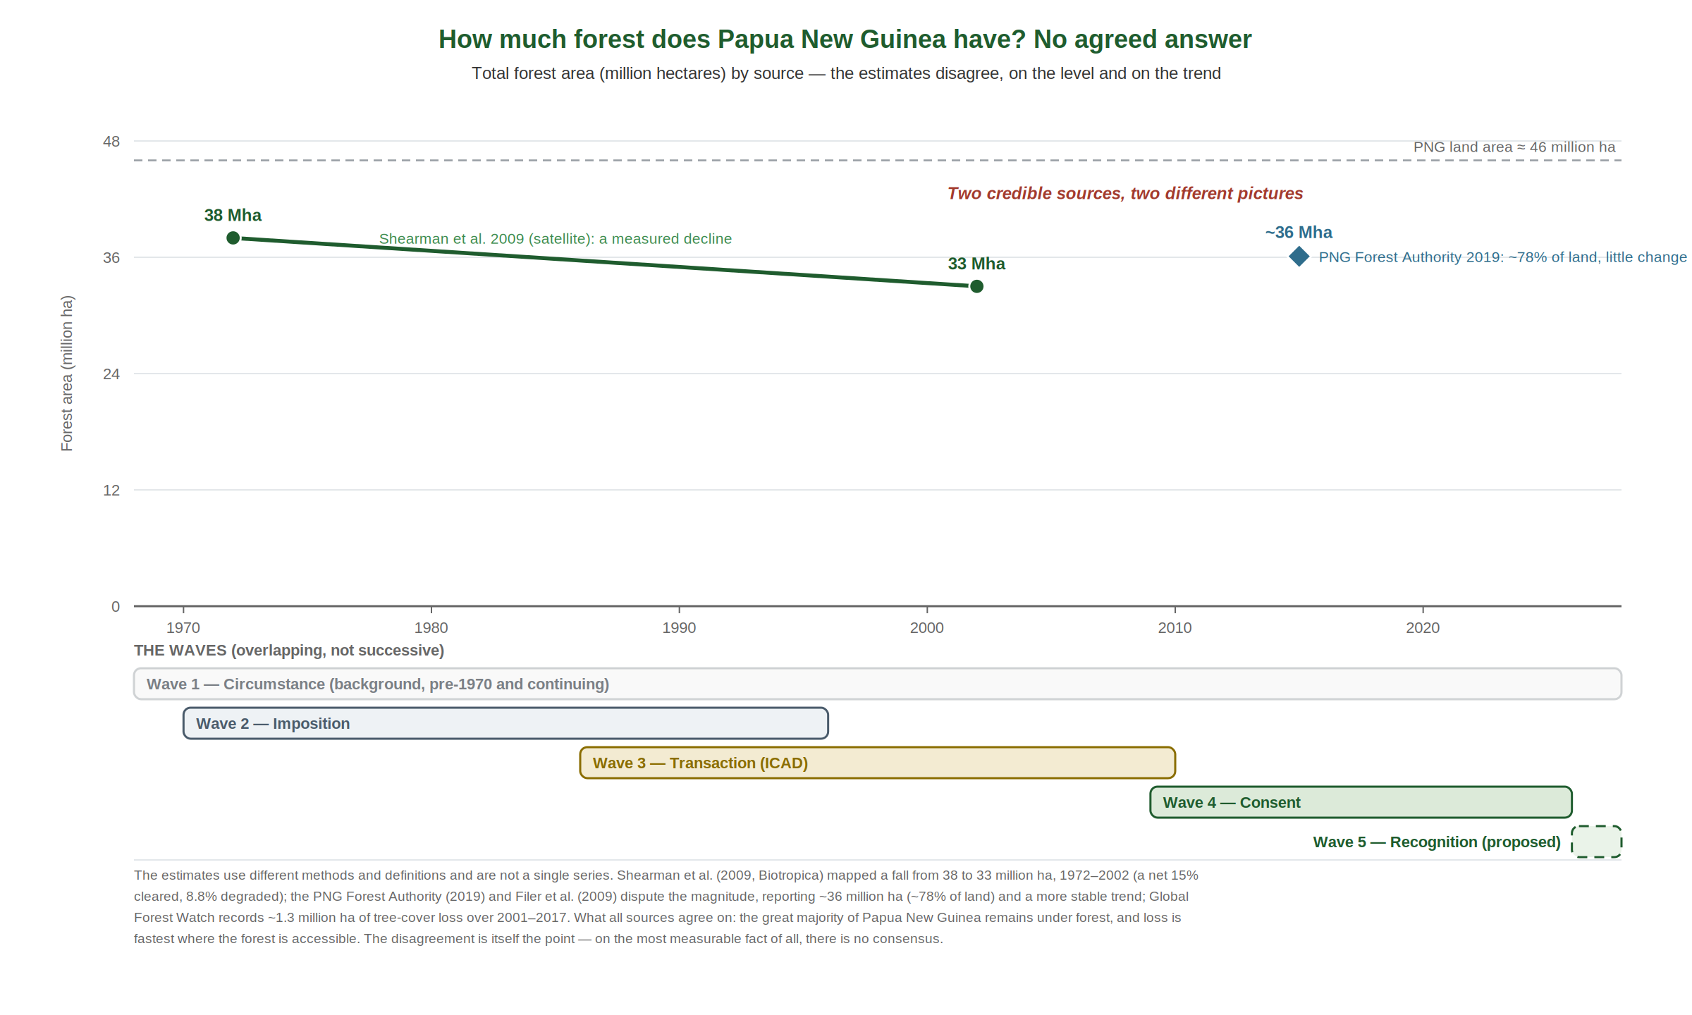
Figure 3. How much forest does Papua New Guinea have? Competing national estimates, set against the waves. Shearman et al. (2009) mapped a decline from 38 to 33 million ha, 1972–2002; the PNG Forest Authority puts it at ~36 million ha and broadly stable. The sources disagree on both level and trend — on the most measurable fact of all, there is no consensus.
Notice what that disagreement means. The most measurable fact about the country’s environment — how much forest it has, and whether that is shrinking — has no agreed answer; two credible sources give two different pictures. If even the easiest, most countable question cannot yet be settled, it is a plain warning about the harder ones this paper now turns to: what conservation is, what 30x30 should mean here, and who decides. Data matters, and better data would help. But it matters less than what is actually on the ground, the forests that still stand and the people who hold them, and it is to that ground, and to who is responsible for what upon it, that we now turn.

6. The ground the future stands on
Any honest account of what conservation must become in Papua New Guinea begins from the realities of the country it serves. The population is young and growing. Formal, salaried employment reaches only a minority; for most citizens a livelihood is drawn directly from the land: gardens, hunting, cash crops, and the sale of timber and other resources. And the national aspiration, widely shared, is for more: more agriculture, more roads, more infrastructure, more of the services that growth is expected to bring.
These are not obstacles but the legitimate conditions of national life, and the development agenda names them plainly. Conservation is written into that agenda, from the Fourth Goal of the Constitution, through Vision 2050, the Development Strategic Plan 2010–2030 and the National Biodiversity Strategy and Action Plan 2019–2024, which records the country’s own target of placing five per cent of its land under protected areas, a target it has not met, and which is now being revised for 2025–2030 to align with the Kunming–Montreal framework (its national targets not yet published at the time of writing), to the current Medium Term Development Plan IV, 2023–2027. But its centre of gravity is unmistakably growth: MTDP IV is subtitled National Prosperity Through Growing the Economy, its headline targets are a K200 billion economy and one million new jobs by 2030, and its Strategic Priority Areas lead with commercial agriculture and the Connect PNG infrastructure programme, with environmental protection eleventh of twelve. Conservation, in the national plan, is present but not paramount.
It helps to see how land-use decisions are actually made. They are settled at the meeting-point of three things: knowledge of what a place is and could be; the needs of the people who live there; and the technical and financial capacity to act. Each sits with a different party. Knowledge is something the conservation effort can supply; providing it is part of the conservation agenda. Technical and financial capacity is largely the government’s to marshal. But needs belong to the community, and they are the least well understood and the least well communicated of the three. A conservation model that cannot hear and represent community needs is missing the very term on which land-use decisions turn.
The implication is direct. Conservation here cannot be posed against development, because the people who own the forests need both, a living from their land and the protection of it; as Melick and colleagues (2012) argue, resource-use decisions here are ultimately political, and any workable approach must be “holistic resource management that includes development”. The future turns on securing the two together, which is why the definition the symposium must settle, taken up next, cannot be one of nature protection alone.
One consequence deserves to be stated plainly, because it inverts the usual order of business, and because it is where this paper parts company with how conservation has been attempted before. Begin by naming the hole, for every wave so far has failed partly by not doing so. Each assumed it knew the problem, and each solved the problem it assumed: the second wave drew the protected area, the third delivered the development incentive, the fourth secured the consent. Each still fell short, because the real need was never stated. The hole these efforts are meant to fill is not conservation. It is the enduring wellbeing of the customary community: a good life lived on and from their own land, a dependable livelihood, health, schooling, secure rights, social order, the continuation of culture, and a healthy environment to hold it all together. Conservation is one part of that, no more.
Name the hole this way and the old failure comes into focus as a failure of expectation. The square peg was conservation made to carry the whole of it: a thing defined, and funded, as an outside donor would understand it, pressed onto communities whose own understanding of it, and whose capacity to deliver it in those terms, were different. A promise the size of the whole hole can only be broken, and it is broken in the way that matters most, not on a ledger but in the eyes of the community, where a shortfall against an oversized promise is felt as betrayal even when something real was delivered. Consent runs on that perception, not on an audit. The first virtue of what follows is therefore not more delivery but honest expectation: each part promising only what it can keep, and the gaps named at the outset rather than discovered at the end.
The way through is to stop asking conservation to be the only peg, and to set it among others, each with a named owner. Conservation, defined narrowly enough to be deliverable, is one peg, held by the landowners and the practitioners who support them, and increasingly by the private sector and by provincial and local-level government where their own lands and laws allow. Infrastructure and basic services are another, and they belong to government, through the national and provincial development budgets, not to conservation. A living from the land is a third, shared among the community, the private sector and development partners. The security of customary rights and boundaries is a fourth. Knowledge of what the land is, and what it could become, is the one part the conservation effort genuinely owns and must supply. Between these pegs there will still be gaps, aspirations no one can meet, chief among them the forms of growth that require clearing the very forest the arrangement exists to keep; naming those gaps plainly, as the agreed limit of what is on offer, holds better than a promise that one peg covers everything.
Some of the most important pegs are not on the land at all. Conservation of a customary landscape does not succeed in isolation from the country around it; it depends on a thriving economy beyond the boundary. Investment in manufacturing and services, the creation of formal jobs, genuine urban development rather than the spread of settlements, home ownership, careers a young person can build: these are nation-building outcomes, the business of the national government, the private sector and development partners, not of any conservation project. Their contribution is quieter but no less vital, for they offer an alternative. Rural smallholder life is honourable and full of meaning, but it is not the only life, and it is not for everyone. An economy that can draw those who wish to leave into formal employment eases the pressure a growing population would otherwise place on the forest, and leaves those who remain on the land doing so by choice rather than necessity. A thriving economy outside the conservation boundaries is not a distraction from conservation; it is one of the conditions of its success.
Unbundling the task this way does not make the problem vanish; it changes its shape, and leaves two kinds of gap. The first lie between the pegs, where they must meet: conservation in place but the road not built, rights recognised but no livelihood to follow. These are not inevitable. They are a coordination problem, and they are where the whole arrangement breaks down if no one holds it together; who coordinates the alliance, and how, is one of the real questions this symposium exists to answer. The second kind sits at the edges: aspirations no peg can meet, because nobody is ever wholly satisfied. These are irreducible, and the mature course is to name and accept them, not to pretend they are closed. One thing more follows, and it is what makes the arrangement durable: a shortfall is now attributable. When a peg fails it can be seen which owner fell short, or where the coordination broke, and that can be put right, rather than the whole structure, and the community’s consent with it, collapsing onto conservation. Failure becomes diagnosable instead of fatal. Only once the shape of the hole and the division of the pegs are agreed does the money question arise, and then in its proper place: the funding is sought, or designed, to fit a conservation that can actually be delivered, never the other way about.
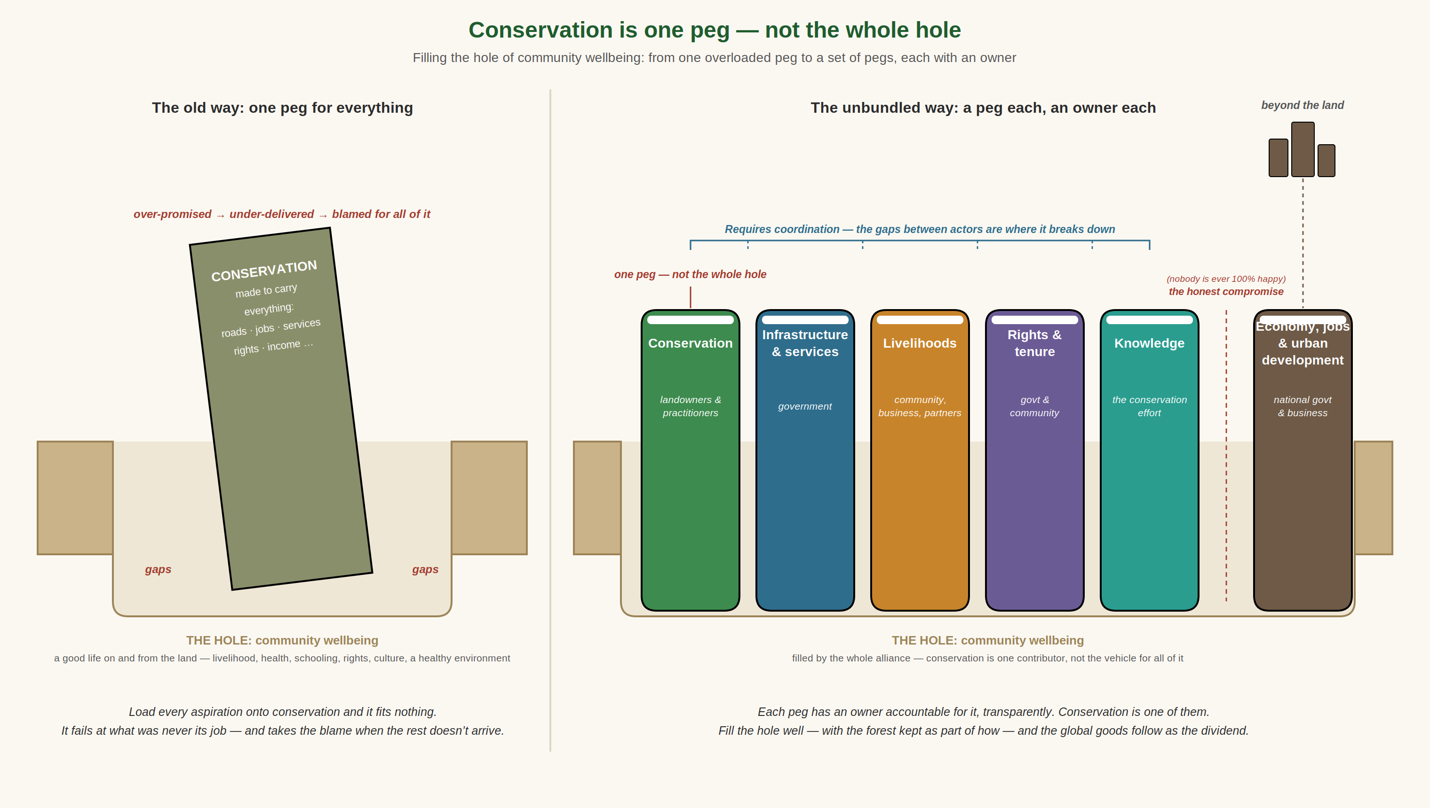
Figure 4. Conservation is one peg, not the whole hole. The old way loads every aspiration onto conservation, which fits nothing and is blamed for the rest; the unbundled way fills the hole of community wellbeing with several pegs, each with an accountable owner, with the coordination between them and the honest residual gaps both named.

7. From the pathway to the questions
The questions that follow are not abstract. They can be read straight off the Wave Four pathway in Figure 1, a receptive community, then consensus, then a protected area under local management, because that pathway is the model this symposium is really convened to test. Each step along it raises a practical question, and one question underlies them all. They fall in a deliberate order: first what is being conserved; then what its effective management requires; then what that costs; and only last how a livelihood flows back to the community that carries it. Purpose comes before method, and method before money. This paper does not attempt to answer the questions. It sets the scene, so that the answers (and, in time, perhaps a shared paper carrying them) belong to the symposium and not to its background reading.
Before a definition, a prior question: what is being conserved? The candidates are not the same thing. Is it forest structure, the standing trees? The biodiversity within them? The carbon they hold? Or the things the forest carries for its owners: their livelihoods, their culture, their language, the traditions and knowledge bound to particular places, the people themselves? International practice has widened its answer over time; the IUCN’s protected-area definition now speaks of nature “with associated ecosystem services and cultural values”, and the new paradigm brings people in (Phillips 2003); yet it still insists that conservation be the primary objective of a protected area, which, as Melick and colleagues (2012) observe, “raises obvious questions as to whether the IUCN notion of protected areas is at all relevant for Melanesia”, where people and land are inseparable. Zeriga and Jimbudo (2024) put the difference from the inside: where the West seeks to conserve “the inherent value of nature”, the Indigenous concern is “to perpetuate the aspects of nature that are useful for survival”, and most Papua New Guineans, still living from the forest, “see conservation as protecting forest resources from overexploitation”. An audience should be walked to a definition, target by target, not simply handed one.
So, what do we actually mean by conservation? This paper has used the word on every page without grounding it, and that is precisely the point. Conservation means very different things to a global donor, a national agency and a customary landowner, and much of the failure traced above began in that unspoken gap. Before the pathway can be walked, the parties must be sure they are describing the same thing: a definition a community, a practitioner and a donor would each recognise and accept. Arriving at it is, this paper argues, the first task of the symposium. As a starting point for that discussion, and no more than a starting point, offered for the symposium to amend or reject, the paper suggests this: conservation in Papua New Guinea is an enduring, community-managed landscape — forest, grassland, mangrove or reef — kept healthy by the people who hold it, through management recognisably their own, in which those communities can thrive. The word enduring is chosen so the landscape may last and adapt, not freeze; the people who hold it because conservation that is not owned does not hold; kept healthy because the test is the state of the land, not the drawing of a line around it; and in which communities can thrive as a condition the whole alliance must meet, not a task conservation performs alone. The definition is written for all of Papua New Guinea’s landscapes and seascapes, so it need not be re-argued for the sea, though this paper develops the terrestrial case. Whether that is the right wording, or even the right idea, is exactly what the participants must decide.
What, then, counts as management “recognisably their own”? Rather than importing a checklist, the symposium might agree a short set of minimum descriptors of effective management, expressed in customary terms: known boundaries, where the community agrees where its landscape begins and ends and the clan boundaries within it are mapped and respected; rules that are owned and kept, with clan land-use rules set, understood and enforced locally; wise and lasting use, so resources are used in ways that can continue indefinitely while still providing a living; knowledge, shared and current, so the community can say what is in the landscape and how it is changing; tradition and tool together, respecting customary practice while adopting appropriate technology to strengthen it; and adaptive care, so management responds to change, slow and sudden alike, rather than assuming the landscape will stay as it is. These are what make effectiveness checkable and owner-legible at once, the rigorous core that the global accounting asks for and that the previous waves never defined. Both the definition and the descriptors are offered here as discussion points, not conclusions: they are for the symposium to settle.
A discipline for the discussion: the what before the how. It will be tempting, once the talking starts, to reach for instruments: a gazettal, a Wildlife Management Area, a conservation deed, an OECM. These are genuinely different tools, and this paper will not pretend they are interchangeable; but neither will it choose among them here, because to do so would put the method before the matter. The instrument is the answer to a question that comes later: once it is clear what is to be conserved, and what the community wants, the appropriate tool is largely settled by that answer. Symposiums have a way of veering into method, into structures, mechanisms and money, before the purpose is agreed. The whole value of these two days rests on holding a razor-sharp focus on one thing: what, for conservation and for the community alike, are we actually trying to do?
A definition that satisfies a community, however, is not automatically one that satisfies a funder. Donors, international partners and the 30x30 accounting require conservation that is bounded (delimited in space) and governed (under a credible, accountable authority). They also, reasonably, want it to deliver measured, reported outcomes (what is the work achieving?); to be lasting, since work that merely monitors a decline is not conservation; to be active and additional, producing a result that would not have happened anyway rather than the mere absence of disturbance; and to be cost-effective, because money that disappears into meetings and administrative structure buys no measurable conservation, and donors know it. Yet the market logic beneath these demands carries its own danger. Henning (2015) shows that direct payments in Melanesia falter when treated as market exchange between self-interested strangers, because landowners understand them as reciprocal obligations within a lasting relationship; to reduce the goals of conservation, as she puts it, to “those of self-interested, cost-benefit rationality” is to misread the ground it stands on. How to hold the two together, capacious enough to be owned locally yet bounded, governed, measured and lasting enough to be funded internationally, is among the questions the symposium must leave open.
At the start of the path: how do communities learn this is an option at all? Wave Four begins not with a chosen site but with a receptive community, and a community cannot choose an option it does not understand. The first practical question is therefore one of communication in two directions. How do conservation practitioners get the message out, broadly and without steering, that conservation is an option available to landowners, something they may choose for their own land, on their own terms? And when a community becomes interested, how does it then approach government, NGOs and funders to register that interest and ask to hear more: is there a ‘front door’ to walk through, and who keeps it open?
At the middle of the path: who decides, and how is consent kept? Consent is not a signature but a standing relationship. Who, within a landowning community, decides, and how is genuine consensus built and then maintained across clans and generations, rather than secured from a few leaders on a single day? And which outside actors (CEPA, provincial governments, NGOs, funders) can accept a genuinely supporting role rather than a directing one? This is the terrain of free, prior and informed consent (FPIC): a principle easier to name than to practise on customary land, and one the symposium should treat as integral to the pathway rather than assumed along it.
Whose consent, and whose benefit? Equity and inclusion within the community. “Community consent” can conceal as much as it reveals, because a community is not a single voice. Within it are women and men, elders and youth, larger clans and minority ones, those present and those away for work, and generations not yet able to speak for themselves. Consent obtained from a handful of senior men on a single day is not the consent of the whole; and benefits captured by the well-placed are not benefits shared. The questions here are practical and unavoidable. How are women, youth and minority clans given a real voice in the decision and a fair share of what flows from it? How is elite capture guarded against, and intra-community conflict worked through rather than papered over? And how is the consent of one generation kept legitimate for the next, whose land it equally will be: an intergenerational consent, not a one-off transaction? A conservation model that cannot answer these has not secured consent so much as a signature. Equity and social inclusion are not an add-on to the pathway; they are the test of whether the consent at its heart is real, and whether the benefits it promises reach the people in whose name it is made.
At the end of the path: from a gazetted area to a managed one. The record is unambiguous that Papua New Guinea is far better at establishing protected areas than at sustaining them (Leverington, Peterson and Peterson 2017). So the question is what management actually means here: its extent and its scope. What must a community-owned area do, and be seen to do, for its conservation to count as active rather than nominal: what monitoring, what rule-making and enforcement, what upkeep of boundaries, what local governance and reporting? The answer matters twice over. It is the difference between a gazetted line and a place genuinely under management; and it is also what makes conservation legible enough to be funded, because no funder will pay for management that cannot be described, shown and verified. Defining that scope, thick enough to be effective and light enough to be afforded, is one of the harder tasks the symposium faces.
And then the cost, and the living it must leave behind. Only once it is clear what is to be conserved, and what managing it requires, can money be discussed in the right order: first what effective management costs, and then how a livelihood, an income, reaches the community that carries it. Two disciplines matter here. The payment cannot be payment for nothing. A landowner who forgoes logging has given up a real income, and that opportunity cost must be honestly met; but meeting it by paying people simply to leave the forest alone breeds the dependency and passivity that helped undo the ICAD bargains. The durable form is payment structured around activities and deliverables that can be identified, done and paid for: the work of monitoring, mapping and upkeep, and the building of real livelihoods from the standing forest, so that the money buys conservation and builds an economy at the same time. The distinction the symposium should hold on to is between compensation, which pays for a loss, and livelihood, which builds something that lasts; between renting a community’s restraint and investing in its future.
Across the whole path: is this genuinely new, and can it scale? Two questions hang over the entire pathway. Is it truly different from the ICAD transaction, or the same bargain in more respectful language, and what, concretely, makes consent-led conservation more durable than the development bargain it replaced? And could this path be walked not once but hundreds of times, across a customary-owned country, to approach the 30x30 target, or does reaching thirty per cent demand something the model does not yet have? And if it can be repeated, can it be repeated more cheaply, and does the unit cost fall as the approach is learned and the systems are built once and reused? Probably it does, but only so far: the expensive, unhurried part is the consent itself, and each community needs its own way, and its own time, to reach a decision that cannot be rushed without breaking it.
Over a changing climate: conservation for a moving target. Every question so far assumes the landscape being conserved will stay roughly as it is; it will not. A protected area is a boundary drawn around a place at a moment in time, but the forests, species and water it is meant to hold are already shifting as the climate changes: rainfall less predictable, dry spells and extreme events more frequent, ranges and growing seasons moving under communities’ feet. Conservation in Papua New Guinea has been built almost entirely around present-day boundaries and present-day threats, and has barely begun to ask what it is conserving for a planet that will not sit still. So a question runs beneath all the others: how do we prepare conservation (the protected areas, the customary landscapes, the pathway itself) for the future impacts of a changing climate? Are fixed gazetted lines the right instrument for a moving target, or must a customary landscape be managed for change: for species that shift, forests that regenerate differently, and communities whose own adaptation will depend on the very land being conserved? Conservation and adaptation are too often run as separate agendas; where people live directly from the forest they may be a single task, and how the two are joined is a question this symposium is well placed to open.
And beyond the path: is there a fifth wave? The four waves tell an unsettling story: the deliberate attempts (imposition, transaction, consent) have between them secured only a few per cent of the country and managed even less, while the forests that remain, remain largely because of the first wave that no one designed. Measured by outcome rather than intention, it is the forests that no one set out to protect that have lasted best. That is not an argument for romanticising the past; the low population and subsistence economy that made it work are passing. It is an argument for looking hard at what of the first wave still survives, and whether it can be recognised and reinforced before it does. Much of Papua New Guinea is still, in practice, intact and lightly used, under customary systems that continue to function. The easy version of 30x30, declaring the steep, remote land no one contests, produces only the “residual reserve” this history warns against. Melick and colleagues (2012) make the point academically: the pressure to hit spatial targets has itself proved counterproductive in Papua New Guinea, wasting scarce resources on “token protected areas” while much apparent protection “is likely due to… inaccessibility”, land counted as saved that was never truly at risk. You cannot, as they quote, “overcome poor quality with greater quantity”. The better question is whether the country’s genuinely functioning customary conservation can be described and formally recognised as what it already is; the conservation deed already gestures at this. The framework allows it: Target 3 counts not only protected areas but “other effective area-based conservation measures” and the conserved territories of indigenous peoples and local communities (IUCN 2023). This is not a marginal accounting trick. Recent global work finds that once national datasets and potential OECMs are counted, conservation-area coverage is far higher than the official figures record, close to 27 per cent of the world’s land rather than the reported 18.5 per cent (O’Neill et al. 2026), though nothing like that in Papua New Guinea, which sits near four per cent even when Managalas is counted. Much of that uncounted land is community-, Indigenous- or privately-governed, and the same study finds it can match or outperform state protected areas, and matters most of all for tropical forests. But it carries the warning this paper has made throughout: adding area achieves little on its own, because the land most easily counted is the land least under threat, and genuine representativeness barely improves. Recognition is therefore real and substantial, but only if it reaches the forests that matter rather than the residual reserve, and, as that study stresses, only where the people who govern the land ask for it. A fifth wave might therefore be less an invention than a recognition of the remaining potential of the first. Whether that recognition can be made rigorous, representative rather than residual, and, the hard test, bounded and governed enough to be funded and counted internationally, without extinguishing the very customary autonomy that makes it work, is the question this symposium is best placed to open.
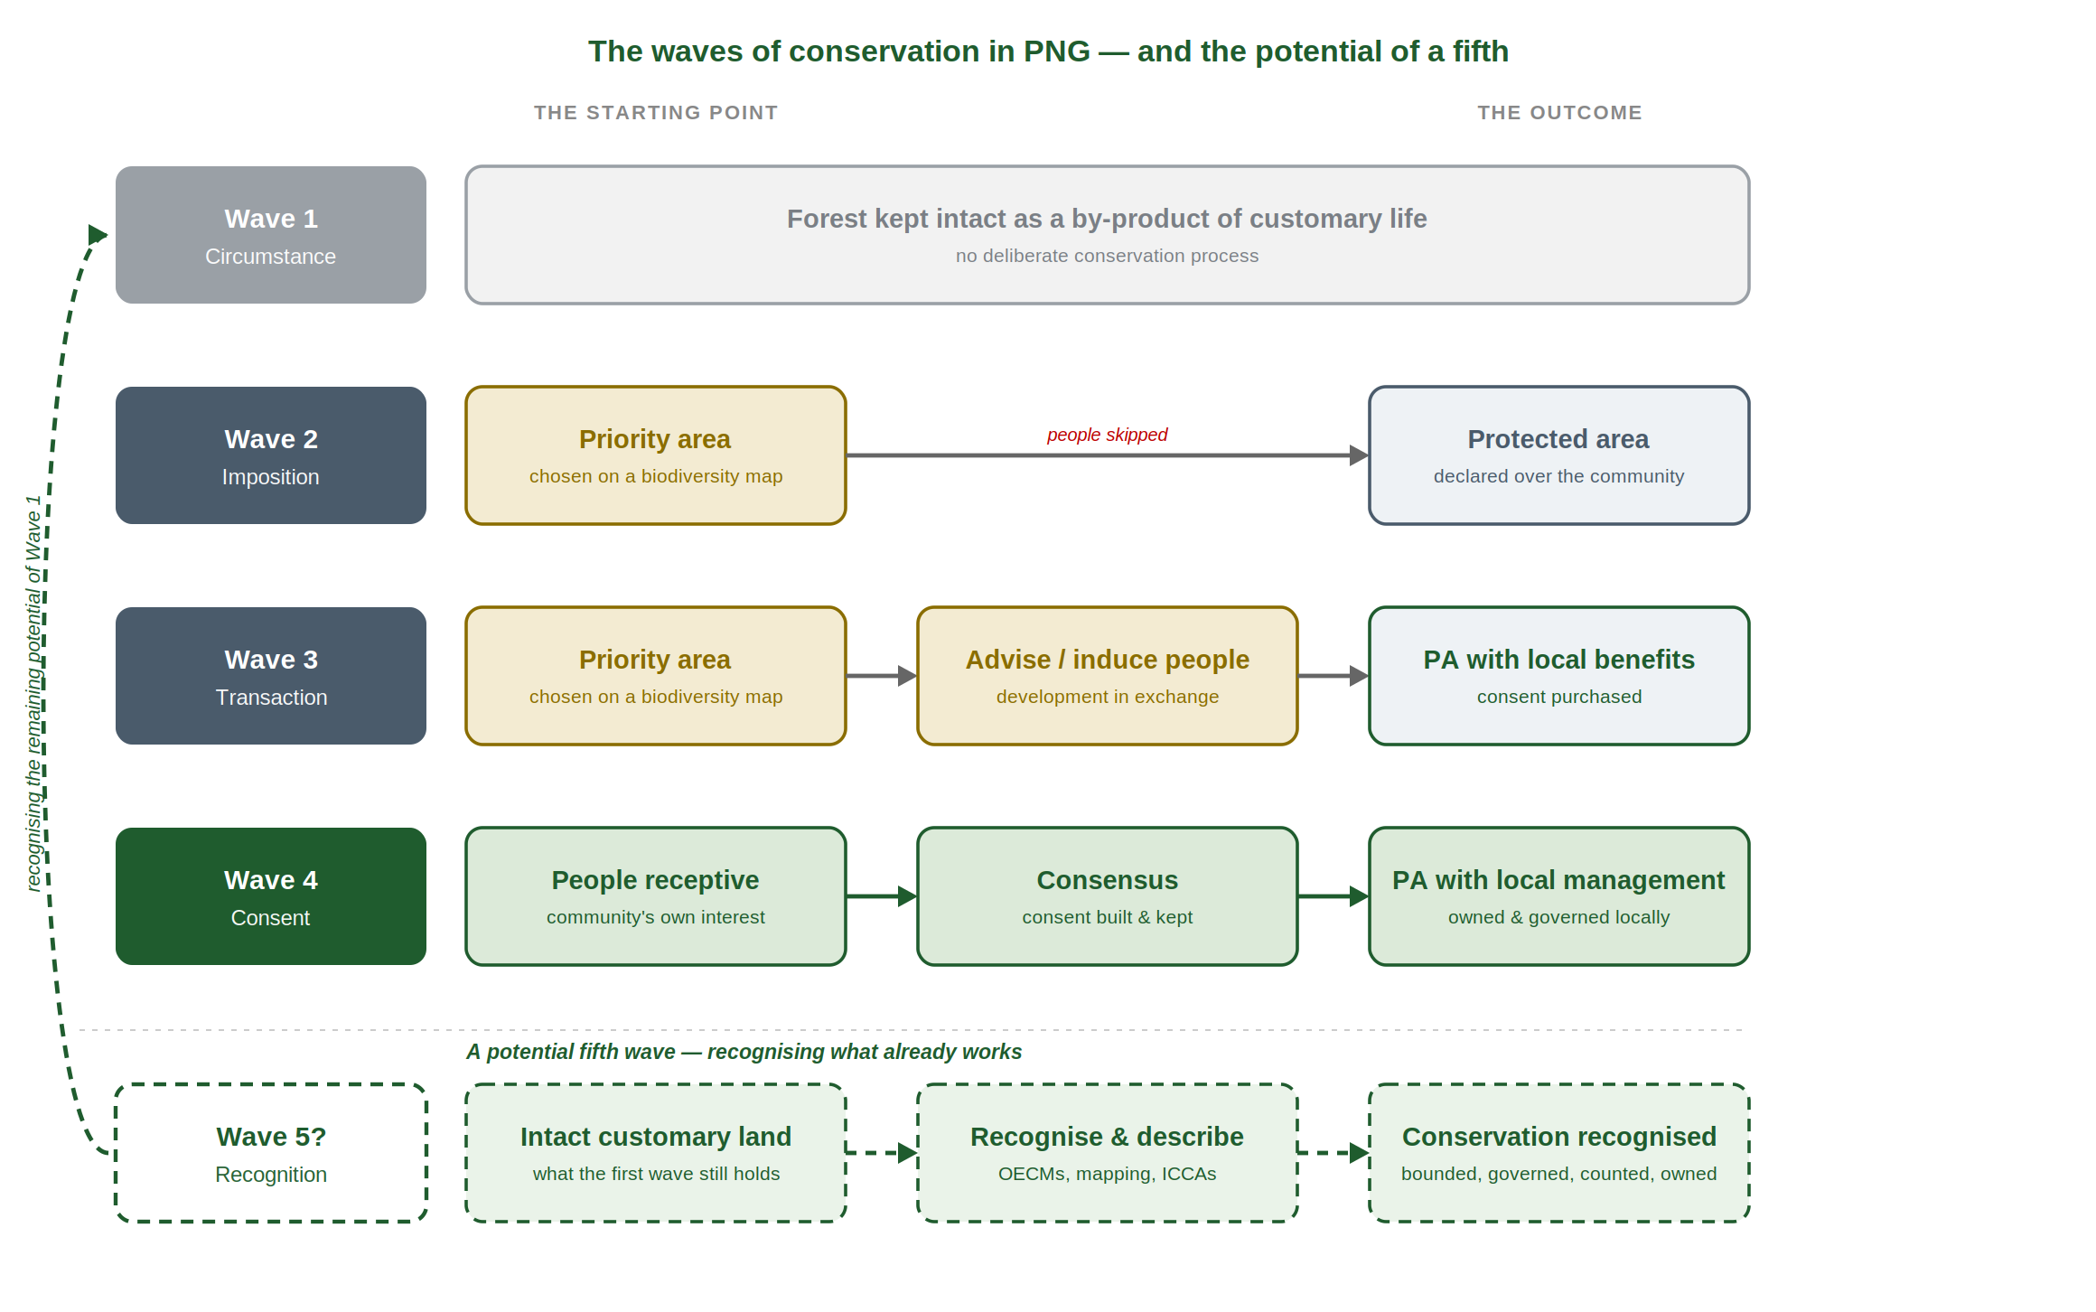
Figure 5. A potential fifth wave. The four deliberate waves are joined by a possible fifth, not a new intervention but the recognition of what the first wave still holds: intact customary land, described and formally acknowledged (through OECMs, mapping and recognised community-conserved areas) as conservation that is bounded, governed, counted and owned. The dashed return to Wave One marks that this fifth wave recognises the remaining potential of the first, rather than replacing it.
These are not rhetorical questions; they are the working agenda. Where the record does offer guidance it is consistent: the lessons drawn from a generation of PNG field projects come down to planning before choosing a site, investing for a decade rather than a project cycle, building trust first, tying conservation to the community’s own needs, working with rather than around government, and securing finance for the long term (Beehler and Kirkman 2013). The task of the days ahead is to turn these into priorities (what must change, who must act, and in what order) and to set that down in the communiqué. The history offers no formula, but it offers something more useful than optimism: a clear record, much of it Papua New Guinean and some of it from this very province, of what has been tried, what has failed, and what, slowly and on the owners’ terms, has begun to work.

8. A closing thought: shared problems, Papua New Guinean solutions
It would be easy to read this history as a catalogue of local failure. It is not. The difficulties that have dogged conservation in Papua New Guinea are, for the most part, the common afflictions of protected areas the world over: areas that exist on paper but are barely managed; chronic underfunding and insecure recurrent finance; too few staff and too little capacity; weak monitoring of whether values are being kept; and management that cannot keep pace with the pressures of logging, mining and agricultural expansion. Leverington and colleagues (2010) found major management deficiencies in around 40 per cent of the world’s protected areas; the “paper park” is a global problem, not a Papua New Guinean one. The country is not failing at a task others have solved; it is grappling, in acute form, with a problem conservation has not cracked anywhere.
That should motivate rather than discourage. Because no off-the-shelf international model fits a country whose land is 97 per cent customary, Papua New Guinea cannot import a solution, and is therefore free, and obliged, to design its own. An approach that genuinely works here, securing durable landowner consent, funding the ongoing management of a protected area rather than the one-off event of its gazettal, and resting conservation on the authority of the people who own the land, would not only resolve Papua New Guinea’s difficulty. It would speak to the problems that beset protected areas everywhere, most of which also depend, in the end, on the people who live alongside them. That is the task the days ahead are meant to take up.

Acknowledgements
This paper was prepared by CIFOR–ICRAF Papua New Guinea for the Managalas and Oro Province Project (MOPP), under the European Union Forestry, Climate Change and Biodiversity (EU–FCCB) Nexus Programme. The work is funded by the European Union; the views expressed are those of the authors and do not necessarily reflect those of the European Union or of CIFOR–ICRAF.
It draws on three decades of work in the Managalas Conservation Area, and the authors are grateful above all to the customary landowners and clans of the Managalas plateau, whose decisions are the substance of much of this history. Thanks are due to the Managalas Conservation Foundation (MCF), to Partners with Melanesians (PwM), and to the long-standing support of Rainforest Foundation Norway (RFN), whose combined efforts over many years underpin the account given here.
The paper was improved by review and comment from colleagues within and beyond CIFOR–ICRAF. In particular, the authors thank Lester Seri for a detailed critical review and for a contribution on national conservation-finance arrangements. [ Names to confirm and complete: reviewers, contributors and co-authors to be listed here before circulation. ]
Responsibility for the argument, and for any error of fact or interpretation, rests with the authors alone.

References
Alcorn, J. B. and Beehler, B. M. (eds) (1993). Papua New Guinea Conservation Needs Assessment (2 volumes). Washington, DC: Biodiversity Support Program.
Anderson, T. (2005). Challenging ‘integrated conservation and development’ in Papua New Guinea: the Bismarck Ramu Group. Pacific Economic Bulletin 20(1): 56–70. Canberra: Asia Pacific Press.
Beehler, B. M. and Kirkman, A. J. (eds) (2013). Lessons Learned from the Field: Achieving Conservation Success in Papua New Guinea. Arlington, VA: Conservation International.
Bulmer, R. N. H. (1982). ‘Traditional Conservation Practices in Papua New Guinea.’ In L. Morauta, J. Pernetta and W. Heaney (eds), Traditional Conservation in Papua New Guinea: Implications for Today. Boroko: Institute of Applied Social and Economic Research. (Cited via Sekhran 1996 and Filer 2004a.)
Chatterton, P., Yamuna, R., Higgins-Zogib, L., Mitchell, N., Hall, M., Sabi, J. and Jano, W. (2006). An Assessment of the Effectiveness of Papua New Guinea’s Protected Areas Using WWF’s RAPPAM Methodology. Port Moresby: Department of Environment and Conservation / PNG Forest Authority / Research and Conservation Foundation.
Ellis, J.-A. (1999). Race for the Rainforest II: Applying Lessons Learned from an Integrated Conservation and Development ‘Experiment’ in Papua New Guinea. Papua New Guinea Biodiversity Conservation and Resource Management Programme, Department of Environment and Conservation / UNDP–GEF.
Filer, C. (2000). How Can Western Conservationists Talk to Melanesian Landowners about Indigenous Knowledge? Resource Management in Asia-Pacific Working Paper No. 27. Canberra: Australian National University.
Filer, C. (2004a). Hotspots and Handouts: Illusions of Conservation and Development in Papua New Guinea. Paper presented at the conference ‘Bridging Scales and Epistemologies’, Alexandria, 17–20 March 2004.
Filer, C. (2004b). ‘The knowledge of indigenous desire: disintegrating conservation and development in Papua New Guinea.’ In A. Bicker, P. Sillitoe and J. Pottier (eds), Development and Local Knowledge. London: Routledge.
Filer, C. (2005). The Conservation Policy Community in Papua New Guinea. Resource Management in Asia-Pacific Working Paper No. 63. Canberra: Australian National University.
Filer, C. (2006). ‘Custom, Law and Ideology in Papua New Guinea.’ The Asia Pacific Journal of Anthropology 7(1): 65–84.
Fisher, R. J., Maginnis, S., Jackson, W. J., Barrow, E. and Jeanrenaud, S. (2008). Linking Conservation and Poverty Reduction: Landscapes, People and Power. Gland: IUCN / London: Earthscan.
Henning, B. M. (2015). ‘Market-based Conservation in Melanesia: Contrasting Expectations of Landowners and Conservationists.’ Conservation & Society 13(3): 299–310.
Independent State of Papua New Guinea (2009). Papua New Guinea Vision 2050. Port Moresby: National Strategic Plan Taskforce.
Independent State of Papua New Guinea (2014). Papua New Guinea Policy on Protected Areas. Port Moresby: Department of Environment and Conservation.
Independent State of Papua New Guinea (2023). Medium Term Development Plan IV 2023–2027: National Prosperity Through Growing the Economy. Port Moresby: Department of National Planning and Monitoring.
Independent State of Papua New Guinea. National Biodiversity Strategy and Action Plan (NBSAP). Port Moresby: Conservation and Environment Protection Authority. (Edition and dates to be confirmed at finalisation.)
IUCN (2023). 30x30: A Guide to Inclusive, Equitable and Effective Implementation of Target 3 of the Kunming-Montreal Global Biodiversity Framework. Gland: IUCN.
Koneha, I. and Tambari, F. (1997). ‘The Oro Butterfly Project Experiences.’ In Saulei and Ellis (eds), The Motupore Conference.
Leverington, F., Costa, K. L., Pavese, H., Lisle, A. and Hockings, M. (2010). ‘A Global Analysis of Protected Area Management Effectiveness.’ Environmental Management 46(5): 685–698. DOI 10.1007/s00267-010-9564-5.
Leverington, F., Peterson, A. and Peterson, G. (2017). Assessment of Management Effectiveness for Papua New Guinea’s Protected Areas 2017. Final Report. Apia: Secretariat of the Pacific Regional Environment Programme (SPREP).
Mace, G. M. (2014). ‘Whose conservation?’ Science 345(6204): 1558–1560.
McCallum, R. and Sekhran, N. (1997). Race for the Rainforest: Evaluating Lessons from an Integrated Conservation and Development ‘Experiment’ in New Ireland, Papua New Guinea. Papua New Guinea Biodiversity Conservation and Resource Management Programme, Department of Environment and Conservation / UNDP–GEF.
Melick, D. R., Kinch, J. P. and Govan, H. (2012). ‘How Global Biodiversity Targets Risk Becoming Counterproductive: The Case of Papua New Guinea.’ Conservation & Society 10(4): 344–353.
Novotny, V. (2010). ‘Rain Forest Conservation in a Tribal World: Why Forest Dwellers Prefer Loggers to Conservationists.’ Biotropica 42(5): 546–549.
O’Neill, H. M. K. et al. (2026). ‘Global conservation area coverage substantially exceeds current estimates.’ Nature. https://doi.org/10.1038/s41586-026-11157-4
Papua New Guinea (2024). Protected Areas Act 2024. Port Moresby: National Parliament of Papua New Guinea.
Phillips, A. (2003). ‘Turning Ideas on Their Head: The New Paradigm for Protected Areas.’ The George Wright Forum 20(2): 8–32.
Saulei, S. M. and Ellis, J.-A. (eds) (1997). The Motupore Conference: ICAD Practitioners’ Views from the Field. Report of the Second ICAD Conference, Motupore Island (UPNG), 1–5 September 1997. Department of Environment and Conservation / UNDP (PNG/93/G31).
Sekhran, N. (1996). Pursuing the ‘D’ in Integrated Conservation and Development Projects (ICADPs): Issues and Challenges for Papua New Guinea. Rural Development Forestry Network Paper 19b. London: Overseas Development Institute.
Sheil, D., Boissière, M. and Beaudoin, G. (2015). ‘Unseen sentinels: local monitoring and control in conservation’s blind spots.’ Ecology and Society 20(2): 39.
Zeriga, T. and Jimbudo, M. (2024). ‘Conservation Deeds by the People, for the People.’ Langscape Magazine, Vol. 13. Salt Spring Island: Terralingua.
Zibe-Kokino, S. and Girard, B. (1997). ‘ICAD Management and Implementation: The Kamiali Experiences.’ In Saulei and Ellis (eds), The Motupore Conference.
This paper was prepared by CIFOR–ICRAF Papua New Guinea for the Managalas and Oro Province Project (MOPP), delivered under the EU Forestry, Climate Change and Biodiversity (EU–FCCB) Nexus Programme with the financial support of the European Union. The contents are the responsibility of the authors and do not necessarily reflect the views of the European Union.

