Questions for Russell
Managalas Conservation Area — 28 October 2026
Each page is one ward. The map shows the villages in that ward. Under it is the question. Write the village name on the line, and record the point when you are there.
Where a name says (approx) we are not sure exactly where that village is, so the dot is only roughly right. Ask locally.

10 Gora
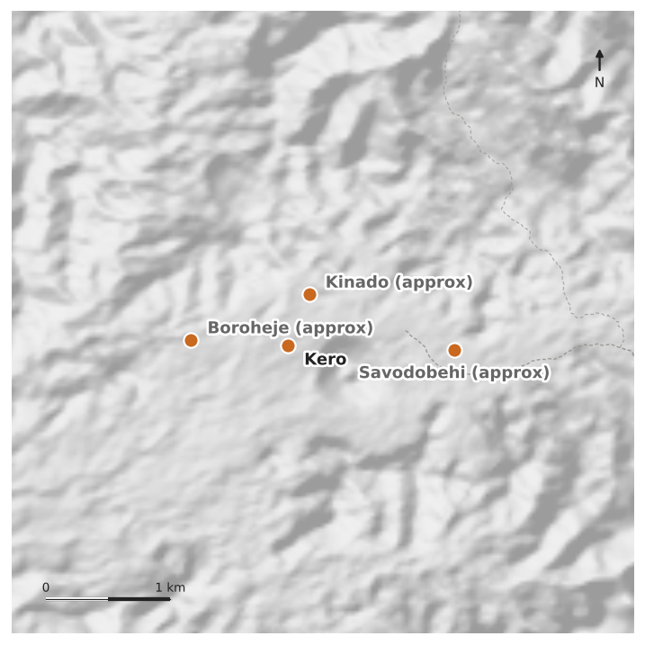
1. Which village in 10 Gora has the elementary school?
Village: ______________________________
2. Which village in 10 Gora has the primary school?
Village: ______________________________
3. Which village in 10 Gora has the aid post with the CHW house?
Village: ______________________________
4. Which village in 10 Gora has the airstrip?
Village: ______________________________

18 Gorobuna
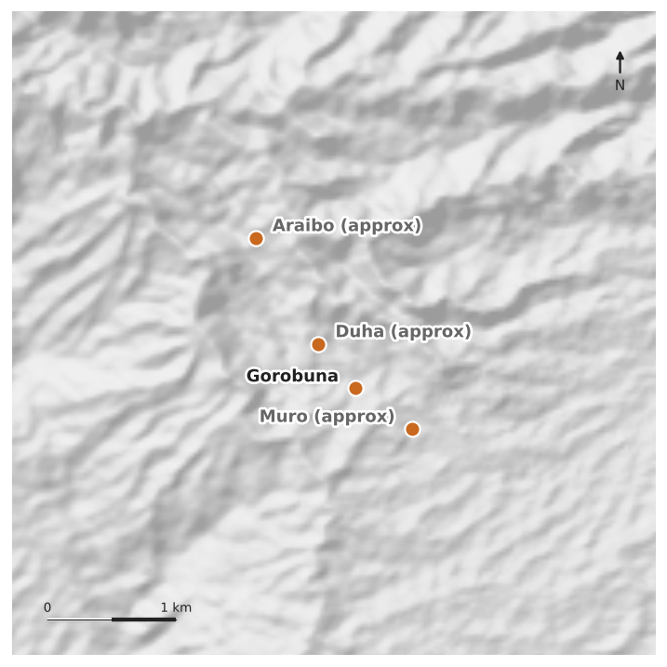
5. Which village in 18 Gorobuna has the elementary school?
Village: ______________________________
6. Which village in 18 Gorobuna has the airstrip?
Village: ______________________________

02 Niniuri — Afore Govt Station
7. You said Afore station is all collected, and we have 34 points from Afore. But we have the three CHW houses and no Health Centre. Is there a Health Centre building there, separate from the CHW houses?
Yes / No: ____________ If yes, please record it.

