Done by: Wong Wee Tin, Vanessa

SRN: 230657135

Sim ID: 10251724

CM3070 Final Project

Final Report
Table of Contents
Done by: Wong Wee Tin, Vanessa 1
SRN: 230657135 1
Sim ID: 10251724 1
CM3070 Final Project 1
Final Report 1
Introduction (732/1000 words) 2
Design (740/2000 words) 5
Overview 5
Navigation architecture 5
Gamification design 5
Location-based alerts design 6
Safety information design 6
Desgin iterations 6
Implementation (956/2500 words) 8
Development environment and technologies 8
Safe notification handling 8
Location services implementation 9
Alert simulation logic 9
Checklist and quiz components 10
Accordion dropdown component 11
Results and visual representation 11
Challenges and solutions 12
Conclusion (495/1000 words) 13
Summary of achievements 13
Limitations 13
Future work 13
Broader reflections 14
References 15

Introduction (732/1000 words)
The project template I have chosen to use is project number 10.1 Project Idea 1: Developing a Mobile App for Local Disaster Preparedness and Response.
Natural disasters and emergencies can have severe consequences for individuals and communities, particularly when people lack adequate preparation or timely access to reliable information. Smartphones provide an opportunity to improve how people prepare for, respond to, and recover from emergencies. For this project, I have developed a mobile application for local disaster preparedness and response, designed to provide users with practical preparation activities, location-based emergency information, response guidance, and access to local support resources.
The motivation for this project is based on the growing importance of proactive disaster preparedness. Orange and Lucas (2026) argue that climate change is increasing the frequency and intensity of several natural hazards, including wildfires, droughts, heatwaves, storms, and floods. At the same time, smartphone applications are increasingly being used as tools for disaster risk management. Their survey identified 322 publicly available natural-hazard applications, demonstrating the significant role that mobile technology can play in communicating risk and supporting communities. However, the study also identified an important limitation: most applications focus on emergency response and information delivery, while comparatively few support preparation, mitigation, or recovery. Consequently, existing applications may encourage a reactive approach to disasters rather than sustained preparedness (Orange and Lucas, 2026).
This gap strongly motivates the proposed application. Rather than functioning primarily as an emergency notification tool, the application will aim to encourage users to prepare before an emergency occurs. Gamification in the app will make preparedness activities more engaging by transforming potentially passive safety advice into practical tasks that users can complete over time. The games include assembling an emergency kit and completing short disaster-preparedness quizzes.
The need for such an approach is reinforced by research into existing disaster-support applications. Syukron et al. (2025) analysed 44 disaster mobile applications and 28,161 user reviews, identifying 13 core capabilities across the preparation, response and recovery stages of the disaster lifecycle. Their analysis found that users frequently discussed alerts and maps, while common frustrations included registration issues, network connectivity problems, and application crashes. The authors therefore emphasise that disaster applications should be treated as safety-critical, human-centred systems, where reliability and ease of use are essential because seemingly minor software problems can have serious consequences during an emergency (Syukron et al., 2025). A simple interface, clear navigation, reliable notifications and concise, actionable information will be prioritised over unnecessary complexity.
Another important motivation is the need to combine technological capability with local relevance and community participation. Orange and Lucas (2026) found that only a small proportion of the applications they surveyed incorporated community or group interaction, despite the importance of local knowledge and peer-to-peer communication in building community resilience. Their findings suggest that disaster applications should move beyond simply providing information and should help users undertake meaningful preparedness actions within their local context. The app will therefore focus on localised resources and information rather than attempting to provide generic disaster information for every possible location.
Singapore provides a particularly relevant context for exploring this concept. Singapore has already adopted several technology-enabled approaches to emergency management. OpenGov Asia (2025) reports that Singapore's emergency response framework includes the SGSecure mobile application and the myResponder application, while the Singapore Civil Defence Force (SCDF) has been developing a Cell Broadcast System that can send real-time, location-based emergency warnings directly to mobile phones in affected areas. The system is intended to provide timely warnings and clear guidance to people affected by emergencies. Singapore has also explored technologies such as artificial intelligence, augmented reality, and 5G to support emergency responders and improve operational decision-making (OpenGov Asia, 2025). These developments demonstrate the potential for mobile and digital technologies to form an important part of a modern emergency-management ecosystem.
The application could provide a single place where users prepare themselves before an emergency, receive simulated or real-time location-based notifications, follow appropriate response instructions and access relevant local contacts and safety information. The prototype will demonstrate the core concept through a limited but functional set of features. Overall, this project is motivated by the opportunity to use mobile technology to shift disaster management from a predominantly reactive model towards greater individual and community preparedness. Existing research indicates that disaster applications can provide valuable emergency information, but also reveals shortcomings in preparedness support, usability, reliability and community interaction (Orange and Lucas, 2026; Syukron et al., 2025).

Design (740/2000 words)

Overview
The application was designed as a mobile disaster preparedness and response tool for local communities, with the primary goal of shifting users from reactive behaviour to proactive preparedness. Three core principles from the literature guided the design: simplicity and reliability (Syukron et al., 2025), local relevance (Orange and Lucas, 2026), and engagement through gamification (Kankanamge et al., 2020). The app follows a hub-and-spoke navigation model, with a central Home screen providing access to four main functional areas: Emergency Alerts, Emergency Essentials (checklists), Test Your Knowledge (quizzes), and Safety Information. This flat hierarchy was chosen to minimise cognitive load during emergencies, as recommended by Syukron et al. (2025), who found that users value clear navigation and concise, actionable information in safety-critical applications.

Navigation architecture
The navigation architecture uses React Navigation's native stack navigator. The Home screen serves as the initial route. It presents a distinctive circular "Alerts" button, visually emphasising the most time-critical feature, followed by three rectangular buttons for the remaining sections. This visual hierarchy reflects the emergency lifecycle: immediate alerts take precedence, while preparedness activities (checklists and quizzes) and reference information (safety guidelines) are secondary. The stack-based navigation allows users to drill down into specific content, for example, from Safety Information to Floods, Hurricane, or Heatwave pages, while maintaining a clear back-navigation path. This structure supports the "step-by-step response guidance" requirement from the project brief without overwhelming users with nested menus.

Gamification design
Gamification was incorporated through two complementary mechanisms: interactive checklists and knowledge quizzes. The Emergency Essentials screen uses a tabbed interface with two categories, Ready Bag and First-Aid Kit, each containing a list of items. Users can check off items as they acquire them, providing a visual sense of progress. An information button (?) next to each item opens a modal with a detailed description, ensuring that users understand not just what to pack, but why it matters. This design turns a passive list into an active, educational task, addressing the gap identified by Orange and Lucas (2026): most disaster apps focus on response rather than preparation. The Test Your Knowledge screen presents multiple-choice questions with immediate visual feedback. Correct answers are highlighted in green, and incorrect selections in red, with the correct answer always revealed. This instant feedback loop reinforces learning and aligns with gamification principles of clear goals, immediate feedback, and a sense of accomplishment (Kankanamge et al., 2020). While the prototype does not include badges or rewards, the design allows for future extension in this area.

Location-based alerts design
The Alerts screen demonstrates the core concept of location-aware emergency notifications. Upon mounting, the screen requests foreground location permission and retrieves the user's current coordinates. The screen then reverse-geocodes these coordinates into a human-readable city name, displayed alongside the raw latitude and longitude. This dual display serves both user-facing and debugging purposes. A critical design decision was the use of simulated alerts rather than real-time integration with an external emergency API. Three trigger buttons, Flood, Hurricane, and Heatwave, allow demonstration of the alert flow without requiring a live data source. When triggered, the app displays an in-app banner with the alert title and a location-specific message, for example, "A flood warning has been issued for Singapore. Move to higher ground...". At the same time, it attempts to schedule a system notification using the device's notification service. This dual-channel approach ensures the alert is visible even if system notifications are unavailable, reflecting the application's safety-critical nature (Syukron et al., 2025).

Safety information design
The Safety Information section provides static, locally relevant guidance for three hazard types: Floods, Hurricane, and Heatwave. Each page uses an accordion-style dropdown component, allowing users to expand and collapse sections such as "Preparing for a flood" and "What to do during a flood." This design choice presents dense information in a digestible, scannable format, which matters when users may be under stress.

Desgin iterations
Several design iterations were made based on self-testing and peer feedback. Initially, the checklist items were simple toggles without descriptions, but feedback indicated that users wanted to understand the rationale behind each item. This led to the addition of the information modal. Similarly, the alert simulation was originally a single generic button; it was expanded to three hazard-specific buttons to demonstrate better the range of scenarios the app could support. The colour scheme, which is a deep blue (#00258a) background with white cards, was chosen for high contrast and readability, with coloured buttons for each hazard type (green for flood, red for hurricane, amber for heatwave) to aid quick recognition.

Implementation (956/2500 words)

Development environment and technologies
The application was built with React Native and Expo, a framework that enables cross-platform mobile development using JavaScript and React. Expo was chosen for its simplified build process, built-in access to device APIs (location, notifications), and the ability to test on physical devices via the Expo Go app. The navigation stack uses @react-navigation/native and @react-navigation/native-stack, providing native-feeling screen transitions and a well-established mobile navigation pattern. The codebase is organised into two primary files: App.js, which contains all screen components and the navigation container, and notificationsHelper.js, a utility module that encapsulates notification functionality. This allows the notification logic to be tested and maintained independently and provides a safety wrapper around the potentially crash-prone expo-notifications library.

Safe notification handling
A key implementation challenge was expo-notifications' instability in certain environments, particularly Expo Go on Android, where the library may cause crashes. To address this, notificationsHelper.js implements a defensive loading strategy:
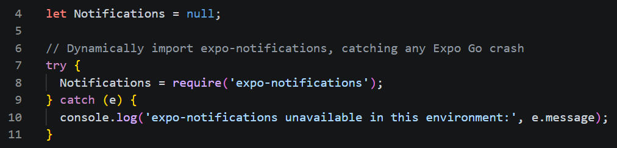
This dynamic require within a try/catch block ensures that if the library fails to load, the app continues to function with Notifications remaining null. All subsequent functions, isNotificationsAvailable(), scheduleNotification(), and setNotificationHandler(), check for this null condition before attempting to use the library. This defensive approach directly addresses the reliability concerns raised by Syukron et al. (2025), who found that application crashes were a common source of user frustration in disaster apps.
The scheduleNotification function uses trigger: null to send notifications immediately, which is appropriate for emergency alerts:

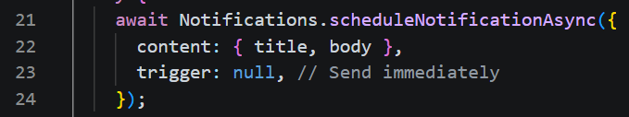
Location services implementation
The Alerts screen implements a complete location acquisition and reverse-geocoding flow within a useEffect hook. The implementation follows a three-step process:
- Permission request: Location.requestForegroundPermissionsAsync() is called, and the resulting status is stored in state. If permission is denied, an error message is displayed to the user, and the function returns early.
- Coordinate retrieval: Location.getCurrentPositionAsync({}) returns the device's current coordinates, which are stored in state and displayed to the user.
- Reverse geocoding: Location.reverseGeocodeAsync() converts coordinates into an address object. The code defensively handles the response by checking places && places.length > 0 and then constructing a readable name from available fields:
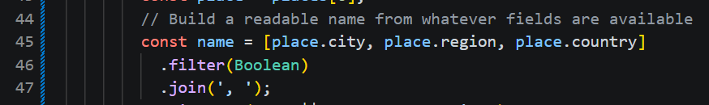
This approach ensures that even if some address fields are missing, which can happen depending on the region, the app displays the best available location name rather than failing silently.

Alert simulation logic
The simulateAlert function is the core of the alert demonstration. It accepts a hazard type string, looks up the corresponding title and message from a local object, and performs two actions:
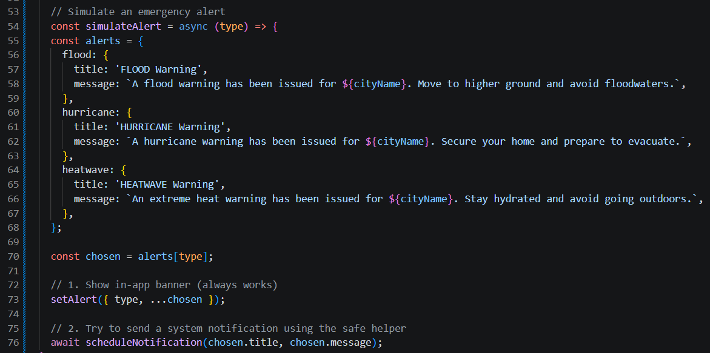
Template literals with ${cityName} personalise the alert message to the user's current location, showing how location-based alerts would work in a production system. The in-app banner is rendered conditionally using React's short-circuit evaluation: {alert && (<View>...</View>)}, ensuring that no banner appears until an alert is triggered.

Checklist and quiz components
The ChecklistScreen component manages two independent lists of items (Ready Bag and First-Aid Kit) using a single activeTab state variable. Checked items are tracked in a checkedItems object keyed by item ID, allowing O(1) lookup and toggle:
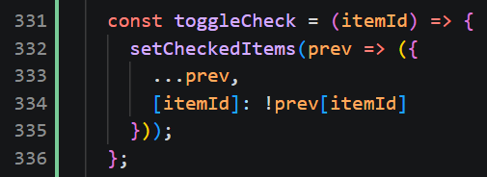
The modal for item descriptions is controlled by modalVisible and selectedItem state, with the modal content dynamically populated from the selected item's name and description properties. The QuizzesScreen implements answer tracking with a selectedAnswers object that stores both the selected option ID and whether it was correct. Once a question is answered, all option buttons for that question are disabled (disabled={!!answer}), preventing changes. The styling logic applies green to the correct answer and red to an incorrect selection, providing immediate visual feedback.

Accordion dropdown component
The DropdownSection component is a reusable UI element used across all three Safety Information pages. It manages its own open/closed state and renders children only when open:
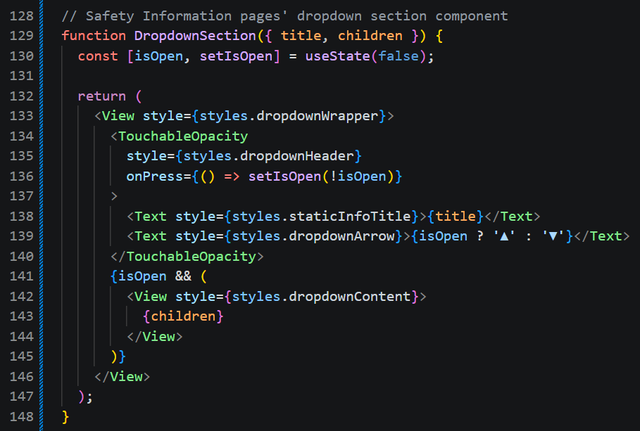
This component demonstrates React's composition model, allowing complex content, such as formatted text and multiple paragraphs, to be passed as children while the component handles only the toggle behaviour.

Results and visual representation
The implemented app was tested on both iOS and Android devices via Expo Go. The Home screen displays the circular Alerts button prominently at the top, followed by three rectangular navigation buttons and a local contacts section showing Police (999), Ambulance (995), and Non-emergency Ambulance (1777) numbers. The Alerts screen successfully retrieves and displays the user's location, for example, "Singapore, Singapore" with coordinates "Lat: 1.3521, Lon: 103.8198". Triggering a flood warning displays a green-tinted in-app banner with the message "A flood warning has been issued for Singapore, Singapore. Move to higher ground and avoid floodwaters." A system notification is also scheduled. However, its appearance depends on the device's notification permissions and settings. The Emergency Essentials screen shows the Ready Bag tab active by default, with eight items listed. Tapping the (?) button on "Torchlight without batteries" opens a modal explaining its purpose. Checking items fills the circle with the app's primary blue colour, providing clear visual progress tracking. The Test Your Knowledge screen displays two questions, each with four options. Selecting "Expensive figurines" for the first question immediately turns that option red while "Childcare supplies and other special care items" turns green, confirming the correct answer. The Safety Information section successfully navigates to Floods, Hurricane, and Heatwave pages, each with expandable sections. The Heatwave page's "Who is most at risk?" section expands to reveal seven categories of at-risk individuals, with bold text highlighting key groups such as "Older people" and "Babies and young children."

Challenges and solutions
The most significant implementation challenge was the expo-notifications crash in Expo Go, which was resolved through the defensive loading strategy described earlier in “Safe notification handling”. Another challenge was handling location permission denial gracefully. The app displays "Permission to access location was denied" and continues to function, allowing users to still access checklists and safety information even without location services. The reverse geocoding API occasionally returned incomplete address data depending on the test location. The defensive coding approach (filtering out null/undefined fields) ensured that the app displayed a partial name rather than crashing or showing "undefined."

Conclusion (495/1000 words)

Summary of achievements
For this project, I delivered a functional prototype of a mobile disaster preparedness and response app for the Singapore context. The app addresses the gap identified in the literature, which was that most existing disaster applications focus on response rather than preparation (Orange and Lucas, 2026), by placing equal emphasis on preparedness activities (checklists and quizzes) and emergency response features (location-based alerts and safety information). The app is functional, stable, and provides a coherent user experience across its four main sections.

Limitations
Several limitations should be acknowledged. First, the alerts are simulated rather than integrated with real-time emergency data sources. While this is appropriate for a prototype, a production version would need to integrate with Singapore's Cell Broadcast System or other official alerting platforms (OpenGov Asia, 2025). Second, the app lacks a backend, so user progress on checklists isn't saved across sessions or devices. Third, the gamification elements are relatively basic, with no badges, points, or social features implemented.

Future work
Future development could proceed in several directions. The most impactful would be integration with real-time alerting systems, such as Singapore's Cell Broadcast System or the SGSecure platform, to provide genuine location-based emergency notifications. This would require coordination with government agencies and careful attention to data privacy and reliability. A second direction would be to add persistent storage, for example, AsyncStorage or a cloud backend, so that users' checklist progress and quiz scores are saved. This would enable more sophisticated gamification, such as streaks, badges, and progress tracking over time. A third direction would be to expand the community features. Orange and Lucas (2026) found that only a small proportion of disaster apps incorporate community interaction. Features such as sharing preparedness progress with family members, neighbourhood check-ins, or local volunteer coordination could significantly enhance the app's impact on community resilience.

Broader reflections
This project has reinforced the importance of designing for the full disaster lifecycle, preparation, response, and recovery, rather than focusing solely on the emergency event itself. The literature consistently shows that preparedness activities, when made engaging and accessible, can significantly improve outcomes when disasters strike. Mobile technology offers a powerful channel for delivering this preparedness support, but only if applications are reliable, easy to use, and locally relevant. The project also highlighted the tension between feature richness and simplicity. In a safety-critical context, every additional feature adds complexity and potential failure points. The decision to focus on a small number of well-implemented features, rather than attempting to cover every possible hazard or scenario, was validated by the literature (Syukron et al., 2025) and resulted in a more polished, reliable prototype. Ultimately, this project demonstrates that a well-designed mobile app can make a meaningful contribution to disaster preparedness. By combining gamification, location-based alerts, and locally relevant safety information, the app encourages users to take proactive steps before an emergency occurs. While the prototype is limited in scope, it provides a solid foundation for future development and clearly shows how mobile technology can support community resilience amid increasing climate-related risks.

References
- Orange, A.B., Lucas, C.H. (2026), How prepared are we? A survey of smartphone applications for managing personal risk of natural hazards [Online] Taylor & Francis Online. Available from: https://www.tandfonline.com/doi/full/10.1080/17477891.2026.2682477#abstract
- OpenGov Asia (2025), Singapore: Leveraging Tech for Smarter Emergency Response [Online] OpenGov Asia. Available from: https://opengovasia.com/singapore-leveraging-tech-for-smarter-emergency-response/?c=sg
- Syukron, A., Madugalla, A., Shahin, M., Grundy, J. (2025), Design Challenges and User Needs in Disaster Support Mobile Apps: A Large-Scale Analysis of Features and Reviews [Online] arxiv. Available from: https://arxiv.org/html/2407.08145v2#abstract1

