1. To perform the action show.

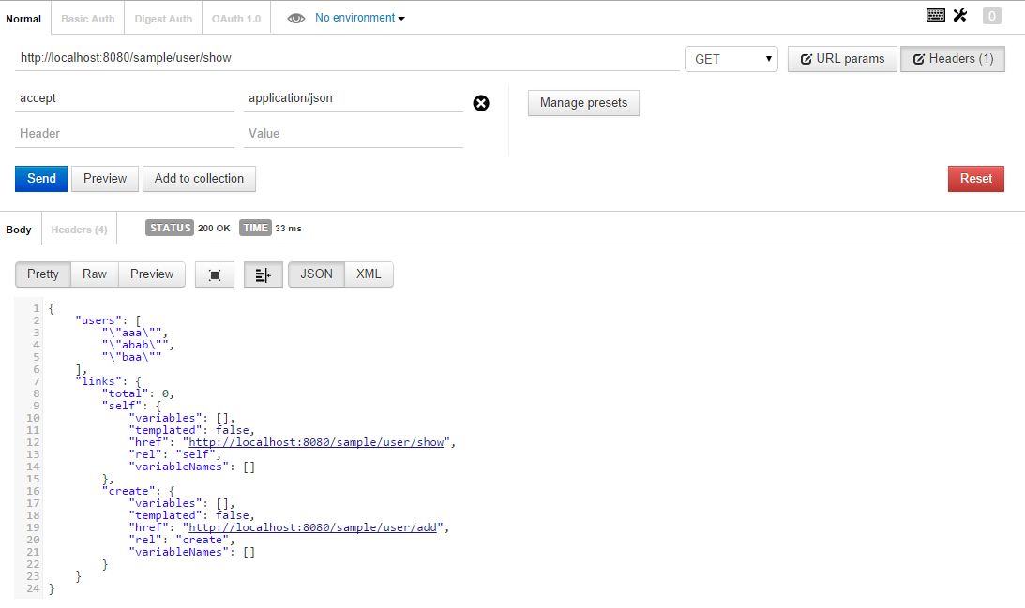

1. To perform the action add user

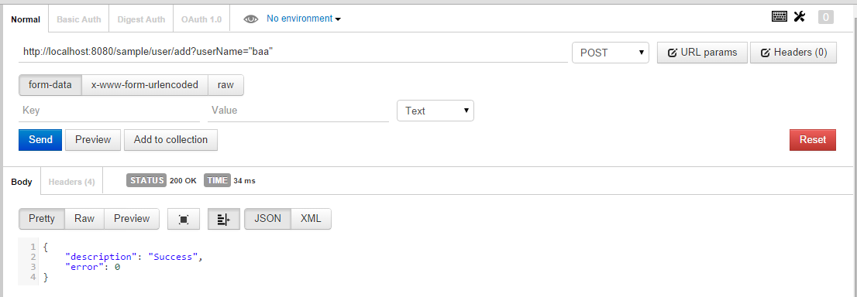

1. Extra to show the user resource description

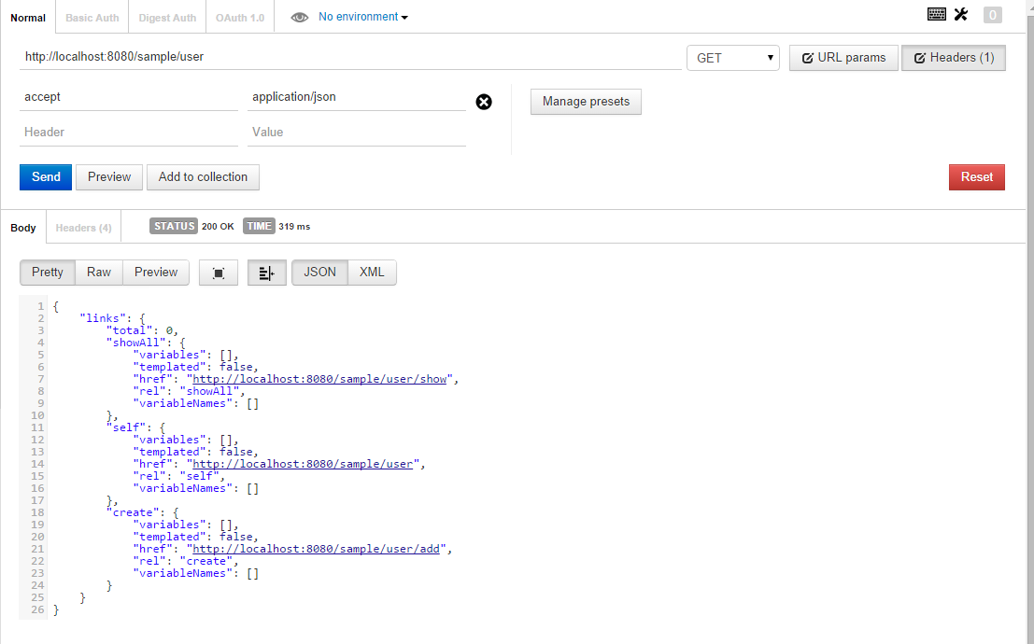

From the WEB browse, issue the show

