

**Master of Applied Information System**

**Project Proposal**

*Web-Based GeoVisualization Tool for Undergraduate Geospatial Information Analytics Education:*

*Design and Usability Study*

**Version 2.2**

***<22 Feb 2014>***

**Version History**

|  |  |  |  |
| --- | --- | --- | --- |
| **Version** | **Change Description** | **Author** | **Date** |
| 1.0 |  | Fu Yue | 12 Jan 2014 |
| 2.0 |  | Fu Yue | 5 Feb 2014 |
| 2.1 |  | Fu Yue | 10 Feb 2014 |
| 2.2 |  | Fu Yue | 21 Feb 2014 |

**Table of Contents**

**1. Background 4**

**2. Objective 5**

**3. Scope 6**

**4. Deliverables 9**

**5. Schedule 10**

**6. Quality definition of deliverables 12**

**7. Key dependencies 12**

**8. Completion criteria 13**

**9. References 14**

# 1. Background

The 21st century is the era of vigorous development of spatial information technology, geographic information science has been widely used in the construction of modern national defense and national economy, and will play an increasingly important role. With the concepts of Digital City, Digital Nation, Digital Earth and other digital construction have arose all over the world, people learn about the urban intelligent transportation, municipal infrastructure management, emergency treatment, urban environmental monitoring and such construction fields more frequently, the importance of geospatial information industry has been paid significant attention to. According to surveys, about 80% of all data maintained by organizations throughout the world has geospatial location component. Then how to take advantage of such geographical feature to analyze kinds of statistical information in financial, political, economic, and environmental fields? The Geographic Information System (GIS) is one of such tools helps to capture, manipulate, analyze and visualize statistical data according to its geospatial indicators, which are the location of the data components. [1]

Different from cartography, geospatial information analytics concerns not only the location, metrics of places, but also the interaction with environmental, economic, social, political factors and human activities in corresponding places. Such feature makes geospatial information analytics education a highly interdisciplinary subject. It strives to equip students with both spatial thinking and problem-solving ability. [2] GIS we talked above can help students to develop geography skills, practice geography-based decision-making, to enhance their ability of spatial thinking and real-world problems solving. [3]

However, when we focus on geospatial information analytics education in undergraduate level, where most of the general students are not professional GIS users at first, some shortcomings of using traditional desktop GIS appear in practice.

First, traditional desktop GIS requires both hardware and software supports, and the cost is expensive. Second, the learning curve is fairly steep, since the system functions are so complete that lead to complex operations, and it is not easy for undergraduate students to grasp in a short time. Even worse, another course may be required for training how to operate the system. Third, teachers have to spend more time on the system training part, which deviates the focus of geospatial information analytics education and geospatial thinking instruction.

Except for traditional desktop GIS, Google Map is another tool for geospatial data analysis, and it is much more user-friendly than desktop GIS for newcomers. Nonetheless, the users can only explore geographic maps, it does not provide choropleth maps or other statistical plots. If students want to analyze other statistical features of the data, they have to use other applications for statistical charts as a supplement.

Due to the factors above, a web-based geovisualiztion tool is strongly needed to make geospatial information analytics education more effectively. The learning curve will be less steep than the traditional desktop one, since students do not need to build maps themselves. Instead, they gain information by using the maps already connected with data, exploring the data relationships and analyzing the data without manipulating the data themselves. And that is the motivation for this project, to combine the undergraduate geographical analytics education goals with geospatial visualization analytics tools to develop an ideal tool which has such advantages:

First, it does not need expensive software or hardware supports, any personal computers with an Internet connection can display the tool that can help to save school budgets.

Furthermore, it is user-friendly and easy to operate. Students need not to have additional technical ability to operate the tool or process data. Just open the browser, the application will be ready on the web page for use.

Third, it has good interaction that can help students inquiry can analyze the maps easily. Spatial thinking will be gradually nurtured on the process of talking and interacting with the attractive tool.

Last but not least, instructors can save the time of equipping the students with operational skills since nowadays every student does know how to browse the Internet and retrieve the information they need.

Although the literature points to the strength of web-based geovisualization tool in undergraduate geospatial information analytics education, user surveys need to conduct so as to uncover whether it actually works and to what extent it can enhance the learning outcomes and save costs. [4] In order to implement a real-world user survey, I have chosen international migration as test model theme. [5] And the final application of project design will be a web-based tool which visualizes the conditions of international migrations and allows users to explore other feature data related to the phenomenon for unexpected discovery and insight provoking. The usability study will mainly focus on the user feedback after they explore the test model application themselves.

# 2. Objective

This project is intended to produce a web-based geospatial information analytics education tool, particularly for undergraduate students from SOSS, SMU, to provide a platform helping them explore and understand the conditions and trends of international migration and underlying causality. The tool will be built as online courseware, which offers an interactive analytical stage for students to visualize and analyze the data they need to reach their individual learning and query goals and solve the proposed problems. And also for teachers to manage the courseware by adding the required data and detect the learning outcomes of the students. The specific goals of the project design are to create online courseware which are:

·User-Friendly – to make the courseware attractive for undergraduate which can provoke their learning interest, and also easy to operate without additional technical skills.

·Interactive – to make the geospatial maps interact with international migration data and other social indicators for users to explore the underlying issues and causes.

·Renewable – to allow the teachers to add and update their own data for specific analysis goals.

The specific objectives of the usability study are as followings:

·Students` Feedback – to learn of whether the courseware is attractive for interest advancement and easy to use. How does the courseware assist them to explore and solve problems?

·Learning Outcomes – under the help of the instructors, to see whether the learning outcomes of students using the courseware are better than the students learn in traditional ways.

·Improvement Plan – according to the survey of usability, propose an improvement plan for the interface, functions, interaction and so on.

# 3. Scope

The specific scope of work entails the following:

**Phase 1 – Project Preparation:**

**·Background Learning** – Research and learn the basic concepts, situations and prospects of undergraduate geography and social science education in Singapore, GIS learning strategy, existing Web-based GIS tools. Compare the advantages and disadvantages of traditional GIS-based geography learning and clarify the necessity of web-based learning tools.

**·User Need Learning** – Meet with course instructors, learn of the teaching goals of certain lessons, analyze how to integrate web-based geospatial visualization analytics tools and courseware to develop a new learning tool for undergraduate geography education. Draft the user needs documentaries.

·**Technology Learning** – Learn D3.js and Leaflet.js two basic JavaScript libraries for developing web-based interactive visualization applications. Get to know how to combine the visualization techniques with the certain teaching goals.

**Phase 2 – Project Design and Development:**

·**Data Collection** – Search and collect the datasets needed to visualize the geographical maps for students to explore and find solutions for their own problems. Data cleaning ability is necessary here.

·**Conceptual Development** – Design the application dashboard to make the learning tool easy to operate, attractive to the students and helpful for analytics and fit the class duration properly.

·**Prototyping** – Implement the initial design of the tool using D3.js and Leaflet.js and other technics, create a sample courseware and make it interactive.

**Phase 3 – Usability Study**

·**User Feedback Survey** – Collect the feedbacks from students who use the tool to analyze and learning themselves, from teachers who manage the data of the tool and compare the learning outcomes of the students before and after using the new tool.

·**Improvement Plan** – According to the feedbacks, summarize the lessons learn for the user experience and feelings, come up with plans to improve the application which can get better user feedbacks.

**Phase 4 – Promotion**

·**Implementation** – Improve the initial courseware according to the improvement plan and develop at least two applications of courseware with complete features .

·**Environment Testing and Debugging** – Test the applications in different browsers and web environment and debug to make them more compatible.

**Phase 5 – Project Documentary**

·**Project Proposal** – Propose the background, objectives, work scope, deliverables, schedule, quality definitions, key dependencies and completion criteria for the project.

·**Capstone Report** – Describe the total design and implementation process of the application, also contains the user feedback survey.

·**Database Dictionary** – Documentation of the data used and access methods.

·**User Guide** – Step-by-step guide on how to use the designed functions of the courseware application.

**·Project Poster** – Summary of the motivation of the application, the design approaches, implementation process, product screenshots and future work.

**·Presentation Slides –** Presentation of the motivation of design, tools used in the implementation process, references list, milestones, user feedback and working demo of the courseware.

The core scope of work is shown as below (refer to [6]):

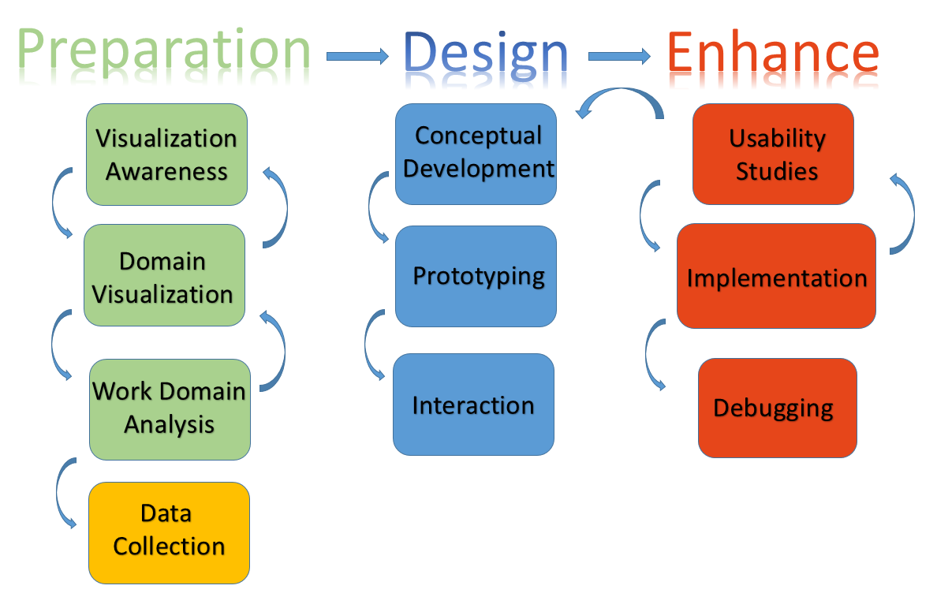

# 4. Deliverables

• **Capstone Report –** A report on the design, implementation and promotion process of the application and a survey of user feedback which the application promotion based on.

• **Visualization Courseware** – A web-based courseware that displays the international migration conditions and trends among countries, and interactively shows the relationships of the phenomenon with certain social indicators. The courseware will allow teachers to add their own data and allow students to meet their problem-solving goals by exploring the web-based interactive geographical maps.

• **Database Dictionary –** A documentary of the datasets used and the access approaches.

•    **User Guide –** Step-by-step guide on how to use the designed functions of the courseware application.

• **Project Poster –** Summary of the motivation of the application, the design approaches, implementation process, product screenshots and future work.

• **Final Presentation Slides –** Presentation of the motivation of design, tools used in the implementation process, references list, milestones, user feedback and working demo of the courseware.

# 5. Schedule

The project starts on January 10th, and will be able to be finished at the end of June. Absolute time prepared to devote for the entire process is 660 hours and the details of work in different project phases are shown in the below timetable.

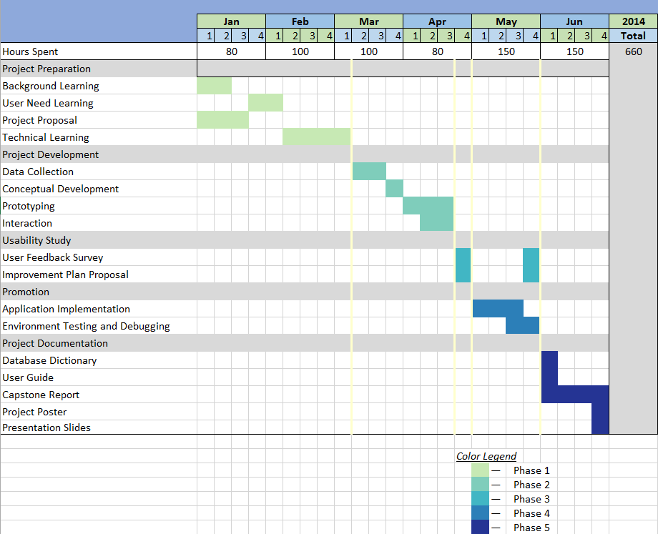

The following table shows every stage of work according to the exact starting and ending time of the phases.

|  |  |  |  |
| --- | --- | --- | --- |
| **S.N** | **Task** | **Start Date** | **End Date** |
| 1 | Phase 1 – Preparation | 10/01/2014 | 09/03/2014 |
| 1.1 | Background Learning | 10/01/2014 | 17/01/2014 |
| 1.1.1 | Secondary Geography Education Research | 10/01/2014 | 12/01/2014 |
| 1.1.2 | PBL Learning Strategy Research | 12/01/2014 | 13/01/2014 |
| 1.1.3 | Existing PBL-based Tools Research | 13/01/2014 | 14/01/2014 |
| 1.1.4 | Web-based Courseware Learning | 14/01/2014 | 17/01/2014 |
| 1.2 | User Need Learning | 29/01/2014 | 09/02/2014 |
| 1.2.1 | Visualization Awareness | 29/01/2014 | 29/01/2014 |
| 1.2.2 | Domain Visualization | 29/01/2014 | 09/02/2014 |
| 1.2.3 | Work Domain Analysis | 29/01/2014 | 09/02/2014 |
| 1.2.4 | Drafting User Need Documentary | 29/01/2014 | 09/02/2014 |
| 1.3 | Project Documentation | 10/01/2014 | 24/01/2014 |
| 1.3.1 | Drafting Project Proposal | 10/01/2014 | 24/01/2014 |
| 1.4 | Technical Learning | 10/02/2014 | 09/03/2014 |
| 1.4.1 | D3.js Learning | 10/02/2014 | 09/03/2014 |
| 1.4.2 | Leaflet.js Learning | 10/02/2014 | 09/03/2014 |
| 2 | Phase 2 – Development | 10/03/2014 | 20/04/2014 |
| 2.1 | Data Collection | 10/03/2014 | 23/03/2014 |
| 2.1.1 | Data Selection | 10/03/2014 | 23/03/2014 |
| 2.1.2 | Data Cleaning | 10/03/2014 | 23/03/2014 |
| 2.2 | Conceptual Development | 23/03/2014 | 30/03/2014 |
| 2.2.1 | User Need Based Structure Design | 23/03/2014 | 30/03/2014 |
| 2.2.2 | Drafting Storyboard | 23/03/2014 | 30/03/2014 |
| 2.3 | Prototyping | 31/03/2014 | 20/04/2014 |
| 2.3.1 | Courseware Sample Design | 31/03/2014 | 20/04/2014 |
| 2.3..1 | Creation of A Sample Courseware | 31/03/2014 | 20/04/2014 |
| 2.4 | Courseware Interaction | 31/03/2014 | 20/04/2014 |
| 3 | Phase 3 – Usability Study | 21/04/2014 | 27/04/2014 |
| 3.1.1 | User Feedback Survey | 21/04/2014 | 27/04/2014 |
| 3.1.2 | Improvement Plan Proposal | 21/04/2014 | 27/04/2014 |
| 4  4. | Phase 4 – Promotion | 28/04/2014 | 01/06/2014 |
| 4.1 | Implementation | 28/04/2014 | 18/05/2014 |
| 4.1.1 | Two Courseware Implementation | 28/04/2014 | 18/05/2014 |
| 4.2 | Environment Testing and Debugging | 19/05/2014 | 01/06/2014 |
| 4.2.1 | Testing Application Based on Web | 19/05/2014 | 25/05/2014 |
| 4.2.2 | Debugging the Applications | 26/05/2014 | 01/06/2014 |
| 5 | Phase 5 – Project Documentation | 02/06/2014 | 30/06/2014 |
| 5.1.1 | Database Dictionary | 02/06/2014 | 04/06/2014 |
| 5.1.2 | User Guide | 05/06/2014 | 08/06/2014 |
| 5.1.3 | Capstone Report | 09/06/2014 | 22/06/2014 |
| 5.1.4 | Project Poster | 22/06/2014 | 25/06/2014 |
| 5.1.4 | Presentation Slides | 25/06/2014 | 30/06/2014 |

# 6. Quality definition of deliverables

|  |  |
| --- | --- |
| **Deliverables** | **Quality definitions** |
| **Capstone Report** | Clarity in the project design and implementation process introduction, usability study, references list and future work |
| **Visualization Courseware** | Complete implementation of the design,  compatible with the web environment, user-friendly interface and positive user feedback |
| **Database Dictionary** | Clarity in listing the data used, including the data format and attributes, and the access approach of the original datasets |
| **User Guide** | Clarity in guiding the students to exploit the courseware and the teachers to manage the application and add data |
| **Project Poster** | Clarity in the statement of the motivation for the project, description of the techniques and approaches used to implement the application and future work which can extend the functions of the application.  Clearness in demo screenshots of the courseware |
| **Final Presentation Slides** | Clarity in presentation the motivation of design, tools used in the implementation process, references list, milestones, user feedback and working demo of the courseware |

# 7. Key dependencies

|  |  |
| --- | --- |
| **Dependency** | **Description** |
| People | This project application will require an experiment participated by two groups of undergraduate school students, one will use the courseware to learn geography lessons as the experimental group, while the other control group members use the traditional way of learning. In order to get user feedbacks and compare the learning results of the two groups, the cooperation and contribution of corresponding school teachers will also be required.  experiment  experiment group |
| Data | International migration data will be collected from OECD, other data for social indicators will be collected from online database according to the specific analytics aspects. |
| Technical skills | The major technological skill I need in the project is to visualize the geography courseware using d3 and leaflet coding libraries. I will learn how to code in JavaScript in the progress of learning part.  Data retrieval, collection mining and analytical skills also help the implementation of the project.  The usability study is necessary in improving the applications, so communication and survey skills are also necessary. |
| Software | **Data Collection**: Excel 2013, Tableau, JMP, Mr. Data Converter, Batch Geocoding  **Project Development**: d3.js, leaflet.js, Geany, EasyPHP DevServer 13.1 VC9  **Project Implementation**: GitHub App Engine |
| [Technical](javascript:void(0);) [Support](javascript:void(0);) | Github:  <https://github.com/mbostock/d3/wiki>  Stackoverflow:  <http://stackoverflow.com/questions/tagged/d3.js>  Google groups:  <https://groups.google.com/forum/?fromgroups#!forum/d3-js> |

# 8. Completion criteria

|  |  |
| --- | --- |
| **Completion Criteria** | **Description** |
| Capstone Report | Sign off by supervisor |
| Visualization Courseware | Sign off by supervisor |
| Database Dictionary | Sign off by supervisor |
| User Guide | Sign off by supervisor |
| Project Poster | Sign off by supervisor |
| Final Presentation Slides | Sign off by supervisor |

# 9. References

[1] Geographic Information System—Wikipedia

<http://en.wikipedia.org/wiki/Geographic_data>

[2] Liu, Y., Bui, E. N., Chang, C. H., & Lossman, H. G. (2010). PBL-GIS in secondary geography education: Does it result in higher-order learning outcomes. Journal of Geography, 109(4), 150-158.

[3] Songer L C. Using web-based GIS in introductory human geography [J]. Journal of Geography in Higher Education, 2010, 34(3): 401-417.

[4] Liu Y, Bui E N, Chang C H, et al. PBL-GIS in secondary geography education: Does it result in higher-order learning outcomes?[J]. Journal of Geography, 2010, 109(4): 150-158.

[5] “International Migration” introduction from Wikipedia:

<http://en.wikipedia.org/wiki/International_migration>

[6] Koh.L.C.al. (2011) “Developing and Applying a User-Centered Model for the Design and Implementation of Information Visualization Tools”. InfoVis 2011, London.