Report for assignment 1

# Degree: Bachelor of Data Science

# Course: INFO 151

# Title：study report on web design

# Tutor name：PHILIP Moore, ZhiLi Zhao

# Student name (English): TianYi Wang

# Student name(Chinese): 王天一

# Student ID number：320200931301

# Date:04/11/2020

## Introduction

This assignment is to design a website for ABC LTD. So I design the website mainly for its business activities and consider the different needs of different people, I introduce the “shopping bag” system and users can chose the way of paying while paying for their orders.

Because this website is mainly for shopping, so I introduce some advertisements on the first page.

## Requirements

At first, I interviewed some of my classmates, friends, and relatives. After collecting their opinions and assessing their opinions, I started to visit the websites which provide the service like ABC’s. Next, I draw the storyboard, design the functions of the websites. And In the end, I design the details about the websites and what content will be put on the website.

## Design

During doing research, many people think that all the functions of the website should be placed in the places easy to see. So, when I design my website for ABC LTD, I place the function at the top of the page to let users see them easily. And I place them in every page and in the same position. And it also serves as a web map. And then I draw the map site to construct the functions. Users can use this website map go to every function no matter where he is.

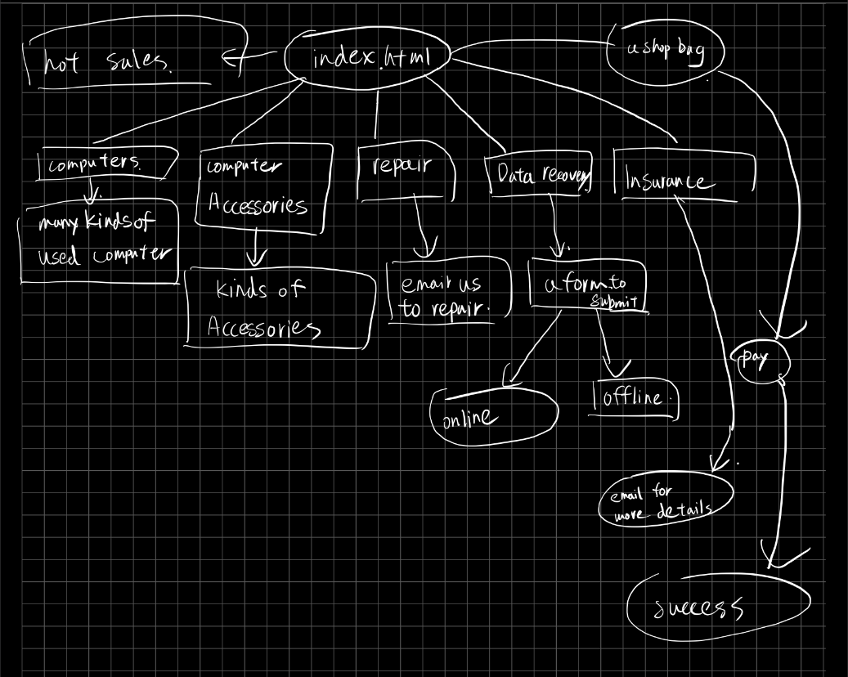

(picture of site map) 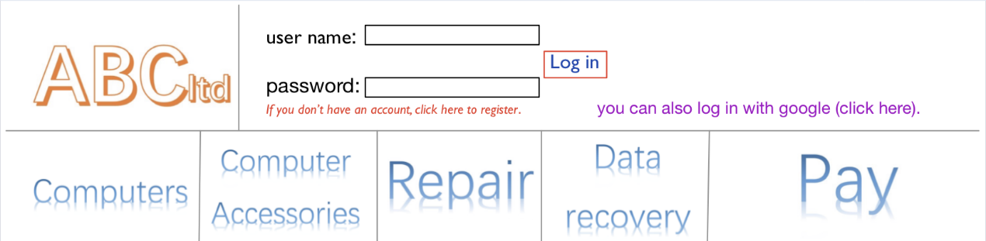

(picture of the website map)

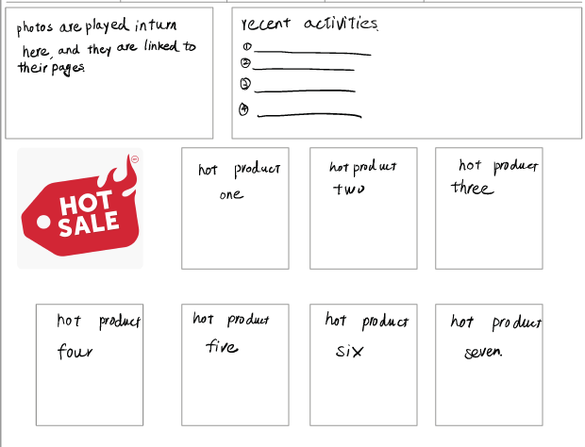

(advertisements in the first page)

For orders, the people who were interviewed said that sometimes they bought more than one thing, but they can only pay for one thing one time. So I introduced a convenient system call “shopping bag”, when they want to bag one thing, they can add it into their “shopping bag”, and when they finish the “select” process, they can pay for them at one time. I think it is very efficient. For payments, considering users’ different needs of paying, lots of ways of payments is essential. So, I provide different ways of payment. Users can choose the way of paying easily. After paying for goods, users will get an “order number”. They can use this number track their good, handle the problem of their good.

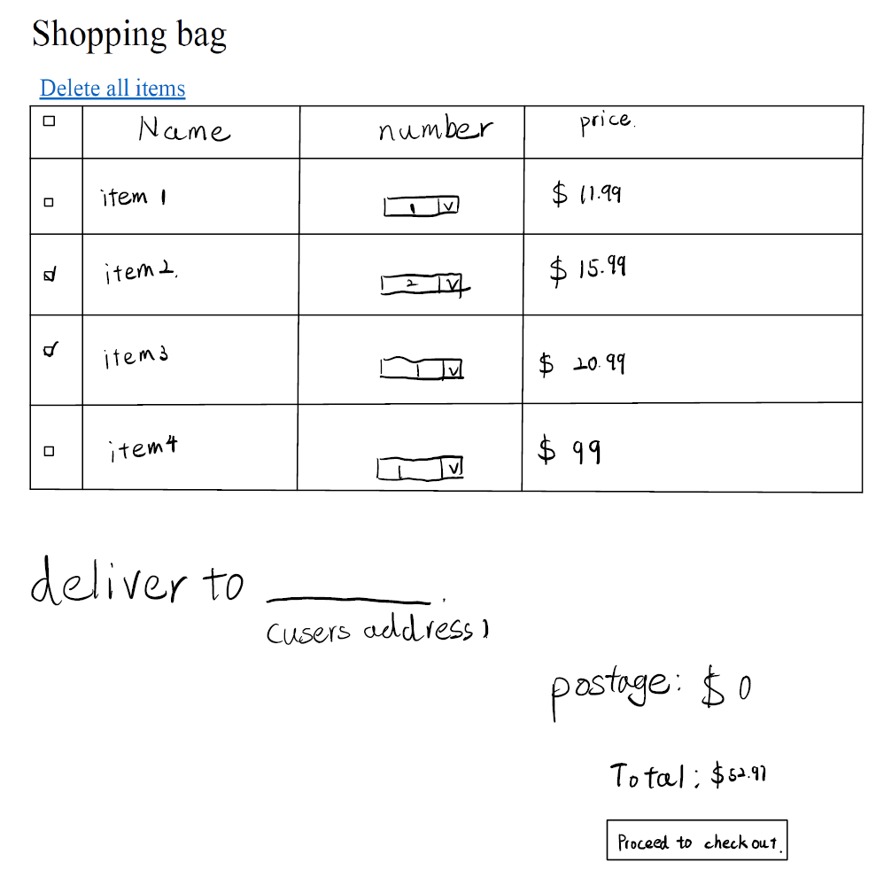

(picture of shopping bag)

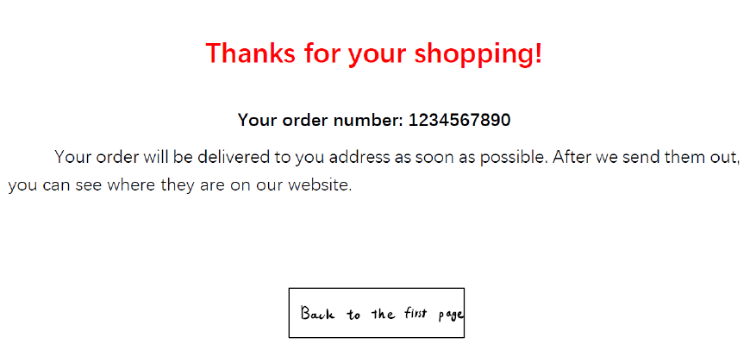  
(order number page)

For the “trade-off” between usability and security, I use an account system. I design this system like other websites’ account system. If we need a little information, this website will be easy to attack. But if the process is too long, it will make users unlike to use our online service. When you first visit this website, you must create your own account. And when you register, you must enter your email address and input the number you received in your e-mail box. After you finish it, you can login with your username and password. You can also connect your account with your google account so that you can use your google account to login.

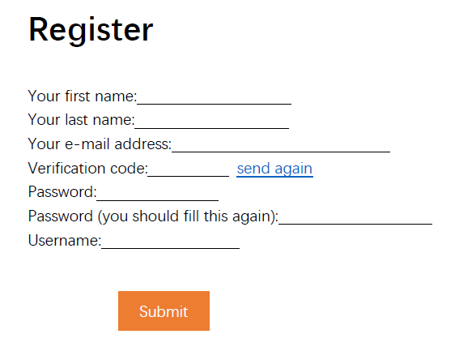

(the process of registering)

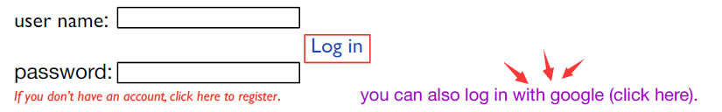

(the way of login with google)

For the insurance services, many users thinks it is useful when they broke their devices by mistake. So, I just show that “we pay for your mistake”. I think that is the only important point of insurance.

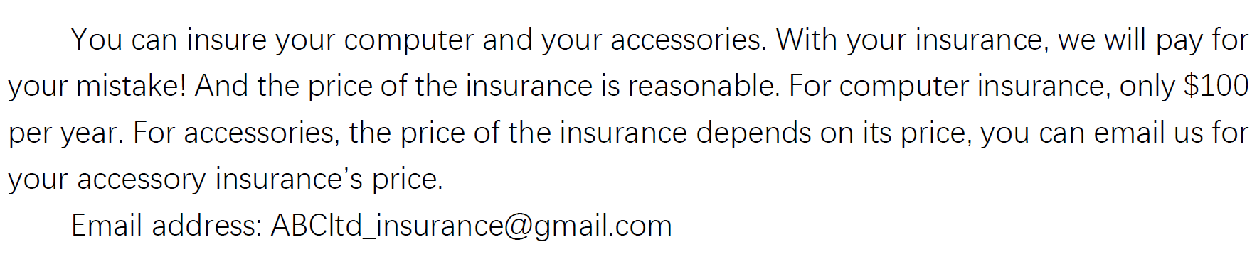

(picture of insurance)

Then for the contents, I am just putting some examples on the website. You can see there are used computers and part exchange and the sale of reconditioned computers in the page “computers” and different kinds of computer accessories in the page “computer accessories” and so on. But in the “repair” page, I do not show the service like “computer” and “computer accessories” because I think the way and the cost of repairment are not sure. So, I just show the email address and phone number of the staff.

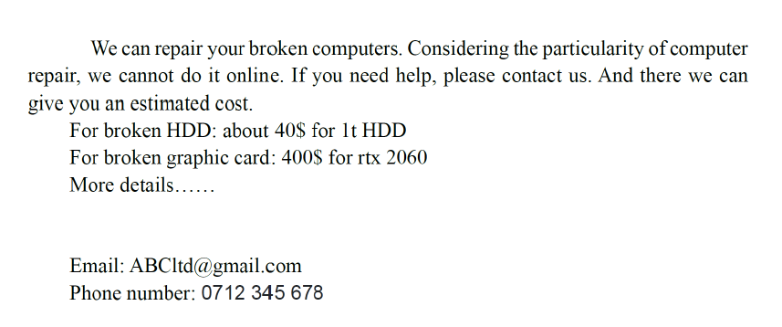

(the “repair” page)

The same as “repair”, I don’t show too many details in the “data recovery” page. Data recovery problem is too complex, so l just provide users with a form. If users have any problem, they can fill the form and submit, then staff will contract with them.

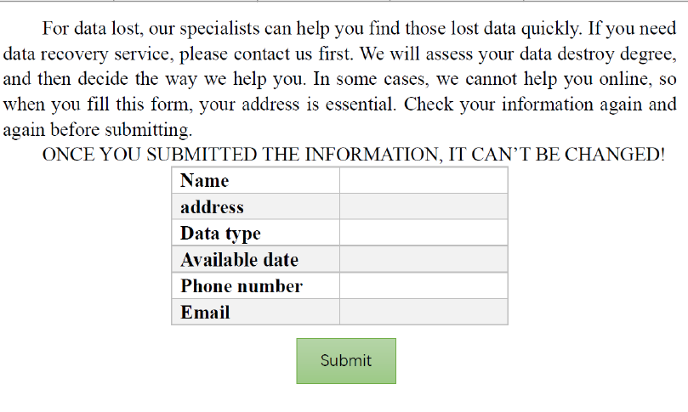

(data recovery page)

## Implementation

For how to take this website into use, my choice is to put it on the cloud-based sever. There are too many examples that serve data were broken just because power failure. Cloud-based serve are less likely to shutdown unexpectedly, and this method can decrease the cost of run the website and make the website easy to maintain.

As for the data storage and data back-up and disaster recovery and risk analysis. I choose to use RAID1. Data lost is common, the best way of decreasing the cost of data lost is to make data backup. That is why I choose RAID1. When one of the disks are broken, another mirror disk still can be read. This method makes data problem almost impossible.

## Conclusion

During this website design, I gradually learned that knowing what users want is of great importance. And knowing the advantages of similar projects is also of great importance. And I have learned two important things about web design.

The first thing is account systems’ complexity. When I started to design the account system, I did not know how to build it. But after I learned how other online shopping websites’ account systems, I got to know how it works and how to design it. The most important section of system is its complexity.

The second thing is the shopping bag system. If users want to buy several goods, we can only pay them one by one without shopping bag system. With shopping bag, users can easily buy several goods at one time.

## Appendix

This report only uses my own project for illustrations.