CHAPTER 11 INTERNATIONAL TRADE AND TRADE POLICY

**Answers to Review Questions**

1. An individual has a comparative advantage in the production of a particular good if she can produce it at a lower opportunity cost than other individuals. An individual has an absolute advantage in the production of a good if she can produce more of that good than another individual, using comparable amounts of time, raw materials and effort.

Learning Objective: 11-01

AACSB: Reflective Thinking

Bloom’s: Understand

1. If the world price of coffeeis twice the world price of tea, the economy will do best by producing only coffee, then trading for as much tea as domestic citizens want at the rate of two pounds of tea per pound of coffee. Likewise, if the price of coffee is half that of tea (i.e., the price of tea is twice that of coffee), the economy should produce only tea and trade for as much coffee as it needs. If the world price of coffee equals the world price of tea, then the opportunity cost of a pound of tea is the same whether it is produced domestically or acquired from abroad. So in this special case there is no benefit from trade and the country should just produce its own coffee and tea in the proportion that its citizens prefer.

Learning Objective: 11-02

AACSB: Reflective Thinking

Bloom’s: Understand

1. False. Even if a country has an absolute advantage in every sector, there are likely to be sectors in which the neighboring country has a comparative advantage. If so, then both countries can benefit from trade.

Learning Objective: 11-02

AACSB: Reflective Thinking

Bloom’s: Understand

1. See the figure below. The tariff raises the domestic price of automobiles to the world price plus the tariff. Facing a higher domestic price for cars, domestic producers supply more cars and domestic consumers demand fewer cars. Imports, the difference between the domestic quantities demanded and supplied, decline. Consumers are hurt by the tariff, as they must pay more for cars, while domestic producers (who receive a higher price for their output) are helped. The government benefits by collecting tariff revenue. Overall, though, the tariff is inefficient; the costs to consumers exceed the benefits to producers and the government.

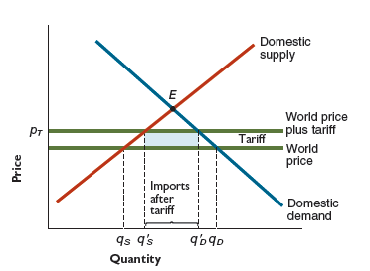

Learning Objective: 11-03

AACSB: Analytic

Bloom’s: Apply

1. See the figure below. If the quota allows fewer imports than would occur under free trade, then the domestic price will be higher than the world price. Consumers face a higher price and are thus worse off; domestic producers, who receive a higher price for their output, are better off. Unlike the case of a tariff, with a quota the government collects no revenue; those revenues flow instead to holders of import licenses, who can buy cars at the world price and re-sell them at the higher domestic price.

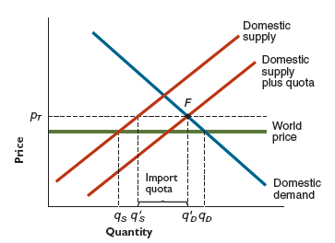

Learning Objective: 11-03

AACSB: Analytic

Bloom’s: Apply

1. A reduction in trade barriers between the two countries would lead to an increase in exports from the industries in each country that enjoy a comparative advantage: more cheese would be shipped from France to England, more bicycles from England to France. British dairy farmers and French bicycle manufacturers would see demand for their products fall, giving these groups a strong incentive to block the trade expansion.  On the other hand, if the adversely affected groups had sufficient political power, they wouldhave an even better option: The fact trade expansion would make national income higher in both countries means that it would be possible to redistribute income in both countries so that all parties come out better off than before the expansion. This better outcome, however, could only be achieved if the two governments implemented the requisite compensation payments.

Learning Objective: 11-03

AACSB: Analytic

Bloom’s: Analyze

### **Answers to Problems**

1. In the time it takes Ted to wash one car, 60 minutes, he can wax 3 cars (60 minutes / 20 minutes per wax job). Therefore, Ted's opportunity cost of washing one car is 3 wax jobs. In the time that it takes Tom to wash one car, 30 minutes, he can wax 2 cars (30 minutes / 15 minutes per wax job). Therefore, Tom's opportunity cost of washing one car is 2 wax jobs.

Alternatively, you can compute how many cars each person can wash or wax in a certain time period, such as an hour, and then use these quantities to compute their opportunity cost. In 60 minutes, Ted can wax 3 cars or wash 1 car, so his opportunity cost of washing one car is 3 (= 3/1) wax jobs. Likewise, in 60 minutes, Tom can wax 4 cars or wash 2 cars, so his opportunity cost of washing one car is 2 (= 4/2) wax jobs.

Because Tom’s opportunity cost of washing a car is lower than Ted’s, Tom has a comparative advantage in washing cars.

Learning Objective: 11-01

AACSB: Analytic

Bloom’s: Apply

1. In the time that it takes Nancy to replace a set of brakes, 2 hours, she can complete one-half of a clutch replacement (2 hours for brakes/4 hours for a clutch). Therfore, Nancy’s opportunity cost of replacing a set of brakes is one-half of a clutch replacement. In the time that it takes Bill to replace a set of brakes, 2 hours, he can complete one-third of a clutch replacement (2 hours for brakes/6 hours for a clutch). Therefore, Bill’s opportunity cost of replacing a set of brakes is one-third of a clutch replacement.

Alternatively, you can compute how many clutches or brakes each person can replace in a certain time period, such as 6 hours, and then use these quantities to compute their respective opportunity cost: Nancy can replace 1.5 clutches or 3 sets of brakes in that time, so her opportunity cost of replacing one set of brakes is one-half of a clutch replacement (1.5/3). Likewise, Bill can replace 1 clutch or 3 sets of brakes, so his opportunity cost of replacing one set of brakes is one-third of a clutch replacement (1/3).  
  
Bill’s opportunity cost of replacing a set of brakes is lower than Nancy’s, so Bill has a comparative advantage in replacing brakes.  This also implies that Nancy has a comparative advantage in replacing clutches (the opportunity cost of replacing a clutch is the inverse of the opportunity cost of replacing a set of brakes).

Finally, neither person has an absolute advantage in brake replacement since Nancy and Bill take the same amount of time to replace a set of brakes. Nancy has an absolute advantage over Bill in clutch replacement since it takes her less time than it takes Bill to perform that job.

Learning Objective: 11-01

AACSB: Analytic

Bloom’s: Apply

1. a. Absolute advantage belongs to the worker that can pick the most fruit in a given

time period. Since Anne can pick 100 apples each day and Bill can pick only 50, Anne has an absolute advantage in picking apples.

Comparative advantage for apples belongs to the worker who can pick an additional apple with the lowest opportunity cost. For Anne, the opportunity cost of picking 100 more apples is 25 fewer bananas (one day's worth of work), so the opportunity cost of each additional apple is 0.25 or one-fourth banana (25/100). Similarly, Bill's opportunity cost of picking 50 more apples is 50 fewer bananas (one day's worth of work), so the opportunity cost of each additional apple is 1 banana (50/50).  Since Anne has the lower opportunity cost for picking apples, she has the comparative advantage in picking apples. Note that each worker’s opportunity cost of picking one more banana is the inverse of his or her opportunity cost of picking one more apple, so Bill has the lower opportunity cost for picking bananas (1 apple for Bill compared to 4 apples for Anne).

b. If Anne and Bill both picked nothing but apples, they could pick 150 apples daily; 100 by Anne and 50 by Bill. With each worker working 200 days per year, the total number of apples picked annually would be 30,000 (150 × 200). Similarly, if Anne and Bill both picked nothing but bananas, they could pick 75 bananas daily; 25 by Anne and 50 by Bill. With each worker working 200 days per year, the total number of bananas picked annually would be 15,000 (75 × 200).

c. If each worker fully specializes according to his or her comparative advantage, Anne would pick nothing but apples, and Bill would pick only bananas. After 200 days, they would have 20,000 apples (100 × 200) picked by Anne and 10,000 bananas (50 × 200) picked by Bill.

Learning Objective: 11-01

AACSB: Analytic

Bloom’s: Apply

1. a. The word price of shoes is $10 a pair, so that a foreign worker can earn $5,000

($10 × 500) annually by working in the shoe industry. The world price of a robot is $5,000, so that a foreign worker can also earn $5,000 ($5,000 × 1) annually working in the robot industry.

b. A U.S. worker can produce either 10 industrial robots or 1,000 pairs of shoes per year, so the opportunity cost for one robot is 100 pairs of shoes: if 10 robots = 1,000 pairs of shoes, then 1 robot = 1,000/10 shoes. Similarly, a foreign worker can produce either 1 industrial robot or 500 pairs of shoes per year, so the opportunity cost for one robot is 500 pairs of shoes. Since U.S. workers have the lower opportunity cost for producing robots, the U.S. has a comparative advantage in the production of robots, and the U.S. will export robots. The opportunity cost for a pair of shoes is 0.01(=10/1,000) robots for a U.S. worker and 0.002 (=1/500) robots for the foreign worker.  Since U.S. workers have the higher opportunity cost of producing shoes, the U.S. will import shoes.

c. Before the opening to trade, a U.S. worker's income will buy 1,000 pairs of shoes ($30,000/$30 = 1,000) or 10 robots ($30,000/$3,000 = 10). Since the world price for industrial robots is $5,000, when the U.S. is open to trade, each worker will earn $50,000 ($5,000 × 10) making robots. That $50,000 is enough to buy 5,000 pairs of shoes ($50,000/$10 = 500), or 10 robots ($50,000/$5,000 = 10).  So buying power in terms of robots is unchanged, but in terms of shoes, it has quintupled.  Even though they are trading with foreign workers who earn much less than they do, U.S. workers are made better off by trade.

d. In the short term, it might be costly for workers in the shoe industry to switch to the robot industry.  The best policy response, however, is not to block trade (which increases consumer buying power in both the U.S. and abroad).  Instead, the government could help facilitate the transition by reducing the costs associated with switching industries. This might include helping workers acquire new skills or relocate to a new area.

Learning Objective: 11-01

AACSB: Analytic

Bloom’s: Apply

1. a. As seen inthe graph below, the quantity of automobiles demanded and supplied

both equal 17,000 at a price of $14,000. So this is the market equilibrium if the economy is closed.

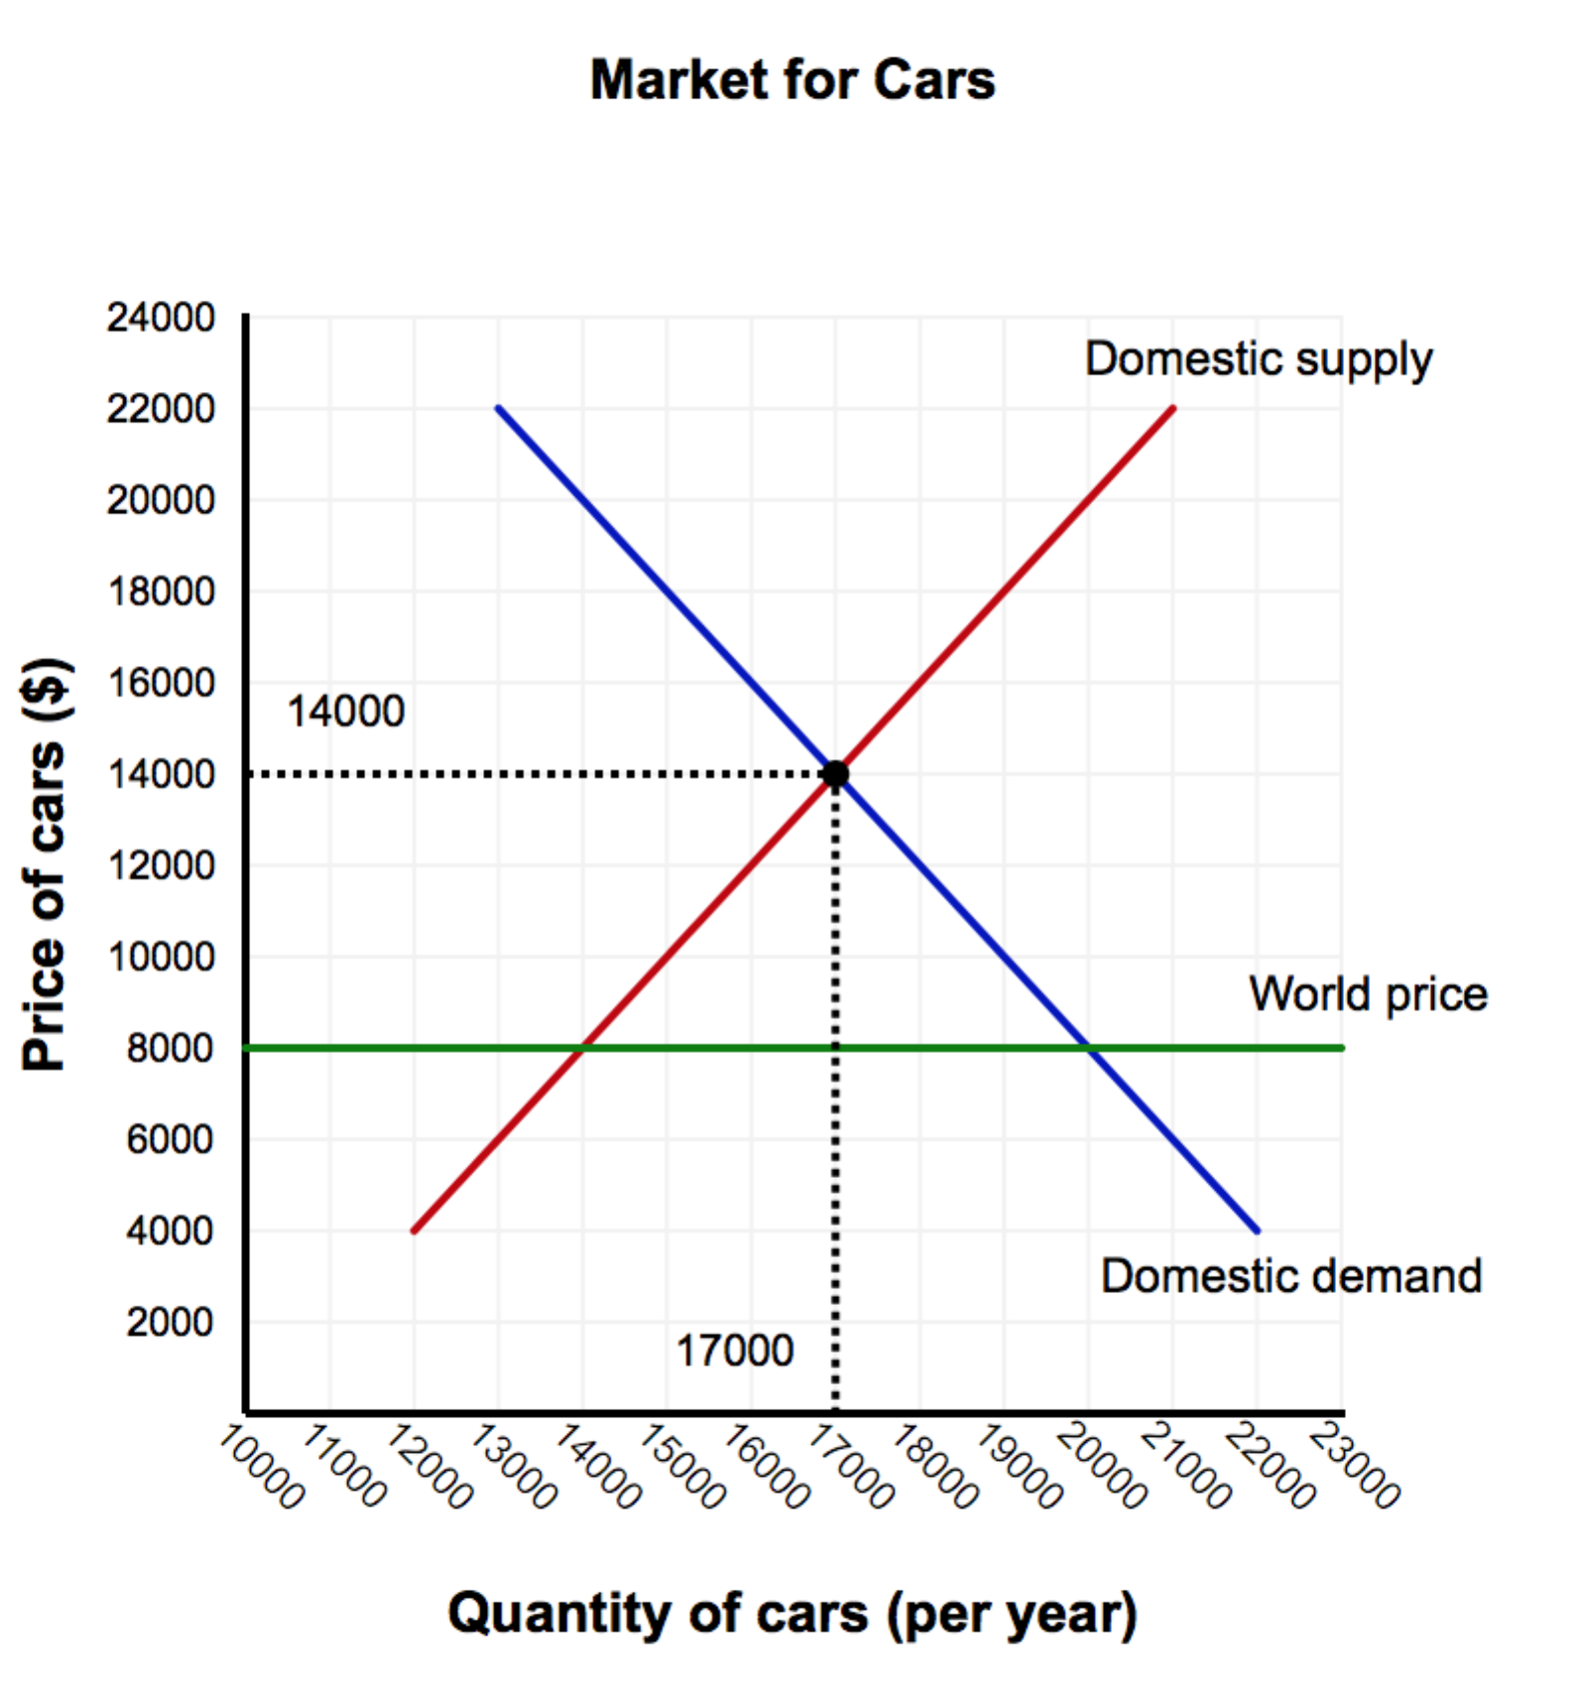

b. If the economy opens to trade, then the world price of automobiles becomes the domestic price. At the world price of $8,000, the domestic quantity demanded will be 20,000 cars per year, and domestic quantity supplied will be 14,000 cars per year. This difference (20,000 - 14,000) is made up by importing 6,000 foreign-produced cars. The opening of the automobile market to trade will be favored by domestic consumers, who will buy more cars at a lower price.  Domestic producers, however, will oppose the opening of the automobile market to trade because they will be forced to lower the price of their cars to compete with cheaper foreign imports.

c. When the government imposes a tariff of $2,000 per car, the domestic price paid for cars increases to $10,000, and as a consequence, the domestic quantity demanded decreases to 19,000 cars per year, and the domestic quantity supplied increases to 15,000 cars per year.

d.   As a result of the tariff, the quantity of imports decreases to 4,000 cars per year (19,000 - 15,000). Since the government collects $2,000 per car and 4,000 cars are imported, $8 million ($2,000 × 4,000) in revenue will be raised by the tariff. Domestic producers will favor the imposition of the tariff since they are now able to sell more cars at a higher price, while domestic consumers will oppose the tariff as cars are now more expensive.

Learning Objective: 11-02, 11-03

AACSB: Analytic

Bloom’s: Apply

1. a. Whenthe economy is open to trade, the world price of automobiles becomes the

domestic price. At the world price of $10,000, the domestic quantity demanded is 19,000 cars per year, and domestic quantity supplied is 15,000 cars per year.  This difference (19,000 - 15,000) is made up by importing 4,000 foreign-produced cars.

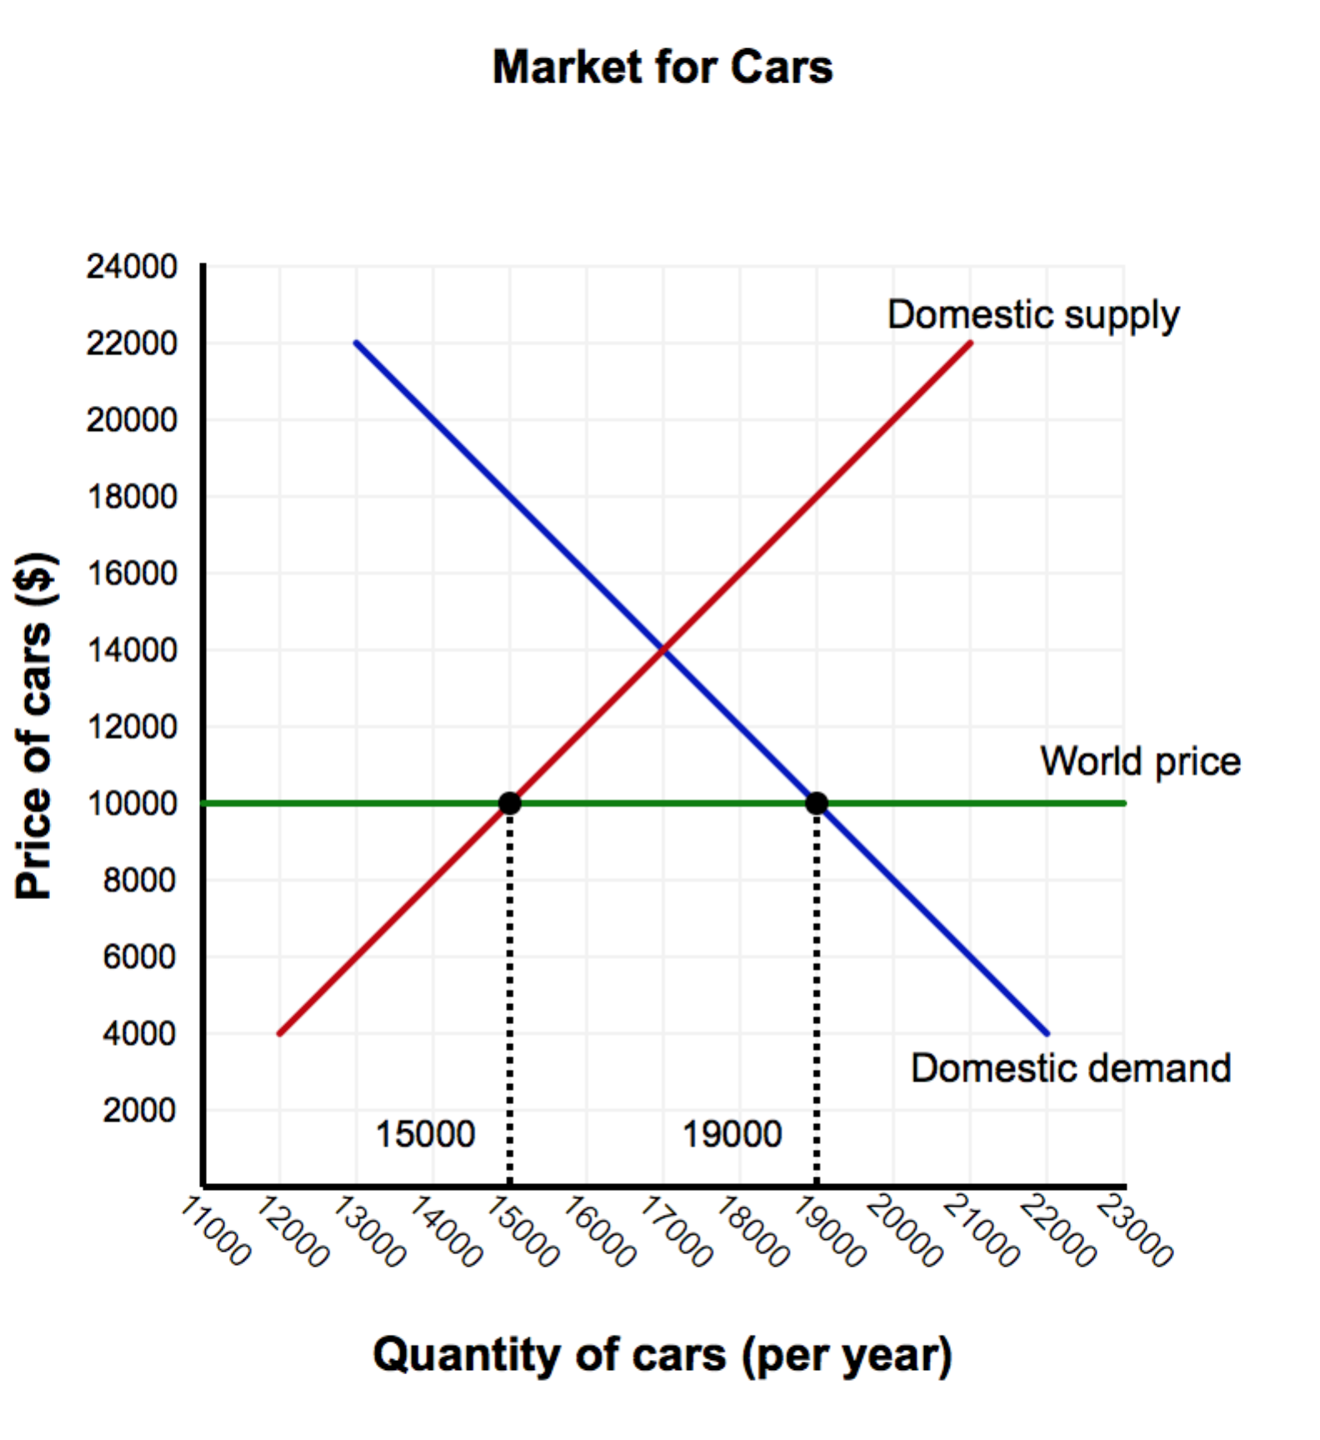

b. If the government imposes a quota on automobile imports of 2,000 cars per year, the total number of cars available to domestic consumers will be the number of cars produced by domestic producers plus the 2,000 imported cars. The total number of cars available to domestic consumers after the quota is illustrated by the new supply curve in the graph above. The domestic demand curve and the "Domestic supply plus quota" curve intersect at a price of $12,000 per car. At this higher price, the domestic quantity demanded decreases to 18,000 cars per year, and the domestic supplied increases to 16,000 cars per year. So, as expected, the quota leads the quantity of imports to fall to 2,000 (= 18,000 - 16,000) cars per year, which is the legal limit on imports.

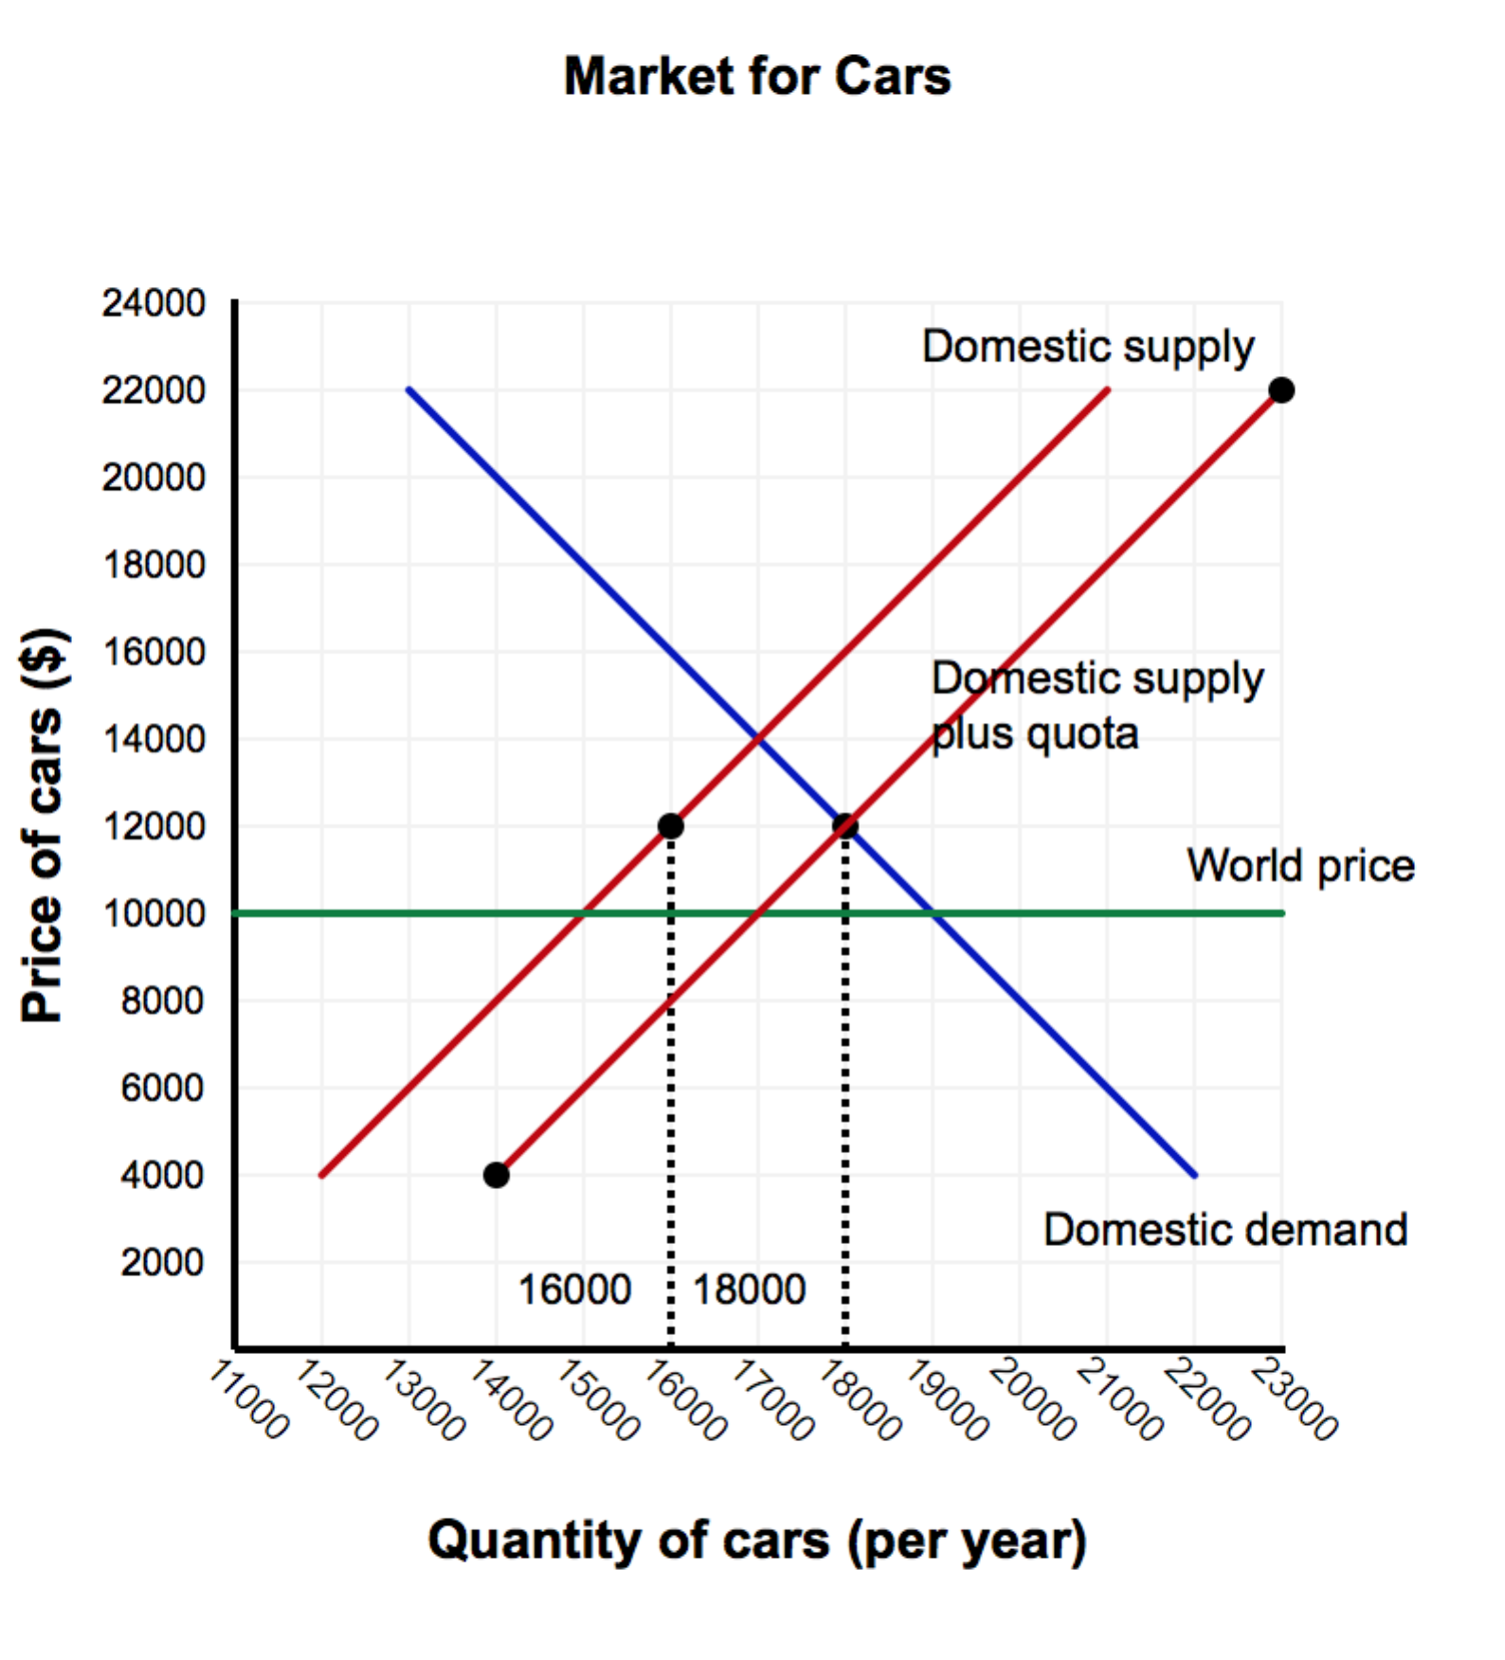

c. Both domestic producers and those with an import license will favor the imposition of

the quota. Domestic producers will be able to sell more cars at a higher price, and those with an import license can pocket an extra $2,000 per car - the difference between the domestic price of $12,000 and the world price of $10,000. Domestic consumers will oppose the quota as it makes cars more expensive.

Learning Objective: 11-02, 11-03

AACSB: Analytic

Bloom’s: Apply

1. You should reject the trade agreement if your election as president depends on how many votes you get in an election. The union representing manufacturing workers can deliver more votes than the union representing tourism workers; since the union representing manufacturing workers opposes the trade agreement, you should take their side in order to get their votes.

Learning Objective: 11-03

AACSB: Analytic

Bloom’s: Analyze