練習題

1. 下列何項因素會影響一項特定商品或勞務之消費者的保留價格：社會影響、商品的價格或生產該商品的成本？

Peer influence provides an example of how social forces often influence demand; it is often the most important single determinant of demand. A change in cost is a supply-side influence that will shift supply and not affect reservation price. A change in the price moves the consumer along the demand curve and does not affect reservation price.

1. 你預期下列哪種餐廳的服務會更積極、更有禮貌：昂貴的美食餐廳、平價的餐館？請解釋之。

We would expect patrons of the gourmet restaurant to have higher incomes, on average, than patrons of the diner, since the willingness to pay for high quality food is likely to increase with higher income. Likewise, the willingness to pay for service is also likely to increase with higher income. Since people tend to leave tips of about 15 percent of the prices of their restaurant meals, gourmet restaurant patrons actually pay for higher service quality, and are therefore more likely to receive it.

3. 某遊樂園門票的買方市場中有兩種類型的消費者，其個別的需求顯示在下圖中，請繪圖顯示此市場的需求曲線。

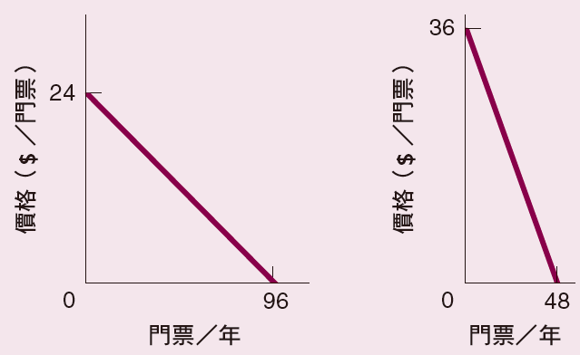

1. The market demand curve (right panel) is the horizontal summation of the two individual demand curves (left and center panels).



4. Ann 住在紐澤西州的普林斯頓 (Princeton)，她因為工作需要必須坐火車至紐約，每個月往返達 20 次。當來回票價自 10 美元上升至 20 美元時，Ann 仍然每個月搭火車往返 20 次，但是她在餐廳用餐的支出則減少了 200 美元。

a. Ann 並未隨著來回票價調漲而改變其搭火車往返的次數，這表示他是一位不理性的消費者嗎？

b. 請解釋為何增加搭車的費用，可能會影響 Ann 在餐廳用餐的支出。

a. Even at twice the original price, the marginal benefit of each of the twenty train trips may be higher than the marginal cost of each trip, even when including the implicit costs of a trip such the best alternative use for the money spent. After all, missing a trip implies missing an entire day’s work.

1. The higher price of train tickets results in Ann having less money to spend on restaurant meals. The income effect of the price increase is what leads to the reduction in the number of restaurant meals she eats.

5. 一輛特定品牌（諸如雪佛蘭，Chevrolet）的汽車需求價格彈性，會比不論品牌之所有汽車的需求價格 彈性高或是低？

The price elasticity of a good generally **increases with the number of available substitutes for the good.** It is easier to substitute a Ford or Toyota for a Chevrolet than it is to substitute a motorcycle or a skateboard for a car. Thus the market demand curve for cars is likely to be less elastic with respect to price than the market demand curve for Chevrolets or any specific car brand.

6. 以絕對值計算下列需求曲線上的 A、B、C、D 及 E 點的需求價格彈性。

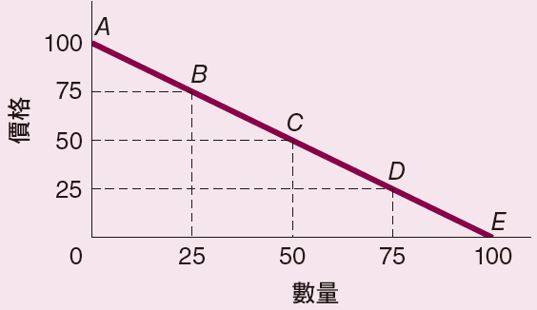

For the demand curve shown, the slope is 1 so 1/slope is also 1. The absolute value of the price elasticity of demand at any point on this demand curve is thus the ratio (*P*/*Q*) at that point.

|  |  |
| --- | --- |
| **Point** | **Elasticity** |
| **A** | infinity |
| **B** | 3 |
| **C** | 1 |
| **D** | 1/3 |
| **E** | 0 |

7. 下表顯示加州戴維斯 (Davis) 的貝果在不同價格水準下的每日銷量。

|  |  |
| --- | --- |
| 貝果價格 **($** ／份 **)** | 每日售出的貝果份數 |
| 6 | 0 |
| 5 | 3,000 |
| 4 | 6,000 |
| 3 | 9,000 |
| 2 | 12,000 |
| 1 | 15,000 |
| 0 | 18,000 |

a. 請繪製戴維斯的每日貝果需求曲線。

b. 當每份貝果的價格為 3 美元時，需求曲線上該點的需求價格彈性值為多少？

c. 若每份貝果的價格由 3 美元上升至 4 美元時，其總收益會發生何種變化？

d. 當每份貝果的價格為 2 美元時，需求曲線上該點的需求價格彈性值為多少？

e. 若每份貝果的價格由 2 美元上升至 3 美元時，其總收益會發生何種變化？

a. See graph below:

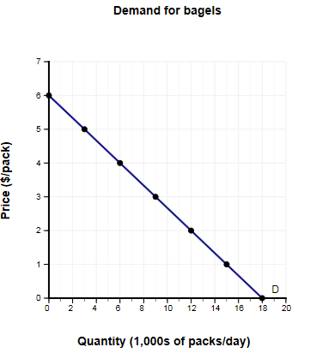

* 1. The formula for calculating the price elasticity of demand is



Substituting *P* = 3, *Q* = 9 and slope is 1/3, we have



* 1. Total revenue equals *P* x *Q*. Thus, if the price per package increases from $3 to $4, total revenue will fall from $27,000 to $24,000.
  2. Using the same formula as in part b:



* 1. Total revenue equals *P* x *Q*. Thus, if the price per package increases from $2 to $3, total revenue will rise from $24,000 to $27,000.

8. 假設你在叔叔的衣櫃中翻找東西時，發現一幅價值不菲的真跡名畫 Dogs Playing Poker，並決定在叔叔家的車庫中對外展示這幅畫。前往觀賞這幅畫的需求曲線顯示於下圖，若你打算銷售門票並取得最大的收益，則應該將票價訂為多少？也請繪圖顯示其需求曲線上的低彈性與高彈性區間。  
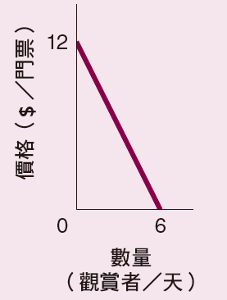

Along any straight-line demand curve, the elasticity of demand is greater than 1 (demand is elastic) at any price and quantity combination above the midpoint, and the elasticity of demand is less than 1 (demand is inelastic) at any price and quantity combination below the midpoint. At the midpoint, the price elasticity of demand is equal to 1 (demand is unit elastic). Revenue is maximized when demand is unit elastic. Thus, the price should be set at the midpoint of the demand curve ($6 per visit).



9. 假設政府為了引導人們節約能源，規範所有冷氣機必須更有效率地使用電力。在執行此規範後，政府單位驚覺人們使用的電力比以前更多，請利用價格彈性理念說明人們用電量增加的可能原因。

The government officials failed to take into account that people don’t demand electricity for its own sake, but rather as a means to accomplish other ends such as producing cooler air for their homes. By requiring people to buy more efficient air conditioners, the government effectively reduced the price of buying cooler air. If the demand for cool air is sufficiently elastic with respect to price, people may buy so much more of it that they end up using more electricity.

10. 當牛奶價格上漲 2%，巧克力糖漿的需求量會減少 4%，請問巧克力糖漿依據牛奶價格變動的需求交叉彈性值是多少？兩種商品的關係是屬於互補性財貨或是替代性財貨？

The cross-price elasticity is



Since this cross elasticity is negative, the two goods are complements.