Lab environment

Operating System: Windows Server 2012 Standard

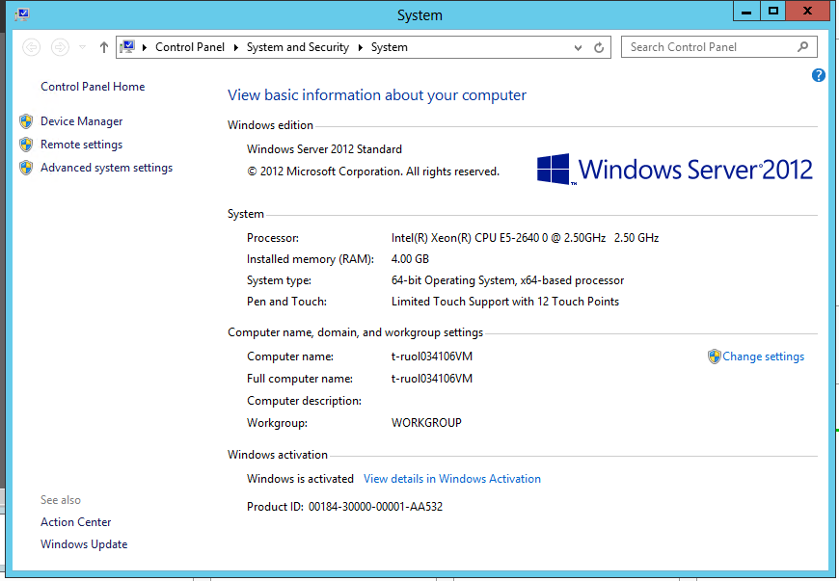

Test the Internet connection under 2 different safe modes, “minimal” and “network”.

1. Normal mode

Network connection:



Website connection

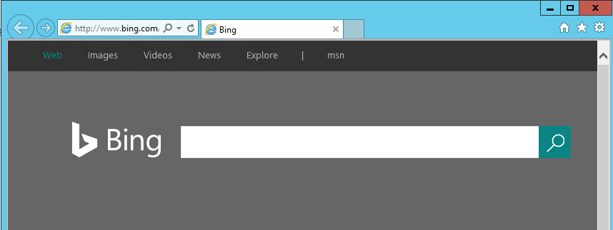

1. Safe Mode(Network)

Enable safe mode in Network option:

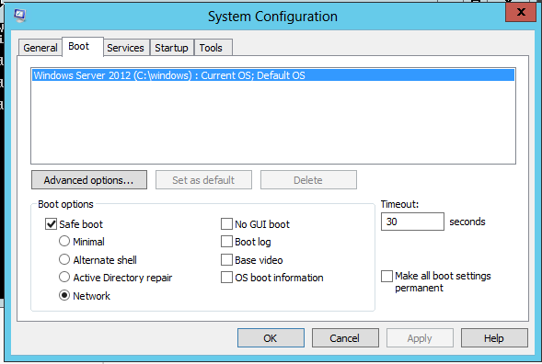

Restart server and press “enter” to enter safe mode

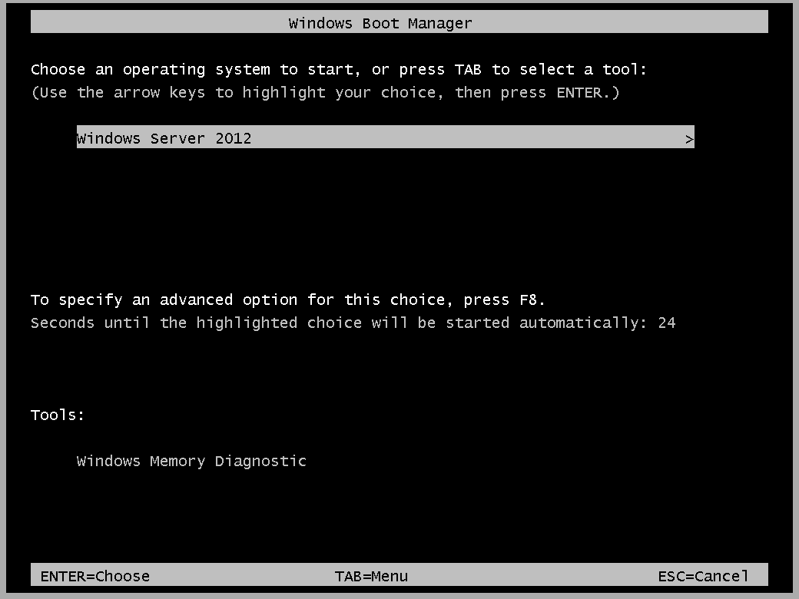

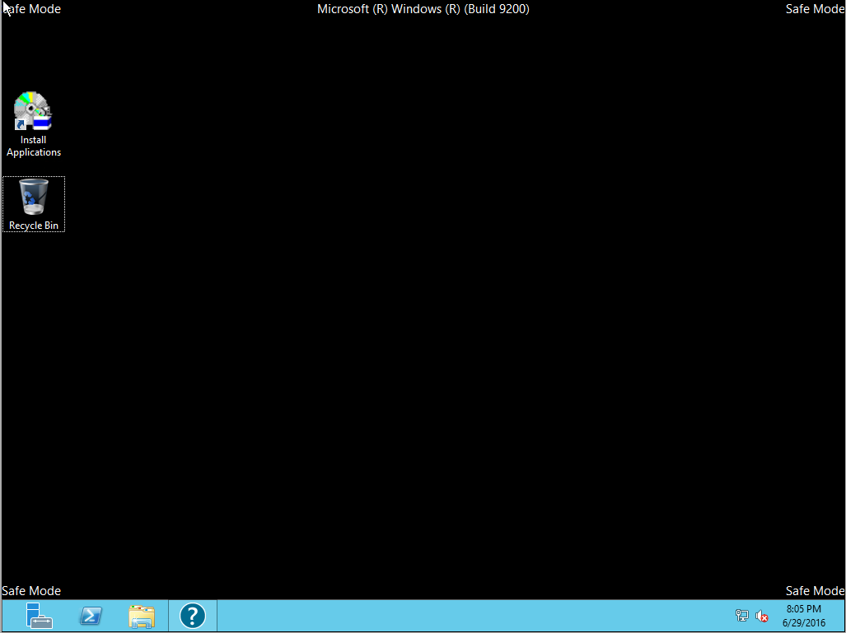

Network connection: connected



IE: can visit Internet



1. Safe Mode(minimal):

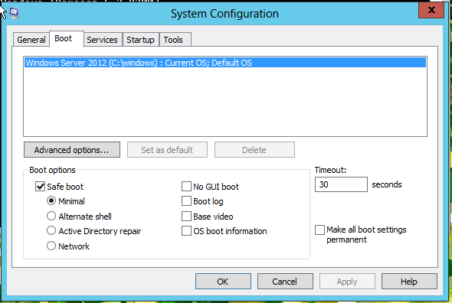



Internet connection: No internet connection



IE: cannot visit internet

