Change spatial resolution

I used OpenCV in C++ to resize images.

Original resolution: 640\*480

New resolution: 400\*300、600\*400、800\*600

Code:

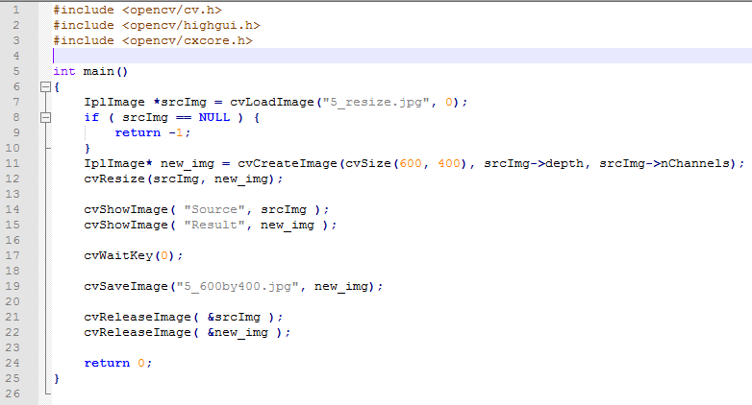

Line 7: IplImang is an object used for images.

Line11: Create an image object whose size is the same as our desired one.

Line12: Call cvResize function to change spatial resolution.