Code:

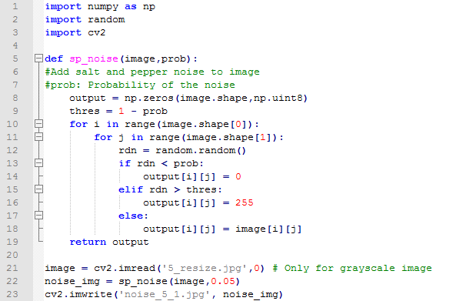

Explanation:

I use OpenCV in python to add random noise.

Line11-18: The type of noise I choose is salt and pepper, which can be seen on the pictures as little black_or_white spots.

Line22: The probability of producing noises is 0.05, it is just the parameter I send in to sp_noise(image,prob) function.