Remove noise

Code:



Explanation:

I use cv2.medianBlur() to remove salt-and-pepper noise in the images.

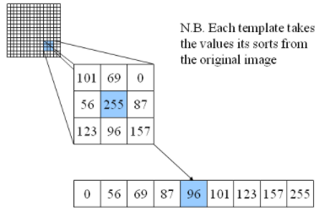

The filter convolves original image to calcutate new values. Then choose the median among those values to represent the central elemenr(pixel).

The approach is effective against salt-and-pepper noise because the new element will not be affected by extreme values in image(white-and-black noise).

And the size of kernal I use is 3*3. I have tried other sizes but 3*3 is the best among all.

References:  
https://docs.opencv.org/3.1.0/d4/d13/tutorial_py_filtering.html