JAVA期末專題Demo_Report

1. 組員與工作分配：  
   組員：吳沛璇  
   工作分配(一人)：  
   繪圖(我用小畫家)  
   程式碼撰寫(我)  
   架構構想(我)
2. 題目敘述與作品介紹：  
   靈感來源來自小朋友下樓梯，但在這裡是阿宅下樓梯，兩者相比做了一些改變：下樓梯是一種運動，所以玩家會先輸入目前體重與理想體重，會面會根據下了多少樓梯去調整體重，達標算成功！
3. 系統架構與分析：  
     
   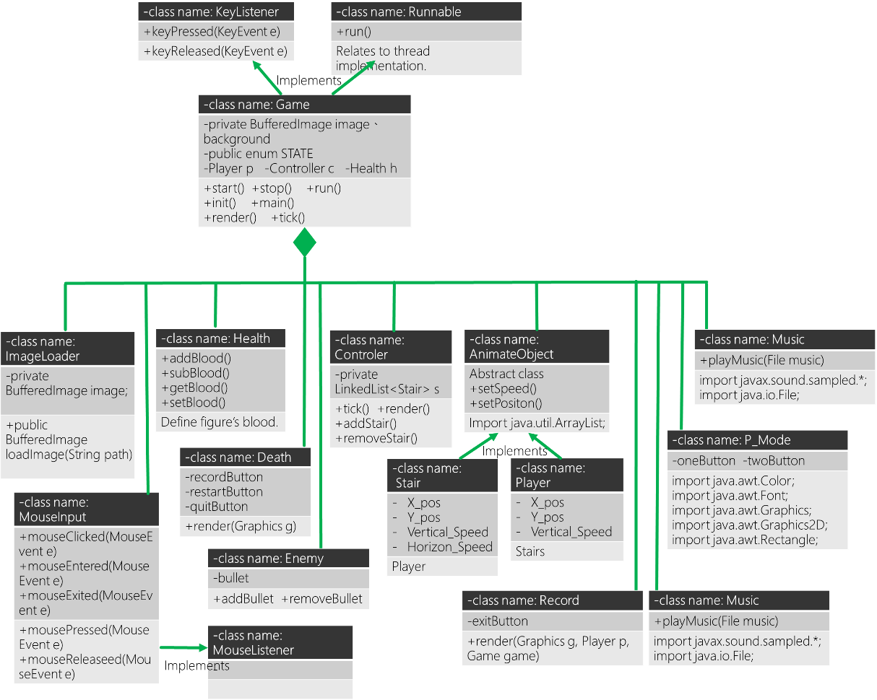  
   使用到的技術：  
   1. 用很多個class分別做不一樣的事，並使用Game當作main class  
    此次project最大收穫  
   2. 使用java.awt.image.BufferedImage和javax.imageio.ImageIO做讀片的讀取，並且使用到上課教的getClass().getResource(path)當技巧  
   3. 開thread做平行處理，提升遊戲流暢度  
   4. 使用timer計算血量回升  
   5. Enum的用法，幫助我更直覺地訂出遊戲不同階段(MENU，GAME，DEATH，RESTART)  
   6. MouseListener和KeyListener的使用  
   7. Graphics和graphics2D(畫按鍵框框)的繪圖  
   8. Setfocus讓eventListener正常運作  
    requestFocus(); //Don't need to press window  
   9. 將所有檔案寫在一個package
4. 執行成果：  
   (執行Game.class，此為主架構)  
   輸入玩家名稱、體重、理想體重：  
   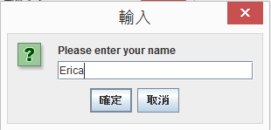  
   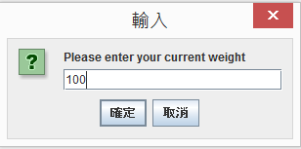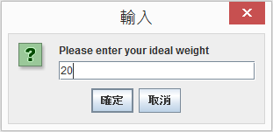  
   遊戲音效：  
   按下Button與Restart重輸資料時，分別有不一樣的音效，歡迎聽聽看！  
   首先選擇1P或2P :  
   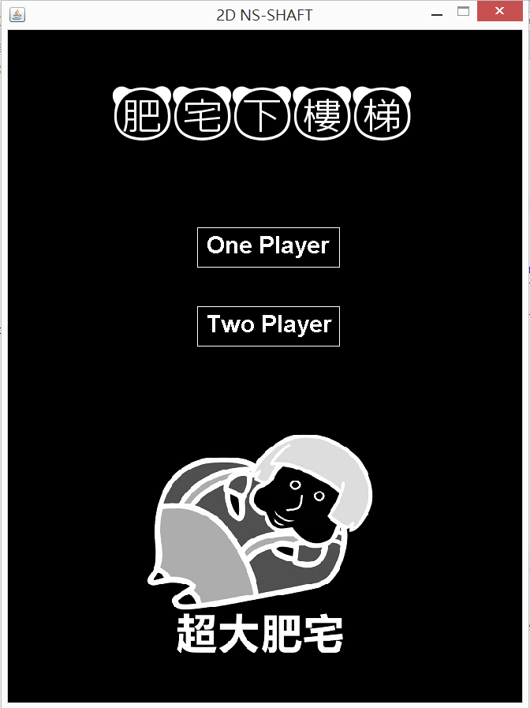  
   遊戲主畫面(目前功能—按Play會開始遊戲、按Quit會結束遊戲)：  
   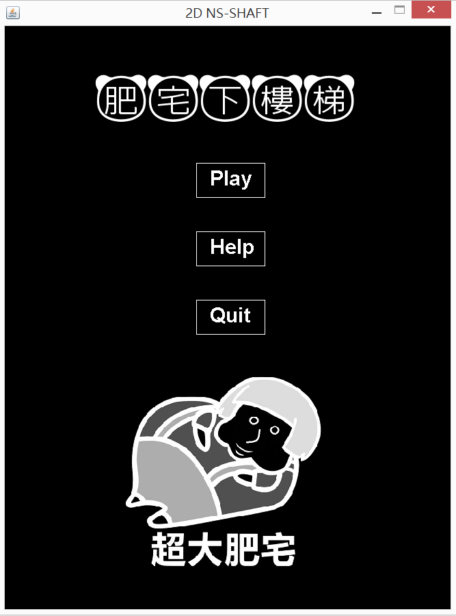  
   遊戲開始：  
   除了正常站在台階上以外，還有往左/右滾動的扶梯(跳上去會往左/右飛)，以及彈簧  
   受限於我的繪畫天分，圖中的綠色為往右，藍色為往左，彈簧則為銀色彈簧，應該還看的出來  
   體重會隨時間而減少，有運動瘦身的感覺  
   此外，我也新增了水果和漢堡功能，吃到水果可以加速瘦身並延長綠色電池壽命，吃到漢堡則相反  
     
   根據玩家的體重，畫面上的宅宅也會有不一樣的胖瘦程度  
   > 80 kg: > 60 kg: > 40 kg: < 40 kg:  
        
   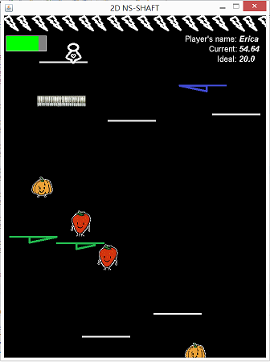  
   被針刺到後會扣血，但我有設定經過一段時間血量會回升10%  
   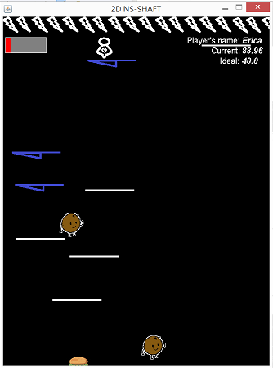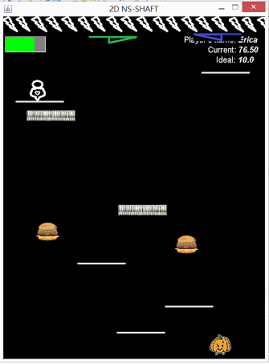  
   當血量扣到0或阿宅掉到畫面下，遊戲結束：  
   共有三個件可以選，目前的功能是按Restart遊戲會重新開始，按Quit整個遊戲會直接關閉，Record的部分則顯示紀錄板  
   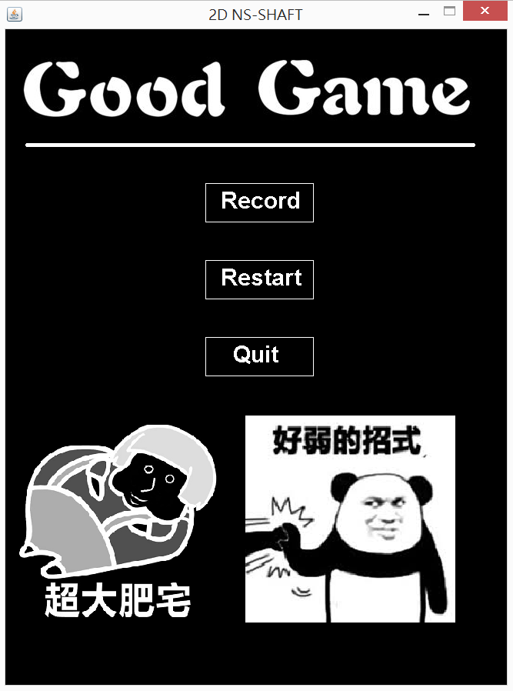  
   按下Restart後，輸入這次挑戰者的名字體重(R為Reset)、並且血會重新回滿：  
   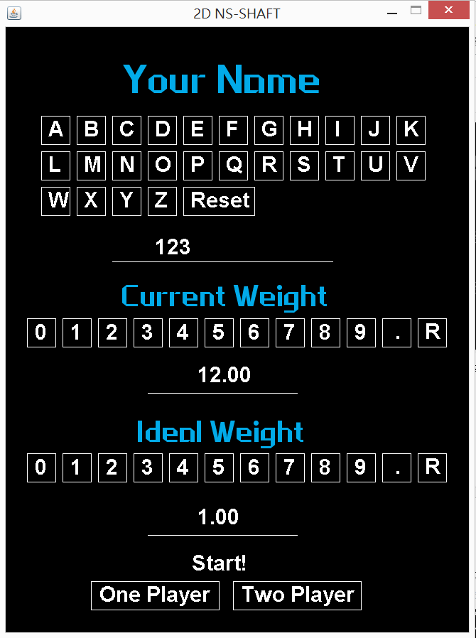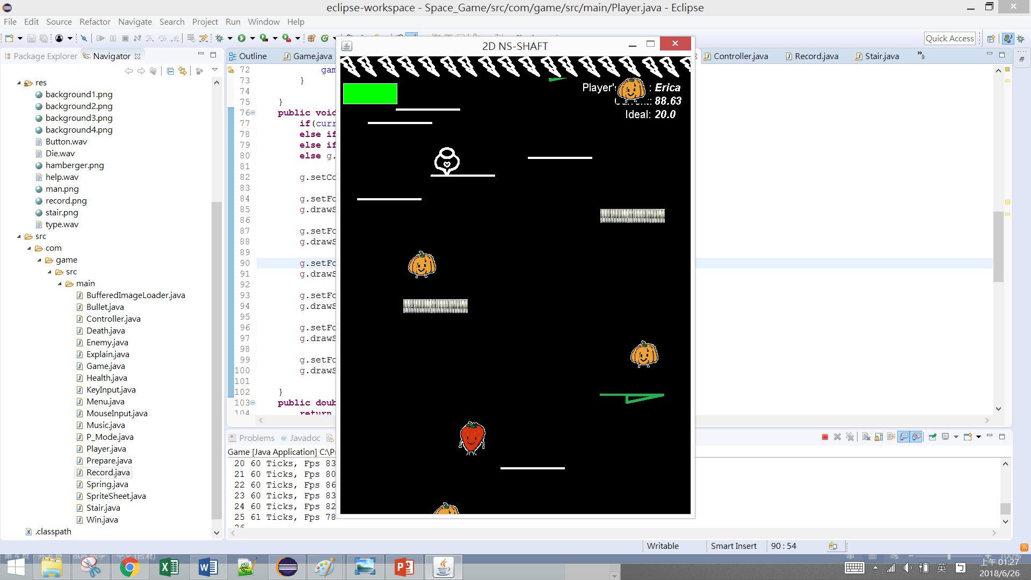  
   按下Record，可以按EXIT離開此畫面回到上一頁MENU:  
   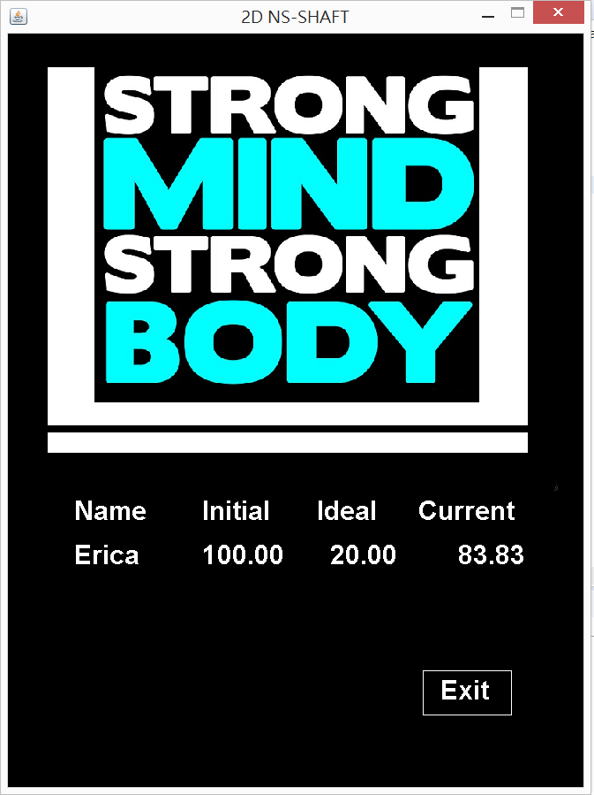  
   如果體重達瘦身目標，進入歡欣鼓舞的畫面  
   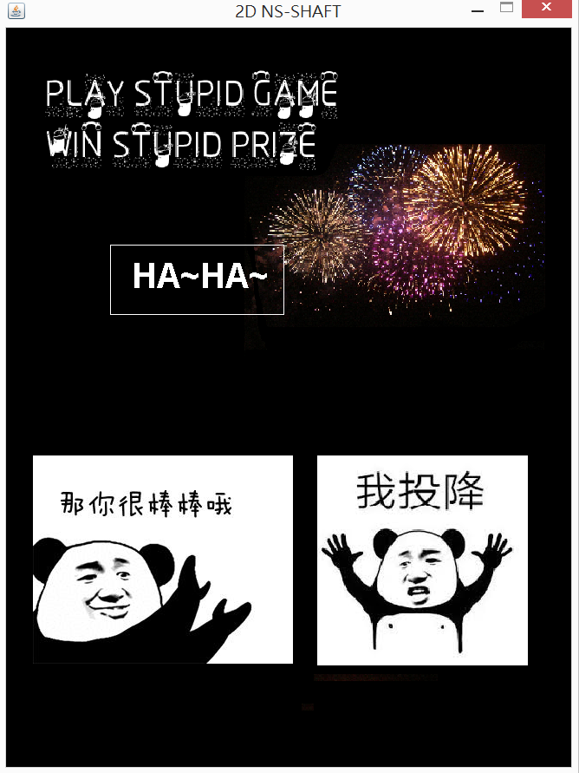  
   這次我還新增了2P功能，讓瘦身的執行更具難度，會有一隻史迪奇在上方發射子彈，讓阿宅壽命一次減10，使運動起來更加艱辛  
   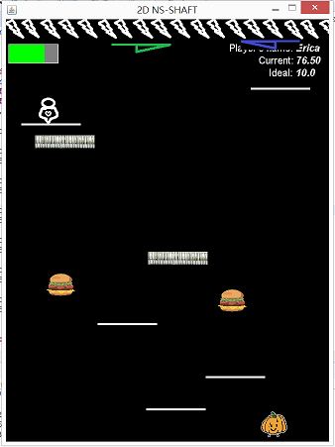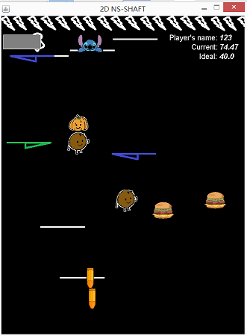  
   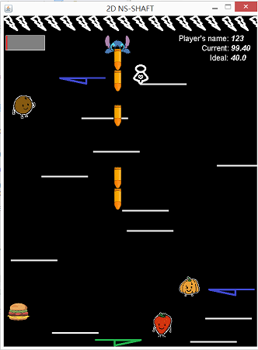
5. 心得報告  
   這次遇到的問題是java的系統架構，在處理swing/awt/swt時，會有自己專屬的thread，所以blocking的程序不太一樣。一開始我直接implement runnable，把全部包在自己開的thread裡，導致每次執行完JOptionpane使用者重新輸入資料時，畫面都會用飆的，後來我才發現需用特殊的使用方式，才能讓他們在thread正常執行，SwingUtilities.invokeLater()能幫助我正確啟用blocking程序。  
   這是我第一次修電機系的課，我覺得老師好認真好有活力，而且上到她覺得重要的地方會很激動，拿著她的棍子一直敲打，我有把這門課推薦給同學，感覺她們明年會來修~  
   專題的部分，因為是一個人做，所以挑了小遊戲，我覺得自己的完成度很高，想不太到要加什麼了QQ  
   期末看被選出來的同學報告，覺得他們好有創意，遊戲也蠻好玩的，我發現要用3D的package做看起來才會精緻。總之這門課很棒，多接觸了新語言和新事物，謝謝老師和助教！
6. 參考資料：  
   有部分圖片是從網站上抓，圖片來源：  
   <https://www.doutula.com/photo/9327870>  
   <https://www.google.com.tw/search?q=%E7%86%8A%E8%B2%93%E6%A2%97%E5%9C%96&source=lnms&tbm=isch&sa=X&ved=0ahUKEwjl6L6q6OjaAhWBWbwKHakDAokQ_AUICigB&biw=837&bih=763&dpr=1.13>  
   <http://www.kunming-spring.com/templates/cache/29067/images/products/photooriginal-29067-932180.jpg?56616>  
   JAVA語法：  
   <https://www.codingmadesimple.com>
7. 請參考java docs的方式，列出class name，extends，implement，Constructor Summary，method Summary：  
   Class BufferedImage

|  |  |
| --- | --- |
| Method | Discription |
| **public** BufferedImage loadImage(String path) **throws** IOException | Gives file name to load image and returns BufferedImage. |

Class Bullet

|  |  |
| --- | --- |
| Method | Discription |
| **public** Bullet(**double** x, Game game) | Constructor. |
| **public** **void** tick() | Updates Bullet’s Y position. |
| **public** **void** render(Graphics g) | Draws Bullet. |
| **public** **double** getX() | Returns Bullet’s X position. |
| **public** **double** getY() | Returns Bullet’s Y position. |
| **public** **double** setVelY() | Sets Bullet’s Y velocity. |
| **public** **double** getVelY() | Gets Bullet’s Y velocity. |

Class Controller

|  |  |
| --- | --- |
| Method | Discription |
| **public** Controller(Game game) | Constructor. |
| **public** **void** tick() | Calculates player’s weight and health. Add a Stair if the number of stairs is less than 15.  Checks whether player is on the stair and whether the player eats food. |
| **public** **void** render(Graphics g) | Draws Stair. |
| **public** **double** addStair(Stair block) | Adds Stair. |
| **public** **double** removeStair(Stair block) | Remove Stair. |

Class Death

|  |  |
| --- | --- |
| Method | Discription |
| **public** Death(Game game, Player p) | Constructor. |
| **public** **void** tick() | Writes down the information of the plater to the vector(full_record). |
| **public** **void** render(Graphics g) | Draws the environment after the player deads. |
| **public** **void** reset_get() | ‘Get’ is the boolean to record whether we get the information of the player. Reset it if there is new player. |

Class Enemy (Class for Player two)

|  |  |
| --- | --- |
| Method | Discription |
| **public** Enemy(Game game) | Constructor. |
| **public** **void** tick() | Controlls Enemy’s X position. Removes bullet if it is out of screen.  Minus Player’s health if it is shot. |
| **public** **void** render(Graphics g) | Draws Bullet. |
| **public** **double** getX() | Returns Enemy’s X position. |
| **public** **double** getY() | Returns Enemy’s Y position. |
| **public** **double** setX(**double** x) | Set Enemy’s X position. |
| **public** **double** setY(**double** y) | Get Enemy’s X position. |
| **public** **void** setVelX(**double** velX) | Set Enemy’s X velocity. |
| **public** **void** addBullet(Bullet block) | Add Bullet from Enemy. |
| **public** **void** removeBullet(Bullet block) | Remove Bullet. |
| **public** **void** removeAllBullet() | Remove all Bullets. |

Class Explain

|  |  |
| --- | --- |
| Method | Discription |
| **public** **void** render(Graphics g) | Draw the environment of explaination. |

Class Game

|  |  |
| --- | --- |
| Method | Discription |
| **public** Enemy(Game game) | Constructor. |
| **public** **void** init() | Create Objects of Player, Controller, P_Mode, Menu, Health, Death, Record, Prepare, Explain, Enemy, Win. |
| **private** **synchronized** **void** start() | Starts thread. |
| **private** **synchronized** **void** stop() | If not running, join all the threads. |
| **public** **void** run() | Implements from Runnable. |
| **private** **void** tick() | Manages every Object’s tick function. |
| **private** **void** render() | Manages every Object’s render function. |
| **public** **void** keyPressed(KeyEvent e) | Renew Player, Enemy position and shoot Bullet. |
| **public** **void** keyReleased(KeyEvent e) | Renew Player, Enemy position and shoot Bullet. |
| **public** **static** **void** main(String[] args) | Main function |
| **public** BufferedImage getSpriteSheet() | Return Sprite Image. |

Class Health

|  |  |
| --- | --- |
| Method | Discription |
| **public** Health(Game game) | Constructor. |
| **public** **void** render(Graphics g) | Draws Energy Bar. |
| **public** **void** subHealth(**double** quantity) | Minus Player’s health. |
| **public** **void** addHealth(**double** quantity) | Add Player’s health. |
| **public** **double** set Health(**int** HEALTH) | Set Enemy’s health. |

Class Menu

|  |  |
| --- | --- |
| Method | Discription |
| **public** **void** render(Graphics g) | Draws Start envoronment. |

Class Music

|  |  |
| --- | --- |
| Method | Discription |
| **public** **void** playMusic(File music) | Plays given music. |

Class P_Mode

|  |  |
| --- | --- |
| Method | Discription |
| **public** **void** render(Graphics g) | Draws the environment of choosing player mode. |

Class Player

|  |  |
| --- | --- |
| Method | Discription |
| **public** Player(**double** x, **double** y, Game game) | Constructor. |
| **public** **void** tick() | Controlls Player’s X position. Player music effect when wins or deads. |
| **public** **void** render(Graphics g) | Draws Player’s body, current weight, ideal weight, name. |
| **public** **double** getX() | Returns Enemy’s X position. |
| **public** **double** getY() | Returns Enemy’s Y position. |
| **public** **double** setX(**double** x) | Set Enemy’s X position. |
| **public** **double** setY(**double** y) | Get Enemy’s X position. |
| **public** **void** setVelX(**double** velX) | Set Enemy’s X velocity. |
| **public** **void** setVelY(**double** velY) | Set Enemy’s Y velocity. |
| **public** **void** subweight(**double** quantity) | Minus Player’s weight. |
| **public** **void** addweight(**double** quantity) | Add Player’s weight. |