LAB 7 Tuesday

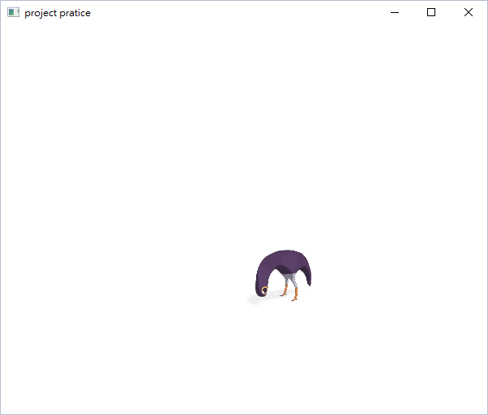

**Requirement:**

1. Show the animation using the picture we provided in “pictures”
2. Each picture should be shown at the duration of about 50 ms.
3. The upper left corner of the animation should be at your curser position, which changes when it moves.
4. You should implement the program only with javafx package.

**Advance:**

1. The feature above remains unchanged.
2. When you mouse scroll scrolls up, the animation becomes blurred.
3. When you mouse scroll scrolls down, the animation becomes clear.

**HINTS:**

JavaFX API  
<https://docs.oracle.com/javase/8/javafx/api/toc.htm>

Creating a Sprite Animation with JavaFX  
<https://netopyr.com/2012/03/09/creating-a-sprite-animation-with-javafx/>

JavaFX Mouse Event  
<http://www.codedata.com.tw/java/javafx-mouseevent-mousedragevent/>

import javafx.animation.Animation;

public void setCycleCount(int);

protected void setCycleDuration(Duration);

public void play(void);

import javafx.animation.Transition;

protected void interpolate(double frac);

import javafx.util.Duration;

import javafx.scene.input.ScrollEvent;

import javafx.scene.input.MouseEvent;

import javafx.event.EventHandler;

public void handle(… …);

import javafx.scene.Scene;

public void setOnScroll(…);

public void setOnMouseMoved (…);

import javafx.scene.effect.GaussianBlur;

public void setRadius(double);