*Bathymetric Landscape Features and Gray Whale Habitat Usage*

― by Michelle Kinzel and David Laskin

## Background

Research has been conducted on gray whales in British Columbia, Canada to study gray whale distribution in order to better understand the relationship between whales and their feeding grounds. Every spring, gray whales make the long journey up the Pacific coastline from Baja California to feast on the swarming mysid shrimp found among kelp beds along the rocky coast of British Columbia. These mysid shrimp require a specific habitat consisting of the kelp beds, shallow water and a complex rocky bottom for the kelp bed attachments. Many gray whales go further north into the Bering and Chukchi seas, feeding on benthic macro fauna. As early as the 1980s, the whales began looking for alternative feeding grounds, and the question arises whether this is the result of insufficient nourishment in the primary feeding ground locations.

The climate change seems to have caused a shift in the primary food dominating shallow water communities in which the whales feed, including several species of swarming mysid shrimp (the gray whales' main nourishment source) during non-El Niño years, as well as schooling anchovy fish (the humpback whales' food) common in the warmer currents of El Niño events. That shift could be a driving factor in the whales' change of feeding ground preference. Within the feeding sites in British Columbia, scientists want to take a closer look at what marine variables influence the local distribution of these hungry giants.

Primary Lab Question: How does the bathymetry and variation in seafloor features influence where the gray whales feed?

Learning Outcomes:   
1. Understand the process of constructing a spatial model to assess habitat use.   
2. Understand the variable affecting habitat selection by a foraging gray whale.  
3. Use geospatial tools to take one data set and create a new layer of spatial data via Geoprocessing.

Disciplines Likely to be Interested: Marine Biology, Oceanography, Biology, Introductory GIS, Physical Geography, Environmental Studies

Content Keywords: indicator species, summer residents, bathymetric depth, slope, distance from shore

Content Background Expected: Basic understanding of biology and ecology is expected

Study Area: Flores Island, British Columbia

Data Used: Flores Island DEM (Digital Elevation Model), Bathymetry Grid, Whale Sightings, Complexity Grid, and Distance to Shore Grid.

Level: Intermediate to Advanced

Estimated time to Complete: This lab can be completed in 3-4 hours or two 90 minute laboratory sessions.

Skill Keywords: Raster Calculator, Benthic Topographic Complexity

Skill Background Expected: Proficiency with beginning skills in ArcGIS 10.1

Esri Software Used: ArcGIS 10.1

Other Software Used: Excel

Date Lab Published: 2014

# Student activity

## Glossary

Bathymetric Depth– this layer is interpolated from discrete MultiBeam sidescan sonar data to create a raster surface with a 30 meter spatial resolution.

Benthic Topographic Complexity– adapted from Ardron (2002), this surface indicates areas with heterogeneous bathymetry that are commonly associated with high species richness. It measures how frequently the seafloor changes, it is a gauge of benthic variability.

Distance From Shore– this surface is the Euclidean distance from the coast, measured in kilometers.

Indicator Species– a species that is affected by changes in the habitat; shifts in their behavior or health may indicate a problem in the surrounding environment.

Raster Calculator–an ArcGIS Spatial Analyst tool used for performing mathematical calculations with operators and functions, setting up selection queries, or typing Map Algebra syntax. Inputs to the Raster Calculator can be raster datasets, raster layers, coverages, shapefiles, tables, constants and numbers.

Slope– derived from the bathymetric grid surface of ocean depths, measured in degrees, represents the steepness of the ocean floor.

Summer Residents– a small subset of the gray whale population that occupies summer feeding grounds outside of the traditional high latitude feeding grounds.

Prepare your workspace

When doing a GIS project, it is good practice to store all your information within a single folder on your computer or storage device and back it up frequently. Create a folder on your C drive with no spaces or special characters in the folder name, such as C:\GrayWhales. Unzip the files for this lesson and extract them into the folder you created.

Set your working space to direct to this folder as well. Select Environment Settings under the Geoprocessing Menu option and select the C:\GrayWhales folder for both your Current Workspace and Scratch Workspace.

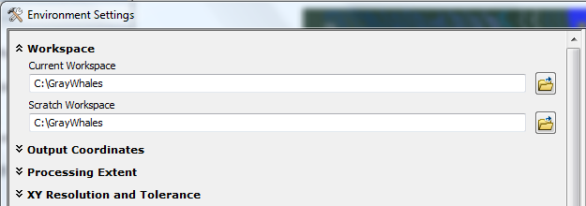

Collect and process data

1. Open the project GrayWhale.mxd. Note the Flores Island and Bathymetry Layers in the Table of Contents.
2. Add the Oceans Basemap. Note the geographic location of Flores Island.

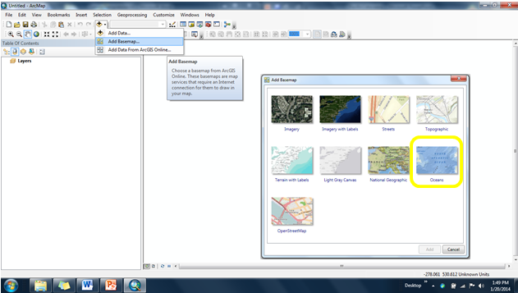

1. Where in the world is Flores Island? Describe the geographic location.
2. To increase the drawing speed of your project, turn off the Oceans Layer and Zoom to the Flores Island layer.
3. Change the symbology of the Bathymetry layer to shades of blue to more closely resemble ocean floor data.
4. Add the Flores_dem layer. Create Contours for Flores Island using ArcToolbox. You may need to move the order of the layers in the Table of Contents to be able to see the Flores_dem layer.

Go to the Geoprocessing Menu 🡪 Search for Tools 🡪 enter Contours and find the Contour Tool (Spatial Analyst).

1. Create Contours for the Bathymetry layer using ArcToolbox. Select contour intervals of 5 (m).

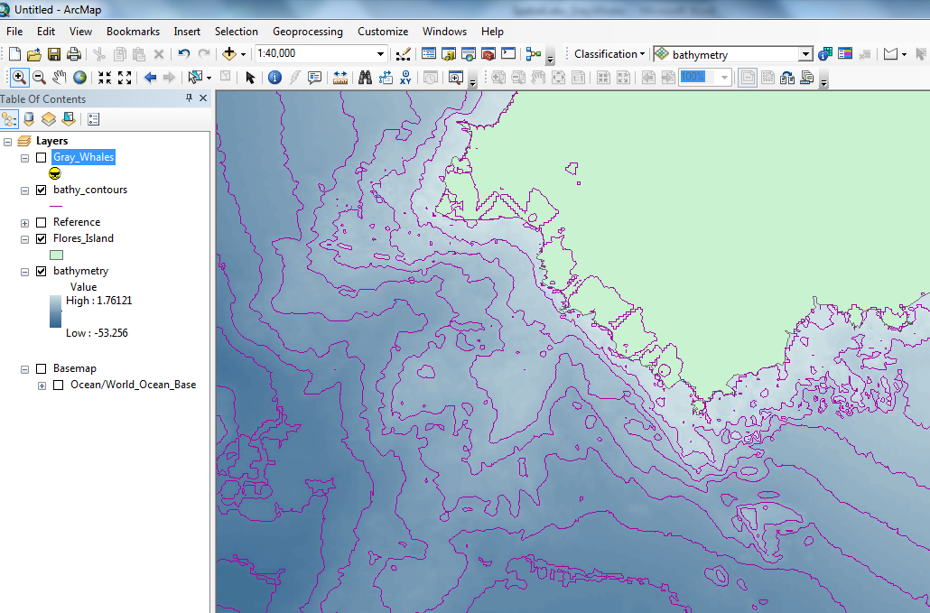

1. Because we want to closely examine the bathymetry of this study area, you need a contour layer with more detail. Can you rerun the tool and create a layer with more detail?

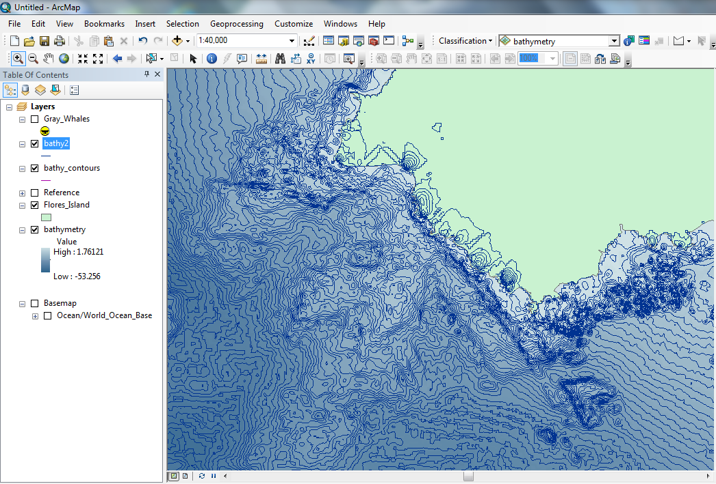

1. What interval did you choose for your second layer?
2. Examine the attribute table of the contours layer created.
3. Describe the depth range of the study area.
4. Highlight the shoreline by changing the 0 contour line from the bathymetry contours to a red thick line.

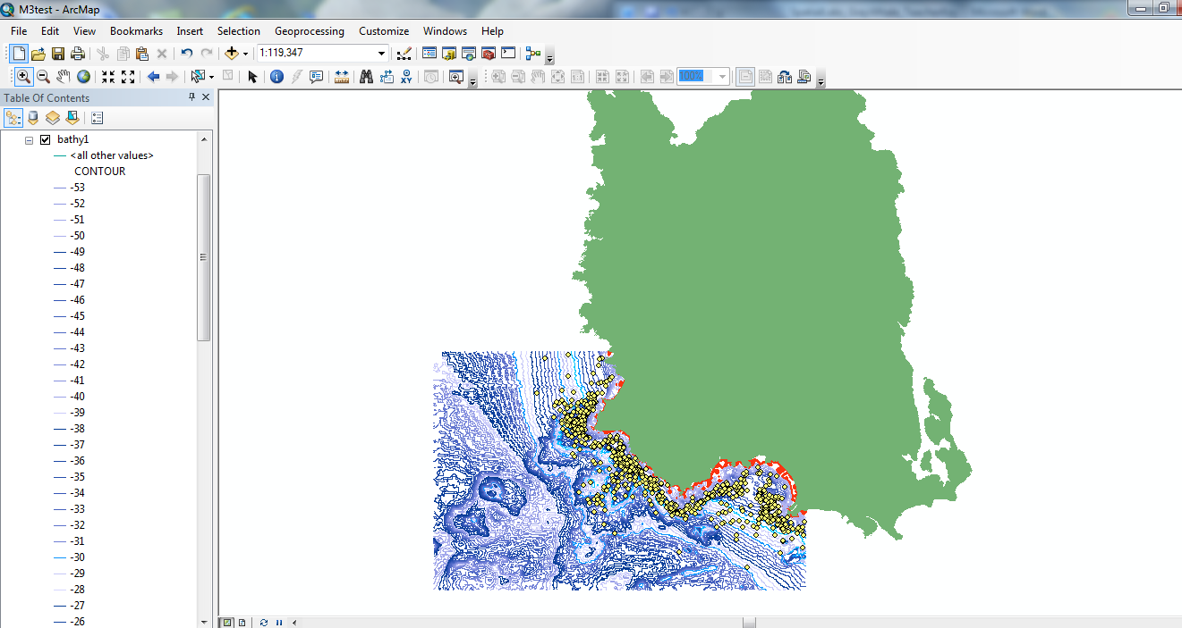

1. Add the gray whale location data, Gray_Whales.shp.
2. Change the gray whale symbols to the whale tale icon found in the Symbol Palette, Conservation layer.

1. Double click on the symbol in the Table of Contents to open the Symbol Selector.

2. Click on Style References.

3. Check the box next to Environmental.

4. Scroll down to find the Whale Tail.

5. Change the size to 10, Color to Yellow.

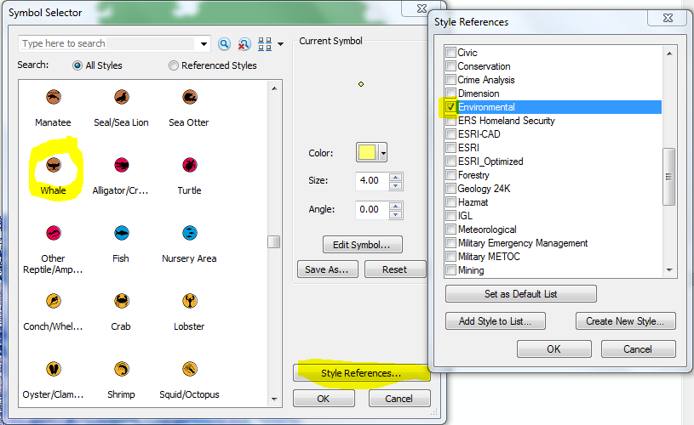

1. What patterns do you notice in the locations of the gray whale locations relative to the Flores Island layer and the Bathymetry layer?

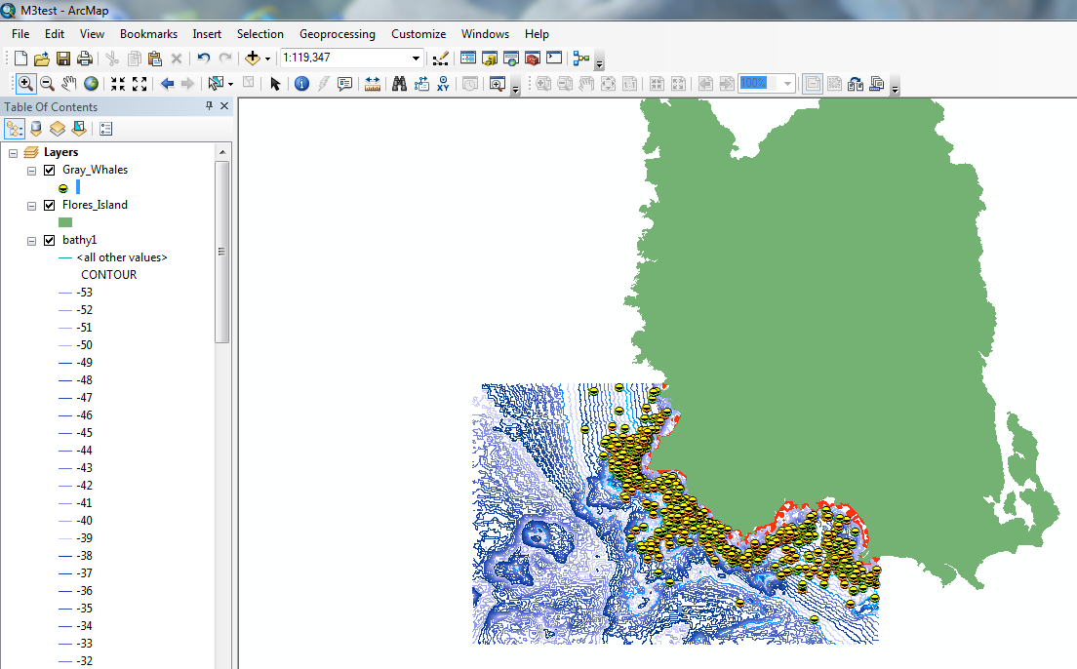

1. Estimate where ‘most’ of the whales are and create a contour that signals the deepest sightings. Using the identify tool, find the deepest contour line that would draw a line for the deepest extent of the whale sightings and make that contour line a bold, red color.

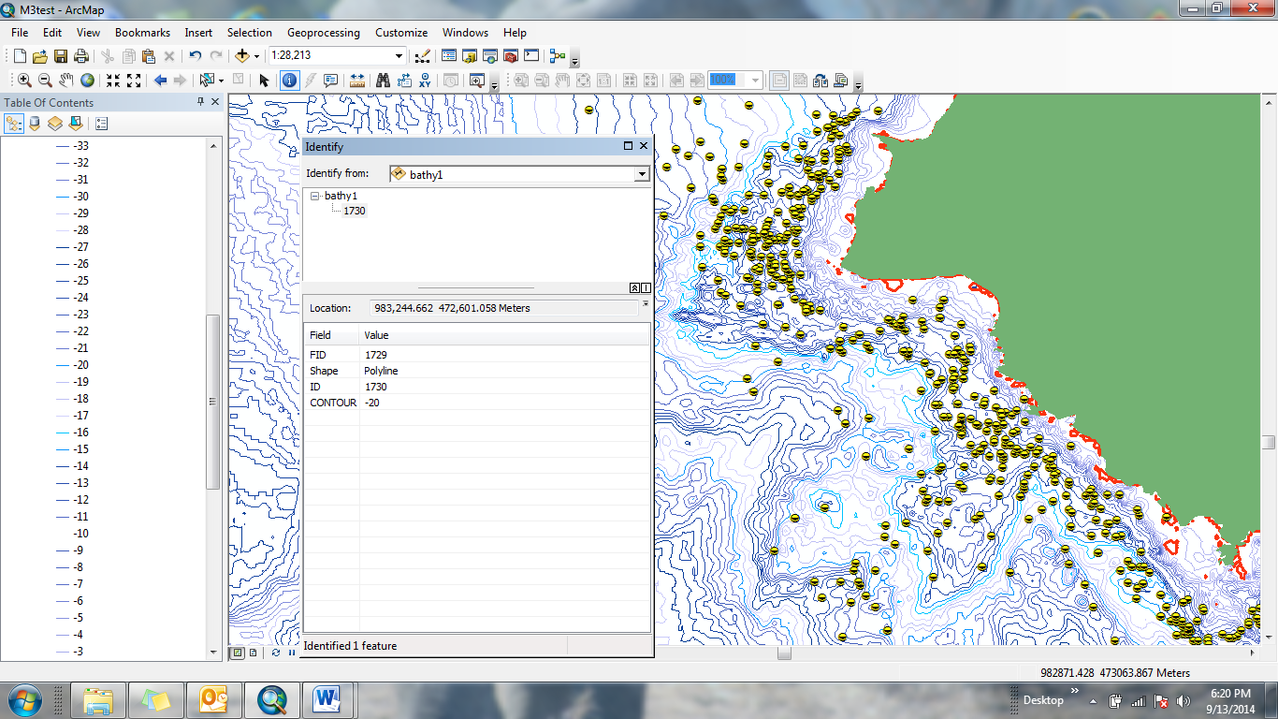

1. At what depth did you create your contour line? Did you create a line at a depth of 25m?
2. Based on what you read in the first page about feeding habits of gray whales, why are the whales occupying this particular part of the habitat?
3. Do you think there might be any other patterns, associations, or correlations?
4. Consider the depth of the study area. Realistically, are there any areas that were included in your output raster that you would not likely find the whales (remember they are approximately 15 m long!)
5. Now we will examine the data using Quantitative tools in ArcMap. Add depth to the gray whale data. Using ArcToolBox - Toolbox – Spatial Analyst Tools 🡪 Extraction 🡪Extract Multi Values to Point. Your input point features layer is Gray_Whales and the input raster is bathymetry.

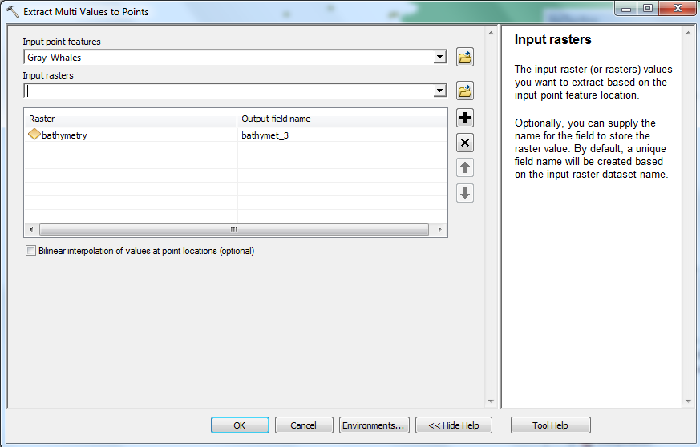

1. Open the Gray_Whales.shp attribute table and sort the depth column by ascending order and note the ranges of depth (shallowest to deepest).
2. Summarize the depth data for each species by right clicking on the attribute header ‘Depth’ and selecting the ‘Statistics’ option. A list of statistical results appears, find the mean value and report in the 3rd column of Table 1.

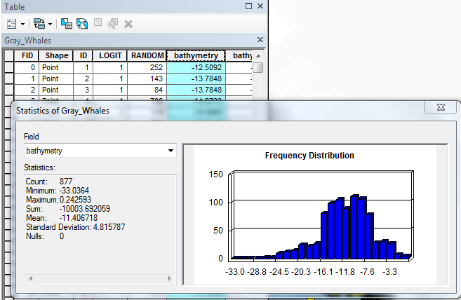

1. Is the data normally distributed?
2. What is the range of depths for the gray whale location data? What is the Mean or Average depth?
3. Except for a few outliers, most of the depth data occurs between 3 and 25 m. Change the contour lines of these values to indicate the most likely depth ranges for finding gray whales.

1. Double click on the lines shown in the layer name to open the symbol window and change the 3 m and 25 m lines for both color and thickness.

2. Choose colors and widths that make the lines stand out from the other bathymetric lines.

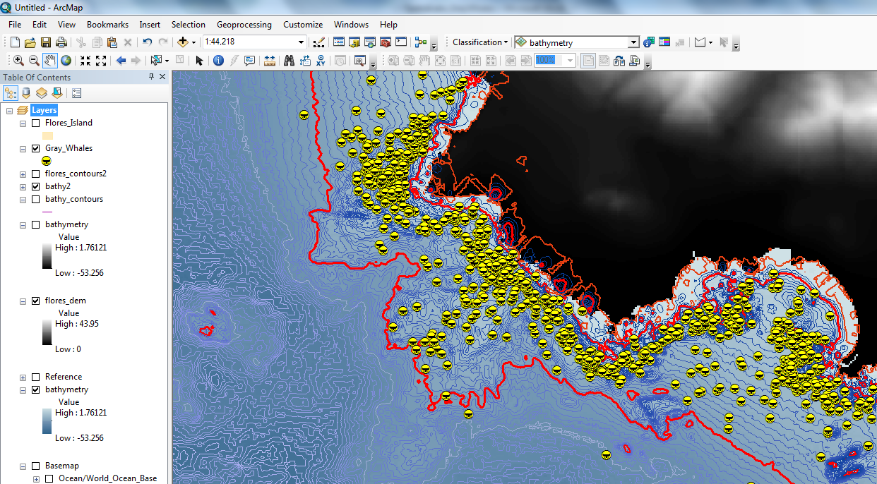

1. Add the other raster layers, **distance** and **complexity**. These layers represent distance to shore and benthic complexity, respectively.
2. What do you notice about the pattern of gray whale sightings and distance to shore Why do you think the gray whales are found in near shore areas?
3. How can you test this distance?
4. Use the measure tool and pick 10 data points to measure – note the distance from shoreline to the whale location. Enter your results in Table 1. Calculate the average value for your 10 points and record it in Table 1.
5. Use the identify tool to measure 10 random points for complexity values. Be sure to change the selectable layer in the identify window to the complexity raster. Calculate the average value for your 10 points and record it in Table 1.

Table 1.

|  |  |  |
| --- | --- | --- |
| Point Number | Distance from Shore (km) | Complexity (absolute value) |
| 1 |  |  |
| 2 |  |  |
| 3 |  |  |
| 4 |  |  |
| 5 |  |  |
| 6 |  |  |
| 7 |  |  |
| 8 |  |  |
| 9 |  |  |
| 10 |  |  |
| Average |  |  |

1. What is the average distance from shore?
2. What do you notice about the pattern of gray whale sightings and benthic complexity? Why do you think the gray whales are found in areas of higher complexity?
3. Form a hypothesis of the relationship between these data layers and the whales’ locations.

In the next section, we will use the Extract by Attributes Tool and Raster Calculator to create a model of gray whale habitat.

1. Search for the Spatial Analyst tool called Extract By Attributes. Create a grid of bathymetry less than 25m. Note that when you build your SQL expression, you must set the instructions for negative bathymetry values (below sea level or shoreline = 0 m).

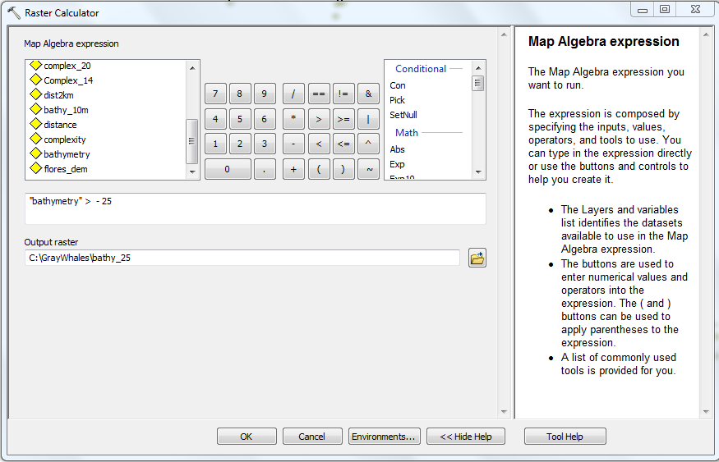

1. Examine your grid. Are there any areas of your grid where you would not realistically find whales? If we take into consideration the size of a gray whale, we are not likely to find them in waters that are shallower than 5 m. Use the Extract by Attributes tool to subset the grid you created in Step 20 (which was shallower than 25m) but deeper than 5 m.

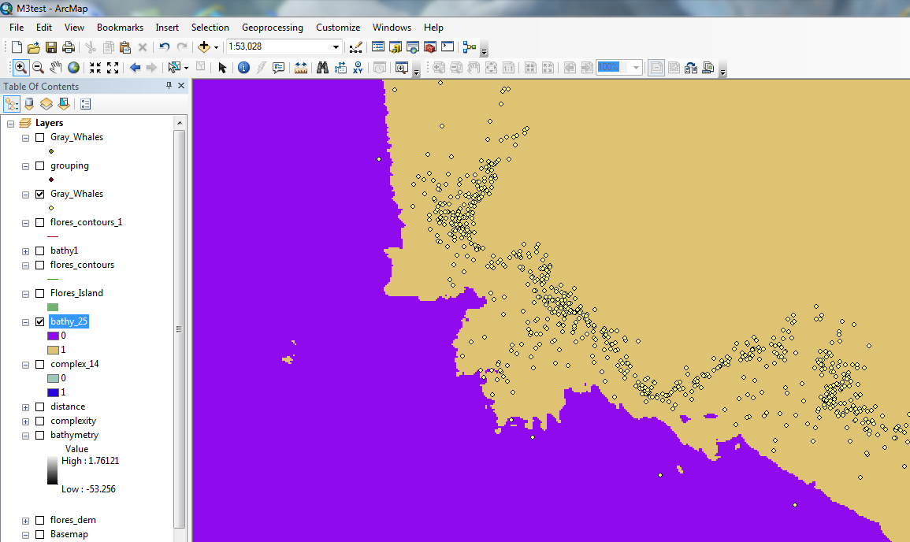

1. Display the **complexity** layer. You may need to reorder the files in the Table of Contents to view this layer.
2. Change the symbology of the complexity layer to a color ramp that goes from light to dark in one color palette. For illustrative purposes, white to red is shown here.
3. Use the zoom and pan tools to spatially explore the data and search for patterns.

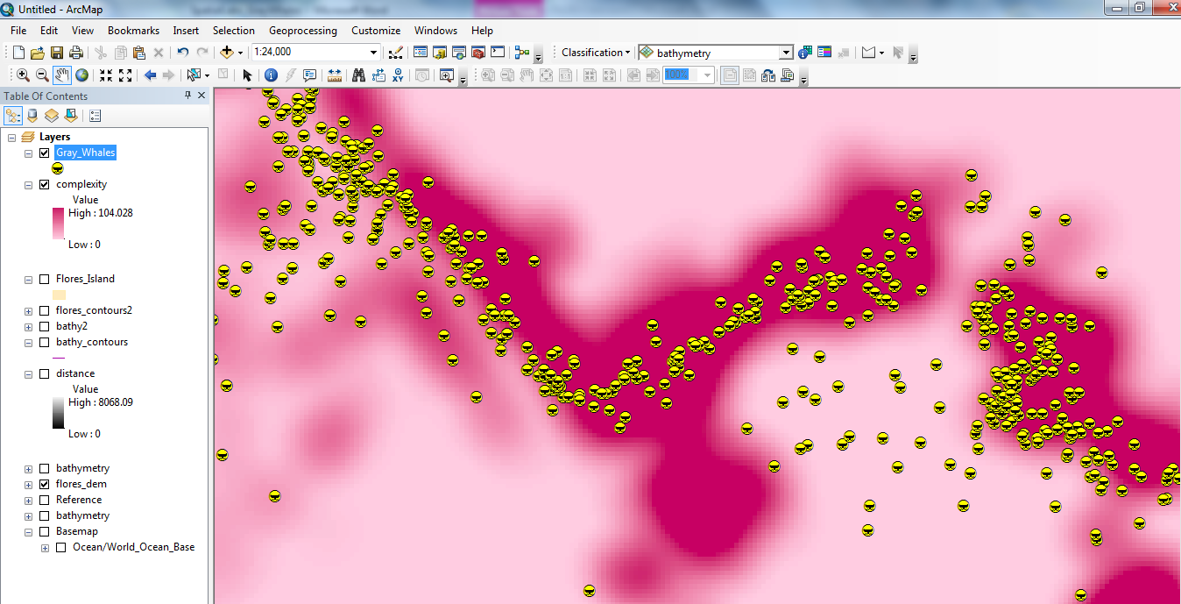

1. Can you detect any patterns between the whale locations and the complexity layer?
2. Use your identify tool and click around in the complexity layer, noting the locations of the whales.
3. Did your exploration produce an approximate range of complexity values for the whale locations in this analysis?
4. Since gray whales are found in areas of higher complexity, use the Raster Calculator Tool to create a grid of complexity greater than 25.

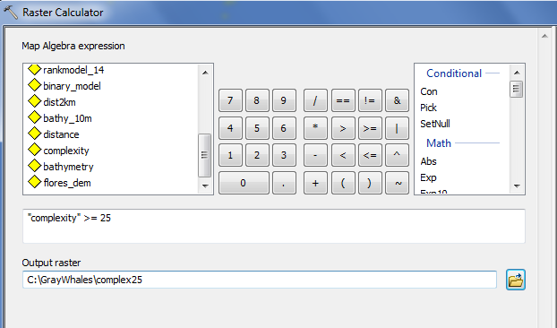

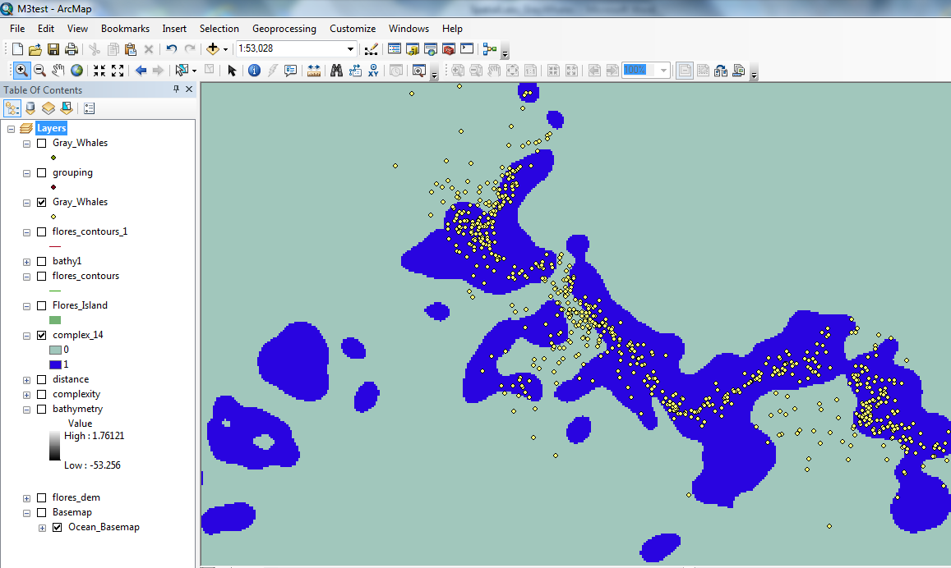

1. Display the **distance** layer. You may need to reorder the files in the Table of Contents to view this layer.
2. Since the whales are found within 2km of shore, use Raster Calculator to create a layer of distance less than 2 km to shore, as shown here.

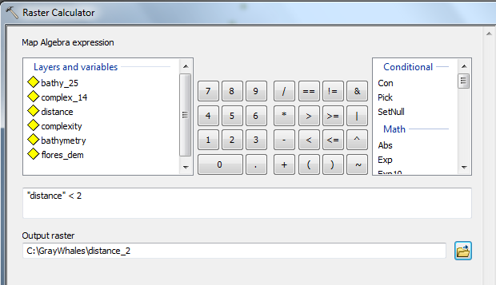

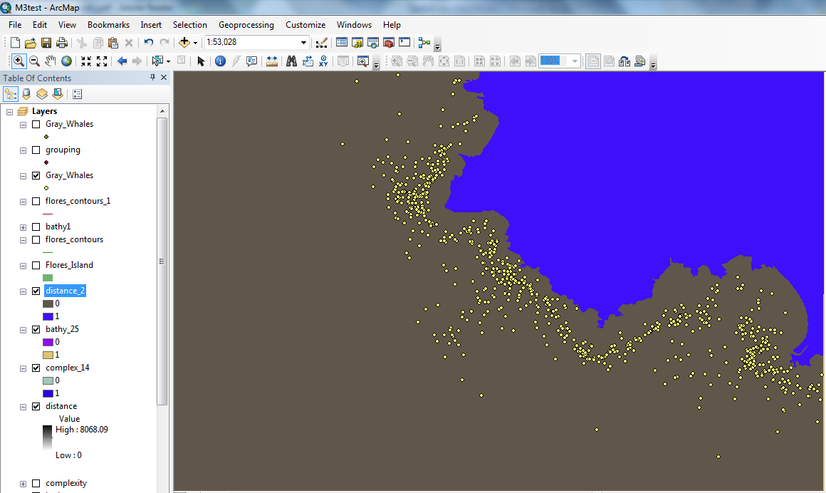

Raster Calculator

1. Using Raster Calculator, enter the expression shown here to create a Binary Model of whale locations. Note that the operator used is an *. This operation multiplies the results and creates an either/or output, the binary model. Each variable will be assessed for absence or presence. If any of the 3 variables are absent, the resultant expression will also be absent (since you are in essence, multiplying be a factor of zero). All 3 variables must be present to return a result of 1 or present. This means that all 3 factors are considered and only habitat that meet all 3 criterion are shown in the final output.

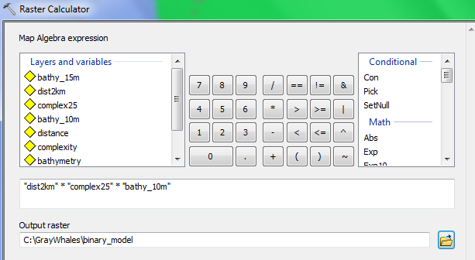

1. Examine the output results of the Binary Model.

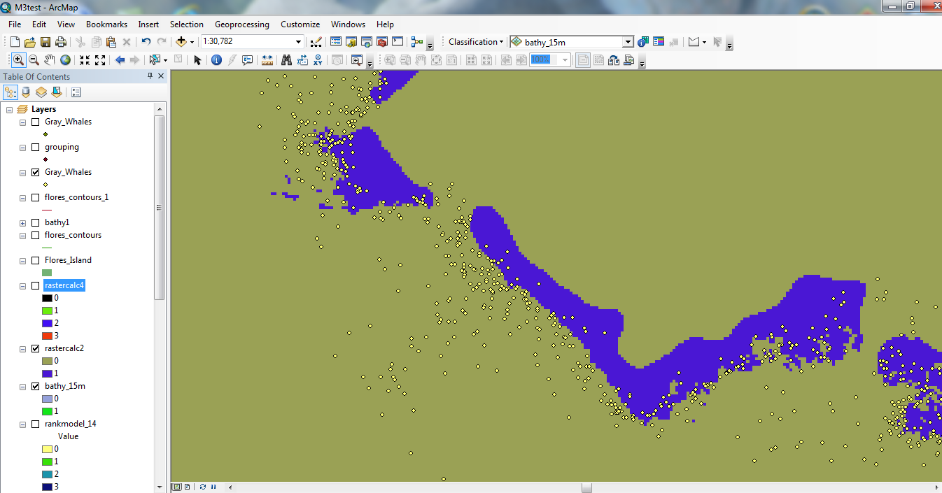

1. What do the values of 1 represent?

What do the values of 0 represent?

Ranking

1. Let’s build another raster with Raster Calculator, creating a ranking model. Note the use of the + operator. In this SQL expression, all factors are considered independently, in an additive fashion. The results show the degree to which the habitat meets the requirements in a ranking method, with each variable possibly contributing to the final output. There are more possible results than zero and 1 in this model.

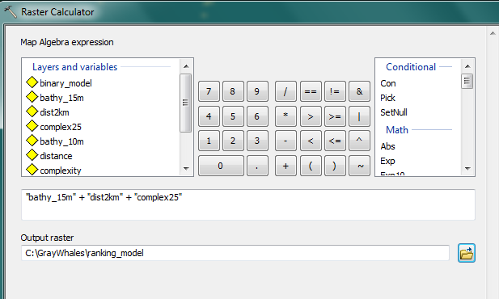

1. Examine the resultant layer of a ranking model.

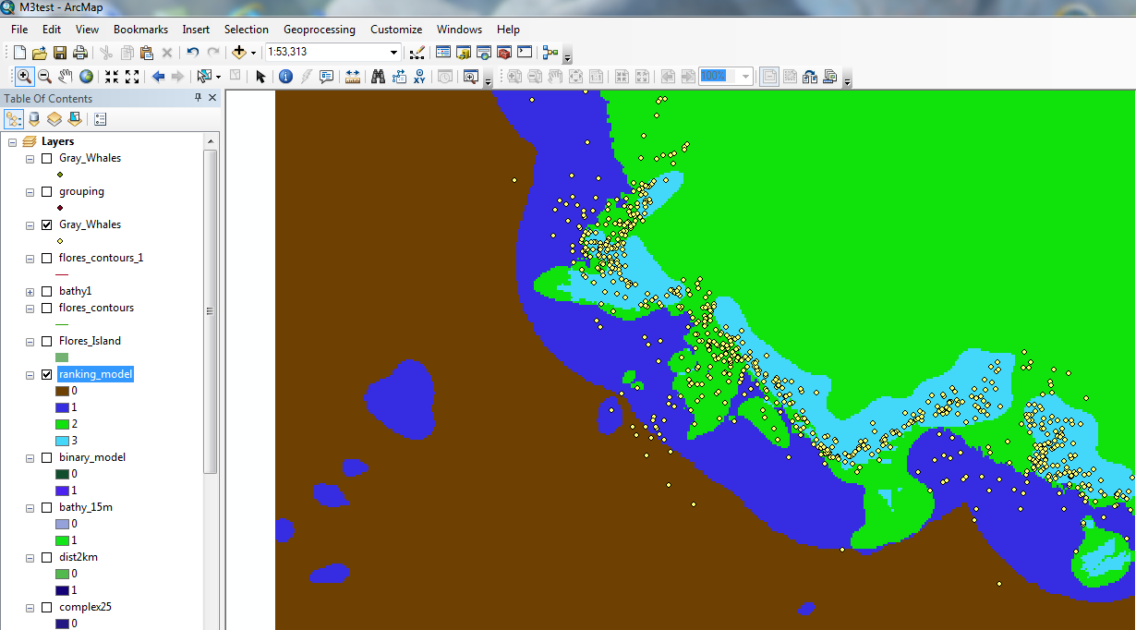

1. What do each of the numbers, 0, 1, 2 and 3 mean?
2. Compare the 2 models you created. Consider how they are similar and how they are different. Which model is better to use for analysis?

If you were going to study these factors in a more rigorous way, you could create a regression model that would test the statistical validity of various data sets.

1. What data sets would you include in your regression model of gray whale feeding preferences?

## Submit your work

This worksheet contains one table and 21 questions and is a suitable assessment for completion of all aspects of the lab.

## Credits

### Images

Images taken by Michelle Kinzel, David Laskin and Svenja Kurth.

### Data

Flores Island, Bathymetry and Gray Whale location data provided courtesy of David Laskin, researcher and the

## References and further reading

The Illustrated Atlas of the Sea. 2010. Weldon Owen Pty Ltd. Tien Wah Press, Singapore.

Impact of Climate Changes on Gray Whale Feeding Grounds Tracked with GIS <http://www.esri.com/news/arcnews/spring08articles/grey-whales.html>

Sea Life: A Complete Guide to the Marine Environment. 1996. Edited by Geoffrey Waller. Smithsonian Institution Press, Washington, D. C.

Esri GIS Dictionary  
<http://support.esri.com/en/knowledgebase/Gisdictionary/browse>

Bathymetry Grid Data : NOAA National Geophysical Data Center, U.S. Coastal Relief Model, <http://www.ngdc.noaa.gov/mgg/coastal/crm.html>

#### C:\Users\Owner\Pictures\Pictures\Pictures\ScreenSaver\spyhop.JPGAuthor Information

Michelle Kinzel earned a Master of Science in Geography at Oregon State University in 2009. She also completed a Graduate Level Certificate in GIScience and studied the use of geovisualizations in education while conducting her research. Her undergraduate work in Biology and 2 years of graduate work in Marine Science prepared her to create and teach GIS lessons in Oceanography and Marine Science. Michelle has spent several years and traveled thousands of miles honing her craft of storytelling and lesson writing, and has created curriculum for dozens of clients, from California to Cameroon, Africa, in many subject areas. She specializes in writing and teaching all kinds of GIS and Remote Sensing content. Michelle has authored esri Spatial Labs Pacific Cetaceans and Migrating Sea Turtles.

#### Scientist Information

David Laskin holds a Master’s Degree in Geography, earned at the University of Calgary. His research focused on the habitat usage of gray whales in relation to oceanographic factors along the west coast of Canada. He is currently a doctoral candidate at the same university, studying remote sensing applications for assessing the habitat-use and dietary regime of grizzly bears. David combines high technology geospatial methods with conservation-based fields of study to better understand ecosystem approaches to wildlife management. David has many years of experience as a trainer and professional development provider, specializing in teaching technology use related to geospatial applications.

© 2015 Esri 

This work is licensed under a Creative Commons Attribution-NonCommercial-ShareAlike 3.0 Unported License. Terms are published at <http://creativecommons.org/licenses/by-nc-sa/3.0/>