SQL Database Project
Student name: Waheed Ullah
ID: 25035673
Github: https://github.com/wu25aad/SQL_Project

1. Introduction
This project is about creating a reproducible, relational SQLite database of a synthetic automotive e-commerce business. It describes customer profiles, catalogue products, purchases, order lines and payments to enable retrieval and analysis of structured information. No external datasets were downloaded and all records have been created dynamically (Beaulieu, 2020).

2. Database design and schema
The database was designed to ensure efficient data organization, reduce data redundancy, and ensure data consistency across related tables. The tables are all different business entities: customer information, product details, orders, and payment transactions are handled independently of each other. Primary keys are used to identify individual records and foreign keys are used to create relationships and ensure referential integrity. The Order_Items table has a composite Primary key to identify multiple products associated with each Order. This relational structure is also helpful for normalizing the data in the database, as it prevents the duplication of information. Additionally, the design allows for efficient SQL queries, easier database maintenance, and potential future scalability due to evolving business needs (Ramez, 2025).
Figure 1. Entity-relationship schema derived from the implemented SQLite tables.
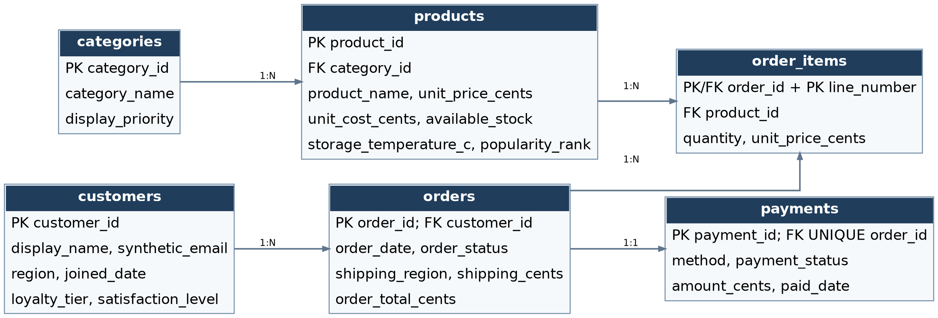

2.1 Table composition
Table | Rows | Purpose / principal relationship
categories | 10 | Catalogue classification; referenced by products
customers | 500 | Synthetic customer profiles; referenced by orders
products | 150 | Priced products with stock and temperature data
orders | 1,500 | Purchases linked to customers
order_items | 3,696 | Order lines linked to orders and products
payments | 1,500 | Payment record per order; order_id is UNIQUE

2.2 Measurement scales and SQL constraints
Scale | Implemented example | Interpretation
Nominal | customers.region (TEXT) | Unordered regions: North, South, East, West, Central
Ordinal | customers.satisfaction_level (TEXT) | Ordered Low, Medium, High, Very High
Interval | products.storage_temperature_c (REAL) | Degrees Celsius; zero does not mean absence of temperature
Ratio | order_items.quantity (INTEGER) | Count with a true zero; positive quantities required
Its schema includes INTEGER, REAL and TEXT storage types, as well as NOT NULL, UNIQUE, CHECK and REFERENCES constraints, which ensure data integrity. These are things such as positive prices, non-negative stock, allowed status categories and 1–5 quantities. Monetary values are saved as integer cents, so as to prevent rounding errors in monetary totals.

3. Synthetic data generation and implementation
The database was created using python standard-library modules sqlite3, random and datetime. A fixed random seed (20261106) makes records reproducible. Input values are provided by fictional product categories and name pools (Beaulieu, 2020). Weighted random selection assigns loyalty tiers, satisfaction levels, order statuses; inventory, prices, quantities, payment methods and dates will be generated within bound values. Customer join dates come before their orders. One to four product lines are present per order with unit prices recorded at the time of order. Totals include item subtotals and shipping for orders that are active and have a zero amount and shipping charge for cancelled orders (Documentation, 2024). Order status is always used to determine payment status. SQL CREATE TABLE statements create the schema ahead of data being inserted into it by Python with parameterised INSERT operation.

4. Testing and validation
Validation check | Result
Required data volume | Orders: 1,500 rows; order_items: 3,696 rows
Database integrity | PRAGMA integrity_check returned "ok"
Referential integrity | PRAGMA foreign_key_check found no violations
Business logic | Order totals and payment amounts matched status-specific rules
Constraint enforcement | Invalid negative quantity and unknown order ID were rejected
The database was then tested for consistency, accuracy and reliability of the information contained in all six tables. SQL queries were run to ensure that the data and relationships were correct. Special attention was paid to the detection of duplicate Primary Key's, missing Foreign Key's and invalid numeric data. Also analysed were transaction patterns, product quantities and payment information, using aggregate queries. The validation process also showed the principle of relational database in terms of accurate storage and retrieval of data. Such checks are crucial for database integrity and for the quality of the information generated to be appropriate for further analytical uses (Silberschatz, Korth and Sudarshan, 2002).

5. Ethical and data privacy considerations
All data is completely synthetic; there is no real customer database used. Email addresses are based on the reserved example.com domain, which helps to decrease the chance of accidental contact with actual people. The names, regions and purchasing patterns are indicative and not evidence of demographics. A production database needs to be limited in access and secure with encryption of sensitive data, enforced by retention policies and applying the principles of ‘privacy by design’. Patterns generated should not be used as proof of real customers' behaviour.

6. Conclusion
In this project, the concepts of relational databases are put into practice and a structured e-commerce database is designed using SQLite and Python. The implementation demonstrates the need for database normalization, using the right data types and having well-defined relationships among entities. The creation of synthetic records also allowed the simulation of realistic business operations without having to use personal customer data. Moreover, they were able to build their knowledge of SQL queries, database constraints, and systematic validation techniques. The resulting database can be expanded for additional analysis of sales trends, customer buying habits, inventory forecasting, and even adding business intelligence tools to help with decision making.

References:
Beaulieu, A., 2020. Learning SQL: Generate, manipulate, and retrieve data. O'Reilly Media.
Ramez, E., 2025. Fundamentals of database systems.
Silberschatz, A., Korth, H.F. and Sudarshan, S., 2002. Database system concepts (Vol. 5). New York: McGraw-Hill.
Documentation, P., 2024. sqlite3—DB-API 2.0 interface for SQLite databases. s Interneta, https://docs. python. org/3/library/sqlite3. html, kolovoz.

Appendix: Reproducible code
Github: https://github.com/wu25aad/SQL_Project

