

TEST REPORT
Report No.:AZT251219005C-E0 Date of issue: December 24, 2025 Page 1 of 10

Applicant | : | Yueqing Yongdong Electric Motor Technology Co., Ltd.
Address | : | No. 307, 19th Weilu Road, Yueqing Economic Development Zone, Yueqing City, Wenzhou City, Zhejiang Province, P.R. China
Manufacturer | : | Yueqing Yongdong Electric Motor Technology Co., Ltd.
Address | : | No. 307, 19th Weilu Road, Yueqing Economic Development Zone, Yueqing City, Wenzhou City, Zhejiang Province, P.R. China

Report on the submitted samples said to be:

Sample Name | : | Motor coil
Model No. | : | YD6W-8KW/Single (Three)-Phase Asynchronous Motor Coil, Model:  YD6W-8KW
Date of Sample Received | : | December 19, 2025
Testing Period | : | December 19, 2025 ~ December 24, 2025
Results | : | Please refer to next page(s).


******************************************************************************************************************************
TEST REQUEST CONCLUSION
According to the customer's request, based on the performed tests on submitted sample, the result of Lead, Cadmium, Mercury, Hexavalent Chromium, PBBs, PBDEs, Dibutyl
Phthalate (DBP), Benzyl butyl Phthalate (BBP), Bis(2-ethylhexyl) Phthalate (DEHP), Diisobutyl phthalate (DIBP) content comply with the limit as set of RoHS Directive 2011/65/EU Annex II amending Directive (EU)2015/863.
Pass
******************************************************************************************************************************


Signed for and on behalf of AZT


Jack Zhong


No.502, Building 1, Yibaolai Industrial City, Qiaotou Community, Fuhai Street, Bao'an District, Shenzhen, Guangdong, China
Shenzhen AZT Technology Co., Ltd.
Tel: 0755-23501189; E-mail: azt-ep@azt-tech.com; Http: www.azt-tech.com

TEST REPORT
Report No.:AZT251219005C-E0 Date of issue: December 24, 2025 Page 2 of 10


Test Item Description And Photo List

No. | Tested Part(s) | The photo of the sample
01 | Red tape |     04
02 | White textile with transparent glue
03 | Copper metal coil |   01 |  |  | 05    06 |  |   '\  08-09
  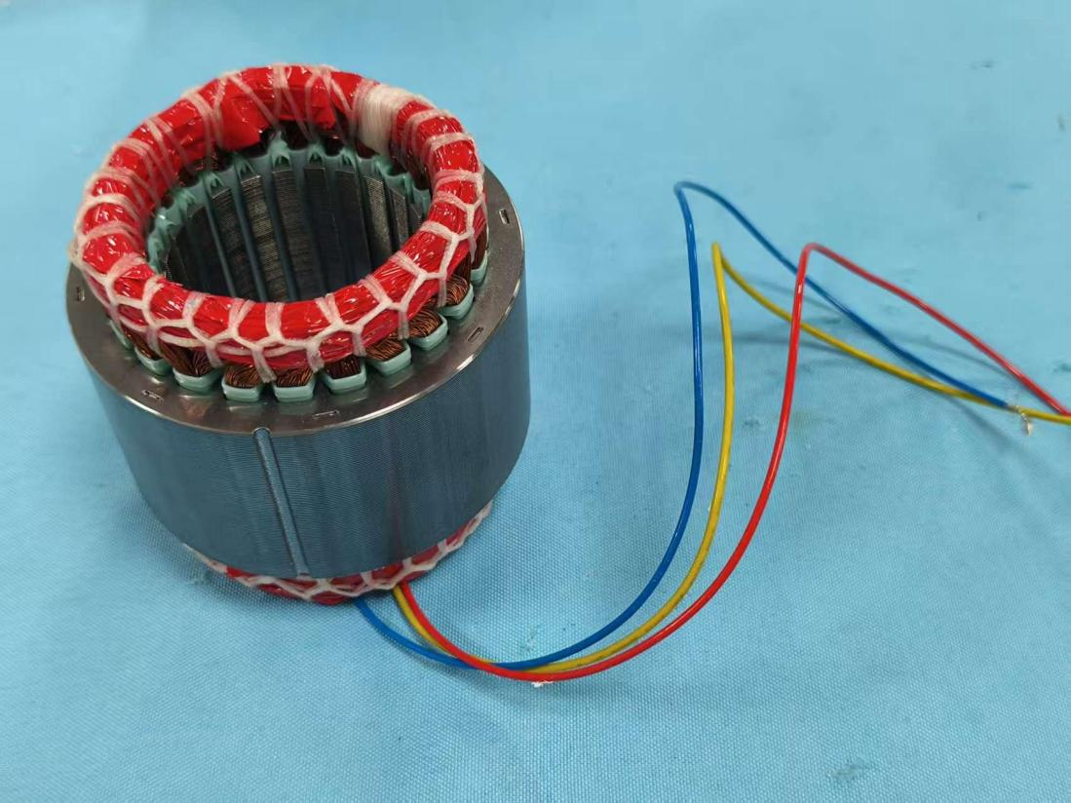
  02
  03
  07
04 | Light blue plastic
05 | Silvery metal
06 | Blue wire jacket
07 | Red wire jacket
08 | Yellow wire jacket
09 | Silvery metal core
10 | Black soft plastic | 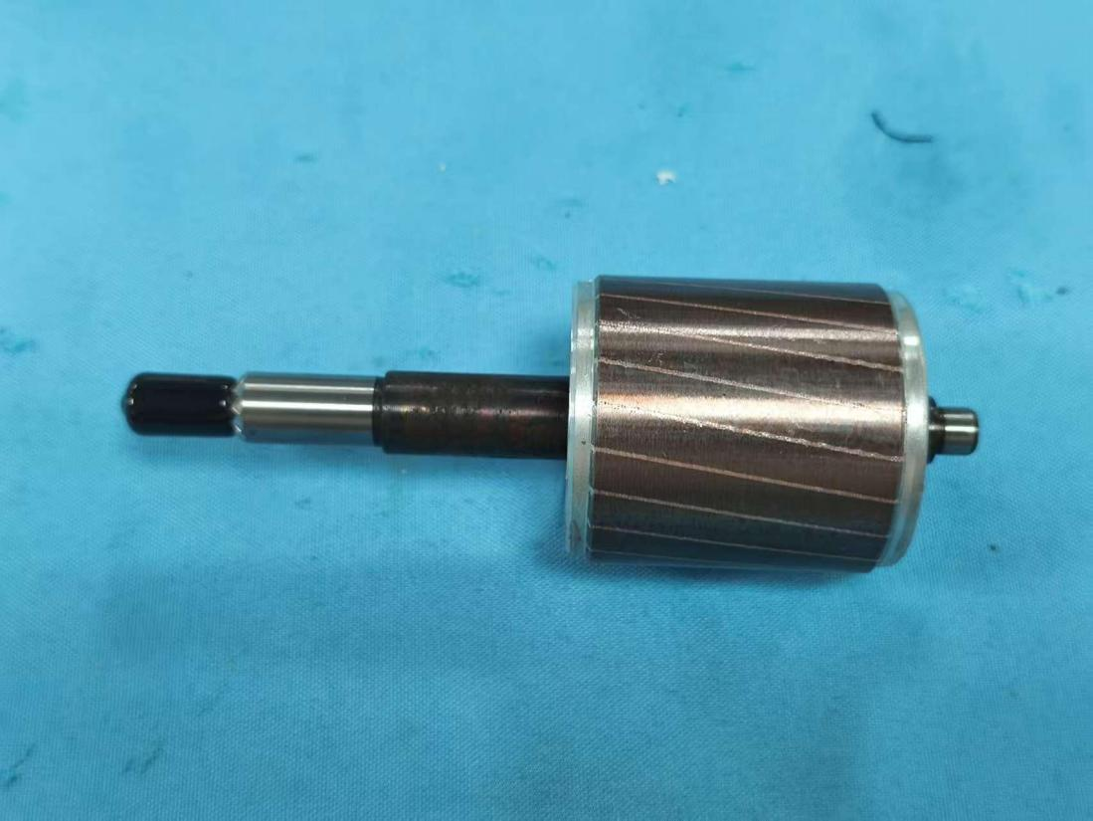  10 | 11 | 12 |  | 13
11 | Silvery metal
12 | Silvery metal
13 | Silvery metal with rose golden plating

No.502, Building 1, Yibaolai Industrial City, Qiaotou Community, Fuhai Street, Bao'an District, Shenzhen, Guangdong, China
Shenzhen AZT Technology Co., Ltd.
Tel: 0755-23501189; E-mail: azt-ep@azt-tech.com; Http: www.azt-tech.com

TEST REPORT
Report No.:AZT251219005C-E0 Date of issue: December 24, 2025 Page 3 of 10

Results:
RoHS Directive 2011/65/EU Annex II amending Directive (EU)2015/863
A. XRF screening Result

Test method: With reference to IEC 62321-3-1:2013, Screening by X-ray Fluorescence Spectroscopy (XRF)

No. | Tested Part(s) | Results
No. | Tested Part(s) | Cd | Pb | Hg | Cr▽ | Br▽
 |  |  |  |  |  | PBBs | PBDEs
01 | Red tape | BL | BL | BL | BL | BL | BL
02 | White textile with transparent glue | BL | BL | BL | BL | BL | BL
03 | Copper metal coil | BL | BL | BL | BL | / | /
04 | Light blue plastic | BL | BL | BL | BL | BL | BL
05 | Silvery metal | BL | BL | BL | BL | / | /
06 | Blue wire jacket | BL | BL | BL | BL | BL | BL
07 | Red wire jacket | BL | BL | BL | BL | BL | BL
08 | Yellow wire jacket | BL | BL | BL | BL | BL | BL
09 | Silvery metal core | BL | BL | BL | BL | / | /
10 | Black soft plastic | BL | BL | BL | BL | BL | BL
11 | Silvery metal | BL | BL | BL | BL | / | /
12 | Silvery metal | BL | BL | BL | BL | / | /
13 | Silvery metal with rose golden plating | BL | BL | BL | BL | / | /

No.502, Building 1, Yibaolai Industrial City, Qiaotou Community, Fuhai Street, Bao'an District, Shenzhen, Guangdong, China
Shenzhen AZT Technology Co., Ltd.
Tel: 0755-23501189; E-mail: azt-ep@azt-tech.com; Http: www.azt-tech.com

TEST REPORT
Report No.:AZT251219005C-E0 Date of issue: December 24, 2025 Page 4 of 10

Note:
( 1) Results were obtained by XRF for primary screening, and further chemical testing by ICP (for Cd, Pb, Hg) , UV-Vis (for Cr(Ⅵ)) and GC-MS (for PBBs , PBDEs) are recommended to be performed, if the
concentration exceeds the below warning value according to IEC 62321-3-1:2013.
XRF screening limits for different materials:
Element | Unit | Non-metal | Metal | Composite Material
Cd | mg/kg | BL≤70-3σ<X <130+3σ≤OL | BL≤70-3σ<X <130+3σ≤OL | BL≤50-3σ<X <150+3σ≤OL
Pb | mg/kg | BL≤700-3σ<X <1300+3σ≤OL | BL≤700-3σ<X <1300+3σ≤OL | BL≤500-3σ<X <1500+3σ≤OL
Hg | mg/kg | BL≤700-3σ<X <1300+3σ≤OL | BL≤700-3σ<X <1300+3σ≤OL | BL≤500-3σ<X <1500+3σ≤OL
Cr | mg/kg | BL≤700-3σ<X | BL≤700-3σ<X | BL≤500-3σ<X
Br | mg/kg | BL≤300-3σ<X | -- | BL≤250-3σ<X
Note:

- BL=Below Limit
- OL=Over Limit (Screening result was over limit , thus further confirmation test was conducted.)
- X= Inconclusive(Screening result was inconclusive, thus further confirmation test was conducted.)
- /= Not Applicable
- mg/kg = milligram per kilogram = ppm
(2) The XRF screening test for RoHS elements – The reading may be different to the actual content in the sample be of non-uniformity composition.
(3) The maximum permissible limit is quoted from the RoHS Directive 2011/65/EU Annex II amending Directive (EU)2015/863.
(4) ▽=For restricted substances PBBs and PBDEs, the results show the total Br content; The restricted substance was Cr (Ⅵ), and the results showed the total Cr content.

No.502, Building 1, Yibaolai Industrial City, Qiaotou Community, Fuhai Street, Bao'an District, Shenzhen, Guangdong, China
Shenzhen AZT Technology Co., Ltd.
Tel: 0755-23501189; E-mail: azt-ep@azt-tech.com; Http: www.azt-tech.com

TEST REPORT
Report No.:AZT251219005C-E0 Date of issue: December 24, 2025 Page 5 of 10

RoHS Restricted Substances | Maximum Concentration Value (mg/kg) (by weight in homogenous materials)
Cadmium (Cd) | 100
Lead (Pb) | 1000
Mercury (Hg) | 1000
Hexavalent Chromium (Cr(Ⅵ)) | 1000
Polybrominated biphenyls (PBBs) | 1000
Polybrominated diphenyl ethers (PBDEs) | 1000
Dibutyl Phthalate (DBP) | 1000
Benzyl butyl Phthalate (BBP) | 1000
Bis(2-ethylhexyl) Phthalate (DEHP) | 1000
Diisobutyl phthalate (DIBP) | 1000
Disclaimers:

This XRF Screening report is for reference purposes only. The applicant shall make its/his/her own judgment as to whether the information provided in this XRF screening report is sufficient for its/his/her purposes.
The result shown in this XRF screening report will differ based on various factors, including but not limited to, the sample size, thickness, area, surface flatness, equipment parameters and matrix effect (e.g. plastic, rubber, metal, glass, ceramic etc.). Further wet chemical pre-treatment with relevant chemical equipment analysis are required to obtain quantitative data.

No.502, Building 1, Yibaolai Industrial City, Qiaotou Community, Fuhai Street, Bao'an District, Shenzhen, Guangdong, China
Shenzhen AZT Technology Co., Ltd.
Tel: 0755-23501189; E-mail: azt-ep@azt-tech.com; Http: www.azt-tech.com

TEST REPORT
Report No.:AZT251219005C-E0 Date of issue: December 24, 2025 Page 6 of 10

B. Result of Wet Chemical Testing
Test method:
Lead & Cadmium Content:
With reference to IEC 62321-5:2013, analysis was performed by Inductively Coupled Plasma-Optical Emission Spectrometer (ICP-OES).
Mercury Content:
With reference to IEC 62321-4:2013+AMD1:2017 CSV, analysis was performed by Inductively Coupled Plasma-Optical Emission Spectrometer (ICP-OES).
Hexavalent Chromium Content:
With reference to IEC 62321-7-1:2015& IEC 62321-7-2:2017, analysis was performed by UV-visible spectrophotometer (UV-Vis).
PBBs & PBDEs Content:
With reference to IEC 62321-6:2015, analysis was performed by gas chromatographic-mass spectrometer (GC-MS).
DBP, BBP, DEHP, DIBP Content:
With reference to IEC 62321-8:2017, analysis was performed by gas chromatographic-mass spectrometer (GC-MS).

1) The test results of DBP, BBP, DEHP & DIBP

Test Items | CAS No. | Unit | MDL | Results |  | Limit
 |  |  |  | 04 | 06+07+08 | Limit
Dibutyl Phthalate (DBP) | 84-74-2 | mg/kg | 50 | N.D. | N.D. | 1000
Benzyl butyl Phthalate (BBP) | 85-68-7 | mg/kg | 50 | N.D. | N.D. | 1000
Bis(2-ethylhexyl) Phthalate (DEHP) | 117-81-7 | mg/kg | 50 | N.D. | N.D. | 1000
Diisobutyl phthalate (DIBP) | 84-69-5 | mg/kg | 50 | N.D. | N.D. | 1000

Test Items | CAS No. | Unit | MDL | Results | Limit
 |  |  |  | 10 | Limit
Dibutyl Phthalate (DBP) | 84-74-2 | mg/kg | 50 | N.D. | 1000
Benzyl butyl Phthalate (BBP) | 85-68-7 | mg/kg | 50 | N.D. | 1000
Bis(2-ethylhexyl) Phthalate (DEHP) | 117-81-7 | mg/kg | 50 | N.D. | 1000
Diisobutyl phthalate (DIBP) | 84-69-5 | mg/kg | 50 | N.D. | 1000
Remark:
- mg/kg = milligram per kilogram = ppm
- N.D. = Not detected
- MDL= Method detected limited
- The samples were mixed for phthalic acid test
- Tested part(s) was/were specified by client
- Flow chart appendix is included
- Photo appendix is included

No.502, Building 1, Yibaolai Industrial City, Qiaotou Community, Fuhai Street, Bao'an District, Shenzhen, Guangdong, China
Shenzhen AZT Technology Co., Ltd.
Tel: 0755-23501189; E-mail: azt-ep@azt-tech.com; Http: www.azt-tech.com

TEST REPORT
Report No.:AZT251219005C-E0 Date of issue: December 24, 2025 Page 7 of 10

Appendix
Pb/Cd/Hg/Cr6+ Testing Flow Chart
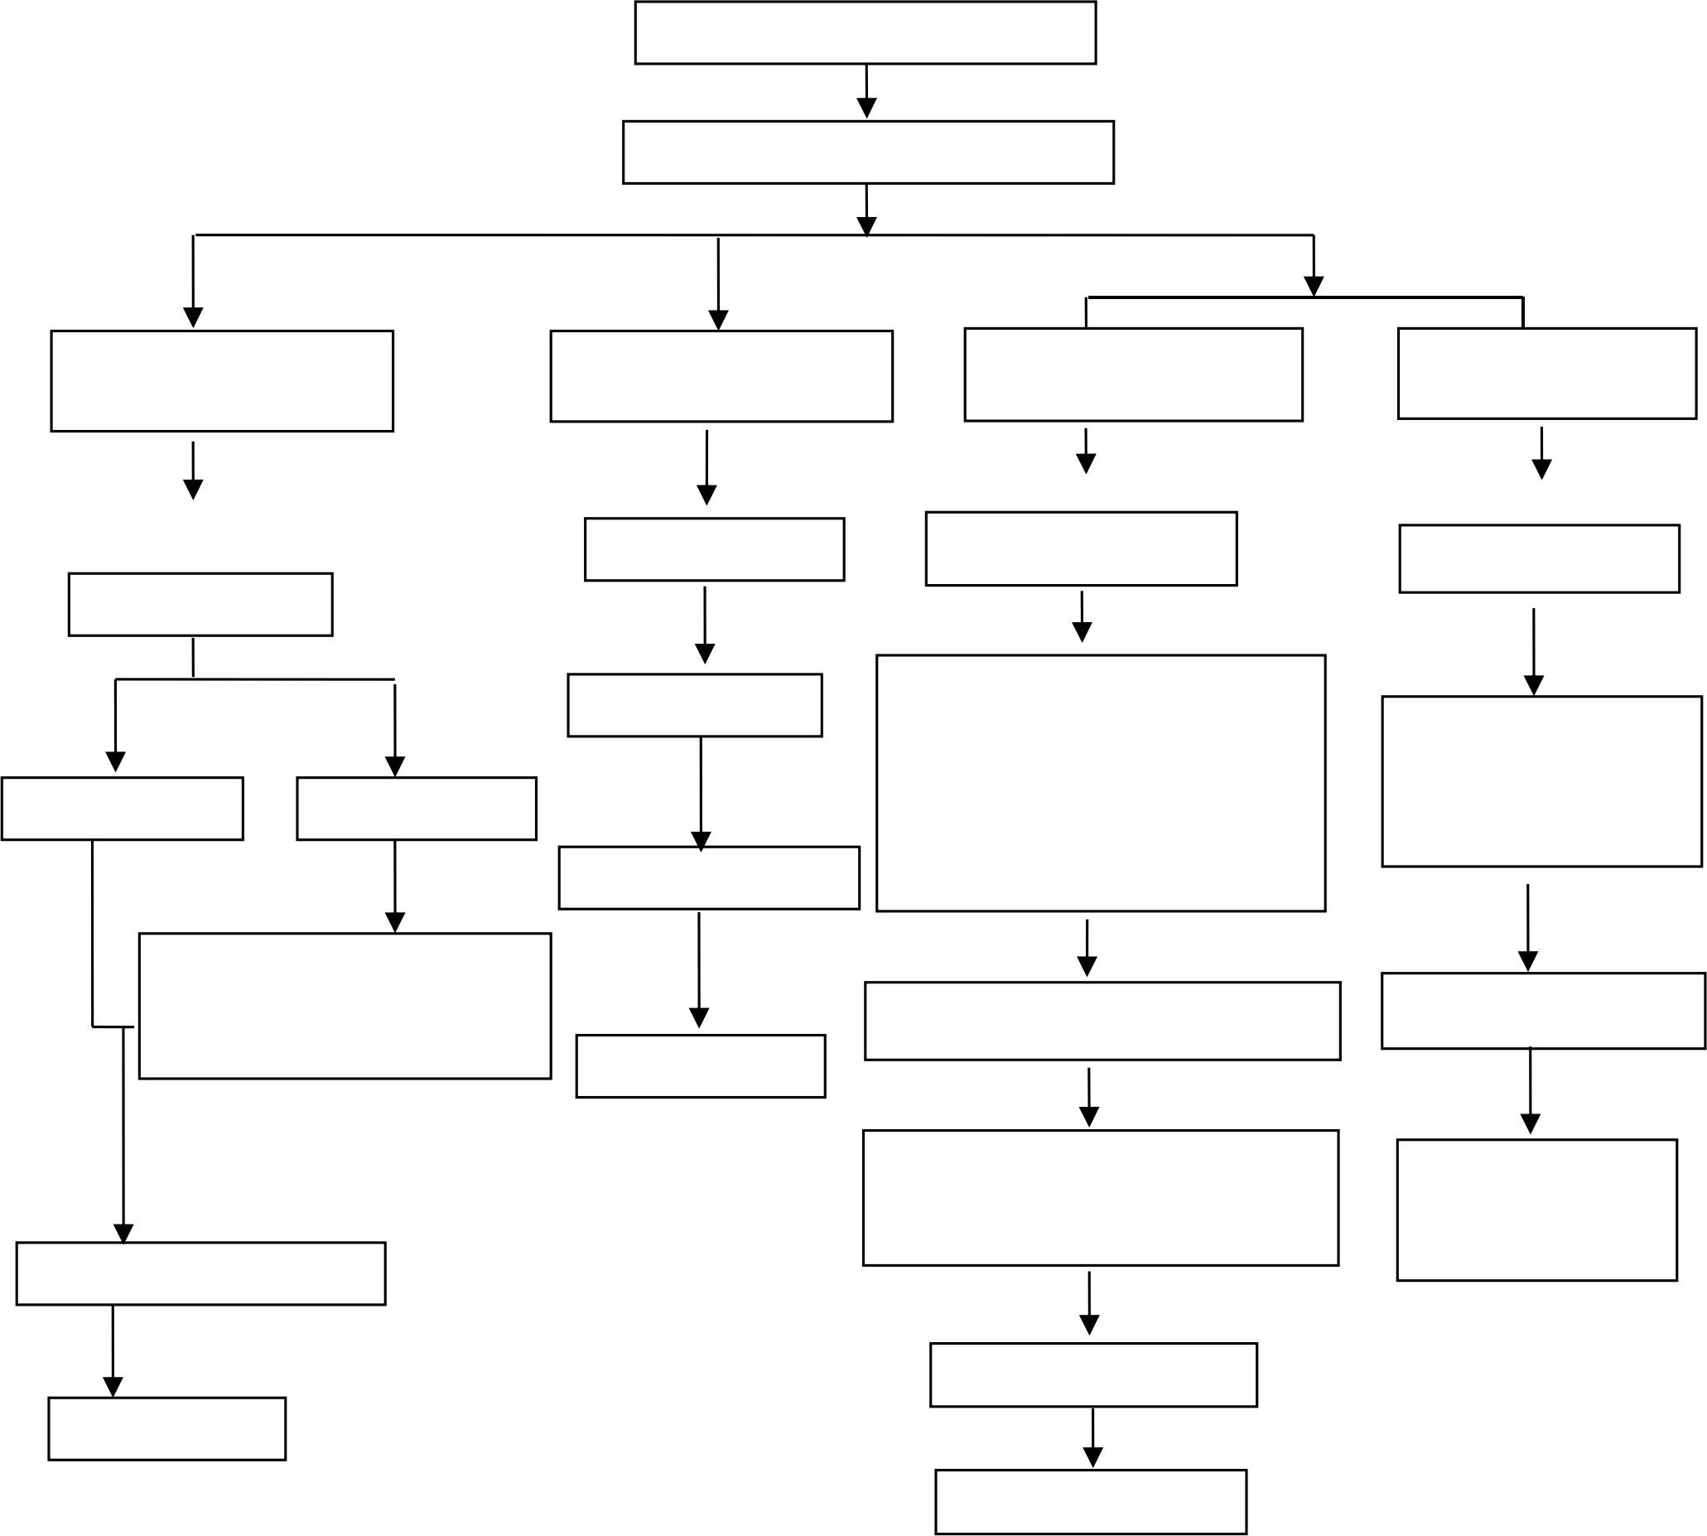
Sample Preparation

Sample Measurement

Pb/Cd
Cr6+
Hg
Acid digestion with microwave/ hotplate
Acid digestion with microwave/ hotplate
Metallic material
Nonmetallic material

Adding digestion
Filtration
Boiling water
Filtration

1)Soluble polymer:
Solution
adding NMP ultrasound
Adding 1, 5
2)Insoluble polymer: adding alkaline digestion
-diphenylcarbazide
for color
development
Solution Residue

1) Alkali Fusion/Dry Ashing
2) Acid to dissolve
solution + toluene, 150℃ -160℃ closed heating
ICP analyze

Filtration and pH adjustment
UV-Vis analyze
DATA

Adding 1, 5
DATA
(Negative/
Positive)
-diphenylcarbazide for color development
ICP/AAS analyze

UV-Vis analyze
DATA
DATA

No.502, Building 1, Yibaolai Industrial City, Qiaotou Community, Fuhai Street, Bao'an District, Shenzhen, Guangdong, China
Shenzhen AZT Technology Co., Ltd.
Tel: 0755-23501189; E-mail: azt-ep@azt-tech.com; Http: www.azt-tech.com

TEST REPORT
Report No.:AZT251219005C-E0 Date of issue: December 24, 2025 Page 8 of 10

PBBs/PBDEs Testing Flow Chart

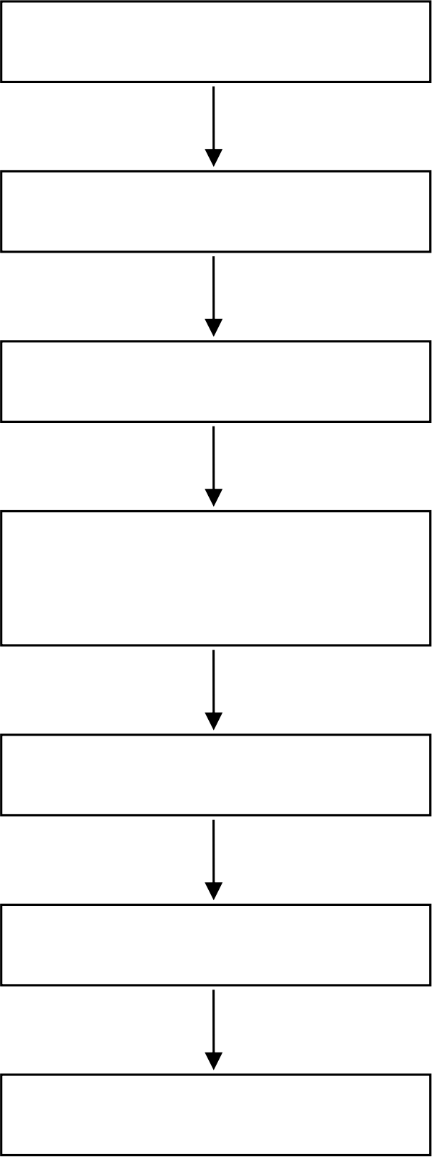
Cutting/ Preparation

Weigh Sample

Sample solvent extraction


Concentration/ Dilution of Extracted solution

Filtration

GC-MS

DATA

No.502, Building 1, Yibaolai Industrial City, Qiaotou Community, Fuhai Street, Bao'an District, Shenzhen, Guangdong, China
Shenzhen AZT Technology Co., Ltd.
Tel: 0755-23501189; E-mail: azt-ep@azt-tech.com; Http: www.azt-tech.com

TEST REPORT
Report No.:AZT251219005C-E0 Date of issue: December 24, 2025 Page 9 of 10

Phthalates Testing Flow Chart

Cutting/ Preparation

Weigh Sample

Sample solvent extraction


Concentration/ Dilution of Extracted solution

Filtration

GC-MS

DATA

No.502, Building 1, Yibaolai Industrial City, Qiaotou Community, Fuhai Street, Bao'an District, Shenzhen, Guangdong, China
Shenzhen AZT Technology Co., Ltd.
Tel: 0755-23501189; E-mail: azt-ep@azt-tech.com; Http: www.azt-tech.com

TEST REPORT
Report No.:AZT251219005C-E0 Date of issue: December 24, 2025 Page 10 of 10

The photo of the sample

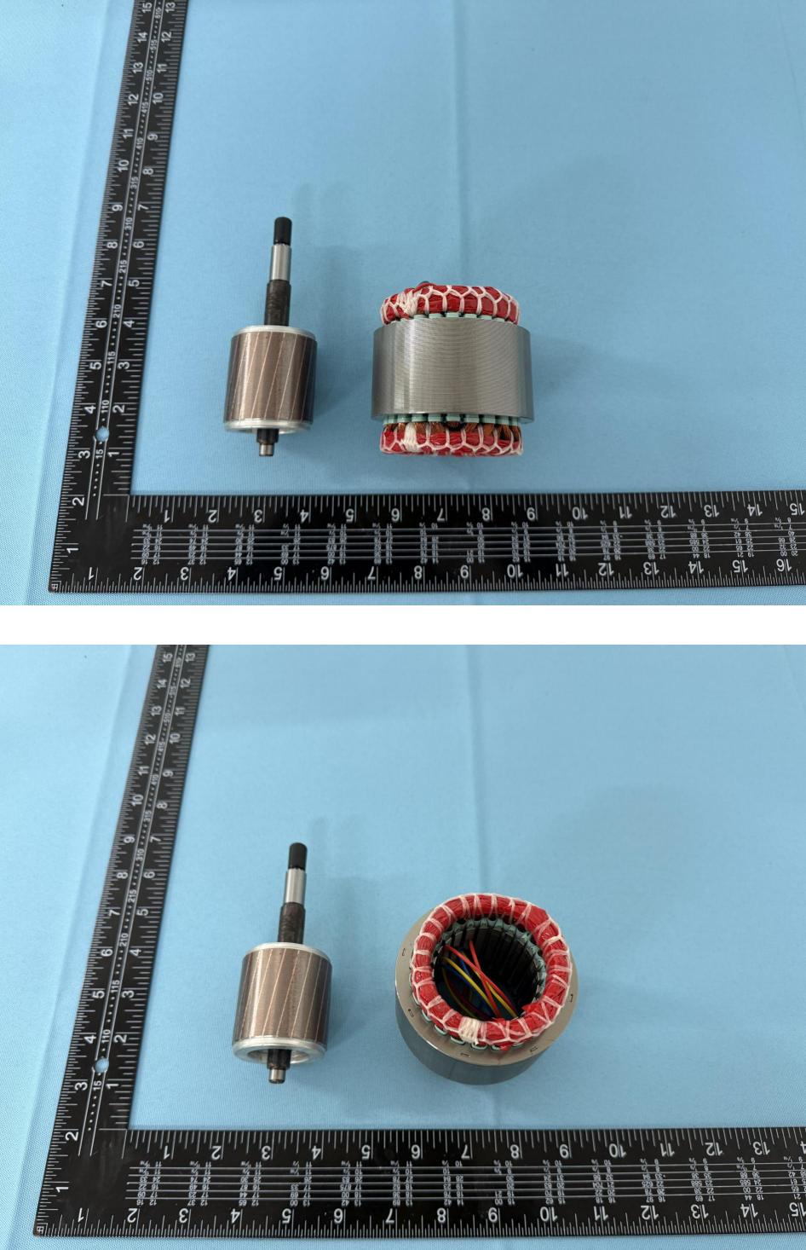

AZT authenticate the photo on original report only
Statement:
1. This test report is invalid without the signature of the approver and the special seal of the company's report.
2. The copy of the test report is invalid if the "Special Seal for Inspection and Testing" or "Special Seal for testing" or the official seal of the testing unit is not re-stamped.
3. After the test report is altered, the test report is invalid.
4. If there is any objection to the test report, please submit written comments to the laboratory within 15 days from the date of receipt of the report.
5. This test is only responsible for samples provided by customers.
6. This report shall not be reproduced in whole or in part without the written authorization of the Company.
7. The laboratory is not responsible for sampling, all samples are provided by customers.
8. The test results in this test report are only related to the samples provided by the customer.
9. If the report is not stamped with the qualification mark, it is only used for scientific research, teaching, internal quality control and other activities, and does not have a proof role for the society.
*** End of Report ***

No.502, Building 1, Yibaolai Industrial City, Qiaotou Community, Fuhai Street, Bao'an District, Shenzhen, Guangdong, China
Shenzhen AZT Technology Co., Ltd.
Tel: 0755-23501189; E-mail: azt-ep@azt-tech.com; Http: www.azt-tech.com

