Download diary at http://crypto.cyberpdx.org/static/diary.zip

1.

116 104 101 32 107 101 121 32 102 111 114 32 110 117 109 98 101 114  
  
32 111 110 101 32 105 115 58

01100011

01100001

01110100

01100011

01101000

01100001

01110111

01100001

01110110

01100101

2.

74 68 65 20 6b 65 79 20 66 6f 72 20 6e 75 6d 62 65 72 20

74 77 6f 20 69 73 20 66 65 6c 69 6e 65 62 61 63 6b 64 6f 6f 72

3.





4. 5.

https://goo.gl/fmRvDt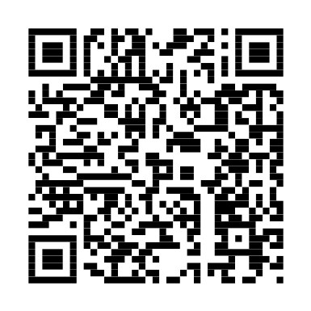

6.

H N E R F C

y k e h t e

m n r o f u

x s r e b i

o n o s i i

e u o r n t

7.

torsthrsaoenetokuvulemebbybneofeirx

8.



9.

You should know how it begins by now....

lfi vim osk qdrxik qbqi be rikkbgrebqlkdebsq

10.

Vigenere Key = CYBERDIS

VFFOVBNGTLVQSHZLGLJWXUMSVUIMKHKSDJFMEOWOGPDEJH

11.

Without the spiritual world the material world is a

disheartening ______. Joseph Joubert (1754-1824)

Try Day 0xB

IAFZ QWBI AKCK LKMN VYES UNHR JBXN GXFN ONEW CWAI QGTP BONK C

12.



PVSNILBCFQYZXSFWARHJSLWFDWBBQRPOZLRYKKSUGNOS

1. 15.

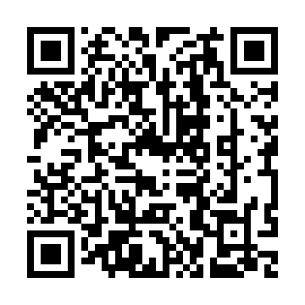H I L O P S

l u e h t r

o t a h t y

t n a w u t

s y r t o i

: p t t h s

. o g / / o

1 r / l g O

x R y

14.

tcoigathaunmyeenngafekbdeooneeunnu.yfsidr

RJQM YTOK PLBK TIQH IOVR UJFC IYBE HQKC VDTA QJLX LZEL

16.



17.

59 6f 75 20 6b 6e 6f 77 20 68 6f 77 20 69 74 20 73 68 6f 75 6c 64 20

67 6f 21

71 79 6f 20 68 6f 6c 20 63 66 75 20 7a 72 69 73 6f 75 20 6e 6f 67 6f

7a 71 6f 6f 7a 20 78 6e 20 75 6f 67 6f 75 6e 6f 6a 66 66 68

18. 19.

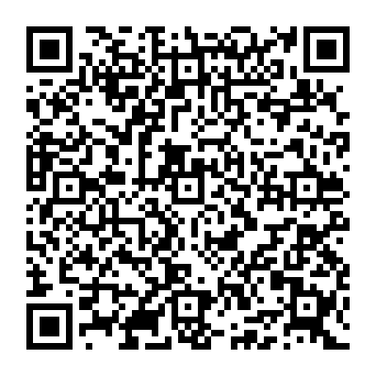



66 6f 20 61 77 64 63 68 61 6c 69 6f 70

20. 21.

01100111

01101111

01101111

00101110

01100111

01101100

00101111

00110111

01010111

01010001

01110010

01101100

01100010

22.

69 71 72 73 76 78 83

116 101 102 101 107 104 121

111 110 101 109 117 114 98

114 119 121 110 101 116 116

116 111 105 115 105 119 114

110 122 114 101 103 111

24.

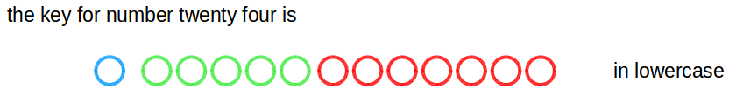

23.

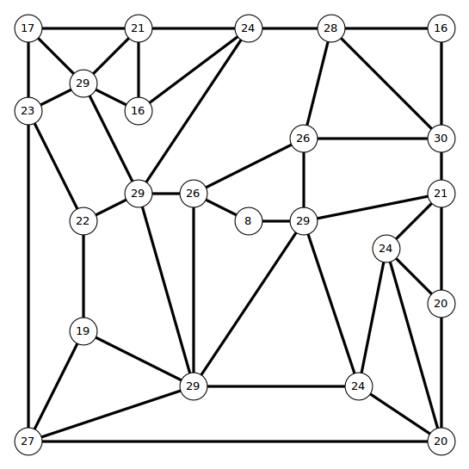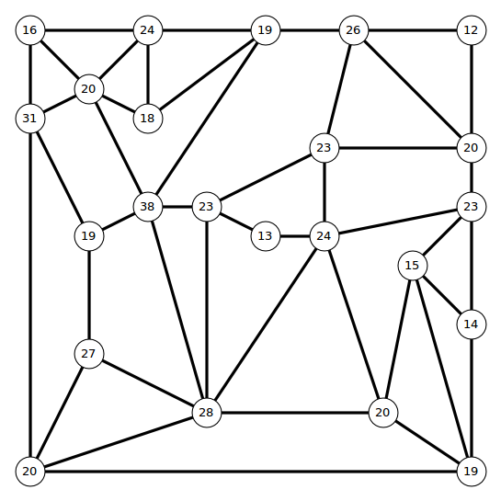**het yke rfo nebumr ytnetw tehre si**

