Diary at http://crypto.cyberpdx.org/

116 104 101 32 107 101 121 32 102 111 114 32 110 117 109 98 101 114  
  
32 111 110 101 32 105 115 58

01100011

01100001

01110100

01100011

01101000

01100001

01110111

01100001

01110110

01100101

74 68 65 20 6b 65 79 20 66 6f 72 20 6e 75 6d 62 65 72 20

74 77 6f 20 69 73 20 66 65 6c 69 6e 65 62 61 63 6b 64 6f 6f 72

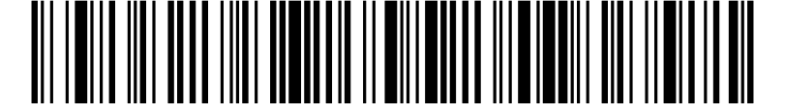

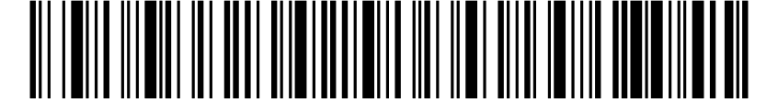

https://goo.gl/fmRvDt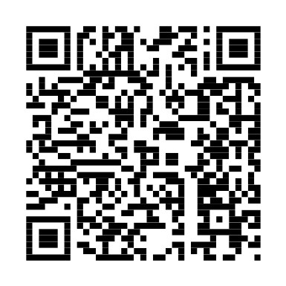

H N E R F C

y k e h t e

m n r o f u

x s r e b i

o n o s i i

e u o r n t

torsthrsaoenetokuvulemebbybneofeirx

Crypto wheel at http://crypto.cyberpdx.org/

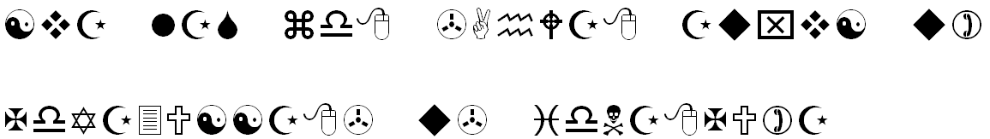

You should know how it begins by now....

lfi vim osk qdrxik qbqi be rikkbgrebqlkdebsq

Vigenere Key = CYBERDIS

VFFOVBNGTLVQSHZLGLJWXUMSVUIMKHKSDJFMEOWOGPDEJH

Without the spiritual world the material world is a

disheartening ______. Joseph Joubert (1754-1824)

Try Day 0xB

IAFZ QWBI AKCK LKMN VYES UNHR JBXN GXFN ONEW CWAI QGTP BONK C

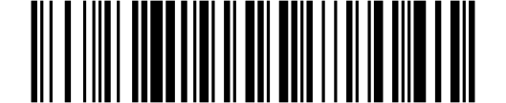

PVSNILBCFQYZXSFWARHJSLWFDWBBQRPOZLRYKKSUGNOS

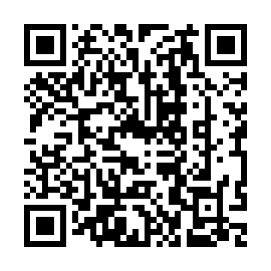H I L O P S

l u e h t r

o t a h t y

t n a w u t

s y r t o i

: p t t h s

. o g / / o

1 r / l g O

x R y

tcoigathaunmyeenngafekbdeooneeunnu.yfsidr

RJQM YTOK PLBK TIQH IOVR UJFC IYBE HQKC VDTA QJLX LZEL

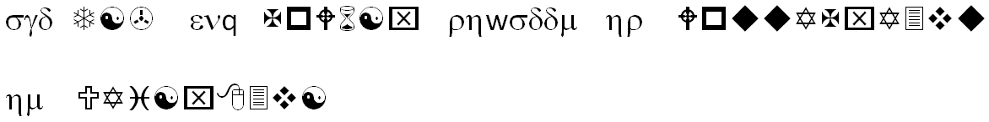

59 6f 75 20 6b 6e 6f 77 20 68 6f 77 20 69 74 20 73 68 6f 75 6c 64 20

67 6f 21

71 79 6f 20 68 6f 6c 20 63 66 75 20 7a 72 69 73 6f 75 20 6e 6f 67 6f

7a 71 6f 6f 7a 20 78 6e 20 75 6f 67 6f 75 6e 6f 6a 66 66 68

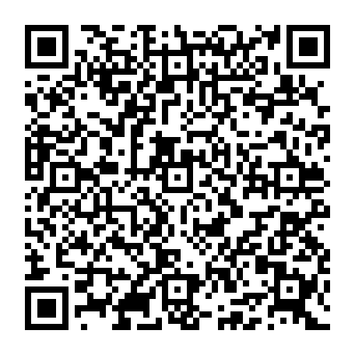

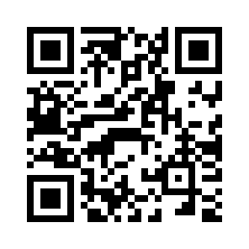

66 6f 20 61 77 64 63 68 61 6c 69 6f 70

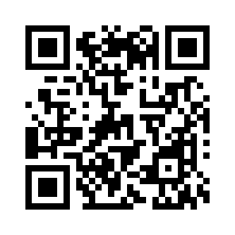01100111

01101111

01101111

00101110

01100111

01101100

00101111

00110111

01010111

01010001

01110010

01101100

01100010

69 71 72 73 76 78 83

116 101 102 101 107 104 121

111 110 101 109 117 114 98

114 119 121 110 101 116 116

116 111 105 115 105 119 114

110 122 114 101 103 111

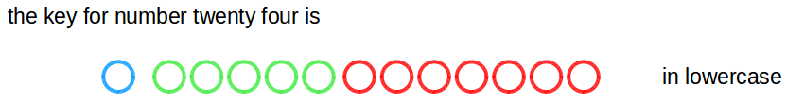

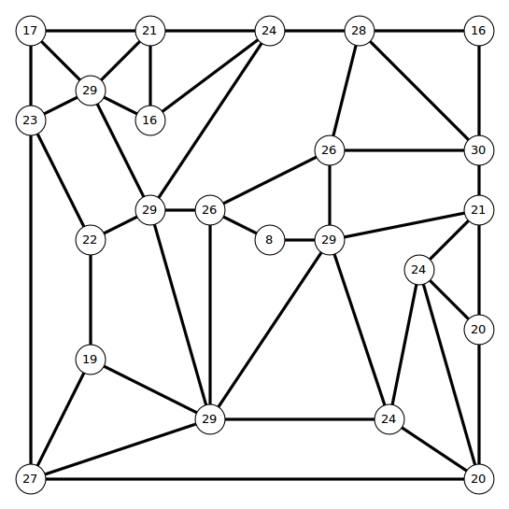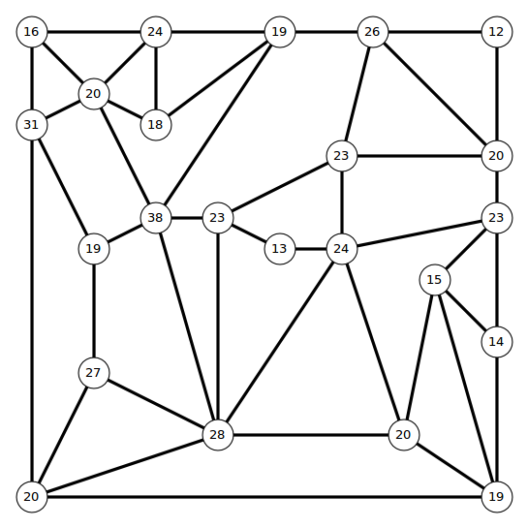**het yke rfo nebumr ytnetw tehre si**

