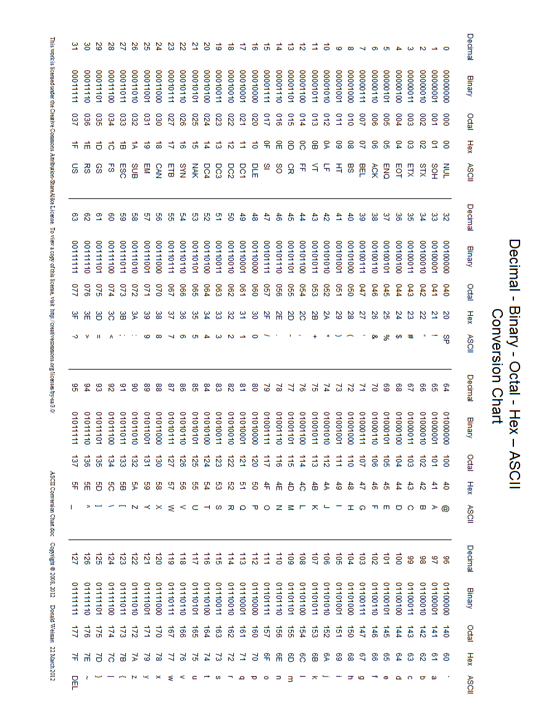



Snippet #1: 54 68 65 20 68 6F 6D 65 20 74 6F

Snippet #2: 65 76 65 72 79 6F 6E 65 20 69 73

Snippet #3: 74 6F 20 68 69 6D 20 68 69 73

Snippet #4: 63 61 73 74 6C 65 20 61 6E 64

Snippet #5: 66 6F 72 74 72 65 73 73 2E

Snippet #6: 45 64 77 61 72 64 20 43 6F 6B 65

Find what binary 01000011 is in decimal, then add it to what hexadecimal 2E is in decimal. Finally, take that decimal number and look up its ASCII character. This is letter number 1 in the 6 missing characters in https://goo.gl/______

Find what binary 00111110 is in decimal, then add it to what hexadecimal 15 is in decimal. Finally, take that decimal number and look up its ASCII character. This is letter number 2 in the 6 missing characters in https://goo.gl/______

Find what binary 00011011 is in decimal, then add it to what hexadecimal 3A is in decimal. Finally, take that decimal number and look up its ASCII character. This is letter number 3 in the 6 missing characters in https://goo.gl/______

Find what binary 00110110 is in decimal, then add it to what hexadecimal 1F is in decimal. Finally, take that decimal number and look up its ASCII character. This is letter number 4 in the 6 missing characters in https://goo.gl/______

Find what binary 00011101 is in decimal, then add it to what hexadecimal 2B is in decimal. Finally, take that decimal number and look up its ASCII character. This is letter number 5 in the 6 missing characters in https://goo.gl/______

Find what binary 00110011 is in decimal, then add it to what hexadecimal 38 is in decimal. Finally, take that decimal number and look up its ASCII character. This is letter number 6 in the 6 missing characters in https://goo.gl/______