plaintext

ciphertext table

key character

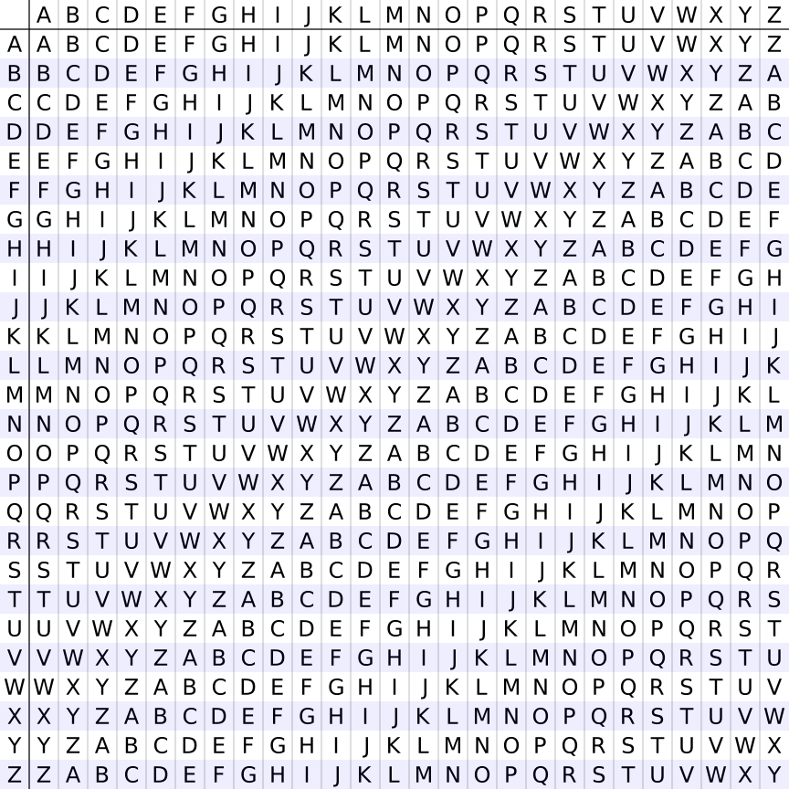



ciphertext table

key character

plaintext

ciphertext table

key character

plaintext

Snippet #1: titoehbifoeeeaplrspl

Snippet #2: eerrrnreewewnviveoel

Snippet #3: leentbcwtreuhhasreen

Snippet #4: sioeuaofilcntretshrr

Snippet #5: scedmaoaftrnlrheceoe

Snippet #6: mrhy8pie1xacn7xtkr8x

Vigenere key = CYBERDIS

Ciphertext #1 = CLZWFFQWVWULRW

Vigenere key = CYBERDIS

Ciphertext #2 = YMVPUJQNGSQECLBLNC

Vigenere key = CYBERDIS

Ciphertext #3 = NGCIIWGXQPBPZWBDG

Vigenere key = CYBERDIS

Ciphertext #4 = UCDYILBQYGMPUHAWTTF

Vigenere key = CYBERDIS

Ciphertext #5 = PCJXYHZSPBMSJHJGVF

Vigenere key = CYBERDIS

Ciphertext #6 = DCONRPQFHPBRBOQF

Enigma sez: AADD LLZB DTQN SNAB JWED RXMD CIYC SQQZ GEGA BLFQ LSAP OXHI UCRC UIPP YVXC NYJZ AIMF OHDE KLRM MDKV SKHR LYOK WGMT

Enigma sez: AADD LLZB DTQN SNAB JWED RXMD CIYC SQQZ GEGA BLFQ LSAP OXHI UCRC UIPP YVXC NYJZ AIMF OHDE KLRM MDKV SKHR LYOK WGMT

Enigma sez: AADD LLZB DTQN SNAB JWED RXMD CIYC SQQZ GEGA BLFQ LSAP OXHI UCRC UIPP YVXC NYJZ AIMF OHDE KLRM MDKV SKHR LYOK WGMT

Enigma sez: AADD LLZB DTQN SNAB JWED RXMD CIYC SQQZ GEGA BLFQ LSAP OXHI UCRC UIPP YVXC NYJZ AIMF OHDE KLRM MDKV SKHR LYOK WGMT

Enigma sez: AADD LLZB DTQN SNAB JWED RXMD CIYC SQQZ GEGA BLFQ LSAP OXHI UCRC UIPP YVXC NYJZ AIMF OHDE KLRM MDKV SKHR LYOK WGMT

E Y B C R

k h e t e

r f o y v

n g e i e

i e 1 r s

N O H J

Vigenere Message Part #1: JHYRNBLKCHV

E Y B C R

k h e t e

r f o y v

n g e i e

i e 2 r s

E N B

Vigenere Message Part #2: LMAHEYCIEUMF

E Y B C R

k h e t e

r f o y v

n g e i e

i e 3 r s

R E O G G

E

Vigenere Message Part #3: TEAVJELXSIG

E Y B C R

k h e t e

r f o y v

n g e i e

i e 4 r s

M H O T A

S

Vigenere Message Part #4: ZHZIHGLLZMSL

E Y B C R

k h e t e

r f o y v

n g e i e

i e 5 r s

E A M J S

Vigenere Message Part #5: WAYIABSOLERDF

E Y B C R

k h e t e

r f o y v

n g e i e

i e 6 r s

A T P

Vigenere Message Part #6: UIGSHXGNTBE