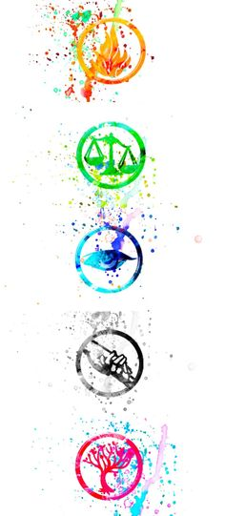

Thanks for helping me save the city yesterday. I need your help again. There is an *URGENT* situation I've been made aware of that involves the theft of a critical supply of sustinence to a vulnerable population of youth. We must act quickly before the supply is lost forever! I need to make sure I have the right people for the job so let's communicate via Twitter Direct Message @CDFour . Send me the message 'Candy' and I will tell you more. I may ask you about the codes below so keep them handy.

Four

56 69 73 69 74 20 67 6f 6f 2e 67 6c 20 77 69 74 68

01110110

01111000

01000110

01101110

00110100

01101010

___________________________________________________________

55 73 65 20 53 63 79 74 61 6c 65 20 50 65 72 69 6f 64 20 38

DheUpCVeeelspoiDcWoeolgeoowIsoecdrAtirnoednstTedTBdOeore

01000010

01001100

01000001

01000011

01001011



BPTEXDLJEEJREBXDTCD

http://cyberd.oregonctf.org/static/____.jpg