1.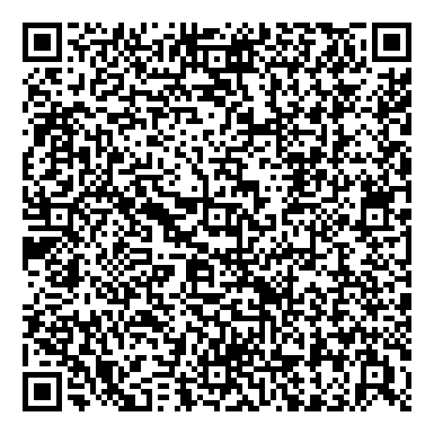

2.

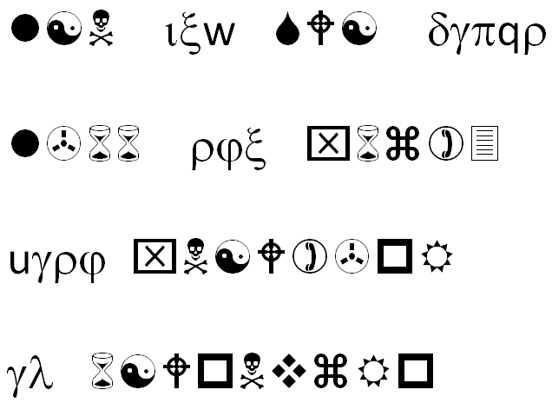

http://cyberd.oregonctf.org/static/________.jpg

3.



WAQB IVQA TFDD DGRB SFQA OEXG XXFT SFJY VVLU RXMV JJMC RXJG RVOU CKWQ CMIT BXRY DDOU WA

5.

68 74 74 70 3a 2f 2f 67 6f 6f 2e 67 6c 2f 46 73 46 69 76 6a

4.

To unlock this message, you will need the key...

OSRXMLJXYRSQAHFLAGENWKYIYBSSANOLKRFHXHRKYSLOSNBGLNYROIAGNRTRZCPJDA

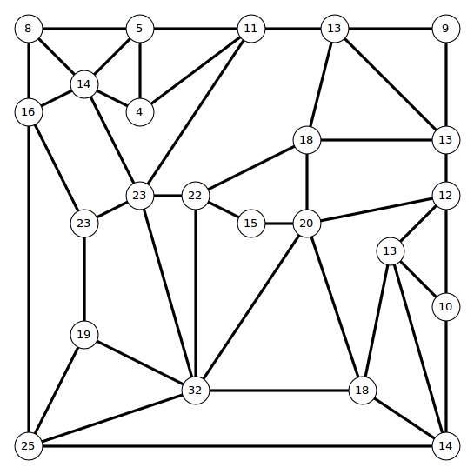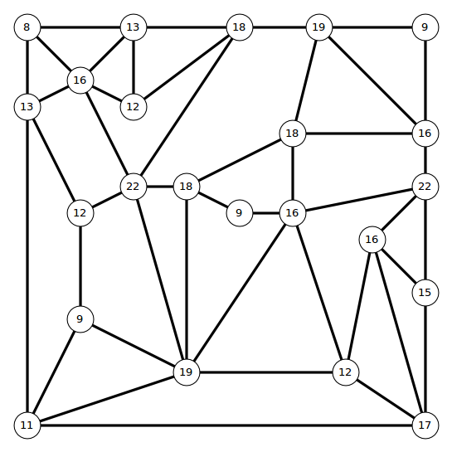

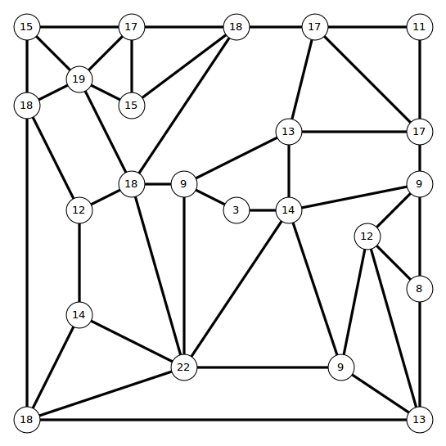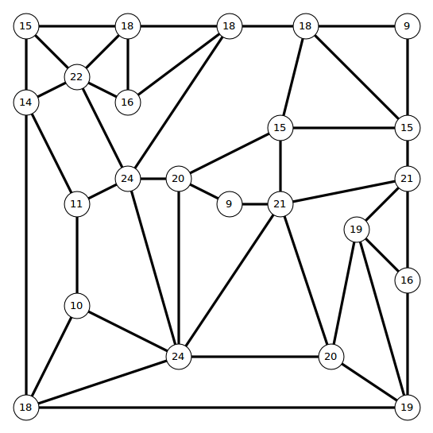

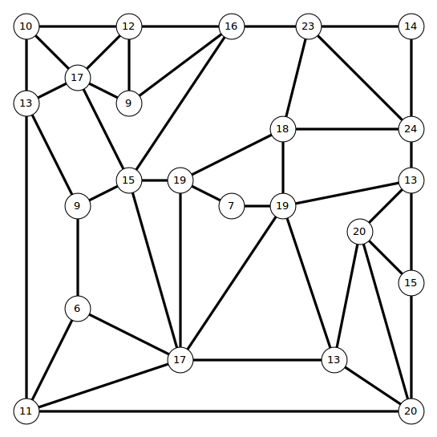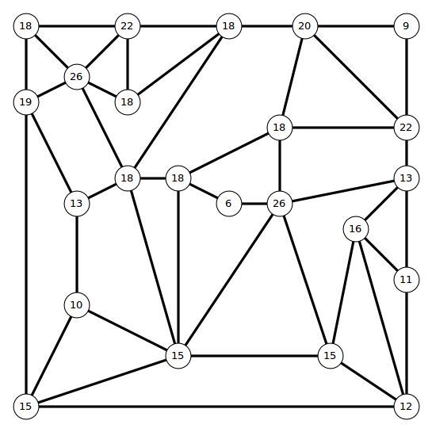

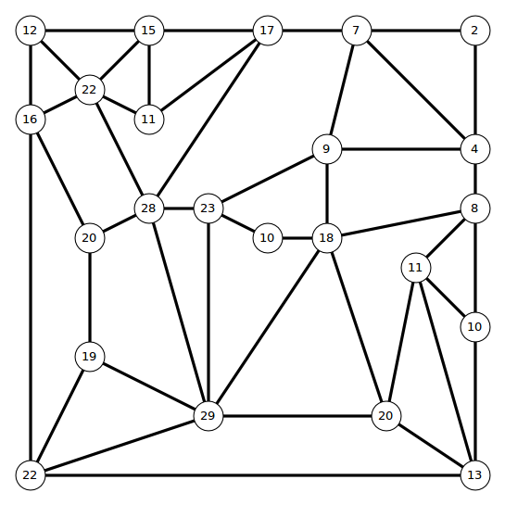

6.

t u b y p o hi a l g ;

hxs mvxj rqcs bjmhsvfjkhdqj vy sdwc bdknnqyfq ;

f w .

sdq twjcs uvjl vt sdq bkqckj oqcckfq wc jqhnkbq.

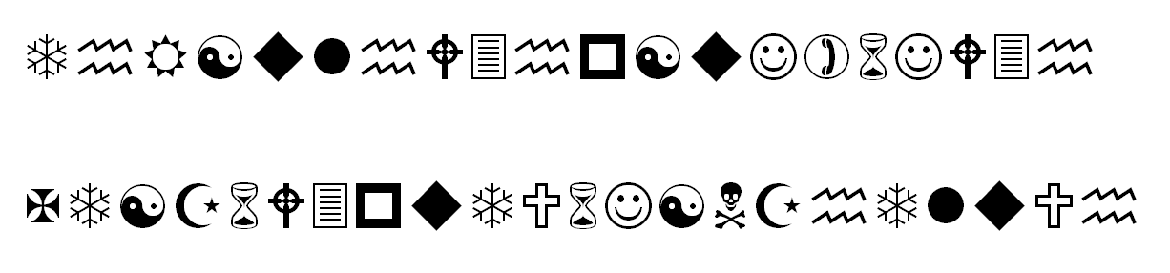

http://cyberd.oregonctf.org/static/____.jpg