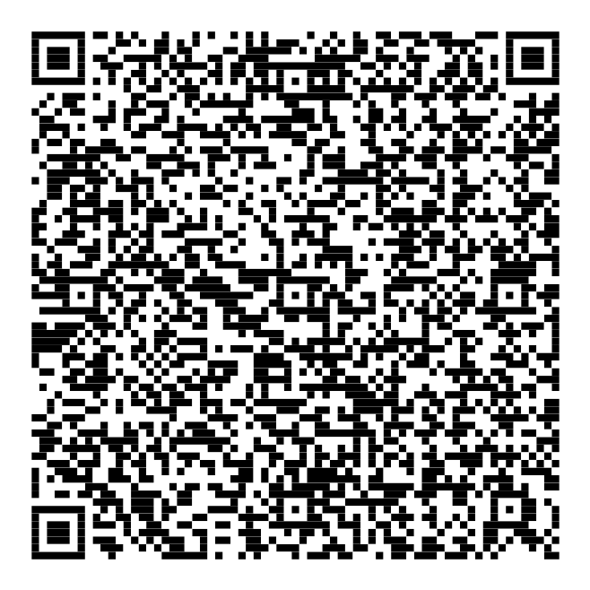1.

2.

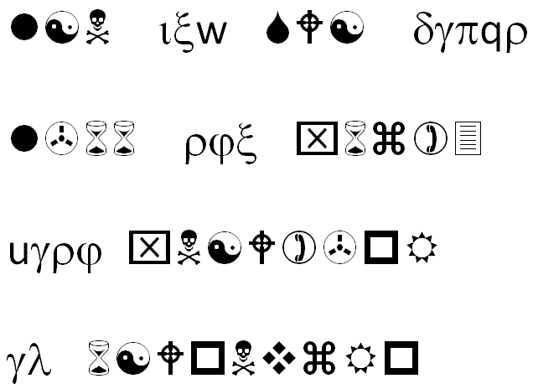

http://crypto.cyberpdx.org/static/________.jpg

3.

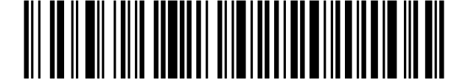

WAQB IVQA TFDP AZAB SFIO CBXW OASE TCZD RDAB GMCS CNTA KDHM KBOP TFYY HTGM FVPK GWBW FCQL UUYX LWYC CKCC S

5.

**68 74 74 70 73 3a 2f 2f 67 6f 6f 2e 67 6c 2f 69 67 4a 79 6c 30**

4.

To unlock this message, you will need the key...

OSRXMLJXYRYWBODTUALRVCLEOZVHPIAPZBWBGRNURVJRDFUVXQXHRVGIUPMREUECCOHBUMWO

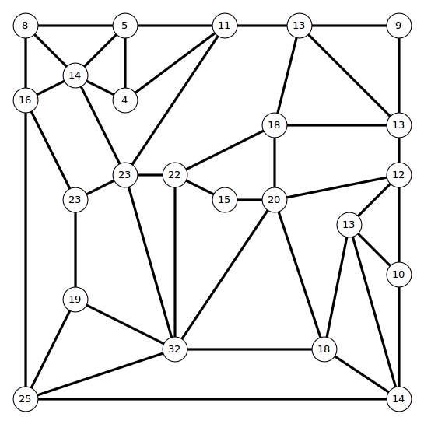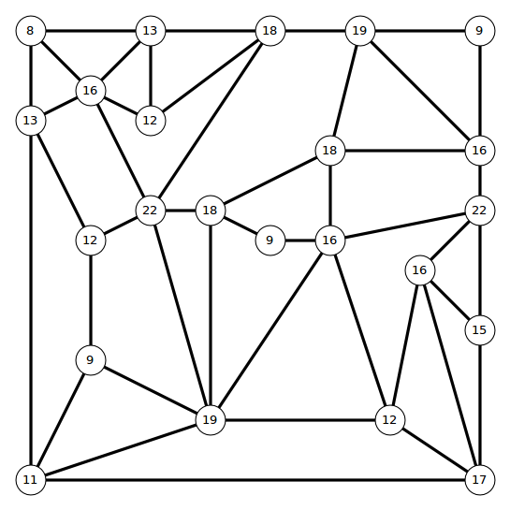

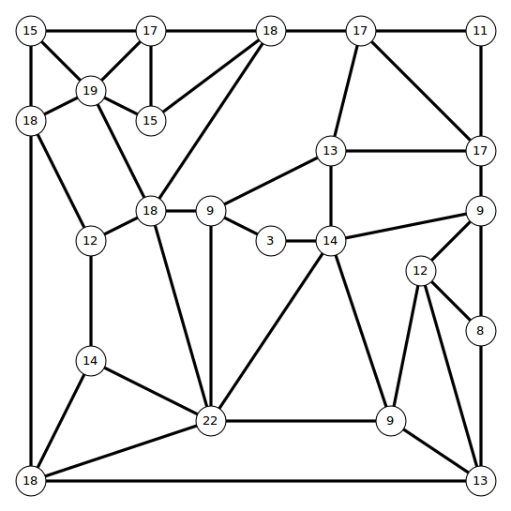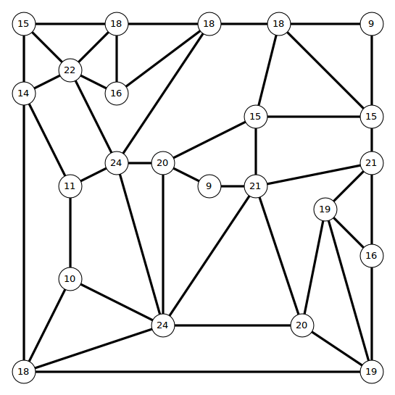

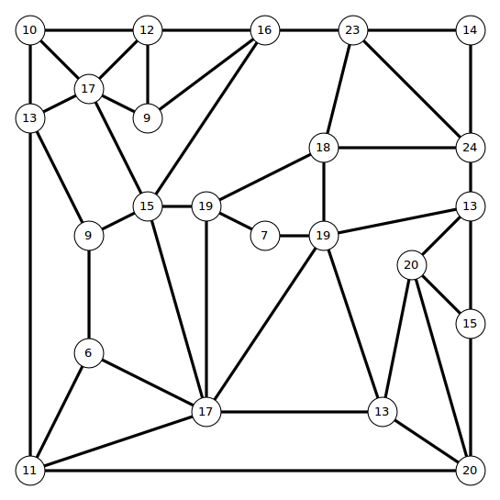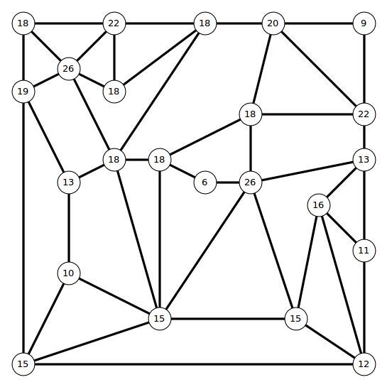

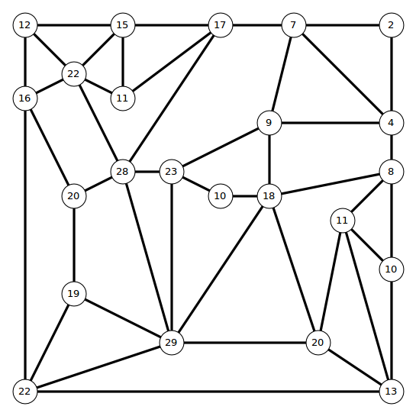

6.

t u b y p o hi a l g ;

hxs mvxj rqcs bjmhsvfjkhdqj vy sdwc bdknnqyfq ;

f w .

sdq twjcs uvjl vt sdq bkqckj oqcckfq wc jqhnkbq.

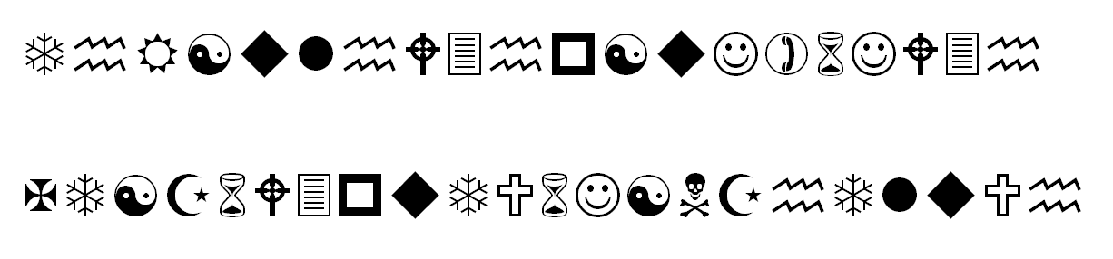

http://crypto.cyberpdx.org/static/____.jpg